## Screenshots

### New game Request:

Using CURL:

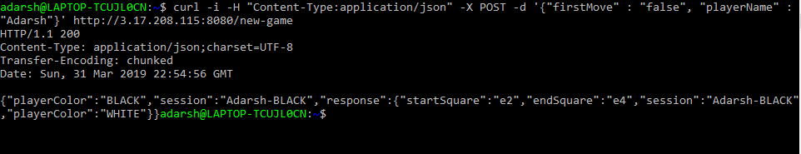

Using Advanced Rest Client

Request:

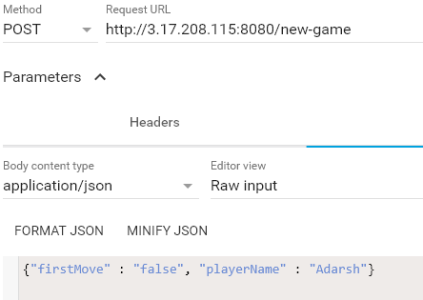

Response:

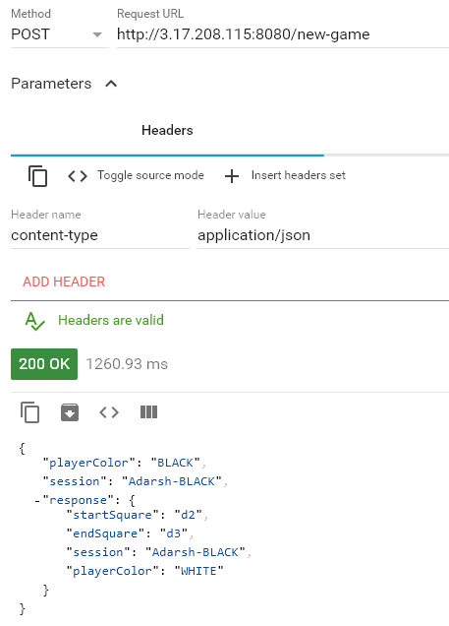

### Move Request (Move a piece on the board)

Using CURL:

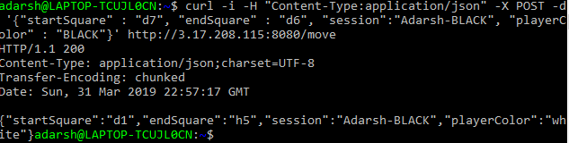

Using Advanced Rest Client:

Request:

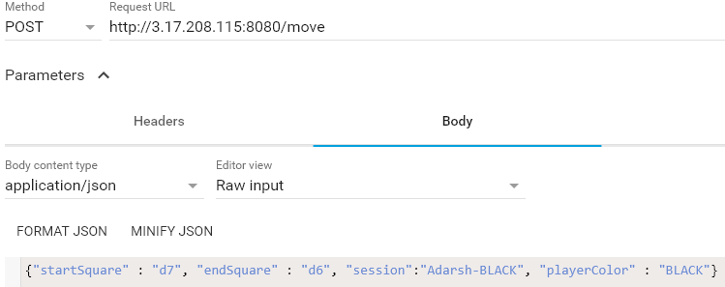

Response:

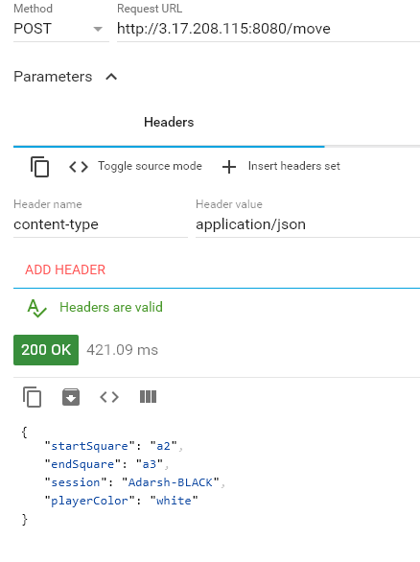

### Quit Game:

Request:

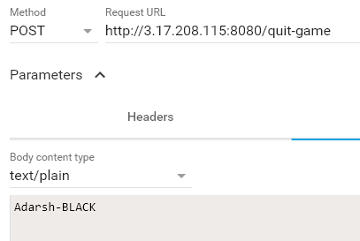

Response:

