Q1. How can you output “physics” and “wallah” in two different line in c++?

ANS)

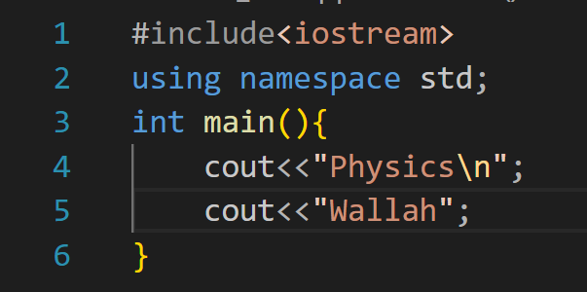

Q2. Print 10 using 2 positive number less than 6 in C++ as output?

Ans)

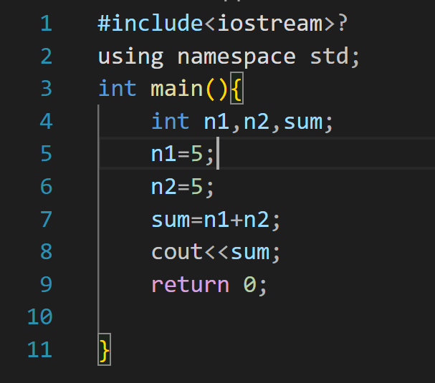

Q3. How much does the following data type need?

1. Int- 4bytes
2. Bool-2bytes
3. Float- 4bytes

Q4.What is the output of this program?

Void main(){

Int a=4;

Int b=3;

a++;b--;

cout<<++a<<” “<<b--;

}

Ans) error: '::main' must return 'int'

Q5. Write a program to find the circumference of a circle with radius 10 in C++?

Ans) 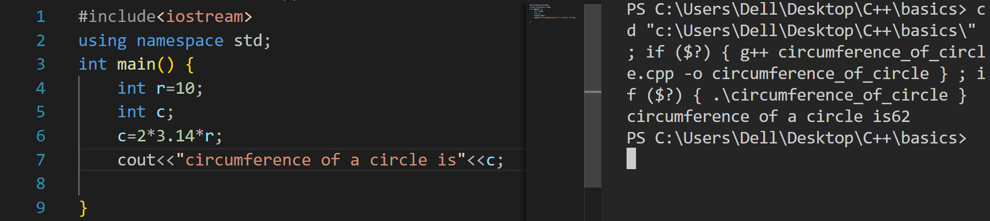

Q6. How many of these can be variable name?\

01PWskills- no

_Float- yes

int- no

Float- yes

You will succeed- no