**RA2211003011653**

**Adarsh Sharma**

**C1. Book a Movie Ticket with Transaction Handling**

**Problem Statement:**

Create a stored procedure that:

1. Books a movie ticket for a user.

2. Ensures seat availability before booking.

3. Handles errors if the seat is already booked.

4. Uses transactions to maintain data integrity.

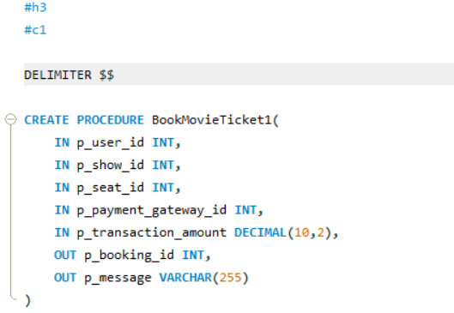

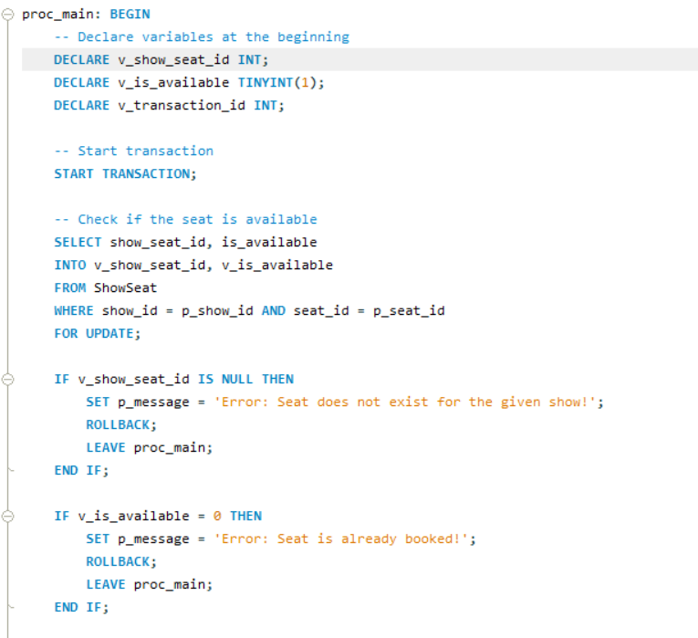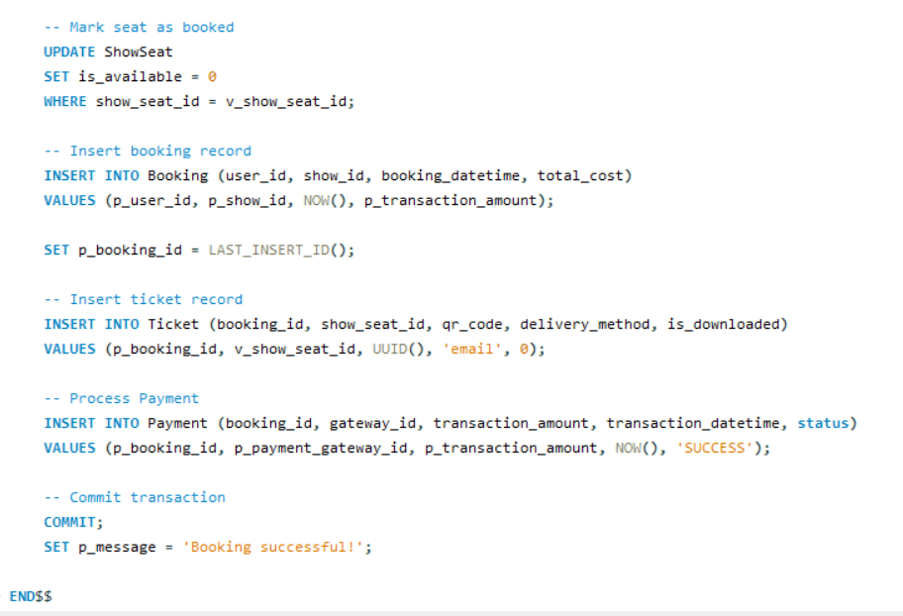

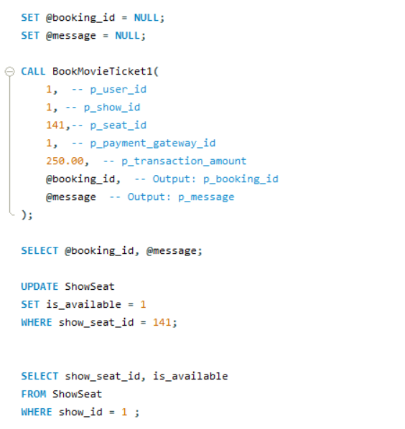

**C2. Calculate Loyalty Points for Booking**

**Problem Statement:**

Create a function that calculates the loyalty points a user earns for a

booking. The function should:

1. Accept a booking_id as input.

2. Award 1 point per 100 INR spent.

3. Return the points earned.

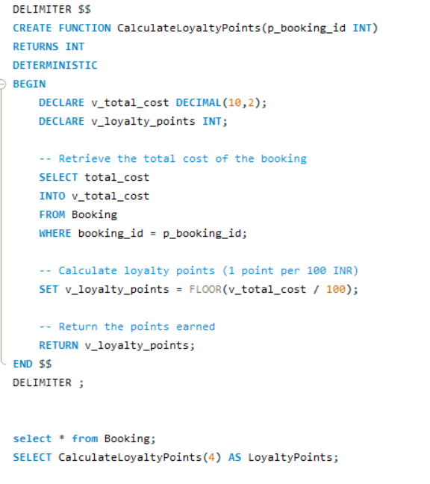

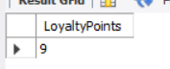

**C3. Automatically Add Loyalty Points After Payment**

**Problem Statement:**

Create a trigger that:

1. Fires after a successful payment (status = 'Success').

2. Uses the CalculateLoyaltyPoints function.

3. Adds the calculated points to the user's Membership balance.

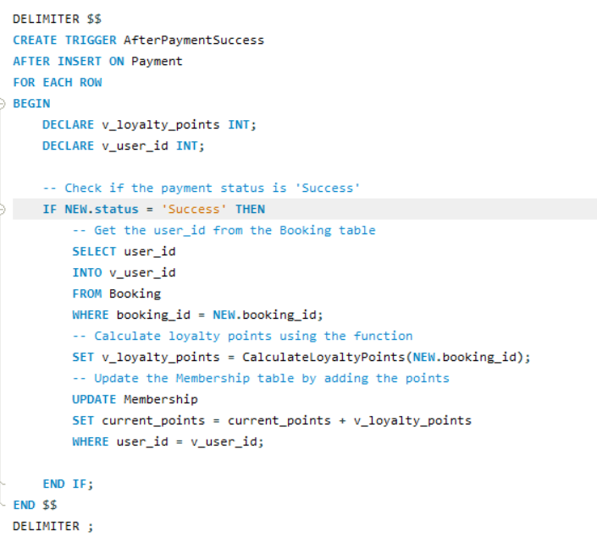

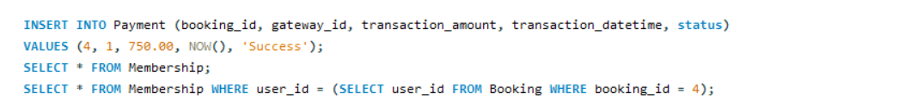

**M1. Revenue Calculation Per Movie**

**Problem Statement:**

Calculate the total revenue generated per movie from ticket sales.

**Base Query (Unoptimized)**

SELECT m.movie_id, m.title, SUM(b.total_cost) AS total_revenue

FROM Booking b

JOIN Show sh ON b.show_id = sh.show_id

JOIN Movie m ON sh.movie_id = m.movie_id

GROUP BY m.movie_id, m.title

ORDER BY total_revenue DESC;

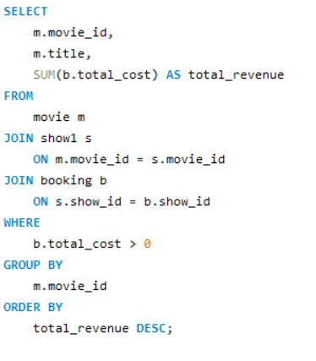



**M2. Movie Popularity Analysis**

**Problem Statement:**

Determine the most popular movies based on the number of bookings and average rating.

SELECT

m.movie_id,

m.title,

b.total_bookings,

r.avg_rating

FROM

Movie m

JOIN

(SELECT sh.movie_id, COUNT(b.booking_id) AS total_bookings

FROM Booking b

JOIN Show sh ON b.show_id = sh.show_id

GROUP BY sh.movie_id

) b ON m.movie_id = b.movie_id

JOIN

(SELECT r.movie_id, AVG(r.rating) AS avg_rating

FROM Review r

GROUP BY r.movie_id

) r ON m.movie_id = r.movie_id

ORDER BY

b.total_bookings DESC,

r.avg_rating DESC;

