Adarsh Sharma   
RA2211003011653

| 13 | **Calculate Total Revenue by Movie and Time Slot** | **H1** | Data Queries | C2 |
| --- | --- | --- | --- | --- |

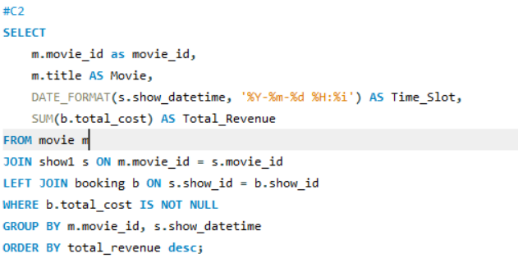  
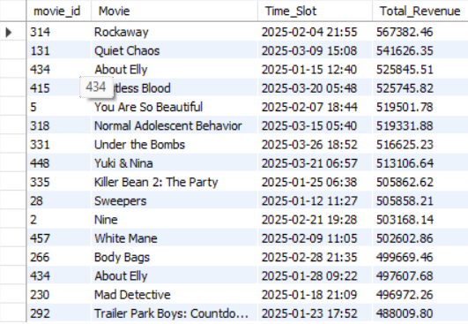

| 14 | **Identify Users Who Have Booked the Most Shows** | **H1** | Data Queries | C3 |
| --- | --- | --- | --- | --- |

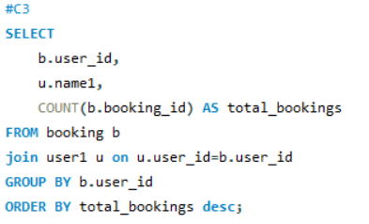

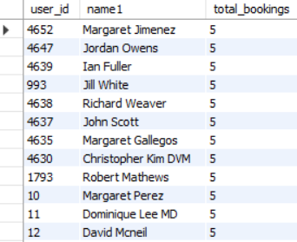

| 15 | **Find the Most Profitable Food Items and Their Sales** | **H1** | Data Queries | C4 |
| --- | --- | --- | --- | --- |

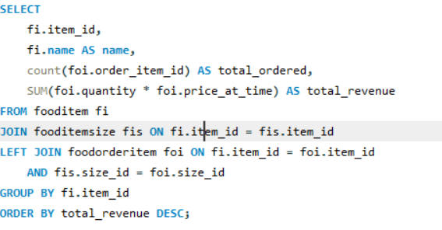

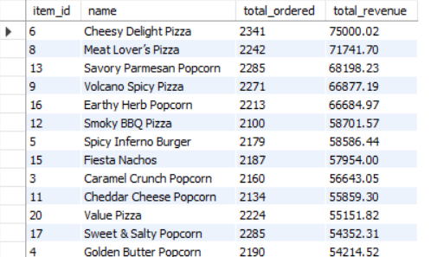

| 16 | **Calculate Total Points Earned by Users in a Given Period** | **H1** | Data Queries | C5 |
| --- | --- | --- | --- | --- |

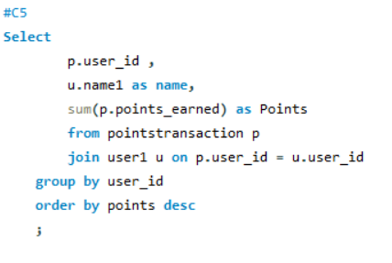

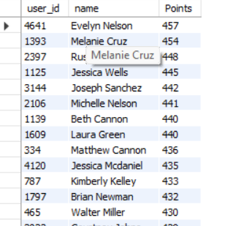

| 18 | **List Users with Membership and Their Current Points** | **H1** | Business Insights | M2 |
| --- | --- | --- | --- | --- |

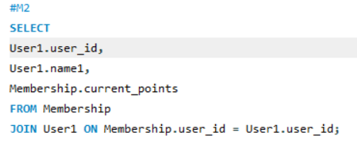

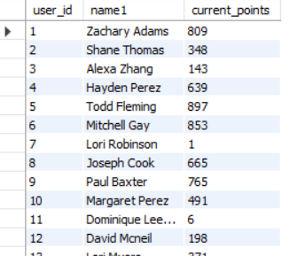

| 24 | **Identify Customers with the Highest Spending on Food Items** | **H1** | Business Insights | C2 |
| --- | --- | --- | --- | --- |

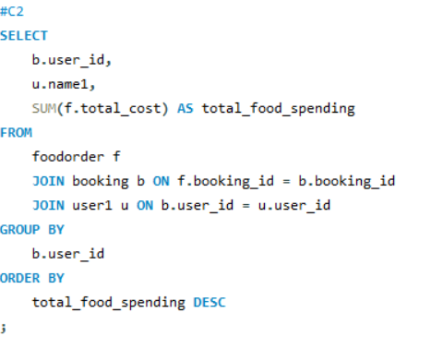

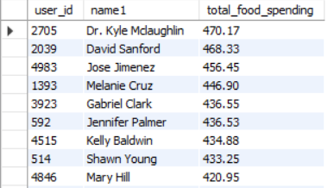

| 29 | **Booking Delivery Method Distribution** | **H2** | Data Visualization | M2 |
| --- | --- | --- | --- | --- |

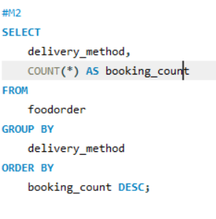

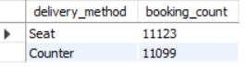

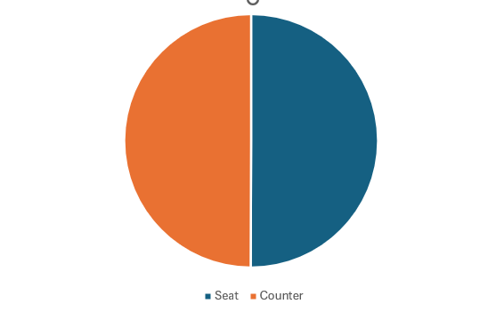

| 30 | **Movie Revenue Analysis by Genre** | **H2** | Data Visualization | M3 |
| --- | --- | --- | --- | --- |

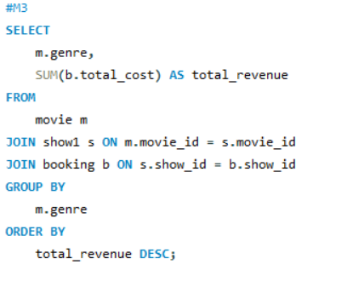

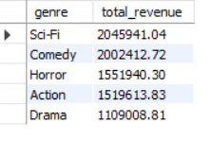

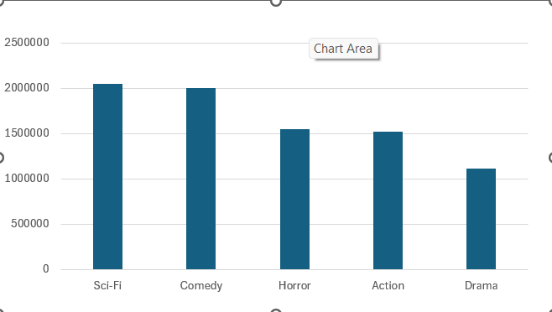

| 35 | **Revenue Calculation Per Movie** | **H3** | Query Optim. | M1 | Adarsh Sharma |
| --- | --- | --- | --- | --- | --- |

