**Cloud computing azure project**

**Project name : DBI movie and show**

**Group member : Adarsh sharma , saad kokate**

**Institution : Magicbus**

**Azure service used : Wed server , DNS ,**

**Availability zone , Virtual machine , zone redundant ,**

**Load balancer**

Azure Portal.

The Azure portal is a web-based, unified console that provides an alternative to command-line tools. You can manage your Azure subscription with the Azure portal. Build, manage, and monitor everything from simple web apps to complex cloud deployments.

Virtual Machine.

A VM is a virtualized instance of a computer that can perform almost all of the same functions as a computer, including running applications and operating systems. Virtual machines run on a physical machine and access computing resources from software called a hypervisor.

Subnet

A subnet, or subnetwork, is a segmented piece of a larger network. More specifically, subnets are a logical partition of an IP network into multiple, smaller network segments. The Internet Protocol (IP) is the method for sending data from one computer to another over the internet.

IIS server

Internet Information Services (IIS) is a flexible, general-purpose web server from Microsoft that runs on Windows systems to serve requested HTML pages or files. An IIS web server accepts requests from remote client computers and returns the appropriate response.

DNS

The Domain Name System (DNS) Server is a server that is specifically used for matching website hostnames (like example.com)to their corresponding Internet Protocol or IP addresses.

availability zones

Azure availability zones are physically and logically separated datacenters with their own independent power source, network, and cooling. Connected with an extremely low-latency network, they become a building block to delivering high availability applications.

load balancing

Azure Traffic Manager. The term load balancing refers to the distribution of workloads across multiple computing resources. Load balancing aims to optimize resource use, maximize throughput, minimize response time, and avoid overloading any single resource.

Zone redundant

Zone-redundant storage (ZRS) copies your data synchronously across three Azure availability zones in the primary region. For applications requiring high availability, Microsoft recommends using ZRS in the primary region, and also replicating to a secondary region

web server

Microsoft Azure Web Sites is a web-hosting platform that supports multiple technologies, and programming languages

**DBI movie and show**

Start Azure Portal.

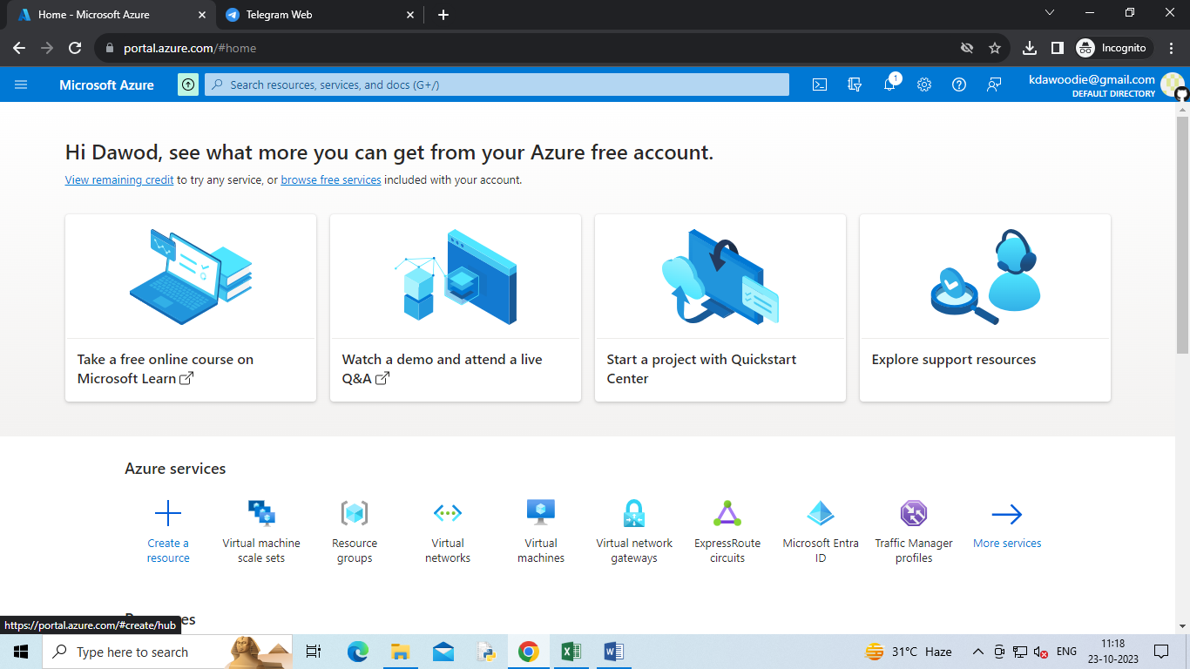

Create a Virtual Machine.

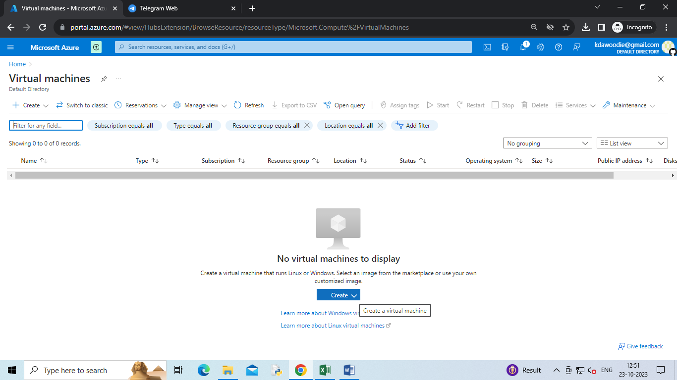

availability zone

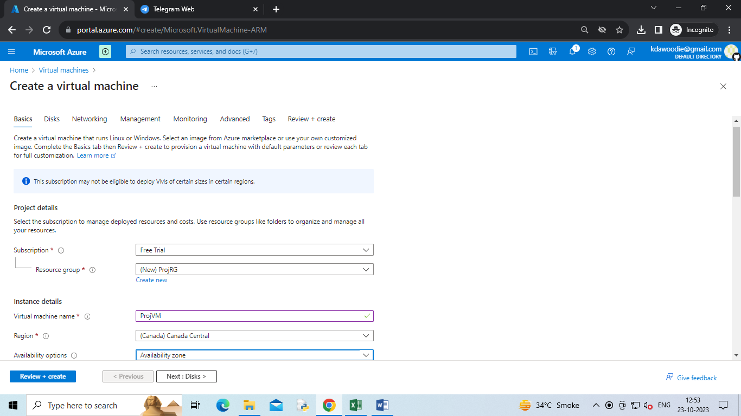

zone redundant

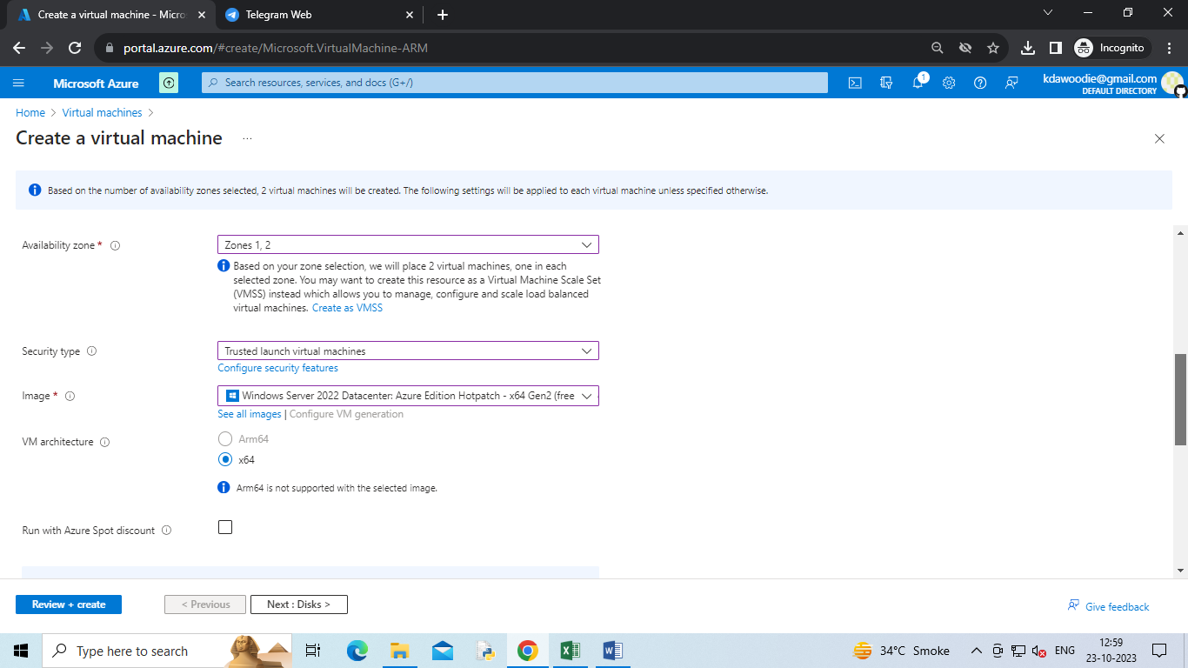

Password and username

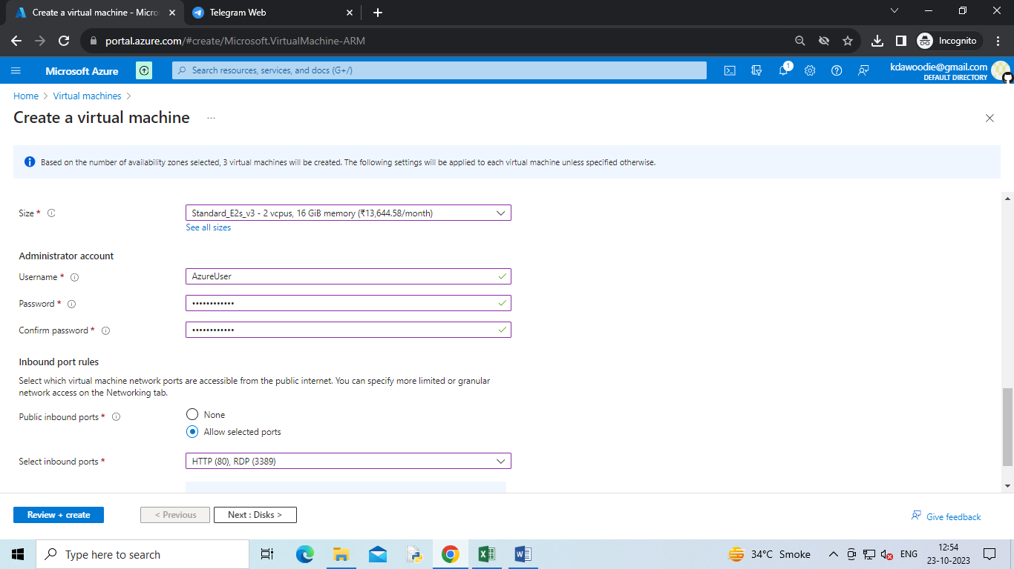

Load balancer

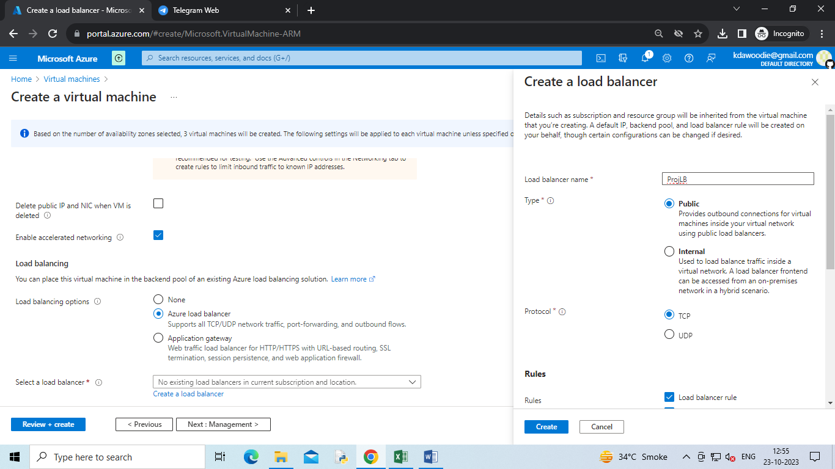

Add subnet

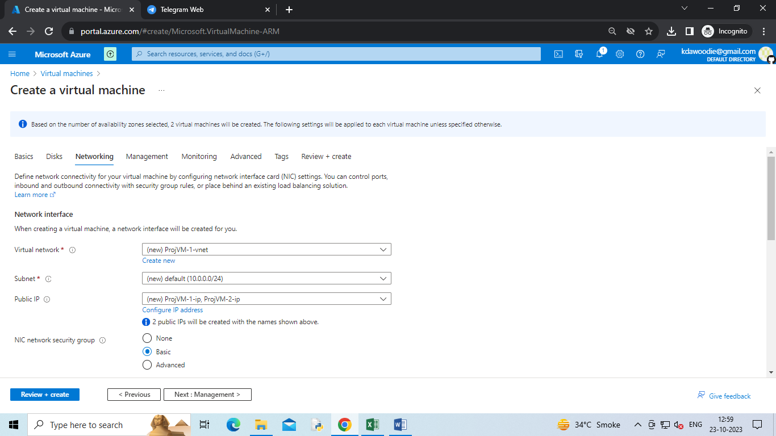

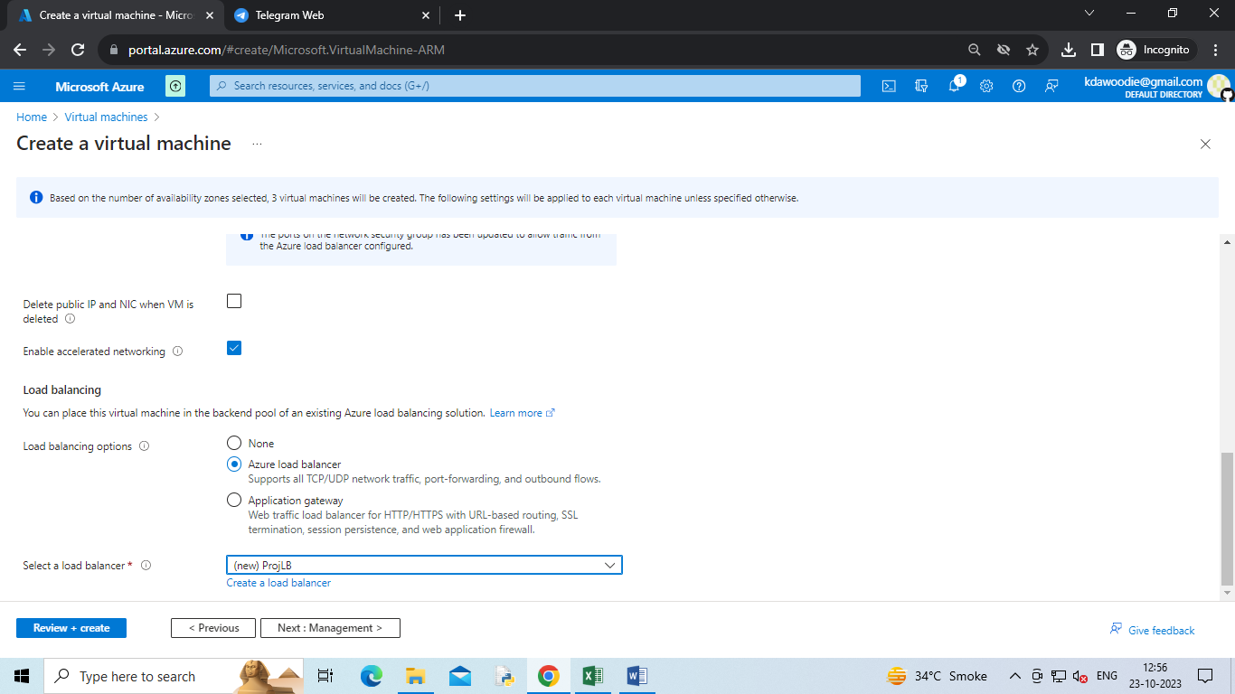

create a virtual machine

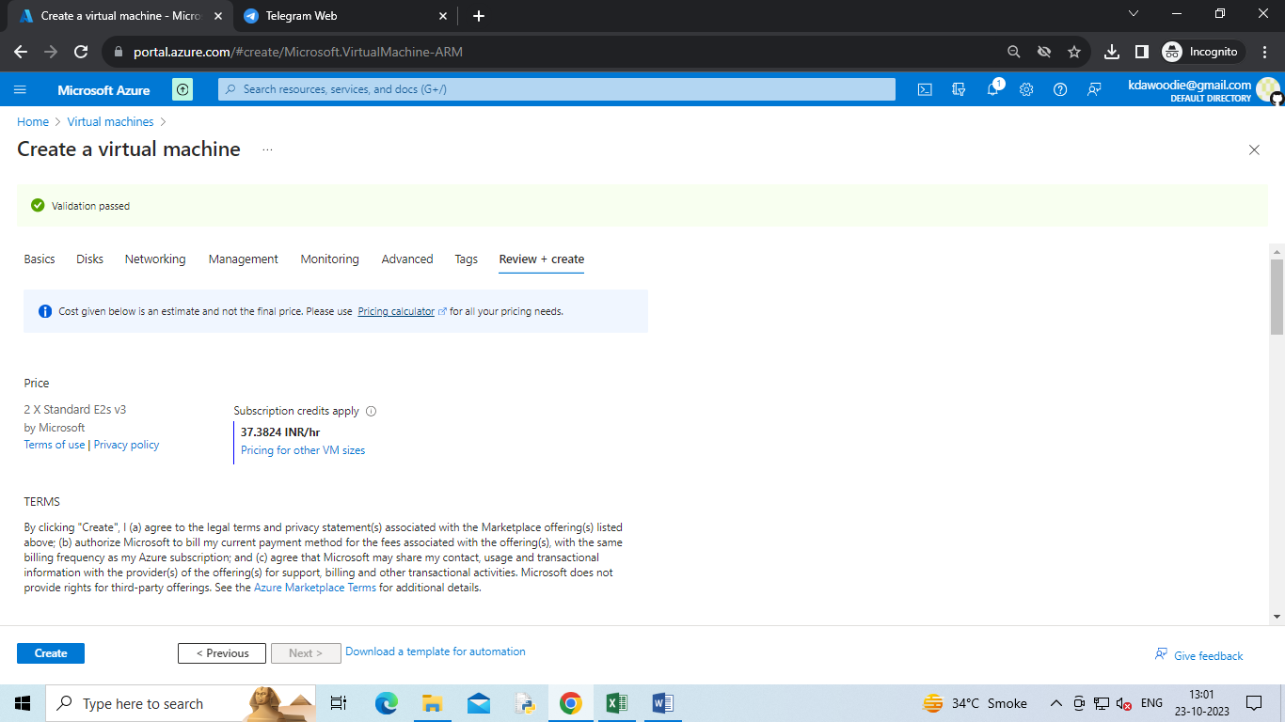

deployment of VM

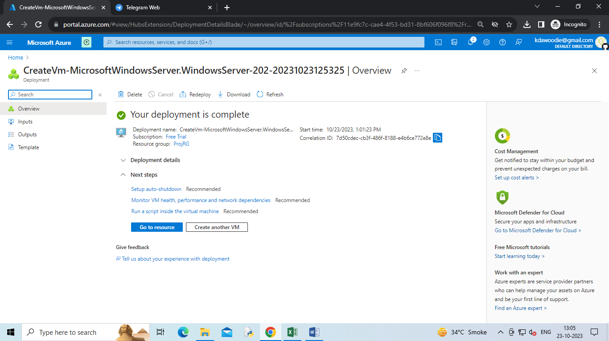

Add role and feature

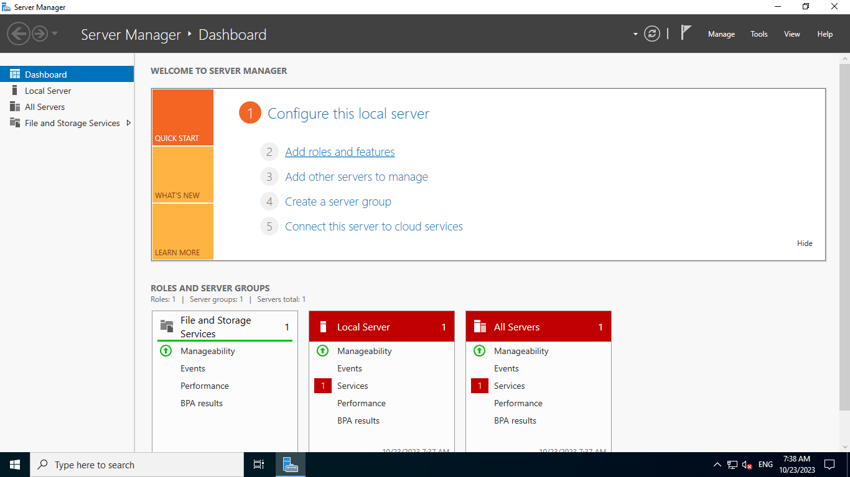

deployment of web server

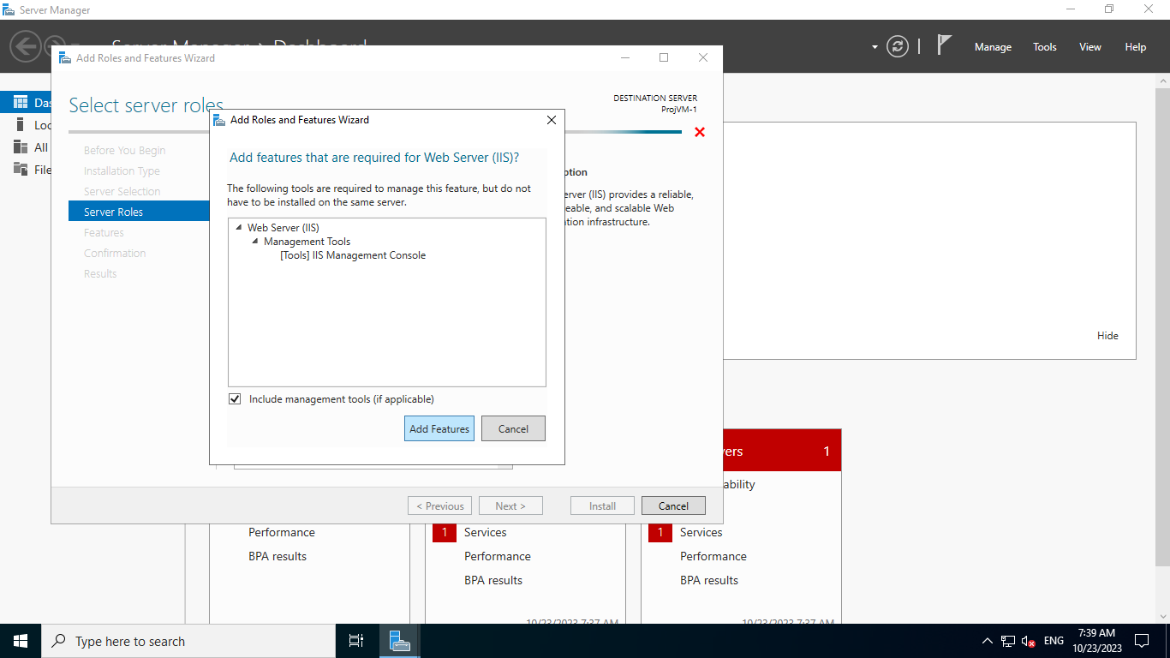

add file to the root address

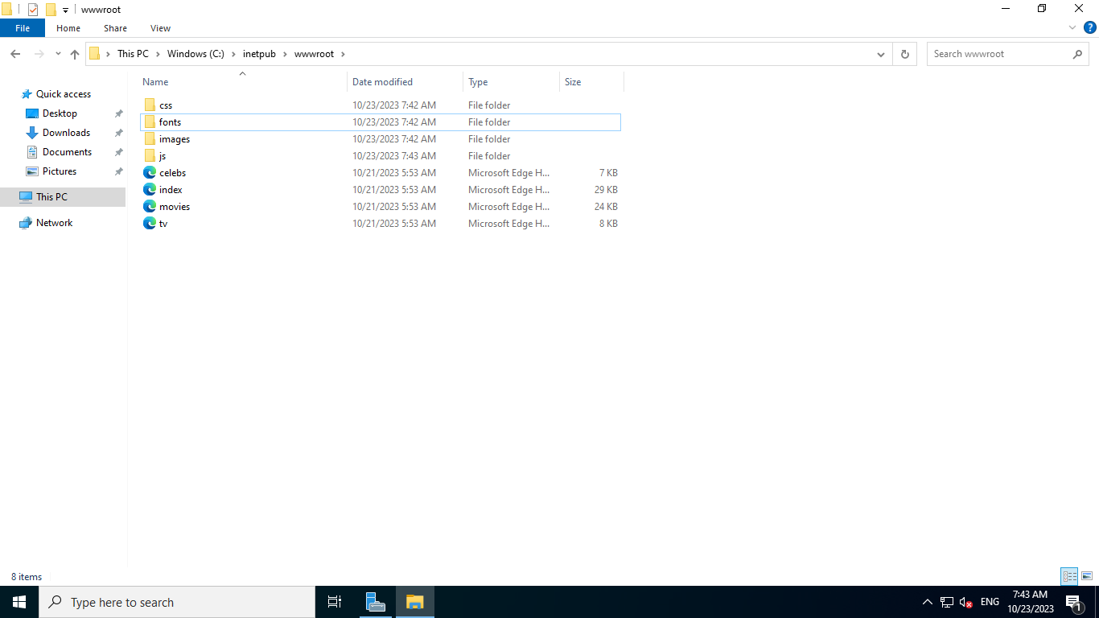

connect the VM by remote access

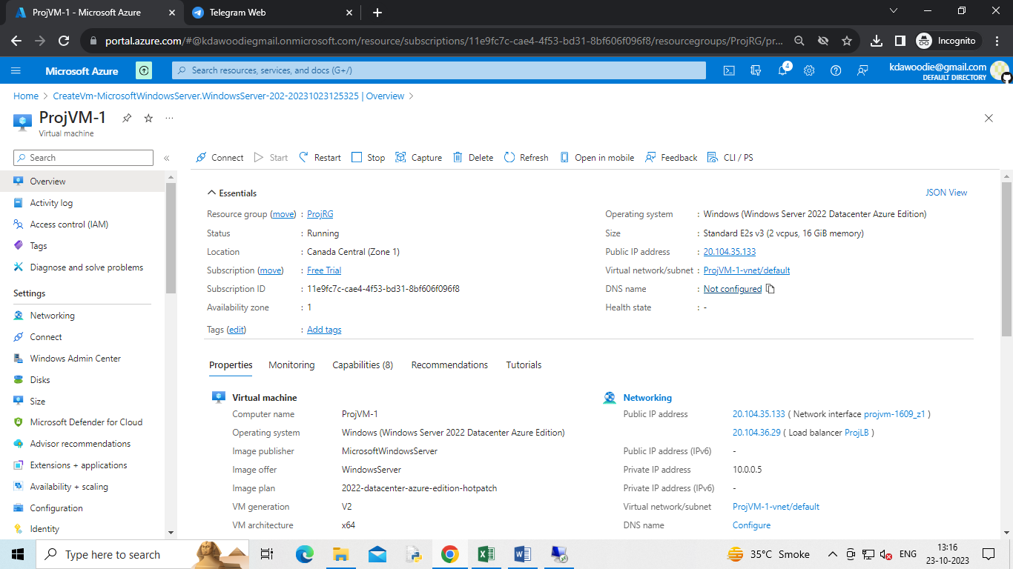

Configuration addition of DNS

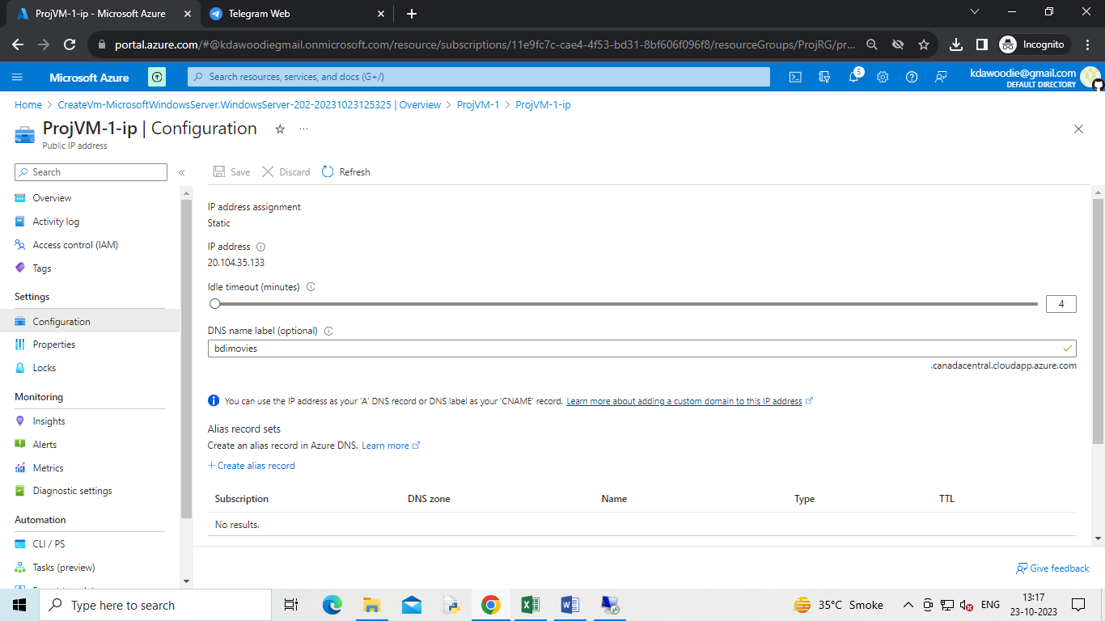

Application

