WEEK 3 REPORT
Advanced Data Analysis and Visualization in Logistics

Exploratory analysis of delivery time, shipment volume and transport cost to find efficiency gaps, cost drivers and bottlenecks
Tools: Python, pandas, NumPy, matplotlib, seaborn, SciPy, scikit-learn
Prepared by: ADARSH SIDDHARTH
Date: 4TH October 2026

1. Executive Summary
This report analyses a hypothetical dataset of 15,000 shipments dispatched from three distribution centres (DCs) during 2025. It records delivery times, shipment weights and volumes, transport modes, carriers and costs. The goal is to show how exploratory data analysis (EDA) and well-chosen charts turn raw logistics records into decisions about efficiency, cost and bottlenecks.
The analysis led to five main findings:
- The warehouse, not the road, is the main bottleneck: 12.4 hours of average dispatch delay at DC-West, against 5.6 at DC-North. DC-West's on-time rate is 93.3% versus 98.8%. Mondays are the worst day everywhere, and DC-West on Mondays averages 16.0 hours.
- Air freight loses much of its advantage: for air shipments, dispatch delay accounts for 67.6% of total delivery hours, so the speed premium paid for air is partly wasted before the parcel leaves the building.
- Cost is concentrated: air carries 9.9% of shipments but generates 43.0% of transport cost, at about 5.7 times the cost per kg of road. Weight (Spearman correlation 0.76) matters far more than distance (0.35).
- Carrier quality varies: Carrier C is the cheapest per kg but has the lowest on-time rate (95.2%), the longest transit and the highest damage rate (2.6%). On the South region its on-time rate drops to 92.7%.
- Season and weather hurt: on-time performance falls from 97.5% off-peak to 94.4% in October to December, and summer weather events add about 18.1 transit hours to the 6.3% of shipments they hit.
A what-if simulation estimates that bringing DC-West's dispatch performance to DC-North's level and removing the Monday backlog would lift the on-time rate from 96.7% to 98.6% and cut late shipments from about 499 to 210 (a 58% reduction). All figures come from simulated data with built-in patterns, as explained in Section 2.

2. Data Simulation

2.1 Dataset definition
The hypothetical company, a regional distributor, ships goods from three distribution centres (DC-North, DC-South, DC-West) to five destination regions using three transport modes and four carriers. The simulated table has 15,000 rows (one per shipment) and 22 columns, created with a fixed random seed so every result can be reproduced.
Variable | Type | Description
ship_date, month, weekday, peak_season | Date / category | Dispatch date, derived month and weekday, and a flag for October to December
dc, region | Category | Origin distribution centre (3) and destination region (5)
mode, carrier | Category | Road, Rail or Air; Carrier A, B, C or D
distance_km | Numeric | Route distance, based on the region with random variation
weight_kg, volume_cbm | Numeric | Shipment weight (right-skewed) and volume in cubic metres
dispatch_delay_h | Numeric | Hours spent in the warehouse before leaving (picking, packing, loading)
transit_h, total_hours, delivery_days | Numeric | Transport hours, total hours, and total in whole days
promised_days, on_time | Numeric / flag | Delivery promise and whether it was met (1 = on time)
weather_event, fuel_index | Flag / numeric | Weather disruption flag and a monthly fuel price index (about 100)
cost_usd, cost_per_kg | Numeric | Shipment cost and cost per kilogram
damaged | Flag | Whether the shipment arrived damaged

2.2 How the data was generated, and an honest caveat
Dispatch delay was modelled with a gamma distribution whose mean depends on the DC, with an extra increase on Mondays and in peak season. Transit hours equal distance divided by a mode-specific speed, multiplied by a carrier quality factor and random noise, plus extra hours for weather events and peak season. Cost follows a rate per kilometre and per kilogram (weight raised to the power 0.85, reflecting volume discounts), multiplied by a carrier mark-up, the fuel index and a peak-season surcharge.
Caveat: because these relationships were built into the simulation, the patterns found below are expected. The purpose of this task is to demonstrate the analytical method: how to detect, visualise and quantify such patterns. With real data the same code would be used, but the effects would be smaller, messier and need more careful interpretation. In particular, the very high R² of the cost model (Section 5.3) is a result of the clean simulated cost formula and would be much lower in real data.
Excerpt: start of the simulate() function
def simulate(n=15000):
dates = pd.to_datetime("2025-01-01") + pd.to_timedelta(rng.integers(0, 365, n), unit="D")
dc = rng.choice(["DC-North", "DC-South", "DC-West"], n, p=[.35, .30, .35])
region = rng.choice(["North", "South", "East", "West", "Central"], n, p=[.22, .24, .18, .20, .16])
mode = rng.choice(["Road", "Rail", "Air"], n, p=[.62, .28, .10])
carrier = rng.choice(["Carrier A", "Carrier B", "Carrier C", "Carrier D"], n, p=[.32, .28, .22, .18])
dist_base = {"North": 650, "South": 900, "East": 1100, "West": 750, "Central": 500}
distance = np.clip(pd.Series(region).map(dist_base).values * rng.lognormal(0, .30, n), 80, 3500)
weight = np.clip(rng.lognormal(5.0, 1.0, n), 5, 8000) # kg, right-skewed
volume = np.round(weight / rng.uniform(150, 350, n), 2) # m3
df = pd.DataFrame(dict(ship_date=dates, dc=dc, region=region, mode=mode, carrier=carrier,
distance_km=distance.round(0), weight_kg=weight.round(1), volume_cbm=volume))
df["month"] = df.ship_date.dt.month
df["weekday"] = df.ship_date.dt.day_name()
df["peak_season"] = df.month.isin([10, 11, 12]).astype(int)
df["weather_event"] = (rng.random(n) < np.where(df.month.isin([6, 7, 8]), .12, .04)).astype(int)
df["fuel_index"] = (100 + 6 * np.sin(2 * np.pi * (df.month - 2) / 12) + rng.normal(0, 1.5, n)).round(1)
...

Excerpt: the built-in warehouse bottleneck
# dispatch (warehouse) delay in hours: DC-West is the built-in bottleneck, Mondays and peak are worse
dc_eff = df.dc.map({"DC-North": 5, "DC-South": 6, "DC-West": 11}).values
mon = np.where(df.weekday == "Monday", 1.35, 1.0)
pk = np.where(df.peak_season == 1, 1.30, 1.0)
df["dispatch_delay_h"] = np.clip(rng.gamma(3, dc_eff / 3, n) * mon * pk, 0.5, 96).round(1)
...

3. Methodology and Tools
The analysis follows a standard sequence: summarise, compare, relate, test, model and then communicate with charts. Each step uses a specific Python tool:
Step | Question answered | Python tools
Descriptive statistics | What is typical, how spread out, how skewed? | pandas describe(), median(), skew()
Group comparison | Do DCs, modes, carriers differ? | pandas groupby().agg(), pivot_table()
Correlation | Which variables move together? | DataFrame.corr(method="spearman")
Hypothesis tests | Are differences larger than chance? | scipy.stats: Kruskal-Wallis, chi-square
Cost driver model | Which factors explain cost, after controlling for others? | scikit-learn LinearRegression on standardized inputs
Visualization | How can patterns be seen and communicated? | matplotlib, seaborn
Scenario analysis | What would an improvement be worth? | NumPy and pandas recalculation

Plotly can be used for interactive versions of these charts in a dashboard. Static matplotlib and seaborn charts were chosen here because they embed cleanly in a Word report and are fully reproducible.

4. Exploratory Data Analysis

4.1 Central tendency, spread and skewness
num = ["distance_km", "weight_kg", "volume_cbm", "dispatch_delay_h", "transit_h",
"total_hours", "delivery_days", "cost_usd", "cost_per_kg"]
desc = df[num].describe().T
desc["median"] = df[num].median()
desc["skew"] = df[num].skew() # > 1 means a long right tail
print(desc[["mean", "median", "std", "skew"]].round(2))

Variable | Mean | Median | Std dev | Skewness
distance_km | 818.24 | 762.00 | 327.27 | 1.09
weight_kg | 247.23 | 148.30 | 321.51 | 5.22
dispatch_delay_h | 8.30 | 6.70 | 6.12 | 1.95
transit_h | 21.01 | 19.50 | 11.67 | 0.87
total_hours | 29.31 | 27.70 | 13.26 | 0.78
cost_usd | 594.72 | 281.04 | 1309.39 | 16.17
cost_per_kg | 3.05 | 1.92 | 3.69 | 3.65

Interpretation. Weight and cost are strongly right-skewed. The mean shipment weighs 247.2 kg but the median is only 148.3 kg, and the mean cost of $594.7 is more than double the median of $281.0. A small number of heavy shipments pull the average up, so the median describes a "typical" shipment better, and cost analysis is done on a log scale. Delivery time is much more symmetric (skewness 0.78), with a mean of 29.3 hours and a median of 27.7 hours. Dispatch delay (skewness 1.95) has a longer tail, which signals occasional severe warehouse delays.
Overall, 96.7% of shipments met their promised delivery date and 2.01% arrived damaged. Total transport spend was about $8,920,841. (The on-time measure here covers timing only; a full OTIF measure would also check that quantities were complete.)

4.2 Distributions
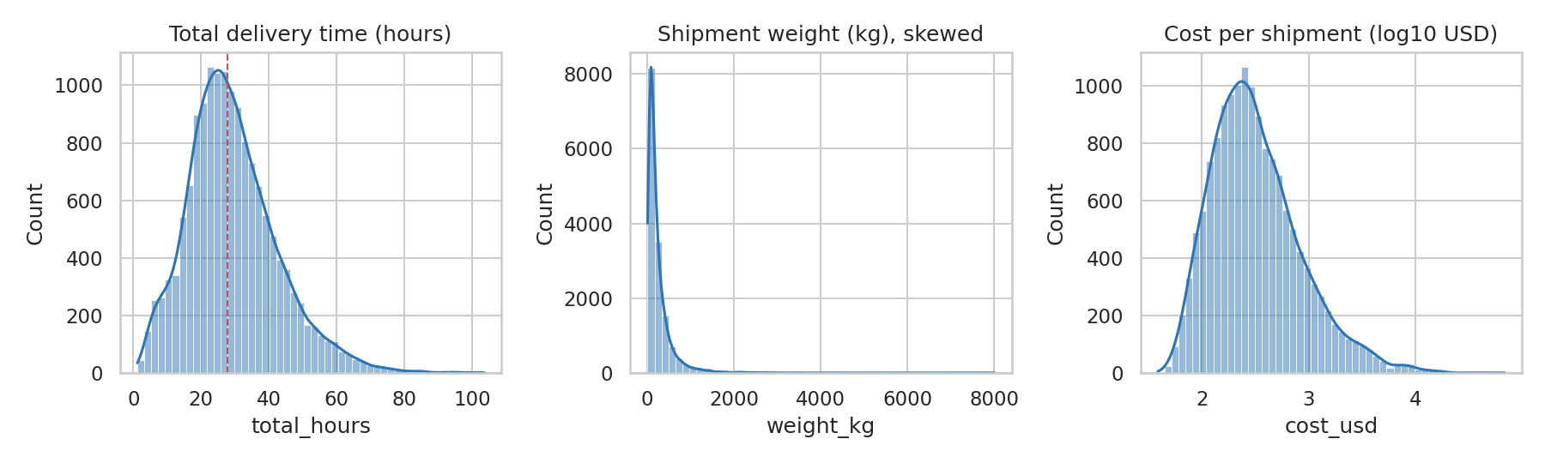
Figure 1: Distributions of delivery time, shipment weight and cost
Why histograms with a density curve: a histogram shows the shape of one numeric variable, and the overlaid curve (KDE) smooths the outline so skew and multiple peaks are easy to see. Delivery time (left) is roughly bell-shaped with its median marked by the red dashed line. Weight (centre) is extremely skewed: most shipments are light and a few weigh thousands of kilograms. Cost is plotted on a log10 scale (right) because on a normal scale the long tail would squash everything else into one bar; on the log scale it becomes close to a bell shape, which also tells us that log-transforming cost is appropriate before modelling.
fig, ax = plt.subplots(1, 3, figsize=(12, 3.6))
sns.histplot(df.total_hours, bins=50, kde=True, ax=ax[0], color="#2E75B6"); ax[0].axvline(df.total_hours.median(), c="r", ls="--", lw=1); ax[0].set_title("Total delivery time (hours)")
sns.histplot(df.weight_kg, bins=50, kde=True, ax=ax[1], color="#2E75B6"); ax[1].set_title("Shipment weight (kg), skewed")
sns.histplot(np.log10(df.cost_usd), bins=50, kde=True, ax=ax[2], color="#2E75B6"); ax[2].set_title("Cost per shipment (log10 USD)")
save("f1_distributions")

4.3 Group comparisons
Grouping the data shows where performance differs. The tables below summarise on-time rate, average dispatch and transit hours, median cost per kg and damage rate.
summary = df.groupby("dc").agg(
shipments=("on_time", "size"),
on_time_pct=("on_time", lambda s: s.mean() * 100),
dispatch_h=("dispatch_delay_h", "mean"),
transit_h=("transit_h", "mean"),
cost_per_kg=("cost_per_kg", "median"),
damage_pct=("damaged", lambda s: s.mean() * 100)).round(2)

By distribution centre
Group | Shipments | On-time % | Dispatch h | Transit h | Cost/kg ($) | Damage %
DC-North | 5,336 | 98.8 | 5.6 | 20.8 | 1.94 | 2.19
DC-South | 4,512 | 98.0 | 6.8 | 21.1 | 1.93 | 1.80
DC-West | 5,152 | 93.3 | 12.4 | 21.1 | 1.89 | 2.02

By transport mode
Group | Shipments | On-time % | Dispatch h | Transit h | Cost/kg ($) | Damage %
Road | 9,402 | 98.0 | 8.3 | 21.9 | 1.98 | 2.35
Rail | 4,107 | 95.1 | 8.3 | 25.2 | 1.40 | 1.31
Air | 1,491 | 93.0 | 8.1 | 3.9 | 11.24 | 1.81

By carrier
Group | Shipments | On-time % | Dispatch h | Transit h | Cost/kg ($) | Damage %
Carrier A | 4,859 | 97.0 | 8.4 | 19.6 | 1.97 | 1.83
Carrier B | 4,076 | 97.0 | 8.3 | 20.9 | 1.82 | 1.79
Carrier C | 3,344 | 95.2 | 8.3 | 24.4 | 1.77 | 2.57
Carrier D | 2,721 | 97.3 | 8.3 | 19.5 | 2.23 | 1.98

Three things stand out. DC-West is clearly the slowest warehouse (12.4 hours versus 5.6 at DC-North), while its transit time is the same as the others, so the problem is inside the building. Air has the shortest transit time (3.9 hours) but a median cost of $11.24 per kg against $1.98 for road. Carrier C's low price is matched by the longest transit, lowest on-time rate and highest damage rate.

4.4 Correlations
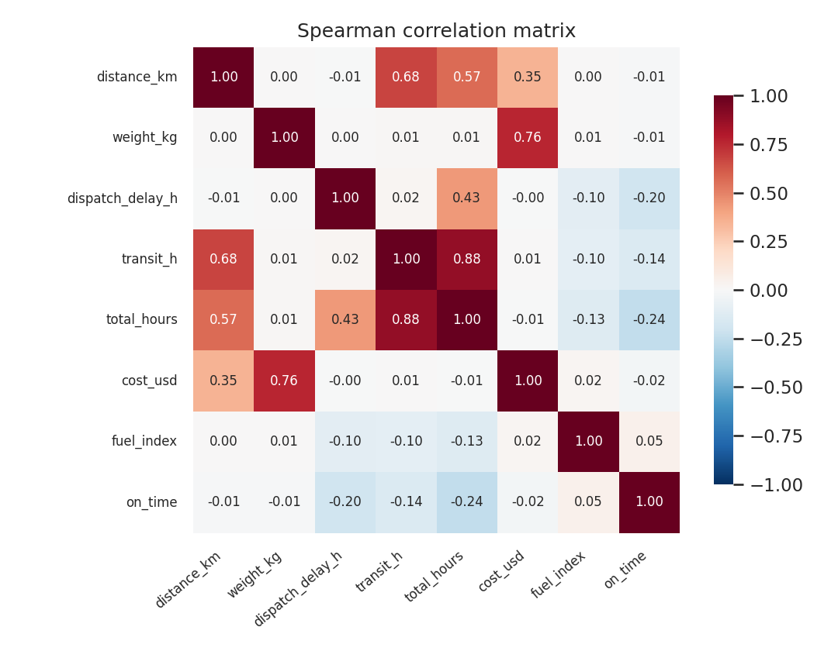
Figure 2: Spearman correlation matrix of key numeric variables
Why a correlation heatmap and why Spearman: a heatmap shows all pairwise relationships at once and uses colour to make strong ones obvious. Spearman rank correlation was chosen over Pearson because weight and cost are heavily skewed and their relationships are not perfectly linear; Spearman measures whether variables rise together regardless of shape and is less affected by extreme values.
Reading the chart. Cost is strongly tied to weight (0.76) and moderately to distance (0.35). Transit hours follow distance (0.68), as expected. On-time delivery is negatively related to dispatch delay (-0.2) and to transit time (-0.14); the dispatch relationship is actually stronger, which supports the warehouse-bottleneck finding. Fuel index has almost no relation to cost at shipment level, because its monthly variation is small compared with the effect of weight and mode. Correlation does not prove cause, which is why a regression model is used in Section 5.3.
corr = df[["distance_km", "weight_kg", "dispatch_delay_h", "transit_h", "total_hours", "cost_usd", "fuel_index", "on_time"]].corr(method="spearman")

4.5 Are the differences real? Statistical tests
A Kruskal-Wallis test (suitable for skewed data, with no normality assumption) compared dispatch delay across the three DCs and gave H = 3548.6 with p < 0.001, so the differences between DCs are far beyond chance. A chi-square test of on-time status across carriers gave chi-square = 28.8 with p < 0.001. With 15,000 rows even small differences become statistically significant, so the size of the difference matters more than the p-value: a 5.5 percentage-point gap in on-time rate between DC-West and DC-North is operationally important, while a 0.2-point gap between Carrier A and B would not be.
# statistical tests
groups = [g.dispatch_delay_h.values for _, g in df.groupby("dc")]
H, p = stats.kruskal(*groups); R["kruskal_dc"] = {"H": round(H, 1), "p": float(p)}
ct = pd.crosstab(df.carrier, df.on_time); chi, p2, _, _ = stats.chi2_contingency(ct); R["chi2_carrier"] = {"chi2": round(chi, 1), "p": float(p2)}

5. Visualizations and Analytical Insights
This section presents the main charts. For each chart it explains why that chart type was chosen, what it shows and what to do about it. The findings are grouped into operational efficiency and bottlenecks (5.1, 5.2) and cost drivers (5.3, 5.4).

5.1 Operational efficiency: where do delays come from?
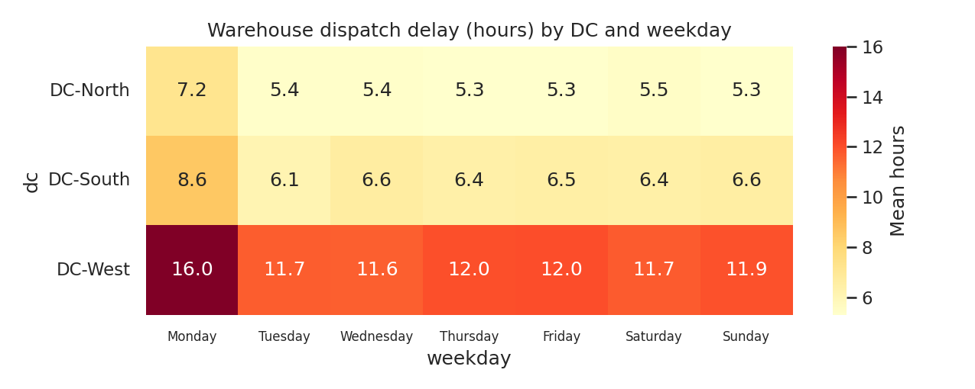
Figure 3: Mean warehouse dispatch delay by DC and weekday
Why a heatmap: two categories (DC and weekday) and one measure (hours) form a small grid, and colour intensity lets the eye find the hot spots instantly, which would take much longer in a table of 21 numbers. Insight: DC-West is slowest on every day, around 12 hours, and reaches 16.0 hours on Mondays. DC-North averages about 5.4 hours midweek. Monday is the worst day in all three DCs, which suggests a weekend backlog of orders that the warehouses cannot clear.
order = ["Monday", "Tuesday", "Wednesday", "Thursday", "Friday", "Saturday", "Sunday"]
pv2 = df.pivot_table(index="dc", columns="weekday", values="dispatch_delay_h", aggfunc="mean")[order]
plt.figure(figsize=(8.5, 3.4)); sns.heatmap(pv2, annot=True, fmt=".1f", cmap="YlOrRd", cbar_kws={"label": "Mean hours"})
plt.yticks(rotation=0); plt.xticks(rotation=0, fontsize=8)
plt.title("Warehouse dispatch delay (hours) by DC and weekday"); save("f7_dispatch_heat")

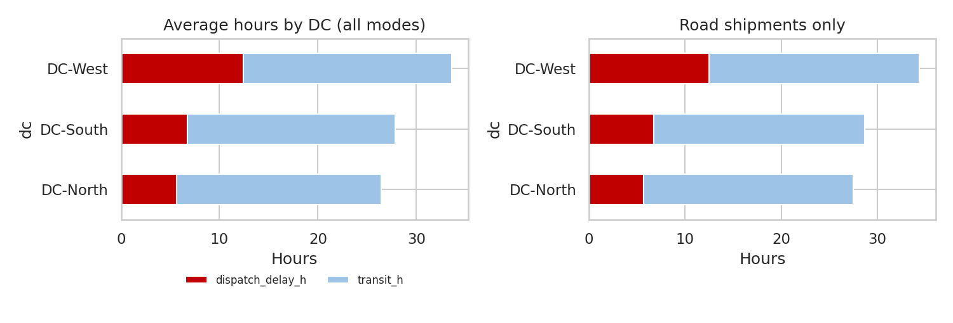
Figure 4: Average hours split into dispatch delay and transit time, by DC
Why stacked horizontal bars: total delivery time is the sum of two stages, and a stacked bar shows both the total and each stage's share at once, so a reader can tell whether the delay sits in the warehouse or on the road. Two panels (all modes, road only) show the pattern is not caused by mode mix. Insight: the red dispatch segment is about twice as long at DC-West, while the blue transit segments are almost identical. Overall, dispatch takes 28.3% of all delivery hours, and 67.6% for air shipments. Investment in faster carriers will not fix a delay that happens before the truck is loaded.

5.2 Carrier, seasonal and regional performance
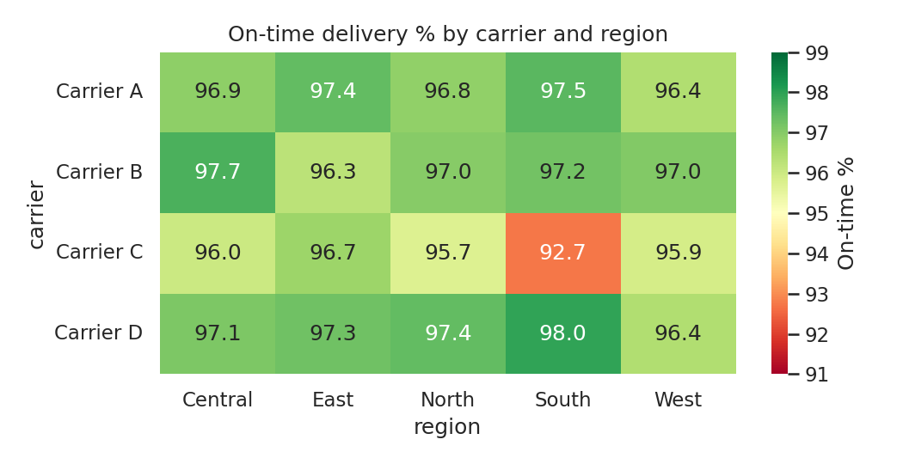
Figure 5: On-time delivery rate by carrier and destination region
Why a second heatmap: the question is an interaction (does a carrier perform differently in some regions?), and a carrier by region grid with a diverging colour scale shows exceptions clearly. The colour range was set to 91 to 99% so that small but meaningful gaps are visible. Insight: most cells lie between 96 and 98%, but Carrier C in the South region reaches only 92.7%, against 96.0% in its other regions. The weakness is local, so a targeted fix (reassign or renegotiate South lanes) is better than dropping the carrier everywhere.
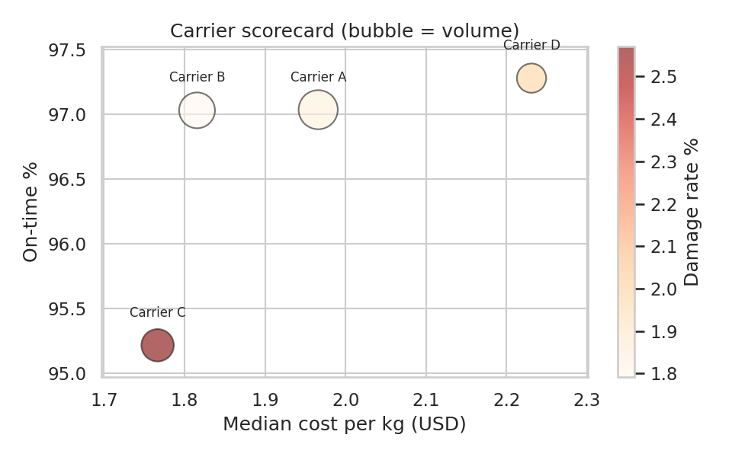
Figure 6: Carrier scorecard: cost per kg versus on-time rate
Why a bubble scatter plot: choosing a carrier is a trade-off between price and service, so cost goes on one axis and on-time rate on the other. Bubble size shows volume and colour shows damage rate, which allows four measures in one view. Insight: Carrier D sits top-right: the best on-time rate (97.3%) but about 26% more per kg than Carrier C. Carrier C sits bottom-left: cheapest but the weakest service and highest damage. Carriers A and B give strong service at moderate prices. Whether C's saving is real depends on the cost of late and damaged deliveries, which this dataset does not include.
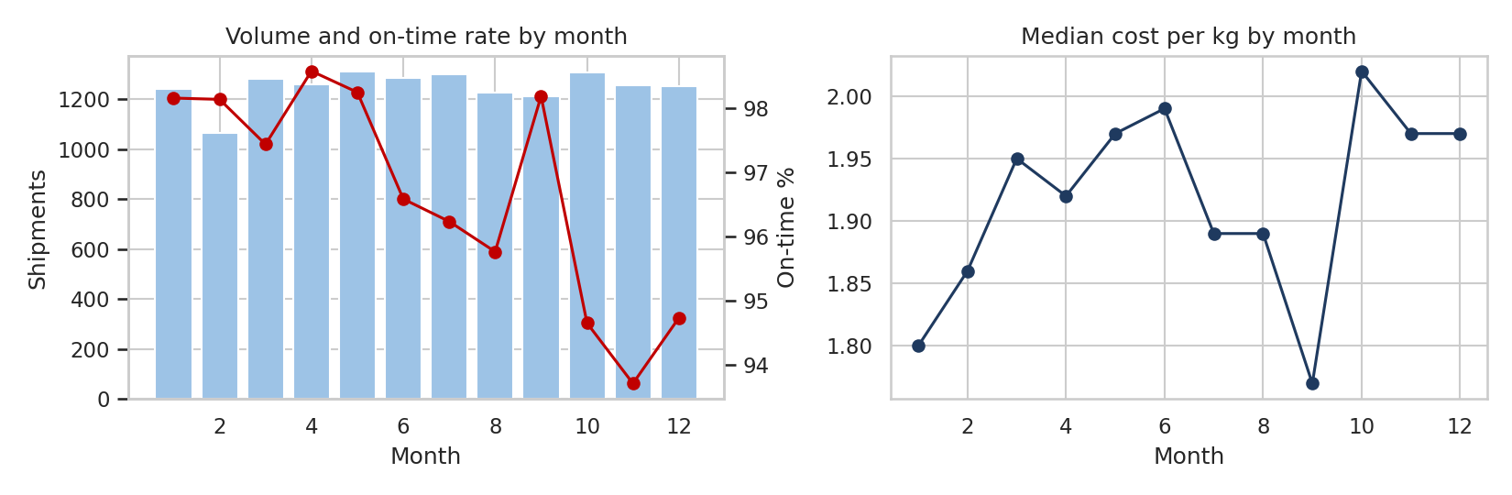
Figure 7: Monthly shipment volume, on-time rate and median cost per kg
Why a bar-and-line combination and a line chart: time trends are best shown with lines, which emphasise direction and turning points. Volume is drawn as bars with the on-time rate as a line on a second axis, so the reader can see whether service falls when volume rises. Insight: volume is roughly flat across the year, so the on-time dip is not a capacity effect. On-time performance falls in the summer weather months and again in the peak season, reaching its lowest in month 11 (93.7%) against 98.6% at its best in month 4. Off-peak, 97.5% of shipments are on time versus 94.4% in October to December. Median cost per kg also rises in the peak quarter (about 10.9% surcharge in the model below).
fig, ax = plt.subplots(1, 2, figsize=(11, 3.6))
ax[0].bar(mo.index, mo.shipments, color="#9DC3E6", label="Shipments"); ax[0].set_xlabel("Month"); ax[0].set_ylabel("Shipments"); ax[0].set_title("Volume and on-time rate by month")
a2 = ax[0].twinx(); a2.plot(mo.index, mo.otif, "-o", color="#C00000"); a2.set_ylabel("On-time %"); a2.grid(False)
ax[1].plot(mo.index, mo.cost_kg, "-o", color="#1F3A5F"); ax[1].set_title("Median cost per kg by month"); ax[1].set_xlabel("Month")
save("f5_monthly")

5.3 Cost drivers
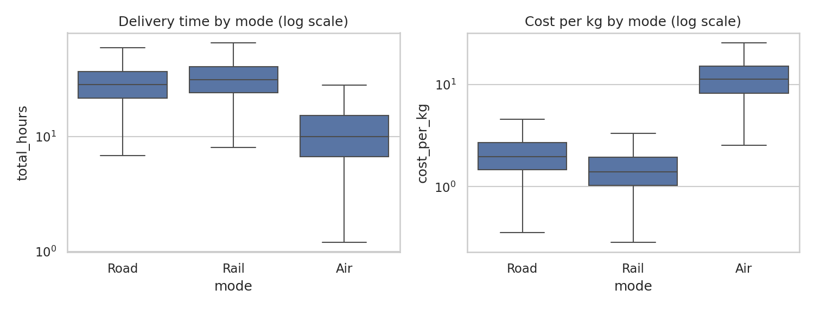
Figure 8: Delivery time and cost per kg by transport mode (log scales)
Why boxplots: a boxplot shows median, spread and outliers for each group side by side, which is ideal for comparing a numeric variable across a few categories. Log scales are used because air and road differ by a large factor. Insight: air delivers in a median of roughly 10 hours but costs about 5.7 times as much per kg as road, while rail is the cheapest per kg and slightly slower than road. Air is 9.9% of shipments but 43.0% of spend.
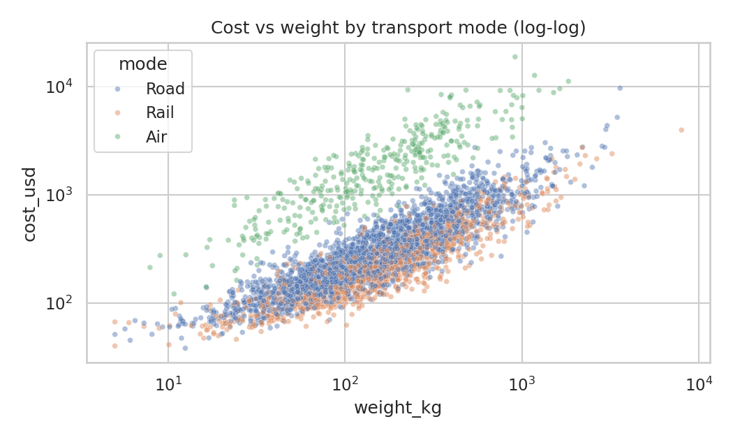
Figure 9: Shipment cost versus weight, coloured by transport mode (log-log)
Why a log-log scatter plot: the relationship between two continuous variables is shown best by a scatter plot, and a colour for mode adds a third dimension. Both axes are logarithmic because weight and cost span several orders of magnitude; on log axes a power-law relationship appears as a straight line. Insight: cost rises steadily with weight, and the three modes form separate bands, with air clearly above road and rail at the same weight. The top 10% heaviest shipments account for 31.7% of total cost, so consolidation and contract negotiation for heavy loads have the largest cost effect.
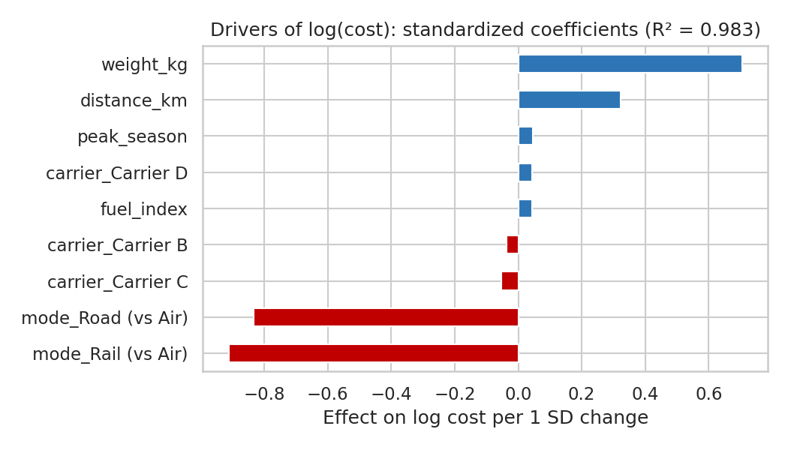
Figure 10: Standardized regression coefficients explaining log shipment cost
Why a coefficient bar chart: correlations cannot separate overlapping effects (for example, air shipments may also be heavier). A regression on standardized inputs puts every factor on the same scale, so bar lengths can be compared directly and the sign shows the direction. Insight: mode is the biggest driver: road and rail are far below the air baseline. Weight is next, then distance. Peak season adds roughly 10.9% to cost, and carrier choice moves cost by only a few percent. The model explains R² = 0.983 of the variation in log cost, which is unrealistically high for real data and reflects the clean simulated cost formula.
X = pd.get_dummies(df[["distance_km", "weight_kg", "fuel_index", "peak_season", "mode", "carrier"]], drop_first=True, dtype=float)
X["weight_kg"] = np.log(X["weight_kg"]); X["distance_km"] = np.log(X["distance_km"])
Xs = StandardScaler().fit_transform(X); y = np.log(df.cost_usd)
lr = LinearRegression().fit(Xs, y)
R["cost_model_r2"] = round(lr.score(Xs, y), 3)
coef = pd.Series(lr.coef_, index=X.columns).sort_values(key=abs, ascending=False)

5.4 Summary of how each visualization supports performance measurement
Performance metric | Best visualization | What it reveals
Delivery lead time | Histogram, boxplot by mode | Typical time, spread, long delays; speed differences between modes
Warehouse efficiency | Heatmap (DC x weekday), stacked bar | Where and when dispatch delay occurs, and its share of total time
On-time delivery | Heatmap (carrier x region), monthly line | Which carriers, lanes and months fall short
Transport cost | Log-log scatter, coefficient chart | What drives cost and how much each factor adds
Cost versus service | Bubble scorecard | Trade-offs between price, punctuality and damage by carrier
Relationships between KPIs | Correlation heatmap | Which measures move together; where to look for causes
Seasonality | Monthly bar and line chart | Peak-season and weather effects on service and cost

6. Insights Summary

Operational efficiency
- Warehouse time is a major share of delivery time: dispatch takes 28.3% of delivery hours overall, so process time in warehouses is as important as transport time.
- One site underperforms: DC-West's on-time rate is 93.3% against 98.8% and 98.0% elsewhere, although its transit time matches the others.

Cost drivers
- Mode and weight dominate: air has 9.9% of shipments and 43.0% of spend, and the heaviest 10% of shipments account for 31.7% of cost.
- Secondary factors: peak season adds about 10.9%, fuel has a small effect, and carrier price differences are modest but come with service differences.

Bottlenecks
- Four specific bottlenecks: Monday backlog in all DCs, DC-West throughput, Carrier C on South lanes, and peak-season and summer-weather disruption.

7. Scenario Analysis and Recommendations
To estimate the value of fixing the main bottlenecks, the on-time rate was recalculated after changing only the dispatch delay, with all transit times unchanged. Scenario 1 scales DC-West dispatch times down to the DC-North average. Scenario 2 scales Monday dispatch delay down to the level of other weekdays. Scenario 3 applies both.
def otif_with(dispatch):
days = np.ceil((dispatch + df.transit_h) / 24).astype(int)
return float((days <= df.promised_days).mean() * 100)

target = df[df.dc == "DC-North"].dispatch_delay_h.mean()
west = df.dc == "DC-West"
d1 = df.dispatch_delay_h.copy(); d1[west] = d1[west] * target / df[west].dispatch_delay_h.mean()
mon_fix = df.weekday == "Monday"
d2 = df.dispatch_delay_h.copy(); d2[mon_fix] = d2[mon_fix] * df[~mon_fix].dispatch_delay_h.mean() / df[mon_fix].dispatch_delay_h.mean()
d3 = d1.copy(); d3[mon_fix] = d3[mon_fix] * df[~mon_fix].dispatch_delay_h.mean() / df[mon_fix].dispatch_delay_h.mean()
base = otif_with(df.dispatch_delay_h)
R["scenario"] = {"baseline": round(base, 1), "fix_dc_west": round(otif_with(d1), 1),
"fix_monday": round(otif_with(d2), 1), "both": round(otif_with(d3), 1)}

Scenario | On-time rate | Change vs baseline
Baseline (current) | 96.7% | -
1. DC-West dispatch matches DC-North | 98.4% | +1.7 points
2. Monday dispatch matches other weekdays | 97.1% | +0.4 points
3. Both fixes together | 98.6% | +1.9 points

The combined scenario cuts late shipments from about 499 to 210 out of 15,000, a reduction of about 58%. The estimate assumes that dispatch times scale proportionally, which is a simplification; the real gain depends on what is causing the delay at DC-West.

Recommendations (in priority order)
# | Action | Evidence | KPI to track
1 | Run a process review at DC-West (staffing, pick-pack layout, loading dock scheduling) and copy DC-North practices | Dispatch 12.4 h vs 5.6 h; scenario 1 adds 1.7 points | Dispatch hours, on-time % by DC
2 | Add weekend or early-Monday capacity, or release orders earlier so Monday is not a backlog day | Monday 10.7 h vs about 7.9 h on other days | Monday dispatch hours
3 | Review air usage: ship by air only when the order promise really needs it, and fix warehouse time first | Air 43.0% of cost; 67.6% of its hours are dispatch | Air share of spend, air on-time %
4 | Renegotiate or reassign Carrier C on the South region and set service-level penalties | On-time 92.7% in South; highest damage rate | Carrier on-time and damage % by lane
5 | Plan for peak season: earlier carrier bookings, temporary staff, and pre-positioned stock | On-time 94.4% in Oct to Dec; cost uplift about 10.9% | Peak-quarter on-time %, cost per kg
6 | Consolidate and tender heavy shipments | Top 10% by weight give 31.7% of cost | Cost per kg for heavy loads

8. Limitations
- Simulated data: the patterns were designed into the data, so findings demonstrate method, not real-world facts.
- Correlation is not causation: the regression and group comparisons show association. In real operations a cause such as a staffing shortage must be confirmed by inspecting the process.
- Simplified measures: on-time is judged only on timing, and cost does not include penalties, lost sales or returns from late and damaged deliveries.
- Scenario assumptions: the dispatch scenarios assume proportional improvement and no extra cost to achieve it.

9. Conclusion
Exploratory analysis and well-chosen visualizations moved the logistics picture from a single average on-time rate to specific, actionable findings: the warehouse at DC-West and the Monday backlog are the largest controllable delays, air freight carries a heavy cost for a speed advantage that warehouse delays partly erase, weight and mode drive cost, and one carrier underperforms on one region. Each chart type was matched to the question it answers: histograms for shape, boxplots for group comparison, scatter plots for relationships, heatmaps for two-way patterns, stacked bars for composition and line charts for time. The same Python code can be applied to real shipment data, where the next steps would be forecasting demand, optimizing routes and building a monitoring dashboard, following the roadmap set out in Week 1.

10. References
- Tukey, J. W. Exploratory Data Analysis. Addison-Wesley, 1977.
- Few, S. Show Me the Numbers: Designing Tables and Graphs to Enlighten (2nd ed.). Analytics Press, 2012.
- Tufte, E. R. The Visual Display of Quantitative Information (2nd ed.). Graphics Press, 2001.
- Waskom, M. seaborn: statistical data visualization. Journal of Open Source Software, 6(60), 3021, 2021.
- Hunter, J. D. Matplotlib: A 2D graphics environment. Computing in Science and Engineering, 9(3), 2007.
- McKinney, W. Python for Data Analysis (3rd ed.). O'Reilly Media.
- Chopra, S. and Meindl, P. Supply Chain Management: Strategy, Planning and Operation. Pearson.
- pandas, SciPy and scikit-learn documentation: pandas.pydata.org, docs.scipy.org, scikit-learn.org

