WEEK 2 REPORT
Data Collection, Cleaning and Preprocessing for Logistics Analysis

Building a reproducible Python pipeline for shipment and order data
Reference dataset: DataCo Smart Supply Chain (public) | Tools: pandas, NumPy, scikit-learn, matplotlib
Prepared by: Adarsh Siddharth
Date: 2nd October 2026

1. Executive Summary
Every logistics model, from a demand forecast to a route optimizer, is only as reliable as the data behind it. Raw operational data usually arrives with duplicate records, missing values, inconsistent labels, impossible dates and extreme outliers. If these are left in, they distort averages, mislead models and produce wrong KPIs such as on-time delivery.
This report documents a complete preprocessing pipeline in Python for shipment and order data. It follows the structure of the public DataCo Smart Supply Chain dataset. Because the real file could not be downloaded in the working environment, a synthetic dataset of 20,400 rows and 13 columns was generated with the same kind of fields and with deliberately injected quality problems. This lets every technique be tested against a known answer. The pipeline audits the data, fixes types and labels, removes duplicates and invalid records, imputes missing values, treats outliers, engineers features, applies transformations and scaling, and ends with automatic validation checks. The final dataset has 20,000 clean rows and 38 columns, split into training (16,000) and test (4,000) sets, and is ready for the forecasting and routing work planned in later weeks.

2. Data Collection (Simulated)

2.1 Reference dataset
The reference dataset is the DataCo Smart Supply Chain for Big Data Analysis dataset, published on Kaggle and Mendeley Data. It describes the order-to-delivery process of a global supply chain. As recalled from its public description, it contains roughly 180,000 order line records and about 50 columns covering order dates, shipping mode, scheduled and actual shipping days, delivery status, late-delivery risk, product category, customer location, sales, discounts and profit. The exact figures and license terms should be confirmed on the source page before any citation.

2.2 How the data would be collected in practice
- Public file: downloading the CSV from Kaggle or Mendeley Data for this project.
- Company systems: exports from an ERP (orders, prices), a warehouse management system (stock, picking) and a transport management system (routes, delivery events).
- External feeds: GPS and telematics feeds, carrier tracking APIs and supplier portals, which usually arrive in different formats and time zones.

2.3 Simulated dataset used in this report
The synthetic dataset mirrors the fields that matter most for logistics analysis. It was created in the function make_raw() and saved as data/raw/logistics_orders_raw.csv.
Column | Type | Meaning
order_id | Integer | Unique order identifier (should never repeat)
order_date, delivery_date | Date (stored as text) | When the order was placed and delivered
shipping_mode | Category | Standard, Second, First Class or Same Day
region, category | Category | Destination region and product category
quantity, unit_price, sales | Numeric | Items ordered, price per item, order value
distance_km, weight_kg | Numeric | Shipping distance and shipment weight
days_shipping_scheduled, days_shipping_real | Integer | Promised versus actual shipping days (basis for late-delivery analysis)

Important note: these are simulated values. Results such as the late-delivery rate (51.9%) describe the synthetic data only and say nothing about real supply chains. The value of the exercise is that each problem was injected by design, so the pipeline can be checked against the truth.

3. Data Quality Issues and Detection
Data quality is commonly judged along six dimensions: completeness (is data missing?), validity (do values follow rules?), uniqueness (are there duplicates?), consistency (are labels and formats uniform?), accuracy (are values realistic?) and timeliness (is the data current?). The first audit of the raw data revealed the following problems.
Issue | How it was detected | Found in raw data | Why it matters
Duplicate records | df.duplicated("order_id") | 400 duplicate rows | Double-counts orders and sales; inflates volumes
Missing values | df.isna().mean() | weight 5.9%, distance 4.09%, region 2.02%, category 1.53%, delivery date 1.11% | Many models fail or silently drop rows; biased results
Wrong data types | df.dtypes shows text for sales and dates | sales stored as text, 15% with "$" sign; dates as text | Cannot calculate or compare dates and values
Mixed date formats | Value inspection, failed parsing | 8% of order dates in dd/mm/yyyy, rest in yyyy-mm-dd | Wrong day/month order creates false lead times
Inconsistent labels | df[col].unique(), nunique() | shipping mode 8 variants (should be 4); region 10 (should be 5) | One category split into several; wrong group totals
Impossible values | Rule checks (quantity <= 0, delivery < order) | 40 negative quantities; 60 deliveries before order date | Corrupts delay and lead-time KPIs
Extreme outliers | IQR rule, boxplots | weight up to 1657.6 kg; distance up to 44,547.5 km | Distort mean, variance, clustering and regression

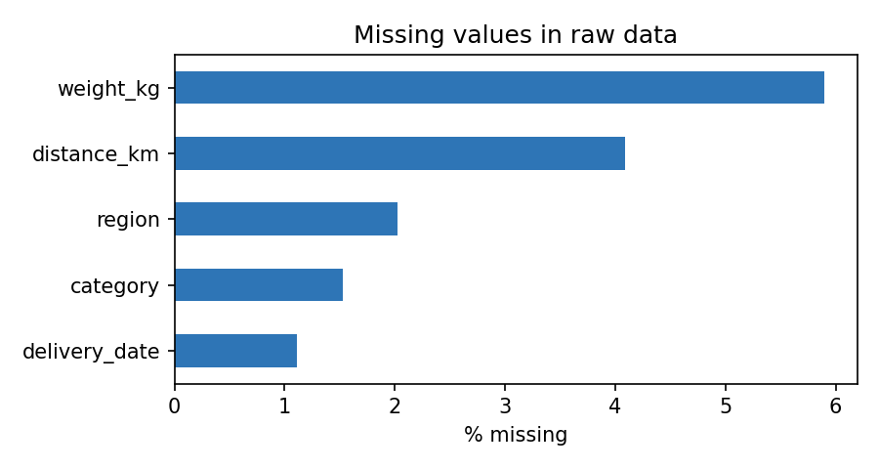
Figure 1: Share of missing values per column in the raw data

4. Methodology, Code and Rationale
The pipeline is organised as small, single-purpose functions so each step can be tested and reused. The order matters: types must be fixed before invalid values can be detected, invalid values must be removed before imputation so they do not influence the filled-in numbers, and outliers are treated after imputation so that imputed values are also checked. Each subsection gives the code (taken directly from the working script), the reason for the chosen technique and its effect on later analysis.

4.1 Step 1: Audit the raw data
Before changing anything, the data is profiled: data types, missing counts, number of unique values and duplicates. This gives a measurable baseline and shows what to fix.
def audit(df, label):
rep = pd.DataFrame({"dtype": df.dtypes.astype(str),
"missing": df.isna().sum(),
"missing_pct": (df.isna().mean() * 100).round(2),
"unique": df.nunique()})
print(f"\n=== Audit: {label} === rows={len(df)} duplicates(order_id)={df.duplicated('order_id').sum()}")
print(rep)
return rep

Why: Cleaning without profiling is guesswork. The audit showed, for example, that shipping_mode had 8 unique values when only 4 exist, which points straight to a labelling problem. Effect: creates the before/after evidence used in Section 5.

4.2 Step 2: Standardise types, text labels and dates
def clean_types(df):
df = df.copy()
for col in ["shipping_mode", "region", "category"]:
df[col] = df[col].astype("string").str.strip().str.title()
df["sales"] = pd.to_numeric(df["sales"].astype(str).str.replace(r"[$,]", "", regex=True), errors="coerce")
# explicit formats: guessing day/month order silently corrupts dates like 03/04/2023
iso = pd.to_datetime(df["order_date"], format="%Y-%m-%d", errors="coerce")
dmy = pd.to_datetime(df["order_date"], format="%d/%m/%Y", errors="coerce")
df["order_date"] = iso.fillna(dmy)
df["delivery_date"] = pd.to_datetime(df["delivery_date"], errors="coerce")
for col in ["distance_km", "weight_kg"]:
df[col] = pd.to_numeric(df[col], errors="coerce")
return df

Why: str.strip().str.title() makes "STANDARD CLASS " and "Standard Class" identical. pd.to_numeric with the "$" removed turns sales into numbers, and errors="coerce" converts anything unreadable to a missing value instead of crashing. For dates, two explicit formats are tried in turn. An earlier version of this pipeline used automatic mixed-format parsing, which guessed day and month order wrongly for dates such as 03/04/2023 and reported 342 "deliveries before order" instead of the true 60. Explicit formats removed that silent error. Effect: shipping-mode variants fell from 8 to 4 and region variants from 10 to 5, so group-by totals are now correct.

4.3 Step 3: Remove duplicates and fix invalid records
def remove_invalid(df):
n0 = len(df)
df = df.drop_duplicates()
df = df.drop_duplicates("order_id", keep="first")
METRICS["duplicates_removed"] = n0 - len(df)
bad_qty = (df["quantity"] <= 0)
METRICS["negative_quantity"] = int(bad_qty.sum())
df.loc[bad_qty, "quantity"] = df.loc[bad_qty, "quantity"].abs() # sign error -> correct
bad_date = df["delivery_date"] < df["order_date"]
METRICS["delivery_before_order"] = int(bad_date.sum())
df.loc[bad_date, "delivery_date"] = pd.NaT # impossible -> treat as missing
return df

Why: Duplicates are removed first on whole rows, then on order_id, because an order must be unique. A negative quantity is treated as a sign error and corrected with abs(), since the sales value and the other fields are consistent with a positive quantity. A delivery date earlier than the order date is physically impossible, so it is set to missing and later rebuilt rather than trusted. Effect: 400 duplicates removed, 40 quantities corrected and 60 impossible dates reset. Lead-time and OTIF calculations are no longer polluted by negative delivery times.

4.4 Step 4: Handle missing values
The right treatment depends on why data is missing. Data missing completely at random (MCAR) can be filled simply. Data missing at random (MAR) depends on other columns, so group-based filling is better. Data missing not at random (MNAR), where the missingness itself carries meaning, needs extra care. The options compared were:
Method | Advantage | Drawback / use here
Delete rows | Simple, no invented values | Loses data; biased if missingness is not random. Used only for key fields that cannot be recovered (order date, sales).
Global mean / median | Fast | Ignores differences between groups; shrinks variance. Used only as a final fallback.
Group median (chosen for numbers) | Respects category and region differences; robust to outliers | Used for weight (1183 missing) and distance (822 missing).
Mode (chosen for categories) | Keeps a valid label | Used for category (303) and region (403).
Rebuild from related fields | Uses true information | Delivery date (280) rebuilt as order date + actual shipping days.
Model-based (KNN, regression) | Can be most accurate | More complex; noted as a future improvement.

def impute(df):
df = df.copy()
num_cols = ["weight_kg", "distance_km"]
for col in num_cols + ["category", "region"]:
df[f"{col}_was_missing"] = df[col].isna().astype(int) # keep the signal
METRICS["missing_before_impute"] = {c: int(df[c].isna().sum()) for c in num_cols + ["category", "region", "delivery_date"]}
for col in num_cols:
df[col] = df[col].fillna(df.groupby(["category", "region"])[col].transform("median"))
df[col] = df[col].fillna(df[col].median())
for col in ["category", "region"]:
df[col] = df[col].fillna(df[col].mode()[0])
# delivery_date can be rebuilt from order date + actual shipping days
rebuilt = df["order_date"] + pd.to_timedelta(df["days_shipping_real"], unit="D")
df["delivery_date"] = df["delivery_date"].fillna(rebuilt)
df = df.dropna(subset=["order_date", "sales"])
return df

Why: Median is used instead of mean because weight and distance are right-skewed and contain outliers, which would drag a mean upward. Filling by category and region keeps typical differences (for example, furniture is heavier than apparel). Before filling, a was_missing flag column is stored for each field, because the fact that a value was missing can itself be informative and a model can learn from it. Effect: no rows are lost, and later models can still see which values were estimated.

4.5 Step 5: Detect and treat outliers
Two common detection rules were considered. The z-score rule flags values more than 3 standard deviations from the mean, but the mean and standard deviation are themselves distorted by the outliers, so extreme values can hide themselves. The interquartile range (IQR) rule uses quartiles, which are resistant to extremes, and flags values beyond Q1 − k·IQR or Q3 + k·IQR. A wide multiplier of k = 3 was chosen so that only clearly extreme values are flagged and ordinary heavy-tailed variation is kept.
def iqr_bounds(s, k=3.0):
q1, q3 = s.quantile([.25, .75])
return q1 - k * (q3 - q1), q3 + k * (q3 - q1)

def treat_outliers(df, cols=("weight_kg", "distance_km", "sales")):
df = df.copy(); out = {}
for col in cols:
lo, hi = iqr_bounds(df[col])
mask = (df[col] < lo) | (df[col] > hi)
out[col] = {"flagged": int(mask.sum()), "upper_bound": round(float(hi), 2)}
df[f"{col}_outlier"] = mask.astype(int)
df[col] = df[col].clip(lower=max(lo, 0), upper=hi) # winsorise, keep the row
METRICS["outliers"] = out
return df

Why winsorizing instead of deleting: capping values at the bound keeps the order in the data set (the shipment still happened) while limiting its influence. Every treated row is flagged in a *_outlier column so the decision is transparent and reversible. Domain judgement: some extreme values are errors (a 1,650 kg parcel in a parcel network, a 44,000 km road trip) but some may be genuine, such as a large corporate order. The sales column flagged 377 rows even though no errors were injected, because order values are naturally heavy-tailed. In a real project these would be reviewed with the business before capping. Effect: flagged 194 weight, 75 distance and 377 sales values. The standard deviation of weight dropped from 29.4 to 9.2.
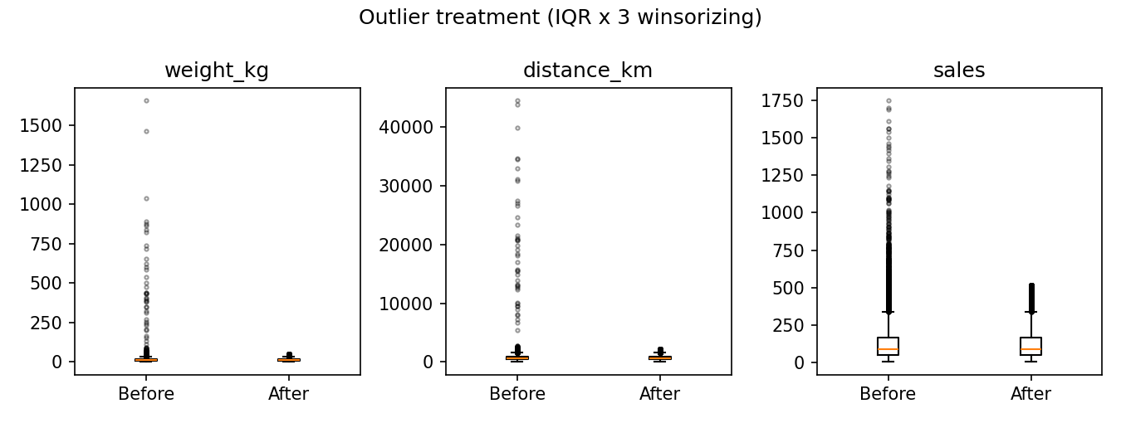
Figure 2: Boxplots before and after outlier treatment

4.6 Step 6: Feature engineering
def add_features(df):
df = df.copy()
df["lead_time_days"] = (df["delivery_date"] - df["order_date"]).dt.days
df["delay_days"] = df["days_shipping_real"] - df["days_shipping_scheduled"]
df["is_late"] = (df["delay_days"] > 0).astype(int)
df["order_month"] = df["order_date"].dt.month
df["order_dow"] = df["order_date"].dt.dayofweek
df["cost_proxy_per_kg_km"] = df["sales"] / (df["weight_kg"] * df["distance_km"]).clip(lower=1)
return df

Why: Raw columns rarely answer logistics questions directly. Lead time, delay days and a late flag translate dates into the quantities that KPIs such as OTIF are built from, and calendar fields (month, weekday) let later models capture seasonality. Effect: creates the target variable (is_late) and predictors for the late-delivery and demand models planned in Weeks 3 and 4.

4.7 Step 7: Transform, encode and scale
Three different operations are used, each for a different reason:
- Log transformation: weight, distance and sales are right-skewed. Applying log1p() compresses the long tail and makes the shape closer to symmetric, which helps linear models and distance-based methods.
- One-hot encoding: categorical columns (shipping mode, region, category) are turned into 0/1 columns with get_dummies(drop_first=True). Dropping one level avoids perfect redundancy between the columns.
- Scaling: StandardScaler (mean 0, standard deviation 1) suits linear models and clustering; MinMaxScaler (0 to 1) suits neural networks and methods that need bounded inputs. Without scaling, distance in km (hundreds) would dominate quantity (1 to 5) in K-Means or KNN.
def scale_and_encode(df):
skewed = ["weight_kg", "distance_km", "sales"]
METRICS["skew_before"] = {c: round(float(df[c].skew()), 2) for c in skewed}
for c in skewed:
df[f"{c}_log"] = np.log1p(df[c])
METRICS["skew_after_log"] = {c: round(float(df[f"{c}_log"].skew()), 2) for c in skewed}
df = pd.get_dummies(df, columns=["shipping_mode", "region", "category"], drop_first=True, dtype=int)
num = [f"{c}_log" for c in skewed] + ["quantity", "days_shipping_scheduled"]
train, test = train_test_split(df, test_size=0.2, random_state=42, stratify=df["is_late"])
train, test = train.copy(), test.copy()
std = StandardScaler().fit(train[num]) # fit on TRAIN only
train[[f"{c}_z" for c in num]] = std.transform(train[num])
test[[f"{c}_z" for c in num]] = std.transform(test[num])
mm = MinMaxScaler().fit(train[num])
train[[f"{c}_mm" for c in num]] = mm.transform(train[num])
test[[f"{c}_mm" for c in num]] = mm.transform(test[num])
METRICS["z_train_mean"] = round(float(train[[f"{c}_z" for c in num]].mean().abs().max()), 4)
METRICS["mm_range"] = [round(float(train[[f"{c}_mm" for c in num]].min().min()), 2),
round(float(train[[f"{c}_mm" for c in num]].max().max()), 2)]
return df, train, test

Why the split comes before fitting the scaler: the scalers are fitted on the training set only and then applied to the test set. If they were fitted on all data, information about the test set (its mean and range) would leak into training, giving results that look better than they really are. This is called data leakage and is one of the most common preprocessing mistakes. Effect: skewness of weight, distance and sales changed from 1.47, 1.07 and 1.69 to -0.25, -0.5 and -0.18 after the log transform; the standardized training columns have a mean of 0, and the min-max columns span 0 to 1.
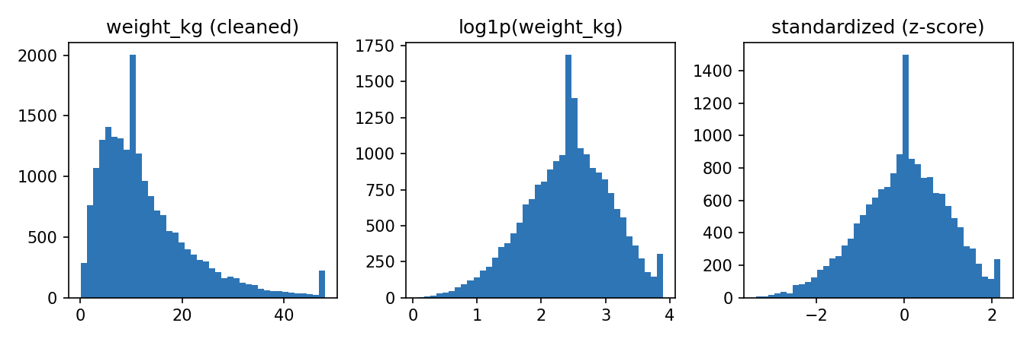
Figure 3: Weight after cleaning, after log transform and after standardization
The small bar at the right edge of the first histogram is the winsorizing cap: all values above the upper bound were set to that bound.

4.8 Step 8: Validate and run the whole pipeline
def validate(df):
checks = {
"no duplicate order_id": df["order_id"].is_unique,
"no missing in key columns": df[["order_date", "sales", "weight_kg", "distance_km", "region", "category"]].notna().all().all(),
"quantity > 0": bool((df["quantity"] > 0).all()),
"delivery >= order": bool((df["delivery_date"] >= df["order_date"]).all()),
"sales > 0": bool((df["sales"] > 0).all()),
}
for k, v in checks.items(): print(f" [{'PASS' if v else 'FAIL'}] {k}")
METRICS["validation"] = {k: bool(v) for k, v in checks.items()}
assert all(checks.values()), "Validation failed"

Automatic checks act as a safety net. If any rule fails, the script stops with an error instead of passing bad data on. The main block runs the steps in order:
typed = clean_types(raw) # types, labels, dates
valid = remove_invalid(typed) # duplicates, sign errors, impossible dates
filled = impute(valid) # missing values + was_missing flags
treated = treat_outliers(filled) # IQR x 3 winsorizing + outlier flags
feat = add_features(treated) # lead time, delay, late flag, calendar
validate(feat) # assertions
full, train, test = scale_and_encode(feat) # log, encode, scale (fit on train)
full.to_csv("data/processed/logistics_orders_clean.csv", index=False)

5. Results: Before and After
Measure | Raw data | Cleaned data
Rows | 20,400 | 20,000 (duplicates removed)
Columns | 13 | 38 (features, flags, encodings)
Duplicate order IDs | 400 | 0
Missing values in key fields | Up to 5.9% per column | 0
Shipping-mode label variants | 8 | 4
Deliveries before order date | 60 | 0
Weight: max / std (kg) | 1657.6 / 29.4 | 48.1 / 9.2
Distance: max / std (km) | 44,547.5 / 1,064.9 | 2,225.8 / 357.1
Sales: max / std | 1750 / 130 | 514.5 / 109.9
Validation checks passed | Not applicable | 5 of 5

The "raw" statistics for weight, distance and sales are taken after type conversion but before outlier treatment, because text values cannot be summarised numerically. All five validation rules passed on the final dataset.

6. Reflection: Impact of Data Quality on Analytics and Decisions
The saying "garbage in, garbage out" is especially true in logistics, where decisions are made daily on the basis of numbers. The experiment makes this concrete in several ways.
- Distorted statistics: a handful of impossible weights and distances raised the standard deviation of weight from 9.2 to 29.4 and pushed the maximum distance above 44,000 km. Any planner reading these averages would size vehicles and budgets wrongly.
- Wrong KPIs: impossible delivery dates would make some lead times negative, so on-time and OTIF figures would be wrong. The date-parsing error discovered in this project (342 false errors instead of 60) shows how a hidden format problem can mislead a KPI without any warning.
- Misleading demand and categories: duplicates inflate demand, so a forecasting model would overstate sales and cause over-ordering. Inconsistent labels split one shipping mode into several categories, so a model sees "STANDARD CLASS " and "Standard Class" as different things.
- Poor model behaviour: clustering, K-Means and nearest-neighbour routing heuristics depend on distances between points. Unscaled features let kilometres overwhelm everything else, and outliers pull cluster centres away from the real groups.
- False confidence: fitting scalers on all data or imputing before splitting gives optimistic test scores that disappear in production.
For decision-makers the consequence is practical. Clean, validated data means a stock-out forecast can be trusted, a route plan reflects real distances and a late-delivery report can be used in a carrier negotiation. Poor data produces confident-looking but wrong recommendations, which is more dangerous than having no analysis at all. Preprocessing is therefore not a side task: in practice it often takes the largest share of an analytics project's time, and documenting it, as done here, makes results reproducible and auditable.

Limitations and good practice
- Synthetic data: the data is synthetic and the injected errors are tidier than real ones, so real data will need more investigation and business input.
- Choices can be questioned: median imputation and IQR capping are reasonable defaults, but their effect should be tested through sensitivity checks (for example, comparing a model trained with and without outlier capping).
- Traceability: every correction is logged and flagged so another analyst can reproduce or reverse it, and the raw file is never overwritten.

7. Conclusion
This report built and documented a full preprocessing pipeline for logistics data: audit, type and label standardisation, removal of duplicates and invalid records, context-aware imputation, IQR-based outlier treatment, feature engineering, transformation, encoding and leakage-safe scaling, followed by automatic validation. Each technique was chosen with a reason and its effect on later analysis was measured. The result is a clean, validated dataset of 20,000 orders with training and test splits, ready for exploratory analysis and predictive modelling in the following weeks. The same functions can be pointed at the real DataCo file by replacing the data-loading step.

8. References
- DataCo Smart Supply Chain for Big Data Analysis. Kaggle and Mendeley Data (public dataset).
- McKinney, W. Python for Data Analysis (3rd ed.). O'Reilly Media. (pandas methods)
- Little, R. J. A. and Rubin, D. B. Statistical Analysis with Missing Data (3rd ed.). Wiley, 2019. (MCAR, MAR, MNAR)
- Tukey, J. W. Exploratory Data Analysis. Addison-Wesley, 1977. (interquartile range rule)
- Pedregosa, F. et al. Scikit-learn: Machine Learning in Python. Journal of Machine Learning Research, 12, 2011.
- Wang, R. Y. and Strong, D. M. Beyond accuracy: What data quality means to data consumers. Journal of Management Information Systems, 12(4), 1996.
- pandas documentation: pandas.pydata.org | scikit-learn preprocessing guide: scikit-learn.org

