WEEK 4 REPORT
Predictive Modeling and Optimization in Logistics Systems

Forecasting shipment delivery time with machine learning, and using the forecasts to set better delivery promises and choose transport modes at lower cost
Tools: Python, pandas, scikit-learn, SciPy (MILP), matplotlib, seaborn
Prepared by: ADARSH SIDDHARTH
Date: October 5TH2026

1. Executive Summary
Customers judge a logistics provider by one question: did the parcel arrive when promised? This report builds a machine learning model that predicts the total delivery time of a shipment at the moment it is dispatched, and then uses those predictions to make two operational decisions: how long a delivery promise to quote, and which transport mode to use for each shipment.
The model was trained on 18,693 simulated shipments (January 2024 to June 2025) and tested on the 6,307 shipments from July to December 2025, a later period that includes the peak season. Five model types were compared. The tuned gradient boosting model was best, with a mean absolute error (MAE) of 4.33 hours and R² of 0.79, 48% lower error than a baseline that simply uses each mode's average time (MAE 8.33).
The predictions were then used in two optimization studies:
- Delivery promise: quoting delivery promises from the model's 90th-percentile forecast gave 89.3% on-time delivery with an average promise of 37.0 hours. The current rule-based promise averages 42.5 hours and achieves only 86.9%. To match 89.3% reliability, a rule-based promise would need to be about 45.0 hours long, so model-based promises are 17.8% shorter at equal reliability.
- Mode selection: a mixed-integer linear program (MILP) chooses the cheapest mode for each shipment subject to an on-time target and an air-freight capacity limit. At the same on-time level as today, it cut simulated transport cost by 40.7% (from $3,986,155 to $2,363,321). With a 90% on-time target it improved on-time delivery to 89.4% and still cut cost by 31.1%.
Because the data are simulated, the exact percentages should be read as a demonstration of the method and not as forecasts for a real company. Section 9 explains which parts of the result depend on the simulation.

2. Problem Definition

2.1 The prediction problem
Business setting. A regional distributor ships goods from three distribution centres (DCs) to five regions using road, rail and air, with four carriers. Each shipment carries a delivery promise to the customer. Currently the promise is set by a simple rule based on distance, and the transport mode is chosen by the dispatcher, with air used mostly for urgent orders.
Prediction task. For each shipment, forecast the total delivery time in hours (warehouse dispatch delay plus transit time) using only information available when the shipment is dispatched. This is a supervised regression problem.
Why this metric. Total delivery time drives on-time performance, customer satisfaction and the cost of expedited shipping. An accurate forecast supports three decisions: what promise to quote, which mode to use, and where warehouse capacity is short.
Success criteria set before modelling. (1) At least 40% lower MAE than the simple baseline; (2) MAE of about 5 hours or less, since promises are made in whole hours or days; (3) stable error across modes, DCs and months, including the peak season; (4) uncertainty estimates that are honest, meaning an 80% interval should contain about 80% of outcomes.

2.2 The optimization problem
Predictions are useful only if they change decisions. Two decisions are studied: (A) how to set the delivery promise so that it is both reliable and not unnecessarily long, and (B) which transport mode to assign to each shipment to minimise total cost while meeting an on-time target. A third what-if looks at warehouse capacity (C).

3. Dataset and Simulation
The dataset covers 25,000 shipments over 24 months (2024 and 2025). It was generated with a fixed random seed. The mode shares are 63.2% road, 25.0% rail and 11.7% air.
Feature | Type | Description
dc, region, carrier | Category | Origin DC (3), destination region (5), carrier (4)
mode | Category | Transport mode actually used: Road, Rail or Air
distance_km, weight_kg | Numeric | Route distance and shipment weight
urgent | Flag | Express order (promise window is 45% shorter)
month, weekday, peak | Calendar | Month, weekday name, and a flag for October to December
weather_forecast | Flag | Severe-weather warning available at dispatch (detects 70% of real events, 3% false alarms)
fuel_index | Numeric | Fuel price index around 100
dc_load | Numeric | Number of orders the DC must process that day (workload)
Target: total_h | Numeric | Total delivery time in hours = dispatch delay + transit time

3.1 Preventing data leakage
Leakage means using information in training that would not be available when the prediction is needed. Three columns were deliberately kept out of the feature set: dispatch_h and transit_h (they sum exactly to the target) and weather_event (the real weather, known only after the fact; only the imperfect forecast is used). A model trained with these columns would look excellent in testing and be useless in practice.

3.2 How the simulation works
Dispatch delay depends on the DC workload relative to its capacity (DC-West has the lowest capacity, and Mondays and the peak season raise the workload). Transit time equals distance divided by a mode-specific speed plus fixed handling time, scaled by a carrier factor, and increased by weather events and peak-season congestion. Cost depends on mode, distance, weight, carrier, fuel and season.
Potential outcomes. For every shipment the simulator also computes what the time and cost would have been under each of the three modes, using the same random noise. The dataset records only the outcome of the mode that was actually used, as real data would. The other outcomes are kept aside and used only to score optimization policies against the truth in Section 7. This is possible only with simulated data; with real data, such evaluation requires a controlled pilot.
Caveat. The patterns are built in, so strong model performance is partly expected. The value of this exercise is the full method: leak-free features, time-aware validation, fair model comparison, uncertainty estimates and decision optimization.
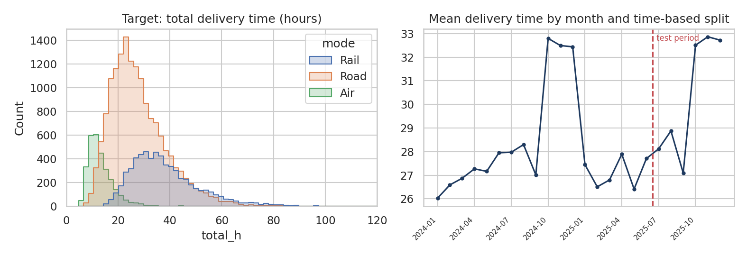
Figure 1: Distribution of the target by mode, and mean delivery time by month with the train/test boundary
The target is right-skewed, with road and rail overlapping and air much faster. Mean delivery time is 28.7 hours (median 26.8), with a clear seasonal rise in October to December, which falls inside the test period. A model that has not learned the peak effect would fail exactly where accuracy matters most.

4. Data Preparation

4.1 Time-based split
Data are sorted by date. Everything up to 2025-06-30 (18,693 shipments) is used for training and validation, and the later 6,307 shipments are held out as the final test. A random split would place shipments from the same day in both sets and let the model "see the future" of weather, workload and fuel prices; it would overstate accuracy. A time-based split mimics real use: train on the past, predict the future.

4.2 Features and preprocessing
Categorical features are one-hot encoded and numeric features are standardised for the linear model only (tree models do not need scaling). Both steps live inside a scikit-learn Pipeline, so that during cross-validation the encoders and scalers are fitted only on each training fold, which prevents leakage through preprocessing.
CAT = ["dc", "region", "mode", "carrier", "weekday"]
NUM = ["distance_km", "weight_kg", "urgent", "month", "peak", "weather_forecast", "fuel_index", "dc_load"]
FEATS = CAT + NUM # leakage guard: dispatch_h, total_h, weather_event are NOT used
TARGET = "total_h"
cut = pd.Timestamp("2025-06-30")
train, test = df[df.date <= cut].copy(), df[df.date > cut].copy()
Xtr, ytr, Xte, yte = train[FEATS], train[TARGET], test[FEATS], test[TARGET]
R["split"] = {"train": len(train), "test": len(test), "train_end": str(cut.date())}

def prep(scale=False):
num = StandardScaler() if scale else "passthrough"
return ColumnTransformer([("cat", OneHotEncoder(handle_unknown="ignore", sparse_output=False), CAT), ("num", num, NUM)])

5. Model Selection and Implementation
Models were chosen to span a range from simple to flexible, so that the added value of complexity can be measured and justified:
Model | Rationale | Expected strengths and weaknesses
Baseline: mean by mode | Simplest sensible benchmark. Any real model must beat it. | Ignores distance, workload and weather
Linear regression | Transparent and fast; coefficients are easy to explain to planners. | Cannot capture interactions such as distance x mode or workload x DC
Decision tree | Captures non-linear rules and interactions; easily visualised. | Unstable and prone to overfitting unless depth is limited
Random forest | Averages many trees; robust to noise and needs little tuning. | Less sharp than boosting; larger model
Gradient boosting | Builds trees sequentially to correct earlier errors; usually most accurate on tabular data; supports quantile loss for intervals. | More hyperparameters; needs careful tuning and validation

Defining and tuning the models
class MeanByMode(DummyRegressor): # baseline: average hours of the shipment's mode
def fit(self, X, y): self.m_ = pd.Series(y.values, index=X["mode"].values).groupby(level=0).mean(); return self
def predict(self, X): return X["mode"].map(self.m_).fillna(self.m_.mean()).values

models = {"Baseline (mean by mode)": MeanByMode(),
"Linear regression": Pipeline([("p", prep(True)), ("m", LinearRegression())])}
# decision tree: tune depth with time-series CV
gs = GridSearchCV(Pipeline([("p", prep()), ("m", DecisionTreeRegressor(min_samples_leaf=20, random_state=0))]),
{"m__max_depth": [4, 6, 8, 10, 14]}, cv=tscv, scoring="neg_mean_absolute_error").fit(Xtr, ytr)
models["Decision tree"] = gs.best_estimator_; R["tree_best_depth"] = int(gs.best_params_["m__max_depth"])
models["Random forest"] = Pipeline([("p", prep()), ("m", RandomForestRegressor(n_estimators=120, min_samples_leaf=5, max_features=.5, random_state=0, n_jobs=-1))])
# gradient boosting: randomised search with time-series CV
default_hgb = Pipeline([("p", prep()), ("m", HistGradientBoostingRegressor(random_state=0))])
rs = RandomizedSearchCV(Pipeline([("p", prep()), ("m", HistGradientBoostingRegressor(random_state=0))]),
{"m__learning_rate": [.03, .05, .08, .12], "m__max_depth": [3, 4, 6, None], "m__max_leaf_nodes": [15, 31, 63],
"m__min_samples_leaf": [10, 20, 40], "m__l2_regularization": [0, .1, 1.0], "m__max_iter": [200, 350, 500]},
n_iter=14, cv=tscv, scoring="neg_mean_absolute_error", random_state=42).fit(Xtr, ytr)
best_hgb = rs.best_estimator_; models["Gradient boosting (tuned)"] = best_hgb
R["hgb_best_params"] = {k.replace("m__", ""): (None if v is None else (float(v) if isinstance(v, float) else int(v))) for k, v in rs.best_params_.items()}

The decision tree depth was chosen by grid search (best depth 10). For gradient boosting, a randomised search tried 14 combinations of learning rate, tree depth, number of leaves, minimum samples per leaf, L2 regularisation and number of iterations. The best combination used a learning rate of 0.03, 500 iterations, 63 leaves, a minimum of 40 samples per leaf and L2 regularisation of 1. A low learning rate with many iterations and regularisation is a conservative setting that favours generalisation.

6. Evaluation and Validation

6.1 Metrics and why they were chosen
Metric | Meaning | Why it is used
MAE | Average absolute error in hours | Easy to interpret: "on average the forecast is off by X hours". Robust to a few extreme errors.
RMSE | Square root of the mean squared error | Penalises large misses more heavily. A big gap between RMSE and MAE signals occasional large errors.
R² | Share of variance in delivery time explained | Scale-free summary compared against predicting the mean (R² = 0)
Within ±6 h | Share of forecasts within 6 hours of the truth | Operational measure: a forecast within a quarter of a day is usually good enough for planning

def metrics(y, p):
return {"MAE": mean_absolute_error(y, p), "RMSE": mean_squared_error(y, p) ** .5, "R2": r2_score(y, p),
"within6h": float(np.mean(np.abs(y - p) <= 6) * 100)}

6.2 Cross-validation and tuning
Ordinary k-fold cross-validation shuffles data and would again leak the future into training. Instead, TimeSeriesSplit with four splits was used on the training period: each fold trains on an earlier block and validates on the next one, so the validation always lies in the future of the training data. Hyperparameters were selected by this procedure, using MAE as the score. The test set was not used for any tuning decision.
res, cvres = {}, {}
for name, mdl in models.items():
if name != "Baseline (mean by mode)": mdl.fit(Xtr, ytr)
else: mdl.fit(Xtr, ytr)
res[name] = metrics(yte.values, mdl.predict(Xte))
if name not in ("Baseline (mean by mode)",):
cvres[name] = (-cross_val_score(mdl, Xtr, ytr, cv=tscv, scoring="neg_mean_absolute_error")).tolist()
default_hgb.fit(Xtr, ytr); res["Gradient boosting (default)"] = metrics(yte.values, default_hgb.predict(Xte))
R["results"] = {k: {m: round(v, 3) for m, v in d.items()} for k, d in res.items()}
R["cv_mae"] = {k: [round(x, 2) for x in v] for k, v in cvres.items()}
R["cv_mae_mean"] = {k: round(float(np.mean(v)), 2) for k, v in cvres.items()}

6.3 Results
Model | MAE (h) | RMSE (h) | R² | Within ±6 h (%)
Baseline (mean by mode) | 8.33 | 11.34 | 0.28 | 47.8
Linear regression | 4.83 | 6.64 | 0.75 | 72.0
Decision tree | 4.82 | 6.71 | 0.75 | 72.5
Random forest | 4.42 | 6.19 | 0.78 | 75.6
Gradient boosting (default) | 4.35 | 6.11 | 0.79 | 76.7
Gradient boosting (tuned) | 4.33 | 6.04 | 0.79 | 77.0

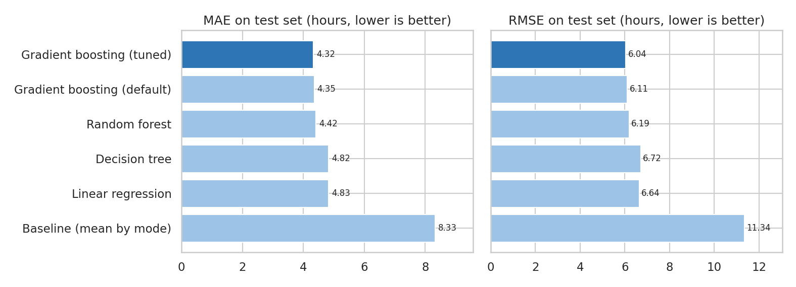
Figure 2: Test-set MAE and RMSE for all models
Interpretation. All learned models beat the baseline by a wide margin (MAE 8.33 down to 4.83 to 4.33 hours). Linear regression already explains 0.75 of the variance, which shows that delivery time is largely driven by distance and mode. Ensemble methods add a further gain: random forest reaches 4.42 hours and tuned gradient boosting 4.33 hours, 10.4% better than linear regression, because they can learn interactions such as the effect of workload at a specific DC. Tuning improved MAE only from 4.35 to 4.33 hours, a sign that the default settings were already reasonable and that gains now come mainly from better features, not more tuning.
Cross-validation on the training period gave the same ranking (mean MAE: linear 4.69, tree 4.58, forest 4.28, tuned boosting 4.17 hours), and in every fold the two ensemble models beat the linear and tree models, with gradient boosting best. (Linear regression and the single tree swap places in one fold, so they are close.) This consistency gives confidence that the choice of model is not an accident of one particular split.
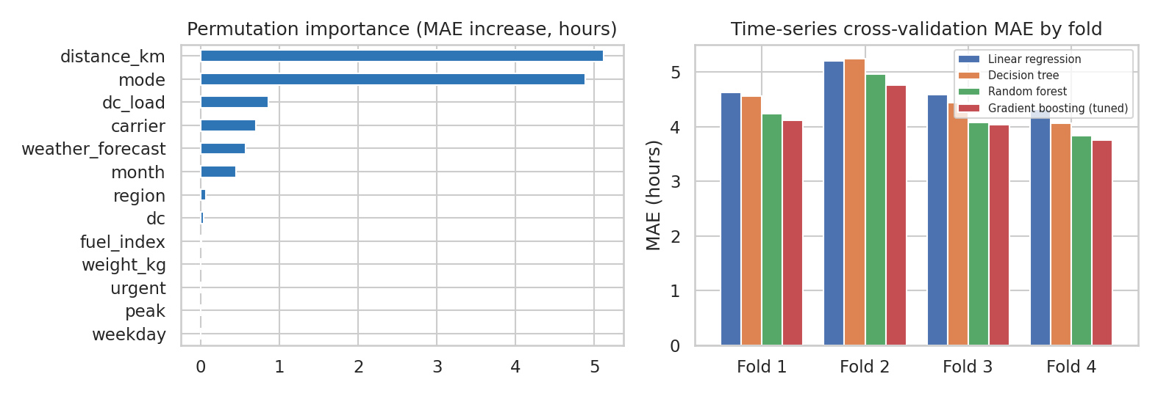
Figure 3: Permutation importance on the test set, and cross-validation MAE by fold

6.4 What drives delivery time?
Permutation importance shuffles one feature at a time on the test set and measures how much the error grows. Distance (+5.12 hours of MAE) and transport mode (+4.88) dominate, followed by DC workload (+0.86), carrier (+0.70), weather forecast (+0.57) and month (+0.45). Weight, urgency, fuel index and the peak flag show near-zero importance. Weight and urgency do not affect transit in the simulation, which the model correctly discovered. The weekday and peak flags matter through the DC workload, which already captures the Monday and peak-season effect, so the model gets that information from dc_load. Importance of strongly related features is shared between them, so a low score does not always mean a feature is useless. The result suggests DC workload is the most useful lever that management can control.

6.5 Residual analysis and stability
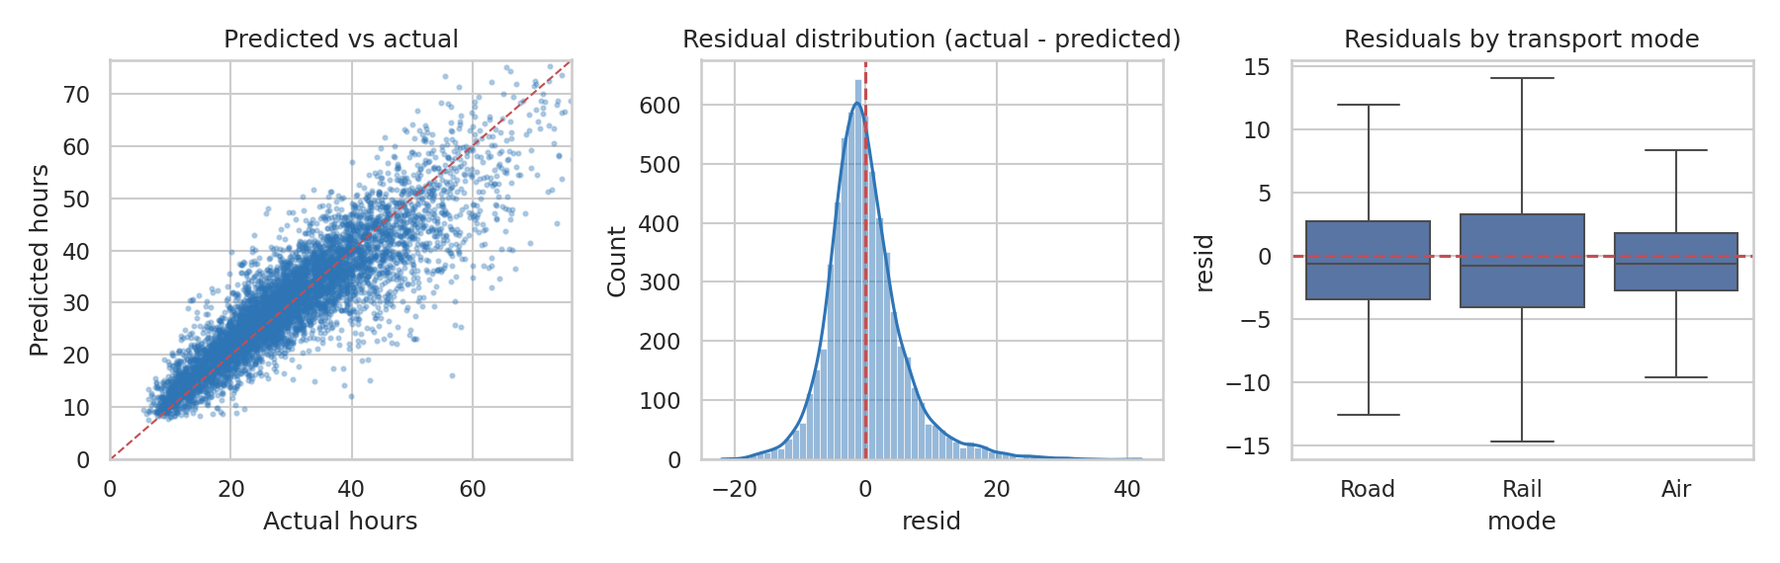
Figure 4: Predicted versus actual delivery time, residual distribution, and residuals by mode
The predicted-versus-actual scatter follows the diagonal closely. Residuals are centred on zero (mean 0.04 hours) with a standard deviation of 6.04 hours, so the model is unbiased on average. The residual distribution has a longer right tail: the model sometimes under-predicts very late shipments, typically those hit by an unforecast weather event, which is unavoidable when the weather is only partly predictable. Error by mode: air 3.11 h, road 4.35 h, rail 4.80 h; by DC: North 4.17 h, South 4.10 h, West 4.68 h. DC-West has the highest error because its workload is the most variable.
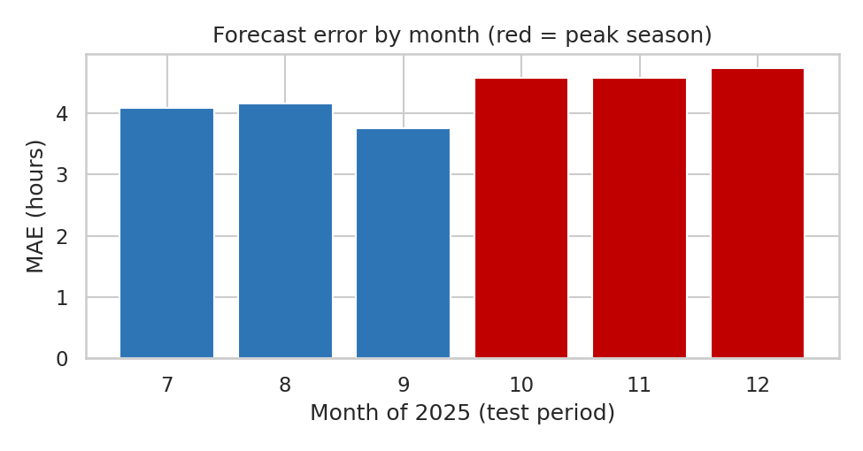
Figure 5: Test-period MAE by month
Error is stable across the test months (3.76 to 4.74 hours) and rises slightly in the peak months October to December, when variability is greater. Monthly bias stays within about ±0.3 hours. In production the model should be monitored in the same way, with retraining triggered when monthly error or bias drifts.

6.6 Prediction intervals: quantifying uncertainty
A single number hides how uncertain a forecast is. Gradient boosting models were also trained with a quantile (pinball) loss to predict the 10th, 30th, 50th, 70th, 80th, 90th and 95th percentiles of delivery time. Predictions were sorted to prevent quantile crossing. These percentile forecasts are the raw material for the promise-setting policy in Section 7.1.
qp = {k: v for k, v in best_hgb.named_steps["m"].get_params().items() if k in ("learning_rate", "max_depth", "max_leaf_nodes", "min_samples_leaf", "l2_regularization", "max_iter")}
QS = [.1, .3, .5, .7, .8, .9, .95]; qmods = {}
def fitq(q): return Pipeline([("p", prep()), ("m", HistGradientBoostingRegressor(loss="quantile", quantile=q, random_state=0, **qp))]).fit(Xtr, ytr)
for q in QS: qmods[q] = fitq(q)
def qpred(X):
P = np.column_stack([qmods[q].predict(X) for q in QS]); return np.maximum.accumulate(P, axis=1) # no crossing
Q = qpred(Xte); qi = {q: i for i, q in enumerate(QS)}

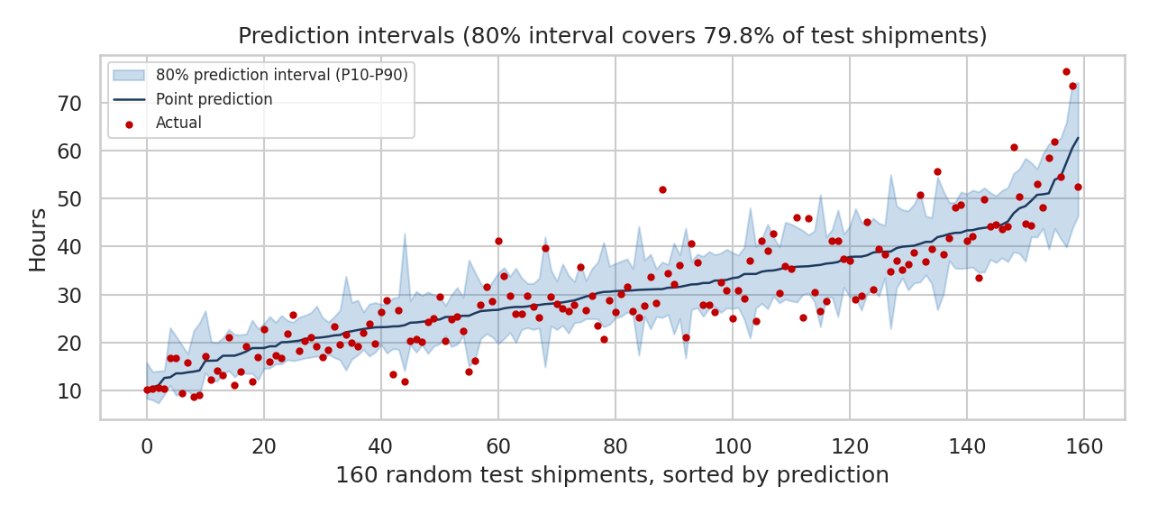
Figure 6: Point predictions and 80% prediction intervals for 160 random test shipments
Calibration check: the P10-to-P90 interval contained 79.8% of actual outcomes (target 80%), and 89.3% of outcomes fell below the P90 forecast (target 90%). The intervals are therefore well calibrated on unseen data, and they widen for long, uncertain shipments, as they should.

7. Optimization Strategies

7.1 Strategy A: data-driven delivery promises
The current promise is a rule based on distance and urgency. Measured on the test period, it averages 42.5 hours and is met for 86.9% of shipments. The alternative is to promise the model's forecast at a chosen percentile: a P90 promise means that the company expects to meet it for nine out of ten shipments, so reliability becomes a controllable setting. Higher percentiles give more reliable but longer promises, and the question is whether the model gives a better trade-off than simply adding a flat buffer to the rule.
Promise policy: model quantiles versus rule with a flat buffer
# Simplified from predictive_optimization.py
quote_p90 = Q[:, qi[.9]] # model's 90th-percentile forecast = the promise
on_time_p90 = np.mean(y_test <= quote_p90) # share of shipments delivered within the promise
avg_promise = quote_p90.mean() # average promise length (hours)

# Comparison: current rule-based promise with a flat buffer factor k
for k in np.linspace(.7, 3.0, 70):
on_time_rule = np.mean(y_test <= base_quote * k)
avg_rule = (base_quote * k).mean()

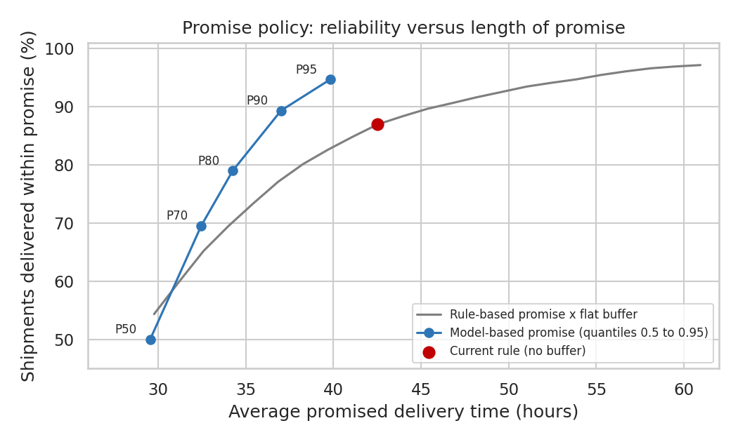
Figure 7: Reliability versus average promise length: model quantiles against the rule-based promise with a flat buffer
Result. The blue model curve lies above and to the left of the grey rule curve at every point. A P90 promise averages 37.0 hours and is met 89.3% of the time. To reach the same reliability, the rule would need an average promise of 45.0 hours, so the model-based promise is 17.8% shorter. A P95 promise reaches 94.7% reliability at 39.8 hours. The model does better because it gives short promises to shipments that are likely to be fast and long ones only to risky shipments (long distance, loaded DC, bad-weather warning), while a flat buffer lengthens every promise equally.

7.2 Strategy B: cost-minimising transport mode selection (MILP)
Historically, urgent shipments often fail even when sent by air: urgent shipments are on time only 69.6% of the time versus 94.0% for standard shipments. At the same time air is by far the most expensive mode. The optimisation asks, for each shipment, which mode gives the cheapest plan that still meets a portfolio-wide on-time target.
Prediction inputs. For every shipment and every mode (changing only the mode feature), two models give the expected cost and the probability of meeting the promise. The cost model (gradient boosting on log cost) has a MAPE of 7.1% and R² of 0.99 on the log scale. The on-time classifier has an AUC of 0.92 and Brier score of 0.06. It estimates a test on-time rate of 87.0% against 86.9% observed, which is well calibrated.
Mathematical formulation. Let x(i,m) = 1 if shipment i is sent by mode m, c(i,m) the predicted cost, p(i,m) the predicted probability of on-time delivery, N the number of shipments, τ the on-time target and K the air capacity. The model is:
minimise sum over i, m of c(i,m) * x(i,m) (total cost)
subject to sum over m of x(i,m) = 1 for every shipment i (one mode each)
sum over i, m of p(i,m) * x(i,m) >= tau * N (expected on-time target)
sum over i of x(i,Air) <= K (air capacity)
x(i,m) in {0, 1}

This is a mixed-integer linear program with 18,921 binary variables for the 6,307 test shipments. It was solved with SciPy's HiGHS-based milp() function in seconds. Air capacity was set at 15% of shipments (946), slightly above today's 11.4%.
A_eq = sparse.kron(sparse.eye(N), np.ones((1, 3))).tocsr()
A_air = sparse.csr_matrix((np.ones(N), (np.zeros(N, int), np.arange(N) * 3 + 2)), shape=(1, 3 * N))
cap_air = int(.15 * N)

def solve(cost, prob, target_otif):
"""min total cost s.t. each shipment gets one mode, expected on-time >= target, air shipments <= cap."""
cons = [LinearConstraint(A_eq, 1, 1), LinearConstraint(A_air, -np.inf, cap_air),
LinearConstraint(sparse.csr_matrix(prob.flatten()[None, :]), target_otif * N, np.inf)]
sol = milp(cost.flatten(), constraints=cons, integrality=np.ones(3 * N), bounds=Bounds(0, 1))
return sol.x.reshape(N, 3).argmax(1) if sol.success else None

Because the data are simulated, every policy can be scored against the true outcomes under each mode, not just against the model's own estimates:
Policy | Total cost | Cost saving | On-time | Late | Road/Rail/Air %
Historical choices | $3,986,155 | 0.0% | 86.8% | 830 | 62.9 / 25.8 / 11.4
All road | $2,597,892 | 34.8% | 84.1% | 1,004 | 100.0 / 0.0 / 0.0
MILP, same on-time level as today | $2,363,321 | 40.7% | 86.0% | 882 | 62.9 / 32.1 / 5.0
MILP, 90% on-time target | $2,744,780 | 31.1% | 89.4% | 667 | 69.7 / 21.3 / 9.1
Oracle, same on-time level (perfect information) | $2,020,632 | 49.3% | 86.8% | 830 | 17.4 / 79.6 / 3.0
Results scored with true outcomes on the test period. Cost saving is relative to historical choices. The oracle uses perfect knowledge of outcomes and shows the upper limit.
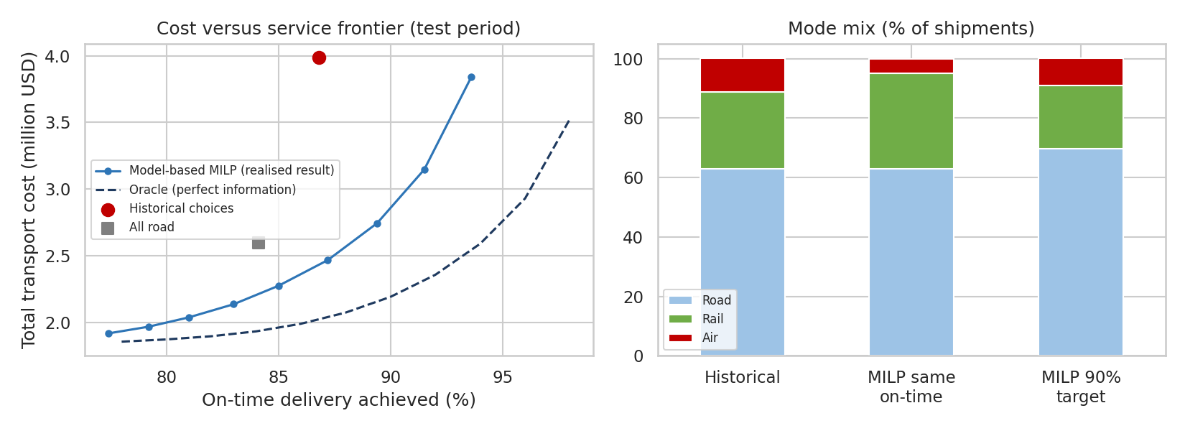
Figure 8: Cost versus service frontier and resulting mode mix
What the results show. (1) At the same on-time level as today, the optimiser lowers cost by 40.7%, mostly by cutting air from 11.4% to 5.0% of shipments and moving suitable shipments to rail (25.8% to 32.1%). Realised on-time delivery is 86.0%, slightly below today's 86.8%, and below the 87.0% the model expected. (2) For a 90% target, cost falls by 31.1% and on-time delivery rises to 89.4%, since the optimiser uses air for the shipments that need it and not for easy ones. (3) A 95% target could not be met with the 15% air cap; the highest realised level on the frontier is about 93.6%. (4) The oracle saves 49.3%, so the model-based plan captures most, though not all, of the achievable gain.
Why realised results fall a little short of the model's estimate. An optimiser chooses the options where the model is most optimistic, which is called the winner's curse. The standard remedy is to add a safety margin: set the model target about one point above the real requirement, then verify with a pilot.
Practical reading: on the same-on-time plan, 1,366 shipments move from road to rail, 477 from air to road and 1,010 from rail to road. Rail takes shipments with a loose promise and road takes those with a tighter one.

7.3 Strategy C: warehouse capacity what-if
Workload at the DC is the third most important driver of delivery time, and the only major one that management controls directly. Using the trained model, the DC-West test shipments (2,193, average predicted delivery 31.3 hours) were re-scored with the daily workload reduced by 10%, 15% and 20%, which is equivalent to adding capacity or smoothing the load. Average delivery time falls by about 1.01, 1.46 and 1.88 hours per shipment. This estimate comes from the model and not from the true process, so it should be confirmed with a pilot, but it provides a way to compare the benefit of extra staff or shifts with their cost.
w = test[test.dc == "DC-West"]; Xw = w[FEATS].copy(); base_pred = best.predict(Xw)
what = {}
for red in (.10, .15, .20):
Z = Xw.copy(); Z["dc_load"] = (Z["dc_load"] * (1 - red)).round()
what[f"{int(red*100)}%"] = round(float(base_pred.mean() - best.predict(Z).mean()), 2)

7.4 Further optimization methods
Method | Idea | Link to this work
Route planning (vehicle routing) | Group deliveries into capacity-limited routes with the savings algorithm or OR-Tools | Developed in Week 1; predicted times can replace distance as the cost of each leg
Carrier allocation | Assign lane volume to carriers with an LP using predicted cost and on-time probability | Extend the on-time classifier with carrier as a decision variable, as was done for mode
Workload levelling | Release or schedule orders to reduce Monday and peak peaks at each DC | Predicted effect of dc_load on delivery time (Section 7.3)
Dynamic promise by risk | Show a longer promise when the weather forecast or workload signals risk | Quantile forecasts from Section 6.6

8. Recommendations
# | Action | Evidence | KPI to track
1 | Deploy the gradient boosting forecaster at dispatch and show planners the predicted time and P10-P90 range | MAE 4.33 h versus 8.33 h for the baseline; intervals 79.8% calibrated | MAE, interval coverage, monthly bias
2 | Quote promises from the P90 forecast instead of the distance rule | Same 89.3% reliability with promises 17.8% shorter | On-time %, average promise length
3 | Use the MILP mode planner daily with a 1-point safety margin, starting with a pilot lane | Cost down 40.7% at equal on-time, or on-time up to 89.4% with cost down 31.1% (simulated) | Cost per shipment, on-time %, air share
4 | Review urgent-shipment handling: 45% of urgent shipments go by road or rail and mostly miss their promise | Urgent on-time 69.6% versus 94.0% | Urgent on-time %
5 | Invest in warehouse capacity or load smoothing at DC-West and for Mondays and peak season | A 15% workload cut saves about 1.46 h per shipment at DC-West | DC workload ratio, dispatch hours
6 | Monitor and retrain: track monthly MAE and bias, retrain quarterly or when drift is detected | Error rises in peak season; relationships may change | Rolling MAE, drift alerts

Implementation roadmap
- Months 1 to 2: build the data feed, run the model in shadow mode, and compare forecasts with outcomes.
- Months 3 to 4: pilot data-driven promises and the mode planner on one or two lanes with a control group.
- Months 5 to 6: measure real savings and on-time change, tune safety margins, and roll out across the network.

9. Limitations
- Simulated data: accuracy and savings depend on the built-in patterns. Real data will be noisier, with missing features and errors, so metrics are likely to be lower.
- Cost structure: the large cost saving arises because the simulated cost of air is about 5.7 times road per kg and because historical choices used air heavily. A network with a smaller air share would see smaller savings.
- Counterfactual evaluation: the true outcome of unused modes is unobservable in real data. A pilot with randomised or controlled mode assignment is the proper way to validate the optimiser.
- Fixed demand: mode choice, promise and customer behaviour could interact (for example, shorter promises may attract different orders). This analysis treats demand as fixed.
- Simplified constraints: the MILP treats shipments independently and ignores carrier capacity, consolidation and route effects.

10. Conclusion
This report defined a clear logistics forecasting problem, predicting total delivery time at dispatch, and solved it with a leak-free, time-validated modelling process. Five models were compared, and a tuned gradient boosting model reduced the error of a simple baseline by 48% (MAE 4.33 hours, R² 0.79), with stable performance in the peak season and well-calibrated uncertainty bands. The predictions were turned into decisions: percentile-based delivery promises that are shorter at equal reliability, and a MILP mode planner that lowers cost or raises on-time delivery. A capacity what-if showed how workload at the warehouse affects delivery time. The main message is that prediction creates value only when it feeds a decision, and that each decision should be tested against a baseline using validation that respects time. The next step is to replace the simulated data with real shipment records and run a controlled pilot.

11. References
- Hastie, T., Tibshirani, R. and Friedman, J. The Elements of Statistical Learning (2nd ed.). Springer, 2009.
- Ke, G. et al. LightGBM: A highly efficient gradient boosting decision tree. NeurIPS, 2017. (histogram-based gradient boosting)
- Hyndman, R. J. and Athanasopoulos, G. Forecasting: Principles and Practice (3rd ed.). OTexts. (time-series cross-validation)
- Koenker, R. and Bassett, G. Regression quantiles. Econometrica, 46(1), 33-50, 1978.
- Pedregosa, F. et al. Scikit-learn: Machine Learning in Python. Journal of Machine Learning Research, 12, 2011.
- Huangfu, Q. and Hall, J. A. J. Parallelizing the dual revised simplex method (HiGHS). Mathematical Programming Computation, 10, 2018.
- Virtanen, P. et al. SciPy 1.0: fundamental algorithms for scientific computing in Python. Nature Methods, 17, 2020.
- Chopra, S. and Meindl, P. Supply Chain Management: Strategy, Planning and Operation. Pearson.
- Toth, P. and Vigo, D. Vehicle Routing: Problems, Methods, and Applications (2nd ed.). SIAM, 2014.

