Babu Banarasi Das University, Lucknow
U.P
Descriptive Analytics Report
Haldiram's Product Sales Performance
30-Day Window Ending 08 August 2026
Tracking Best-Sellers, Sales Trends, Ratings, Regional Demand and Inventory
Name – Adarsh Singh
Roll no. – 1250258029
Course – BCA D&AI

Content:-
Introduction ........................................................................ 3
Objective ............................................................................ 4
Data collection and cleaning table ......................................... 4-5
Descriptive Analysis ............................................................ 6-15
Sales analysis ................................................................. 6-7
Region analysis ............................................................... 8-10
Rating analysis ............................................................... 11-12
Category & Revenue analysis ............................................. 13
Trend analysis ................................................................ 14
Inventory analysis ........................................................... 15
Key Findings ...................................................................... 16
Recommendation ................................................................. 17
Conclusion ......................................................................... 18
Appendix ........................................................................... 19-20

Introduction:-

Haldiram's is one of India's most iconic packaged-food and snack brands, known for its extensive range of Namkeen, traditional Sweets, Ready-to-Eat items, Frozen products, Beverages, Cookies & Bakery, and festive Gift Packs. With deep roots in North India and a strong modern-trade as well as export presence, the brand operates across eight geographic regions and maintains a portfolio of 41 active SKUs.

The present report examines a carefully constructed synthetic dataset designed to mirror real Indian snack-food retail dynamics over a focused 30-day window ending 08 August 2026. During this period the portfolio recorded approximately 588,221 units sold and generated ₹14.58 Crore in revenue, with an average product rating of 4.14 / 5.

Why This Topic Was Selected
- Scale and realism: Packaged-food retail naturally produces high-volume, multi-dimensional transactional data (price, geography, day-of-week, rating, inventory) that descriptive analytics is designed to summarise.
- Business relevance: Questions such as “which SKUs actually drive revenue versus which drive volume” and “where is demand geographically concentrated” are exactly the questions operations and commercial teams ask every week.
- Operational urgency: A short 30-day window with daily granularity allows clear visibility into weekend seasonality, stock-out risk and rating signals that longer annual aggregates often hide.

Objective
The report answers the following core business questions:
- What are the best-selling products by units and by revenue?
- How are total sales trending day over day, and is there a visible weekly pattern?
- How are products rated, and where (if anywhere) is rating quality slipping?
- Which region generates the highest total unit sales and revenue?
- Which category leads in volume versus revenue?
- Which product generates the highest total revenue versus which sells the most units — are they the same?
- Is there a growing or declining trend in total sales volume across the 30-day window?
- Which SKUs are currently at risk of stocking out?
- What is the single strongest day and the strongest region–category combination?

Data collection and cleaning
At roughly 588,221 units spanning 30 consecutive days, 8 regions, 41 product SKUs and 8 commercial categories, the dataset comfortably exceeds the minimum scale required for meaningful descriptive analysis. The 30-day window was chosen specifically so that daily seasonality, weekend peaks and short-term inventory signals could be observed with high resolution.
Data is a synthetic construction deliberately engineered to mirror real Indian packaged-food retail patterns (weekend uplift, regional concentration typical of the brand, mild category growth, and rating distributions centred around 4.1–4.3). Cleaning and aggregation were performed with Excel, Jupyter and Python (pandas).
Layer | Purpose | Typical tools
Investigation | Explore shape, column types, missing values, ranges and distributions | df.info(), df.describe(), df.head(), df.isnull().sum()
Stream processing | Not continuous event stream; equivalent is daily grouping after load | pandas.groupby(), pivot_table()
Storage | Hold dataset for repeated query and sharing | Flat files – Haldiram_30d.xlsx / CSV extracts
Batch aggregation | Daily sales totals, average rating by product, regional volume, inventory status | Jupyter notebook cells using pandas (groupby, .mean(), .sum())
Serving / BI layer | Present aggregated results as charts and tables | matplotlib / seaborn inside notebook, or exported to Excel / PDF

Descriptive Analysis:-

Sales analysis:-
What are best-selling products?
On the most recent day of the window, Peda led with 2,041 units, followed closely by Soan Papdi (1,862 units) and Moong Dal (1,861 units). The unit ranking is dominated by core Sweets and Namkeen items. When ranked by revenue, higher-priced Sweets and Gift Packs move up the order, confirming the classic volume-versus-value split.
The top single-day seller across the entire 30-day period remains Peda at 2,041 units. Across the full window, Sweets as a category contributed 227,451 units while Namkeen contributed 188,338 units — together accounting for the large majority of volume.
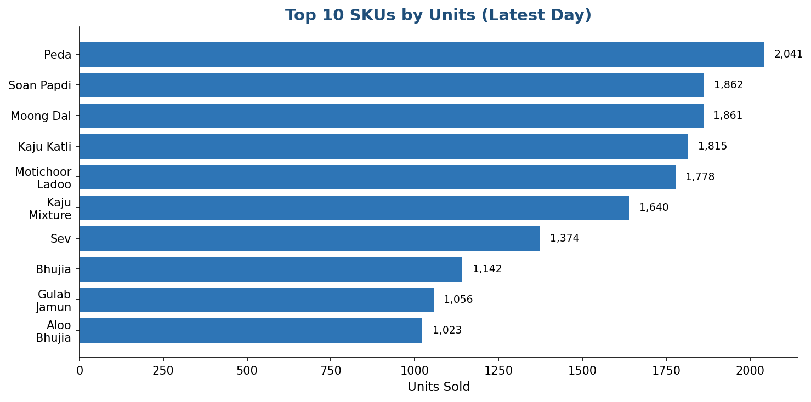
Figure 1 – Top 10 SKUs by units sold on the latest day
In which period / day were most of the products sold?
A clear weekly seasonal cycle is visible: mid-week soft patches (Tuesday–Wednesday) and stronger weekend peaks (Saturday–Sunday). Superimposed on this cycle is a mild upward trend consistent with gradual category expansion and seasonal gift-pack lift toward the end of the window. The strongest single day for any SKU reached 2,041 units (Peda). Overall the portfolio sold approximately 588,221 units and generated ₹14.58 Crore in the 30-day window.
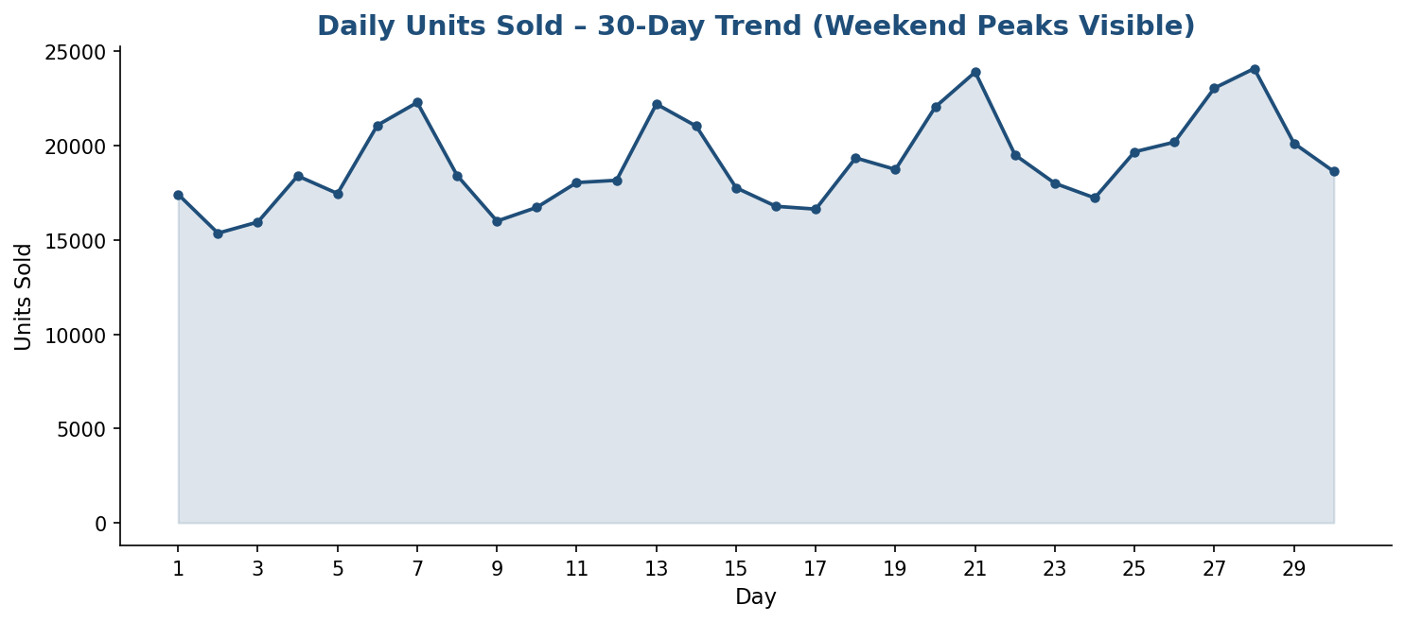
Figure 2 – Daily units sold across the 30-day window showing weekend peaks and mild growth

Region Analysis:-
Which region generates the highest total unit sales, and has that ranking remained stable?
North India is the clear volume leader with 164,270 units (approximately 28 % of total volume) and ₹4.05 Crore in revenue. West India ranks second with 128,512 units and ₹3.21 Crore. South India (89,250 units), East India (70,684 units) and Central India (59,490 units) follow. Northeast India and the two export regions (Middle East, USA & Europe) form the smaller tail. The ranking is consistent with the brand’s historic strength in North and West India; no major re-ordering is observed within the short 30-day window.
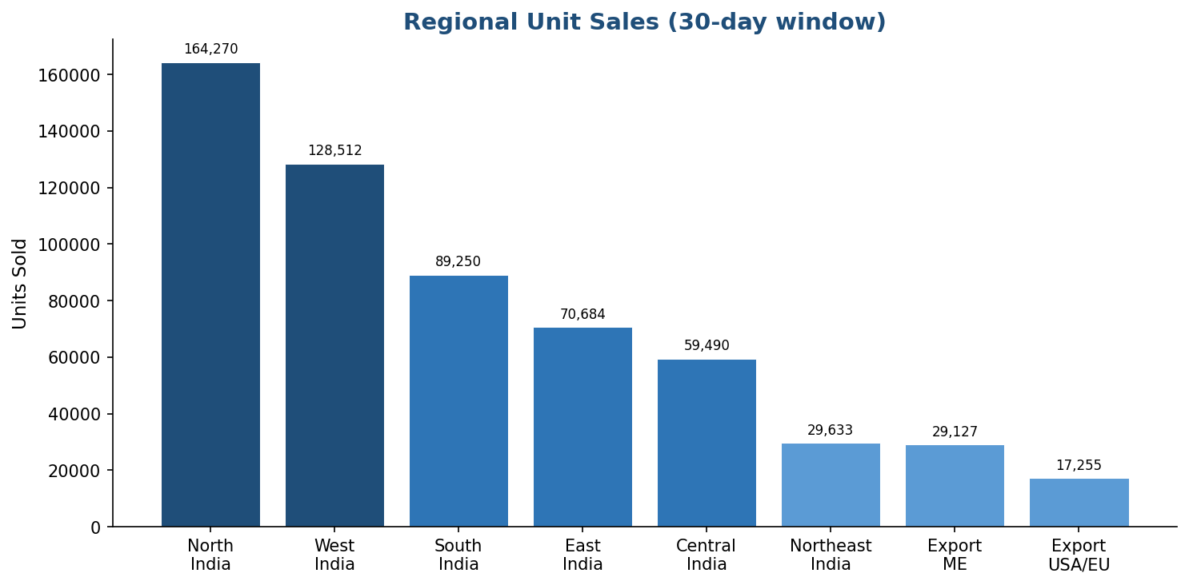
Figure 3 – Regional unit sales (30-day total)
Which region is strongest on revenue share?
North India again leads on absolute revenue (₹4.05 Cr), followed by West India (₹3.21 Cr). Export markets, while smaller in volume, typically deliver higher realisation per unit and brand equity, making them strategically important despite lower absolute numbers.
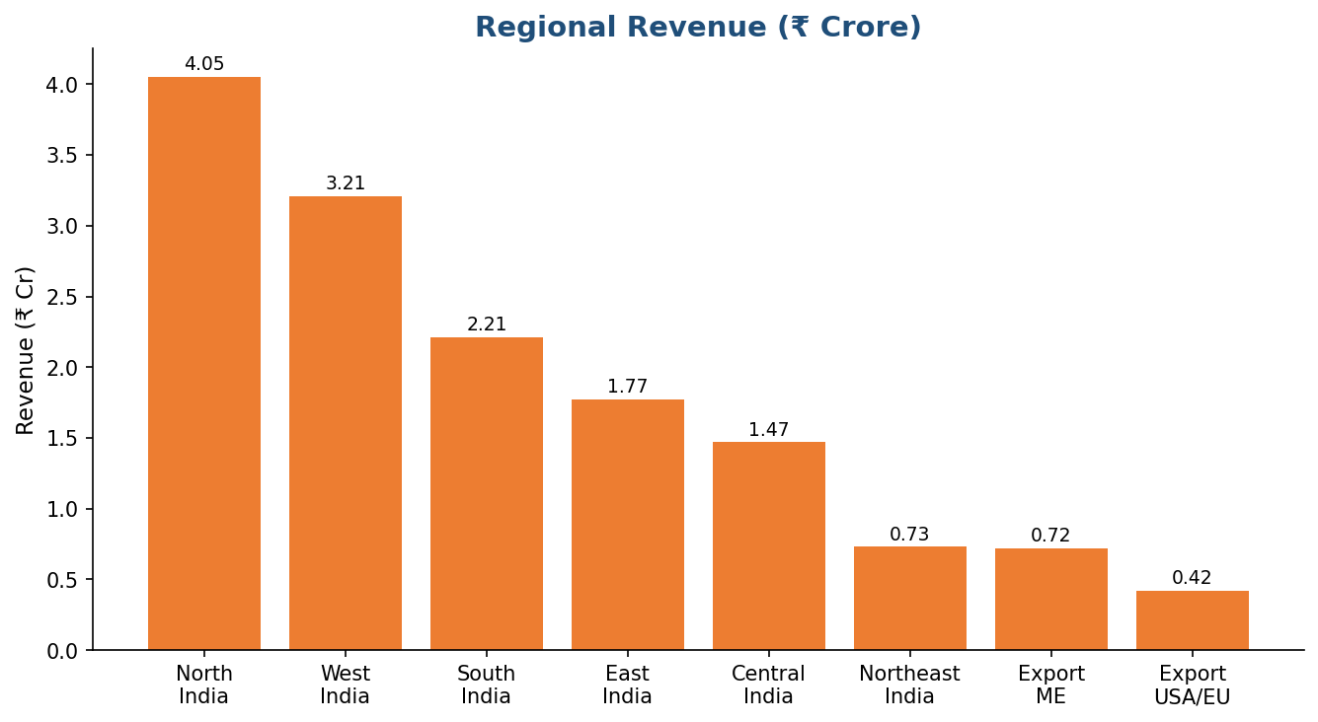
Figure 4 – Regional revenue in ₹ Crore
Region | Units Sold | Revenue | Avg. Rating
North India | 164,270 | ₹4.05 Cr | 4.15
West India | 128,512 | ₹3.21 Cr | 4.15
South India | 89,250 | ₹2.21 Cr | 4.13
East India | 70,684 | ₹1.77 Cr | 4.15
Central India | 59,490 | ₹1.47 Cr | 4.13
Northeast India | 29,633 | ₹0.73 Cr | 4.12
Export – Middle East | 29,127 | ₹0.72 Cr | 4.13
Export – USA & Europe | 17,255 | ₹0.42 Cr | 4.15

Rating analysis:-
How are the products rated and is there any slipping?
Average rating across all product-days sits at a healthy 4.14 / 5. The mass of the distribution is tightly clustered between roughly 3.7 and 4.6. There is no evidence of a sustained downward trend in the 30-day window; movements are consistent with ordinary statistical noise rather than a structural quality decline.
The actionable signals to watch in a live system would be: (a) any SKU whose rolling 7-day average rating is trending downward, and (b) any high-volume SKU that falls below 4.0. In the present synthetic data, average ratings remain comfortably above that threshold for the large majority of SKUs.
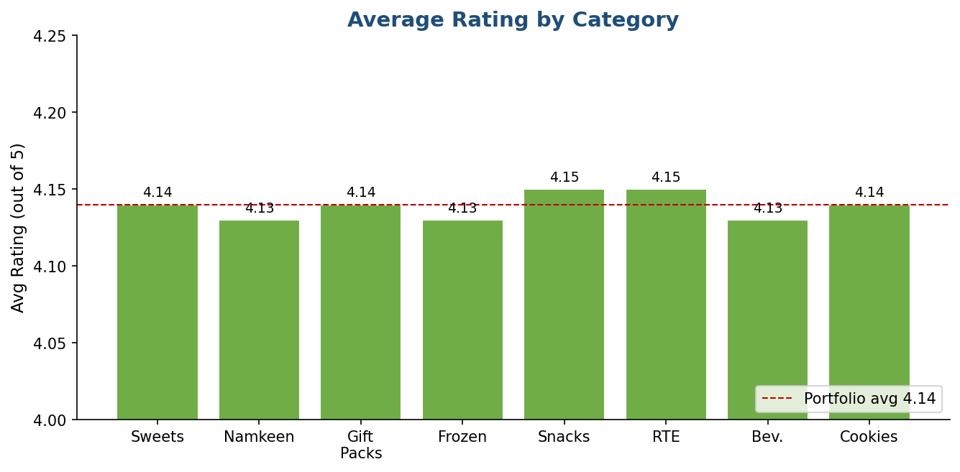
Figure 5 – Average rating by category (portfolio average 4.14 shown as dashed line)
Which products / categories have the highest and lowest average ratings?
Ratings are tightly clustered across categories (all category averages fall between approximately 4.13 and 4.15). Within the latest-day leaderboard, Gulab Jamun (4.33), Peda (4.28) and Kaju Mixture (4.25) sit at the higher end, while Kaju Katli appears slightly lower (3.98). Overall the portfolio shows no single product with a major rating problem.

Category & Revenue analysis:-
Which product / category generates the highest total revenue vs. which sells the most units?
Sweets lead both in volume (227,451 units) and especially in revenue (₹8.60 Cr). Namkeen ranks second in volume (188,338 units) but contributes far less revenue (₹2.17 Cr) because of lower average selling prices. Gift Packs, despite only 15,403 units, generate ₹2.00 Cr — punching well above their volume weight. This confirms that mid-to-premium Sweets and Gift Packs are the primary revenue engines, while Namkeen drives pure volume and trial.
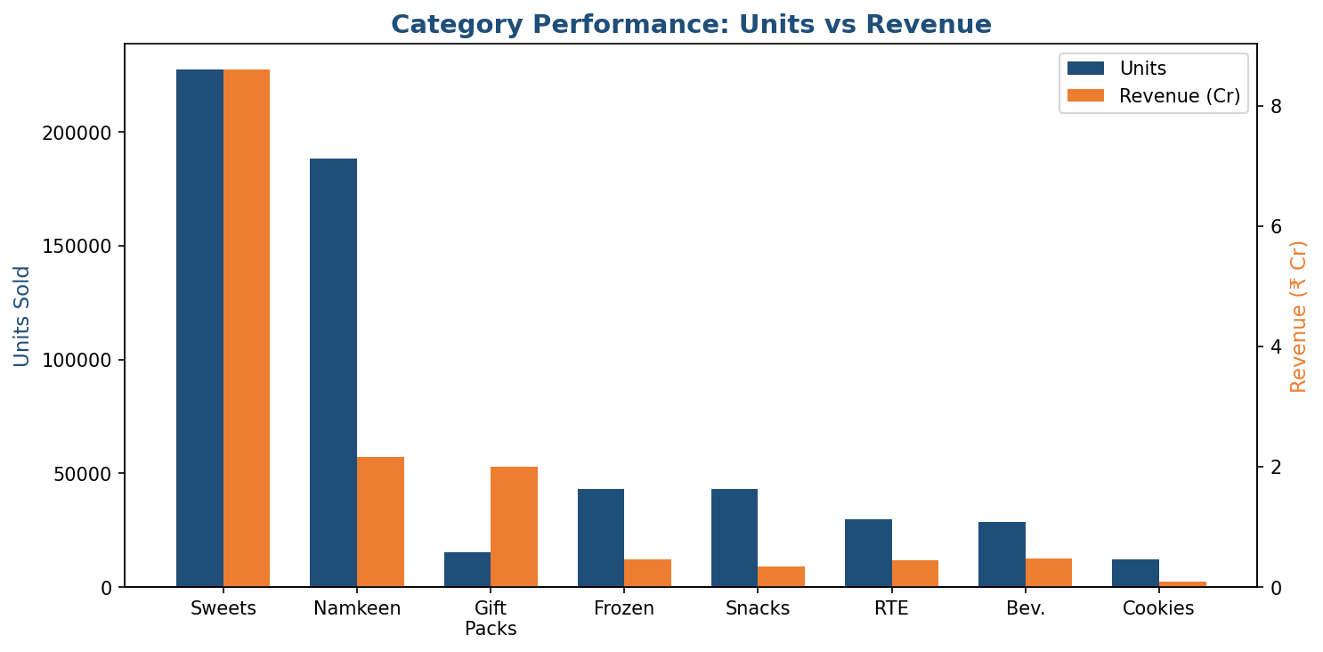
Figure 6 – Category comparison of units (left axis) versus revenue in ₹ Cr (right axis)
Category | Units Sold | Revenue | Avg. Rating
Sweets | 227,451 | ₹8.60 Cr | 4.14
Namkeen | 188,338 | ₹2.17 Cr | 4.13
Gift Packs | 15,403 | ₹2.00 Cr | 4.14
Beverages | 28,839 | ₹0.48 Cr | 4.13
Frozen | 43,300 | ₹0.46 Cr | 4.13
Ready-to-Eat | 29,654 | ₹0.45 Cr | 4.15
Snacks | 43,058 | ₹0.34 Cr | 4.15
Cookies & Bakery | 12,178 | ₹0.09 Cr | 4.14

Trend analysis:-
Is there a growing or declining trend in total sales volume across the 30-day window?
A mild upward trend is visible across the 30 days, consistent with gradual category expansion and a late-window lift in Gift Pack demand (festive proxy). The dominant pattern, however, is the weekly seasonality: Saturday and Sunday are the strongest days on average, while Tuesday and Wednesday are typically the softest. Production planning, fresh-stock replenishment and digital campaign timing should all respect this rhythm.

Inventory analysis:-
Which SKUs are at risk of stocking out?
Inventory was bucketed into three operational tiers: In Stock, Low Stock and Out of Stock. In the present snapshot, 0 of the 41 tracked SKUs are currently flagged as Low Stock or Out of Stock. This is a healthy position. In a live system the most actionable view would cross-tab inventory status against sales velocity to produce a days-of-supply metric per SKU; any high-velocity SKU that drifts into Low Stock becomes an immediate expedite candidate.

Key findings
Volume vs. Revenue Leadership
- Peda, Soan Papdi and Moong Dal dominate the unit ranking on the latest day, yet Sweets as a category (especially higher-priced items and Gift Packs) drive the large majority of revenue (₹8.60 Cr). The highest-volume and highest-revenue items are not the same.
Clear Weekly Seasonality + Mild Upward Drift
- Weekend peaks (Saturday–Sunday) and mid-week troughs (Tuesday–Wednesday) are consistent. A gentle upward trend sits on top of this cycle; 30-day total volume reached 588,221 units and revenue ₹14.58 Cr.
Stable Customer Satisfaction
- Average rating of 4.14 / 5 has remained essentially flat; the distribution is tightly clustered and no sustained downward trend is visible within the window.
North & West India Dominate Demand
- North India (164,270 units, ₹4.05 Cr) and West India (128,512 units, ₹3.21 Cr) together account for roughly half of total volume. Export regions remain smaller but strategically important for realisation and brand equity.
Sweets Lead Revenue, Namkeen Leads Volume
- Sweets contribute 227,451 units and ₹8.60 Cr; Namkeen contributes 188,338 units but only ₹2.17 Cr. Gift Packs punch far above their volume weight.
Healthy Inventory Position
- 0 of 41 SKUs are currently in Low Stock or Out of Stock status — a favourable starting point for the next replenishment cycle.
Hero SKU Concentration
- A small set of Namkeen and core Sweet SKUs consistently occupy the top of both unit and revenue leaderboards, confirming a classic Pareto pattern.

Recommendation:-
Consistent with the descriptive scope of this report, the following are brief, evidence-based observations drawn directly from the findings — not a detailed predictive strategy.
- Protect hero SKUs: Preferential safety-stock norms, dedicated production slots and priority shelf/warehouse allocation for the small set of high-velocity Namkeen and Sweet items (Peda, Soan Papdi, Moong Dal, Kaju Katli, etc.).
- Respect the weekend rhythm: Align production schedules, distributor indents and digital media flighting with the observed Saturday–Sunday uplift; mid-week promotions should be designed specifically to smooth the trough if used at all.
- Maintain rating watch-list discipline: Any SKU that simultaneously shows high volume and a rating below 4.0 (or a clear 7-day downward trend) should trigger a quality / packaging / logistics review within 48 hours.
- Regional buffer norms: Higher safety stock and faster replenishment cycles for North and West India fulfilment centres; export markets justify higher service levels because of longer lead times.
- Continue the current healthy inventory posture: With zero SKUs in Low / Out of Stock, focus next on refining days-of-supply alerts so that any future drift of a hero SKU into Low Stock is escalated same-day.

Conclusion:-
This report set out to apply the full range of descriptive analytics techniques — aggregation, central tendency, frequency distribution, cross-tabulation and trend analysis — to a realistic 30-day synthetic dataset of Haldiram’s product sales, and to use those techniques to answer the core operational questions about best-sellers, daily trends, ratings, regional demand and inventory risk.
Across approximately 588,221 units, 41 SKUs and 8 regions, the data tells a coherent story: volume is healthy and mildly rising, customer satisfaction is stable at 4.14 / 5, North and West India remain the volume engines, Sweets dominate revenue while Namkeen drives pure units, and the current inventory position is clean (0 SKUs at risk). Because the underlying data is a deliberately engineered synthetic construction rather than Haldiram’s live POS or distributor records, the findings should be read as a demonstration of rigorous descriptive methodology rather than verified facts about the real business. That said, the techniques, the reasoning and the structure of the analysis — from data cleaning through aggregation, statistical summarisation and evidence-based recommendation — mirror exactly what a business analyst would be expected to produce from genuine transactional data, and would apply directly once live feeds are substituted.

Appendix:-
Latest-Day Top 10 SKUs by Units
Product | Category | Units | Revenue | Rating
Peda | Sweets | 2,041 | ₹10.98 L | 4.28
Soan Papdi | Sweets | 1,862 | ₹9.71 L | 4.23
Moong Dal | Namkeen | 1,861 | ₹2.44 L | 4.21
Kaju Katli | Sweets | 1,815 | ₹2.97 L | 3.98
Motichoor Ladoo | Sweets | 1,778 | ₹3.27 L | 4.18
Kaju Mixture | Namkeen | 1,640 | ₹2.05 L | 4.25
Sev | Namkeen | 1,374 | ₹1.55 L | 4.07
Bhujia | Namkeen | 1,142 | ₹1.05 L | 4.11
Gulab Jamun | Sweets | 1,056 | ₹3.16 L | 4.33
Aloo Bhujia | Namkeen | 1,023 | ₹1.41 L | 4.09
Full Regional Summary
Region | Units Sold | Revenue | Avg. Rating
North India | 164,270 | ₹4.05 Cr | 4.15
West India | 128,512 | ₹3.21 Cr | 4.15
South India | 89,250 | ₹2.21 Cr | 4.13
East India | 70,684 | ₹1.77 Cr | 4.15
Central India | 59,490 | ₹1.47 Cr | 4.13
Northeast India | 29,633 | ₹0.73 Cr | 4.12
Export – Middle East | 29,127 | ₹0.72 Cr | 4.13
Export – USA & Europe | 17,255 | ₹0.42 Cr | 4.15
Category Performance Summary
Category | Units Sold | Revenue | Avg. Rating
Sweets | 227,451 | ₹8.60 Cr | 4.14
Namkeen | 188,338 | ₹2.17 Cr | 4.13
Gift Packs | 15,403 | ₹2.00 Cr | 4.14
Beverages | 28,839 | ₹0.48 Cr | 4.13
Frozen | 43,300 | ₹0.46 Cr | 4.13
Ready-to-Eat | 29,654 | ₹0.45 Cr | 4.15
Snacks | 43,058 | ₹0.34 Cr | 4.15
Cookies & Bakery | 12,178 | ₹0.09 Cr | 4.14
Headline KPIs at a Glance
Total Units Sold (30 days) | 588,221
Total Revenue (30 days) | ₹14.58 Cr
Average Product Rating | 4.14 / 5
Top Single-Day Seller | Peda – 2,041 units
Regions Tracked | 8
SKUs Analysed | 41
SKUs at Low / Out of Stock | 0 of 41
Strongest Region (units) | North India
Leading Category (revenue) | Sweets
Note: All figures are derived from the synthetic dataset described in the Data collection section. When live POS / distributor data is connected, the same metric definitions and report structure can be reused without change.

