III Semester B.Tech., (CSE)

Data Analytics – CES2103

Internal Assessment- Mini Project Report
School of Computer Engineering
Manipal Institute of Technology, MAHE
on
“To analyse how patient attributes are associated with heart disease using exploratory data analysis and statistical tests.”
Submitted by:
Group No: 7 | Section: I
Name: Spandan Shetty
Roll No: 21
Registration Number: 251090050998
Section: I
Branch: CSE
Name: Adarsh S P
Roll No: 7
Registration Number: 251090050196
Section: I
Branch: CSE
Name: Siddharth Hari
Roll No: 8
Registration Number: 251090050231
Section: I
Branch: CSE
26 October 2026

Table of Contents
1. Introduction 3
2. Objectives 3
3. Problem Statement 3
4. Literature Review / Background Study 3
5. Methodology 4
5.1 Data Collection 4
5.2 Tools and Technologies Used 4
6. Implementation / Experimentation 5
7. Results and Discussion 8
7.1 Five main statistical tests 8
7.2 Cholesterol missingness 8
8. Conclusion and Future Work 9
9. Team Member’s Contribution 9
10. References 9
11. Appendix 10
The report follows the supplied MIT template. Page numbers refer to the complete report, including the cover and contents pages.

1. Introduction
This project examines associations between recorded patient attributes and a heart-disease label through exploratory data analysis (EDA) and statistical tests. The supplied data contain 918 records. The five selected comparisons identify differences in the outcome groups, while the missingness check reveals a limitation in cholesterol recording. The outcome does not specifically identify heart attacks, and the findings do not establish causes or provide an individual diagnosis.

2. Objectives
• Check data types, duplicates, missing entries and unusual values, and document preprocessing decisions.
• Describe outcome counts, numeric distributions, category percentages and correlations using EDA charts.
• Use three chi-square tests and two Welch t-tests to assess selected patterns, and check cholesterol missingness separately.

3. Problem Statement
To analyse how patient attributes are associated with heart disease using exploratory data analysis and statistical tests.
We compare attributes across HeartDisease = 0 and HeartDisease = 1 and assess whether the observed group patterns are compatible with the corresponding null hypotheses. The scope is exploratory analysis of the supplied sample.

4. Literature Review / Background Study
Detrano et al. [2] studied the use of clinical findings in coronary artery disease assessment across populations. Their work provides background for examining several recorded attributes, while also showing the importance of the setting in which data are collected.
Diamond and Forrester [3] examined how clinical information can inform disease probability. This motivates our descriptive comparisons of age and chest-pain categories; we do not reproduce their clinical assessment method.
Gianrossi et al. [4] reviewed exercise-induced ST depression and found substantial variation in diagnostic accuracy across studies. Their review gives context for examining Oldpeak and ST-slope, without treating these attributes as individually decisive.
Li et al. [5] compared missing-data methods using a cardiovascular cohort. Their work motivates explicit attention to recording quality. Here, cholesterol zeros remain missing, and we describe the measured subset with a clear limitation. These four papers provide background; our calculations use the separate combined dataset [1].

5. Methodology

5.1 Data Collection
The supplied heart.csv matches Federico Soriano’s Heart Failure Prediction Dataset on Kaggle [1]: 918 rows, 11 attributes and one binary outcome. Earlier heart-disease data are documented by UCI [6]. We use the supplied file unchanged and retain all rows. This combined sample is not established as a random sample of the general population.
Check | Observed | Handling
Blank cells / duplicates | 0 / 0 | No rows removed
RestingBP = 0 | 1 record | Replace with nonzero median, 130 mm Hg
Cholesterol = 0 | 172 records (18.7%) | Mark missing; retain all records
IQR screen / Oldpeak < 0 | 68 values / 13 records | Retain; not established as errors

Zero cholesterol is treated as an unavailable measurement. We do not fill these values using the outcome label, because doing so would use the outcome to construct the data being compared. Cholesterol summaries cover 746 measured records. The IQR screen flags values across five columns, not necessarily 68 distinct records.
Columns | Recorded meaning
Age; Sex | Age in years; F = female, M = male
ChestPainType | TA typical angina; ATA atypical angina; NAP non-anginal pain; ASY asymptomatic
RestingBP; Cholesterol | Resting blood pressure (mm Hg); serum cholesterol (mg/dL)
FastingBS; RestingECG | Fasting sugar >120 mg/dL indicator; ECG category Normal, ST or LVH
MaxHR; ExerciseAngina | Maximum heart rate; exercise-induced angina Y/N
Oldpeak; ST_Slope | Exercise ST depression relative to rest; ST-segment slope Up, Flat or Down
HeartDisease | Recorded outcome: 0 = absent, 1 = present

5.2 Tools and Technologies Used
The project uses Python 3.12 and Jupyter Notebook. pandas and NumPy support data preparation; Matplotlib and Seaborn produce charts; SciPy supplies the statistical tests; IPython displays the tables. requirements.txt records the tested package versions. The notebook reads heart.csv using a relative path.

6. Implementation / Experimentation
The notebook loads the CSV, checks and cleans measurements, produces EDA charts, runs the five main tests and then checks cholesterol missingness. Figures 1–7 reproduce the same data preparation and summaries, with related charts arranged as panels for readability.
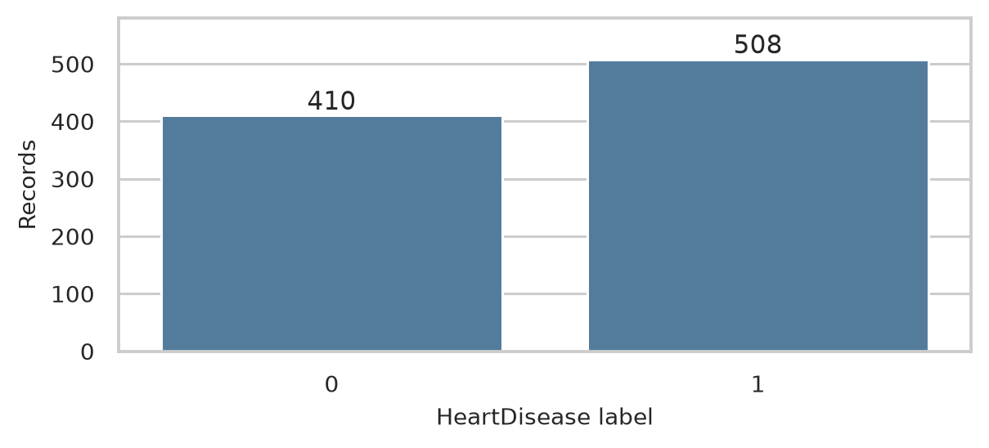
Figure 1. Outcome counts in the supplied dataset.
There are 410 records labelled 0 and 508 labelled 1 (55.3% of all records). These are sample counts, not an estimate of population disease prevalence.
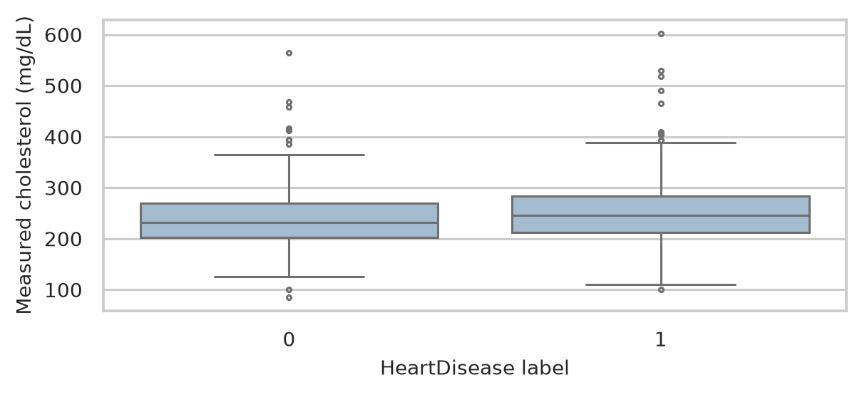
Figure 2. Cholesterol among measured records only.
Measured cholesterol has medians of 231.5 mg/dL for label 0 and 246.0 mg/dL for label 1. This plot includes 390 and 356 records, respectively; unequal missingness limits conclusions about the full dataset.

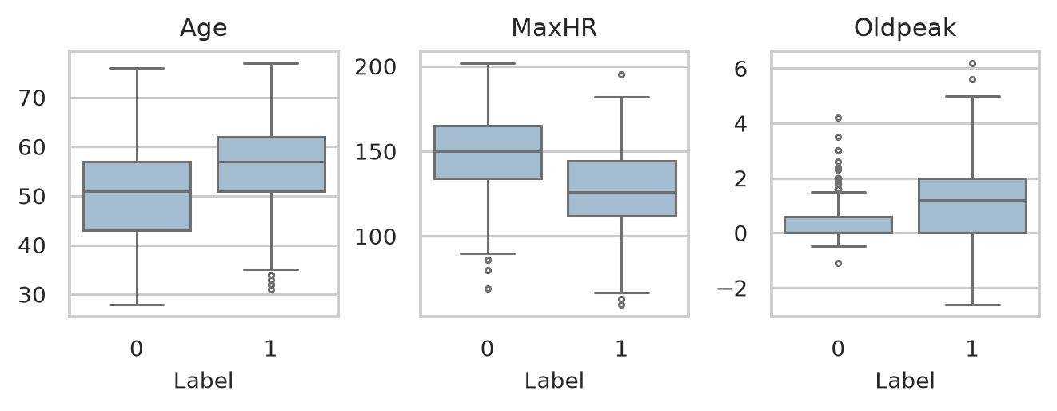
Figure 3. Age, maximum heart rate and Oldpeak by outcome label.
The label-1 group has higher mean age (55.90 vs 50.55 years), lower mean MaxHR (127.66 vs 148.15) and higher mean Oldpeak (1.27 vs 0.41). The distributions overlap. Oldpeak is described in EDA and is not one of the five main tests.
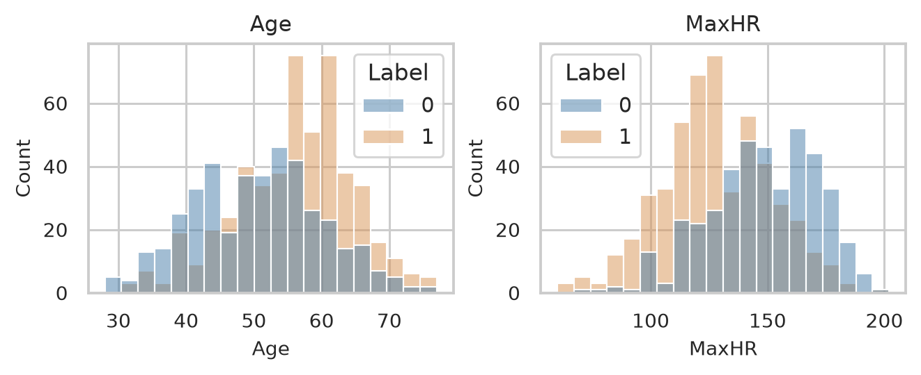
Figure 4. Age and MaxHR distributions by outcome label.
The histograms show how each variable is distributed within the two groups. Their overlap reinforces that group differences do not identify an individual record’s outcome.
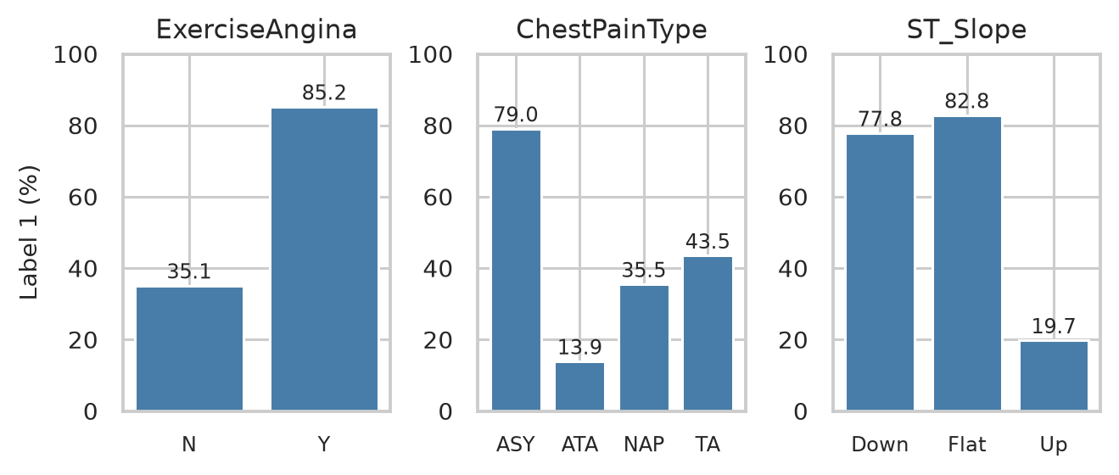
Figure 5. Within-category percentage with HeartDisease = 1.
ExerciseAngina = Y has an 85.2% label-1 rate versus 35.1% for N. ASY chest pain has 79.0% versus 13.9% for ATA. Flat ST-slope has 82.8% versus 19.7% for Up. Each percentage uses the count in that category as its denominator.

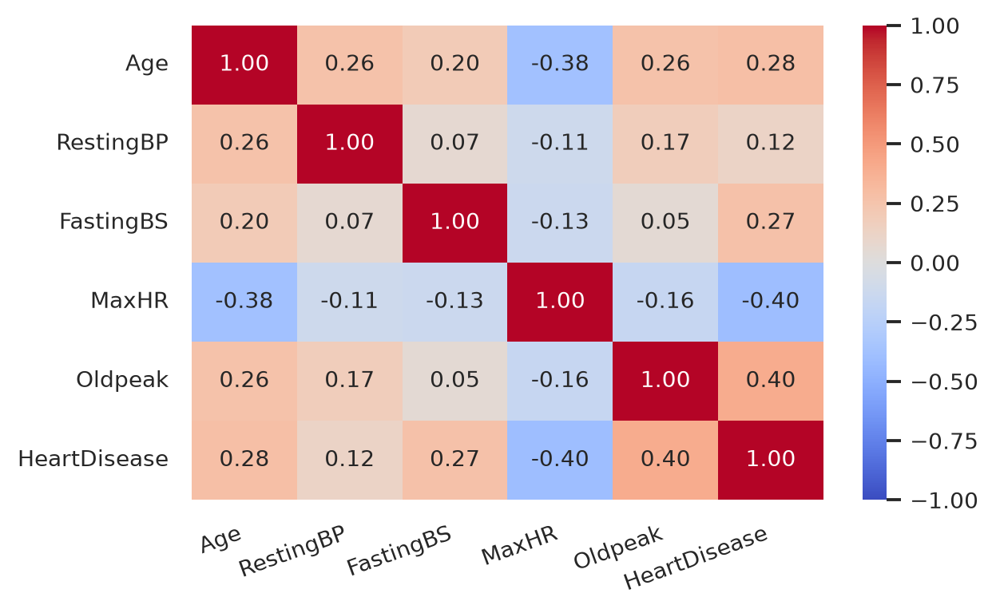
Figure 6. Correlation heatmap for the selected numeric columns.
The heatmap describes pairwise linear relationships, including the binary FastingBS and HeartDisease variables. MaxHR is negatively correlated with the outcome, while Oldpeak is positively correlated. Cholesterol is excluded because of its missing readings. These correlations do not establish causes or independent effects.
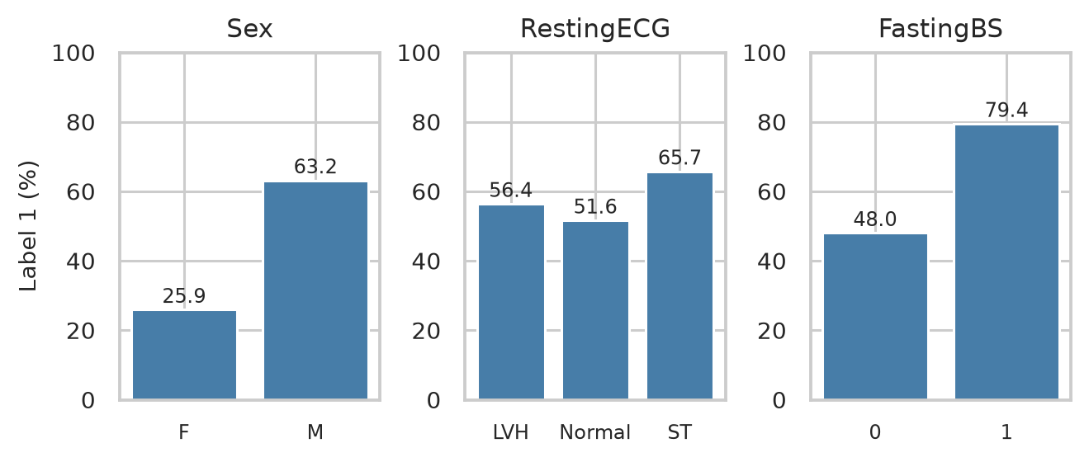
Figure 7. Outcome percentages within Sex, RestingECG and FastingBS categories.
Male records form 725/918 (79.0%) of the sample; their label-1 rate is 63.2% versus 25.9% for female records. The rate is 79.4% for FastingBS = 1 versus 48.0% for 0. RestingECG rates are 56.4% for LVH, 51.6% for Normal and 65.7% for ST. These are descriptive comparisons.

7. Results and Discussion

7.1 Five main statistical tests
For each categorical attribute, H0 states independence from HeartDisease and H1 states an association. For each numerical attribute, H0 states equal group means and H1 states different means. We use a 5% significance level and two-sided Welch t-tests. All five comparisons reject H0 at this level.
Attribute | Test | Statistic | p-value
ExerciseAngina | Chi-square, df = 1 | 222.26 | 2.91e-50
ChestPainType | Chi-square, df = 3 | 268.07 | 8.08e-58
ST_Slope | Chi-square, df = 2 | 355.92 | 5.17e-78
MaxHR | Welch t | 13.23 | 1.43e-36
Age | Welch t | -8.82 | 6.35e-18

The chi-square tests support associations for exercise angina, chest-pain type and ST-slope. Welch tests support lower mean MaxHR and higher mean age in the label-1 group. The t statistics use label 0 minus label 1. They do not measure an attribute’s independent contribution.
The chi-square calculations apply SciPy’s continuity correction to 2-by-2 tables. The smallest expected counts for ExerciseAngina, ChestPainType and ST_Slope are 165.7, 20.5 and 28.1, all above 5. Welch tests allow unequal variances. Independent records are assumed; this cannot be verified from the CSV alone. Because EDA guided the questions, these separate p-values should be read as exploratory evidence.

7.2 Cholesterol missingness
HeartDisease | Measured | Missing | Missing (%)
0 | 390 | 20 | 4.9
1 | 356 | 152 | 29.9

A separate chi-square test checks H0: missingness is independent of the outcome. It gives chi-square = 91.82, df = 1 and p = 9.50e-22, with a smallest expected count of 76.8. The result supports an association between recording availability and the label.
This result concerns missingness, not cholesterol concentration. It does not explain why readings are missing or show whether the unobserved readings are high or low. The measured medians in Figure 2 therefore describe only the observed subset. No cholesterol measurement test is included, and the missing values are not filled using the outcome label.

8. Conclusion and Future Work
The objectives were met through documented preprocessing, EDA and five selected statistical comparisons. Exercise angina, chest-pain type and ST-slope are associated with the recorded outcome, and mean age and MaxHR differ between groups. Uneven cholesterol missingness limits interpretation of its measured subset. These findings describe this sample and do not establish causation, independent effects or a clinical diagnosis.
Future work could trace missing readings to the original sources, assess whether records are independent, and repeat prespecified comparisons in an independent dataset. Better recording provenance would help explain the cholesterol missingness pattern.

9. Team Member’s Contribution
Team member | Contribution
Spandan Shetty
Adarsh S P
Siddharth Hari

10. References
[1] F. Soriano, “Heart Failure Prediction Dataset,” Kaggle. https://www.kaggle.com/datasets/fedesoriano/heart-failure-prediction (accessed 26 October 2026).
[2] R. Detrano et al., “International application of a new probability algorithm for the diagnosis of coronary artery disease,” American Journal of Cardiology, 1989. https://pubmed.ncbi.nlm.nih.gov/2756873/.
[3] G. A. Diamond and J. S. Forrester, “Analysis of probability as an aid in the clinical diagnosis of coronary-artery disease,” New England Journal of Medicine, 1979. https://pubmed.ncbi.nlm.nih.gov/440357/.
[4] R. Gianrossi et al., “Exercise-induced ST depression in the diagnosis of coronary artery disease: a meta-analysis,” Circulation, 1989. https://doi.org/10.1161/01.cir.80.1.87.
[5] J. Li et al., “Comparison of the effects of imputation methods for missing data in predictive modelling of cohort study datasets,” BMC Medical Research Methodology, vol. 24, article 41, 2024. https://doi.org/10.1186/s12874-024-02173-x.
[6] UCI Machine Learning Repository, “Heart Disease.” https://archive.ics.uci.edu/dataset/45/heart+disease (accessed 26 October 2026).

11. Appendix
The accompanying analysis is Heart_Disease_Analysis.ipynb, with heart.csv as its unchanged input. The notebook includes data checks, preprocessing, all EDA plots, the five main tests and the separate cholesterol missingness test. It was executed from first cell to last, with all 14 code cells completing without errors and their outputs saved.
Public project repository:
https://github.com/adarshsp18/heart-disease-data-analytics-group7
Reproduction steps
1. Place heart.csv beside Heart_Disease_Analysis.ipynb.
2. Create and activate a Python 3.12 virtual environment.
3. Run python -m pip install -r requirements.txt.
4. Run python -m notebook Heart_Disease_Analysis.ipynb.
5. Restart the notebook kernel, run all cells in order and save.
Submission files
File | Purpose
Heart_Disease_Analysis.ipynb | Notebook with code, interpretations and saved outputs
heart.csv | Unchanged input dataset
Team_07.pdf | Report for LMS submission
Team_07.docx | Editable report for completing contribution fields
README.md; requirements.txt | Project overview and environment setup

The three contribution fields in Section 9 are intentionally blank. Team members are listed in the README; GitHub collaborator invitations are managed separately by the repository owner.

