
Tribhuvan University
Faculty of Humanities and Social Sciences

“ Designly”
GRAPHIC DESIGN MANEMENT SYSTEM

A PROJECT REPORT

Submitted to
Department of Computer Application Divya Gyan College
Kamaladi mod, Kathmandu, Nepal

In partial fulfillment of the requirements for the Bachelors in Computer Application

Submitted by
Adarsh Tamang Symbol no: 75102125
June 2025

Under the Supervision of
Er. Shirish Timilsina

Tribhuvan University
Faculty of Humanities and Social Sciences Divya Gyan College

SUPERVISOR’S RECOMMENDATION

I hereby recommend that this project prepared under my supervision by Mr. Adarsh Tamang (Exam Roll no: 75102125) entitled “Designly” in partial fulfilment of the requirements of BCA VIth (Project-II) for the degree of Bachelor of Computer Application is recommended for the final evaluation.

…………………

SIGNATURE
Er. Shirish Timilsina
SUPERVISOR
Project Coordinator Department of IT Divya Gyan College
Kamaladi Mod, Kathmandu

Tribhuvan University
Faculty of Humanities and Social Sciences Divya Gyan College

LETTER OF APPROVAL

This is to certify that this project prepared by Mr. Adarsh Tamang (Exam Roll no: 75102125) entitled “Designly” in partial fulfillment of the requirements for the degree of BCA VIth (Project-II) has been evaluated. In our opinion it is satisfactory in the scope and quality as a project for the required degree.

SIGNATURE of Supervisor  …………………………………..  Er. Shirish Timilsina  Supervisor  Department of IT  Divya Gyan College  Kamaladi Mod, Kathmandu | SIGNATURE of HOD/Coordinator  …………………  Mr. Rabindra Poudel  Coordinator  Divya Gyan College  Kamaladi Mod, Kathmandu
SIGNATURE of Internal Examiner  …………………  Er. Shirish Timilsina  Divya Gyan College  Kamaladi Mod, Kathmandu | SIGNATURE of External Examiner  …………………

acknowlement
I would like to express my sincere gratitude to everyone who continuously supported and motivated me throughout the completion of this project. Their encouragement played a vital role in helping me stay focused and committed to my work.
I am deeply thankful to Divya Gyan College for providing me with this valuable opportunity. I would especially like to acknowledge the teachers of my college for their guidance, support, and efforts in enhancing my knowledge in this field. Their teachings and encouragement gave me the confidence to apply what I learned and showcase my skills through this project.
I would like to convey my special thanks to my project supervisor, Er. Shirish Timilsina, whose constant guidance, motivation, and vast knowledge were extremely helpful at every stage of this project. His advice and support helped me overcome challenges and successfully complete my work. I feel truly fortunate to have had such a supportive supervisor and mentor. I am also grateful to Thomas Basyal, Bibek Aryal, and Shailendra Basnet for their valuable suggestions and constructive feedback.
I would also like to thank my classmates for their cooperation, shared experiences, and helpful suggestions throughout the project period. Their support made the journey more meaningful and enjoyable.
Finally, I would like to express my heartfelt thanks to my friends for their constant encouragement and support. Their presence and motivation meant a lot to me during the completion of this project.
Adarsh Tamang

ABSTRACT

Designly is an intuitive and versatile design platform that empowers users to create stunning visuals, graphics, and marketing materials with ease. With Designly, users can drag and drop elements, add shapes, text, and images, and customize designs using a rich library of templates. Designly’s advanced features include AI-powered image generation, background removal, and the ability to create professional-quality logos, posters, social media graphics in minutes.
The platform supports seamless content creation by enabling auto-save, editing, and exporting designs in multiple formats. By combining ease of use with powerful design tools, Designly makes creative expression accessible to everyone, from beginners to professionals. Whether users want to build a logo, design a marketing campaign, generate unique AI images, or craft visually compelling social media content, Designly provides the tools and flexibility to turn ideas into polished visuals quickly.
Its user-friendly interface, extensive customization options make Designly a comprehensive solution for modern design needs, helping individuals and businesses elevate their visual communication and streamline the creative process. With Designly, creating professional, high-quality designs has never been faster, easier, or more engaging.

Keywords :Designly ,AI, Logo ,Social Media, Create, User-friendly, Customize, Drag and Drop, Shapes, Text, Background Removal, Auto-save

TABLE OF CONTENT
SUPERVISOR’S RECOMMENDATION I
LETTER OF APPROVAL II
ACKNOWLEDGEMENT III
ABSTRACT IV
TABLE OF CONTENT V
TABLE OF FIGURES VII
LIST OF TABLES VIII
LIST OF ARREVIATIONS IX
CHAPTER 1: INTRODUCTION 1
  - Introduction 1
  - Problem Statement 1
  - Objectives 1
  - Project Scope and Limitations: 1
    - Scope of the System: 1
    - Limitations of the System: 2
  - Development Methodology 2
  - Report Organization: 2
CHAPTER 2: BACKGROUND STUDY AND LITERATURE REVIEW 3
  - Background Study 3
  - Literature Review 3
CHAPTER 3: SYSTEM ANALYSIS AND DESIGN 5
  - System Analysis: 5
    - Requirement Analysis 5
    - Feasibility Study: 6
    - Object Modeling: 8
    - Dynamic Modeling: 9
3.15 Process Modeling: 11
  - System Design: 12
    - Refinement of Classes and Objects: 12
    - Component Diagram 12
    - Deployment Diagram 13
  - Algorithm Details: 13
    - Collaborative Filtering: 13
    - Fuzzy Search: 15
    - Inverted Index Filtering: 18
    - LRU Caching: 20
CHAPTER 4: IMPLEMENTATION AND TESTING 22
  - Implementation: 22
    - Tools Used: 22
    - Languages Used: 22
    - Implementing Details of Modules 23
  - Testing: 23
    - Test Case for Unit Testing: 23
    - Test Case for System Testing: 25
CHAPTER 5: CONCLUSIOG AND FUTURE RECOMMENDATION 27
  - Outcome: 27
  - Conclusion: 27
  - Future Recommendation: 27
APPENDICES 28
REFERENCES 31

TABLE OF FIGURES
Figure 3- 1 Use Case Diagram of Designly 5
Figure 3- 2 Gantt Chart of Designly 7
Figure 3- 3 Class Diagram of Designly 8
Figure 3- 4 Object Diagram of Designly 8
Figure 3- 5 State Diagram of Designly 9
Figure 3- 6 Sequence Diagram of Designly 10
Figure 3- 7 Activity Diagram of Designly 11
Figure 3- 8 Refined Class Diagram of Designly 12
Figure 3- 9 Component Diagram of Designly 12
Figure 3- 10 Deployment Diagram of Designly 13

LIST OF TABLES
Table 4-1 Tools Used 22
Table 4-2 Languages Used 22
Table 4-3 Test Case for Login Module 23
Table 4-4 Test Case for Add Recipe Module 23
Table 4-5 Test Case for Ingredients Filter Module 24
Table 4-6 Test Case for View Recipe Module 24
Table 4-7 Test Case for System Testing 25

LIST OF ARREVIATIONS

AI | Artificial Intelligence
API | Application Programming Interface
CSS | Cascading Style Sheet
HTML | Hyper Text Markup Language
JS | Java Script
LRU | Least Recently Used
TTL | Time To Live

CHAPTER 1: INTRODUCTION

Introduction
Designly is a modern, web-based graphic design application developed to simplify the process of creating visual content. The platform is inspired by popular design tools such as Canva and is designed to provide an intuitive, drag-and-drop interface for users to create professional-quality designs with ease.The application allows users to sign in securely using Google authentication and work on a dynamic canvas where they can add, edit, and arrange shapes, text, images, and templates. Designly supports essential design features such as customizable colors, fonts, layouts, and templates, making it suitable for both beginners and intermediate users.To enhance productivity.

Problem Statement
- In the current digital era, creating visual designs has become an essential requirement for students, professionals, and content creators. However, many available graphic design applications are either complex to use, require advanced design skills, or depend on expensive subscription models. This creates a barrier for beginners and students who need a simple, affordable, and easy-to-use platform for designing posters, presentations, social media graphics, and other visual content.

Objectives
- To develop a user-friendly web-based design application that allows users to create, edit, and customize visual content using drag-and-drop tools, templates, and real-time auto-save functionality.
- To integrate AI-powered features such as image generation and background removal, along with support for exporting designs in multiple formats including PNG, JPG, SVG, and JSON.

Project Scope and Limitations:

Scope of the System:
      - Provides a web-based design platform with drag-and-drop canvas functionality.
      - Supports Google sign-in,templates,text,shapes, and color customization.
      - Integrates AI features such as image generation and background removal.
      - Allow exporting designs in multiple formats including PNG,JPG,SVG and JSON

Limitations of the System:
      - Requires a stable internet connection as it is a web-based application.
      - AI features may have accuracy and performance limitations.
      - Does not support advanced professional features like animations or 2D designs.

Development Methodology
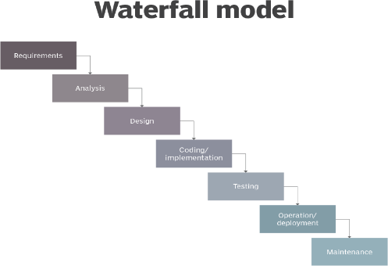
The framework I will be using for developing this project is waterfall model. The waterfall methodology is a project management approach that emphasizes a linear progression from beginning to end a project. Waterfall model was used since the requirements of the system were clear and confined. There was no chance of adding new functionalities in the system.

Report Organization:
- Chapter 1: “Introduction” – In this chapter, I have introduced the problem statement, Objectives, Development Methodology and the scopes of the project.
- Chapter 2: “Background Study and Literature Review” – In this chapter, I have described about the background of the study and literature reviews done.
- Chapter 3: “System Design” – In this chapter, I have described about the functional and non-functional requirements, and system feasibility.
- Chapter 4: “Implementation and Testing” – In this chapter, I have illustrated the methods and tools used to implement the project.
- Chapter 5: “Conclusion and Future Works” – In this concluding chapter, I have successfully completed the project and discussed our future test

CHAPTER 2: BACKGROUND STUDY AND LITERATURE REVIEW

Background Study
Graphic design has become an essential skill in the digital era, with applications ranging from social media content creation to academic projects, marketing, and professional presentations. Traditional design software, such as Adobe Photoshop and Illustrator, offers advanced features but often requires extensive training and comes with high costs, making them less accessible for beginners and students.
Recent trends in web development have led to the emergence of online graphic design platforms like Canva, Figma, and Crello. These platforms focus on simplicity, templates, drag-and-drop interfaces, enabling users to create professional designs without deep technical knowledge. Additionally, the integration of AI technologies in design tools has introduced capabilities such as automated image generation, background removal, further improving user efficiency and creativity.

Literature Review
Over the past decade, the demand for easy-to-use graphic design tools has increased significantly due to the growing need for visual content in education, marketing, and social media. Traditional desktop-based design software such as Adobe Photoshop and Illustrator offers extensive features but often requires substantial training and financial investment, limiting accessibility for students and casual users [1].
During this time, web-based platforms like Canva, Figma, and Crello emerged, providing intuitive drag-and-drop interfaces and pre-designed templates, enabling non-experts to create professional-quality visuals efficiently [2].

Recent research has focused on integrating artificial intelligence into design tools to enhance creativity and productivity. AI-driven features, such as automated image generation, background removal, and content-aware editing, allow users to quickly modify visuals without needing advanced design skills [3]
Despite the advancements in AI-assisted design, challenges remain in terms of user interaction, workflow efficiency, and export flexibility. Many existing tools are optimized for a single output format, requiring users to rely on external applications to convert designs into multiple formats such as SVG, PNG, JPG, or JSON [4]
Furthermore, research indicates that real-time collaborative editing and auto-save features greatly improve user experience and reduce data loss, yet they are not universally implemented across all platforms [5].

CHAPTER 3: SYSTEM ANALYSIS AND DESIGN

System Analysis:
The Analysis of the system is done by conducting requirement analysis, feasibility analysis, data modeling and process modeling as follows:

Requirement Analysis:
The requirement analysis of Designly is done through finding the functional and non- functional requirements.
      - Functional Requirements:
Functional requirements define what the system does or must do. The
functional requirement contains the following:

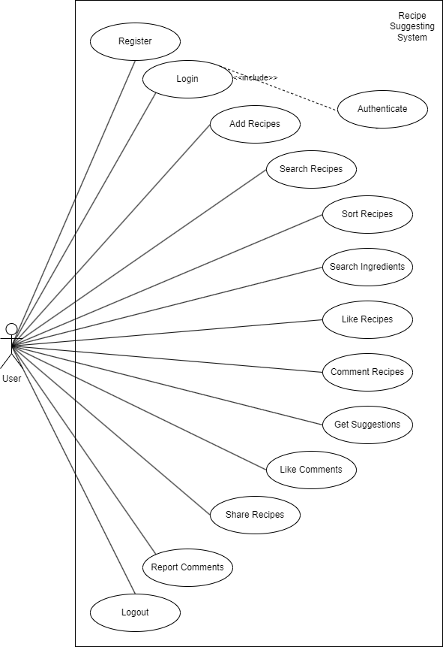
Figure 3- 1 Use Case Diagram of Designly
      - Non Functional Requirements:
Performance Requirement:

        - The user shall be able to login into the System

Usability Requirement:

        - The User shall be able to use the system in easy manner

Availability Requirement:

        - The System is available 100% of the user and used 24hrs a day and 365 days a year
        - The System shall be operational 24hrs a day and 7 days a week

Environmental Requirement:

        - The system shall require a localhost server and a web browser to run successfully

Compatibility Requirement:

        - The system shall be compatible across all platforms under required environment

Security Requirement:

        - The user password shall be stored in encrypted format in the database
        - Every user shall have a unique Session while logging into the system

Feasibility Study:
      - Technical Feasibility:
This project can be easily created using the languages such as Next.JS and MongoDB. Since all these languages can be run on all modern system. It can be run on any device that supports a web browser. So, it can be considered Technically Feasible.
      - Operational Feasibility:
This project prioritizes user-friendly design, ensuring effortless operation without extensive training or technical expertise. It uses plain language to avoid confusion and ensure understanding. Most users can become proficient within minutes, significantly reducing training time and costs.
      - Economic Feasibility:
This project offers significant cost savings compared to traditional solutions. By running on local machines, it eliminates the need for expensive servers. Additionally, lightweight design minimizes resource requirements, reducing ongoing maintenance and licensing fees.
      - Schedule Feasibility:
Here is the Gantt chart showing the probability of the project to be completed within its scheduled time limits, by a planned due date.
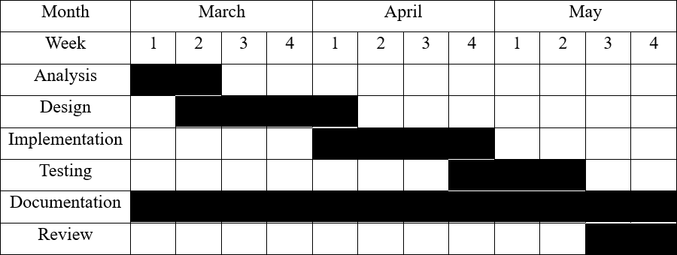

Figure 3- 2 Gantt Chart of Designly

Object Modeling:

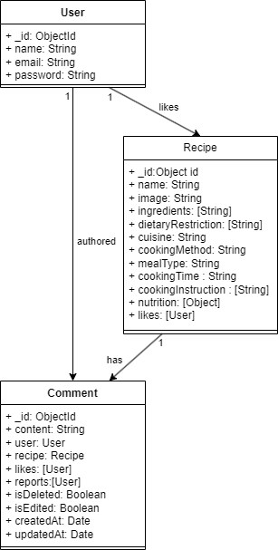
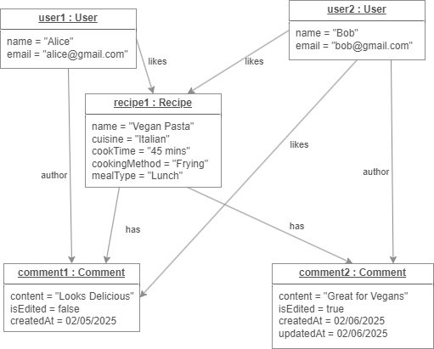
Figure 3- 3 Class Diagram of Kitchen Genie

Figure 3- 4 Object Diagram of Designly

Dynamic Modeling:
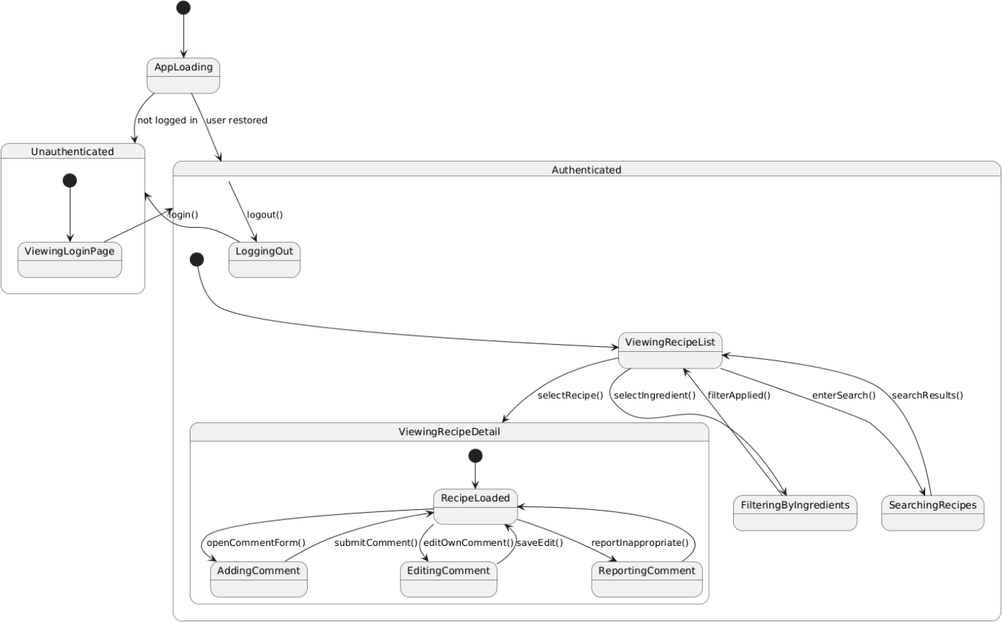

Figure 3- 5 State Diagram of designly
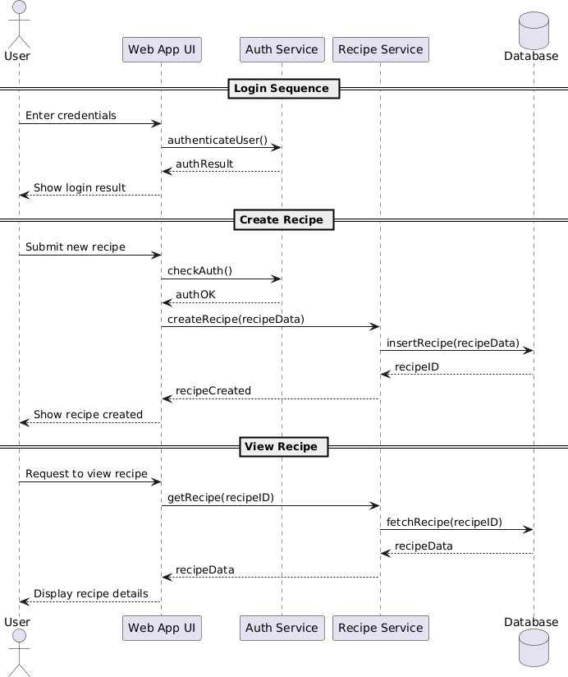
Figure 3- 6 Sequence Diagram of designly

3.15 Process Modeling:
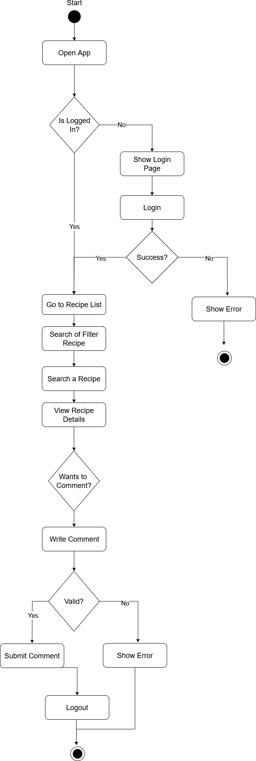

Figure 3- 7 Activity Diagram of designly

System Design:

Refinement of Classes and Objects:

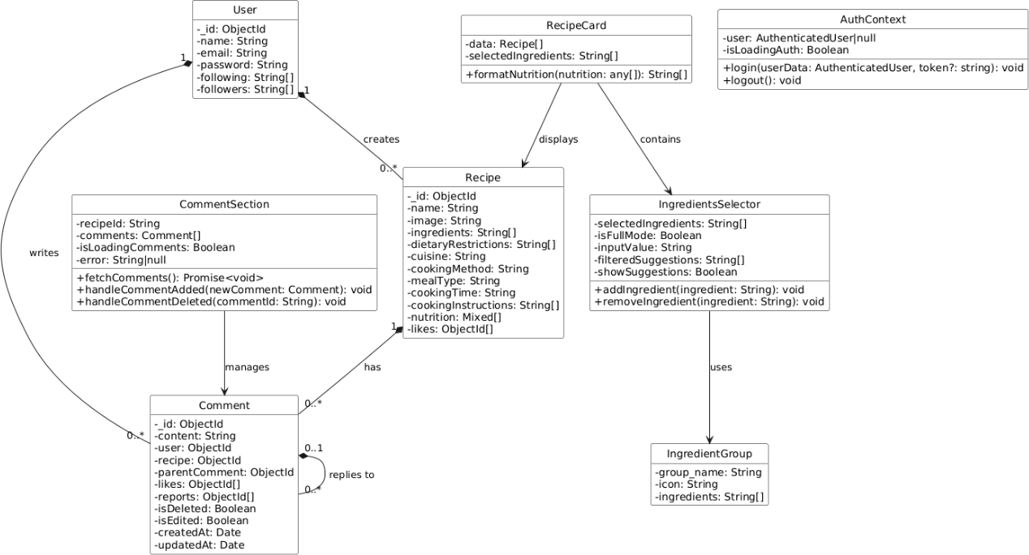
Figure 3- 8 Refined Class Diagram of designly

Component Diagram
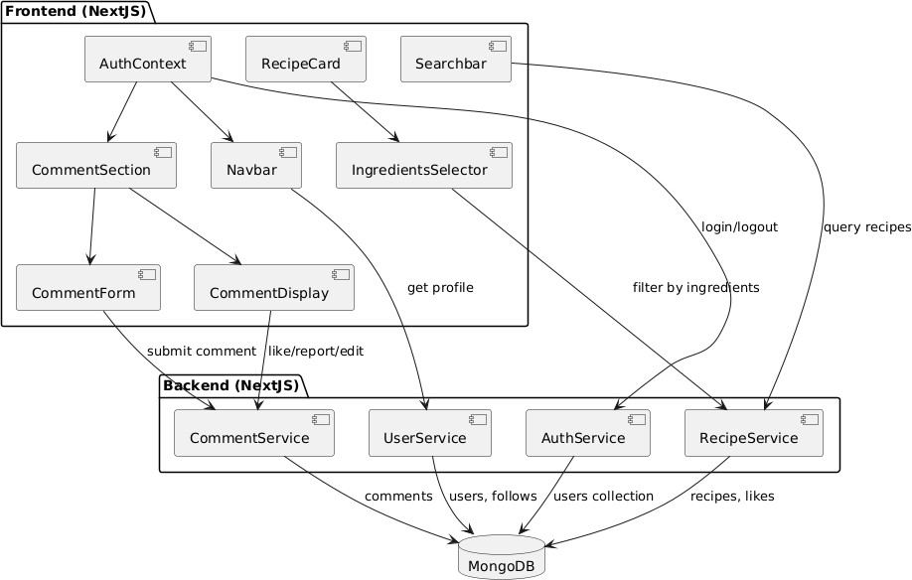

Figure 3- 9 Component Diagram of Kitchen Genie

Deployment Diagram
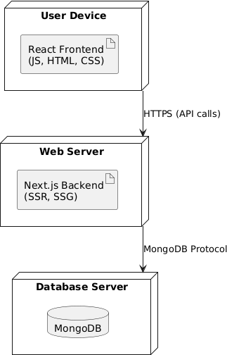

Figure 3- 10 Deployment Diagram of Kitchen Genie

Algorithm Details:

Collaborative Filtering:
The Collaborative Filtering algorithm provides personalized recipe recommendations to users. Its goal is to answer the question: "What other recipes would a user like, based on the behavior of other users with similar tastes?". This algorithm powers the "You Might Also Like" section on the recipe details page, offering suggestions that are not strictly based on content but on community behavior, leading to more serendipitous discovery.

How It Works
The algorithm is implemented as a multi-stage aggregation pipeline in MongoDB, which makes it highly efficient. The process is as follows:
- Identify Similar Users: When a user is viewing a recipe, the system first identifies all other users who have also "liked" that same recipe. This group of users is considered to have similar tastes.
- Aggregate Liked Recipes: The algorithm then gathers a complete list of *all other* unique recipes that this group of "similar users" has liked. The original recipe is excluded from this list.
- Score and Rank: Each of these potential recommendations is scored based on how many users from the "similar" group have liked it. The more likes a recipe has from this group, the higher its `recommendationScore`.
- Sort and Limit: The list is then sorted in descending order based on the
`recommendationScore`, and the top 5 results are returned to be displayed to the user.

Formulas Used:

  - User Similarity Calculation: For a target recipe `r` and user `u`, the set of similar users `S(u, r)` is defined as:
S(u, r) = {v ∈ U | v ≠ u ∧ r ∈ L(v)}
Where:
    - `U` is the set of all users
    - `L(v)` is the set of recipes liked by user `v`
    - `r ∈ L(v)` means user `v` has liked recipe `r`
  - Recipe Recommendation Scoring: For each candidate recipe `c` that is not the target recipe `r`, the recommendation score is calculated as:
recommendationScore(c, r, u) = |{v ∈ S(u, r) | c ∈ L(v)}|
This represents the number of users in the similar users set who have also liked recipe
`c`.
  - Normalized Recommendation Scoring: To account for the varying sizes of similar user groups, a normalized score can be calculated:
normalizedScore(c, r, u) = recommendationScore(c, r, u) / |S(u, r)| This gives a value between 0 and 1, where:
    - 1.0 = all similar users liked this recipe
    - 0.0 = no similar users liked this recipe
  - Confidence Weighing: The confidence in a recommendation can be weighted by the total number of similar users:
confidenceWeight(c, r, u) = recommendationScore(c, r, u) × log(|S(u, r)| + 1) The logarithmic scaling prevents recommendations with very few similar users from being over-weighted.
  - Confidence Weighing: The final ranking combines both the recommendation score and confidence:
finalScore(c, r, u) = α × normalizedScore(c, r, u) + β × confidenceWeight(c, r, u) Where:
    - `α` and `β` are weighting parameters (typically α = 0.7, β = 0.3)
    - Recipes are sorted by `finalScore` in descending order.
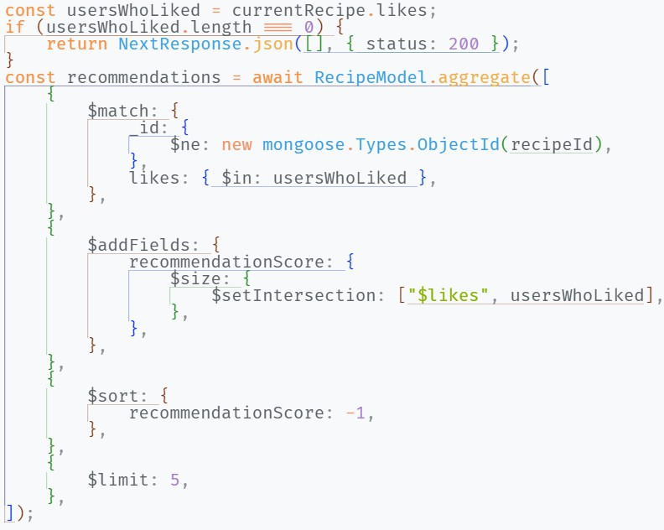

Fuzzy Search:
The Fuzzy Search algorithm provides a more forgiving and user-friendly search experience. It allows users to find what they're looking for even if they make typos, use partial words, or have minor misspellings in their search query. This significantly improves usability over a traditional, literal string search.
How It Works
We use the popular `Fuse.js` library to implement fuzzy matching on the client side.
- Initialization: A `Fuse` instance is created and provided with the dataset to be searched (e.g., the list of all recipes or all ingredients). I configured it with the keys to search against (`name`, `ingredients`) and a `threshold` value.
- Search and Scoring: When a user types a query, `Fuse.js` calculates a "distance" score for each item in the dataset, measuring how close it is to the query. It returns a list of items that are below the specified `threshold`, sorted by relevance.
- Threshold: The `threshold` (set to `0.4` in our implementation) controls how "fuzzy" the search is. A value of `0.0` would only allow perfect matches, while a value of `1.0` would match anything. `0.4` provides a good balance between flexibility and relevance.
Formulas Used:

  - Levenstein Distance Formula: The Levenstein distance between two strings `a` and
`b` is defined as the minimum number of single-character edits (insertions, deletions, or substitutions) required to change one string into the other. The recursive formula is: lev(a, b) =
|a| if |b| = 0
|b| if |a| = 0 min(
lev(tail(a), b) + 1, // deletion lev(a, tail(b)) + 1, // insertion
lev(tail(a), tail(b)) + cost // substitution
)
where cost = 0 if a[0] == b[0], else 1
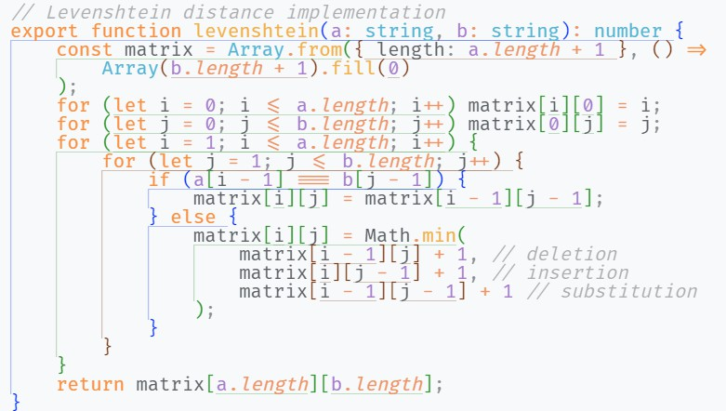

  - Dynamic Programming Matrix Implementation: In practice, this is implemented efficiently using dynamic programming with a matrix-based approach to avoid redundant calculations:
Let D[i][j] be the Levenstein distance between the first i characters of string a and the first j characters of string b.
Base cases:
D[0][0] = 0
D[i][0] = i for all i > 0 D[0][j] = j for all j > 0 Recurrence relation:
D[i][j] = min(
D[i-1][j] + 1, // deletion
D[i][j-1] + 1, // insertion
D[i-1][j-1] + (a[i-1] == b[j-1] ? 0 : 1) // substitution
)
  - Similarity Score Calculation: The similarity score between a search query `q` and a target string `t` is calculated as:
similarity(q, t) = 1 - (Levenstein(q, t) / max(|q|, |t|))
This normalizes the Levenstein distance to a value between 0 and 1, where:
    - 1.0 = exact match
    - 0.0 = completely different strings
  - Threshold Based Filtering: Given a threshold `θ`, a string `t` is considered a match for query `q` if:
Levenstein(q, t) ≤ θ
The optimal threshold value typically ranges from 1-3 for most applications, with 2 being a good default that balances flexibility and relevance.
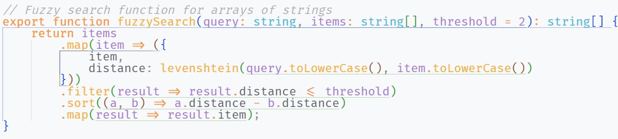

Inverted Index Filtering:
The Inverted Index is a high-performance algorithm used to make filtering by selected ingredients on the main recipe page nearly instantaneous. Its purpose is to avoid slow, repetitive searching through the entire list of recipes every time a user adds or removes an ingredient.
How It Works
Instead of iterating through every recipe, we pre-process the data to create an optimized data structure.
- Index Creation: The algorithm creates an "index" (a JavaScript `Map`) that maps each unique ingredient to a list of all the recipes that contain it. For example:
{

"chicken": [recipe1, recipe5, recipe8], "tomato": [recipe2, recipe3, recipe8]
}

This index is created only once and is then reused, thanks to React's `useMemo` hook, which caches the result.
- Instant Lookup: When a user selects ingredients, the algorithm performs a very fast lookup in this index to get the lists of matching recipes.
- Union of Results: It then efficiently combines these lists to get the final, filtered set of unique recipes to display to the user. This is dramatically faster than a direct, brute- force search.
Formula Used:

  - Inverted Index Data Structure: The inverted index `I` is defined as a mapping from ingredients to recipe sets:
I: G → P(R)
Where:
    - `G` is the set of all unique ingredients
    - `R` is the set of all recipes
    - `P(R)` is the power set of recipes (all possible subsets) For each ingredient `g ∈ G`:
I(g) = {r ∈ R | g ∈ ingredients(r)}
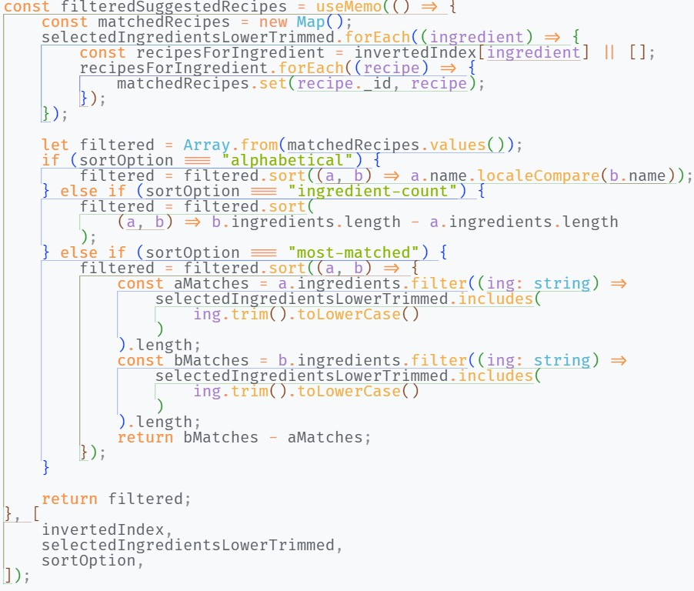

LRU Caching:
The LRU (Least Recently Used) Cache is a server-side performance optimization. Its purpose is to reduce database load and significantly speed up API response times for frequently requested data, such as the main recipe list. This makes the application feel much faster and more responsive to the end-user.
How It Works

I have used the `lru-cache` library to implement a caching layer in our API.

- Cache Initialization: A cache with a fixed size (`max: 100` items) and a TTL (`Time To Live` of 5 minutes) is created on the server.
- Cache-First Strategy: When a request for a page of recipes arrives at the API:
  - Cache Hit: The API first checks if a valid (non-expired) result for that specific page already exists in the cache. If it does, the cached data is returned immediately, and no database query is performed.
  - Cache Miss: If the data is not in the cache, the API queries the database as usual. The result is then stored in the cache before being returned to the user. Subsequent requests for the same page will now be cache hits.
- Cache Invalidation: The cache is a snapshot of the data at a point in time. To prevent stale data, we must invalidate it when the underlying data changes. The cache is automatically cleared whenever a new recipe is successfully added via the `POST` request, ensuring that the next `GET` request will fetch fresh data from the database.
Formulas Used:

- Cache Hit Ratio: The cache hit ratio `H` is defined as the proportion of requests that are served from cache:
H = N_hits / (N_hits + N_misses)
Where:
  - `N_hits` is the number of cache hits
  - `N_misses` is the number of cache misses
The hit ratio ranges from 0 to 1, where higher values indicate better cache performance.
- LRU Eviction Policy: The LRU algorithm maintains a doubly-linked list where each cache entry has a timestamp `t`. When the cache reaches capacity `C`, the entry with the oldest timestamp is evicted:
evict_entry = argmin_{e ∈ cache} t(e) The cache size constraint is enforced as:
|cache| ≤ C
- Time-to-Live (TTL) Expiration: Each cache entry has an expiration time calculated as:
expiration_time = creation_time + TTL Where `TTL = 5` minutes in our implementation.
The cache validity check is:
is_valid(entry) = current_time < entry.expiration_time
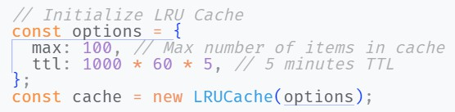

CHAPTER 4: IMPLEMENTATION AND TESTING

Implementation:
In this stage, physical system specifications are converted into working and reliable solution. This is a stage where the system is developed. On the receiving the system design documents, the work is divided in modules/units and actual coding is started. It is flowed by testing. Several tools are used in this phase if software development.

Tools Used:
Table 4-1 Tools Used

Tools | Purpose
VS code | To write and Compile code
MongoDB | For Database
Draw.io, PlantUML | For making Diagrams
Figma | For making Wireframes

Languages Used:
Table 4-2 Languages Used

Language/Framework | Purpose
Typescript | For Creating Components of the  Application
Tailwind CSS | For Designing of the Application
Next JS | For Client-Side and Server-Side  Functionality of the Application

Implementing Details of Modules
The Major functional modules of Kitchen Genie and their implementations are mentioned below:
      - Login Module: This Module is available to all users. In this module the user provides their email and password.
      - Add Recipe Module: This Module is available for all users. This Module allows users to insert a new recipe to the System.
      - Filter Ingredients Module: This Module is available for all users. This Module allows the users to Filter the ingredients.
      - View Recipe Module: This Module is available for all users. This Module allows the users to view Recipes

Testing:

Test Case for Unit Testing:
Table 4-3 Test Case for Login Module

ID | Test Case  Description | Test Data | Expected  Result | Actual Result | Test  Result
1 | User enters valid email and password | Email: john@gmail.com Password:  john@321 | Login to the System | Logged in to the System | Pass
2 | User enters correct Email and wrong Password | Email: john@gmail.com Password:  john@@321 | Incorrect Password | Incorrect Password | Pass
3 | User enters wrong Email and correct password | Email: jhon@gmail.com Password:  john@321 | Incorrect Username | Incorrect Username | Pass
Table 4-4 Test Case for Add Recipe Module

ID | Test Case  Description | Test Data | Expected  Result | Actual Result | Test  Result
1 | User enters all the data | Recipe name: Chicken Tikka Instructions: […]  Nutrition:[…] | Successful Insertion | Successful Insertion | Pass
2 | User enters partial the data | Recipe name: Chicken Tikka  Nutrition:[…] | Insertion Failed | Insertion Failed | Pass

Table 4-5 Test Case for Ingredients Filter Module

ID | Test Case  Description | Test Data | Expected  Result | Actual Result | Test  Result
1 | User enters valid ingredient | Ingredient:” Chicken” | Successful Fetching of  Ingredients | Successful Fetching of  Ingredients | Pass
2 | User enters ingredient with  typos | Ingredient:” Vicken” | Successful Fetching of  Ingredients | Successful Fetching of  Ingredients | Pass

Table 4-6 Test Case for View Recipe Module

ID | Test Case  Description | Test Data | Expected  Result | Actual Result | Test  Result
1 | User Searches for a correct recipe | Query : “Chicken Tikka Masala” | Successful Fetching of  the Recipe | Successful Fetching of the  Recipe | Pass
2 | User searches recipe with typos | Query : “Thicken Tikka Masala” | Successful Fetching of  the Recipe | Successful Fetching of the  Recipe | Pass
3 | User doesn’t  search for recipe | Query = “” | Successful  Fetching of all the Recipe | Successful  Fetching of all the Recipe | Pass

Test Case for System Testing:
Table 4-7 Test Case for System Testing

ID | Test Case  Description | Input | Expected  Result | Actual Result | Pass  / Fail
1 | User enters valid email and password | Email: john@gmail.com Password:  john@321 | Login to the System | Logged in to the System | Pass
2 | User enters correct Email and wrong Password | Email: john@gmail.com Password:  john@@321 | Incorrect Password | Incorrect Password | Pass
3 | User enters all the data | Recipe name: Chicken Tikka  Instructions: […]  Nutrition: […] | Successful Insertion | Successful Insertion | Pass
4 | User enters partial the data | Recipe name: Chicken Tikka  Nutrition: […] | Insertion Failed | Insertion Failed | Pass
5 | User enters valid ingredient | Ingredient:” Chicken” | Successful  Fetching of Ingredients | Successful  Fetching of Ingredients | Pass
6 | User enters ingredient with  typos | Ingredient:” Vicken” | Successful Fetching of  Ingredients | Successful Fetching of  Ingredients | Pass

7 | User Searches for a correct recipe | Query: “Chicken Tikka Masala” | Successful  Fetching of the Recipe | Successful  Fetching of the Recipe | Pass
8 | User searches recipe with typos | Query: “Thicken Tikka Masala” | Successful Fetching of the  Recipe | Successful Fetching of the  Recipe | Pass
9 | User doesn’t  search for recipe | Query = “” | Successful Fetching of all  the Recipe | Successful Fetching of all  the Recipe | Pass

CHAPTER 5: CONCLUSIOG AND FUTURE RECOMMENDATION

Outcome:
The KitchenGenie project successfully developed a full-stack platform that enables users to explore, filter, and interact with a diverse range of recipes. Users can register, log in, and manage their profiles, while the app allows them to search recipes by ingredients, cuisine, or dietary preferences using intuitive components like the Searchbar and IngredientsSelector. Authenticated users can like recipes, post comments, and follow other users, fostering social engagement around food. The admin panel provides an overview of user interactions and content moderation tools. The backend, built with Node.js and MongoDB, manages users, recipes, and comments through dedicated services, while the React frontend ensures a smooth experience through components like RecipeCard, CommentSection, and AuthContext. The platform promotes community-driven recipe discovery and offers a responsive and engaging interface for everyday cooking enthusiasts.

Conclusion:
In conclusion, the Kitchen Genie project delivers a robust and user-friendly platform that seamlessly integrates recipe discovery, social interaction, and personalized content filtering. Through its well-structured backend and interactive frontend components, the application not only meets the functional requirements but also enhances user engagement by enabling commenting, liking, and following features. The successful integration of MongoDB, Next.JS, and React ensures scalability, maintainability, and a modern user experience. Overall, the project demonstrates a well-executed full-stack implementation tailored for dynamic, community-driven food exploration.

Future Recommendation:
    - Include video tutorials and step-by-step cooking modes for an enhanced cooking experience.
    - Support multi-language content to expand the platform’s global reach.
    - Integrate AI-powered recipe recommendations based on user behavior and preferences.

APPENDICES
- Homepage
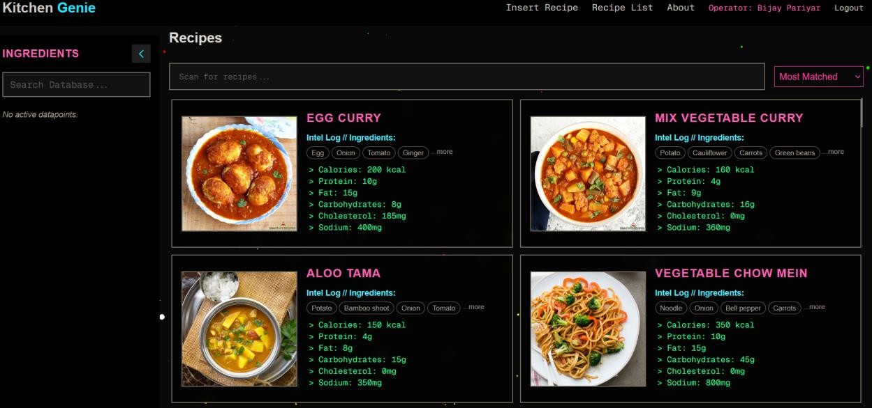
- About Page
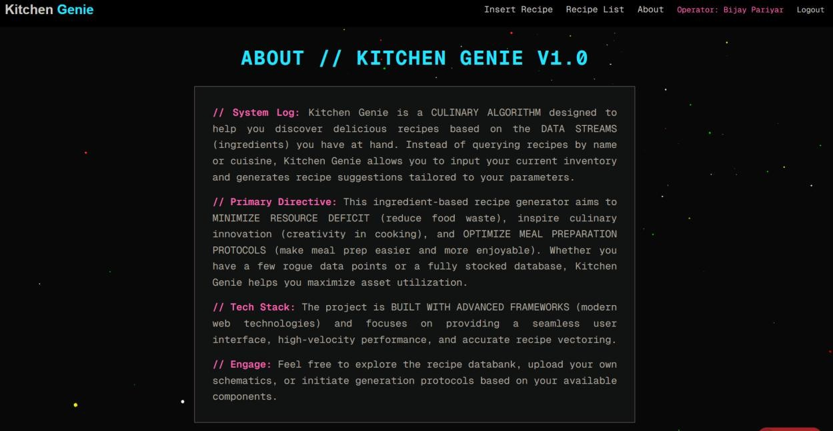
- Login Page
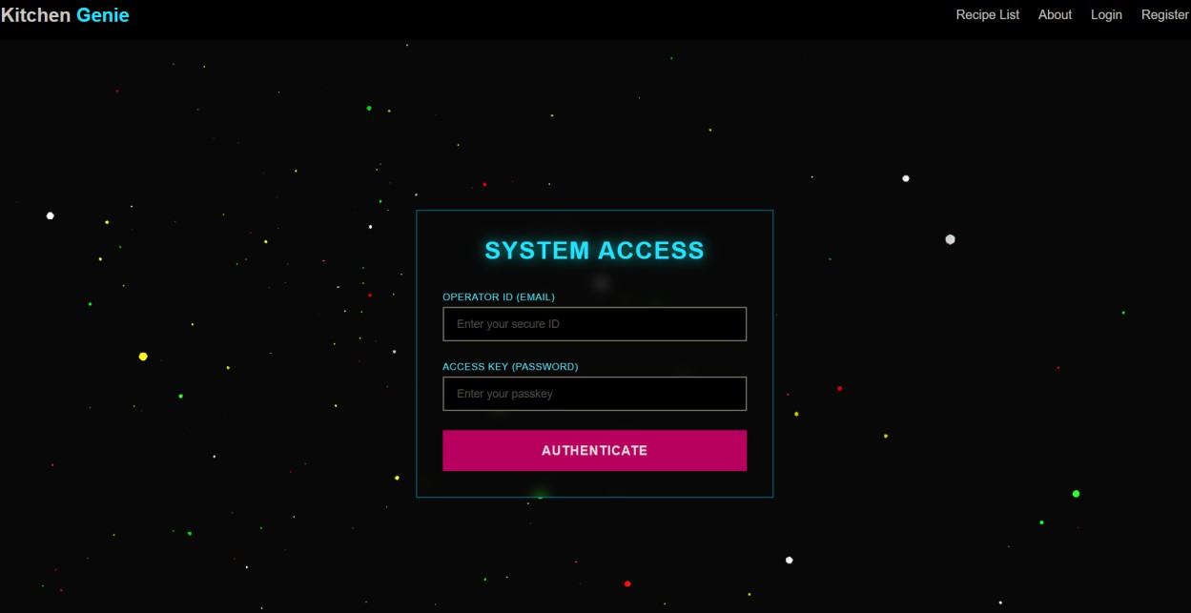
- Register Page
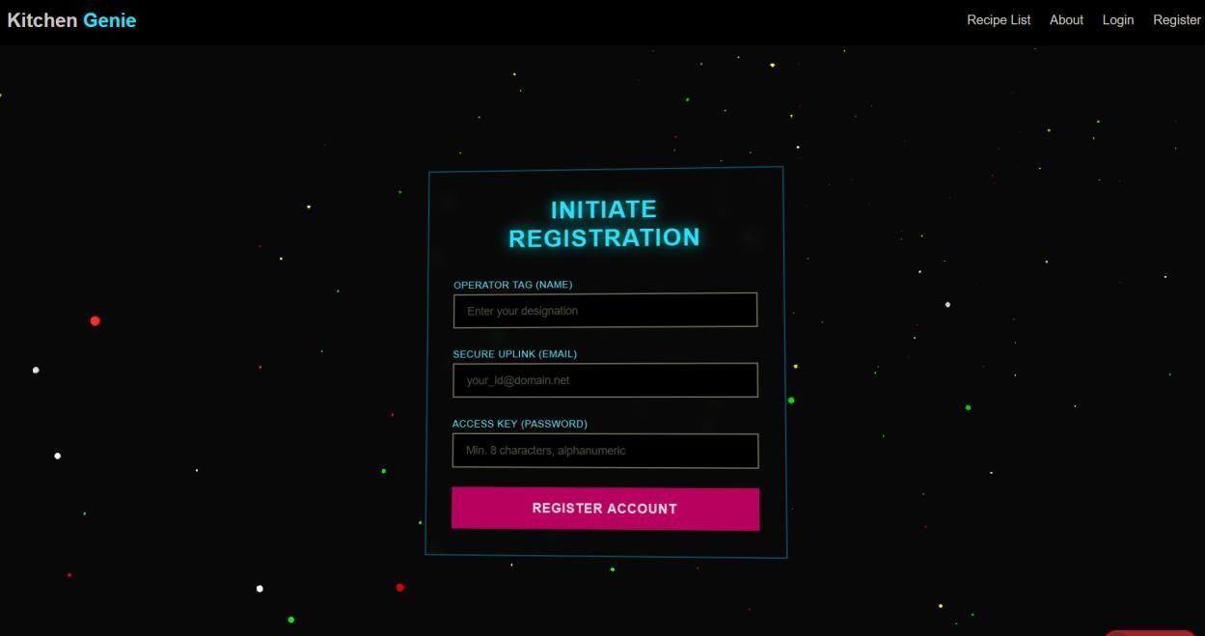
- Recipe Insertion Page
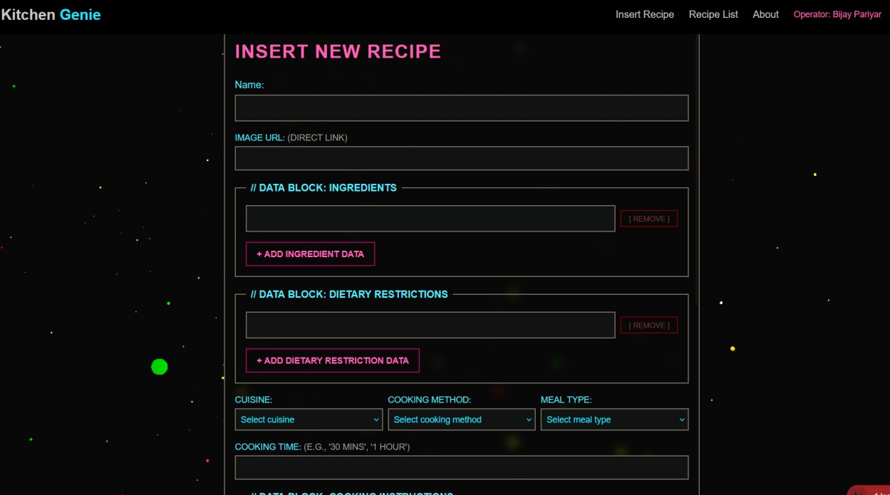
- Recipe Detail Page
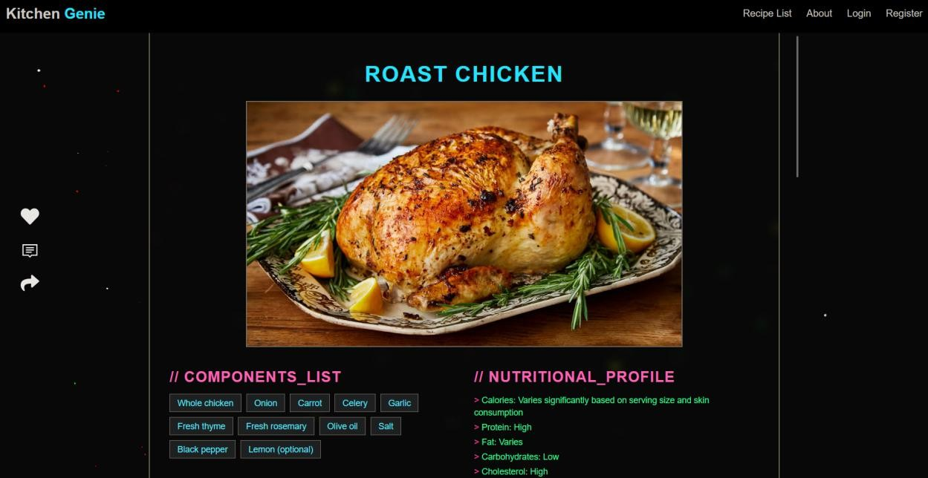

REFERENCES
- D. Elsweiler, C. Trattner and M. Harvey, "Exploiting Food Choice Biases for Healthier Recipe Recommendation," Proceedings of the 40th International ACM SIGIR Conference on Research and Development in Information Retrieval, vol. I, no. 2, pp. 23- 25, 2017.
- J. Marin, A. Biswas, F. Ofli, N. Hynes, A. Salvador, Y. Aytar, I. Weber and A. Torralba, "A Dataset for Learning Cross-Modal Embeddings for Cooking Recipes and Food Images," IEEE Transactions on Pattern Analysis and Machine Intelligence, vol. II, no. 2, pp. 5-7, 2019.
- S. L. a. J. McAuley, "Recipes for Success: Data Science in the Home Kitchen," Harvard Data Science Review, pp. 20-23, 2020.
- A. Salvador, N. Hynes, Y. Aytar, J. Marin, F. Ofli, I. Weber and A. Torralba, "Learning Cross-Modal Embeddings for Cooking Recipes and Food Images," IEEE Conference on Computer Vision and Pattern Recognition, vol. I, no. 4, pp. 14-15, 2017.
- Q. Zhang, C. Trattner, B. Ludwig and D. Elsweiler, "Understanding Cross-Cultural Visual Food Tastes with Online Recipe Platforms," Proceedings of the International AAAI Conference on Web and Social Media, vol. IV, no. 12, pp. 6-8, 2019.

