WEEK 2 TASK
CUSTOMER BEHAVIOR ANALYSIS AND SEGMENTATION
eCommerce Data Analytics Project
Based on the supplied OnlineRetail.xlsx dataset
Prepared by: Adarsh Mani Tripathi

1. Executive Summary
This report performs customer behavior analysis and segmentation using the supplied Online Retail dataset rather than a purely theoretical or simulated dataset. The workbook contains 406,829 transaction-line records. After removing 8,945 rows associated with cancellations/returns or invalid positive-sales conditions, 397,884 positive-sales records remain. These represent 18,532 invoices, 4,338 customers, 3,665 products and 37 countries.
Customer-level RFM analysis shows a repeat-purchase rate of 65.6%. The segmentation identifies 934 Champions (21.5%), 666 Loyal Customers (15.4%), 677 Potential Loyalists (15.6%), 757 At-Risk Customers (17.5%), and 1,304 Dormant/Low-Value customers (30.1%).

2. Why This Version Addresses the Week 1 Evaluation
- Uses the actual supplied OnlineRetail.xlsx data instead of invented customer figures.
- Provides concrete calculations for customer count, revenue, invoices, repeat rate and segment sizes.
- Shows the complete RFM methodology and actual customer-level segment results.
- Adds behavioral clustering and a silhouette-score evaluation rather than only proposing clustering.
- Includes charts based on the supplied data.
- Provides practical customer examples and segment-specific marketing actions.
- Clearly identifies limitations: the dataset contains transaction, country and product fields but does not contain customer age, gender, income, website visits, email activity or other digital-behavior fields; therefore those dimensions are not fabricated.

3. Dataset and Data Quality
The workbook sheet 'Online Retail Data Set' contains InvoiceNo, StockCode, Description, CustomerID, Country, InvoiceDate, UnitPrice, Quantity and Total price. All 406,829 rows have populated CustomerID in the supplied sheet. Quantity ranges from -80,995 to 80,995, and Total price includes negative values, indicating returns/cancellations are present.
Measure | Result | Use
Raw rows | 406,829 | Original dataset size
Positive-sales rows | 397,884 | Used for customer RFM
Removed rows | 8,945 | Returns/cancellations or invalid sales
Customers | 4,338 | Customer-level analysis
Invoices | 18,532 | Purchase frequency
Countries | 37 | Geographic behavior
Products | 3,665 | Product behavior
Positive sales revenue | £8,911,407.90 | Revenue KPI
Average invoice value | £480.87 | AOV proxy

4. Research Methodology
RFM (Recency, Frequency, Monetary) is a widely used retail customer-segmentation method. Recency measures the number of days since the customer's latest purchase, Frequency measures the number of unique invoices, and Monetary measures total positive sales revenue. RFM is suitable here because the supplied dataset contains transaction dates, invoice numbers and prices.
To extend the analysis, K-Means clustering was applied to standardized Recency, Frequency and Monetary variables. Solutions from k=2 through k=6 were compared using the silhouette score. The best result for this dataset was k=2, with a silhouette score of 0.896. This is an exploratory behavioral segmentation and should be validated before production use.

5. RFM Calculation and Segmentation Criteria
The analysis uses 09 December 2011 as the reference date because it is the latest transaction timestamp in the cleaned positive-sales data. Each RFM variable is converted into a 1–5 quintile score. Recency is reverse-scored so that a more recent customer receives a higher score; Frequency and Monetary are scored positively. The total RFM score therefore ranges from 3 to 15.
RFM Score | Segment | Meaning | Primary Action
13–15 | Champions | Recent, frequent and high-value customers | Retention/VIP
11–12 | Loyal Customers | Strong repeat behavior | Cross-sell/loyalty
9–10 | Potential Loyalists | Moderate value with growth potential | Second-purchase campaigns
7–8 | At-Risk Customers | Previously engaged but increasingly inactive | Win-back
3–6 | Dormant / Low Value | Low recent activity and/or low value | Low-cost reactivation

6. Actual Customer Segmentation Findings
Segment | Customers | Share | Avg Revenue | Avg Orders | Avg Recency (days)
Champions | 934.0 | 21.5% | £6,697.36 | 11.7 | 13.6
Loyal Customers | 666.0 | 15.4% | £1,575.52 | 4.3 | 36.3
Potential Loyalists | 677.0 | 15.6% | £1,061.91 | 2.8 | 62.2
At-Risk Customers | 757.0 | 17.5% | £690.93 | 1.8 | 90.6
Dormant / Low Value | 1,304.0 | 30.1% | £279.78 | 1.1 | 191.3
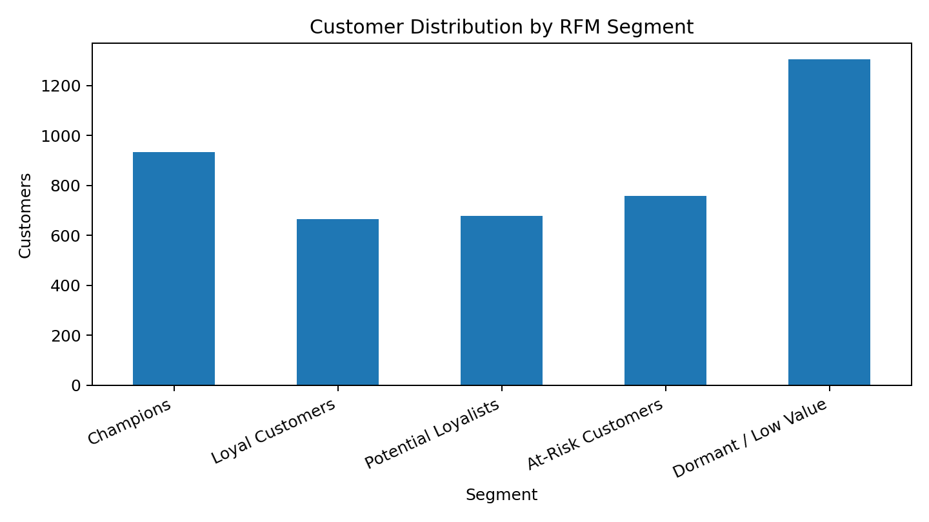
Figure 1. Actual customer distribution across RFM segments.

7. Interpretation of Behavioral Trends
Champions represent 21.5% of customers and have an average customer revenue of £6,697.36. Dormant/Low-Value customers are the largest group at 30.1% and average only £279.78. This contrast shows why a single marketing strategy is inefficient: the two groups differ substantially in both recency and monetary value.
The At-Risk segment contains 757 customers (17.5%). Their average recency is 90.6 days. A targeted reactivation campaign is therefore more appropriate than treating these customers as completely inactive.

8. Geographic and Product Behavior
The United Kingdom is the largest revenue market in the supplied data, generating £7,308,391.55 in positive sales. The top country accounts for 82.0% of positive-sales revenue. The highest-revenue product in the cleaned data is PAPER CRAFT , LITTLE BIRDIE, with £168,469.60 in sales.
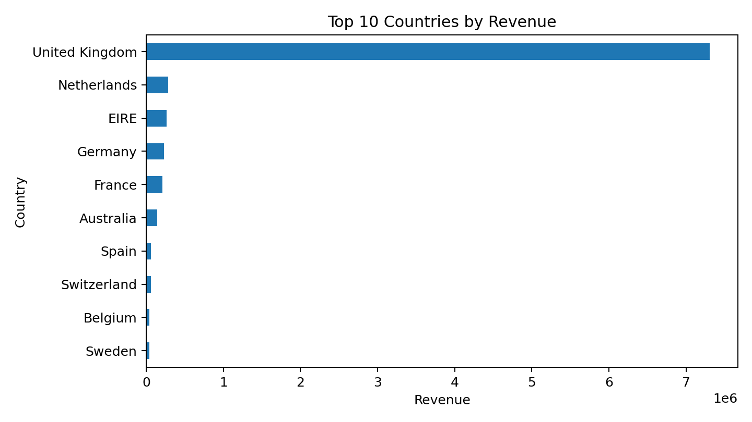
Figure 2. Top 10 countries by actual positive-sales revenue.

9. Monthly Customer/Revenue Behavior
Monthly revenue varies across the dataset period. The highest positive-sales month is November 2011 with £1,161,817.38. The lowest positive-sales month is February 2011 with £447,137.35. This seasonality is useful for campaign timing, inventory planning and retention activity.
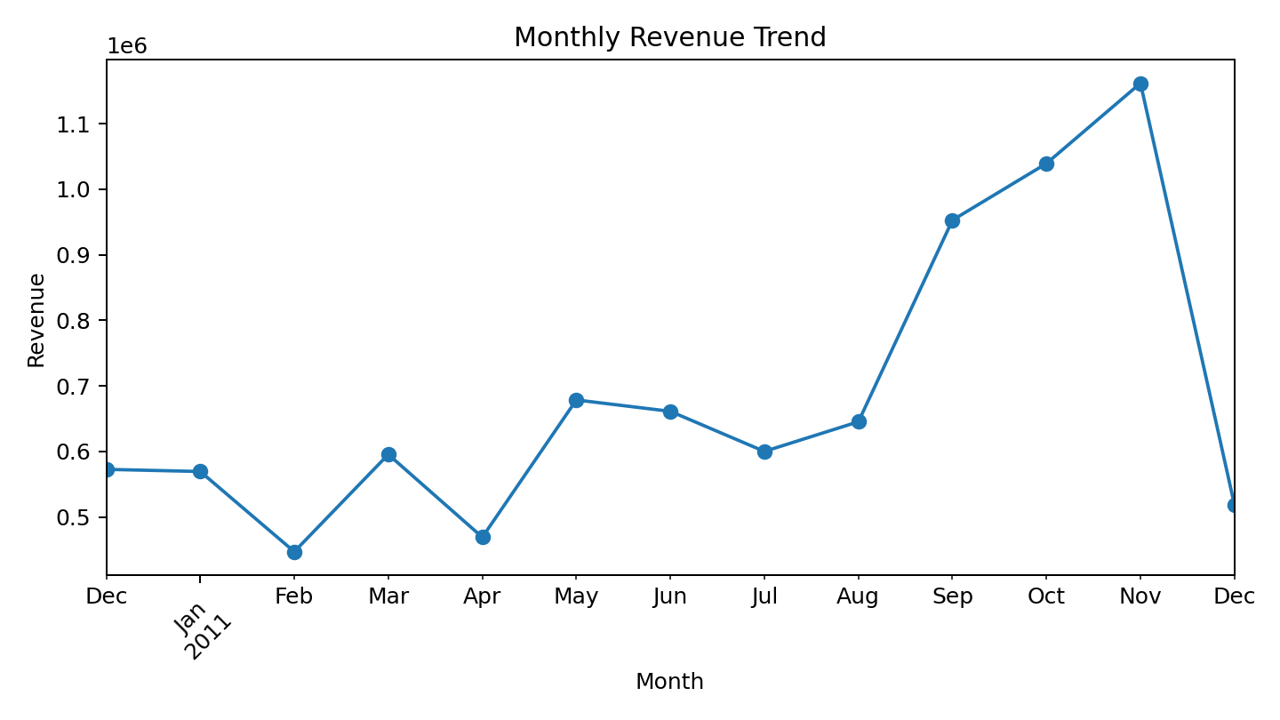
Figure 3. Actual monthly positive-sales revenue trend.

10. Behavioral Clustering
K-Means clustering was applied to Recency, Frequency and Monetary value after standardization. The best solution was k=2 with a silhouette score of 0.896. This result should be interpreted as exploratory: clustering groups customers with similar numerical profiles, while RFM labels make those profiles easier for marketing teams to understand.
Cluster Profile | Customers | Avg Recency | Avg Orders | Avg Revenue
Regular/Engaged | 4312 | 92.1 | 3.9 | £1,548.68
High Value | 26 | 5.0 | 66.4 | £85,904.35
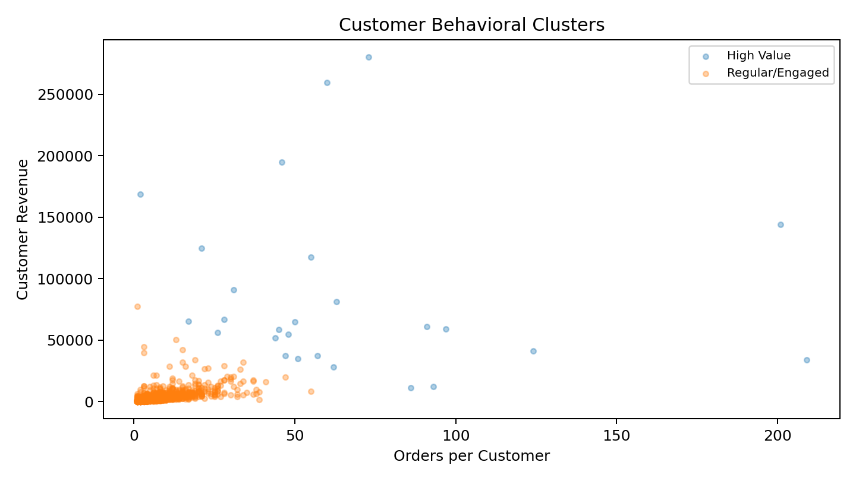
Figure 4. Actual customer behavioral clusters using frequency and monetary value.

11. Hypotheses and Evidence
- H1 — Repeat purchasing is common among customers. Result: 65.6% of identified customers placed at least two invoices.
- H2 — Higher purchase frequency is associated with higher monetary value. Result: Frequency and Monetary have a Pearson correlation of 0.55 in the cleaned customer-level data.
- H3 — Customer value is concentrated in a smaller high-value group. Result: the Champions group contains 21.5% of customers but contributes £6,255,336.53, or 70.2% of customer revenue.
- H4 — At-risk customers are strategically different from dormant customers. Result: At-Risk customers average 90.6 days since purchase versus 191.3 days for Dormant/Low-Value customers, supporting differentiated win-back treatment.

12. Practical Customer Examples
Example | Behavior | Recommended Action
Champion | Customer with a high RFM score, frequent purchases and recent activity. | VIP rewards, early access and personalized cross-sell.
Potential Loyalist | Customer with reasonably recent activity but lower frequency/value. | Second-purchase incentive and relevant product recommendations.
At-Risk Customer | Customer with previous purchase history but long recency. | Personalized win-back email/offer and reminder.
Dormant / Low Value | Customer with very long recency and low purchase value. | Low-cost automated reactivation; avoid expensive incentives.

13. Segment-Based Marketing Strategy
- Champions: protect loyalty through VIP benefits, early product access, personalized recommendations and referral programs.
- Loyal Customers: increase basket size through bundles, cross-selling and loyalty-point incentives.
- Potential Loyalists: encourage a second/third purchase using category recommendations and time-limited but controlled incentives.
- At-Risk Customers: run targeted win-back campaigns based on previous purchases rather than generic discounts.
- Dormant / Low Value: use inexpensive automated email campaigns and suppress high-cost paid targeting unless engagement returns.

14. Important Data Limitation
The assignment asks for demographic factors and digital behavior. Those variables are not present in the supplied Online Retail sheet. Specifically, there are no fields for age, gender, income, website visits, app activity, email opens, clicks or device usage. Therefore, this report does not invent those attributes. The segmentation is based on the variables that the actual dataset supports: transactional behavior, product/category information, geography and time.

15. Conclusion
The supplied Online Retail dataset supports a strong practical customer segmentation exercise. After transaction cleaning, 4,338 customers were analyzed using RFM. The results reveal clear differences between Champions, Loyal Customers, Potential Loyalists, At-Risk Customers and Dormant/Low-Value customers. Clustering provides an additional data-driven view, while country, product and monthly analysis adds business context.
The most important business recommendation is to move from one-size-fits-all marketing to segment-specific actions. High-value customers should be retained, potential loyalists converted, at-risk customers reactivated and dormant customers approached with low-cost campaigns. Before production use, the organization should add digital and demographic variables if available and validate the segments on a future time period.

16. References / Research Basis
- Chen, D., Sain, S. L., & Guo, K. (2012). Data mining for the online retail industry: A case study of RFM model-based customer segmentation using data mining. Journal of Database Marketing & Customer Strategy Management, 19, 197–208.
- Doğan, O., Ayçin, E., & Bulut, Z. A. (2018). Customer segmentation by using RFM model and clustering methods: A case study in retail industry. International Journal of Contemporary Economics and Administrative Sciences, 8(1), 1–19.
- Patron, M. (2004). Case Study: Applying RFM segmentation to the SilverMinds catalogue. Journal of Direct, Data and Digital Marketing Practice, 5, 269–275.
- UCI Machine Learning Repository: Online Retail dataset, the transaction dataset underlying the supplied workbook.

Appendix: Reproducibility Notes
Cleaning rule: Quantity > 0, UnitPrice > 0, and InvoiceNo not beginning with 'C'. Revenue was recalculated as Quantity × UnitPrice. Customer frequency is unique InvoiceNo count; Monetary is total positive-sales revenue per CustomerID. RFM scores use quintiles. K-Means uses standardized RFM variables and random_state=42.

