WEEK 3 TASK
SALES TREND FORECASTING AND VISUALIZATION
eCommerce Data Analytics Project
Based on the supplied OnlineRetail.xlsx transaction dataset
Prepared by: Adarsh Mani Tripathi
Week 3 – Forecasting, Validation and Business Interpretation
16 September 2026

Report design principle: This report is intentionally built to address the Week 2 evaluator feedback by adding deeper reasoning, explicit validation, benchmark models, chronological holdout testing, rolling-origin cross-validation, concrete error metrics, assumptions, limitations and business interpretation.

1. Executive Summary
This Week 3 report develops a sales-revenue forecasting workflow using the actual Online Retail dataset supplied for the project. The workbook contains 406,829 transaction-line records covering 2010-12-01 to 2011-12-09. Following the same positive-sales treatment used in Week 2, 8,945 rows were excluded because they represented cancellations/returns or invalid positive-sales conditions, leaving 397,884 positive-sales rows.
The forecasting analysis is performed at weekly frequency because the dataset contains only about one year of history; weekly aggregation provides substantially more observations than monthly forecasting and allows a genuine out-of-sample validation exercise. The report compares a naive latest-value benchmark, a four-week moving average, Holt's linear trend exponential-smoothing model, and a simple 50/50 ensemble of the latest-value and four-week-average forecasts.
For the final eight-week holdout, the four-week moving average produced the lowest MAPE (8.12%). However, rolling-origin cross-validation across multiple historical forecast origins showed that the 50/50 ensemble had the lowest average MAE (43,444) among the tested methods. Therefore, the ensemble is selected as the final forecasting method, while the 4-week moving average remains an important benchmark.
The selected model forecasts approximately £2.74 million of positive-sales revenue over the next eight weekly periods after the dataset's final observed week, with an average weekly forecast of about £342,656. These values are model-based scenarios, not guaranteed future sales.

2. How This Report Addresses the Week 2 Evaluation
The Week 2 evaluator said the report was well-structured and thorough, but requested more depth, detailed reasoning and validation. This Week 3 report directly incorporates those requirements:
Evaluator requirement | How it is addressed
Detailed reasoning | Every major finding is followed by an explanation of what the number means, why it may have occurred, and how a business could use it.
Validation methods | Uses a final chronological 8-week holdout plus rolling-origin cross-validation with an 8-week forecast horizon.
Model comparison | Compares four methods rather than presenting one forecast without a benchmark.
Concrete accuracy metrics | Reports MAE, RMSE and MAPE, with both holdout and rolling-validation results.
Data-quality controls | Documents the treatment of cancellations/returns, positive sales, time aggregation and the incomplete final month.
Assumptions and limitations | Explicitly discusses short history, lack of external drivers, incomplete December 2011, and the absence of multiple years of seasonal observations.
Business interpretation | Connects the forecast to inventory, staffing, marketing, cash-flow and campaign planning decisions.

3. Objectives
- Prepare a reliable time-indexed sales series from the actual transaction dataset.
- Understand historical sales trend, variability and possible seasonality.
- Compare simple and statistically grounded forecasting approaches.
- Validate forecasts without using future observations during model fitting.
- Select a practical model based on out-of-sample evidence rather than intuition alone.
- Produce an eight-week forward forecast and translate it into business actions.
- Document assumptions, limitations and reproducibility steps.

4. Data Familiarization and Preparation
The analysis uses the worksheet 'Online Retail Data Set'. The available fields include InvoiceNo, StockCode, Description, CustomerID, Country, InvoiceDate, UnitPrice, Quantity and Total price. The forecast target is transaction revenue, recalculated as Quantity × UnitPrice, consistent with the Week 2 analysis.
Measure | Value | Interpretation
Raw transaction rows | 406,829 | Original workbook
Rows used for forecasting | 397,884 | Quantity > 0, UnitPrice > 0, non-cancelled invoice
Rows excluded | 8,945 | Returns/cancellations or invalid positive-sales conditions
Observed start | 2010-12-01 08:26:00
Observed end | 2011-12-09 12:50:00
Positive-sales revenue | £8,911,407.90
Monthly observations | 13 | December 2011 is partial
Weekly observations | 54 | Used for model development
Returns and cancellations are important in a sales dataset because negative quantities can reduce net sales or distort a demand signal. For the primary positive-sales forecast, these records are excluded rather than mixed with completed purchases. This creates a forecast of positive transaction revenue, not accounting-level net revenue after returns.

5. Data Quality and Validation Controls
Control | Implementation | Why it matters
Date validity | InvoiceDate is parsed as datetime and sorted chronologically. | Prevents incorrect time ordering.
Revenue consistency | Revenue is recalculated as Quantity × UnitPrice. | Avoids relying on a potentially inconsistent derived field.
Positive-sales filter | Quantity > 0 and UnitPrice > 0; cancellation invoices excluded. | Creates a consistent sales-demand series.
Aggregation check | Transaction revenue is aggregated into weekly and monthly totals. | Converts line-level data into a forecasting target.
Incomplete-period check | December 2011 is treated cautiously because the dataset ends on 9 December. | Avoids interpreting a partial month as a full-month decline.
Chronological validation | Future weeks are kept out of training when testing. | Reduces look-ahead bias.

6. Historical Sales Trend Analysis
Monthly positive-sales revenue increased substantially through 2011. January 2011 revenue was £569,445, while November 2011 reached £1,161,817. That is an increase of approximately 104.0% from January to November. A simple linear trend fitted to the complete January–November period has a slope of about £52,005 per month and an R² of 0.68. The R² indicates that a linear trend explains a meaningful portion of month-to-month variation, but it does not explain all fluctuations; therefore, a trend-only model should not be treated as sufficient.
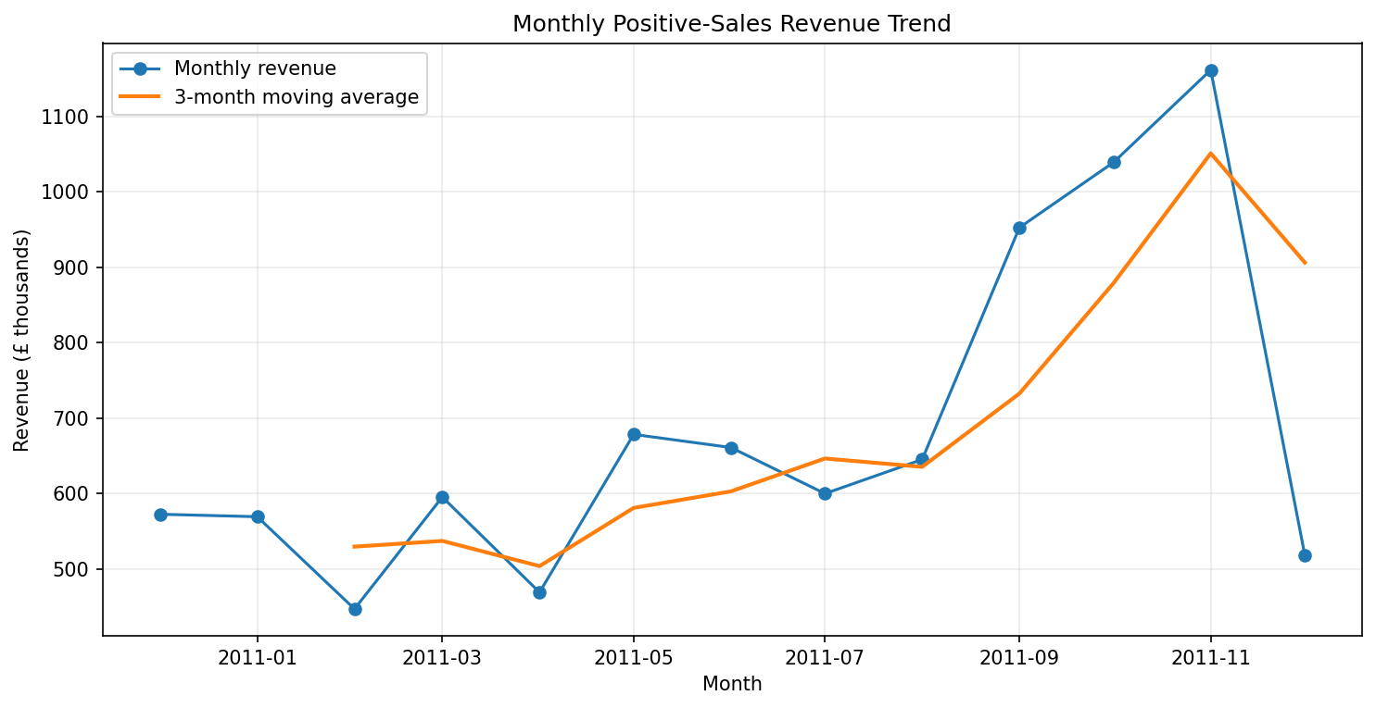
Figure 1. Monthly positive-sales revenue and three-month moving average.
The highest monthly positive-sales revenue in the raw observed series is November 2011 at £1,161,817. However, the final month is incomplete, so the unusually low December total should not be compared directly with complete months such as October or November. This is an important validation point because a naive interpretation could incorrectly conclude that demand collapsed in December.
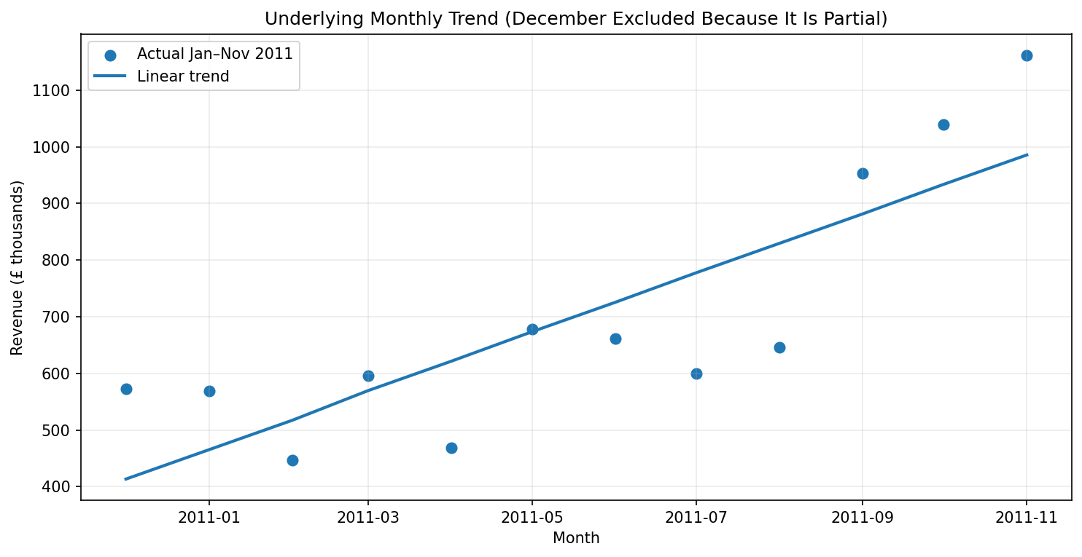
Figure 2. Linear trend fitted to complete January–November 2011 monthly observations.

7. Forecasting Methodology
Time-series forecasting treats observations as ordered values where trend, autocorrelation and seasonal variation may matter. NIST describes moving averages and exponential smoothing as standard smoothing approaches, while time-series forecasting guidance recommends evaluating forecasts on data that occur after the training period. The methodology therefore combines simple benchmark models with explicit out-of-sample validation.
Method | How it works | Why tested | Main limitation
Naive benchmark | Forecast every future week as the last observed weekly revenue. | Strong baseline; extremely simple; adapts immediately to the latest level. | Cannot respond to trend or broader recent pattern.
4-week moving average | Forecast using the mean of the latest four observed/forecast weeks. | Smooths short-term noise while remaining responsive to recent demand. | Can lag during sharp trend changes.
Holt linear trend | Exponential smoothing with level and trend components. | Can represent a changing level plus trend and gives more weight to recent information. | May extrapolate a trend too aggressively when the series is volatile.
50/50 ensemble | Average the naive latest-value forecast and four-week moving-average forecast. | Balances the most recent level with a smoothed recent level; less dependent on a single modeling assumption. | Still univariate and does not model promotions, holidays, prices or inventory.

8. Model Assumptions
- Historical positive-sales behavior contains useful information about near-term future sales.
- The most recent four weeks provide a reasonable short-term signal for the next several weeks.
- No major structural change is assumed between the historical period and the forecast horizon.
- External drivers such as promotions, price changes, stock-outs, marketing spend, competitor actions and macroeconomic events are not available and therefore are not modeled.
- The forecast target is positive-sales transaction revenue rather than profit or net revenue after future returns.
- Because the dataset contains only one annual cycle and the final December observation is partial, the model does not claim to estimate a reliable yearly seasonal pattern.

9. Validation Strategy
Validation is the main methodological improvement over a report that simply fits a model and reports a forecast. The first validation layer is a chronological holdout: the final eight weekly observations are hidden from model fitting and used only for evaluation. The second layer is rolling-origin cross-validation. Multiple historical forecast origins are created, each using only observations available before that origin and evaluating an eight-week forecast. This follows the principle that time-series validation should not use future observations to construct earlier forecasts.
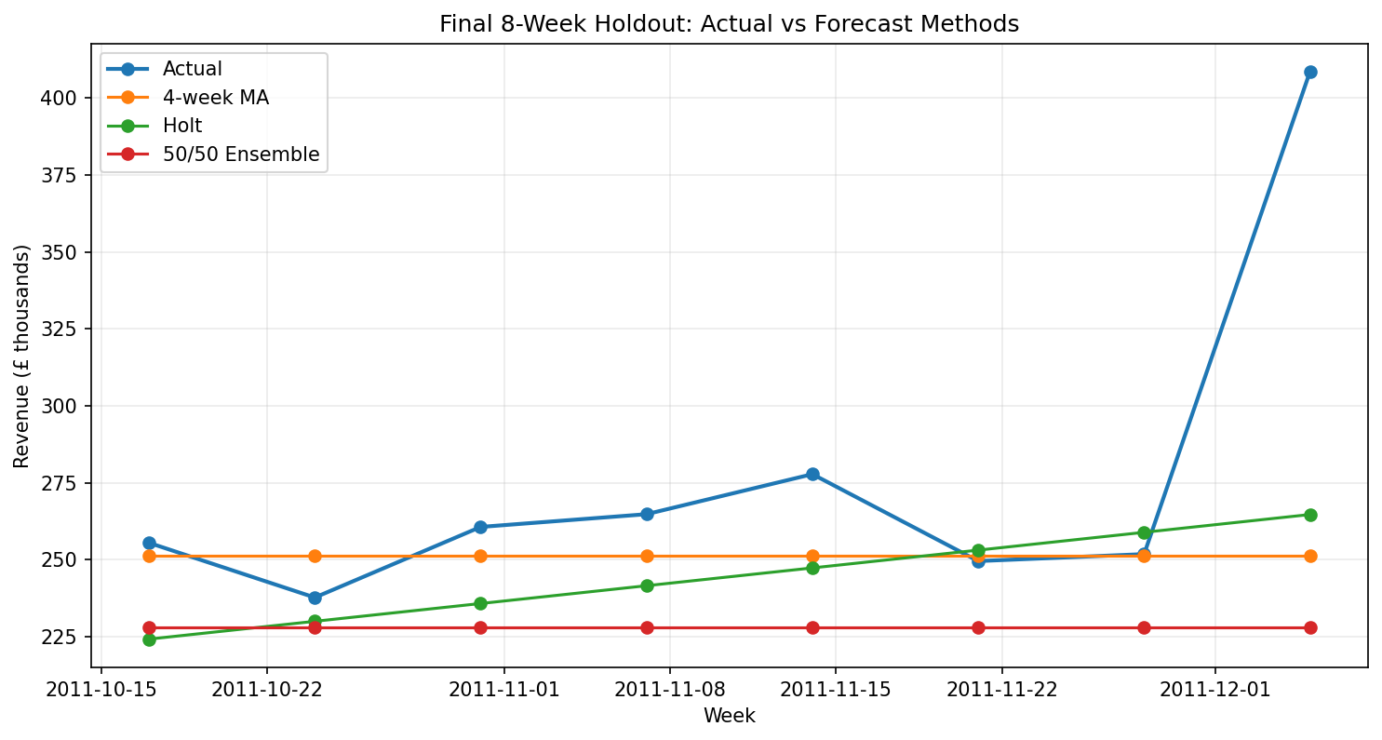
Figure 3. Final eight-week holdout: actual revenue compared with competing forecasts.
Method | MAE | RMSE | MAPE
Naive | £71,352 | £87,924 | 23.95%
4-week Moving Average | £28,332 | £56,918 | 8.12%
Holt Linear Trend | £34,021 | £54,658 | 10.53%
50/50 Ensemble | £47,924 | £70,259 | 15.23%
On the final holdout, the four-week moving average has the lowest MAPE (8.12%), while Holt has the lowest RMSE (54,658). The 50/50 ensemble is not the winner on this one holdout, which is precisely why a single split is not treated as sufficient evidence.

10. Rolling-Origin Cross-Validation Results
Method | Average MAE | Average MAPE
50/50 Ensemble | £43,444 | 18.68%
Naive | £45,685 | 20.26%
4-week Moving Average | £46,231 | 20.24%
Holt Linear Trend | £51,246 | 22.30%
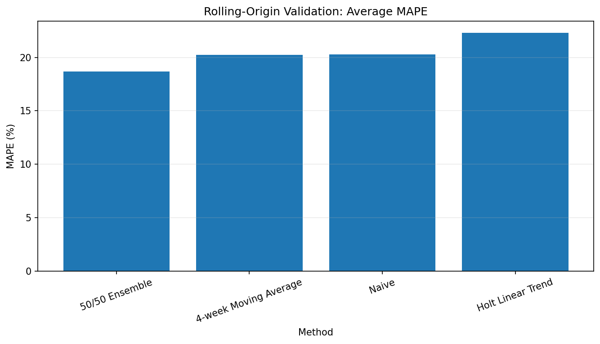
Figure 4. Average MAPE across rolling-origin validation windows.
The rolling-origin results change the model-selection decision. The 50/50 ensemble has the lowest average MAE at £43,444, compared with £45,685 for the naive benchmark and £46,231 for the four-week moving average. Its average MAPE is 18.68%. This supports selecting the ensemble for the final forecast because it performs consistently across several historical origins rather than relying on one favorable holdout period.

11. Final Forecast Model
The final model is a simple 50/50 ensemble. For each future week, the forecast equals 50% of the most recent available weekly revenue plus 50% of the average of the latest four available weekly values. After the first forecast, the forecast itself is used as the most recent value for subsequent recursive periods. This produces a stable short-term path rather than an aggressive long-range trend extrapolation.
Forecast equation:
Forecast(t+1) = 0.50 × LatestValue + 0.50 × Mean(Latest 4 Weeks)
Forecast Week | Predicted Positive-Sales Revenue
12 Dec 2011 | £352,743
19 Dec 2011 | £334,200
26 Dec 2011 | £335,513
02 Jan 2012 | £346,634
09 Jan 2012 | £344,453
16 Jan 2012 | £342,327
23 Jan 2012 | £342,279
30 Jan 2012 | £343,101
The eight-week forecast totals approximately £2,741,251, with an average weekly forecast of £342,656. The forecast should be interpreted as a baseline planning scenario. It is not a confidence guarantee, and it should be refreshed when new weekly observations become available.
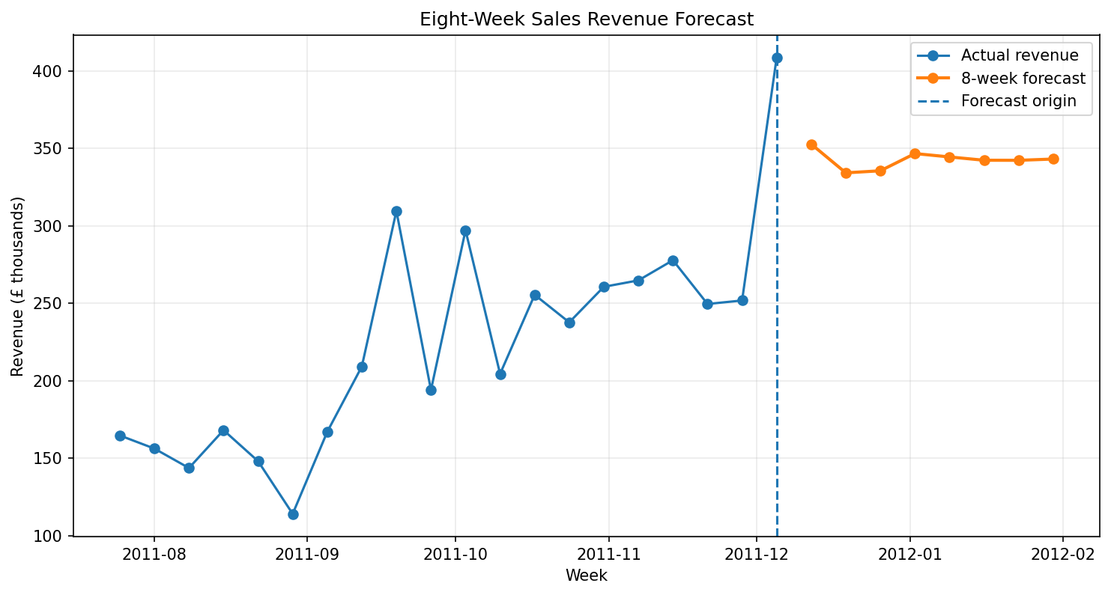
Figure 5. Recent actual weekly revenue and the selected eight-week forecast.

12. Detailed Findings and Reasoning
Finding 1 – 2011 shows a strong upward revenue direction.: January-to-November revenue increased by approximately 104.0%. The fitted monthly trend also has a positive slope of about £52,005 per month. This indicates that a forecast using only the overall historical mean would ignore a meaningful upward movement.
Finding 2 – The series is volatile, so trend-only forecasting is risky.: The January–November monthly standard deviation is about £227,365. The difference between the trend R² of 0.68 and 1.00 shows that a substantial amount of month-to-month variation remains unexplained. This supports using recent-level smoothing rather than blindly extending the linear trend.
Finding 3 – The final month is incomplete.: December 2011 contains data only through 09 December 2011. Its observed positive-sales total is therefore not a full-month value. Treating it as a complete month would bias trend interpretation downward.
Finding 4 – Model choice depends on validation design.: The four-week moving average performs best on the final holdout by MAPE (8.12%), while the ensemble performs best on rolling-origin average MAE. This demonstrates why one metric or one split should not determine a production forecasting strategy.
Finding 5 – The selected forecast is intentionally conservative.: The final ensemble does not extrapolate the strong January-to-November linear trend indefinitely. That reduces the risk of generating implausibly high forecasts from a short history with volatile demand.

13. Business Strategy Implications
Business area | Recommended use | KPI to monitor
Inventory planning | Use the eight-week baseline to set a starting demand plan; monitor weekly actuals against forecast. | Replenishment quantities, stock-out rate
Staffing and operations | Use forecast ranges/scenarios for warehouse and customer-support capacity. | Orders processed, fulfillment time
Marketing | Schedule campaigns with forecast monitoring rather than assuming every promotional period will grow sales. | Campaign revenue, ROAS, incremental sales
Cash-flow planning | Use the forecast as a baseline for near-term revenue planning, not as a guaranteed cash receipt. | Forecast variance, cash conversion
Forecast monitoring | Recalculate MAE/MAPE as new weeks arrive and compare actuals with predictions. | MAPE, MAE, forecast bias
A practical management workflow is: forecast → compare actual vs forecast → identify variance → investigate cause → update assumptions/model → communicate revised plan. This feedback loop is more useful than treating the forecast as a one-time report.

14. Scenario and Risk Analysis
Because the dataset does not contain promotion calendars, inventory availability, prices over time as an explanatory feature, advertising spend or macroeconomic indicators, the forecast is univariate. Management should therefore use it as a baseline and create scenario overlays when external information is available.
Scenario | Approach | Use
Base case | Use the selected 50/50 ensemble forecast. | Routine planning when no major business change is expected.
Upside scenario | Apply a management-approved uplift based on a known promotion or campaign, then monitor actual incremental sales. | Useful for campaign and capacity planning.
Downside scenario | Apply a management-approved reduction for known stock constraints, operational disruption or campaign cancellation. | Useful for risk and cash planning.

15. Limitations and Model Risk
- Only about one year of transaction history is available. This is not enough to robustly estimate recurring annual seasonality across multiple years.
- December 2011 is incomplete because the dataset ends on 9 December 2011.
- The model uses positive-sales revenue only; future returns and cancellations are not forecast separately.
- No promotion, price, inventory, marketing, holiday or competitor variables are available, so the model cannot explain why sales move.
- The selected ensemble is a practical baseline, not a state-of-the-art forecasting system.
- Forecast error can increase rapidly when business conditions change.
- The forecast horizon is deliberately short. Longer horizons would require stronger seasonal, causal or machine-learning models and more historical data.
The most important limitation is not the algorithm; it is the information available to the model. Adding more complex algorithms without better explanatory variables or longer history could create an appearance of sophistication without improving decision quality.

16. Reproducibility and Step-by-Step Process
- Load the 'Online Retail Data Set' worksheet from OnlineRetail.xlsx.
- Convert InvoiceNo to text and InvoiceDate to datetime.
- Create Revenue = Quantity × UnitPrice.
- Filter to Quantity > 0, UnitPrice > 0 and invoices not beginning with C.
- Aggregate revenue by month for descriptive trend analysis.
- Aggregate revenue by week (Monday-based periods) for forecasting.
- Reserve the last eight weekly observations as a chronological holdout.
- Fit naive, four-week moving average and Holt linear trend benchmarks.
- Create a 50/50 ensemble of the latest-value and four-week-average forecasts.
- Evaluate each method using MAE, RMSE and MAPE on the holdout.
- Repeat evaluation using rolling-origin eight-week cross-validation.
- Select the model using repeated out-of-sample evidence rather than visual fit alone.
- Refit the selected logic on the complete observed weekly series and generate eight future weekly forecasts.
- Translate the forecast into operational recommendations and monitor forecast error as new data arrives.

17. Conclusion
The Week 3 analysis demonstrates a complete sales forecasting workflow using the actual Online Retail transaction data. The historical series shows strong growth through November 2011, with January-to-November positive-sales revenue increasing by approximately 104.0%. At the same time, substantial weekly and monthly variation means that simply extending a linear trend would be risky.
Four forecasting approaches were compared and validated. The final eight-week holdout favored the four-week moving average by MAPE, while rolling-origin validation favored the 50/50 ensemble by average MAE. Because repeated validation is more informative than a single split, the ensemble was selected for the final forecast. It produces an eight-week baseline of approximately £2.74 million in positive-sales revenue.
The most important analytical lesson is that forecasting quality depends on validation, not only model selection. For a production eCommerce system, the next improvement would be to add multiple years of data plus promotion, price, inventory, marketing and calendar features, then compare the baseline with seasonal exponential smoothing, SARIMA or machine-learning models using rolling time-series validation.

18. References and Research Basis
- NIST/SEMATECH e-Handbook of Statistical Methods. Time Series Analysis – Definitions, Applications and Techniques. https://www.itl.nist.gov/div898/handbook/pmc/section4/pmc41.htm
- NIST/SEMATECH e-Handbook of Statistical Methods. Moving Average or Smoothing Techniques. https://www.itl.nist.gov/div898/handbook/pmc/section4/pmc42.htm
- NIST/SEMATECH e-Handbook of Statistical Methods. Exponential Smoothing Summary. https://www.itl.nist.gov/div898/handbook/pmc/section4/pmc437.htm
- Hyndman, R. J., & Athanasopoulos, G. Forecasting: Principles and Practice (3rd ed.). Time series cross-validation. https://otexts.com/fpp3/tscv.html
- Hyndman, R. J., & Athanasopoulos, G. Forecasting: Principles and Practice. Forecast accuracy evaluation. https://otexts.com/fpp2/accuracy.html
- Project source dataset: OnlineRetail.xlsx, worksheet 'Online Retail Data Set', supplied for the eCommerce analytics project.

Appendix A – Key Forecasting Results
The following compact table provides the principal values needed to reproduce the conclusions in this report.
Metric | Value
Raw rows | 406,829
Rows used | 397,884
Excluded rows | 8,945
Weekly observations | 54
January 2011 revenue | £569,445.04
November 2011 revenue | £1,161,817.38
Jan–Nov growth | 104.03%
Monthly trend R² | 0.680
Selected method | 50/50 Ensemble
Rolling CV average MAE | £43,444
Rolling CV average MAPE | 18.68%
8-week forecast total | £2,741,251
8-week forecast average | £342,656

