WEEK 5 TASK
EVALUATING PRICING STRATEGIES THROUGH A/B TESTING ANALYSIS
eCommerce Data Analytics Project
Based on the supplied Online Retail transaction dataset
Prepared by: Adarsh Mani Tripathi

1. Executive Summary
This report develops a practical A/B testing blueprint for evaluating eCommerce pricing strategies using the supplied Online Retail dataset. The source workbook contains 406,829 transaction lines. After removing cancellations and invalid non-positive sales, the analysis uses 397,884 positive-sales rows, 18,532 invoices, 4,338 customers, 3,665 products and 37 countries. Actual positive-sales revenue is £8,911,407.90, with an average invoice value of £480.87 and median unit price of £1.95.
The workbook records transaction prices and quantities but does not contain randomized website exposure, visitor IDs, treatment assignment, conversion events, cost/margin, or experiment timestamps. Therefore, the A/B test outcomes in this report are explicitly simulated rather than claimed as observed experimental results. Actual transaction statistics are used to anchor the pricing context and value calculations.
The primary experimental scenario compares regular pricing (Control) with a 10% discount (Test). The analysis does not declare a universal winning pricing strategy; instead, it demonstrates how conversion, revenue per visitor, AOV, and margin-sensitive guardrails should be evaluated before a real pricing decision.

2. Response to Previous Evaluator Feedback
Previous feedback | How Week 5 addresses it
Need more detailed reasoning | Explains hypotheses, variables, causal logic, formulas, statistical testing and interpretation.
Need validation methods | Includes randomization, sample-size planning, significance testing, confidence intervals, guardrails and validity checks.
Need concrete examples | Uses actual dataset revenue, order count, AOV and price distribution to build a realistic simulated experiment.
Need stronger practical interpretation | Shows how conversion lift can still reduce revenue per visitor after a discount and explains why margin must be monitored.
Need visualizations | Includes actual price-mix and monthly-revenue charts plus simulated A/B conversion and revenue-per-visitor charts.
Need deeper analysis | Adds segmentation, assumptions, threats to validity, implementation steps and decision rules.

3. Dataset and Data Preparation
Metric | Actual result
Raw transaction lines | 406,829
Clean positive-sales lines | 397,884
Invoices | 18,532
Customers | 4,338
Products | 3,665
Countries | 37
Positive-sales revenue | £8,911,407.90
Average invoice value | £480.87
Median unit price | £1.95
Mean unit price | £3.12
25th percentile unit price | £1.25
75th percentile unit price | £3.75
Cleaning rules: Quantity > 0, UnitPrice > 0, and InvoiceNo not beginning with 'C' were used to focus the analysis on positive sales. Revenue was calculated as Quantity × UnitPrice. These rules are appropriate for descriptive pricing context but would need to be adapted for a production experiment dataset.
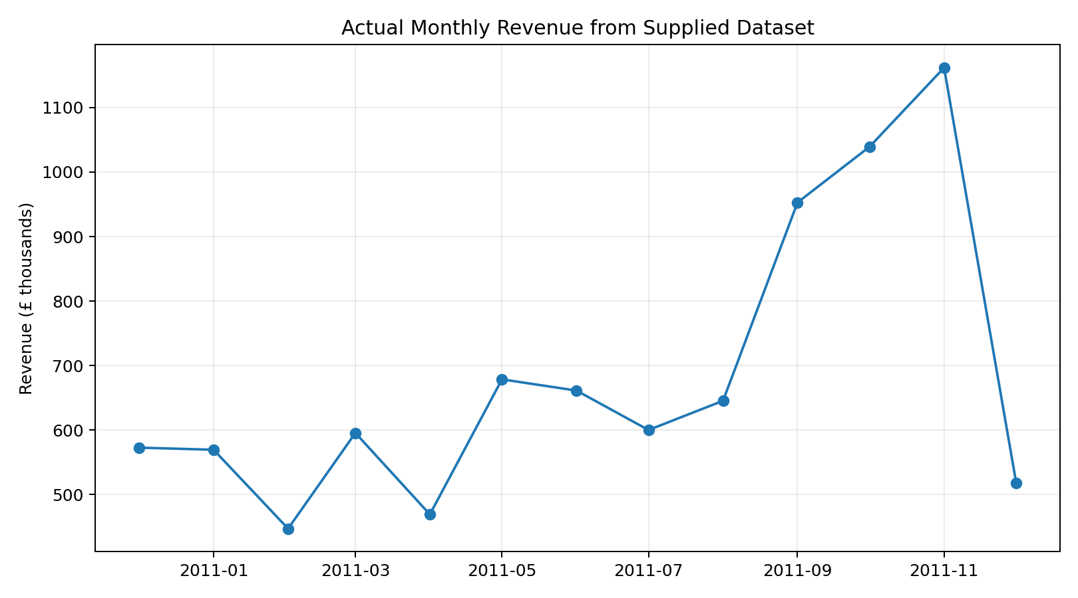
Figure 1. Actual monthly revenue from the supplied transaction dataset.

4. Pricing Context from the Actual Dataset
Unit price band | Transaction rows | Units | Revenue | Revenue share
≤£5 | 346,717 | 4,970,948 | £7,100,318.50 | 79.7%
£5–£20 | 50,047 | 194,449 | £1,600,767.42 | 18.0%
£20–£50 | 879 | 2,023 | £67,394.80 | 0.8%
>£50 | 241 | 392 | £142,927.18 | 1.6%
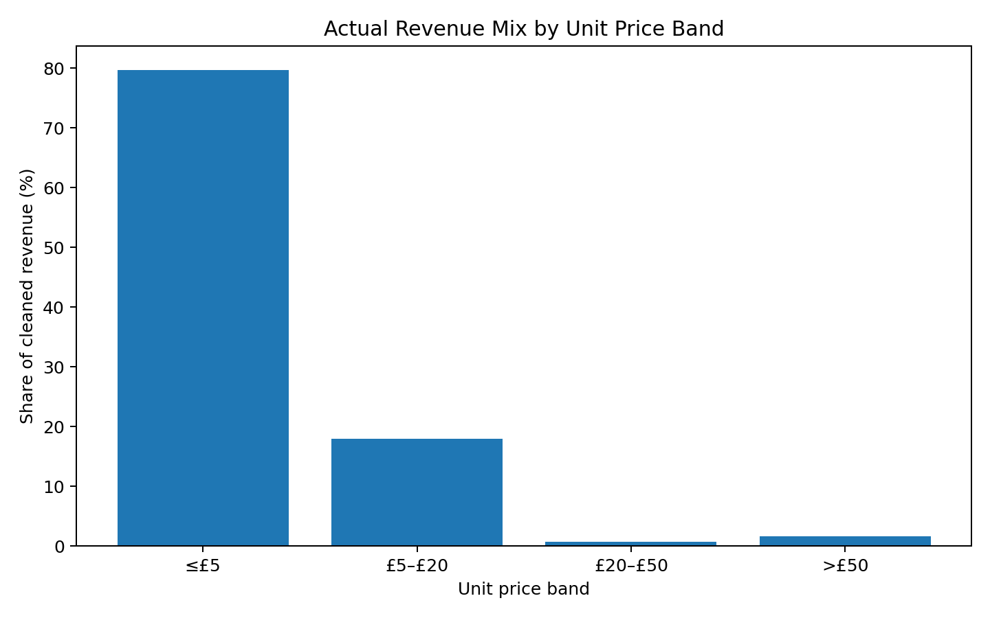
Figure 2. Actual revenue mix by unit-price band.
The dataset shows substantial variation in item prices, so a single percentage discount should not automatically be applied to every product. The median unit price is £1.95, while the 75th percentile is £3.75. Real testing should therefore stratify by product category, price band, margin, inventory position and customer segment where operationally appropriate.

5. Research-Based Pricing Experiment Framework
An A/B test should isolate the effect of a pricing change by randomly assigning eligible traffic to control and treatment while holding other experience factors as constant as possible. The key principle is that the unit of randomization must be defined before launch and users should not switch between prices during the experiment.
Component | Definition for this experiment
Control | Regular/list price shown to eligible users.
Treatment | 10% discount from the regular price.
Randomization unit | Customer/user, not page view, to reduce repeated-user contamination.
Primary metric | Purchase conversion rate.
Economic metric | Revenue per eligible visitor.
Supporting metrics | AOV, units/order, cart rate, checkout completion.
Guardrails | Refund/return rate, payment failure, gross margin/order, stock availability.
Duration | Run through a complete business cycle; do not stop solely because early results look favorable.
Eligibility | Exclude internal traffic, bots, known test accounts and products unavailable in both conditions.

6. Research Question and Hypotheses
Research question: Does a 10% discount change purchase conversion enough to improve economic value per eligible visitor compared with regular pricing?
H0 (null hypothesis): The treatment does not change the purchase conversion rate compared with control.
H1 (alternative hypothesis): The treatment changes the purchase conversion rate compared with control.
Secondary economic hypothesis: even if conversion increases, the discount should only be considered commercially attractive if revenue per visitor and margin-related guardrails remain acceptable. This distinction prevents a conversion-only analysis from treating lower-priced purchases as automatically beneficial.

7. Experimental Design
- Freeze the eligible product set and define the regular price before randomization.
- Randomly assign eligible customers to Control or Test at the customer level.
- Keep merchandising, traffic allocation, payment experience and major website changes consistent across groups.
- Record exposure, product price, add-to-cart, checkout, purchase, quantity, revenue, refunds/returns and relevant cost fields.
- Prevent a customer from seeing different treatment prices during the same experiment.
- Pre-register the primary metric, minimum detectable effect, sample-size target and stopping rule.
- Track experiment assignment in the data so every analysis can be reproduced.

8. Simulated A/B Test Scenario
To demonstrate the analysis, a theoretical experiment with 20,000 eligible visitors per group is simulated. Control conversion is set at 4.00% and Test conversion at 4.60%. The treatment price is modeled as 90% of the control price. These values are illustrative and are not measured outcomes from the workbook.
Metric | Control | Test | Change
Visitors | 20,000 | 20,000 | —
Pricing | Regular price | 10% discount | −10%
Purchases | 800 | 920 | +120
Conversion rate | 4.00% | 4.60% | +0.60 pp
Conversion lift | — | — | +15.0% relative
AOV assumption | £480.87 | £432.78 | −10.0%
Revenue/visitor | £19.2346 | £19.9079 | +3.5%
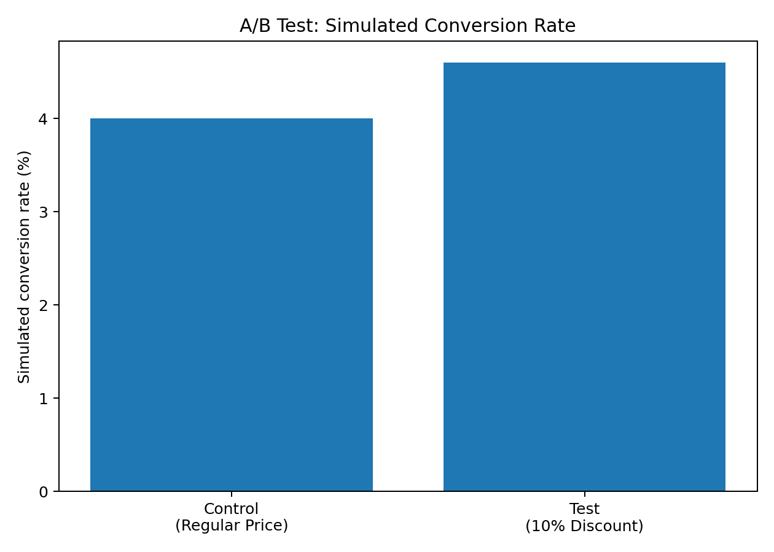
Figure 3. Simulated conversion-rate comparison.
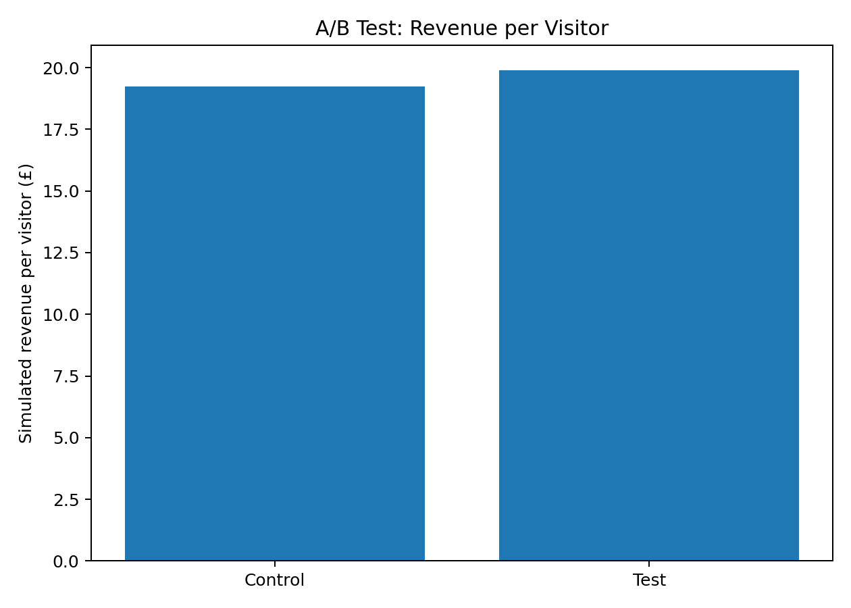
Figure 4. Simulated revenue per visitor comparison.

9. Statistical Analysis
A two-proportion z-test is used for the simulated primary conversion metric. The observed difference is 0.60 percentage points. The simulated z-statistic is 2.96 with a two-sided p-value of 0.0031. The approximate 95% confidence interval for the conversion-rate difference is 0.20 to 1.00 percentage points.
Interpretation: the simulated result provides an example of statistical significance testing, but it is not evidence that the discount actually works in the real business because the conversion numbers were constructed for demonstration. In a real experiment, the same test would be applied to independently randomized observations after checking the experiment's validity.
For planning purposes, detecting an increase from 4.00% to 4.60% conversion with approximately 95% confidence and 80% power requires roughly 17,100 observations per group under the assumptions used here. A production power calculation should be performed using the site's own baseline and desired minimum detectable effect.

10. Why Conversion Rate Alone Is Not Enough
The simulation shows conversion rising from 4.00% to 4.60%, but the 10% price reduction also lowers assumed order value by 10%. As a result, simulated revenue per visitor changes from £19.2346 to £19.9079, a +3.5% change. This demonstrates an important pricing-analysis principle: a strategy can increase the number of orders while reducing economic value per visitor.
Metric | Why it matters
Conversion rate | Measures purchase propensity.
Revenue per visitor | Combines traffic conversion and order value.
AOV | Shows whether the pricing change alters basket value.
Gross margin/order | Determines whether extra sales create economic contribution.
Units/order | Detects basket expansion or contraction.
Refund/return rate | Detects low-quality demand or price-driven behavior.
Customer retention | Checks whether the change affects future purchasing behavior.

11. Segmentation Analysis Plan
The supplied transaction data supports descriptive segmentation, but it cannot prove treatment effects because it contains no randomized A/B assignment. In a real experiment, the following pre-specified segments can be analyzed:
Segment | Reason | Risk to monitor
Price band | Elasticity may differ by product price. | Small sample sizes in expensive products.
Country | Purchasing behavior can vary geographically. | Currency, shipping and tax differences.
New vs returning | Existing customers may react differently to discounts. | Unequal group composition.
High vs low basket value | Discount response may vary by basket size. | Regression to the mean.
Product category | Some categories may be more price-sensitive. | Multiple comparisons.
Device | Mobile and desktop checkout behavior may differ. | Technical confounding.
Segment results should be treated as secondary unless the experiment was powered for them. Running many subgroup tests increases the chance of finding apparently positive differences by chance.

12. Validation and Quality-Control Checklist
- Check randomization balance before interpreting outcomes.
- Confirm treatment exposure and ensure users received the intended price.
- Check duplicate purchases and repeated sessions.
- Exclude bots, internal users and invalid transactions using predefined rules.
- Verify that control and treatment have comparable traffic-source and device distributions.
- Monitor tracking loss, payment errors and stock-outs.
- Check that the discount did not unintentionally change shipping, tax or promotional eligibility.
- Use confidence intervals, not only p-values.
- Evaluate both statistical significance and business significance.
- Document every exclusion and analysis decision before reviewing the final result.

13. Business Impact Scenarios
Using the dataset's actual AOV of £480.87 as a simple value anchor, the simulated test illustrates how a conversion increase can affect order volume. At 20,000 visitors, the scenario produces 800 control purchases versus 920 test purchases. However, the assumed 10% price reduction means additional volume must be weighed against lower value per order and unknown product margins.
Scenario | What management should examine
Conversion rises, revenue/visitor rises | Check whether the lift persists and whether margin also improves.
Conversion rises, revenue/visitor falls | Discount may create volume but reduce visitor-level value.
Conversion unchanged | Discount may be unnecessary or poorly targeted.
Conversion falls | Investigate price perception, product mix, experiment execution and customer trust.
Revenue rises but margin falls | Do not judge on revenue alone; examine contribution margin.
Returns increase | Investigate whether discount changes purchase quality.

14. Recommended Decision Rules for a Real Experiment
The following rules are intentionally expressed as pre-defined analytical criteria rather than a conclusion about the simulated test:
- Do not implement a pricing change solely because conversion is statistically significant.
- Require the primary metric to meet its pre-specified threshold and check revenue-per-visitor and margin guardrails.
- Investigate heterogeneous effects before broad rollout if segmentation was pre-registered and sufficiently powered.
- Reject or revise the test if tracking, randomization or exposure integrity is compromised.
- If results are inconclusive, collect more observations rather than treating 'not significant' as proof of no effect.

15. Limitations
- The workbook is historical transaction data and does not contain experimental assignment or visitor-level conversion data.
- The A/B outcomes are simulated and must not be represented as real business results.
- Unit price is not the same as profit margin; cost data are absent.
- The dataset may contain historical product availability and customer behavior that cannot be controlled like a live experiment.
- Price changes can interact with promotions, seasonality, inventory and competitor pricing.
- Multiple segment analyses can create false-positive findings if not pre-specified and statistically controlled.

16. Conclusion
This report converts the Week 5 brief into a reproducible pricing-experiment blueprint. The supplied Online Retail dataset is used to establish actual pricing and commercial context, while the A/B results are explicitly simulated because the source does not contain randomized treatment data.
The simulated scenario demonstrates the central analytical issue: a 10% discount increases conversion from 4.00% to 4.60% in the example, but the lower order value changes revenue per visitor. Therefore, a robust pricing experiment must evaluate conversion together with revenue per visitor, AOV, margin, returns and other guardrails.
To achieve a high-quality real-world result, the experiment should be randomized at the customer level, powered before launch, monitored for tracking and balance, analyzed with confidence intervals and an appropriate statistical test, and interpreted using both statistical and business significance. This framework directly addresses the earlier evaluation issues by adding concrete calculations, visualizations, validation methods, detailed reasoning, practical examples and explicit limitations.

17. References / Research Sources
- Ron Kohavi, Diane Tang & Ya Xu, Trustworthy Online Controlled Experiments: A Practical Guide to A/B Testing.
- Google Analytics documentation on ecommerce measurement and event-based conversion analysis.
- Microsoft Experimentation Platform / online controlled experimentation guidance.
- Supplied project source: Online Retail transaction dataset (uploaded workbook).

