SR UNIVERSITY
Campus Warangal
AI ASSISTED CODING – ASSIGNMENT 13
Refactoring Legacy Python Code
Student Name | V. ADARSH
Roll Number | 2503A52334
Program / Semester | II B.Tech (CS & AI) / I
Faculty: Dr. Mathivanan | Date: 05-10-2026

Objective
To improve legacy Python code by making it more readable, removing duplicated logic, simplifying conditions, choosing suitable data structures, and verifying that refactored code preserves the required behavior.
Note: The test outputs below are the expected outputs from the shown Python code. Run the code in Python to confirm them as part of the assignment instructions.

TASK 1 – Improve Readability

1. Original Code
a = 80
b = 70
c = 90
x = (a + b + c) / 3
if x >= 50:
print("pass")
else:
print("fail")

2. AI Prompt
Refactor this code using meaningful variable names and a calculate_average() function. Keep the pass/fail rule unchanged, improve formatting, and show the output.

3. AI Suggestion
Use descriptive names such as mark_one and average_marks, move the average calculation into calculate_average(), and use a clear if/else statement.

4. Refactored Code
def calculate_average(mark_one, mark_two, mark_three):
return (mark_one + mark_two + mark_three) / 3
average_marks = calculate_average(80, 70, 90)
print("Average =", average_marks)
if average_marks >= 50:
print("Pass")
else:
print("Fail")

5. Test Output
VS Code Terminal Output – Task 1
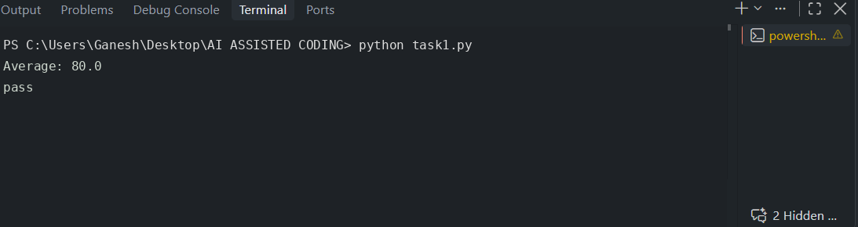
Average = 80.0
Pass

6. Explanation and Verification
The original variables a, b, c, and x do not explain their purpose. Meaningful names make the code easier to understand. A function separates the calculation from the decision, so the average can be reused. The average is (80 + 70 + 90) / 3 = 80.0, which is at least 50, so both versions produce a passing result. The refactored version preserves the original behavior.

TASK 2 – Remove Repeated Code

1. Original Code
name1 = "Arun"
marks1 = 85
if marks1 >= 50:
print(name1, "Pass")
else:
print(name1, "Fail")
name2 = "Priya"
marks2 = 72
if marks2 >= 50:
print(name2, "Pass")
else:
print(name2, "Fail")

2. AI Prompt
Identify duplicated pass/fail logic and refactor it into a reusable function. Test at least four students, including a student who fails. Keep the pass mark at 50.

3. AI Suggestion
Create check_result(name, marks). The function should contain the pass/fail condition once and can be called for any student.

4. Refactored Code
def check_result(student_name, marks):
if marks >= 50:
print(student_name, "Pass")
else:
print(student_name, "Fail")
check_result("Arun", 85)
check_result("Priya", 72)
check_result("Rahul", 42)
check_result("Meena", 50)

5. Test Output
VS Code Terminal Output – Task 2
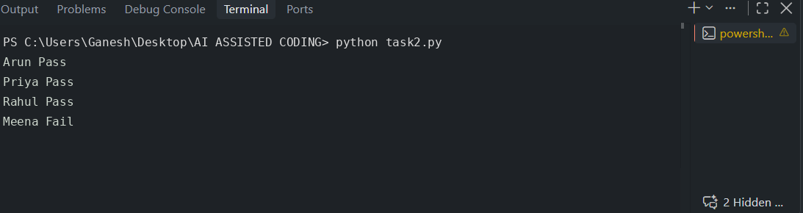
Arun Pass
Priya Pass
Rahul Fail
Meena Pass

6. Explanation and Verification
The original code repeats the same condition for each student. The function stores this logic in one place and accepts different names and marks. This improves maintainability because a future change to the pass mark or output format only needs to be made in one function. Four test cases were included: marks above 50, below 50, and exactly 50. The result for 50 is Pass because the condition is marks >= 50.

TASK 3 – Refactor a Long Conditional

1. Original Code
age = 68
temperature = 39
if age >= 60 and temperature >= 38:
print("High Priority")
elif age >= 60 and temperature < 38:
print("Medium Priority")
elif age < 60 and temperature >= 38:
print("Medium Priority")
else:
print("Normal Priority")

2. AI Prompt
Simplify the conditional logic using determine_priority(age, temperature). Test at least four combinations and preserve the original rules exactly.

3. AI Suggestion
The first condition remains the high-priority case. The two medium-priority cases can be combined with OR: an older person OR a high temperature, provided the high-priority condition was not met.

4. Refactored Code
def determine_priority(age, temperature):
if age >= 60 and temperature >= 38:
return "High Priority"
elif age >= 60 or temperature >= 38:
return "Medium Priority"
else:
return "Normal Priority"
test_cases = [(68, 39), (68, 37), (40, 39), (40, 37)]
for age, temperature in test_cases:
print(age, temperature, "->", determine_priority(age, temperature))

5. Test Output
VS Code Terminal Output – Task 3
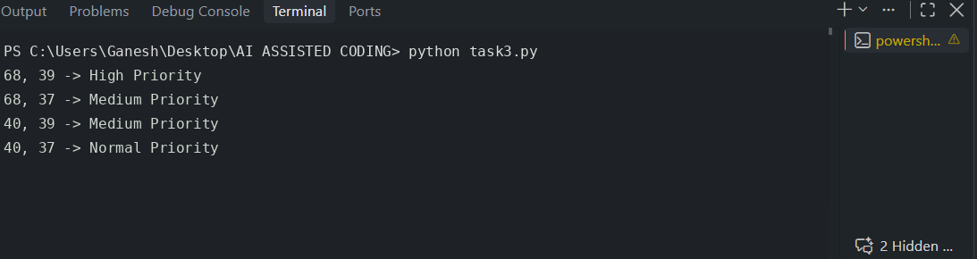
68 39 -> High Priority
68 37 -> Medium Priority
40 39 -> Medium Priority
40 37 -> Normal Priority

6. Explanation and Verification
The function makes the decision reusable and returns a value instead of printing inside every branch. The OR condition correctly combines the two medium-priority cases because the high-priority case is checked first. The four test combinations cover both conditions being true, only age being true, only temperature being true, and both being false. For these rules, the refactored code preserves the original behavior. This is a demonstration of the assignment's stated logic, not medical advice.

TASK 4 – Refactor Inefficient List Processing

1. Original Code
patient_ids = [101, 205, 309, 412, 518, 623]
target = 412
found = False
for patient_id in patient_ids:
if patient_id == target:
found = True
if found:
print("Patient Found")
else:
print("Patient Not Found")

2. AI Prompt
Improve readability and decide whether a list or set is better for frequent membership lookups. Implement the justified choice and test an existing ID and a missing ID.

3. AI Suggestion
For a simple membership check, use target in patient_ids for readability. If the program performs many membership lookups in a large collection, a set is usually a better choice because average membership lookup is O(1), while list membership is O(n). A set also removes duplicate IDs, so use it only when uniqueness/order requirements allow it.

4. Refactored Code
patient_ids = [101, 205, 309, 412, 518, 623]
patient_id_set = set(patient_ids)
def check_patient(patient_id, known_patient_ids):
if patient_id in known_patient_ids:
print("Patient Found")
else:
print("Patient Not Found")
check_patient(412, patient_id_set)
check_patient(999, patient_id_set)

5. Test Output
VS Code Terminal Output – Task 4
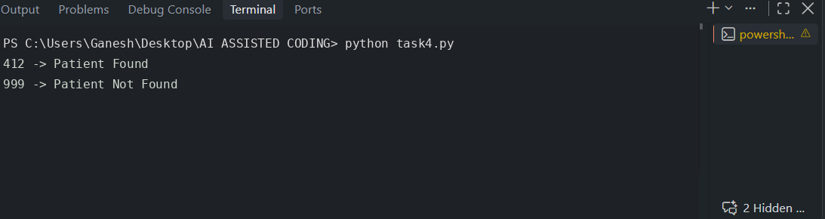
Patient Found
Patient Not Found

6. Explanation and Verification
The original loop checks every ID even after it finds a match. The refactored version uses direct membership testing, which is clearer. A list lookup is O(n) in the typical/worst case because elements may be checked one by one. A set lookup is average O(1), making it suitable for frequent lookups, though worst-case behavior can differ. The set is justified here for repeated membership tests. If the program needs to preserve duplicate IDs or list order, keep the list as the main data structure.

TASK 5 – Complete Legacy Code Review with AI

1. Original Code
students = [("Arun", 78), ("Priya", 45), ("Rahul", 88), ("Meena", 52)]
total = 0
for s in students:
total = total + s[1]
avg = total / len(students)
for s in students:
if s[1] >= 50:
print(s[0], "Pass")
else:
print(s[0], "Fail")
print("Average =", avg)

2. AI Prompt
Review this legacy student-results code. Identify at least five improvements, refactor it with meaningful names and reusable functions, use Python features only when they improve clarity, verify equivalent output, and list accepted/rejected suggestions with reasons.

3. AI Suggestions
- Replace the unclear variable s with student or student_name/student_marks.
- Use meaningful names such as total_marks and average_marks.
- Move average calculation into a calculate_average() function.
- Move pass/fail reporting into a reusable print_student_results() function.
- Use sum() with a generator expression to calculate total marks clearly.
- Keep the pass threshold of 50 unchanged.
- Avoid unnecessary complexity; the list of tuples is sufficient for this small example.

4. Refactored Code
students = [("Arun", 78), ("Priya", 45), ("Rahul", 88), ("Meena", 52)]
def calculate_average(student_records):
total_marks = sum(marks for name, marks in student_records)
return total_marks / len(student_records)
def print_student_results(student_records):
for student_name, student_marks in student_records:
if student_marks >= 50:
print(student_name, "Pass")
else:
print(student_name, "Fail")
print_student_results(students)
average_marks = calculate_average(students)
print("Average =", average_marks)

5. Test Output
VS Code Terminal Output – Task 5
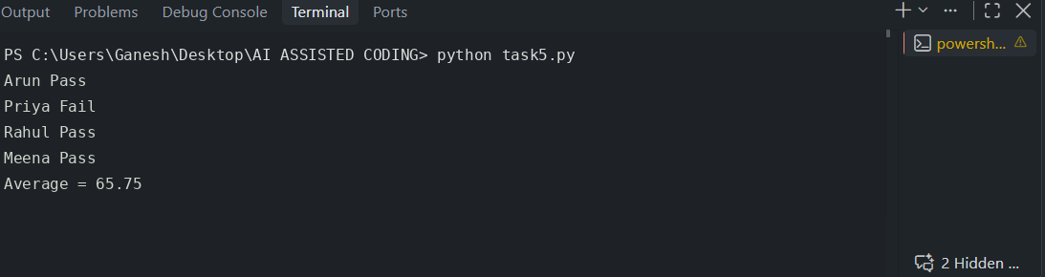
Arun Pass
Priya Fail
Rahul Pass
Meena Pass
Average = 65.75

6. Verification and Explanation
The total marks are 78 + 45 + 88 + 52 = 263. Dividing by 4 students gives an average of 65.75. The original pass mark is 50, so Priya fails and the other three students pass. The refactored code keeps the same student data, threshold, order of output, and average calculation; it therefore preserves the original behavior.

7. AI Suggestions: Accepted / Rejected
Suggestion | Decision | Reason
Use descriptive variable names | Accepted | Names such as student_records and average_marks make the purpose clear.
Create reusable functions | Accepted | Calculation and reporting are separated and easier to test.
Use sum() with a generator expression | Accepted | It expresses the total-mark calculation concisely without changing the result.
Change the pass mark or priority rules | Rejected | That would change the original program behavior and is not required.
Add classes or a complex data model | Rejected | Unnecessary for this small task; tuples and functions are sufficient.

8. Most Useful Refactoring Change
The most useful change is separating the code into calculate_average() and print_student_results(). Each function has one clear responsibility, making the program easier to read, test, reuse, and modify. Meaningful variable names further reduce confusion.

Conclusion
Refactoring improves the structure and readability of existing code without intentionally changing its behavior. In these tasks, functions reduce duplication, simplified conditions make decisions easier to follow, and a set can improve repeated membership lookups. Test cases and output comparisons help verify that the refactored programs still produce the expected results.

