LAB SHEET – 01
NOSQL DATABASE
Session: 2026–2027
Submitted by: Adarsh Yadav
Course / Semester: BCA / V Semester
Roll Number: 243026026
College / Department: College of Smart Computing

Aim
To understand NoSQL database design and perform database and collection creation, document insertion, retrieval, updating, deletion, and database management operations using MongoDB Shell and MongoDB Compass.

2. Objectives
- To create and manage a MongoDB database and collections.
- To insert, retrieve, update, replace, and delete documents.
- To use query filters, projections, update operators, and countDocuments().
- To rename and drop collections and databases.
- To perform CRUD operations through MongoDB Compass.
- To compare MongoDB document operations with SQL operations.

3. Software and Tools Required
• MongoDB Community Server
• MongoDB Shell (mongosh)
• MongoDB Compass
• Windows Command Prompt
• Microsoft Word for report preparation

4. Introduction
MongoDB is a NoSQL document-oriented database. It stores records as BSON documents, which look similar to JSON objects. A database contains collections, and collections contain documents. Unlike a traditional relational database, MongoDB documents can have a flexible structure. MongoDB supports CRUD operations: Create, Read, Update, and Delete.

5. Practical Tasks and Commands
Note: These commands document the practical steps. Run them in the order required by the lab sheet. The database drop operation in Question 20 permanently removes the database and its contents; save screenshots and any required evidence first. The outputs and screenshots sections must be completed using results captured on your own computer.

Q1. Create StudentDB and verify it
use StudentDB
db.createCollection("Students")
show dbs

Q2. Create Students, Faculty, and Courses collections
db.createCollection("Students")
db.createCollection("Faculty")
db.createCollection("Courses")
show collections

Q3. Insert one student
db.Students.insertOne({rollNo: 101, name: "Aarav Sharma", department: "Computer Science", semester: 5, cgpa: 8.2})

Q4. Insert multiple students
db.Students.insertMany([{rollNo: 102, name: "Priya Singh", department: "Computer Science", semester: 5, cgpa: 7.5}, {rollNo: 103, name: "Rohan Verma", department: "Information Technology", semester: 5, cgpa: 8.7}, {rollNo: 104, name: "Neha Gupta", department: "Commerce", semester: 5, cgpa: 6.8}, {rollNo: 105, name: "Karan Joshi", department: "Mechanical", semester: 5, cgpa: 7.2}])

Q5. Retrieve all students
db.Students.find()

Q6. Retrieve a student by roll number
db.Students.findOne({rollNo: 103})

Q7. Retrieve students from Computer Science
db.Students.find({department: "Computer Science"})

Q8. Display only Name and Department
db.Students.find({}, {_id: 0, name: 1, department: 1})

Q9. Update one student's department
db.Students.updateOne({rollNo: 102}, {$set: {department: "Information Technology"}})

Q10. Update semester for matching students
db.Students.updateMany({department: "Computer Science"}, {$set: {semester: 6}})

Q11. Replace one document
db.Students.replaceOne({rollNo: 105}, {rollNo: 105, name: "Karan Joshi", department: "Mechanical", semester: 6, cgpa: 7.2})

Q12. Add an Email field to all students
db.Students.updateMany({}, {$set: {email: "student@example.com"}})

Q13. Add and then remove a temporary field
db.Students.updateMany({}, {$set: {temporaryNote: "Practical"}})
db.Students.updateMany({}, {$unset: {temporaryNote: ""}})

Q14. Delete one student by roll number
db.Students.deleteOne({rollNo: 104})

Q15. Delete students whose CGPA is below 7.3
db.Students.deleteMany({cgpa: {$lt: 7.3}})

Q16. Count documents
db.Students.countDocuments({})

Q17. Rename Students to StudentDetails
db.Students.renameCollection("StudentDetails")
show collections

Q18. Create Departments and insert sample documents
db.createCollection("Departments")
db.Departments.insertMany([{departmentId: 1, departmentName: "Computer Science", hod: "Dr. Mehta"}, {departmentId: 2, departmentName: "Information Technology", hod: "Dr. Verma"}, {departmentId: 3, departmentName: "Commerce", hod: "Dr. Singh"}])

Q19. Drop Departments
db.Departments.drop()
show collections

Q20. Drop StudentDB and verify
use StudentDB
db.dropDatabase()
show dbs

Q21. Recreate StudentDB and insert sample data
use StudentDB
db.createCollection("Students")
db.Students.insertMany([{rollNo: 201, name: "Ananya Rawat", department: "Computer Science", semester: 5, cgpa: 8.4}, {rollNo: 202, name: "Rahul Kumar", department: "Information Technology", semester: 5, cgpa: 7.8}])
db.Students.find()

Q22. Perform CRUD in Compass and compare with Shell
In Compass, connect to mongodb://localhost:27017, open StudentDB > Students, insert a temporary test document, filter a document, edit a field, and delete the temporary test document.

Q23. Demonstrate Shell and Compass
Run db.Students.find() in mongosh and view the same collection in Compass. Compare the displayed records.

Q24. Compare MongoDB CRUD with SQL
Insert: insertOne() / SQL INSERT INTO
Read: find() / SQL SELECT
Update: updateOne() / SQL UPDATE
Delete: deleteOne() / SQL DELETE

6. Outputs and Screenshots
Insert screenshots of the actual MongoDB Shell and Compass results below.,
- [ Create Students, Faculty, and Courses Collections.
- Insert a Single Student Document into the Students Collection.
- Insert Multiple Student Documents into the Students Collection.
- Retrieve All Documents from the Students Collection.
- Create a Database Named Student DB and Verify Its Creation.
- Retrieve a Student Document Using Roll Number.
- Retrieve Students Belonging to the Computer Science Department.
- Display Only the Name and Department Fields of Students.]

Screenshot 1______________________________________________
[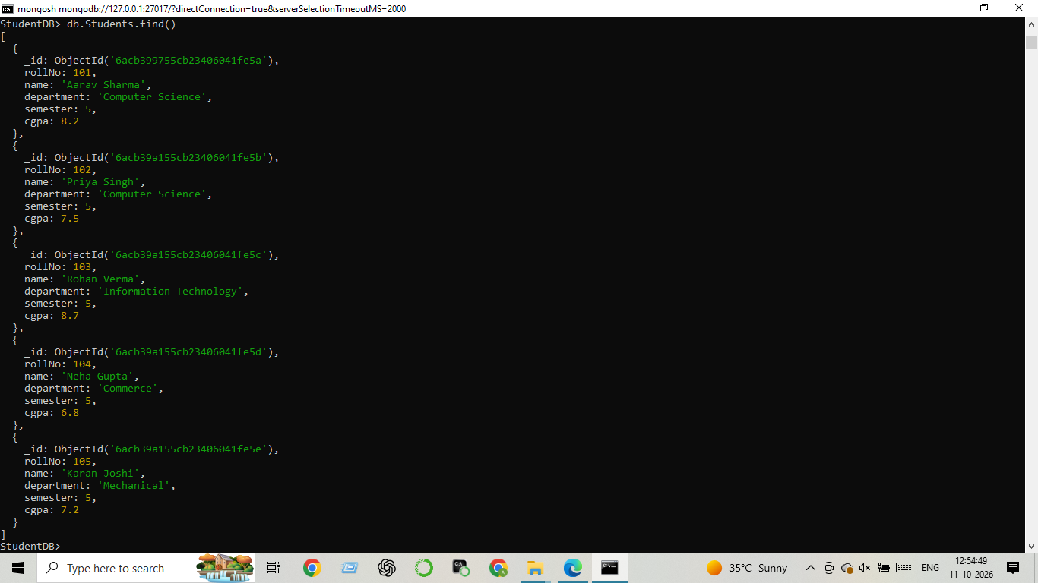]
Screenshot 2: ______________________________________________
[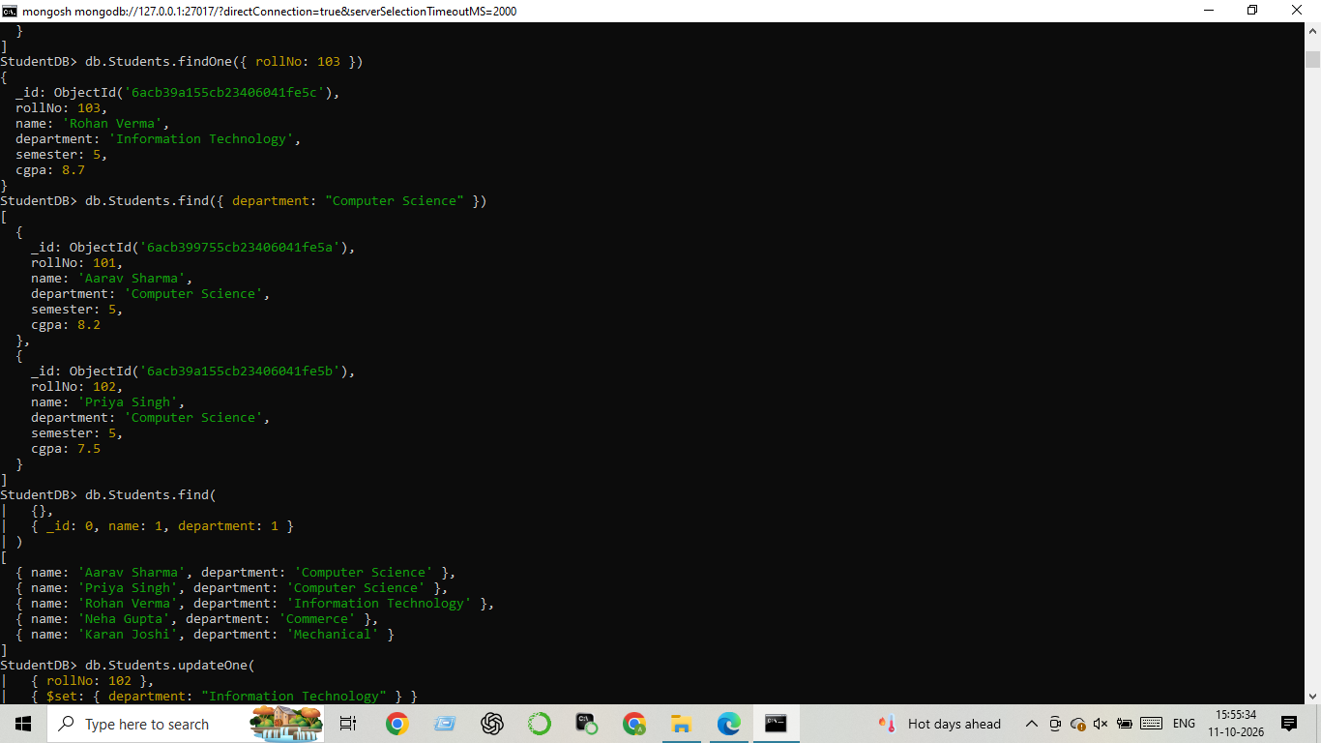]
- Update the Department of a Student Using update One().
- Update the Semester of Multiple Students Using update Many().
- Replace a Student Document Using replace One(). ]

Screenshot 3: ______________________________________________
[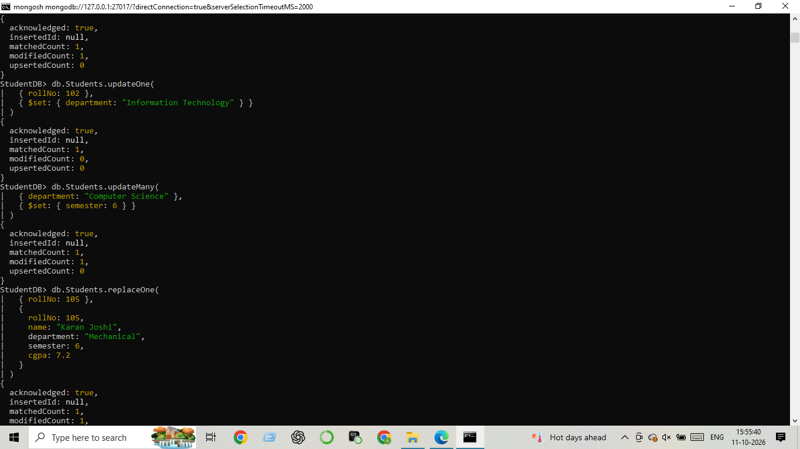]
- [ Add an Email Field to All Student Documents.
- Remove a Field from Student Documents Using the $unset Operator.
- Delete a Single Student Document Using Roll Number.]
Screenshot 4_____________________________________________
[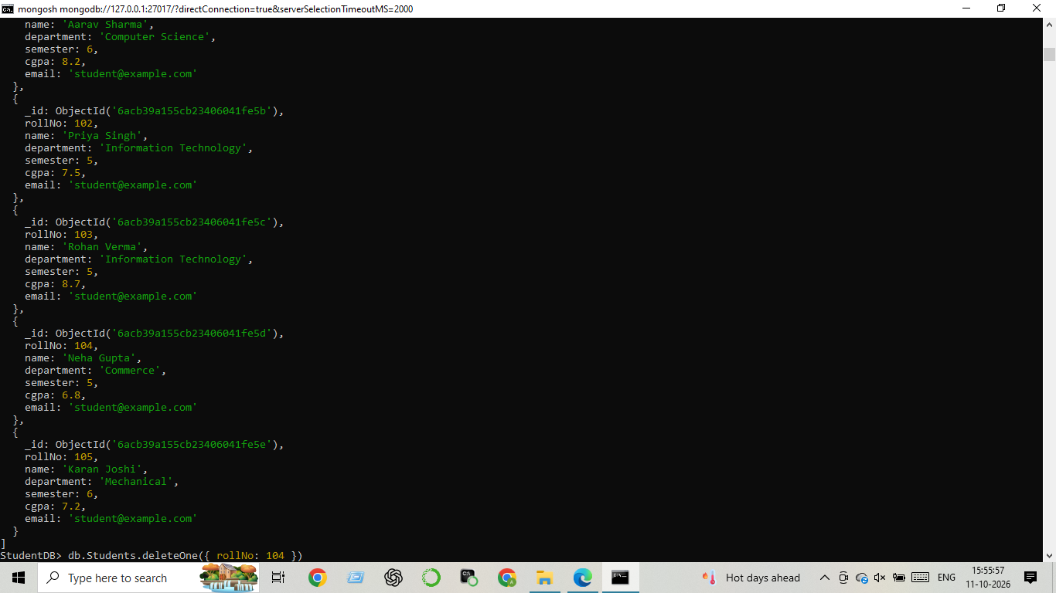]
- [ Delete Multiple Student Documents Based on a Condition.
- Count the Total Number of Documents in the Students Collection ]
Screenshot 5: ______________________________________________
[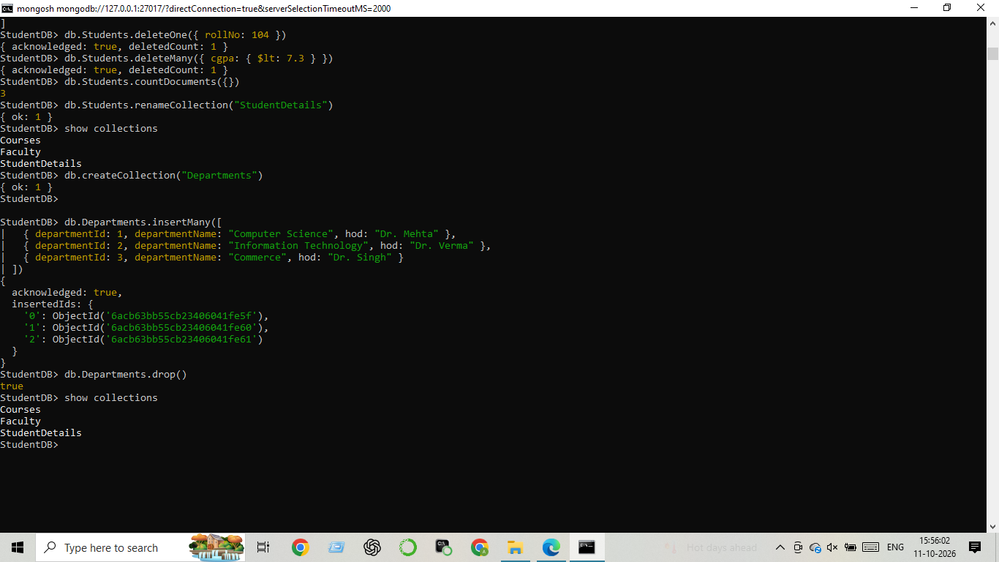]
- [ Re-Name the Students Collection to Student Details.
- Create a Departments Collection and Insert Sample Department Documents.]
Screenshot 6: ______________________________________________
[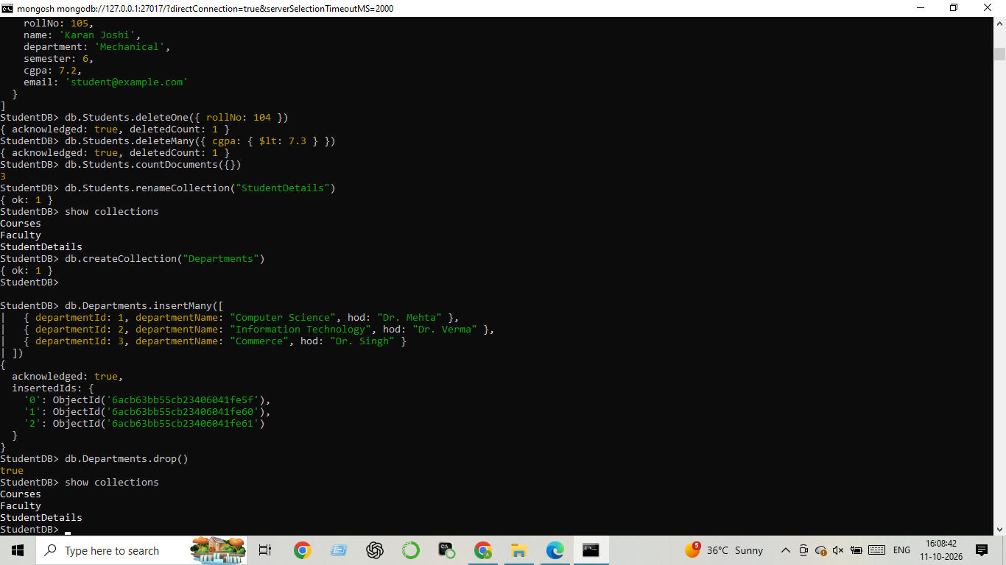]

Screenshot 7: ______________________________________________
[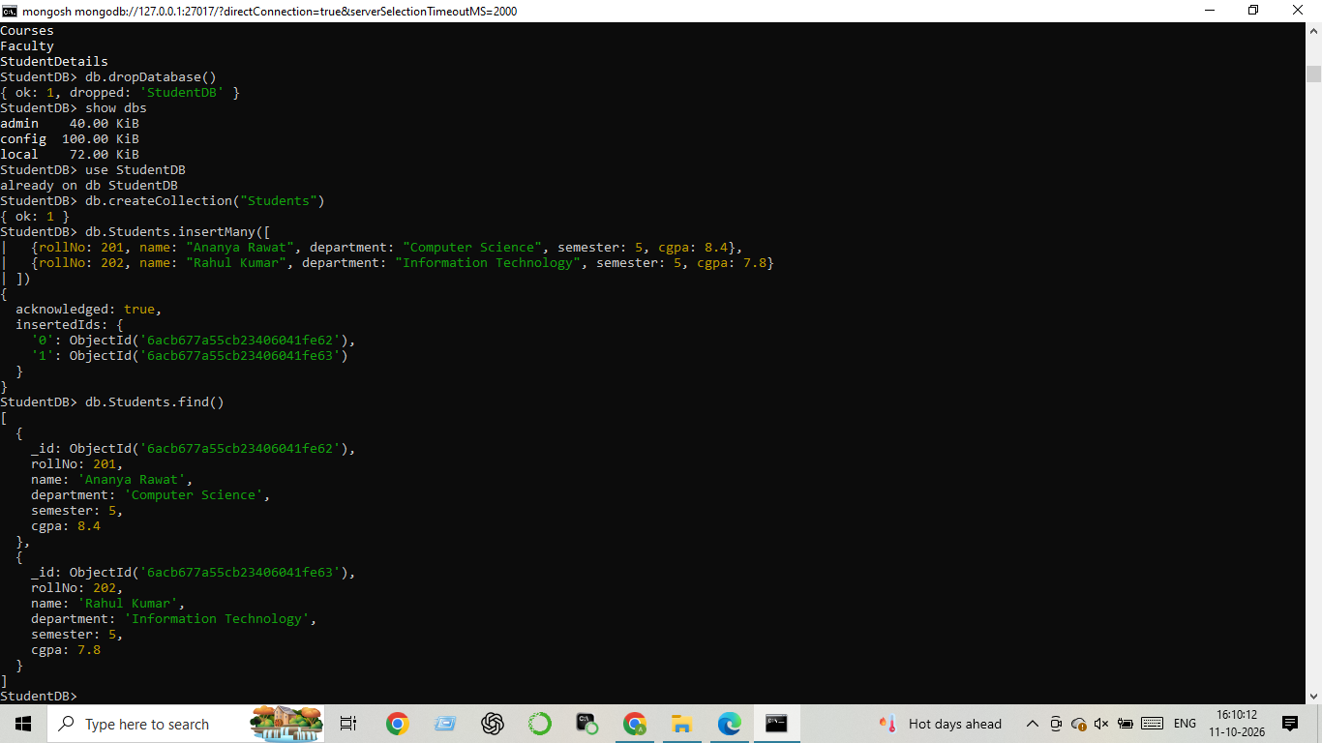]

Screenshot 8: ______________________________________________
[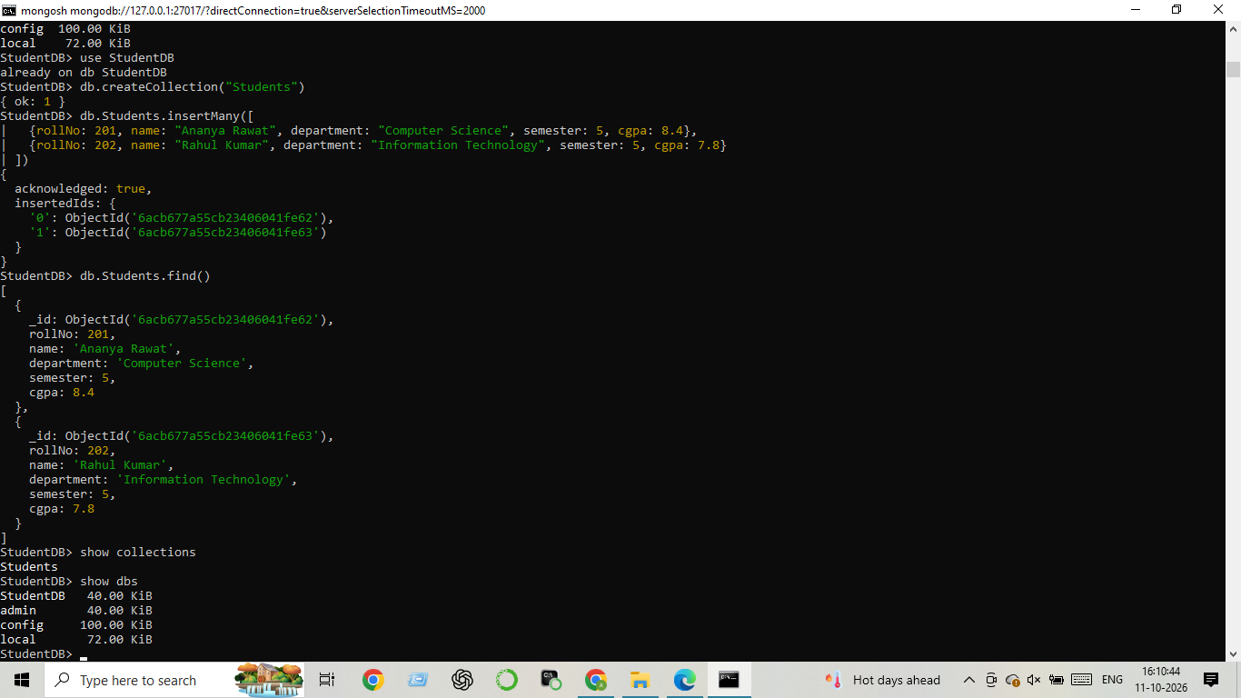]

Screenshot 9: ___ Q22_Compass_CRUD.png ____
[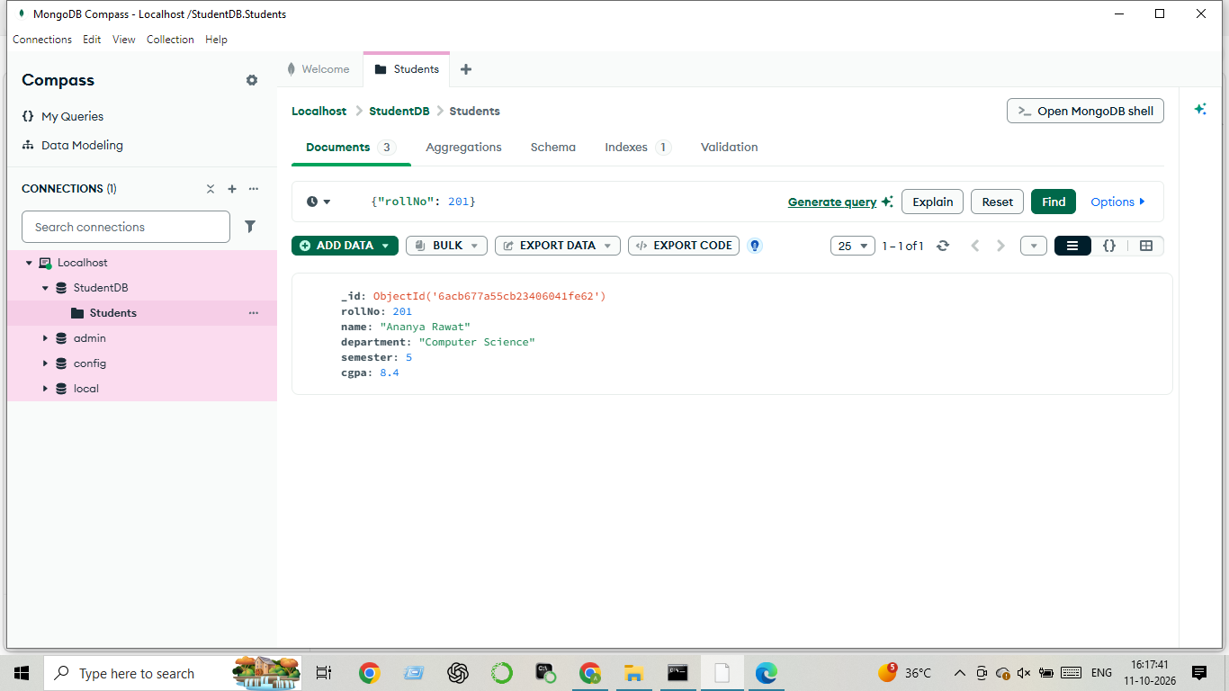]

Screenshot 10: _____ Q22_Compass_CRUD.png ____
[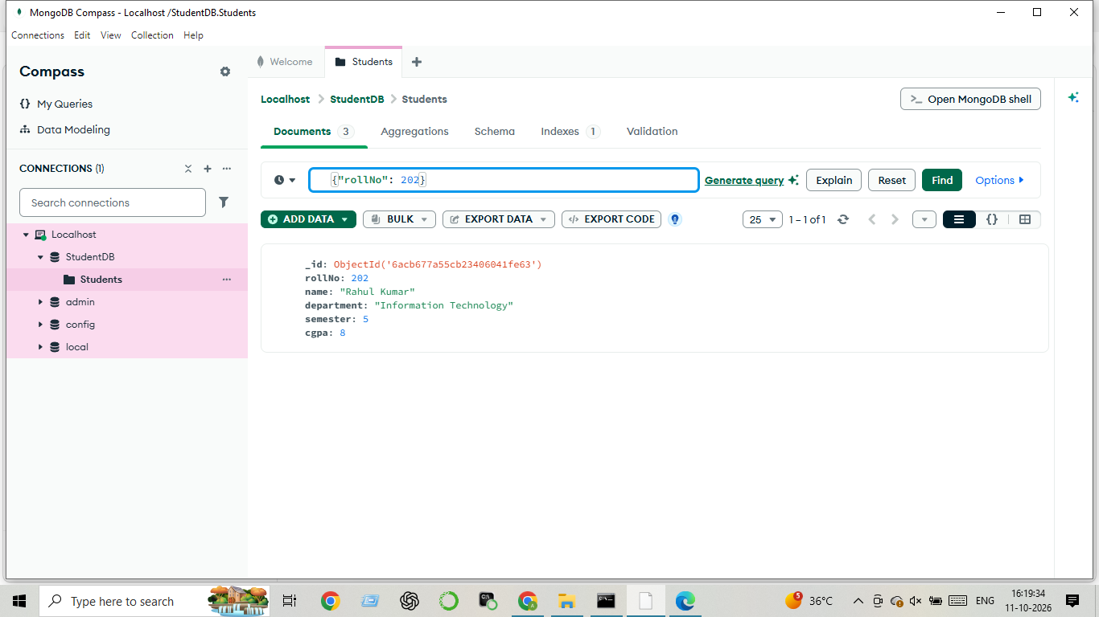]

Screenshot 11: _ Q22_Compass_CRUD.png___
[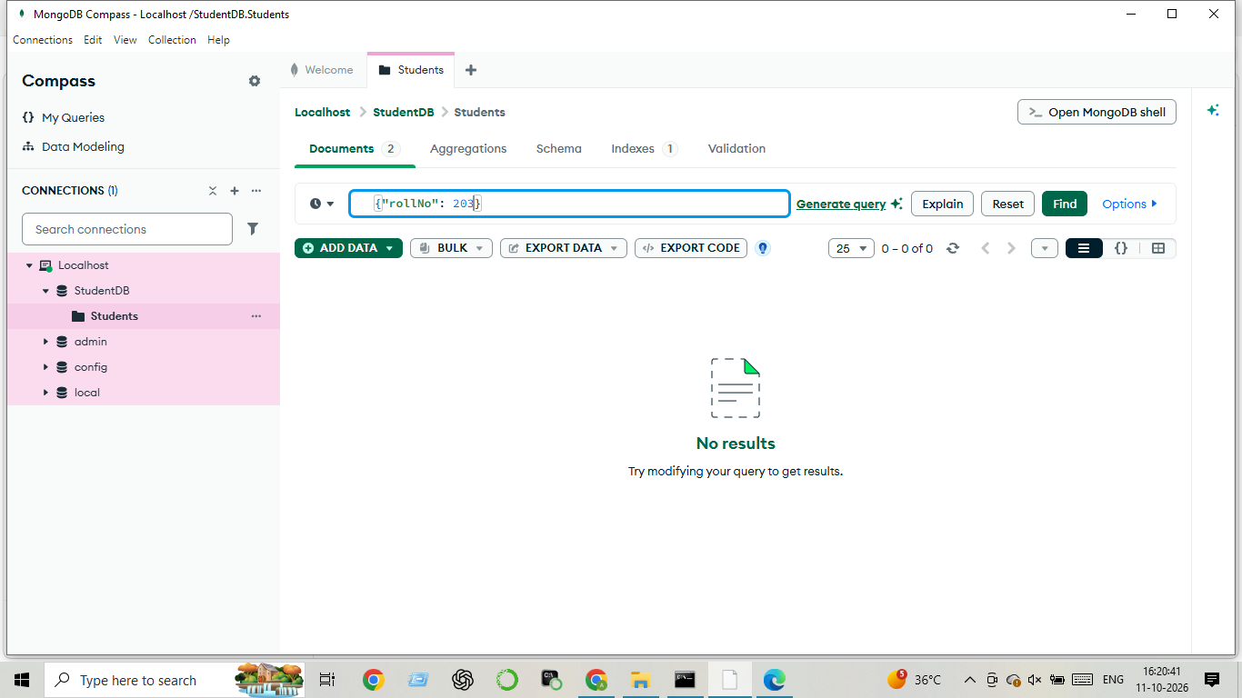]

Screenshot 11- Q 23_Compass _______
[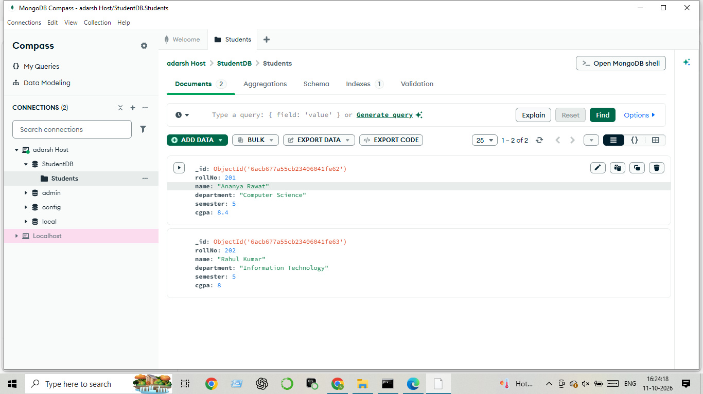
Screenshot 12 - Q 22 Compass shell
[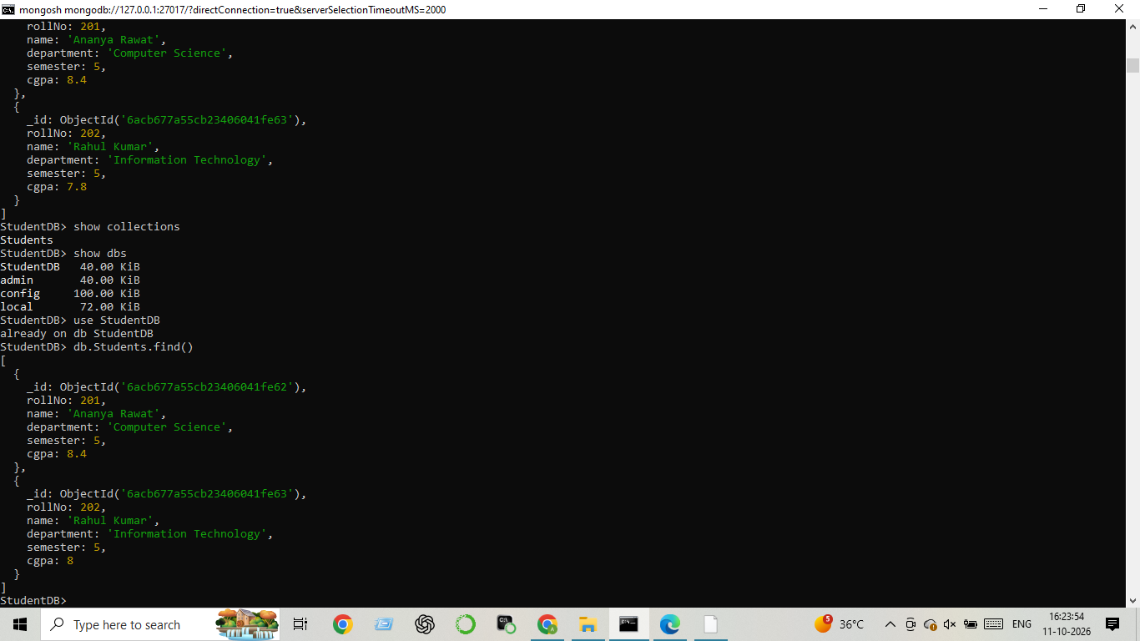]

7. MongoDB Shell vs MongoDB Compass
MongoDB Shell | MongoDB Compass
Uses written commands. | Uses a graphical interface.
Useful for scripts and repeated operations. | Useful for visual inspection and editing.
Requires knowledge of command syntax. | Often easier for beginners to navigate.

8. MongoDB vs SQL
Feature | MongoDB | SQL databases
Data structure | Documents in collections | Rows in tables
Typical read operation | find() | SELECT
Typical insert operation | insertOne() | INSERT INTO
Schema | Flexible document structure | Usually predefined table schema

9. Observations
MongoDB Shell commands were used to manage databases, collections, and documents. Insert, read, update, replace, delete, count, rename, and drop operations were practised. MongoDB Compass provides a graphical way to inspect and modify the same database.

10. Conclusion
This practical introduced the basic concepts of NoSQL database design using MongoDB. The tasks demonstrated database and collection management and the four CRUD operations. Using both MongoDB Shell and Compass helped compare command-based and graphical database work.

