Objective 3

4500H – 11

3200H - 45

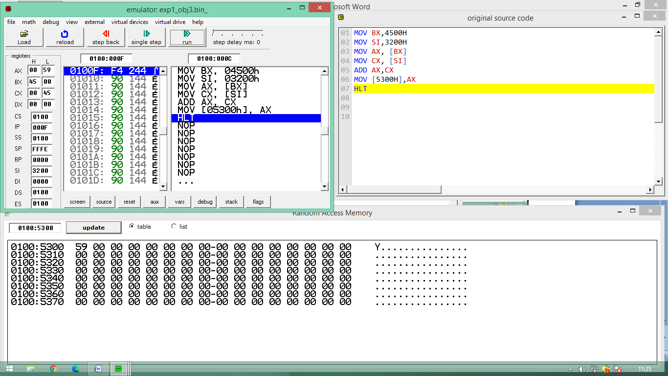

Objective 4

DI – 45C0 = A6  
SI – 24F0 = 44

Result – 75FFH= EA

