Experiment 1

Objective 1

Input

BX = 0AF10H

0F100H = AAFF

OUTPUT

RES BX = AE BF

CF = 1

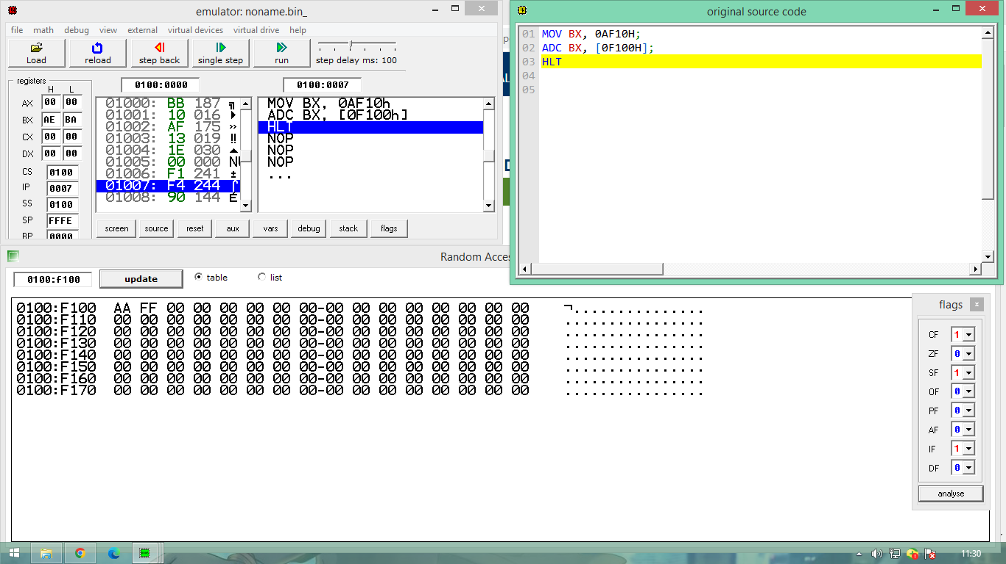

Objective 2

BX = 00ff1h

Cx = [0440h] = dd00h

Output

Res = BX = 0f14

