Optimizing Bank
Lending Decisions Using Metaheuristics

OPTIMISATION AND HEURISTIC
METHODS TERM PROJECT
(IM39003)

ADARSH MODI
19IM30004
Industrial and Systems Engineering Department
IIT KHARAGPUR

INDEX

- PROBLEM STATEMENT
- PROBLEM REPRESENTATION
- PROBLEM FORMULATION
- CHROMOSOME ENCODING
- FITNESS FUNCTION
- GENETIC ALGORITHM IMPLEMENTATION
- GENETIC ALGORITHM WITH AMALGAMATION OF TABU SEARCH IMPLEMENTATION
- RESULTS
- INFERENCES
- REFERENCES

PROBLEM STATEMENT

In times of financial crisis, illiquidity becomes a major issue for both lenders as well as borrowers. Insolvency of banks can lead to a reduction in bank loans. This is due to two reasons. Namely:
- Banks with inefficient allocation of loans have a large proportion of loans which are at risk of default reducing the capital available to these banks
- Moreover, even healthy banks which have more efficient allocation of loans become more cautious in their lending practices through cutting back on lending

Due to these reasons, there is a credit crunch which makes it essential to develop an optimal mechanism for determining bank lending decisions which maximize the bank profits in a timely manner.
The issue at hand here is not whether the borrowers are eligible to get the required loan but rather, to make lending decisions in a credit crunch environment where all applicable borrowers are eligible to get the desired loans. This, therefore, is an NP-hard optimization problem which can be solved using meta-heuristic algorithms such as evolutionary algorithms.
The Paper proposes an intelligent model based on Genetic Algorithm (GA) to organize bank lending decision.
BENEFITS OF USING GENETIC ALGORITHM?
The problem of bank lending decision in a credit crunch environment- where all applicable customers are eligible to get the desired loan is an NP-hard optimization problem that can be solved using meta-heuristic algorithms such as evolutionary algorithms.
The main focus of the GA model is two-fold:
- To stabilize banks systemically while achieving maximum profit
- to establish the capital base so that banks would increase lending efficiently

PROBLEM REPRESENTATION
In our proposed method, the lending decision is dynamically decided based on customer’s loan characteristics. With the assumption that all customers are applicable to get the required loan, GA is employed to search for the most suitable customers depending on a set of factors such as-
• Loan age
• Loan size
• Loan interest rate
• Loan type
• Borrower credit rating.

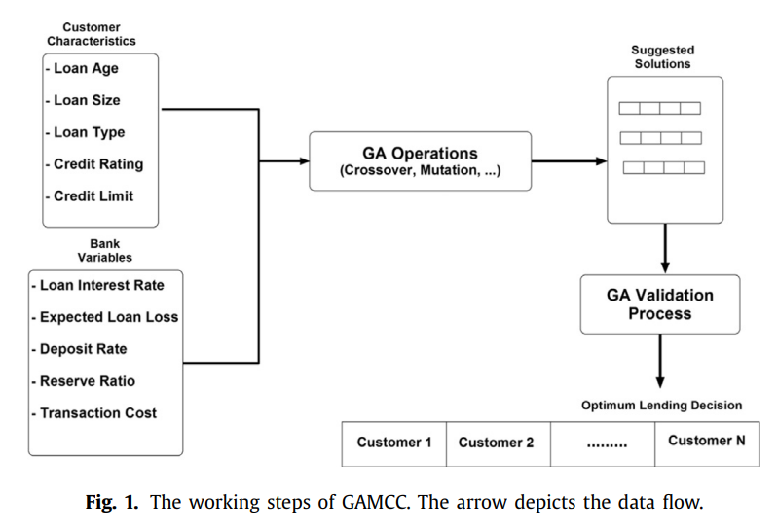

PROBLEM FORMULATION –

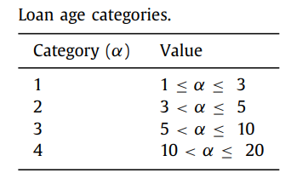
- Loan Age (α): With an assumption that the maximum number of years for any loan is 20 years, the loan age is divided into four categories depending on its expected period time.

- Loan Size (L): Depending on the credit limit, the loan size is determined. The loan size determines the amount of loan requested by a specific customer.

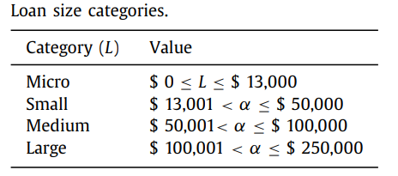

- Loan Type (ϕ): There are three types of loans assumed: Mortgage (M), Personal (P), and Auto (A)
- Credit Rating: Borrow Credit Rating is used to measure the range of the expected loan loss.

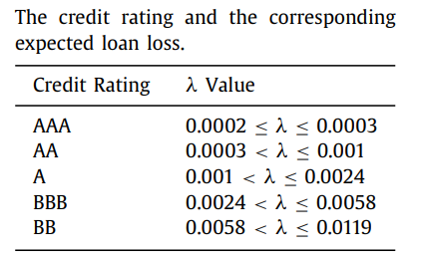

- Credit Limit: The credit limit represents the maximum loan amount that can be given to the customer based on his income and occupation.
- Loan interest rate (rL): Based on the values of ϕ and α, the loan interest rate rL is assigned.
- Expected Loan Loss (λ): The expected loan loss from different borrowers is calculated by the credit rating assigned to them.

CHROMOSOME ENCODING
The genes in the chromosome have binary encoding (and therefore have values 0 or 1). The length of the chromosome is equal to the number of eligible borrowers. Each borrower is therefore represented by a gene in the chromosome. A 0 in the gene means that the loan was not provided to the borrower. Similarly, a 1 in the gene means that the loan was provided to the borrower. Each customer is identified by their index number in the chromosome. Therefore, each chromosome with combinations of 0s and 1s represent a loan allocation solution.

1 | 2 | 3 | 4 | 5 | 6 | 7 | 8 | 9 | 10
0 | 1 | 1 | 0 | 0 | 1 | 1 | 1 | 0 | 1
A chromosome which consists of 10 genes corresponding to 10 borrowers

FITNESS FUNCTION
The GA’s fitness function ( F x ) simply consists loan revenue ( ϑ), loans cost ( μ), total transaction cost ( ϖ), and cost of demand deposit ( β).
- Loan Revenue (ϑ): The value of the loan revenue is calculated using the loan interest rate (rL), loan size (L), and the expected loan loss (λ).
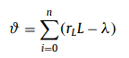
- Loans Cost (μ): The value of the loan cost is determined using the loan size (L) and the predetermined institutional cost (δ).
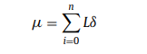
- Total Transaction Cost (omega): The value of the total transaction cost is determined using institute transactional cost (T) and the customer transaction rate (rT). The value of rT has been assumed to be 0.01 for the purpose of this project.
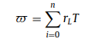
- Cost of Demand deposit (β): The value is determined using the bank’s deposit interest rate (rD) and the bank’s deposit (D).
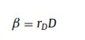
- Final Fitness function (Fx):
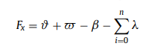

GENETIC ALGORITHM IMPLEMENTATION
FLOW OF GA:
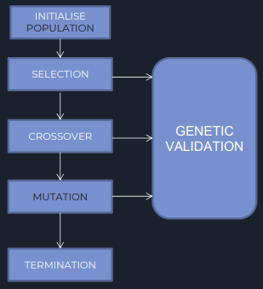
STEPS FOR IMPLEMENTATION:
- INITIALISED THE POPULATION -
Randomly generated an initial population of chromosomes and validated each randomly generated chromosome (rgc) for feasibility to create a population of feasible solutions. The function returns a list of chromosomes which are represented as a list. The length of chromosomes is the size of the dataset, and the length of the list is the population size.

- EVALUATED THE FITNESS –
Evaluated the fitness of each chromosome in the population and added it to the fitness list. On the basis of this determined the average fitness of a generation and the maximum fitness of each generation. This function returns a list of fitness values. Also, in order to easily calculate probabilities, it has been ensured that all the values in the fitness are positive.

- SELECTION USING ROULETTE WHEEL SELECTION –
Selection of parent pool for reproduction is performed based on the fitness values of the current generation individual. There are different ways of forming the reproduction pool like proportionate selection, roulette wheel selection, tournament selection etc. In our model, Roulette Wheel Selection is used.

- CROSSOVER (SINGLE POINT CROSSOVER) -
In the crossover function we create pairs of chromosomes, then on the basis of the probability of a crossover occurring called the crossover ratio, we randomly determine which pairs will undergo crossover. For the pairs which undergo crossover, we determine the position of crossover. Here we conduct a one-point crossover. We must ensure that the position of crossover is not an end gene in the chromosome otherwise it would mean no crossover is occurring. Before appending the chromosome to the population, we validate it.

- MUTATION –
Randomly determined the chromosomes to carry out the mutation on, with the probability equal to the mutation ratio. For the chromosomes where the mutation is to be carried out, a random gene is selected, and its value is inverted. Then mutated chromosome is validated and only then it’s appended to the mutated population.

- CHECKING THE VALIDITY –
At every step of generating a new chromosome, the solutions are maintained within the constraints. Therefore, feasibility of the solutions is validated using the check_validition function.

- TERMINATION CRITERIA –
When the termination condition is reached – the required number of generations created or no significant change in average fitness over multiple generations – the final population is arrived at and returned.

AMALGAMATION OF GENETIC ALGORITHM AND TABU SEARCH IMPLEMENTATION –
FLOW OF GA-TABU AMALGAMATION ALGORITHM –
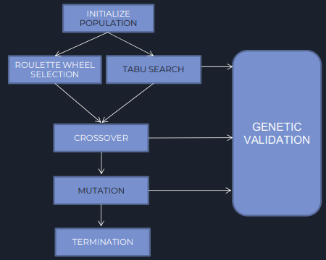
STEPS FOR IMPLEMENTATION:
After performing mutation in GA, following steps are performed –
- NEIGHBOURHOOD SOLUTION IS SELECTED –
Neighbourhood solution (chromosome) from the candidate list is selected such that the chromosome has the maximum fitness value from the list
If the chosen chromosome is not already present in the Tabu list, this chromosome gets updates as the neighbourhood solution
Else the Aspiration Criteria is checked and if the chromosome in Tabu list leads to better solution, it gets updated as neighbourhood solution.
- FITNESS VALUE OF THE NEIGHBOURHOOD SOLUTION IS CALCULATED –
Fitness value of the neighbourhood solution is calculated and if the fitness of neighbourhood solution is better, the current chromosome is updated and equals to neighbour solution.

- TABU LIST IS UPDATED –
Add the chromosome to Tabu list and update the Tabu counter List.
- TERMINATION CRITERIA -
The above process is repeated until termination criteria reached.

RESULTS
VISUALISING THE RESULTS –
We maintain a history of maximum fitness values for each generation of the algorithm. These allow us to visualize the progress of the algorithm in reaching the near-optimal solution.

GENETIC ALGORITHM –

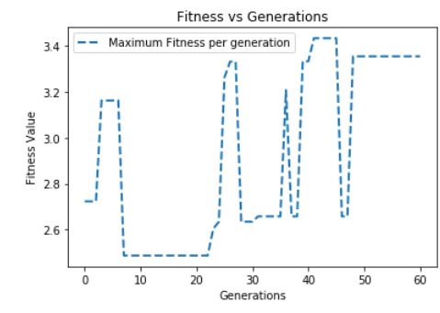

Best solution obtained from GA –

1 | 2 | 3 | 4 | 5 | 6 | 7 | 8 | 9 | 10
1 | 1 | 1 | 0 | 1 | 1 | 0 | 0 | 1 | 0

Best solution Fitness Value = 3.4328
Customers 1, 2, 3, 5, 6, 9 will have their loan sanctioned

GA-TABU –

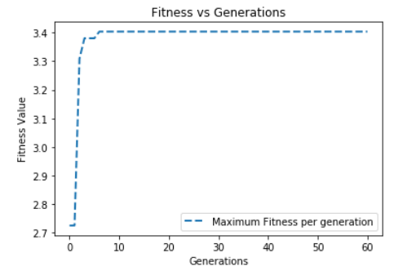

Best solution obtained from GA –

1 | 2 | 3 | 4 | 5 | 6 | 7 | 8 | 9 | 10
1 | 1 | 1 | 1 | 0 | 1 | 1 | 0 | 0 | 0

Best solution Fitness Value = 3.4034

Customers 1, 2, 3, 4, 6, 7 will have their loan sanctioned.

ALGORITHM | BEST CONFIGURATION | FITNESS VALUE
GA | [1, 1, 1, 0, 1, 1, 0, 0, 1, 0] | 3.4328
GA-TABU | [1, 1, 1, 1, 0, 1, 1, 0, 0, 0] | 3.4034

At max iterations = 60 GA achieved optimal solution, fitness
Value = 3.4328, whereas GATS solution has fitness value of
3.4034 .Thus, performance of GA is better than GATS.

INFERENCES –

- The average fitness for a generation initially increases rapidly and with later generations, the increase slows down.
- In GATS, the maximum fitness value for a generation does not change much. This is due to the fact that chromosomes which have the maximum fitness have the maximum probability of advancing to the next generation and hence are maintained.
- At max iterations = 60, GA achieved optimal solution, fitness value = 3.4328, whereas GA-TABU solution has fitness value of 3.4034.
- Both the algorithms result in providing the optimal bank lending decision almost every time, given the number of generations is high.
- Both the algorithms are capable of solving the given, NP-hard optimization problem, signifying the use of evolutionary algorithms in the field of decision making.

REFERENCES –

- https://www.sciencedirect.com/science/article/abs/pii/S0957417417301677
- Teimouri, S., & Dutta, N. (2016). Investment and bank credit recovery after banking crises. Journal of Financial Stability, 26,306–327. (http://dx.doi.org/10.1016/j.jfs.2016.07.013). 2)
- Bhargava, S. (2013). A note on evolutionary algorithms and its applications. Adults Learning Mathematics: An International Journal, 8 (1), 31–45. 3)
- Metawa, N., Hassan, M. and Elhoseny, M., 2017. Genetic Algorithm Based Model For Optimizing Bank Lending Decisions.

**END**

