Name: _________________________

1. (20 pts) Given below are a list of terms that you should learn in this course and a list of definitions for a subset of them. Fill in the blanks from the list terms with the one that best fits the given definition or description. (2 pts each)
(a) A generic process model characterized by the cyclic repetition of four phases, one of which is the evaluation of the risks associated with alternative solution strategies.
Spiral Model
(b) Algorithms for developing software: A set of activities, methods, practices, and transformations that people employ to develop and maintain software and the associated products. Software Process

(c) A kind of abstraction that assigns a name, perhaps with defined parameters, to a well-defined and reusable computational process or algorithm. This allows the designer to reason in terms of inputs and results of the named computation without having to think about the details of how the computation will be accomplished or implemented. Procedural Abstraction
(d) The type associated with an object reference based on its runtime value.
Dynamic Type
(e) A kind of class defined by the Unified Software Process that handles data entering (leaving) the system from some external user or system. Boundary Class
(f) A sequence of actions a proposed system performs to offer some results of value to a User.
Use Case
(g) A separately named and addressable software unit that encapsulates and abstracts a set of related software capabilities and features. It generally consists of two parts: an interface – for access by similar software units, and an implementation – that specifies how the capabilities and features of the interface are realized. Module (Class -1)
(h) A kind of design property that exploits language mechanisms and encapsulation techniques to prevent client access to, and use of, details about the representation of data structures and types. Information Hiding
(i) A type of UML diagram used to express the static structure of an OO software design in terms of its modular components and their relationships. Class Diagram

(j) The re-definition of a method in a subclass having the same name and equivalent profile as a method in the superclass. Overriding
2. (10 pts) Give a brief definition or description of the following focus area of design.
(a) Focus Area: Architectural Design. (5 pts)
An enumeration of all the relevant modules (logical organizational units) and components (processing units), their functionality and data processing responsibilities, their inter-dependencies, connectivity and/or communication relationships with other architectural units.

(b) Focus Area: Interface Design. (5 pts)
An interface is defined when two or more architectural units must exchange data with each other or interact in some way. An interface design must specify the data content exchanged, the direction of flow, timing constraints, interaction protocols, and mechanism for communication (e.g., hardware signal, hardware registers, shared variables, data file, database record or relation, gui).

3. (40 pts ) Based on your knowledge and experience, identify the most fitting UML relationship that best describes the real-world relationship between each of the following pairs of objects or classes. Answer with one of the following: aggregation, affiliation, composition, association, gen/spec, instance-of. In addition, give the UML diagram that describes the relationship in each case. 4pts each: 2pts for correct relation, 2pts for modeling the relation correctly in UML
(a) In Lab2: Vending Machine to Vending Item Aggregation
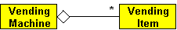
(b) In a Use Case Model: Actor to Use Case Diagram(UCD) Composition
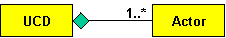
(c) In Lab1: AppError to TokenError Gen/Spec
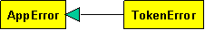
(d) In the real world: Home to Electrical System Composition 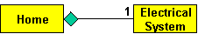
(e) In the OO Development Process: Use Case Model to Analysis Model Association
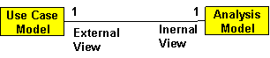
(f) In OO Design: Class to AppError Instance Of
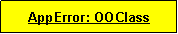
(g) In Grocery Checkout Scenario: Cart to Grocery Aggregation
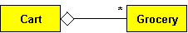
(h) In the real world: Software Engineer to IEEE Society Affiliation

(i) Here and now: Student to Exam Association
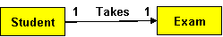
(j) In the real world: Dishwasher to Dish Association
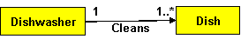
4. (15 pts) Draw on your experience with Lab2 to answer this question. Complete the Use Case Diagram below by adding any missing actors and/or use cases, and then draw in the relationships (correct UML notation for these relationships).
2pt Credit Institution
2pts Select Item
1p for each correct relation
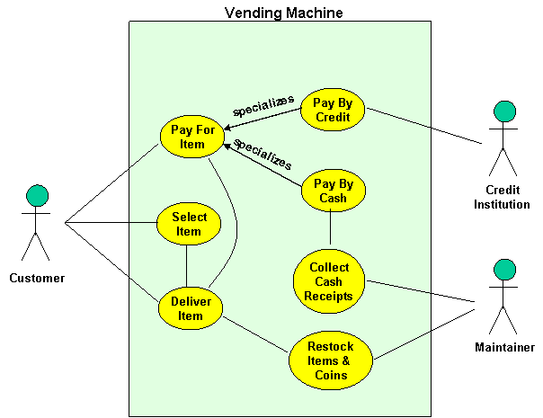
5. (15 pts) Using Data Flow Diagrams, model a Movie Theatre as an entertainment system that services movie goers by providing pop corn, candy and drinks to its patrons while watch a movie. Give the Context Diagram and make sure that all data flows are properly labeled.
5pts for correct external data source/sink & System Process bubble
10pts for correct data flows

