Name: _________________________

1. (30 pts) Given below are a list of terms that you should learn in this course and a list of definitions for a subset of them. Fill in the blanks from the list terms with the one that best fits the given definition or description. (2 pts each)
(a) The first formally defined software process model. This model classified development effort into the following phases: system requirements, software requirements, design, code & unit test, installation and maintenance. ___________________________
Water Fall Model
(b) The application of a systematic, disciplined, quantifiable approach to the development, operation, and maintenance of software. _____________________________
Software Engineering

(c) A kind of abstraction that assigns a name, perhaps with defined parameters, to a well-defined and reusable computational process or algorithm. This allows the designer to reason in terms of inputs and results of the named computation without having to think about the details of how the computation will be accomplished or implemented. ___________________________
Procedural Abstraction
(d) The type associated with an object reference based on its declaration. __________________
Static Type
(e) Used during requirements analysis and specification to model modules that monitor and otherwise manage or coordinate, sequencing, transactions, and control of other objects.
__________________________
Control Class/Object
(f) A sequence of actions a proposed system performs to offer some results of value to a User.
_________________________
Use Case
(g) A collection of objects offering a common set of services and possessing a common set of data attributes. It defines or characterizes a new “data type” in the problem or solution domain.
_________________
OO Class
(h) A property of design that exploits language mechanisms and encapsulation techniques to prevent client access to, and use of, details about the representation of data structures and types.
____________________
Information Hiding
(i) A type of UML diagram used to express the dynamic interactions among objects and actors participating in a use case. ______________________ Communication or Collaboration Diagram

(j) A programming concept exhibited when two or more methods of the same class have the same name, but different parameter profiles that uniquely distinguish them. _________________
Overloading

(k) A type of UML diagram that illustrates the interactions between use cases of a given system and the actors that interact with them. ________________________
Use Case Diagram
(l) A type of design activity that focuses on enumerating all relevant information that must be handled by the system together and with specifying the relationships that must be defined, created and maintained among these elements. Examples: composition, aggregation, association, specialization, generalization, and multiplicity are relationships used in object-oriented design methods. _______________________
Data Design

(m) A type of design activity that focuses on the enumeration of all the relevant modules (logical organizational units) and components (processing units), their functionality and data processing responsibilities, their inter-dependencies, connectivity and/or communication relationships with other architectural units. _________________________
Architectural Design

(n) A frame of mind and set of concepts that permit the designer to reason about the problem and its solution at some level of generalization that disregards irrelevant details – it organizes the problem and its solution into various strata of concepts, entities and their logical relationships.
______________________
Abstraction

(o) A type of UML diagram used to express the control flow among processes and use cases at the system level, or the flow of control of algorithmic steps in a method or procedure at the detailed design level. ______________________
Activity Diagram
2. (26 pts)

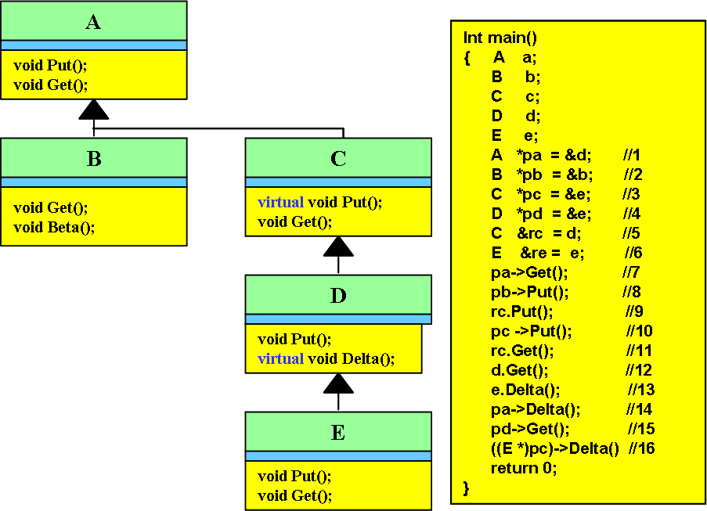

Shown above is a class hierarchy and to its right a C++ program segment using the typed defined by the hierarchy. Note that sixteen of the program statements are labeled by comments. For each part of this question fill in the relevant table based on the class hierarchy and the code segment provided.

Part (a)(6 pts) For each of the variables declared in the given line of code, give the variables static type and its dynamic type. Both typeS must be correct to receive credit – 1pt each.

Line # | Static Type | Dynamic Type
//1 | A | D
//2 | B | B
//3 | C | E
//4 | D | E
//5 | C | D
//6 | E | E

Part (b)(20 pts) For each line determine whether or not it is correct as written. If it is not correct then indicated, in the Error column, what kind of error it would cause, a compile error or a runtime error.

If the statement is correct, then determine what method is actually called at runtime. Indicate your answer in the Method column using the notation Class::Method , that is specify the name of the class and the name of the method separated by the scope resolution operator. Be careful here – this question tests whether or not you understand runtime binding.

Finally, in the Object column give the name of the actual object (at runtime) used for the method invocation (your answer will be one of: a, b, c, d, e ).

Line # | Object | Method | Error
//7 | d | A::Get()
//8 | b | A::Put()
//9 | d | D::Put()
//10 | e | E::Put()
//11 | d | C::Get()
//12 | d | C::Get()
//13 | e | D::Delta()
//14 |  |  | Compile Error
//15 | e | C::Get()
//16 | e | D::Delta()
3. (24 pts ) Based on the context specified, identify the most fitting UML relationship that best describes the relationship between each pair of objects or classes given. Answer with one of the following: aggregation, affiliation, composition, association, gen/spec, instance-of. In addition, give the UML diagram that describes the relationship you identified.
4pts each: 2pts for correct relation, 2pts for modeling the relation correctly in UML
(a) In software process: People to Development Activity Association
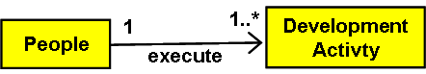
(b) In Travel: Car Trunk to Luggage Aggregation
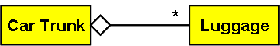
(c) In life: Political Party to Senator Affiliation
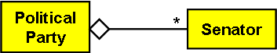
(d) In a Use Case Model: Use Case Diagram(UCD) to Use Case Composition
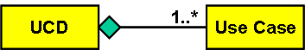
(e) In Lab2: Pet to Dog Gen/Spec


(f) In system specification:
Requirements Document to Requirements Statements Composition
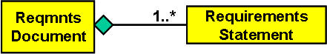
4. A UPS Store offers a variety of services to its customers. One can fax documents, purchase packaging materials, ship packages via UPS either ready to ship (you package items yourself), or optionally, have store personnel package the items to make them ready to ship. Of course it is implied that you have to pay for these services, either by cash or by credit card. A receipt of your transaction is always returned before you leave the store.

For this question you are asked to model various aspects of the UPS Store “system”.
Part (a) (10 Pts) In this part imagine modeling the UPS Store as a Use Case Diagram.

a.1 (2 pts) List four major use cases in this scenario.
________________________ ____________________________
________________________ _____________________________
Any four of: fax documents, purchase packaging materials, ship package, pay for services. Take off 1pt if they only get 2 or 3 correct, take off 2pts if they only get 0 or 1 correct.

a.2 (4 pts) Model in UML notation the following use cases and their relationship. Do this in the style of question 3.0 by giving the name of the relationship and then expressing that relationship in proper UML notation. The two use cases are: ship package and prepare package for shipping.
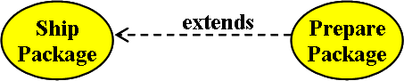

2pts for “extends” 2 pts for diagram (open arrow head, dashed arrow pointing as shown)
a.3 (4 pts) Model in UML notation the following use cases and their relationship. Do this in the style of question 3.0 by giving the name of the relationship and then expressing that relationship in proper UML notation. The three use cases are: Pay For Services, Pay-By-Credit, Pay-By-Cash. 2pts for specializes or generalizes (both arrows should have the same label and point the same direction)(generalizes points opposite to what I have drawn). Two points for the type of arrow (not dashed and closed arrow head).
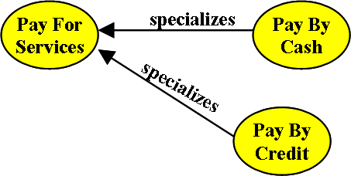
4. (continued)

Part (b)(10 pts) Imagine modeling the UPS Store as a collection of Data Flow Diagrams.

b.1 (7 pts) Show the Context Diagram for the UPS Store. (Hint: model “needy customers” going into the store and “satisfied customers” leaving the store.) Count 3pts for correct external interfaces, 3 pts for correct data flows, 1 pt for having one system bubble.

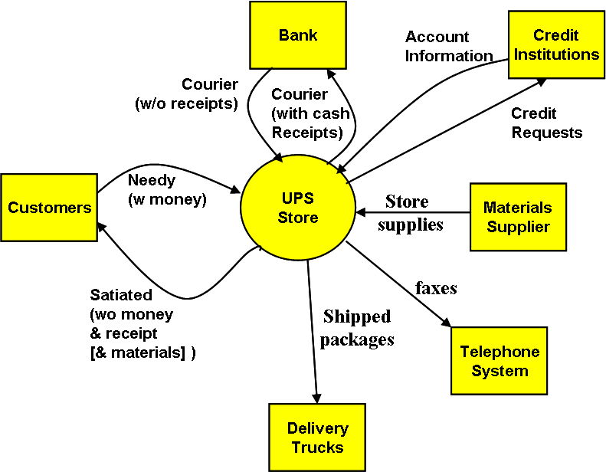

b.2 (3 pts) Show part of the Level 1 decomposition that might involve a DFD “store”, that is, name the store and all process bubbles that connect to it.

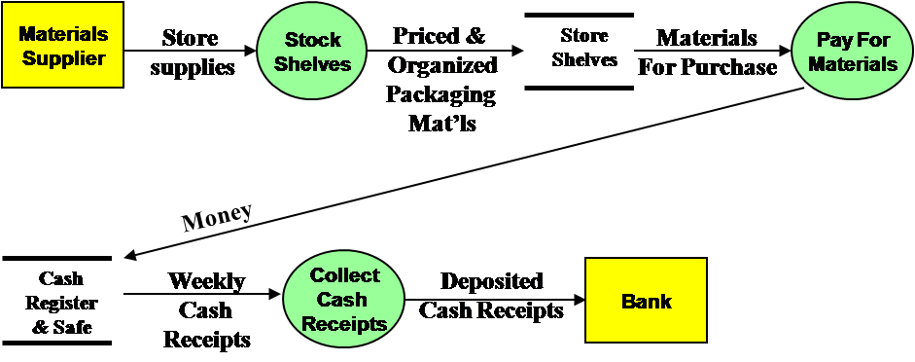

Diagram must show a “Store” and the process bubbles that move data into and out of the Store.
And, of course, properly labeled data flows connecting the Store and Processes.

