Protocol for Microbial Pressure Experiments

Date: 11.06.2026
Author: Ada Ciortan

Figure 1: Schematic overview of the experimental setup

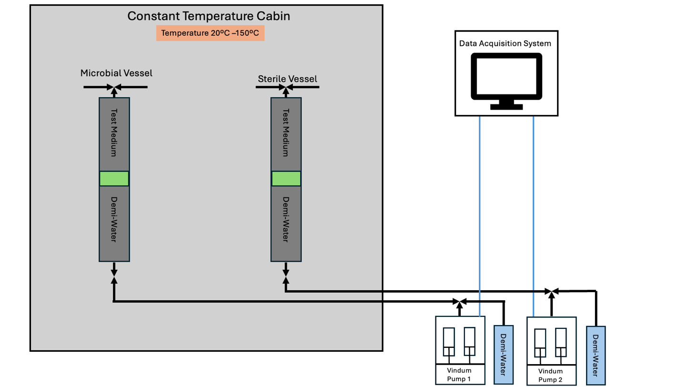

Contents
Contents 2
1. Purpose and scope 4
2. Safety and hazards 4
3. Equipment and materials 4
3.1 Apparatus 4
3.2 Consumables to prepare beforehand 5
4. Pump operation 6
4.1 Modes used 6
4.2 Vpware 7
4.3 Scheduler 7
4.4 Graphing 8
4.5 Data log 8
4.6 Leak test 8
5. Starting the experiment 8
5.1 Prepare the medium (degassing) 8
5.2 Prepare the vessels 8
5.3 Load medium anaerobically 9
5.4 Sterilisation 9
5.5 Inoculation and initial sampling (next day) 10
5.6 Pressurisation and hydrogen injection 10
5.7 Start the run and monitor 10
6. Ending the experiment 11
7. Sample handling and measurements 11
7.1 pH and optical density (on the spot) 11
7.2 Frozen samples - sulfate and acetate 12
8. Cleaning 12
9. Data processing 12
9.1 Pipeline overview 12
9.2 Step 1 - Raw data preprocessing 13
9.3 Step 2 - Main analysis 13
9.4 Uncertainty (Monte Carlo) 16
9.5 Initial H₂ injected and fraction consumed 16
9.6 Stoichiometric cross-check 17
9.7 Key parameters 17
Reference list 18
Appendix A. Pre-run checklist 18

1. Purpose and scope
This setup is used to calculate the rates and total amounts of hydrogen consumed due to microbial activity under high pressure. Two titanium vessels are run in parallel: one inoculated with a 10% pre-culture, the other kept sterile as a control. Comparing the two separates microbial H₂ consumption from abiotic losses, dissolution into the medium and diffusion into the rubber o-rings. The net microbial consumption is taken as the difference between the inoculated and sterile vessels.
Experiments can be run at a wide range of temperatures and pressures up to at least 400 bar. Experimental volume can be modified.

2. Safety and hazards
⚠ HAZARD — Flammable gas (hydrogen), biological material, and very high pressure. Hydrogen forms explosive mixtures with air. All high-pressure work and hydrogen injection must be done with appropriate training and, where stated, with a lab technician present.
Key controls already embedded in the procedure:
- Hydrogen is injected only with the assistance of a lab technician.
- Check the safety regulation for maximum volume of hydrogen that can be handeled in the laboratory
- During pressurised incubation the oven flap is left open with light fanning to circulate air and prevent accumulation of any leaked hydrogen.
- Leaks are checked with Snoop
- An isolated pump cylinder (cylinder B) is monitored as the leak reference for pump.
- No plastic is ever left in the oven.
- Consult lab technitian if in doubt
- Emergency shut-down steps: close all valves, transfer vessels to fumehood, use backpressure regulator to remove hydrogen from vessels, open the vessels and pour the medium into the chemical waste container.
⚠ HAZARD — Biogenic hydrogen sulfide (H₂S): the microbes produce toxic H₂S. All opening of vessels and ejection of medium must be done inside the fume hood. Amount is not high enough to be lethal.

3. Equipment and materials

3.1 Apparatus
Component | Description / specification
Titanium vessels (×2) | Two Proserv titanium vessels, total volume capacity 640 cc, maximum pressure 690 bar. Each vessel contains a piston that divides the test side from the demi-water side. The flat face of the piston must sit on the same side as the vessel’s flat cap, this is the test side.
Medium bottle + cap | The medium bottle and its cap (fitted with a red and a green rod, each with its own separate valve) are used together to transfer medium into the vessels.
Pumps (×2) | Vindum VP-Series dual-piston high-pressure metering pumps — not syringe pumps (model VP-12K, rated to 12,000 psi ≈ 827 bar). Connected to the demi-water side to regulate and monitor pressure. Each pump has two cylinders (A and B) flow in constant-pressure or constant-rate modes via the VPware software.
Oven | Used for sterilisation (120 °C) and incubation (37 °C). Run with flap open + fanning during hydrogen incubation.
Nitrogen line | N₂ supply with pressure regulator, for purging and anaerobic transfer of medium.
Vacuum apparatus | Used to evacuate the test side of the vessel and the transfer lines. Has an in-line valve and a transparent section so you can see when medium reaches it.
Lines & connectors | Metal lines connect the vessels to the pumps. Each vessel also has its own dedicated metal line — shorter, with the specific connectors needed for that vessel (one microbial, one sterile, never cross-used). No plastic is left in the oven.

3.2 Consumables to prepare beforehand
Item | Notes
Microbial preculture | 10% inoculum
Growth medium (~250 mL per batch) | Degassed before use; turns pink, a redox indicator.
Demi water | For the pressure regulator side of the cylinders.
Nitrogen gas | For purging / anaerobic transfer.
Hydrogen gas | For each experiment approx 20 mL needed.
8 × microcentrifuge tubes | Labelled with cylinder number and date; frozen and later used for sulfate and acetate analysis.
2 × syringes | For sampling.
2 × 15 mL tubes | For pH measurement.
pH 4 and pH 7 buffer solutions | For probe calibration.
Ethanol, paper towels, warm water | For cleaning.
Aluminium foil, Ziploc bags | Foil to cover the dedicated lines; Ziploc bags for freezer storage of samples.

4. Pump operation
The pumps are a key element of the experiment, so understanding their modes is crucial. The Vindum VP-Series are dual-piston metering pumps: each has two cylinders (A and B) that can be operated together or independently, giving pulse-free flow in constant-pressure or constant-rate modes. They are driven from a PC through the VPware software, which also builds the pressure-ramp schedules and logs the data.
VPware features relevant to this experiment: 13 pump modes (set pressure or set rate; deliver, receive, or bi-directional); multi-step ramping sequences that change pressure or rate as a function of time or volume pumped; real-time graphing; and flexible data logging at intervals as fast as 50 ms (Vindum Engineering Inc., 2026)

4.1 Modes used
Abbrev. | Mode | Typical use in this experiment
PPD | Paired Pressure Deliver | Deliver fluid continuously until a set pressure is reached or to maintain a set pressure.
PPR | Paired Pressure Receive | Receive fluid continuously until a set pressure is reached.
PRD | Paired Rate Deliver | Deliver fluid continuously at a constant rate (e.g. injecting preculture).
PRR | Paired Rate Receive | Withdraw fluid continuously at a constant rate (e.g. retracting 75 mL medium, sampling).
IPD | Independent Pressure Deliver | Deliver fluid continuously until a set pressure is reached or to maintain a set pressure, with only one piston. (e.g. leak monitoring).
IR | Independent Rate | Move one cylinder at a set rate independently (manual retract/fill at 0.1 mL/min).

Start/stop data log (see §4.5)

4.2 Vpware
Create/open graphs (see §4.4)

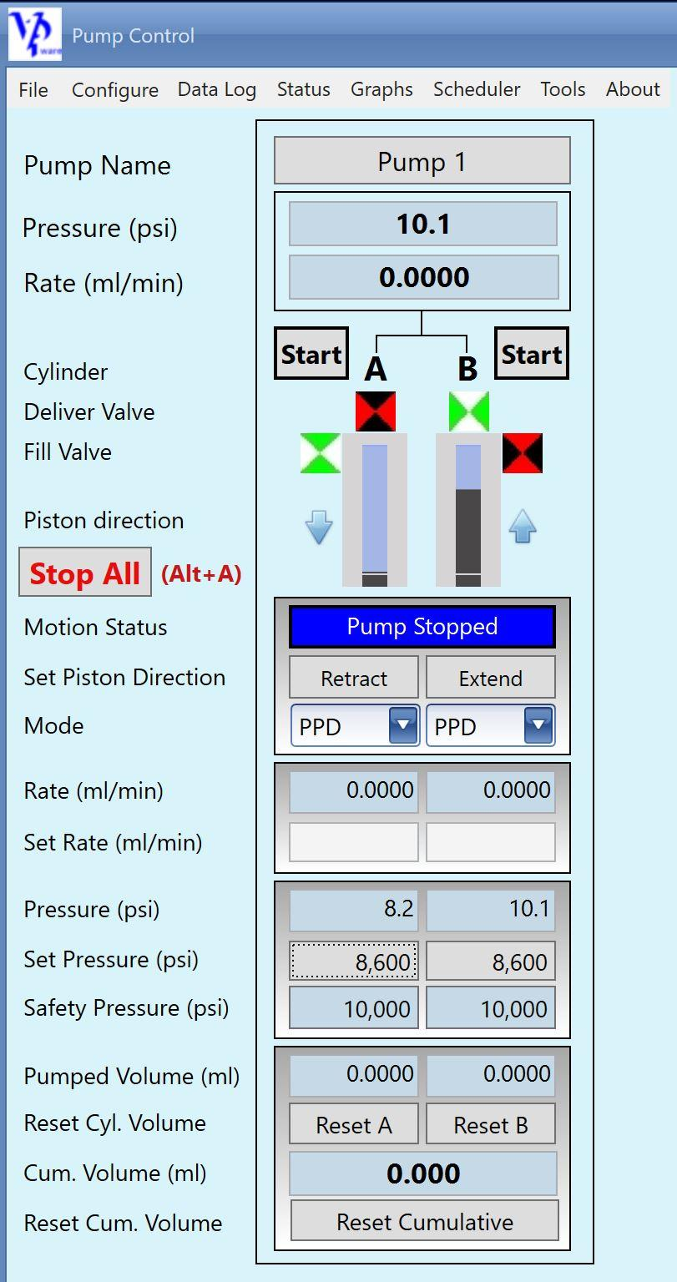
Configure new/existing schedule (see §4.3)
Figure 2: Vpware interface (Vindum Engineering Inc., 2026)

4.3 Scheduler
In VPware a ramp is built as multi-step set-points that change pressure (or rate) as a function of time or volume pumped. Both pumps are started together so thermal expansion and dissolution begin simultaneously. In this experiment, it is used for gradual pressurisation in constant-pressure deliver mode (approx. 5 bar/min, depending on microbial strain).

4.4 Graphing
To continuously monitor the setup, while starting/stopping, also while running. Graphs should be set up, to see any unusual activity and be able to act in time.

Reccomendation: open graph showing pressure and volume for each cylinder of each pump.

4.5 Data log
The data log is the most important part of the experiment. This is the function that stores all your data. If data log is not turned on, the data will not be saved. Even if the graph is on, but the data log is not, the data that made the graph will not be saved.

4.6 Leak test
Leak rates are monitored by tracking the volume needed to maintain an isolated pump cylinder at pressure: cylinder B is held at experiment pressure with both valves closed as a sealed reference, and operators switch A↔B at mid-experiment to check both pump cylinders.
Note: at higher temperatures, leaks need more attention — the joints swell and must be re-tightened.

5. Starting the experiment
⚠ HAZARD — Before every stage: check that all valves are in the correct open/closed position and that pistons are in the correct position. Otherwise you might need to restart experiment.
On average one experiment takes about 14 days for Oleidesulfovibrio alaskensis G20 bacterium. Each microbial strain behaves differently.When the slope of the microbial vessel is the same as the curve of the sterile vessel, leave it for another 2 days and then the experiment is finished.

5.1 Prepare the medium (degassing)
- Take approx. 250 mL of medium in a separate container. (Target final volumes per vessel: ~67.5 ± 2 mL medium and ~20 ± 1 mL H₂ headspace at experiment pressure, i.e. total experimental volume ~87.5 mL. In practice 75 mL is retracted into the vessel and 7.5 mL is removed at initial sampling, leaving 67.5 mL medium.)
- Add a magnetic stir bar and degas for approx. 1 hour, until no bubbles are visible and the medium turns pink (oxidation of the redox indicator).
- Keep the stir speed below half so bubbles do not get trapped on the magnet.

5.2 Prepare the vessels
- Assemble each vessel. Make sure the flat face of the piston is on the same side as the flat cap, this is the test side.
- Put the piston at the top of the test side and fill the bottom side with demi water (see Figure 1).
- Place the vessels in the oven and connect to the pumps using the metal lines.
- Bleed the lines so there is no air inside.

5.3 Load medium anaerobically
- Take the medium bottle, keep it upright (top up), and connect it to the test side of the cylinder. Connect the vacuum to the other side, make sure to add an extra valve between the vacuum line and the vessel.
- Start the vacuum; open the vessel valve, vacuum valve and the medium-bottle valve (the one connected to the vessel) to remove oxygen from all lines.
- Connect the nitrogen line to the other port of the medium bottle. Open the valve between the bottle and nitrogen, and bleed nitrogen through the line to purge oxygen.
- Close all valves.
- Make sure the piston is as high as possible (at the top).
- Tilt the bottle top-down, keeping it connected to the vessel and the nitrogen line; support it with a claw and stand.
- Slowly pressurise the medium bottle to max 1 bar using the nitrogen line, then close the nitrogen valve.
- Open the valve on the vacuum line and the valve on the top side of the vessel, start the vacuum to evacuate the test side of the vessel.
- Open the medium-bottle valve and bleed medium through the lines until it appears in the transparent vacuum line. Close the valve between vacuum and vessel to avoid losing medium. At this point, there should be nothing but degassed medium in all lines connected to the test side.
- Confirm that only these valves are open: the test-side vessel valve, the medium-bottle cap valve connected to the vessel, and the demi-water (bottom) side valve.
- Start the pumps in constant-rate receive mode and retract 75 mL of medium.
- Repeat for the second vessel.

5.4 Sterilisation
- When both vessels are filled, close all valves and disconnect everything from the cylinders. Leave only the dedicated vacuum line on each cylinder (one stays with the microbial cylinder, one with the sterile cylinder - never swap).
- Do not leave anything plastic in the oven.
- Cover the lines with aluminium foil and plug the remaining connection points on the vessel.
- Make sure only the bottom valve is open and the top valve is firmly closed.
- Set the oven to 120 °C, pressurise the cylinders to 3 bar, and leave them in constant-pressure receive mode.
- When the oven reaches 120 °C, hold for 20 minutes.
- Set the oven to 37 °C and leave overnight to cool.

5.5 Inoculation and initial sampling (next day)
Prepare sample containers, labelled with cylinder number and date: 8 microcentrifuge tubes, 2 × 15 mL tubes for pH, and 2 syringes (or more). Clean the syringe connector before use. Handle these initial samples as in §7 (measure pH and OD600 on the spot, freeze aliquots for sulfate/acetate). Do not forget to shake cylinder 10 times before taking out the sample.
- From the sterile cylinder, take out 7.5 mL into a syringe for the tests (constant-rate receive mode).
- From the microbial cylinder (C1): take out 10 mL (constant-rate receive), inject 7.5 mL of microbial preculture (constant-rate deliver), then inject 2.5 mL of the withdrawn medium back (constant-rate receive) to flush the lines.
- Close the top valves.
- Close the oven.

5.6 Pressurisation and hydrogen injection
- Start gradually pressurising at approx. 5 bar/min (rate dependens on microbial strain used) using a scheduler in constant-pressure delivery mode (see §4.2).
- At 100 bar, and with the help of a lab technitian, inject hydrogen into each vessel. Injection is done at 100 bar because the supply gas cylinders deliver H₂ at a maximum of approx. 150 bar. Target headspace is ~20 ± 1 mL of H₂ at the final experiment pressure.
- Confirm the top valves are closed. Disconnect all lines from the test side and plug the connections to ensure a leak-free environment.
- Set the oven so the flap is open with light fanning to circulate air and prevent explosion in case of a hydrogen leak.
- Gradually pressurise both vessels to test pressure using the scheduler, starting both together so thermal expansion and dissolution begin simultaneously.
- Use Snoop to check for leaks meanwhile; wipe it off the surface after use.

Start the run and monitor
- When test pressure is reached, set up the pump cylinders A on each pump: keep all valves closed, set to independent-rate manual retract at a very low flow (0.1 mL/min) until pressure of 0 bar is reached.
- Open the fill valve and fill/empty cylinder A on both pumps until half full (4.5 mL), then close the fill valve.
- Pressurise to experiment pressure (same low flow rate), open deliver valve and set cylinder A to independent constant-pressure at the experiment pressure.
- Set cylinder B of each pump to the same mode and pressure to monitor whether leaks develop in the pump, with both the fill and deliver valves closed.
- Optionally connect temperature measurement to capture lab temperature variation so this trend can be removed from the data.
- Turn on the data log (the volume injected to maintain constant pressure is logged every minute and is used to calculate the total volume of H₂ consumed). Leave cylinder A (half full) on independent pressure mode at experiment pressure with the deliver valve open; leave cylinder B on independent pressure mode at experiment pressure with both valves closed (see Vindum interface, §4).
- After half of the experiment has passed, switch from cylinder A to B on both pumps to monitor leaks in both pump cylinders.

6. Ending the experiment
⚠ HAZARD — Microbial H₂S: open the vessels and eject the medium only inside the fume hood. The released gas and liquid may contain toxic hydrogen sulfide. The quantity is not enough to be harmful.
- Turn off the data log.
- Turn off the oven.
- For vessel 1, start retracting to lower pressure (constant-rate receive).
- When pressure is around 20 bar, close the bottom valve, disconnect, move it to the fume hood, connect to the backpressure regulator, and open the top valve to release gas.
Prepare (labelled with cylinder number and date): 8 microcentrifuge tubes, 2 × 15 mL tubes for pH, and 2 syringes (or more). Clean the syringe connector before use.
- Connect vessel 1 to the pump using the long plastic tube.
- Check that the valves are open.
- Eject all remaining gas until fluid comes out, then close all valves.
- Shake vessel 1 ten times before sampling.
- Take out at least 10 mL of solution (more is better).
- Repeat for vessel 2.
- Put the microcentrifuge tubes in a Ziploc bag and place it in the freezer.

7. Sample handling and measurements
Samples are taken at the start of the experiment (§5.5) and at the end (§6). At each sampling point, measure pH and OD600 on the spot, and freeze microcentrifuge tubes for later sulfate and acetate analysis.

7.1 pH and optical density (on the spot)
Measure pH and OD600 immediately, at both the start and the end of each experiment.
OD: measure at 600 nm (OD600) on a HACH spectrophotometer blanked with water.
pH: measure with a pH electrode. Recalibrate the probe with the pH 4 and pH 7 buffers before measuring; have both solutions ready.
After measuring, pour the microbe-containing liquid from the OD cuvette into the 15 mL tube used for the pH measurement, close it, and place it in the chemical waste bin. Also place the microbial cuvette into the chemical waste.
All remaining and extracted medium must also be disposed of in the chemical waste.

7.2 Frozen samples - sulfate and acetate
Store the microcentrifuge tubes in the freezer. These frozen samples are later used to measure sulfate and acetate concentrations by ion chromatography. The observed sulfate consumption feeds the theoretical H₂ calculation in §10.5.

8. Cleaning
- Use ethanol, paper towels, and warm water. Disassemble the vessels and clean each part individually.
- Change all three o-rings (per vessel) after each run.
- Take care of the split ring on the piston.
- Add grease/lubricant to split rings and o-rings (check with lab technitian)
- Clean the inside of the test side of the microbial vessel as thoroughly as possible, biofilm also forms inside the lines.
- Flush lines with water and air.
Tip: when cleaning the split ring, wrap it tighter and store it inside a bottle cap to keep it small, so it is not damaged when reassembling the vessel. Silicone gel can also be used to make it stick to the piston (discuss with the technician).

9. Data processing
The aim is the net microbial H₂ consumption. Abiotic losses (dissolution into the medium and diffusion through the materials) are accounted for with the parallel sterile control. Because the system is held isobaric, the driving forces for diffusion and dissolution stay roughly constant (following Fick’s and Henry’s laws), and both vessels are pressurised at the same time. The microbial consumption is therefore obtained by subtracting the sterile curve from the inoculated (biotic) curve point by point (Mushabe et al., 2025).
The processing is done in three Jupyter notebooks, run in order. Each notebook is run top to bottom, and only its configuration cell is edited between experiments (paths, the experiment prefix, and the per-run settings). The notebooks use numpy, pandas, matplotlib and scipy.

9.1 Pipeline overview
Notebook | Purpose | Input → output
relevant_column_extraction.ipynb | Turn the raw pump log into clean arrays. | Raw Quizix .dat or Vindum .csv → <prefix>-time.npy, -volume_1.npy (biotic), -volume_2.npy (sterile)
rate_calculations.ipynb | Main analysis: convert, subtract control, fit, rates, uncertainty, fraction injected. | The three .npy arrays → total consumed, rates (±σ), fraction of injected H₂ consumed, plots
hydrogen_from_sulphide.ipynb | Independent stoichiometric cross-check from sulfate data. | IC sulfate table (Excel) → H₂ from sulfate consumed and theoretical maximum (mmol)

9.2 Step 1 - Raw data preprocessing
This notebook (relevant_column_extraction.ipynb) reads the raw pump output and writes three aligned arrays per experiment: time (minutes), volume_1 (biotic vessel) and volume_2 (sterile vessel), saved as .npy. Two input formats are handled. Quizix pumps export a .dat file: the header and footer rows are trimmed and the time/volume columns are extracted. Vindum pumps export a .csv: if the pump cylinders were switched part-way through the run (to check for a leak), the file is first split at that point — by timestamp or by row index — each half is parsed (cylinder A before the switch, cylinder B after), and the two halves are stitched back into one continuous cumulative series by offsetting the second half so it continues from the first. If there was no switch, the file is parsed directly.

9.3 Step 2 - Main analysis
This notebook (rate_calculations.ipynb) takes the three arrays through the full chain: load → convert units → trim the start-up → subtract the sterile control → fit a smooth model → read off totals and rates → propagate uncertainty.

9.3.1 Unit conversion
Time is converted from minutes to days (divide by 1440) (Figure 3). Volume is converted from millilitres to millimoles of H₂ by multiplying by the hydrogen density and dividing by the molar mass (2.016 g/mol). The density must be the H₂ density at the experiment pressure and temperature, read per run from hydrogendensitycalculator.com (for example 14.14 kg/m³ for the 200 bar case). The unit factors cancel so that millilitres × density / molar mass gives millimoles directly.

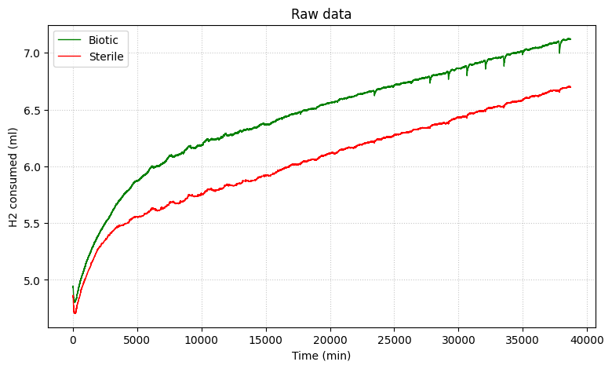
Figure 3: Example of raw data

9.3.2 Trim and subtract the control
If end data is noisy and it wasn’t removed in the previous step, a small number of trailing points can be dropped (the notebook removes the last ~100, which are end-of-run artefacts).

To normalise the data, the start point is set as the minimum of the biotic curve (Figure 4). For all three arrays, everything before the start point is then trimmed off. Then, time and both volume curves are shifted so they begin at zero. The microbial consumption is the biotic curve minus the sterile curve, re-zeroed at the start (Figure 5).

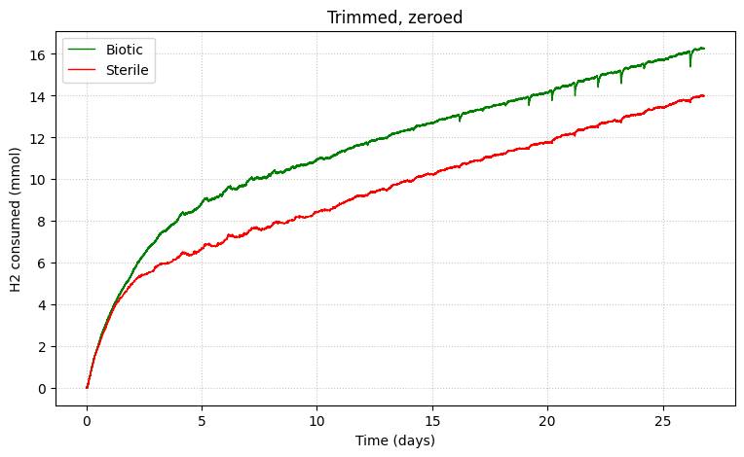
Figure 4: Trimmed and normalized curves, with converted units.
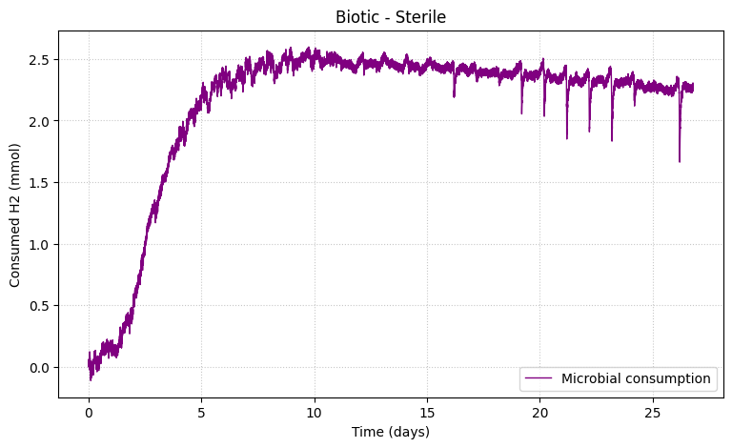
Figure 5: Microbial consumption curve (Biotic-Sterile).

9.3.3 Curve fitting
Both a four-parameter sigmoid and a polynomial are fitted to the consumption curve and plotted together for comparison (Figure 6). The operator chooses which model is used downstream by setting the MODEL option, the choice is deliberate, not automatic. Fit quality is judged with the R² / adjusted R² and by inspecting the residuals (a residual scatter plot and histogram) (Figure 7).. Fitting onto a dense, smooth grid also removes the high-frequency noise that comes from the pumps sitting outside the oven and reacting to daily temperature variation in the lab.

For best fit, focus on representing the slope representing the “active phase” as accurately as possible, the rest of the features are of less importance.

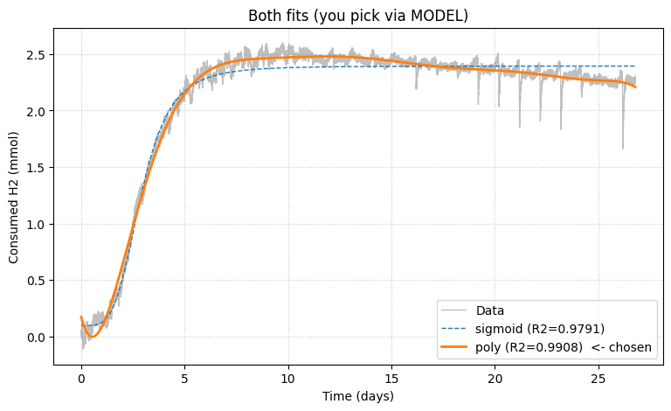
Figure 6: Polynomial and sigmoid fitted curves with R² values.

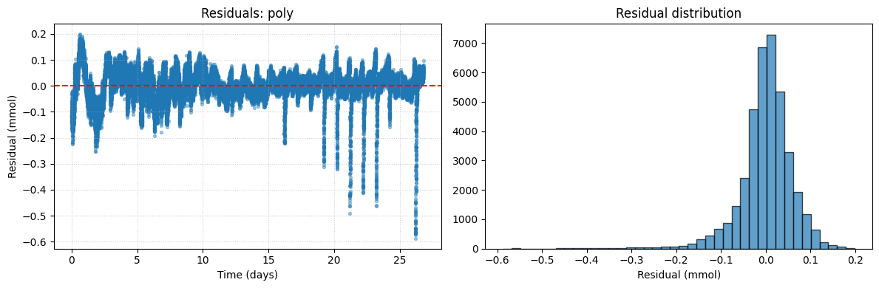
Figure 7: Plot and histogram of residual distribution for chosen fitted curve.

9.3.4 Consumption phase, total and rates
The consumption phase is defined as baseline to the peak of the fitted curve. The peak is located while ignoring the final day, so a late-time artefact is not mistaken for the peak; any decline after the peak (gas re-release or external effects) is not microbial consumption and is excluded. The total consumed H₂ is the peak minus the baseline. The total (active-phase) rate is the slope of the straight line (secant) between the 5% and 80% points of the rise — these bounds are configurable — because the very start and end of the curve are strongly curved. The maximum rate splits the active phase into consecutive one-day windows, fits a least-squares slope to each, and reports the largest; day one starts at the beginning of the experiment and a day is 24 hours from that moment, not a calendar day (Figure 8).

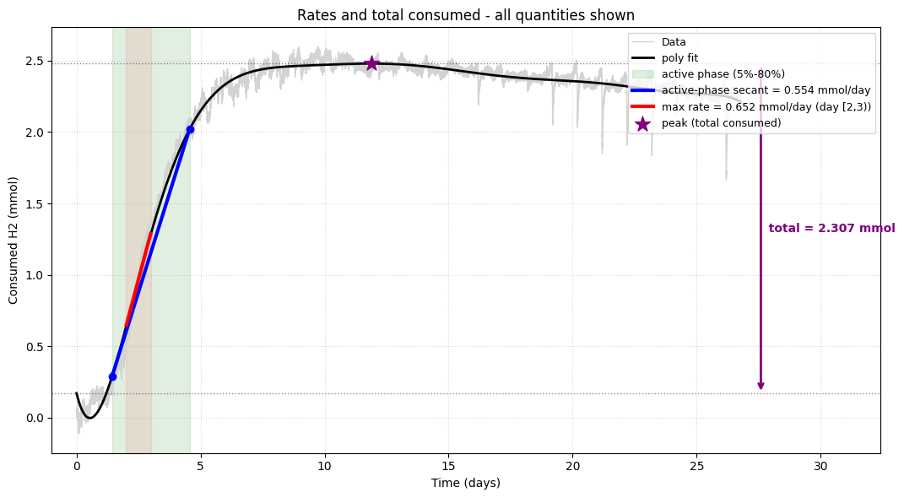
Figure 8: Rate and total hydrogen consumption visualisation.

9.4 Uncertainty (Monte Carlo)
Uncertainties are propagated by Monte Carlo (4000 draws by default). Each draw samples the fit parameters from the fit covariance and the normalisation volume from 67.5 ± 2 mL, then recomputes every quantity using the same functions and the same active-phase window as the main graph; the median and standard deviation are reported. Results are also expressed per unit area (using the vessel cross-section from the 4.5 cm diameter), per millilitre, and as grams per day, so the run can be compared on different bases (Table 1).

quantity | value ± 1σ
total consumed H2 (mmol) | 2.298 ± 0.002199
total consumed H2 (mmol/ml) | 0.03404 ± 0.001002
max rate (mmol/day) | 0.8341 ± 0.001829
max rate (mmol/day/cm^2) | 0.05245 ± 0.000115
total rate (mmol/day) | 0.6488 ± 0.00169
total rate (mmol/day/cm^2) | 0.04079 ± 0.0001062
total rate (g/day) | 0.001308 ± 3.407e-06
max rate (g/day) | 0.001682 ± 3.687e-06
max rate (mmol/day/mL) | 0.01236 ± 0.0003642

Table 1: Example of table with rates of a 200 bar experiment after Monte Carlo run.

9.5 Initial H₂ injected and fraction consumed
The amount injected is computed as volume × density / molar mass, with 20 ± 1 mL at experiment pressure injected. Because moles are conserved during pressurisation, injecting at 100 bar and then raising to the experiment pressure does not change the injected amount — only the density used to express that volume matters. Two bases are supported: “experiment” expresses the 20 mL at experiment pressure (same density as the consumption conversion, so the fraction consumed is a clean ratio), and “injection” treats the 20 mL as measured at the 100 bar injection pressure (which needs the H₂ density at 100 bar and experiment temperature). The fraction of injected H₂ consumed is the total consumed divided by the amount injected, combining the ±1 mL injection uncertainty with the consumption Monte Carlo from §10.4.

9.6 Stoichiometric cross-check
This notebook (hydrogen_from_sulphide.ipynb) provides an independent check from the ion-chromatography sulfate data, using a ratio of 4 mol H₂ consumed per mol sulfate reduced. The sulfate actually consumed is Δsulfate = (sulfate_start − sulfate_end) × V, giving n(H₂) = 4 × Δsulfate. The theoretical maximum, if all the starting sulfate were reduced, is 4 × sulfate_start × V. Concentrations are in mM (mmol/L) and the liquid volume is 0.0675 L (67.5 mL), so the results come out directly in mmol. These values are compared against the measured H₂ consumption from §10.3–10.5.

This is the reaction caused by the sulfate-reducing bacterium Oleidesulfovibrio alaskensis, from which theoretical hydrogen consumption values can be determined:

$$\frac{1}{4}{SO}_{4}^{2-}+H_{2}+\frac{1}{4}H^{+}→ \frac{1}{4}{HS}^{-}+H_{2}O$$
$${HS}^{-}+H^{+}↔ H_{2}S$$

9.7 Key parameters
The settings that change between runs all live in the configuration cells. The main ones:
Parameter | Default / example | Meaning
PREFIX | e.g. 2026-04-02_h2-200bar_SRB | Base name for the experiment’s arrays/files.
DENSITY | 14.14 kg/m³ (200 bar example) | H₂ density at experiment P and T; re-read per run.
MOLAR_MASS | 2.016 g/mol | H₂ molar mass (fixed).
VOL_NORM / VOL_NORM_SD | 67.5 / 2.0 mL | Normalisation volume and its 1σ.
DIAMETER | 4.5 cm | Vessel bore, used for per-area rates.
MODEL / POLY_DEGREE | poly / 9 | Chosen fit model and polynomial degree.
ACTIVE_LO / ACTIVE_HI | 0.05 / 0.80 | Active-phase bounds (fraction of total rise).
TRIM_START_IX | None (auto) | Manual start-cut index; None = min of biotic curve.
N_MC | 4000 | Number of Monte Carlo draws.
V_INJECT / V_INJECT_SD | 20 / 1 mL | H₂ injected and its 1σ.
INJECT_BASIS / DENSITY_INJECT | experiment / None | Whether 20 mL is at experiment or 100 bar; density if the latter.

Reference list

Vindum Engineering Inc. (2026, February 27). VP-Series High-Pressure Metering Pumps. Vindum Engineering. https://vindum.com/products/vp-series-high-pressure-metering-pumps
Mushabe, R., Liu, N., Dopffel, N., Ersland, G., & Fernø, M. A. (2025). Experimental study of microbial hydrogen consumption rates by Oleidesulfovibrio alaskensis in porous media. InterPore Journal., 2(2), IPJ040625-3. https://doi.org/10.69631/ipj.v2i2nr72

Appendix A. Pre-run checklist
- All valves checked (open vs. closed) for the current stage.
- Pistons in the correct position.
- Lines bled — no air.
- No plastic left in the oven.
- Oven flap open + fanning before hydrogen incubation.
- Dedicated vacuum/sampling/hydrogen injection line kept with the correct cylinder (microbial vs. sterile).
- Sample containers labelled with cylinder number and date.

