**Introduction**

The progressive and recent success in technology have played a major role in evolving the Health sectors, as most medical practitioners

are now key into the idea of computational practices over conventional processes, Also Pharmaceutical practices have evolved over time from its conventional practices to using computational methods in all aspects of pharmacy itself. which include: dispensing of drugs, consultation, drug regulation, and the sale of these drugs. The birth of modern pharmacy has brought with it some positive effects in the society as pharmaceutical practices have grown beyond conventional buying and selling of drugs over time, to more robust activities which include inventory of stocks, transaction tracking, door to door services and the general implementation of medical orders which entails the evaluation and the interpretation of the medical orders, the administration of drugs, dispensation of prescribed drugs from qualified medical practitioners, the review of prescribed drug regimen, invention of methods and devices to accurately dispense drugs and the correct storage of drugs.

The proposed system aims to automate pharmaceutical practices and serve as an intermediary between pharmacies and general public, through a platform that allows the order of drugs with the click of a button, and simultaneously keeps track of what drugs have been ordered and in what quantity (inventory), provide online platform for buying of medicine and also create avenue for a one on one interaction between pharmacist and the general public.

**Project Objectives**

1. To create online web base system that fully automate pharmaceutical practices

2. To create a platform for buying and selling of drugs.

3. To create a platform for interaction between pharmacist and general public

4. To create an inventory platform for pharmaceutical stores

5. To create a platform that provides an avenue for the general public to seek for counsel on medical health concerns and related medication from qualified pharmacist.

5. To create a platform for professional pharmacist to write and publish health related articles

**Project Aim**

Our aim is to develop a fully online web application management system that completely implements all our set objectives and at the end provide a well-tested and fully functional system that handles all pharmaceutical process from consultation services to buying and selling of medicines and inventory.

**Project Description**

The proposed pharmaceutical management system will provide a real time platform for general public or registered users to seek for professional counselling from professional pharmacist where they can discuss their health concerns on a one on one interaction and at the end get a drug prescription of which they can then proceed to search and order from the online stores. the users can also choose the drugs be delivered to their homes or anywhere suggested. The system will provide a platform for user’s education on medical health from reading articles written by professional pharmacist on the platform. The system will also provide inventory functionalities for the pharmaceutical stores. The system will also provide platform to register new users and pharmacist and another platform for administrative users to manage every type of users that uses the system.

**Problem Addressed**

The system will address many of the pitfalls in a conventional way of running pharmaceutical business, which include:

1. The bottleneck in buying and selling of drugs

2. Lack of access to medical health education.

3. Abuse of drug.

4. Lack of proper professional medical prescription.

5. Self-treatment and medication.

6. Lack of transaction history and stock inventory for pharmaceutical stores.

7. Lack of adequate and accurate medication or treatment history of individuals.

**Project deliverables**

1. A fully functional web application

2. Database system (RDBMS)

3. System designs and architectures

4. Usage manual

5. Project documentation

**Project Evaluation**

The system testing and evaluation will be done in three ways:

1. **Unit Testing**:

The system is tested in modules before integration is done. This is important as faults are discovered before the systems complexity increases through system integration.

At this stage of evaluation, we intend to evaluate every single aspect or functionality of the system to ensure it meets up to the standard output and objective we have set by providing the required input and comparing the output with our expected output.

Both the black-box and white-box methods will be used in the unit testing

1. **System Testing:**

The system is tested for conformity with requirements after all modules have been put together and the system as a whole is tested to authenticate that general system requirements have been met.

1. **Load and Tolerance test:**

The system is tested to see the response time and the efficiency of the system to handle large number of users accessing the resources concurrently.

In the development of the System, various criterions were used as testing yardsticks of the system. These yardsticks include Graphic User Interface, usability testing, database and exceptionhandling (Martin, 1991).

**Resources required**

**Software requirements**

1. Operating system: Windows (98, 2000, ME, NT, XP, Vista, 7, 8, 10), Linux, Mac OS
2. JavaScript-enabled web browsers: Mozilla Firefox (most suitable), Internet Explorer, Google Chrome, and Opera-mini
3. Virtual Server: PostGress server.

**Hardware requirements**

1. A physical memory (RAM) of 512MB and above are required
2. Intel, Celeron or AMD Pentium 3 processor or higher processor
3. Hard disk capacity: 5 GB.
4. Internet enabled.

**Work breakdown structure**

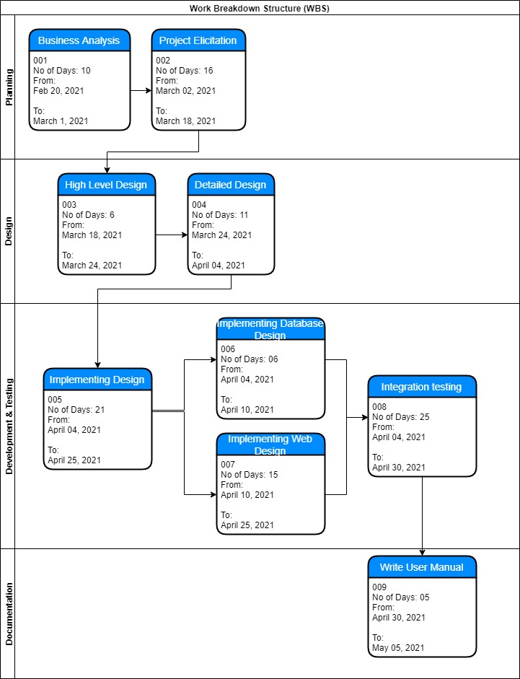

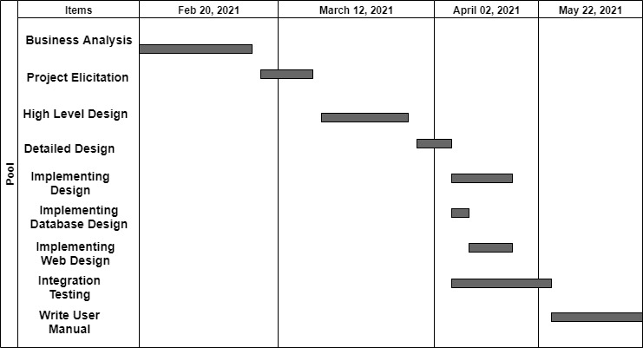**Timeline (Gantt chart)**

**Conclusion**

This research work dealt with Online Pharmaceutical Management Systems. It is eminent that the system provides a safe, secure and verified platform for all parties which help to bridge the communication gap, provide medical health education, provide legitimate drugs through verifiable professional pharmacist and a powerful inventory system for pharmaceutical stores. Because drugs are harmful when abused or misused by individuals or organizations, security checks have been added to the design logic. Therefore, if all recommendations are strictly adhered to, there will be strict monitoring and regulation of how drugs are circulated and a decrease in the spread of fake drugs and self-medication.

**Reference**

Martin, J. (1991). Rapid Application Development. Macmillan