Manage – Proof of Performance

Adding completion reports to contracts in Quattro.
After generating completion reports from Quattro a digital signature can be added to the completion report. This signed document needs to be saved to a location that is accessible from Quattro and the signed document can then attached in the campaign screen.

How To
Click on menu option Charting – Open Campaign.
Select the contract number using; the quick campaign search icon.
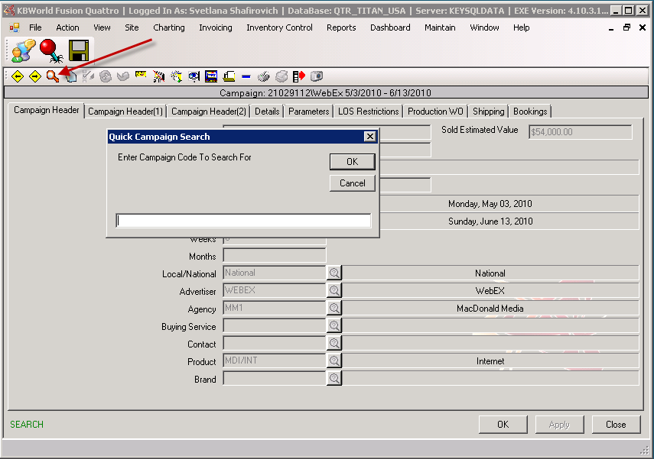

You can also use the advanced search from the file menu. Go to Action – Find.
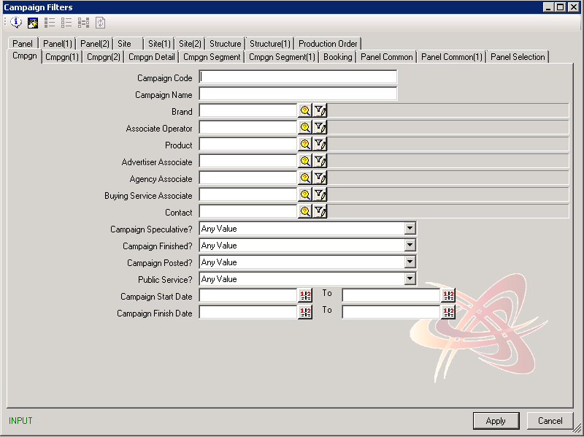

Add File
To attach a file in the campaign screen, go to the View pull down menu off the main toolbar and select Media Library, Upload Objects.

Option 1
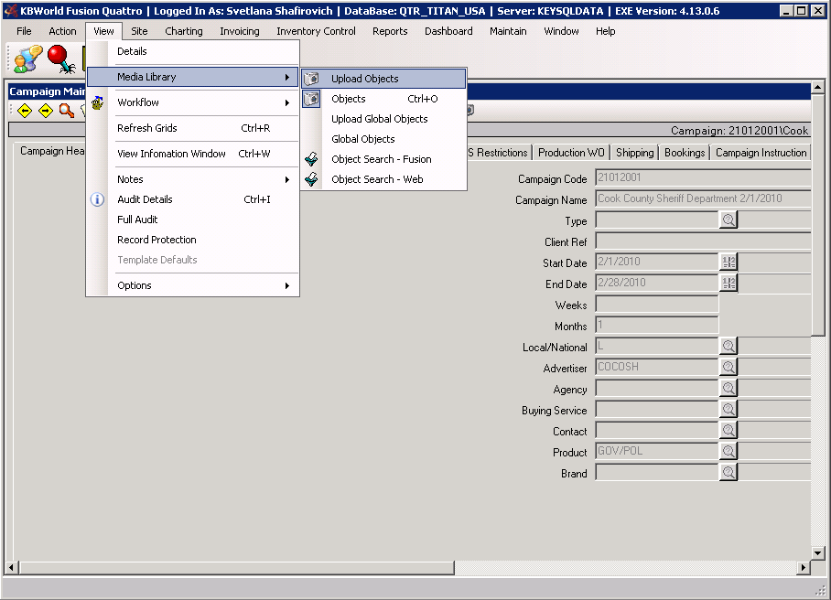
You can also click on the camera icon if there is already a file attached to the contract.

Option 2
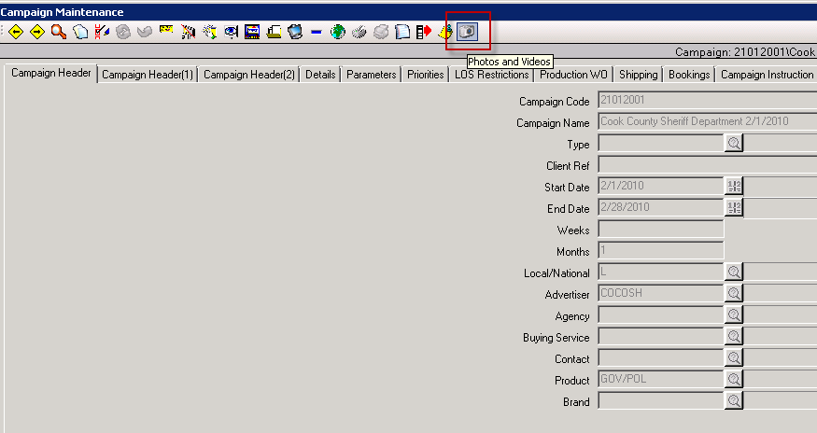

This will bring you to the Objects window. This screen can be used to attach any document in Quattro.
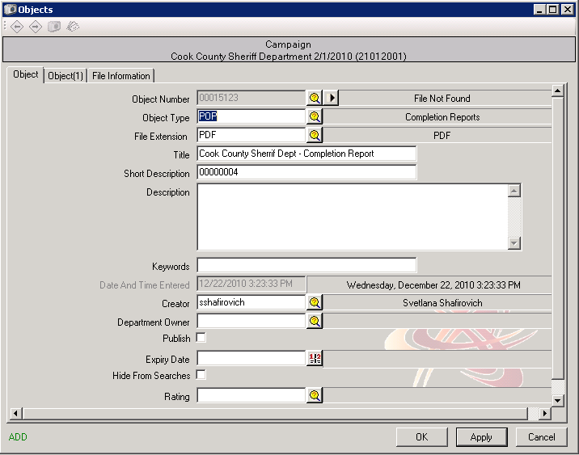

The Objects window will open in Add mode with the following fields to fill in:

Object Number | Use the browse button to search for the file on your computer that you want to attach.
Object Type | Use the browse button to select the type of object you are attaching.  For Completion Report Documents select POP (Completion Reports)  For Affidavit of Posting select AOP (Signed Affidavit)
File Extension | Use the browse button to select a file type. (eg. jpg, bmp etc.)
Title | Give the object a title. (optional)
Short Description | Give the file name a short description. (optional)
Description | Enter description of the file. (optional)
Keywords | Enter any keywords for the object. (optional)
Date And Time Entered | This field will auto populate with the date and time the object was attached. This field cannot be edited.
Creator | Defaults to the user ID that is attaching this object
Department Owner | Use the browse button to select the department that owns the object. (optional)
Publish | Check off this box if you want this photo to be published to the web
Expiry Date | Enter the date this photo object should expire. (optional)
Hide From Searches | Check this box if you don’t want this object to be found in searches.
Rating | Give the photo object a rating. (optional)
 | Click Apply to save and Close to return back to the campaign screen.

Now that the object has been saved, the Photos and Videos button will appear at the top of the Campaign window to flag you that an Object is attached to this contract.

