**Document Title: Test <Report>   
Author: Simon & Bond's   
Date: 16:18 16 May 1987**

Section: Baseline

Table 1.1.1 Summary Table

Note A  
Population: Safety (N = 100)

| **Variable** | **Statistics with a long line of text to check folding** | **A** | **B** | **Total** |
| --- | --- | --- | --- | --- |
| Endpoint | n | 50 | 40 | 90 |
|  | Mean (SD) | -0.0020 (0.928) | 0.0602 (1.195) | 0.0257 (1.049) |
|  | Median | -0.015 | 0.075 | 0.045 |
|  | Min, Max | -2.13, 2.44 | -3.11, 1.97 | -3.11, 2.44 |

fictitious data

Section: NA

Table 1.1.2 NA

| **Variable** | **Statistics** | **A** | **B** | **Total** |
| --- | --- | --- | --- | --- |
| Endpoint | n | 50 | 40 | 90 |
|  | Mean (SD) | -0.0020 (0.928) | 0.0602 (1.195) | 0.0257 (1.049) |
|  | Median | -0.015 | 0.075 | 0.045 |
|  | Min, Max | -2.13, 2.44 | -3.11, 1.97 | -3.11, 2.44 |

Section: Baseline

Table 1.1 Summary Table

Population: Full Analysis (N = 90)

| **Variable** | **Statistics** | **A** | **B** | **Total** |
| --- | --- | --- | --- | --- |
| Endpoint | n | 50 | 50 | 100 |
|  | Mean (SD) | -0.0020 (0.928) | 0.0490 (1.125) | 0.0235 (1.026) |
|  | Median | -0.015 | 0.045 | 0.04 |
|  | Min, Max | -2.13, 2.44 | -3.11, 1.97 | -3.11, 2.44 |

fictitious data

Figure 1.10 Summary Figure

Note B  
Population: Full Analysis (N = 90)

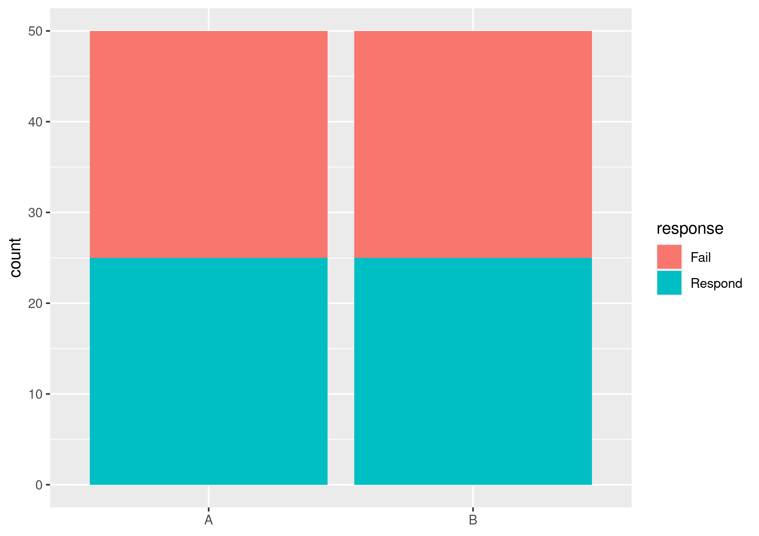

Section: Safety

Table 2.1 Deaths

Population: Full Analysis (N = 90)

There were no deaths