A Survey of 1 Dimensional Radar Signals

Drew Barnett

2/4/2020

**Why measuring radar data is important.**

Radar has been used throughout many industries to achieve a multitude of functions. The principle behind radar technology is simple, a transmitter sends out an electromagnetic signal at a specific time (t0) and a receiver listens for that signal. If the receiver detects the same electromagnetic wave that was transmitted but at a later time (t1), then there must be an object where that wave was reflected off of. By multiplying the speed of the wave (3*108 m/s) by the measured difference in time sent vs time received (t0 – t1), then the distance of that object can be found. Radar can not only give us information to determine distance, but it can also give us information to determine the speed of any specific object as well. This can be achieved through application of the doppler effect. If the receiver detects a higher incoming frequency than what was transmitted (fs < fo) then it can be concluded that the detected object is heading toward the original source of transmitted electromagnetic waves. The opposite is true when the receiver observes a lower frequency than what was transmitted. Radar is also robust to noise, which means that its data will remain true in a variety of environments. Because of this and everything else listed above, it has been used in many industries, including military for early warning systems, aviation for air traffic control and collision avoidance, space exploration in studying compositions of alien planets, and many more. Only recently has it been deployed to the consumer automotive market for low level autonomous technology.

**The challenges of measuring this physical signal data**

There are many challenges to consider when attempting to acquire radar data. First of all, there poses challenges in making sure that the correct signal is being transmitted from the transmitter. This will then need to be validated by the receiver in order to be deemed operational. Additionally, radar transmitters have the potential to produce unexpected outputs, which would invalidate the measurement of the radar entirely. Since most modern-day radar systems are governed by software environments, varying types of transmitter outputs can be achieved. Modulated pulses and chirps are a few of the outputs produced by current radar software, but because they are created in a series of complex software environments, there have been cases of incorrect transmitter outputs due to mistakes present within the code. In terms of signal monitoring however, there are separate challenges. Because there are multiple types of signals present within the environment, receivers need to be able to distinguish the desired signal among a multitude of interfering signals. In some cases, multiple signals may be sharing the same frequency which can ultimately interfere with the measurement results.

**Existing solutions of measuring this physical data.**

At a low level, there are many methods in which the measurement of physical radar data is taken. Radar transmits in unique pulses, which is achieved by modulating the pulses in various ways. Because of the uniqueness of each pulse, radar data is measured by observing the amplitude, phase, or frequency within the time domain. Additionally, one can perform chirp measurements and general-purpose modulation measurements. To visualize the solutions implemented for measurement of radar data, a figure below was provided which illustrate the frequency and phase of the measured signal in order to properly recognize the unique signal.

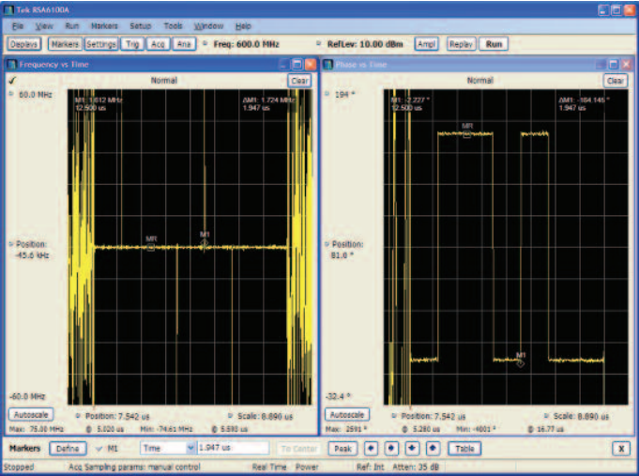

Figure 1. Freq vs Time (left) and Phase vs Time (right) [1].

It’s clear to see from the above figure that the radar pulse is recognized in the phase vs time plot where the amplitude oscillates in the form of a square wave. In the frequency domain plot, it’s clear to see the unique signature of the radar signal.

Another method for measuring this data is modulation measurement. Whenever the signal is digitally modulated, it becomes more complex and therefore requires a more in-depth measurement method to analyze the data properly. The modulation measurement method requires inputs for modulation type, symbol rate, and the measurement & reference filter parameters in order to generate a useful output [1]. The measurement can display constellation, error plots, signal quality and a demodulated symbol table [1]. The figure below illustrates what this measurement might look like.

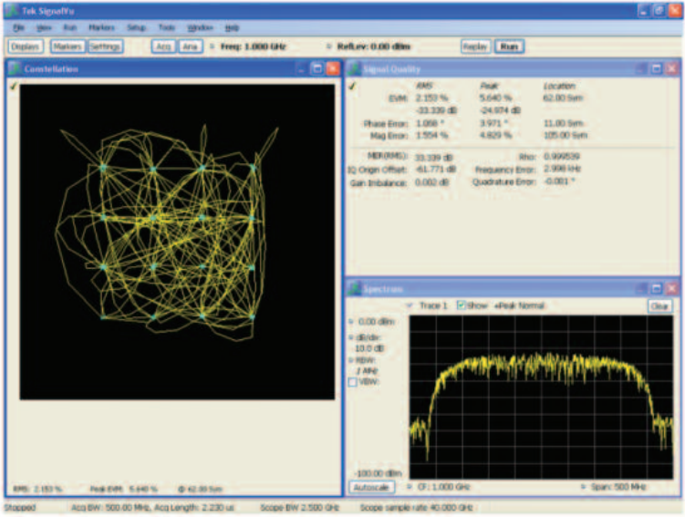

Figure 2. Modulation analysis measurement results [1].

Modulation measurement methods are becoming more and more important for radar since more complex modulations are being used throughout many industries.

Another method for measurement which is one of the simplest, is the magnitude histogram method. This method is used to detect radar pulses with a relatively high signal-to-noise ratio by plotting the pulse acquisition against the magnitude of the pulse. If the signal does not have a high signal-to-noise ratio then this method may not be appropriate for taking measurements. In the case of radiofrequency (RF) pulsed transmitters, measurements can be made easily. See the figure below for an example illustrating what this measurement might look like.

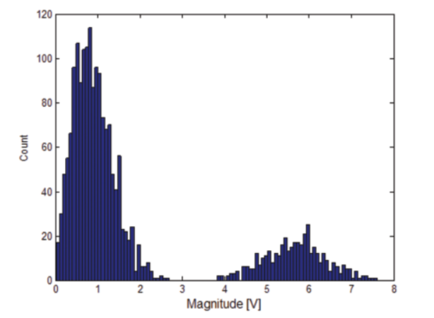

Figure 3. Histogram plot of a 15 db S/N pulse [1].

**Existing problems for measuring this data.**

At a higher level, current radar technology faces many problems which have not entirely been solved. The most common challenges facing the performance of radar technologies today are:

1. Maximizing its range when detecting objects of a specified size.

Radars have the ability to detect objects of various forms at a specific range, but although it may detect the object, it may not accurately display the size of the detected object correctly. For example, a radar can detect a flat plate of a specified area and accurately display its measured size, but it cannot do the same for a conical object. Objects which are conical in shape will have a much larger indicated size by radar than its actual size measured manually.

1. The accuracy (range and angle) of the measurement.

Measuring radar data accurately becomes increasingly difficult the further away an object is from the transmitter. Because of this, high-powered radars need to be designed and built with maximum precision in order to detect an object’s location and range accurately.

1. Distinguishing between targeted objects.

Similar to the first point, because objects of different shapes produce different indicated sizes through radar, it’s very difficult to validate the actual size of the indicated objects without the assistance of some novel measurement method or hardware.

1. Recognizing the target object echo in the presence of external noise.

The external noise detected by radar is often the cause of “clutter” within the environment. Clutter occurs when unanticipated echoes are detected from external sources. It’s important to note however that one radar’s clutter is not necessarily another radar’s clutter. For example, a radar with the sole purpose of detecting missiles and military vessels would consider clutter to be unanticipated echoes from wildlife and other moving objects like planes and commercial jets or passenger boats. Overall, one of the major downfalls for the measurement of radar data is the fact that there are many ways in which it can be tampered with.

*References*

[1] Admin. (2017, December 8). 100 RADAR Uses or Applications–RADAR World. Retrieved from http://lidarradar.com/apps/100-radar-uses-or-applications

[2] Fundamentals of Radar Measurements. (n.d.). Retrieved from https://www.tek.com/document/primer/fundamentals-radar-measurements

[3] LIDAR vs RADAR for Applied Autonomy. (2019, June 27). Retrieved from https://semcon.com/what-we-do/applied-autonomy/lidar-vs-radar-for-applied-autonomy/

[4] Skolnik, M. I. (2019, March 5). Factors affecting radar performance. Retrieved from https://www.britannica.com/technology/radar/Factors-affecting-radar-performance