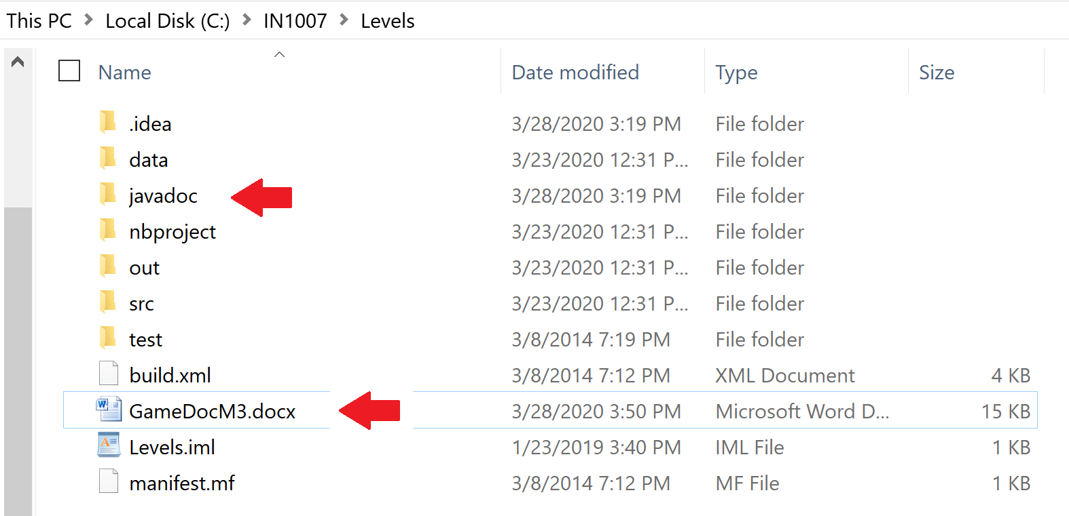

***Place the Javadoc and the information about your submission directly in the game directory as shown above***

1. **Instructions:**

Move character with the left and right arrow keys and press space bar to jump.

Avoid all Goombas (brown mushroom looking things), collect as many coins as you can, and reach the gate.

1. **Extra feature is sound:** different background music for each level; sound effects for all pickups and collisions; background sounds changes (becomes more alert), a GUI which allows the user to mute and change the volume of the sounds.
2. **Save/Load:** I’m implementing full game save/load. I’ve added a GUI that allows me specify the file to save to.
3. **Other features:** In addition to sound my game also contains shooting, enemies that move on their own. The game has 4 levels and each level has a different layout to reach the next level/complete the game and to avoid the enemy. Also at the end of the game the player can save his high score. In terms of coding, I’m making extensive use of packages and inheritance. I have paid close attention to respect naming conventions.
4. **Javadoc classes:** GameSaver.java; Game. Java, MyView.java, Pickup.java, Level1.java, Level2.java, Level 3.java, Level4.java, Head.java, Goomba.java, Controller.java, Coins.java, DoorListener.java