Center of gravity analysis of 2J3KL capelin

Center of gravity (CG) metrics have been used in fisheries research for decades to assess shifts in the mean location of fish populations (Rufino, Bez, and Brind’Amour 2018). Here we assess the CG of capelin using data from the fall RV trawl survey of 2J3KL conducted by DFO between 1983 to 2016 to assess potential shifts in their population over time. The CG metric used here was calculated by weighting the mean latitudes and longitudes of sets conducted in the survey by abundance:

$$CG=\frac{\sum_{i=1}^{n}{x_{i}}s_{i}z_{i}}{\sum_{i=1}^{n}{s_{i}}z_{i}}$$

where $x_{i}$ represents the coordinates of the sets, $z_{i}$ is abundance and $s_{i}$ is the area of influence(Woillez et al. 2007). Given the irregular sampling of the RV survey, the CG indicator was weighted by area of influence, which was calculated using Voronoï tessellation of sets conducted within the survey strata each year (Woillez, Rivoirard, and Petitgas 2009). The spatial dispersion of the population around its center of gravity (i.e. inertia) was also calculated:

$$I=\frac{\sum_{i=1}^{n}{(}x_{i}−CG)^{2}s_{i}z_{i}}{\sum_{i=1}^{n}{s_{i}}z_{i}}$$

and this spatial indicator was decomposed into two orthogonal axes describing the maximum and the minimum components of the inertia, and isotrophy (i.e. the shape of the dispersion around the center of gravity) was calculated by taking the square root of the ratio of the maximum and minimum components (Woillez et al. 2007). These calculations were conducted in R (R Core Team 2017) using the RGeostats package (Renard et al. 2017). Results from this analysis are shown below in Figures A1 to A3.

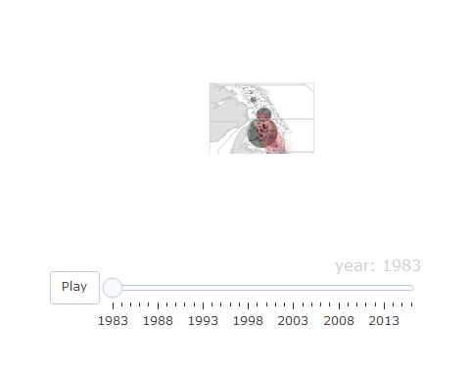

**Figure A1.** Annual bubble plots of the number of capelin caught in the Fall RV survey from 1983 to 2016. Center of gravity (x) and inertia (shaded area) is shown for the survey in red and for capelin in blue.

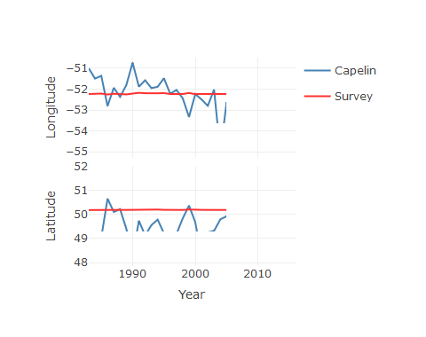

**Figure A2.** Trend in the longitude and latitude of the center of gravity of the survey and capelin.

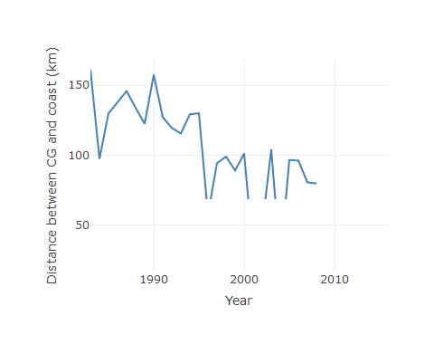

**Figure A3.** Trend in the minimum distance between the coast of Newfoundland and Labrador to the center of gravity of capelin.

# References

R Core Team. 2017. *R: A Language and Environment for Statistical Computing*. Vienna, Austria: R Foundation for Statistical Computing. <https://www.R-project.org/>.

Renard, Didier, Nicolas Bez, Nicolas Desassis, Helene Beucher, Fabien Ors, and Xavier Freulon. 2017. *RGeostats: Geostatistical Package*. <http://cg.ensmp.fr/rgeostats>.

Rufino, Marta Mega, Nicolas Bez, and Brind’AmourAnik. 2018. “Integrating Spatial Indicators in the Surveillance of Exploited Marine Ecosystems.” *PloS One* 13 (11): e0207538.

Woillez, Mathieu, Jean-Charles Poulard, Jacques Rivoirard, Pierre Petitgas, and Nicolas Bez. 2007. “Indices for Capturing Spatial Patterns and Their Evolution in Time, with Application to European Hake (Merluccius Merluccius) in the Bay of Biscay.” *ICES Journal of Marine Science* 64 (3): 537–50.

Woillez, Mathieu, Jacques Rivoirard, and Pierre Petitgas. 2009. “Notes on Survey-Based Spatial Indicators for Monitoring Fish Populations.” *Aquatic Living Resources* 22 (2): 155–64.