# The collapse of a keystone forage species: A response to Frank et al. 2016

Buren, A.D.1*§, Murphy, H.M.1§, Adamack, A.T.1, Davoren, G. K.2, Koen-Alonso, M.1, Montevecchi W.A.3, Mowbray, F. K.1, Pepin, P.1, Regular, P.1, Robert, D.4, Rose, G.A.5, Stenson, G.1, Varkey, D.1

Affiliations:

1. Northwest Atlantic Fisheries Centre, Fisheries and Oceans Canada, St. John's, NL, Canada

2. Department of Biological Sciences, University of Manitoba, Winnipeg, MB, Canada

3. Cognitive and Behavioural Ecology Progamme, Departments of Biology and Psychology, Memorial University of Newfoundland, St. John’s, NL, Canada

4. Institut des sciences de la mer, Université du Québec à Rimouski, Rimouski, QC, Canada

5. Institute for the Oceans and Fisheries, UBC, Vancouver, Canada.

*corresponding author: Tel: +1 709 772 4049; Fax: + 1 709 772 4138; e-mail: Alejandro.Buren@dfo-mpo.gc.ca

§ A.D.B and H.M.M. contributed equally to this paper and others have contributed equally. Authors have been listed in alphabetical order for each contribution level.

## Abstract

Acoustic monitoring surveys conducted by Canada and the USSR found that the Newfoundland (NAFO Division 2J3KL) capelin stock suffered an order of magnitude decline in the early 1990s. This decline in capelin was concomitant with drastic changes in the ecosystem during the late 1980s and early 1990s, and the capelin collapse was a key signal in the identification of a regime shift that occurred in the early 1990s. While more than a dozen studies corroborate and support evidence of the capelin stock collapse, Frank et al. (2016) disputed this conclusion. Frank et al. (2016) postulated either 1) capelin changed its migratory patterns while the timing of the acoustic survey remained constant leading to a spatio-temporal mismatch between the survey and the stock or 2) the capelin stock has become less migratory and remains inshore and is therefore undetected by the offshore surveys. We tested these hypotheses using multiple independent datasets, which included both fishery-dependent (inshore commercial catch) and fishery-independent data (spring acoustic and fall bottom trawl surveys, oceanography cruises, capelin larval indices, aerial surveys, predator diet and behaviour, and diverse statistical methods). The hypothesis of a non-collapse of the capelin stock was rejected by our analyses. The weight of evidence approach led us to conclude that the Newfoundland capelin stock suffered a population collapse in 1991 with minimal recovery over the subsequent 25 years.

*Ale:*

*I think that the Intro is tight and well written. The idea to make this a paper comparing hypotheses is a good one. Then, as we discussed, if Frank writes a “Response”, you can write back and get the last word. I have tried to review with this in mind. However, I think that there are places where the text sounds like a response, e.g., the references to the 3-6M tonnes of missing capelin.*

*I suggest that the ms would benefit from a section on the methods and capelin biology. I’m having a hard time following the arguments on migration of capelin bc I don’t know that part of their biology very well. Further, the methods distract from the flow of the discussion in some places.*

*Also, there are some sections where Frank’s analysis is just invalid, i.e., the data cannot be used to support or refute either hypothesis. I would focus on that (even if its not a “Response” paper) and not try to force a hypothesis test when there is none.*

*Similarly, there are some sections (like seabirds) where the diet data does not support a collapse/non-collapse hypothesis but does support a migration/non-migration hypothesis which is the pillar of Frank’s argument.*

*This is an important ms. Lots of things to work on but I think that the bulk of the material is there – it may just be a matter of repackaging.*

*Happy to review the next draft.*

*K*

*PS. I have not reviewed the abstract and have done very little copy editing but I can do that if you wish.*

*Caveats: I have not read Frank. I don’t know any of this literature very well.*

## Introduction

Forage fish play crucial roles in many ecosystems, acting as an energy conduit between lower trophic levels and large vertebrate predators. Typically, they are small shoaling species that characteristically have rapid growth, short life expectancies, and population responses that are tightly linked to environmental controls. Forage fish species often exhibit boom and bust population dynamics, i.e. their abundances change rapidly and substantially and undergo phases of extremely high and extremely low abundances (Soutar & Issacs 1969, Schwartzlose et al. 1999, Chavez et al. 2003, Alheit et al. 2009, Pikitch et al. 2012, 2014). Forage fish species can experience prolonged periods of ‘bust’ dynamics. For example, the Norwegian spring-spawning herring (*Clupea harengus*) stock collapsed in the late 1960s after a pulse of overfishing and remained at very low levels until the late 1980s (Toresen & Østvedt 2000, Skagseth et al. 2015); while sardine (*Sardinops sagax*) and anchovy (*Engraulis* spp.) have decade-scale regimes of high and low abundances where populations thrived for 20 to 30 years and then disappeared for similar periods (Schwartzlose et al. 1999, Chavez et al. 2003).

Capelin (*Mallotus villosus*) is the focal forage species in ecosystems of the northern Atlantic Ocean (Templeman 1948, Jangaard 1974, Vilhjálmsson 1994, Carscadden et al. 2001). The three most important capelin populations in the North Atlantic are in the Barents Sea, off the coast of Iceland, and along the Newfoundland and Labrador (Canada) continental shelf. The Barents Sea capelin stock experienced four collapses over the past 4 decades: the mid- to late-1980s, the mid-1990s, the mid-2000s, and the mid-2010s. The size of the stock fluctuated between 3 -and 7 million tonnes during the boom phase and around 200 thousand tonnes during bust phases. There is general agreement that ecosystem changes were the driving forces behind these dynamics (Gjøsæter et al. 2009). The Icelandic capelin stock underwent similar dynamics, with three bust phases over the past 4 decades: the early 1980s, the early 1990s, and most of the 2000s. The size of the stock was around 1.5 - 2 million tonnes during the boom phase and between 100-500 thousand tonnes during bust phases (ICES 2017). The first two bust phases were due to a combination of poor recruitment and the stock being easily available to the fishing fleet, while the most recent bust phase was likely associated with a climate-related shift in distribution (Pálsson et al. 2012, Carscadden et al. 2013).

Fisheries and Oceans Canada (DFO) is responsible for the assessment of the Newfoundland and Labrador (NL) capelin stock. DFO concluded that the stock experienced an order of magnitude decline in the early 1990s with minimal recovery during the past two decades (DFO 1994, Miller 1994, 1997, DFO 2008, 2010, 2013, 2015) DFO 2018. The size of the stock fluctuated between 2 and 6 million tonnes before 1991, and between 25 and 900 thousand tonnes during the ensuing period (DFO 2015). This decline was concomitant with drastic changes in the ecosystem during the late 1980s and early 1990s (deYoung & Rose 1993, Gomes et al. 1995, Montevecchi and Myers 1997, Lilly et al. 2000, Rice 2002, Rose 2007, Koen-Alonso et al. 2010, Hammill et al. 2011, Pedersen et al. 2017), including major changes in the biology and ecology of capelin, such as delayed and protracted spawning, changes in their geographical and vertical distribution, and declines in somatic condition and size and age at maturity (Frank et al. 1996, Carscadden & Nakashima 1997, Carscadden et al. 2001, Mowbray 2002, Nakashima & Wheeler 2002, DFO 2010). The collapse of capelin was a key signal in the identification of regime shift such as occurred in the early 1990s (Rose 2005, Buren et al. 2014a,b).. *Capelin ( Mallotus villosus ) distribution and climate: a sea “canary” for marine ecosystem change. G.A. Rose, ICES Journal of Marine Science, Volume 62, Issue 7, 1 January 2005, Pages 1524–1530, https://doi.org/10.1016/j.icesjms.2005.05.008*

Frank et al. (2016) argued that the capelin stock off NL did not collapse; alternatively, they argued that the offshore surveys have failed to detect large capelin aggregations since 1991 because of spatio-temporal mismatch between the surveys and the stock. Specifically, they hypothesized that post-1991 either 1) capelin changed their migratory patterns while the timing of the acoustic survey remained constant leading to a spatio-temporal mismatch between the survey and the stock or 2) the capelin stock has become less migratory and now remains inshore, and is, therefore, undetected by the offshore surveys. Support for the hypothesis of non-collapse of capelin was based on changes in the biology of capelin post-1991 (e.g., distribution and demography), re-analysis of the offshore research surveys (multi-species bottom trawl and acoustic), and the response of various components of the ecosystem [e.g., zooplankton, Atlantic cod (*Gadus morhua*), seabirds, seals] to the large-scale changes that have occurred since the early 1990s (Frank et al. 2016). The objective of this paper is to assess the empirical support for the hypotheses of stock collapse (DFO 2015) vs non-collapse (Frank et al. 2016) using all available data.

**Methods**

To test the hypotheses of collapse and non-collapse of the capelin stock in NAFO Divisions 2J3KL (hereafter Div. 2J3KL; Fig. 1), we applied the weight of evidence approach using multiple, independent data sets and diverse statistical methods (e.g., triangulation, sensu Munafò & Davey Smith 2018). To do this, we constructed our paper based on Frank et al. (2016) (hereafter Frank et al.). Each section of this review opens with a statement of the main conclusion(s) from the analyses presented in Frank et al. and the counter-argument in the primary and government literature. In some sections, new data and analyses were used to test the main hypotheses. Each section concludes with an evaluation of the data in support of each hypothesis. Once this approach was completed for all sections, the weight of evidence approach was used to determine which hypothesis was best supported by the independent data sets, analyses, and reviewed literature.

## Capelin

### Offshore capelin distribution: acoustic surveys

Frank et al. contended that Canada and the USSR offshore acoustic surveys found low capelin biomasses in the fall of 1991 and 1992 because capelin became non-migratory in the fall of 1990 in Div. 2J3KL. The alternative hypothesis is that the fall acoustic surveys detected a real and sudden decrease in capelin biomass in Div. 2J3KL in 1990 (e.g., Miller & Lilly 1991, Bakanev 1992, Miller 1992, 1993, 1994, Mowbray 2014), and, while capelin changed their distribution offshore post-1991 [southern shift in distribution (e.g., Miller & Lilly 1991, Miller 1992)], they did not become non-migratory.

From 1977 to 1992, Canada conducted fall (October) acoustic surveys for capelin in Div. 2J3K (Fig. 2) (e.g., Miller and Carscadden 1984, Miller and Lilly 1991). The fall acoustic surveys targeted the maturing portion of the stock during winter feeding migrations to provide estimates of the size and number of maturing fish being recruited to the fishery the following year (Mowbray 2014). The capelin stock in Div. 2J3K was also acoustically surveyed by the former USSR in November from 1972-1992 although the USSR acoustic survey covered a more restricted geographic area compared to the Canadian acoustic survey as it did not go as far into the inshore area (Bakanev 1992; Fig. 2). The USSR fall acoustic surveys were conducted later than the Canadian surveys and consistently estimated higher capelin abundances, which may have been due to timing, as capelin cease feeding in November and aggregate into large overwintering shoals (Winters 1995). In 1990, the Canadian fall acoustic survey reported a very low capelin biomass while the USSR acoustic survey reported the smallest biomass since 1984 (Winters 1995). Both the USSR and Canadian acoustic surveys reported record low biomasses in the fall of 1991 and 1992 (Winters 1995). The decrease in capelin biomass in both surveys corresponded with very few capelin being detected off the coast of Labrador and a southward shift in stock distribution to the southern portion of Div. 3K and northern portion of Div. 3L (Miller & Lilly 1991, Miller 1992). A Canadian expanded fall survey (Div. 2J3KL) in 1993-94 was conducted to determine if the ‘missing’ capelin could be located. However, the expanded fall acoustic survey confirmed the findings of the 1991-92 fall surveys that offshore capelin biomass was low and had a southern distribution (Miller 1994, 1995).

High densities of overwintering maturing capelin as well as large schools of immature capelin in seasonal surveys conducted in Trinity Bay in 1967-68 (Winters 1970) were used by Frank et al. to support the hypothesis of a non-migratory capelin stock post-1991 by suggesting that capelin can inhabit inshore areas year round. Fisheries and Oceans Canada tested the hypothesis of year round residency of capelin in the inshore by conducting seasonal acoustic surveys in Trinity Bay (September and October 2003; January, June and September 2004-05) and expanding the annual spring offshore acoustic survey into Trinity Bay (1999-2005, 2007-13, 2017) (Fig. 3 a; see supplementary section for details on methods). Seasonally, capelin densities were low in Trinity Bay in January and May, and the maximum mean density of capelin was observed in June (10,000 kg / km2), which corresponded with the start of the spawning period when capelin were highly aggregated inshore (Fig. 3 a). In September and October, capelin densities were low once again (Fig. 3 a). There was also a distinct pattern in the seasonal age and maturity composition inshore. Overwintering fish in January were composed of ~70% immature age-1 and age-2 fish (Fig. 3 b, c); the relative contribution of older fish increased through the spring as maturing age-2 and 3 fish migrated into Trinity Bay (Fig. 3 b, c); and by October, immature age-1 fish dominated the inshore area as spent fish either died or left the bay (Fig. 3 b). The seasonal surveys found no evidence of a large inshore, non-migratory capelin stock. In agreement, an inshore acoustic survey in January 2000 for overwintering cod from Conception to Notre Dame Bay found concentrations of juvenile capelin (e.g., O’Driscoll and Rose 2001) but few older fish (G.A.Rose, unpublished data). *In situ acoustic target strength of juvenile capelin. Richard L. O'Driscoll George A. Rose. ICES Journal of Marine Science, Volume 58, Issue 1, 1 January 2001, Pages 342–345, https://doi.org/10.1006/jmsc.2000.1015*

In the majority of years, the biomass of capelin surveyed in Trinity Bay during the spring acoustic survey was less than 10% of the capelin biomass surveyed offshore (Fig. 4). However, in three years (2000, 2001 and 2010) when the offshore capelin biomass was low, there was increased capelin biomass inshore in Trinity Bay (Fig. 4). This change in spatial distribution of the stock may be linked to changes in the environment as the capelin stock in Iceland experienced inter-annual variability in spatial distribution and migration routes likely in response to changes in environmental conditions, e.g., water temperature (Olafsdottir & Rose 2012). Furthermore, while capelin biomass was higher inshore in these three years, it was not large enough to account for the missing 3 - 6 million tonnes (Mt) of capelin from the offshore since 1991.

In summary, while the fall acoustic surveys in Div. 2J3KL (1977-1992) cannot refute the hypothesis that capelin are non-migratory post-1991 as the inshore areas were not surveyed, the lack of significant inshore aggregations of capelin outside of the peak spawning period during seasonal and annual spring acoustic surveys does support the hypothesis of a collapse of the capelin stock post-1991. Furthermore, capelin stocks in other regions did not become non-migratory in response to changes in stock abundance and environmental conditions but rather demonstrated changes in spatial distribution and migration routes (Olafsdottir & Rose 2012, Carscadden et al. 2013), and these changes were best documented for the fall feeding periods of these stocks (Ingvaldsen & Gjøsæter 2013).

**Offshore capelin distribution: annual multi-species bottom-trawl surveys**

Frank et al. hypothesized that there was an abrupt change in capelin migration patterns post-1991, with capelin now remaining inshore year round. The fall bottom trawl survey (FBTS) data were used to point to a westerly, inshore shift in the centre of capelin concentration in 1996-2010 compared to 1985-1995 (Frank et al. 2016). Alternatively, the use of bottom-trawl gear with low catchability of pelagic species has limited usefulness as an abundance index (O’Driscoll et al. 2002) and is likely to produce biased data on the demographic trends of these species (Jech and Quinn 2016). In the NL region, the trawl gear on the FBTS was changed in 1995 from an Engels otter trawl (1978-1994) to a Campelen 1800 shrimp trawl (1995-2016). Counting capelin: a comparison of acoustic density and trawl catchability

R. L. O'Driscoll G. A. Rose J. T. Anderson

ICES Journal of Marine Science, Volume 59, Issue 5, 1 January 2002, Pages 1062–1071, https://doi.org/10.1006/jmsc.2002.1262

Frank et al.’s annual mapping of the centre of concentration of capelin using the FBTS presence/absence data aligns with the high degree of inter-annual variability in capelin abundance within the earlier period (1985-1995), with inshore distributions occurring in three high abundance years (1986-1988, Fig S2 in Frank et al. 2016). This variability is likely related to the poor catchability of capelin in the Engel otter trawl, which was designed for commercial ground fish (ref). A similar centre of gravity analysis using only post-1995 FBTS data, which corresponded with the time period of improved catchability of capelin with the use of a Campelen 1800 shrimp trawl, showed a southerly shift in capelin distribution with a recent shift to the northwest in 2011-14 (DFO 2015). Neither of these analyses accounted for inter-annual changes in capelin spatial distribution due to FBTS sampling effort or uncertain catchability of capelin in bottom trawls.

Nevertheless, Frank et al.’s hypothesis of an inshore centre of distribution of capelin post-1991 was tested using FBTS data and the center of gravity approach described in Thorson et al. (2016). Specifically, the VAST package in R (Thorson & Barnett 2017) was used to fit a geostatistical delta-generalized linear mixed model to estimate the spatial and temporal distribution of capelin. The main advantages of this approach is that it accounts for inter-annual changes in the spatial distribution of sampling effort and provides a means of estimating the standard error of the centre of gravity metric, which provides perspective on the significance of distributional shifts. Like DFO (2015), we focused on the post-1995 period when the catchability of capelin improved with the use of a Campelen 1800 shrimp trawl. Our geostatistical analysis did not support the hypothesis that capelin shifted their distribution towards the inshore post-1995 and there is no evidence of an easterly or westerly movement in the center of gravity of capelin (Fig. 5). Instead, the center of gravity of capelin remains > 100 km offshore and demonstrates pronounced shifts in the north-south dimension (Fig. 5).

Other analyses using the FBTS data indicate that it is unrealistic to assume that the 3 to 6 Mt of capelin that are ‘missing’ in the offshore surveys are now residing in the inshore. The inshore strata are inconsistently covered by the annual FBTS and an inshore area of ~35,000 to ~71,000 km2 remains unsurveyed each year. The minimum density of 3 to 6 Mt of capelin in these inshore waters would have to be between ~41,000 to ~170,000 kg / km2, uniformly distributed throughout the unsurveyed area. In contrast, the maximum mean density of capelin observed in the Trinity Bay survey strata in June was 10,000 kg / km2, and the maximum mean density of capelin observed outside the spawning period was only 40 kg / km2 (Fig. 3 a). This analysis indicates it is unlikely that the capelin stock is currently non-migratory and has remained inshore since 1991.

In summary, recognizing the bias in catchability of pelagic fish in the Engel vs Campelen trawls, we only used FBTS data from 1995 onwards, which precludes the FBTS centre of gravity analysis from providing support for the non-collapse hypothesis. When we looked at other sources of capelin distribution data during this time period (sensu Jech & McQuinn 2016) the juvenile capelin surveys using an IGYPT trawl in the northeastern bays and the offshore from 1994-99 also found a southward distribution of capelin juveniles compared to the 1980s with centers of distribution on the northern Grand Bank and along the northeast coast, but not in the bays, of Newfoundland (Anderson et al. 2002). These two independent datasets and corresponding analyses suggest that capelin were not residing in the bays of Newfoundland post-1991.

### Capelin depth distributions during offshore acoustic surveys in Div. 3L

Frank et al. do not use the change in capelin diel vertical migrations (DVM) post-1991 to support or refute the capelin collapse hypothesis. The change in capelin DVM post-1991 required dedicated experiments in 1995 and 1999 to address the potential impact of DVM changes on the availability of capelin to the acoustic surveys (Mowbray 2002). The proportion of capelin biomass in the trawl zone (bottom 4 m of the water column) increased post-1991 (Mowbray 2002), likely a response to a decline in the risk of predation by Atlantic cod which may drive capelin into the pelagic zone (Rose 1993). Furthermore, when capelin densities were low, capelin were found in closer association with the bottom and DVM was less pronounced compared to when capelin densities were high (Mowbray 2002). The range of values for diel changes in capelin detectability obtained from these experiments were used in the calculation of confidence estimates for each survey since 1988 using a Monte Carlo simulation. Confidence estimates indicate a significant decline in capelin biomass between the late 1980s and 1991 (Fig. 4).

In summary, while the DVM experiments were performed to improve acoustic estimates, they also demonstrate how capelin were more available to the FBTS post-1991 and, along with a change in trawl gear in 1995, introduced a bias in the pelagic data obtained from the FBTS. The change in DVM behavior of capelin post-1991 suggests that the population has declined and supports the capelin collapse hypothesis.

### Residence time of capelin concentrations during offshore acoustic surveys in Div. 3L

Frank et al. hypothesized that delays in the timing of capelin spawning post-1991 led to a mismatch between capelin availability and the spring acoustic survey which has resulted in the spring acoustic survey underestimating the capelin biomass offshore. Alternatively, the Canadian regional stock assessment process concluded that the stock experienced an order of magnitude decline in the early 1990s and has remained at historic lows for the past 25 years based on the offshore fall and spring acoustic surveys (DFO 1994, Miller 1994, 1997, DFO 2008, 2010, 2013, 2015, 2018).

Since 1991, capelin spawning has been persistently delayed on average by four weeks (DFO 2018). Meanwhile the spring acoustic survey has been fixed spatially and temporally since the 1980s, there is likely a mismatch between the spring acoustic survey and capelin spawning migrations post-1991. However, the spring acoustic survey, which encompasses a capelin nursery area, was only designed to survey the non-migratory, immature portion of the stock rather than the spawning migration (Mowbray 2014). Specifically, the spring acoustic survey primarily provides an index of abundance of the age-2 portion of the stock. While other age classes are encountered in the spring acoustic survey, they are not fully recruited to the survey, either due to their poor recruitment to the trawling gear and their weak acoustic signal (age-1 or younger) or due to their behaviour (ages-3+) (e.g., more northerly distribution of older fish and highly aggregated shoals for a spawning migration). All age classes acoustically surveyed are included in the annual index of capelin abundance, but the spring acoustic survey does not target capelin spawning migrations, and, therefore, cannot estimate spawning stock biomass.

While the delay in spawning time has no effect on the spring acoustic abundance index as the spawning migration is not targeted, earlier maturation of capelin post-1991 may have an effect on the capelin abundance index. The age-2 portion of the stock is the main component being surveyed and the proportion of maturing age-2 capelin has increased since 1991 (4% pre-1991 compared to 37-79% post-1991) (Mowbray 2014; DFO 2018). Earlier maturation could alter the internal structure of the stock with inter-annual variability in the proportion of age-2s starting their adult migration patterns and are, therefore, unavailable to the survey. However, there has been high internal consistency in the spring acoustic survey, with the index of abundance for the age-3 cohort being strongly correlated with the index of abundance of the age-2 cohort from the previous year (DFO 2018), which implies that the spring acoustic survey can meaningfully capture relative changes in the overall stock, regardless of migration/non-migration fractions.

In summary neither the persistent delay in spawning time nor earlier maturation of capelin post-1991 affects the ability of the spring acoustic survey to provide an index of capelin abundance. The spring acoustic survey supports the capelin collapse hypothesis.

### Independent indices of inshore capelin abundance

Frank et al. postulated that since independent inshore indices of capelin abundance post-1991 were strongly correlated and showed little change in the capelin spawning stock biomass compared to the 1980s, the capelin stock did not collapse. In contrast, the offshore fall and spring acoustic surveys indicated a stock collapse (Miller 1994, 1997, DFO 2008, 2010, 2013, 2015, 2018, Mowbray 2014).

The inshore indices that Frank et al. considered in their review involved an aerial abundance index and inshore commercial catch rates. The aerial survey was designed to estimate an index of capelin spawning stock biomass based on the area of capelin schools near spawning beaches in NAFO Div. 3L (Nakashima 1997). The aerial survey commenced in 1982, and initially followed four defined survey tracks in Conception and Trinity Bays during a fixed period of mid-June to early July (Carscadden et al. 1994). Protracted spawning post-1991 violated a key assumption of the aerial surveys: all schools arrive at the same time in each bay to form a single spawning peak. Protracted spawning from early July to mid-August in 1991-93 resulted in multimodal capelin spawning peaks that were covered with variable success by the aerial survey (Nakashima 1996). For example, in 1993, the peak spawning period was adequately surveyed in Conception Bay, but two spawning peaks in Trinity Bay, based on the egg deposition index, were missed (Nakashima 1996). In 1996, aerial coverage was at its lowest since 1991 due to poor weather and technical problems (Nakashima 1997). In 1997, the geographical coverage of the aerial survey was reduced to two transects in the inner areas of Trinity and Conception bays (Anon 1998). While the estimated aerial abundance index in 1997 was fourth highest in the series, there were concerns that the limited geographical coverage of the aerial survey did not accurately reflect the status of the stock, especially when harvester opinion surveys indicated that stock abundance was changing at different rates within the stock area (e.g., bays vs headlands) (Anon 1998). Six of the eight years of aerial data post-1991 did not adequately cover peak spawning times (1991-93), had poor weather and technical difficulties (1996), and had reduced geographical coverage (1997-98). The aerial survey was discontinued in 1999.

The inclusion of inshore catch rate data after 1993 in the analysis presented in Figure 6 in Frank et al. is misleading and not reflective of capelin inshore abundance. Due to the small sizes of spawning capelin post-1991, management regulations introduced a size criterion of 50 count/kg to reduce dumping of undersized capelin (Carscadden & Nakashima 1997). This size criterion effectively closed the fishery in 1994 and 1995. From 1996, the size criterion was removed but management regulations to reduce discarding of small, unmarketable capelin resulted in fishing effort being concentrated to a few days when capelin were highly available (Anon 1998). Post-1991, the inter-annual variability in participation in the fishery due to fish quality and market forces in combination with high catch rates in a short period rendered the inshore catch rate index useless as an indicator of stock abundance (Anon 1998).

In summary, due to changes in capelin biology and management measures post-1991, neither of the inshore indices provide reliable data on spawning stock biomass. These indices cannot be used to support or refute either hypothesis.

### Demographic change of both inshore and offshore capelin

Based on the truncation in capelin age structure and reductions in condition, growth, and maturation timing post-1991, Frank et al. hypothesized that capelin are no longer migratory post-1991. However, earlier maturation is also consistent with the hypothesis that age at maturity will decline in stressed (e.g. experiencing a substantial decline in size) fish populations ( Shuter 1990, Trippel 1995). Rapid changes in age at maturity occur in response to changes in stock size (Trippel 1995). For example, as Atlantic herring stocks increased in the mid-1980s in Georges Bank, there was a 50% decrease in the percentage of mature age-3 fish (Melvin et al. 1995).

Unlike Frank et al., we used the annual age composition data from both the inshore commercial catch and the spring acoustic survey to test the migration hypothesis. If capelin were no longer migrating, we would expect to see a higher proportion of age-2 fish caught in the inshore post-1991 (e.g. fish that are vulnerable to the fishing gear, but are immature). The alternative hypothesis, based on the spring acoustic data, is capelin were migrating post-1991. We predicted that the proportion of age-2 fish in the offshore is similar pre and post-1991 as capelin were still maturing offshore before their spawning migration. There were large shifts in capelin age compositions from 1980-2016. For the inshore commercial fishery pre-1991, age-2 capelin were a negligible component of the fishery (< 5% of total catch; DFO 2018). Post-1991, the contribution of age-2 capelin increased to almost half of commercial inshore catches (DFO 2018), which supports the hypothesis of non-migratory fish maturing early. However, the population demographics from catches offshore refute the non-migratory hypothesis as the proportion of ages 2 and 3 sampled offshore has remained consistent pre- and post-1991 at ~60% and ~28% of the catch, respectively (DFO 2018). Furthermore, post-1991, the increased proportion of maturing age-2 fish offshore provides an explanation for the increased catch rate of mature age-2 fish inshore (DFO 2018).

In summary, the inshore commercial catch data provides support for the hypothesis that the capelin stock is no longer migratory, while the demographic composition of capelin obtained from the offshore acoustic survey refutes the hypothesis that capelin are currently non-migratory. Furthermore, the increased proportion of mature age-2 fish in the inshore post-1991 can be explained by the increase in proportion of age-2 fish maturing offshore and undergoing a spawning migration. While these two indices provide conflicting support for the capelin collapse hypothesis, the fact that the change in capelin demographics in the inshore post-1991 can be explained by the change in demographics in the offshore (i.e. earlier maturation) provides support for the capelin collapse hypothesis.

### Timing of inshore capelin beach spawning

Frank et al. hypothesized that the late spawning of capelin produced a temporal mismatch with the spring acoustic survey, as they postulated that persistently late spawning post-1991 has delayed the timing of arrival of high concentrations of capelin to the offshore acoustic survey area. However, as noted earlier, the spring acoustic survey in Div. 3L targets the immature, non-migratory portion of the stock. Moreover, if mature capelin are present in the surveyed area in May, the dense, highly aggregated shoals of migrating fish are difficult to quantify because shoals are relatively sparse in terms of both the spatial (e.g., transect lines are ~10 to 30+ km apart) and the temporal coverage (e.g., each line is only surveyed once) of the spring acoustic survey program. This is in contrast to immature capelin that were in broadly distributed shoals of feeding fish that are non-migratory. Indeed, capelin surveys in the Barents Sea are timed to avoid spawning migrations (Gjøsæter 1998). In Iceland, if capelin are not detected in surveys during the fall feeding period due to shifting stock distribution, follow-up surveys during spawning migrations are required using coordinated effort from numerous vessels to find the highly aggregated migrating shoals (reviewed in Carscadden et al. 2013). In summary, the delay in spawning post-1991 does not explain the sudden, and persistent, decrease in capelin abundance offshore post-1991.

### Inshore recruitment index

Frank et al. argued that since larval production in Trinity Bay did not decrease appreciably post-1991, capelin biomass did not collapse. However, post-1991, a larval index from Trinity Bay was related to the age-2 abundance index from the spring acoustic survey, which suggests that the spring acoustic survey is providing a valid index of capelin abundance (Murphy et al. 2018).

DFO collects two larval indices in Trinity Bay: an emergent larval index (3-10 mm SL) in a nearshore area and a late-larval index (10-30 mm SL, see Nakashima & Mowbray 2014 for more details). The late-larval index was collected both pre- and post-1991. While Frank et al. compared the late-larval index in August for both datasets, the persistently late spawning in capelin since 1991 has resulted in smaller and younger larvae in August 2008-12 compared to August 1982-86, and a better comparison would be between August pre-1991 and September post-1991 (Nakashima & Mowbray 2014). The average late-larval density in Trinity Bay in September 2002-15 is 30.9 m-2 (SD: 26.9, range 6.73-96.95 m-2), which is considerably lower than the August 1982-86 estimate (48.8 m-2, SD: 15.1, range 33.2-73.6 m-2). The trend in the 2000s is for lower and more variable late-larval densities compared to the 1980s; for example, in 12 of the 14 years in the 2000s, average late-larval densities in September were less than the average August larval densities in the 1980s.

If the majority of capelin biomass was in the inshore area and was not available to the annual offshore spring acoustic survey, then no relationship would be expected between larval productivity and the age-2 abundance index from the spring acoustic survey. However, post-1991, the emergent larval index was related to the age-2 abundance index from the spring acoustic survey (Murphy et al. 2018), which suggests that the offshore acoustic survey tracks inshore productivity. There is currently no relationship between the late-larval index in Trinity Bay and the age-2 abundance index (Murphy et al. 2018). This could be due to changes in the survey design post-1991 including a spatio- temporal contraction of sampling with 19 of the original 52 stations sampled in 1 week in September from 2003-07 and 1 week in both August and September from 2008-15; and a temporal mismatch between capelin spawning times and the late-larval survey which may result in capelin larvae either being too small for the gear in August or already advected from the area in September.

In summary, while the appreciable decrease in the late-larval productivity index post-1991 supports the capelin collapse hypothesis, the spatio-temporal contraction of the survey post-1991 reduces our ability to directly compare larval productivity between the two periods. The positive, significant relationship between the emergent larval index and the offshore age-2 abundance index post-1991 supports previous research that identified capelin larval survival as an important driver of recruitment (Frank & Leggett 1982, Leggett et al. 1984, Dalley et al. 2002). This significant relationship between two fishery-independent inshore and offshore indices post-1991 provides support for the capelin collapse hypothesis.

**Ecosystem response**

**Temporal dynamics of cod weight at age and condition**

Frank et al. contend that since Atlantic cod’s weight at age and liver condition indices post-collapse were not spatially homogenous then capelin did not collapse. Alternatively, Atlantic cod’s weight at age and liver condition indices were never spatially homogenous due to the species complex inhabiting distinct ecosystem production units in NAFO Div. 2J3KLNO (e.g., Lilly 2005, Koen-Alonso et al. 2013, Morgan et al. 2017) on the Labrador and northeast Newfoundland Shelf and Grand Bank. These units are characterized by distinct marine communities and food web systems (Pepin et al. 2010, 2012, 2014, Koen-Alonso et al. 2013, NAFO 2014). Hence the non-homogenous traits of Atlantic cod from Labrador (2J) to the southern Grand Bank (3NO) are typical of this species. Furthermore, post-1991 changes in spatial overlap between the collapsed stocks of Atlantic cod and capelin may have exacerbated spatial differences in Atlantic cod condition indices (Rose et al. 2000).

The existence of spatial structure in traits of Atlantic cod in NAFO 2J3KL (also known as Northern cod) is well known historically (e.g., Lilly 2005, Neville et al. 2018, Rose & Rowe 2018), with gradients from north to south in growth (length at age) and condition indices (liver, gutted and total body mass) (Buren et al. 2014b, Morgan et al. 2017). Historically, Atlantic cod was a dominant fish predator on the NL Shelf, with capelin its primary prey (Winters & Carscadden 1978, Lilly 1987, Lilly 1991). During and post-1991, capelin shifted its fall distribution from having two distinct aggregations, one in the northwest (NAFO Div. 2J3K) and one in the southeast (NAFO Div. 3L, at the northern slope of the Grand Bank) to having only one in the southeast (Lilly & Davis 1993, Miller 1994), with records of excursions onto the Flemish Cap and the Scotian Shelf (Frank et al. 1996). Coincidently, Atlantic cod moved southward on the northeast Newfoundland Shelf in the late 1980s/early 1990s and aggregated within a small area on the north of the Grand Bank and in the Bonavista Corridor by the early 1990s (Rose 1993, Rose et al. 2000). One hypothesis by Rose et al. (2000) to explain this shift in Atlantic cod distribution is that they moved in response to the distribution of capelin. Atlantic cod’s weight at age and liver condition worsened in northerly areas where there was no spatial overlap between Atlantic cod and capelin, and remained relatively stable in southerly areas, where the collapsed Atlantic cod stock overlapped with capelin.

In summary, the spatial structure of Atlantic cod condition indices is explained by the distinct ecosystem production units this stock complex inhabits. Since 1991, Atlantic cod’s condition worsened in northerly areas where there was no spatial overlap with capelin, and remained relatively stable in southerly areas, where the collapsed Atlantic cod stock overlapped with the remaining capelin. The observed change in Atlantic cod distribution and condition indices post-1991 supports the capelin collapse hypothesis.

**Harp seal population trends and diet**

Frank et al. argued that the absence of an obvious response in Northwest Atlantic harp seals (*Pagophilus groenlandicus*), specifically large number of starving harp seals as observed following the collapse of capelin in the Barents Sea (Haug & Nilssen 1995), supports their contention that the capelin stock did not collapse. However, there are significant differences between the two regions. In the Barents Sea, the collapse of capelin during the mid-1980s occurred when the stock of other important forage fish, namely Atlantic herring and arctic cod (*Boreogadus saida*), were severely depleted (Hamre 1994, Hop & Gjøsæter 2013). Therefore the effects of the capelin collapse were amplified and reached several taxa including seals, seabirds and Atlantic cod (Hamre 1994). Barents Sea capelin also declined between 1992 and 1993 without a similar ‘invasion’ of starving seals. This was likely due to the availability of alternative prey (Atlantic herring and arctic cod, Nilssen et al. 1998). In the Northwest Atlantic, however, alternate prey, particularly arctic cod and Atlantic herring, were still available during the early 1990s (Lilly et al. 1994, Bourne et al. 2015) and were the main prey of harp seals (Stenson 2012).

Further, while Northwest Atlantic harp seals did not show catastrophic mortalities post-1991, they have been impacted by the decline in capelin. Since the 1980s, pregnancy rates of harp seals declined while inter-annual variability in pregnancy rates increased, ranging from ~20% to 75% over the past 3 decades (Stenson et al. 2014, 2016). Also, since 1987, harp seals have shown indications of late term abortions. Stenson et al. (2016) found that while the general decline in fecundity reflects density-dependent processes associated with increased population size, including the late term abortion rates into their model allowed them to explain the large inter-annual variability in pregnancy rates. Changes in the abortion rates, in turn, were found to be influenced by ice cover in late January and capelin biomass. Buren et al. (2014a) showed that capelin abundance is correlated with ice conditions suggesting that late January ice conditions reflect changes in environmental conditions that influence many prey species. While, as pointed out by Frank et al., higher catches in the Canadian commercial hunt between 1996 and 2008 contributed to reductions in the rate of population growth, these lower pregnancy rates have also had a major impact on the population dynamics of this population, particularly since commercial catches have declined over the past decade and there has not been a concomitant increase in harp seal population abundance.

In summary, the absence of an obvious response in Northwest Atlantic harp seals does not support the hypothesis of a collapsed capelin stock as there were alternative forage fish available for harp seals post-1991. Increased inter-annual variability in pregnancy rates of harp seals post-1991, which was related to capelin biomass, indicates the dependency of harp seals on capelin availability and supports the hypothesis of stock collapse.

### Seabird population trends and diets

Frank et al. (Figure 11B) considered that the post-1990 trend in abundance of common murres (*Uria aalge*) on Funk Island (NAFO Div. 3K) does not reflect an order of magnitude decrease in their primary prey. In doing so, Frank et al. misinterpreted the murre abundance graph from Figure 3 in Davoren and Montevecchi (2003) as an indication of population increase on Funk Island (mislabeled as Fogo Island in Figure 1 of Frank et al.). Figure 3 in Davoren and Montevecchi (2003) depicts the numbers of breeding murres present during August and documents a temporal shift toward later breeding in the late 1990s. This shift in breeding corresponds with the later inshore arrivals of capelin in the murres’ foraging range. Yet the population of murres on Funk Island did increase during the 2000s (Chardine et al. 2003), though it is in no way paradoxical with reduced capelin biomass. Much of this population increase is associated with major reductions in adult mortality due to the coincident closure of the Atlantic cod fishery. The removal of thousands of gillnets from inshore areas during the 1990s and 2000s resulted in a significant reduction in bycatch mortality (Regular et al. 2013). As well, reductions in adult mortality associated with ship-sourced oil pollution and hunting also decreased during this same period (Wilhelm et al. 2009). The cumulative effects of these reductions in adult mortality would have overweighed negative population effects associated with bottom-up prey base reductions. Along these same lines, the population growth of Atlantic puffins *Fratercula arctica* and northern gannets *Morus bassanus* also increased over this period (Chardine et al. 2003), and these increases are associated with the above cumulative effects.

Frank et al. contend that the fact that throughout the 1990s common murre chicks on Funk Island were fed almost exclusively capelin during rearing represents support for the non-collapse hypothesis. However, maintaining a high percentage of capelin in parental deliveries resulted from an increased abundance of capelin at spawning sites within seabird foraging ranges of breeding colonies (Davoren et al. 2012). These spawning sites are persistent and predictable interannually (Davoren 2013), which explains the persistent high percentage of capelin in the diet. However, if the timing of the diet sampling does not overlap with the timing of capelin spawning, the percentage of gravid capelin (energy rich prey) in the diets of murres decreases greatly (Davoren et al. 2012).

Frank et al. also questioned why the northern gannets’ consumption of capelin is considerably higher from 1990-2004 (20 – 100 %) than it was before 1990 (<12%, Montevecchi 2007), yet they ignore the primary contention that the cold water regime shift precluded the gannet’s preferred large pelagic warm-water prey (mackerel *Scomber scombrus*, Atlantic saury *Scomberesox saurus* and short-finned squid *Illex illecebrosus*) from moving into the region which facilitated a prey switch to capelin (Montevecchi & Myers 1997, Montevecchi 2007). Moreover, the contribution of capelin to the gannets’ diet is highly dependent on the timing of diet sampling and whether diet sampling temporally overlaps with capelin spawning (Davoren et al. 2012). In addition, the pulse of incoming spawning capelin into the inshore is reflected in a reduction of the dietary niche breadth of seabird and cetacean predators (Gulka et al. 2017).

In summary, the trends in seabird abundance do not provide support for either the collapse or non-collapse hypothesis as other variables, such as removal of gill nets in the inshore area, had a larger impact on seabird survival. However, seasonal seabird dietary information does support the hypothesis of capelin collapse as it refutes the hypothesis of capelin as an inshore year-round resident.

### Zooplankton response: *Calanus finmarchicus* abundance

B and given the magnitude of the capelin collapse, Frank et al. expected a significant increase in their main prey prey, *Calanus finmarchicus (Dalpadado & Mowbray 2013)*. They used the continuous plankton recorder (CPR) data to estimate *C. finmarchicus* abundance pre- and post-1991 in the NL region. However, the usefulness of CPR data for the Northwest Atlantic has been questioned . Head and Pepin (2010) noted that only two years between 1960-1978 had more than 8 months of observations over the Grand Banks sections of the CPR sampling (corresponding to Area E9 used by Frank et al.), and inconsistencies in the course of the survey tracks from ships-of-opportunity resulted in uneven sampling of different water masses (Pepin et al. 2011). Furthermore, there was a substantial reduction in CPR mileage towed in the 1980s with a contraction of monitoring to 20° W in the eastern Atlantic (Reid et al. 2003). During this decade, monitoring science fell out of favour (Reid et al. 2003). Other researchers have looked at the CPR data as a potential source for productivity levels in the NL region, but the large CPR data gap in the region from 1979-1990 precluded its use in a recent capelin study (Mullowney et al. 2016).

Since 1999, Fisheries and Oceans Canada has run the Atlantic Zonal Monitoring Program (AZMP) in three regions in eastern Canada: Scotian Shelf, Gulf of St. Lawrence, and NL. The AZMP program collects physical, chemical and biological data at stations along 14 oceanographic transects during offshore spring and fall cruises (see Pepin et al. 2015 for details).The yearly changes in densities of *C. finmarchicus* based on AZMP surveys are highly significant for the four main sections across the Newfoundland Shelf, and range from 3 to 70-fold changes in abundance from 1999-2015 (Pepin et al. 2017). However, there has been a sustained decrease in *C.* *finmarchicus* biomass since 2013, which is consistent with the decrease in the spring acoustic index of capelin biomass in recent years (DFO 2018).

In summary, neither the CPR nor AZMP data can be used to support or reject the hypothesis of a capelin stock collapse. The AZMP data does, however, support the hypothesis that bottom-up processes are driving capelin survival in the NL region (Buren et al. 2014a, Obradovich et al. 2014, Murphy et al. 2018).

**Physical variability**

Frank et al. argued that their analysis of ocean climate showed a change in conditions ~ 5 years after the proposed capelin collapse and, therefore, the physical evidence was weak for an environmental driver of capelin collapse. They contend that the transition from cold to warm conditions in 1996 is the distinguishing signal of their PC1 analysis (see Fig. 3 in Frank et al). However, elsewhere in the literature, 1991, not 1996, has been identified as climatologically important due to its strong cold anomaly (e.g., Drinkwater 1996, Colbourne et al. 2014, 2015, 2016) and biologically important due to the dramatic regime shift in the North Atlantic ecosystem in 1991 with the collapse of Atlantic cod, capelin and other finfish species and an increase in shellfish biomass (Gomes et al. 1995, Lilly et al. 2000, Rice 2002, Koen-Alonso et al. 2010, Hammill et al. 2011, Buren et al. 2014a, Pedersen et al. 2017); seabird dietary shifts from warm- to cold-water pelagic prey (Montevecchi & Myers 1992, Montevecchi & Myers 1997, Montevecchi 2007); and shifts in fish diet (Dawe et al. 2012).

In summary, based on the extensive published literature on the regime shift in the Northwest Atlantic (e.g., Drinkwater 1996, Buren et al. 2014a, Pedersen et al. 2017), the weight of evidence approach suggests that the cold-water anomaly of the early 1990s was the physical driver of capelin collapse.

## Discussion

Numerous sources of primary and government literature have concluded that the NL capelin stock suffered an order of magnitude decline in the early 1990s (DFO 1994, Miller 1994, 1997, Rose & O'Driscoll 2002, Davoren & Montevecchi 2003, Rose 2007, DFO 2008, 2010, 2013, Buren et al. 2014a, Mullowney & Rose 2014, DFO 2015, Murphy et al. 2018). In contrast, Frank et al. postulated that the capelin stock did not suffer a collapse but rather experienced a dramatic change in phenology post-1991 and became non-migratory. We used the weight of evidence approach to evaluate the empirical support for the hypothesis of a capelin stock collapse using multiple, independent lines of enquiry with diverse statistical methods (e.g., triangulation, sensu Munafò & Davey Smith 2018). The weight of evidence approach led us to conclude that the Div. 2J3KL capelin stock suffered a bottom-up, climate-driven population collapse in 1991 with minimal recovery in the subsequent 25 years.

Frank et al. proposed two explanations for their hypothesis of non-collapse: (1) a spatio-temporal mismatch between the spring acoustic survey and capelin phenology; and (2) a change in biology of capelin from a highly migratory stock to one that inhabits the inshore. The first hypothesis was rejected by both Frank et al. and our analyses. While the spring acoustic survey surveys all age classes (age-1 to age-3+), it primarily targets the younger, immature portion of the stock that is not migrating, so late spawning post-1991 would not affect the abundance index of the immature portion of the stock. The positive significant relationship between an inshore larval index and the offshore age-2 abundance index also provides strong support for the ability of the spring acoustic survey to produce an index of age-2 capelin abundance (Murphy et al. 2018). Therefore, we argue that the spring acoustic survey provides a robust index of a currently depressed capelin stock in the offshore.

Frank et al.’s second hypothesis is that the capelin stock has become less migratory and stayed inshore year round post-1991. We tested this hypothesis using multiple independent datasets, which included both fishery-dependent (inshore commercial catch) and fishery-independent (spring acoustic survey, FBTS, AZMP oceanography cruises, larval indices, predator diet, predator behaviour) data. Using the FBTS data and the center of gravity approach described in Thorson et al. (2016), we found no evidence of inter-annual longitudinal movements post-1995, but rather capelin’s centre of gravity moved latitudinally depending on abundance. In years with low capelin abundance, capelin were distributed further south. This southerly distribution of capelin post-1991 was also found for juvenile capelin (Anderson et al. 2002) and in fall acoustic surveys (Miller & Lilly 1991, Miller 1992, 1993, 1994). However, the FBTS surveys a limited number of inshore strata. If we considered all of the inshore strata not surveyed by the FBTS, there would need to be a minimum of 41,000 kg/km2 of capelin uniformly distributed in the inshore strata to compensate for the ‘missing’ 3-6 Mt capelin from the offshore. Seasonal acoustic surveys in Trinity bay found a maximum of 10,000 kg/km2 in June, and the inshore capelin densities were a fraction of this outside of the peak spawning period. The lack of adult capelin in the inshore area outside of the spawning period is also corroborated with predator diet and behavior data. Atlantic cod inshore diet data from 1996-2003 found that consumption of capelin was highly prevalent in June compared to January (Sherwood et al. 2007); murres exhibited a temporal shift towards later breeding in the late 1990s, which corresponded with the later inshore arrivals of capelin in the murres’ foraging range (Davoren & Montevecchi 2003); dietary shifts in four seabird species (great shearwater *Ardenna* *gravis*, sooty shearwater *Ardenna grisea*, herring gull *Larus argentatus*, great black-backed gull *Larus marinus*) and humpback whale (*Megaptera novaeangliae*) throughout the summer was associated with dramatic shifts in inshore capelin abundance associated with the spawning season (Gulka et al. 2017) which is inconsistent with a large mass of inshore capelin. Furthermore, it is highly unlikely that 3-6 Mt of capelin inshore would have been missed by both DFO and harvesters since 1991, given that there are hundreds(?) of harvesters with echo sounders on the water throughout the year pursuing inshore fisheries for capelin, Atlantic herring, snow crab (*Chionoecetes opilio*) and Atlantic cod.

Using the weight of evidence approach, the majority of the independent data sources examined support the hypothesis of a collapsed capelin stock. Therefore, the spring acoustic survey provides a robust index of abundance and biomass of the capelin stock. Given the survey design, these are minimum estimates, but all data sources examined indicate that the spring acoustic survey captures trends in the capelin population, which collapsed in the early 1990s.

## Figure captions

Fig. 1. Capelin stock area in NAFO Divisions 2J3KL including the embayments of Newfoundland, Canada.

Fig. 2. The fall acoustic survey track in NAFO Div. 2J3K for capelin of (a) Canada in October 1983 (see Miller and Carscadden 1983 for more details) and (b) USSR in November 1991 (see Bakanev 1992 for more details).

Fig. 3. (a) Capelin biomass estimated from the seasonal inshore acoustic survey. The May values are for the main portion of Trinity Bay only, while the other months surveyed the entire bay, including the arms and headland (note the log scale); and (b) capelin maturity stage composition (n = 5319) and (c) capelin age composition (n=864) sampled in the seasonal inshore acoustic surveys in Trinity Bay in 2003-05. S/R is spent/recovering, Mat. is maturing, and Imm. is immature.

Fig. 4. Spring (May) acoustic index of capelin in NAFO Div. 3L (black circles) (1988-1992, 1996, 1999-2005, 2007-2015, 2017) and Trinity Bay May inshore acoustic index (grey triangles) (1999-2005, 2007-2013, 2017). Black and grey vertical lines indicate 95% confidence intervals. Note the log scale.

Fig. 5. Center of gravity analysis using the VAST package in R (Thorson et al. 2016, Thorson & Barnett 2017) using data from the fall bottom-trawl survey (1995-2017) to fit a geostatistical delta-generalized linear mixed model to estimate the spatial and temporal distribution of capelin. Annual center of gravity estimates are connected by lines through time, where cooler colors (blue) indicate earlier years and warmer colors (red) indicate more recent years. The red area indicates areas not covered by the survey and the light pink (cream) area indicates inshore strata that are poorly covered by the fall bottom-trawl survey.

**Fig. 1**

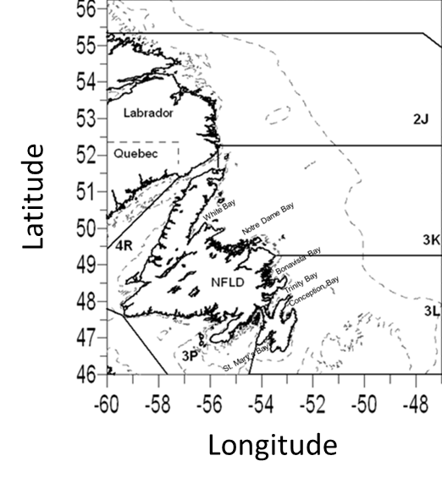

**Fig. 2**

**Are there nicer versions of these maps available?**

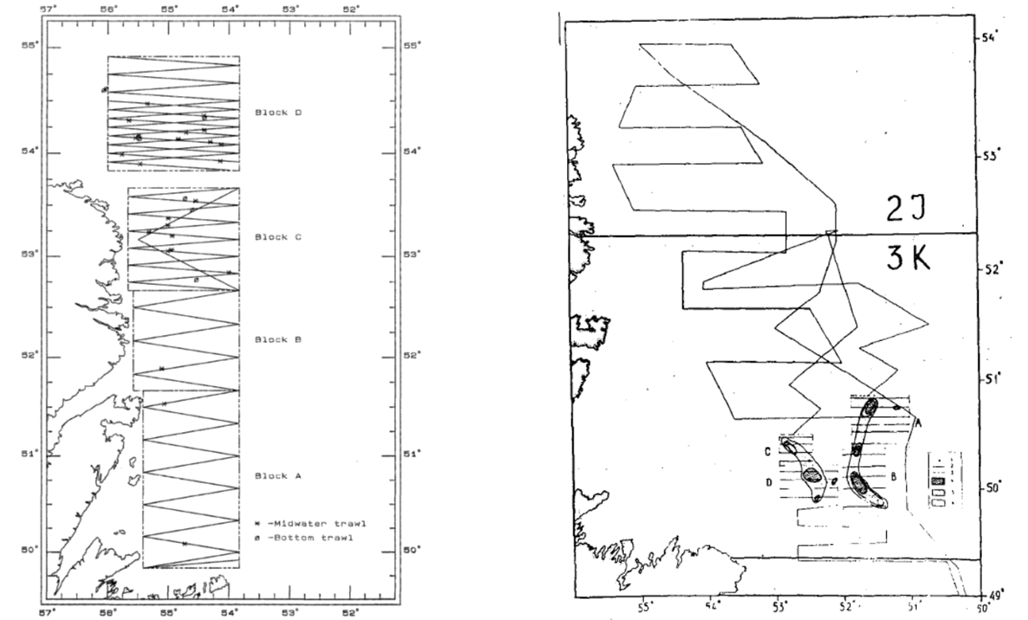

b

a

**Fig. 3**

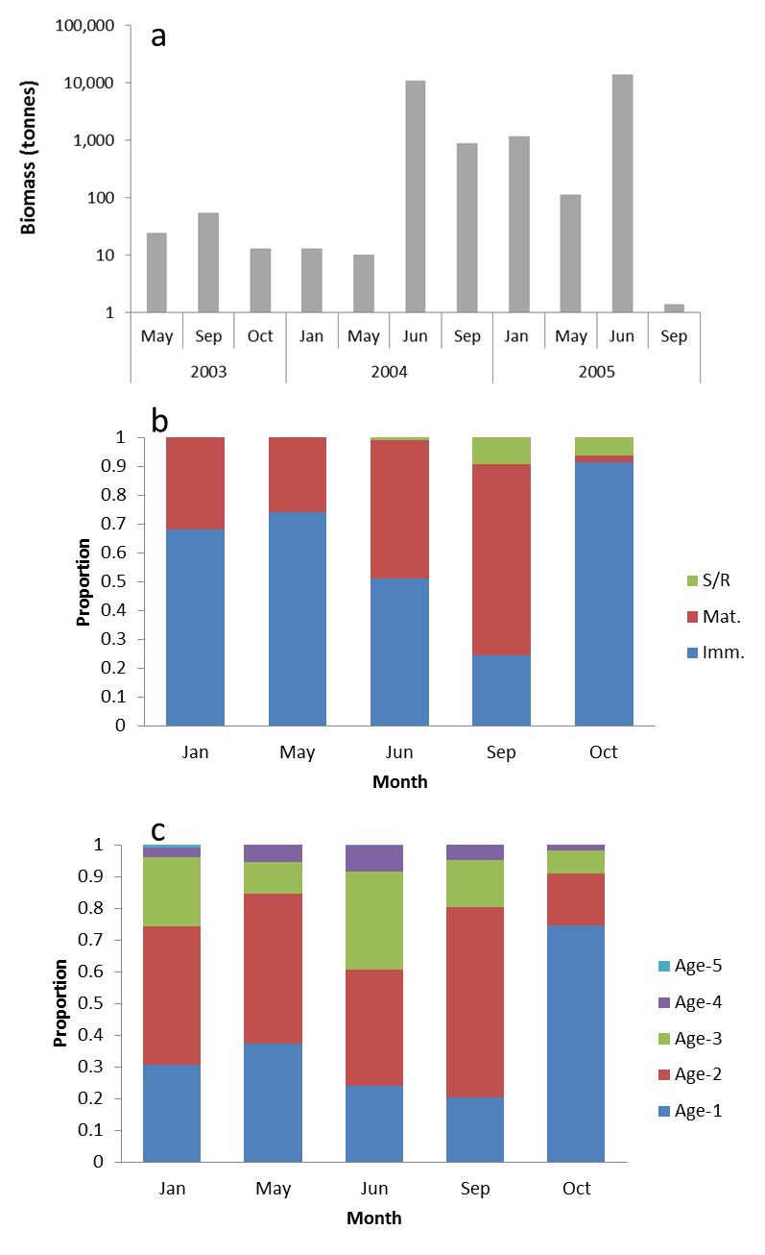

**Fig. 4**

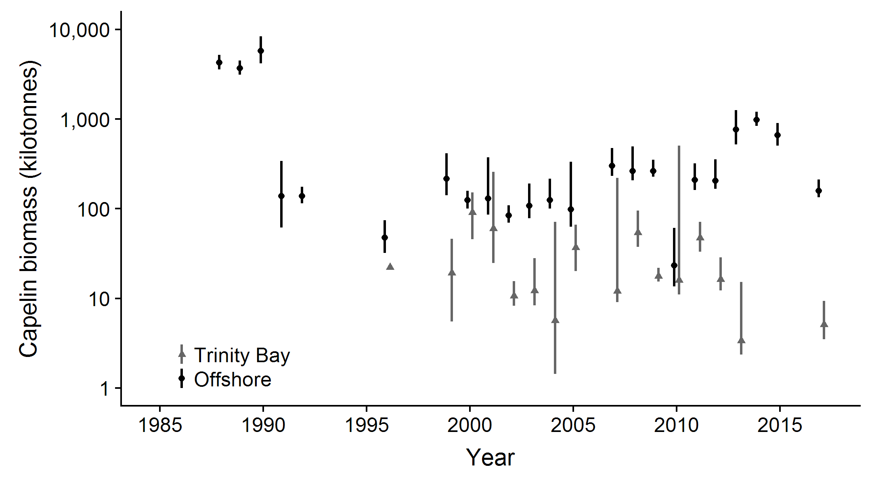

**Fig. 5**

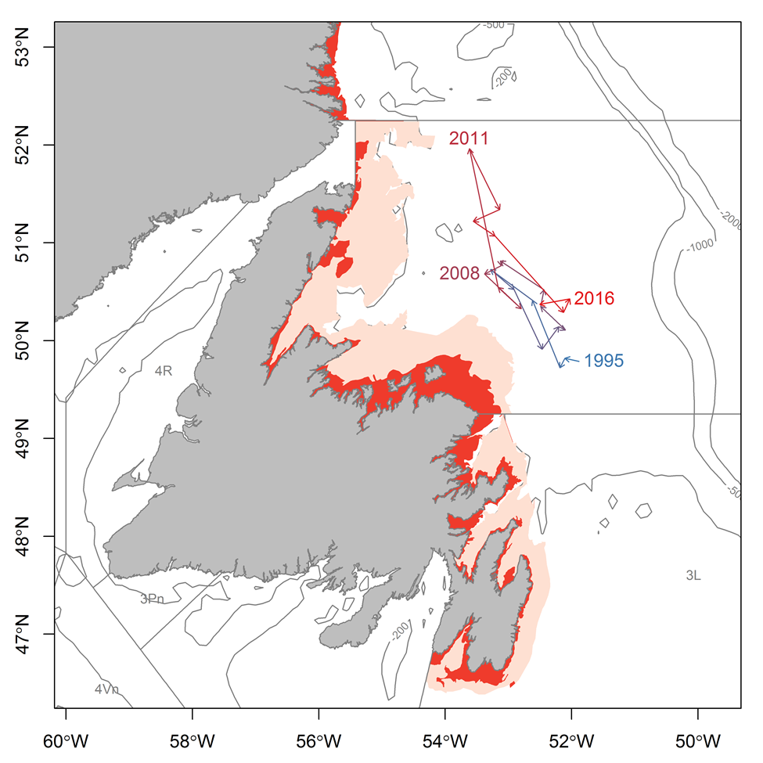

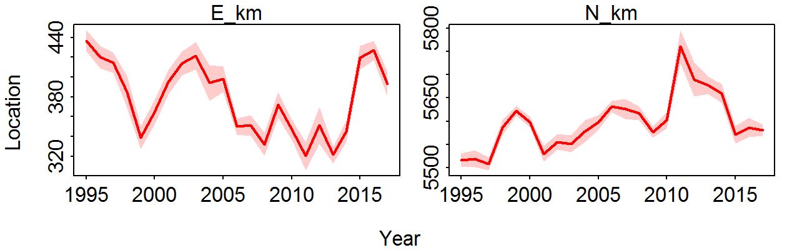

## Supplementary material

### Trinity Bay seasonal inshore acoustic surveys (2003-2005)

Inshore seasonal acoustic surveys (January, June, September) in Trinity Bay were conducted from a 23 m inshore research vessel (CCGS Shamook) using a calibrated EK500 echo-sounder with a towed 38 kHz transducer. Surveys followed a fixed transect design and covered both the main portions and the four arms of Trinity Bay (Suppl. Fig 1). When acoustic targets were encountered, sampling was conducted using bottom and midwater trawls to target the portion of the water column where the acoustic signal occurred. The lack of fishable aggregations of capelin during the seasonal surveys precluded extensive sampling but samples were obtained from most aggregations. Length, sex and maturity stage were recorded for all fish sampled and ages determined for two fish per sex per 0.5 cm interval.

Spatial patterns in age composition were similar to those patterns reported by Winters (1970) with older larger capelin overwintering in the main portion of the bay while juvenile capelin were more prevalent in the inner arms. In all months except June, capelin were aggregated along the sides of the trench around 200 m depth, whereas in June they present in the arms and in shallower water closer to shore at the bottom of the bay (Suppl. Fig. 2).

The spring acoustic surveys have opportunistically surveyed other northeastern bays of Newfoundland including Conception Bay (XXXX), Notre Dame Bay (1999) and Bonavista Bay (XXXX) (Fig. 1). These surveys did not produce a biomass estimate due to low densities of capelin surveyed.

## References

Alheit J, Roy C, Kifani S (2009) Decadal-scale variability in populations. In: Checkley D, Alheit J, Oozeki Y, Roy C (eds) Climate Change and Small Pelagic Fish. Cambridge University Press, Cambridge, UK

Anderson JT, Dalley EL, O'Driscoll RL (2002) Juvenile capelin (*Mallotus villosus*) off Newfoundland and Labrador in the 1990s. ICES Journal of Marine Science 59:917-928.

Anon (1998) Capelin in SA2 + Div. 3KL. Book 98/63. Canadian Science Advisory Secretariat (CSAS) Research Document

Bakanev VS (1992) Results from the acoustic capelin surveys in Div 3LNO and 2J+3KL in 1991. NAFO SCR Doc 92/1

Bourne C, Mowbray F, Squires B, Croft J (2015) An assessment framework and review of Newfoundland east and south coast Atlantic herring (*Clupea harengus*) stocks to the spring of 2013. Canadian Science Advisory Secretariat (CSAS) Research Document 2015/029

Buren AD, Koen-Alonso M, Pepin P, Mowbray F, Nakashima BS, Stenson GB, Ollerhead N, Montevecchi WA (2014a) Bottom-up regulation of capelin, a keystone forage species. PLoS ONE 9:e87589.

Buren AD, Koen-Alonso M, Stenson GB (2014b) The role of harp seals, fisheries and food availability in driving the dynamics of northern cod. Marine Ecology Progress Series 511:265-284.

Carscadden J, Nakashima BS, Miller DS (1994) An evaluation of trends in abundance of capelin (Mallotus villosus) from acoustics, aerial surveys and catch rates in NAFO Division 3L, 1982-89. Northw Atl Fish Sci 17:45-57.

Carscadden JE, Frank KT, Leggett WC (2001) Ecosystem changes and the effects on capelin (*Mallotus villosus*), a major forage species. Canadian Journal of Fisheries and Aquatic Sciences 58:73-85.

Carscadden JE, Gjøsæter H, Vilhjálmsson H (2013) A comparison of recent changes in distribution of capelin (*Mallotus villosus)* in the Barents Sea, around Iceland and in the Northwest Atlantic. Progress in Oceanography

Carscadden JE, Nakashima BS (1997) Abundance and changes in distribution, biology and behavior of capelin in response to cooler water of the 1990s. Forage fishes in marine ecosystems Proceedings of the International Symposium on the Role of Forage Fishes in Marine Ecosystems Alaska Sea Grant College Program Rep No AK-SG-97-01. University of Alaska Fairbanks, Fairbanks, Alaska

Chardine JW, Robertson GJ, Ryan PC, Turner B (2003) Abundance and distribution of common murres breeding at Funk Island, Newfoundland in 1972 and 2000. Canadian Wildlife Service Technical Report Series Atlantic Region:iv + 15.

Chavez FP, Ryan J, Lluch-Cota SE, Ñiquen MC (2003) From anchovies to sardines and back: multidecadal change in the Pacific Ocean. Science 299:217-221.

Colbourne E, Holden J, Craig J, Senciall D, Bailey W, Stead P, Fitzpatrick C (2014) Physical oceanographic conditions on the Newfoundland and Labrador Shelf during 2013. Canadian Atlantic Fisheries Scientific Advisory Committee Research Document 2014/094

Colbourne E, Holden J, Senciall D, Bailey W, Craig J, Snook S (2015) Physical oceanographic conditions on the Newfoundland and Labrador Shelf during 2014. Canadian Atlantic Fisheries Scientific Advisory Committee Research Document 2015/053

Colbourne E, Holden J, Senciall D, Bailey W, Snook S, Higdon J (2016) Physical oceanographic conditions on the Newfoundland and Labrador Shelf during 2015. Canadian Atlantic Fisheries Scientific Advisory Committee Research Document 2016/079

Dalley EL, Anderson JT, deYoung B (2002) Atmospheric forcing, larval drift, and recruitment of capelin ( Mallotus villosus ). ICES Journal of Marine Science 59:929-941.

Dalpadado P, Borkner N, Bogstad B, Mehl S (2001) Distribution of *Themisto* (Amphipoda) spp. in the Barents Sea and predator-prey interactions. ICES Journal of Marine Science 58:876-895.

Dalpadado P, Mowbray F (2013) Comparative analysis of feeding ecology of capelin from two shelf ecosystems, off Newfoundland and in the Barents Sea. Progress in Oceanography 114

Davoren GK (2013) Distribution of marine predator hotspots explained by persistent areas of prey. Marine Biology 160:3043-3058.

Davoren GK, Montevecchi WA (2003) Signals from seabirds indicate changing biology of capelin stocks. Marine Ecology Progress Series 258:253-261.

Davoren GK, Penton P, Burke C, Montevecchi WA (2012) Water temperature and timing of capelin spawning determine seabird diets. ICES Journal of Marine Science 69:1234-1241.

Dawe E, Koen-Alonso M, Chabot D, Stansbury D, Mullowney D (2012) Trophic interactions between key predatory fishes and crustaceans: comparison of two Northwest Atlantic systems during a period of ecosystem change. Marine Ecology Progress Series 469:233-248.

deYoung B, Rose GA (1993) On recruitment and distribution of Atlantic cod (*Gadus morhua*) off Newfoundland. Canadian Journal of Fisheries and Aquatic Sciences 50:2729-2741.

DFO (1994) Report on the status of pelagic fishes (capelin off Newfoundland and in the Gulf of St. Lawrence, and herring off the East, Southeast and South coasts off Newfoundland). DFO Atlantic Fisheries Stock Status Report 1994/3

DFO (2008) Assessment of capelin in SA2+Div. 3KL in 2008. DFO Canadian Science Advisory Secretariat Science Advisory Report 2008/054

DFO (2010) Assessment of Capelin in SA 2 + Div. 3KL in 2010. DFO Canadian Science Advisory Secretariat Science Advisory Report 2010/090

DFO (2013) Assessment of capelin in SA2 + Div. 3KL in 2013. DFO Canadian Science Advisory Secretariat Science Advisory Report 2013/11

DFO (2015) Assessment of capelin in Subarea 2 and Divisions 3KL in 2015. DFO Canadian Science Advisory Secretariat Science Advisory Report 2015/036

Drinkwater KF (1996) Atmospheric and oceanic variability in the Northwest Atlantic during the 1980s and early 1990s. Journal of Northwest Atlantic Fishery Science 18:77-97.

Evans GT, Nakashima BS (2002) A weighted multiplicative analysis to estimate trends in year-class size of capelin. ICES Journal of Marine Science 59:1116-1119.

Frank KT, Carscadden JE, Simon JE (1996) Recent excursions of capelin (*Mallotus villosus*) to the Scotian Shelf and Flemish Cap during anomalous hydrographic conditions. Canadian Journal of Fisheries and Aquatic Sciences 53:1473-1486.

Frank KT, Leggett WC (1982) Coastal water mass replacement: its effect on zooplankton dynamics and the predator–prey complex associated with larval capelin (*Mallotus villosus*). Canadian Journal of Fisheries and Aquatic Sciences 39:991-1003.

Frank KT, Petrie B, Boyce D, Leggett WC (2016) Anomalous ecosystem dynamics following the apparent collapse of a keystone forage species. Marine Ecology Progress Series 553:185-202.

Gjøsæter H (1998) The population biology and exploitation of capelin (Mallotus villosus) in the barents sea. Sarsia 83:453-496.

Gjøsæter H, Bogstad B, Tjelmeland S (2009) Ecosystem effects of the three capelin stock collapses in the Barents Sea. Marine Biology Research 5:40-53.

Gjøsæter H, Dalpadado P, Hassel A (2002) Growth of Barents Sea capelin ( *Mallotus villosus* ) in relation to zooplankton abundance. ICES Journal of Marine Science 59:959-967.

Gomes MdC, Haedrich RL, Villagarcia MG (1995) Spatial and temporal changes in the groundfish assemblages on the north-east Newfoundland/Labrador Shelf, north-west Atlantic, 1978-1991. Fisheries Oceanography 4:85-101.

Gulka J, Carvalho PC, Jenkins E, Johnson K, Maynard L, Davoren GK (2017) Dietary niche shifts of multiple marine predators under varying prey availability on the Northeast Newfoundland Coast. Frontiers in Marine Science 4

Hammill MO, Stenson GB, Doniol-Valcroze T, Mosnier A (2011) Northwest Atlantic harp seals population trends, 1952-2012. DFO Canadian Science Advisory Secretariat Research Document 2011/099

Hamre J (1994) Biodiversity and exploitation of the main fish stocks in the Norwegian - Barents Sea ecosystem. Biodiversity & Conservation 3:473-492.

Haug T, Nilssen K (1995) Ecological implications of harp seals *Phoca groenlandica* invasions in northern Norway. In: Schytte Blix A, Walløe L, Ulltang Ø (eds) Whales, seals, fish and man. Elsevier Science

Head EJH, Pepin P (2010) Spatial and inter-decadal variability in plankton abundance and composition in the Northwest Atlantic (1958–2006). Journal of Plankton Research 32:1633-1648.

Hop H, Gjøsæter H (2013) Polar cod (*Boreogadus saida*) and capelin (*Mallotus villosus*) as key species in marine food webs of the Arctic and the Barents Sea. Marine Biology Research 9:878-894.

ICES (2017) Report of the North Western Working Group (NWWG). Copenhagen, Denmark

Ingvaldsen RB, Gjøsæter H (2013) Responses in spatial distribution of Barents Sea capelin to changes in stock size, ocean temperature and ice cover. Marine Biology Research 9:867-877.

Jangaard PM (1974) The capelin (*Mallotus villosus*): biology, distribution, exploitation, utilization, and composition. Bulletin of the Fisheries Research Board of Canada 186:1-70.

Jech JM, McQuinn IH (2016) Towards a balanced presentation and objective interpretation of acoustic and trawl survey data, with specific reference to the eastern Scotian Shelf. Canadian Journal of Fisheries and Aquatic Sciences 73:1914-1921.

Koen-Alonso M, Fogarty M, Pepin P, Hyde K, Gamble R (2013) Ecosystem production potential in the Northwest Atlantic. Northwest Atlantic Fisheries Organisation Science Council Research Document 13/075

Koen-Alonso M, Pepin P, Mowbray F (2010) Exploring the role of environmental and anthropogenic drivers in the trajectories of core fish species of the Newfoundland-Labrador marine community.

Leggett WC, Frank KT, Carscadden JE (1984) Meteorological and hydrographic regulation of year-class strength in capelin (*Mallotus villosus*). Canadian Journal of Fisheries and Aquatic Sciences 41:1193-1201.

Lilly GR (1987) Interactions between Atlantic cod (*Gadus morhua*) and capelin (*Mallotus villosus*) off Labrador and eastern Newfoundland: a review. Canadian Technical Report in Fisheries and Aquatic Sciences 1567:1-37.

Lilly GR (1991) Interannual variability in predation by cod (*Gadus morhua*) on capelin (*Mallotus villosus*) and other prey off southern Labrador and northeastern Newfoundland. ICES Marine Science Symposia 193:133-146.

Lilly GR (2005) Southern Labrador and eastern Newfoundland (NAFO Divisions 2J+3KL). In: Brander KM (ed) Spawning and life history information for North Atlantic cod stocks ICES Cooperative Research Report, No 274

Lilly GR, Davis DJ (1993) Changes in the distribution of capelin in Divisions 2J, 3K and 3L in the autumns of recent years, as inferred from bottom-trawl by-catches and cod stomachs examinations. NAFO SCR Doc 93/54

Lilly GR, Hop H, Stansbury DE, Bishop CA (1994) Distribution and abundance of polar cod (*Boreogadus saida*) off southern Labrador and eastern Newfoundland. ICES CM 0:6

Lilly GR, Parsons DG, Kulka DW (2000) Was the increase in shrimp biomass on the northeast Newfoundland shelf a consequence of a release in predation pressure from cod? Journal of Northwest Atlantic Fishery Science 27:45-61.

Melvin GD, Fife FJ, Sochasky JB, Power MJ, Stephenson RL (1995) The 1995 Update on Georges Bank 5Z Herring Stock. DFO Atlantic Fisheries Research Document 95/86

Miller DS, Carscadden, JE (1984) Capelin acoustic biomass survey for NAFO Division 2J3K, October 1983. Canadian Atlantic Fisheries Scientific Advisory Committee Research Document 84/79

Miller DS (1992) Observations and studies on SA2 + Div. 3K capelin in 1991. Canadian Atlantic Fisheries Scientific Advisory Committee Research Document 92/15

Miller DS (1993) Observations and studies on SA2 + Div. 3K capelin in 1992. Canadian Atlantic Fisheries Scientific Advisory Committee Research Document 93/10

Miller DS (1994) Results from an acoustic survey for capelin (*Mallotus villosus*) in NAFO Divisions 2J3KL in the autumn of 1993. Capelin in SA2 + Div 3KL DFO Atlantic Fisheries Research Document 94/18

Miller DS (1995) Results from an Acoustic Survey for Capelin (*Mallotus villosus*) in NAFO Divisions 2J3KL in the Autumn of 1994. Capelin in SA2 + Div 3KL DFO Atlantic Fisheries Research Document 95/70

Miller DS (1997) Results from an acoustic survey for capelin (*Mallotus villosus*) in NAFO Divisions 3KL in the spring of 1996. Capelin in SA2 + Div 3KL DFO Atlantic Fisheries Research Document 97/29

Miller DS, Lilly GR (1991) Observations and studies on SA2 + Div. 3K capelin in 1991. Canadian Atlantic Fisheries Scientific Advisory Committee Research Document 91/11

Montevecchi WA (2007) Binary dietary responses of northern gannets *Sula bassana* indicate changing food web and oceanographic conditions. Marine Ecology Progress Series 352:213-220.

Montevecchi WA, Myers RA (1997) Centurial and decadal oceanographic influences on changes in Northern Gannet populations and diets in the Northwest Atlantic: Implications for climate change. ICES Journal of Marine Science 54:608-614.

Montevecchi WA, Myers RA (1992) Monitoring fluctuations in pelagic fish availability with seabirds. Canadian Atlantic Fisheries Scientific Advisory Committee Research Document 92/94

Morgan MJ, Koen-Alonso M, Rideout RM, Buren AD, Maddock Parsons D (2017) Growth and condition in relation to the lack of recovery of northern cod. ICES Journal of Marine Science:fsx166-fsx166.

Mowbray F (2002) Changes in the vertical distribution of capelin (*Mallotus villosus*) off Newfoundland. ICES Journal of Marine Science 59:942-949.

Mowbray F (2014) Recent spring offshore acoustic survey results for capelin, *Mallotus villosus*, in NAFO Division 3L. DFO Canadian Science Advisory Secretariat Research Document 2013/040

Mullowney D, Maillet G, Dawe E, Rose G, Rowe S (2016) Spawning delays of northern capelin (*Mallotus villosus*) and recovery dynamics: A mismatch with ice-mediated spring bloom? Progress in Oceanography 141:144-152.

Mullowney DRJ, Rose GA (2014) Is recovery of northern cod limited by poor feeding? The capelin hypothesis revisited. ICES Journal of Marine Science: Journal du Conseil

Munafò MR, Davey Smith G (2018) Robust research needs many lines of evidence. Nature 553:399-401.

Murphy HM, Pepin P, Robert D (2018) Re-visiting the drivers of capelin recruitment in Newfoundland since 1991. Fisheries Research 200:1-10.

NAFO (2014) Report of the 7th Meeting of the NAFO Scientific Council (SC) Working Group on Ecosystem Science and Assessment (WGESA). Northwest Atlantic Fisheries Organisation Science Council Studies Doc 14/023 Serial No N6410, NAFO Headquarters, Dartmouth, NS, Canada

Nakashima B (1996) The relationship between oceanographic conditions in the 1990s and changes in spawning behaviour, growth and early life history of capelin (M*allotus villosus)*. NAFO Sci Coun Studies 24:55-68.

Nakashima BS (1997) Results of the 1996 aerial survey of capelin (*Mallotus villosus*) schools. Capelin in SA2 + Div 3KL DFO Atlantic Fisheries Research Document, 97/29

Nakashima BS, Mowbray F (2014) Capelin (*Mallotus villosus)* recruitment indices in NAFO Division 3KL. DFO Canadian Science Advisory Secretariat Research Document 2013/091

Nakashima BS, Wheeler JP (2002) Capelin (*Mallotus villosus*) spawning behaviour in Newfoundland waters - the interaction between beach and demersal spawning. ICES Journal of Marine Science 59:909-916.

Neville V, Rose GA, Rowe S, Jamieson R, Piercey G (2018) Otolith chemistry and redistributions of northern cod: evidence of Smith Sound-Bonavista Corridor connectivity. Canadian Journal of Fisheries and Aquatic Sciences

Nilssen KT, Haug T, Øritsland T, Lindblom L, Kjellqwist SA (1998) Invasions of harp seals *Phoca groenlandica* Erxleben to coastal waters of nor way in 1995: Ecological and demographic implications. Sarsia 83:337-345.

Obradovich SG, Carruthers EH, Rose GA (2014) Bottom-up limits to Newfoundland capelin (Mallotus villosus) rebuilding: the euphausiid hypothesis. ICES Journal of Marine Science 71:775-783.

Olafsdottir AH, Rose GA (2012) Influences of temperature, bathymetry and fronts on spawning migration routes of Icelandic capelin (*Mallotus villosus*). Fisheries Oceanography 21:182-198.

Pálsson ÓK, Gislason A, Guðfinnsson HG, Gunnarsson B, Ólafsdóttir SR, Petursdottir H, Sveinbjörnsson S, Thorisson K, Valdimarsson H (2012) Ecosystem structure in the Iceland Sea and recent changes to the capelin (Mallotus villosus) population. ICES Journal of Marine Science 69:1242-1254.

Pedersen EJ, Thompson PL, Ball RA, Fortin M-J, Gouhier TC, Link H, Moritz C, Nenzen H, Stanley RRE, Taranu ZE, Gonzalez A, Guichard F, Pepin P (2017) Signatures of the collapse and incipient recovery of an overexploited marine ecosystem. Royal Society Open Science 4

Pepin P, Colbourne E, Maillet G (2011) Seasonal patterns in zooplankton community structure on the Newfoundland and Labrador Shelf. Progress in Oceanography 91:273-285.

Pepin P, Cuff A, Koen-Alonso M, Ollerhead N (2010) Preliminary Analysis for the Delineation of Marine Ecoregions on the NL Shelves. NAFO SCR Doc 10/72

Pepin P, Higdon J, Koen-Alonso M, Fogarty M, Ollerhead N (2014) Application of ecoregion analysis to the identification of Ecosystem Production Units (EPUs) in the NAFO Convention Area. NAFO SCR Doc 14/069

Pepin P, Johnson CL, Harvey M, Casault B, Chassé J, Colbourne EB, Galbraith PS, Hebert D, Lazin G, Maillet G, Plourde S, Starr M (2015) A multivariate evaluation of environmental effects on zooplankton community structure in the western North Atlantic. Progress in Oceanography 134:197-220.

Pepin P, Koen-Alonso M, Higdon J, Ollerhead N (2012) Robustness in the delineation of ecoregions on the Newfoundland and Labrador continental shelf. NAFO SCR Doc 12/067

Pepin P, Maillet G, Fraser S, Doyle G, Robar A, Shears T, Redmond G (2017) Optical, chemical and biological oceanographic conditions on the Newfoundland and Labrador Shelf during 2014-2015. Canadian Science Advisory Secretariat (CSAS) Research Document 2017/009

Pikitch EK, Boersma PD, Boyd IL, Conover DO, Cury PM, Essington TE, Heppell SS, Houde ED, Mangel M, Pauly D, Plagányi E, Sainsbury KJ, Steneck RS (2012) Little fish: big impact: managing a crucial link in ocean food webs. Lenfest Ocean Program, Washington, DC

Pikitch EK, Routos KJ, Essomgton TE, Santora C, Pauly D et al. (2014) The global contribution of forage fish to marine fisheries and ecosystems. Fish and Fisheries*.* 15:43-64. doi.org/10.1111/faf.12004

Regular P, Montevecchi W, Hedd A, Robertson G, Wilhelm S (2013) Canadian fishery closures provide a large-scale test of the impact of gillnet bycatch on seabird populations. Biology Letters 9

Reid PC, Colebrook JM, Matthews JBL, Aiken J (2003) The Continuous Plankton Recorder: concepts and history, from Plankton Indicator to undulating recorders. Progress in Oceanography 58:117-173.

Rice J (2002) Changes to the large marine ecosystem of the Newfoundland-Labrador shelf. In: Sherman K, Skjoldal HR (eds) Large marine ecosystems of the North Atlantic. Elsevier Science B.V.

Rose GA (1993) Cod spawning on a migration highway in the north-west Atlantic. Nature 366:458-461.

Rose GA (2007) Cod: an ecological history of the North Atlantic fisheries. Breakwater Books, St John's, NL

Rose GA, deYoung B, Kulka DW, Goddard SV, Fletcher GL (2000) Distribution shifts and overfishing the northern cod (*Gadus morhua*): a view from the ocean. Canadian Journal of Fisheries and Aquatic Sciences 57:644-663.

Rose GA, O'Driscoll RL (2002) Capelin are good for cod: can the northern stock rebuild without them? ICES Journal of Marine Science 59:1018-1026.

Rose GA, Rowe S (2018) Does redistribution or local growth underpin rebuilding of Canada’s Northern cod? Canadian Journal of Fisheries and Aquatic Sciences:1-11.

Schwartzlose RA, Alheit J, Bakun A, Baumgartner TR, Cloete R, Crawford RJM, Fletcher WJ, Green-Ruiz Y, Hagen E, Kawasaki T, Lluch-Belda D, Lluch-Cota SE, MacCall AD, Matsuura Y, Névarez-Martínez MO, Parrish RH, Roy C, Serra R, Shust KV, Ward MN, Zuzunaga JZ (1999) Worldwide large-scale fluctuations of sardine and anchovy populations. South African Journal of Marine Science 21:289-347.

Sherwood GD, Rideout RM, Fudge SB, Rose GA (2007) Influence of diet on growth, condition and reproductive capacity in Newfoundland and Labrador cod (*Gadus morhua*): Insights from stable carbon isotopes (ä13C). Deep Sea Research Part II: Topical Studies in Oceanography 54:2794-2809.

Shuter BJ (1990) Population level indicators of stress. In: Adams SM (ed) Biological indicators of stress in fish. American Fisheries Society Symposium 8

Skagseth Ø, Slotte A, Stenevik EK, Nash RDM (2015) Characteristics of the Norwegian Coastal Current during Years with High Recruitment of Norwegian Spring Spawning Herring (Clupea harengus L.). PLOS ONE 10:e0144117.

Soutar A, Issacs JD (1969) History of fish populations inferred from fish scales in anaerobic sediments off California. CalCOFI Reports 13:63-70.

Stenson GB (2012) Estimating consumption of prey by harp seals (*Pagophilus groenlandicus*) in NAFO Divisions 2J3KL. Canadian Science Advisory Secretariat (CSAS) Research Document 2012/156

Stenson GB, Buren AD, Koen-Alonso M (2016) The impact of changing climate and abundance on reproduction in an ice-dependent species, the Northwest Atlantic harp seal, *Pagophilus groenlandicus*. ICES Journal of Marine Science: Journal du Conseil 73:250-262.

Stenson GB, Wakeham D, Buren AD, Koen-Alonso M (2014) Density-dependent and density-independent factors influencing reproductive rates in Northwest Atlantic harp seals, *Pagophilus groenlandicus*. DFO Canadian Science Advisory Secretariat Research Document 2014/058

Templeman W (1948) The life history of the caplin (*Mallotus villosus* O. F. Müller) in Newfoundland waters. Bulletin of the Newfoundland Government Laboratory 17:1-151.

Thorson J, T., Pinsky M, L., Ward E, J., Gimenez O (2016) Model‐based inference for estimating shifts in species distribution, area occupied and centre of gravity. Methods in Ecology and Evolution 7:990-1002.

Thorson JT, Barnett LAK (2017) Comparing estimates of abundance trends and distribution shifts using single- and multispecies models of fishes and biogenic habitat. ICES Journal of Marine Science 74:1311-1321.

Toresen R, Østvedt OJ (2000) Variation in abundance of Norwegian spring-spawning herring (Clupea harengus, Clupeidae) throughout the 20th century and the influence of climatic fluctuations. Fish and Fisheries 1:231-256.

Trippel EA (1995) Age at Maturity as a Stress Indicator in Fisheries: Biological processes related to reproduction in northwest Atlantic groundfish populations that have undergone declines. BioScience 45:759-771.

Vilhjálmsson H (1994) The Icelandic capelin stock. Rit Fiskideildar 13:1-281.

Winters GH (1970) Biological changes in coastal capelin from the over-wintering to the spawning condition. Journal of the Fisheries Research Board of Canada 27:2215-2224.

Winters GH (1995) Interaction between timing, capelin distribution and biomass estimates from the Div. 2J3K capelin acoustic survey. Capelin in SA2 + Div 3KL. DFO Atlantic Fisheries Research Document 95/70

Winters GH, Carscadden JE (1978) Review of capelin ecology and estimation of surplus yield from predator dynamics. International Commission for the Northwest Atlantic Fisheries Research Bulletin 13:21-30.