# The collapse of a keystone forage species

Buren, A.D.1*§, Murphy, H.M.1§, Adamack, A.T.1, Davoren, G. K.2, Koen-Alonso, M.1, Montevecchi W.A.3, Mowbray, F. K.1, Pepin, P.1, Regular, P.1, Robert, D.4, Rose, G.A.5, Stenson, G.1, Varkey, D.1

Affiliations:

1. Northwest Atlantic Fisheries Centre, Fisheries and Oceans Canada, St. John's, NL, Canada

2. Department of Biological Sciences, University of Manitoba, Winnipeg, MB, Canada

3. Cognitive and Behavioural Ecology Progamme, Departments of Biology and Psychology, Memorial University of Newfoundland, St. John’s, NL, Canada

4. Institut des sciences de la mer, Université du Québec à Rimouski, Rimouski, QC, Canada

5. Institute for the Oceans and Fisheries, UBC, Vancouver, Canada.

*corresponding author: Tel: +1 709 772 4049; Fax: + 1 709 772 4138; e-mail: Alejandro.Buren@dfo-mpo.gc.ca

§ A.D.B and H.M.M. contributed equally to this paper and others have contributed equally. Authors have been listed in alphabetical order for each contribution level.

## Abstract

Capelin is the linchpin of the Northwest Atlantic ecosystem, where they are the primary conduit from lower to higher trophic levels. According to acoustic monitoring surveys conducted by Canada and the USSR, the Newfoundland (NAFO Division 2J3KL) capelin stock suffered an order of magnitude decline in biomass during the early 1990s. This collapse was concomitant with drastic changes in the ecosystem during the late 1980s and early 1990s, and the capelin collapse was considered a key signal in the identification of a regime shift that occurred in the early 1990s. However, while more than a dozen studies have provided evidence supporting a capelin stock collapse, there is also literature that supports a non-collapse hypothesis of capelin. The non-collapse hypothesis purports that rather than collapsing in 1991 the capelin stock either (1) changed its migratory patterns with the timing of the acoustic survey remaining constant, leading to a spatio-temporal mismatch between the survey and the stock, or (2) capelin becoming less migratory and remained inshore year round, therefore being largely underestimated by the offshore surveys. We tested the collapse and non-collapse hypotheses using multiple independent datasets, which included both fishery-dependent (inshore commercial catch) and fishery-independent (spring and fall acoustic and fall bottom trawl surveys, oceanography cruises, capelin larval indices, aerial surveys, predator diet and behaviour, and diverse statistical methods) data. The hypothesis of a non-collapse of the capelin stock was rejected by our analyses. The weight of evidence approach led us to conclude that the Newfoundland capelin stock suffered a population collapse in 1991 with minimal recovery over the subsequent 25 years.

## Introduction

Forage fish play crucial roles in many ecosystems, transferring the bulk of energy from lower trophic levels to large vertebrate predators. Typically, they are small shoaling species that are characterized by short life expectancy and rapid but variable growth driven by environmental factors. Forage fish species often exhibit “boom and bust” population dynamics, i.e. their abundances change rapidly and substantially and undergo phases of extremely high and extremely low abundances (Soutar & Issacs 1969, Schwartzlose et al. 1999, Chavez et al. 2003, Pikitch et al. 2012, Pikitch et al. 2014). Forage fish species can experience prolonged periods of ‘bust’ dynamics. For example, the Norwegian spring-spawning herring (*Clupea harengus*) stock collapsed in the late 1960s after a pulse of overfishing and remained at very low levels until the late 1980s(Toresen & Østvedt 2000, Skagseth et al. 2015); while sardine (*Sardinops sagax*) and anchovy (*Engraulis* spp.) have decade-scale regimes of high and low abundances where populations thrived for 20 to 30 years and then disappeared for similar periods (Schwartzlose et al. 1999, Chavez et al. 2003).

Capelin (*Mallotus villosus*) is the focal forage species in ecosystems of the northern Atlantic Ocean (Templeman 1948, Jangaard 1974, Vilhjálmsson 1994, Carscadden et al. 2001). The three most important capelin populations in the North Atlantic are in the Barents Sea, off the coast of Iceland, and along the Newfoundland and Labrador (Canada) continental shelf. The Barents Sea capelin stock experienced four collapses over the past 4 decades: the mid- to late-1980s, the mid-1990s, the mid-2000s, and the mid-2010s. The size of the stock fluctuated between 3 and 7 million tonnes during the boom phase and around 200 thousand tonnes during bust phases. There is general agreement that ecosystem changes were the driving forces behind these dynamics (Gjøsæter et al. 2009). The Icelandic capelin stock underwent similar dynamics, with three bust phases over the past 4 decades: the early 1980s, the early 1990s, and most of the 2000s. The size of the stock was around 1.5-2 million tonnes during the boom phase and between 100-500 thousand tonnes during bust phases (ICES 2017). The first two bust phases were due to a combination of poor recruitment and the stock being easily available to the fishing fleet, while the most recent bust phase was likely associated with a climate-related shift in distribution (Pálsson et al. 2012, Carscadden et al. 2013).

Fisheries and Oceans Canada (DFO) is responsible for the assessment of the Newfoundland and Labrador (NL) capelin stock. DFO concluded that the stock experienced an order of magnitude decline in the early 1990s with minimal recovery during the past two decades (DFO 1994, Miller 1994, 1997, DFO 2008, 2010, 2013, 2015, 2018). The size of the stock fluctuated between 2 and 6 million tonnes between 1982 and 1991 1991, and between 25 and 900 thousand tonnes during the ensuing period (DFO 2015). This decline was concomitant with drastic changes in the ecosystem during the late 1980s and early 1990s (deYoung & Rose 1993, Gomes et al. 1995, Montevecchi & Myers 1997, Lilly et al. 2000, Rice 2002, Rose 2007, Koen-Alonso et al. 2010, Hammill et al. 2011, Pedersen et al. 2017), including major changes in the biology and ecology of capelin, such as delayed and protracted spawning, changes in their geographical and vertical distribution, and declines in somatic condition and size and age at maturity (Frank et al. 1996, Carscadden & Nakashima 1997, Carscadden et al. 2001, Mowbray 2002, Nakashima & Wheeler 2002, DFO 2010). The collapse of capelin was a key signal in the identification of the regime shift that occurred in the early 1990s (Rose 2005, Buren et al. 2014a, Pedersen et al. 2017).

Frank et al. (2016) argued that the capelin stock off NL did not collapse; alternatively, they argued that the offshore surveys have failed to detect large capelin aggregations since 1991 because of spatio-temporal mismatch between the surveys and the stock. Specifically, they hypothesized that post-1991 either (1) capelin changed their migratory patterns while the timing of the acoustic survey remained constant, leading to a spatio-temporal mismatch between the survey and the stock or (2) capelin suddenly became less migratory and now remains inshore, and are therefore undetected by the offshore surveys. Support for the hypothesis of non-collapse of capelin was based on changes in the biology of capelin post-1991 (e.g., distribution and demography), re-analysis of the offshore research surveys (multi-species bottom trawl and acoustic), and the response of various components of the ecosystem [e.g., zooplankton, Atlantic cod (*Gadus morhua*), seabirds, seals] to the large-scale changes that have occurred since the early 1990s (Frank et al. 2016). The objective of the present paper is to assess the empirical support for the hypothesis of stock collapse (DFO 2015) versus that of non-collapse (Frank et al. 2016) using all available data.

**Methods**

To test the hypotheses of collapse and non-collapse of the capelin stock in NAFO Divisions 2J3KL (hereafter Div. 2J3KL; Fig. 1), we applied the weight of evidence approach using multiple, independent data sets and diverse statistical methods (e.g., triangulation, sensu Munafò & Davey Smith 2018). In some sections, new data and analyses were presented to test alternative hypotheses. Each section concludes by weighting evidence in support for each alternative hypothesis. Once this was completed for all sections, the weight of evidence approach was used to determine which hypothesis was best supported by the combination of previously-published results and additional analyses based on independent data sets.

## Capelin

### Offshore capelin distribution: acoustic surveys

The capelin collapse hypothesis is supported by the fall and spring offshore acoustic surveys conducted by Canada and the former USSR that found a sudden decrease in capelin biomass in the fall of 1990 in Div. 2J3KL (Miller & Lilly 1991, Bakanev 1992, Miller 1992, 1993, 1994, Mowbray 2014). The non-collapse hypothesis purports that Canada and the USSR offshore acoustic surveys found low capelin biomasses in the fall of 1991 and 1992 in Div. 2J3KL because capelin did not migrate offshore starting in the fall of 1990 (Frank et al. 2016).

From 1982 to 1992, Canada conducted fall (October) acoustic surveys for capelin in Div. 2J3K (Fig. 1) (e.g., Miller and Carscadden 1984, Miller and Lilly 1991). The fall acoustic surveys targeted the maturing portion of the stock during winter feeding migrations to provide estimates of the size and number of maturing fish being recruited to the fishery the following year (Mowbray 2014). The capelin stock in Div. 2J3K was also acoustically surveyed by the former USSR in November from 1982-1992 (Bakanev 1992; Fig. 1). The USSR fall acoustic surveys were conducted approximately a month later than the Canadian surveys and consistently estimated higher capelin abundances, which may have been due to timing, as capelin start aggregating into large overwintering shoals in November (Winters 1995). In 1990, the Canadian fall acoustic survey reported a very low capelin biomass (96 thousand tonnes, < 5% of the biomass surveyed in 1989) while the USSR acoustic survey reported the smallest biomass since 1984 (631 thousand tonnes) (Winters 1995). Both the USSR and Canadian acoustic surveys reported record low biomasses in the fall of 1991 and 1992 (16-55 thousand tonnes) (Winters 1995). The decrease in capelin biomass in both surveys corresponded with very few capelin being detected off the coast of Labrador and a southward shift in stock distribution to the southern portion of Div. 3K and northern portion of Div. 3L (Miller & Lilly 1991, Miller 1992). A Canadian expanded fall survey (Div. 2J3KL) in 1993-94 was conducted to determine if the ‘missing’ capelin could be located. However, the expanded fall acoustic survey confirmed the findings of the 1991-92 fall surveys that offshore capelin biomass was low and characterized by a southward change in distribution (Miller 1994, 1995). Post-1991, capelin is only acoustically surveyed in the spring in Div. 3L by Canada (1996, 1999-2005, 2007-2015, 2017) with the discontinuation of the other three acoustic surveys in the early 1990s (Canada fall acoustic survey in 1994; USSR fall and spring acoustic surveys in 1992 and 1994, respectively).

While the offshore acoustic surveys provide strong evidence of a capelin collapse, they do not survey the inshore area. The non-collapse hypothesis uses unquantified densities of overwintering maturing capelin and large schools of immature capelin observed during winter surveys conducted in Trinity Bay in 1967-68 (Winters 1970) as evidence that significant densities of capelin can inhabit the inshore year-round. DFO tested the hypothesis of year-round residency of capelin in the inshore by conducting seasonal acoustic surveys in Trinity Bay (September and October 2003; January, June and September 2004-05) and expanding the annual offshore spring acoustic survey into Trinity Bay (1999-2005, 2007-13, 2017) (Fig. 2 a; see supplementary section for details on methods). Seasonally, capelin densities were low in Trinity Bay in January and May, and the maximum mean density of capelin was observed in June (10,000 kg km-2), which corresponded with the start of the spawning period when capelin were highly aggregated inshore (Fig. 2 a). In September and October, capelin densities were low once again (Fig. 2 a). There was also a distinct seasonal pattern in the age and maturity composition inshore. In January, overwintering fish were composed of ~70% immature age-1 and age-2 fish (Fig. 2 b, c); the relative contribution of older fish increased through the spring as maturing age-2 and age-3 fish migrated into Trinity Bay (Fig. 2 b, c); and by October, immature age-1 fish dominated the inshore area, strongly suggesting that spent mature fish either died or left the bay (Fig. 2 b). The seasonal surveys found no evidence of a large inshore, non-migratory capelin stock. In agreement with this finding, an inshore acoustic survey in January 2000 for overwintering cod from Conception to Notre Dame Bay found concentrations of juvenile capelin (O’Driscoll and Rose 2001) but few older fish (G.A. Rose, unpublished data).

With little evidence of a change in capelin migratory behavior inshore post-1991, we assumed that the portion of the capelin stock available to each of the five acoustic surveys (spring and fall offshore Canada and USSR; and Trinity Bay inshore) has remained constant through time, plus or minus inter-annual variability caused by changes in migration routes such as those observed in Icelandic capelin stocks (Olafsdottir & Rose 2012). If this is true, then the trends observed in each survey are theoretically generated by the same population process. Using this logic, we fitted a state-space Ricker-logistic model to the acoustic estimates of biomass from the five acoustic surveys conducted in Div. 2J3KLNO. Under this classic discrete population model, the expected biomass of individuals in year *y* is modeled as a function of the biomass in year *y-1*,

$${log⁡(B}_{y})={log⁡(B}_{y-1})+ r\left(1- \frac{B_{y-1}}{K}\right)+ u_{y}$$

$$u_{y} \sim N\left(0, σ^{2}\right)$$

Where *r* is interpreted as the intrinsic growth rate of the population, *K* is the carrying capacity of the environment, and $u_{y}$ is the process error which is assumed to follow a normal distribution with a mean of 0 and a standard deviation of σ. All surveys are assumed to be “observing” the same latent process and, as such, survey indices are modeled as a function of $B_{y}$,

$${log⁡(I}_{s,y})=\log\left(q_{s}\right)+ {log⁡(B}_{y})+v_{s,y}$$

$$v_{s,y} \sim N(0, τ_{s}^{2})$$

Here $q_{s }$ are catchability parameters that adjust stock biomass to the scale of the surveys and $v_{s,y}$ represents the observation error of each survey which is assumed to follow a normal distribution with a mean of 0 and a standard deviation of $τ_{s}$. Under this formulation, all catchability parameters could not be estimated freely, therefore the catchability parameter of the Canadian spring acoustic survey was fixed to 1 because it is the longest running time series and it also has a history of obtaining the largest population estimates. The model was constructed and fit using TMB (Kristensen et al. 2016). The model provides a good fit to each of the five survey indices and strongly supports a dramatic collapse in capelin biomass from 1990 to 1991 (Fig. 3). While this model does not rule out the possibility that the population became non-migratory and remained inshore (i.e. the catchability of all acoustic surveys dropped dramatically in 1990), it is telling that the standard deviation around the inshore acoustic survey of Trinity Bay is nearly six times that estimated for the spring acoustic survey (1.26 vs. 0.22, respectively). This means that, in the context of a Ricker-logistic population model, the Trinity Bay acoustic survey is providing little information on the population dynamics of capelin. If the majority of the population were inshore, then one would expect inshore indices to be much more influential. Moreover, biomass estimates from the Trinity Bay acoustic survey in the spring are typically a small fraction of the estimates from the offshore (~10% of the spring acoustic survey). It is, therefore, unlikely that the 3-6 million tonnes (Mt) of ‘missing’ capelin reside along the coast of NL.

In summary, while the fall and spring acoustic surveys in Div. 2J3KL cannot refute the hypothesis that capelin are non-migratory post-1991 as inshore areas were not systematically surveyed, the lack of significant inshore aggregations of capelin outside of the peak spawning period during seasonal and annual spring acoustic surveys provides support for the hypothesis of a capelin stock collapse in the early 1990s.

**Offshore capelin distribution: annual multi-species bottom-trawl surveys**

The non-collapse hypothesis used the fall bottom trawl survey (FBTS) data to point to a westerly, inshore shift in the center of capelin concentration in 1996-2010 compared to 1985-1995 (Frank et al. 2016). However, the center of concentration of capelin using the FBTS presence/absence data from 1985-1995 found inshore distributions occurred in three high abundance years (1986-1988, Fig S2 in Frank et al. 2016). This variability is likely related to the poor catchability of capelin in the Engel otter trawl (used from 1978-1994), which was designed for harvesting commercial groundfish like flatfish and Atlantic cod. The gear used for sampling in the FBTS was changed in 1995 to a Campelen 1800 shrimp trawl, which improved the catchability of capelin in the survey. A similar center of gravity analysis using only post-1995 FBTS data showed a southerly shift in capelin distribution post-1995 with a recent shift to the northwest in 2011-14 (DFO 2015). However, neither of these analyses accounted for inter-annual changes in capelin spatial distribution due to FBTS sampling effort nor considered the uncertainty around the center of gravity estimates.

To address the abovementioned issues and to test the non-collapse hypothesis of a shoreward shift in capelin distribution post-1991, we revisited the center of gravity analysis of the FBTS data using the approach described in Thorson et al. (2016). We used the VAST package in R (Thorson & Barnett 2017) to fit a geostatistical delta-generalized linear mixed model to estimate the spatial and temporal distribution of capelin (Thorson et al. 2016). The advantages of this approach are that it accounts for inter-annual changes in the spatial distribution of sampling effort and offers a means of estimating the standard error of the center of gravity metric, which provides perspective on the significance of distributional shifts. Like DFO (2015), we focused on the post-1995 period when the catchability of capelin improved with the use of a Campelen 1800 shrimp trawl. Our geostatistical analysis did not support the hypothesis that capelin shifted their distribution towards the inshore post-1995 and there is no evidence of an easterly or westerly movement in the center of gravity of capelin (Fig. 4). Instead, the center of gravity of capelin remains > 100 km offshore and demonstrates pronounced shifts in the north-south axis (Fig. 4).

Like the acoustic surveys, the FBTS has poor survey coverage of the inshore. It is, therefore, possible that significant aggregations of capelin could go unnoticed. Nonetheless, simple back-of-the-envelope calculations indicate that it is unrealistic to assume that the 3 to 6 Mt of capelin that are ‘missing’ in the offshore surveys are now residing in the inshore. Even though the inshore strata are inconsistently covered by the annual FBTS with an inshore area of ~35,000 to ~71,000 km2 remaining un-surveyed each year, the minimum density for 3 to 6 Mt of capelin hiding in these inshore waters would have to be between ~41,000 to ~170,000 kg km-2, uniformly distributed throughout the un-surveyed area. It is unlikely that such densities of capelin would go unnoticed by the FBTS; furthermore, if they were present, then the center of gravity would be oriented towards the inshore during years when more inshore strata were surveyed (1996-1998, 2000-2002, 2004-2006, 2010, 2013) (Fig. 4). These inshore density estimates also appear unrealistic in the context of existing inshore acoustic estimates of capelin density. Specifically, the maximum mean density of capelin observed in the Trinity Bay acoustic survey in June was 10,000 kg km-2 , and the maximum mean density of capelin in Trinity Bay observed outside the spawning period was only 40 kg km-2 (Fig. 2 a). Overall, this analysis indicates it is unlikely that the capelin stock is currently non-migratory and has remained inshore since 1991.

For the FBTS data post-1995, there has been a bias for increased catches of capelin not only due to a change in gear but also due to the increased proportion of capelin biomass in the trawl zone (bottom 4 m of the water column) post-1991 (Mowbray 2002), likely a response to a decline in the risk of Atlantic cod predation that may drive capelin into the pelagic zone (Rose 1993, McQuinn 2009). Furthermore, when capelin densities are low, capelin are found in closer association with the bottom and DVM is less pronounced compared to when capelin densities are high (Mowbray 2002). Due to the inherent biases in the FBTS data, we also considered other data sources to investigate the center of distribution of capelin post-1991 (sensu Jech & McQuinn 2016). Juvenile capelin surveys using an International Young Gadoid Pelagic Trawl (IYGPT) in the northeastern bays and the offshore from 1994-99 found centers of distribution of capelin juveniles on the northern Grand Banks and along the northeast coast, but not in the bays, of Newfoundland (Anderson et al. 2002) which is consistent with capelin leaving the bays as juveniles and migrating to their nursery areas in the offshore. This independent study of juvenile capelin distribution supports our center of gravity analysis using the FBTS data.

In summary, capelin distribution moved in the north-south rather than east-west axis post-1995 based on an analysis of the center of gravity of capelin that accounts for both the inter-annual changes in the spatial distribution of sampling effort in the FBTS and the uncertainty around the center of gravity estimates. While this center of gravity analysis supports the capelin collapse hypothesis, there remain inherent biases in using the bottom-trawl data to quantify pelagic species demographics. However, the impossibility of the ‘missing’ 3-6 Mt of capelin (up to 170,000 kg km-2, uniformly distributed throughout the un-surveyed area) remaining undetected in the inshore strata post-1991 when there are hundreds of inshore harvesters on the water with echo sounders provides support for the capelin collapse hypothesis.

### Residence time of capelin concentrations during offshore acoustic surveys in Div. 3L

The capelin non-collapse hypothesis purports that the delays in the timing of capelin spawning post-1991 led to a mismatch in capelin availability to the spring acoustic survey, which has resulted in the spring acoustic survey severely underestimating the capelin biomass offshore (Frank et al. 2016). The Canadian regional stock assessment process supports the capelin collapse hypothesis by concluding that the stock experienced an order of magnitude decline in the early 1990s and has remained at historic lows for the past 25 years based on the offshore fall and spring acoustic surveys (DFO 1994, Miller 1994, 1997, DFO 2008, 2010, 2013, 2015) 2018).

Since 1991, capelin spawning has been persistently delayed on average by four weeks (DFO 2018). Meanwhile, the spring acoustic survey has been fixed spatially and temporally since the 1980s, implying changes in how the spring acoustic survey perceives migrating capelin post-1991. However, it is important to note that the spring acoustic survey, which encompasses a capelin nursery area, was primarily designed to survey the non-migratory, immature portion of the stock, rather than the spawning migration (Mowbray 2014). All age classes acoustically surveyed are included in the annual index of capelin abundance, but the spring acoustic survey does not target capelin spawning migrations, and, therefore, cannot be used to derive a proxy for spawning stock biomass.

While the delay in spawning time should not have a direct effect on the acoustic abundance index derived from the spring acoustic survey, the earlier observed maturation of capelin post-1991 may have an effect on the capelin abundance index produced by the spring acoustic survey. The age-2 portion of the stock is the main component being surveyed and the proportion of maturing age-2 capelin has increased since 1991 (4% pre-1991 compared to 37-79% post-1991) (Mowbray 2014, DFO 2018). Earlier maturation could alter the internal structure of the stock with inter-annual variability in the proportion of age-2s starting their adult migration patterns and would therefore be unavailable to the survey. However, there has been high internal consistency in the spring acoustic survey, with the index of abundance for the age-3 cohort being strongly correlated with the index of abundance for the age-2 cohort from the previous year (DFO 2018) which implies that the spring acoustic survey can meaningfully capture relative changes in the overall stock, regardless of migration/non-migration fractions.

If there was a significant inshore capelin population post-1991, we would expect to see this change in population demographics reflected in both the offshore acoustic survey and the inshore commercial catch. For the inshore commercial fishery pre-1991, mature age-2 capelin were a negligible component of the fishery (< 5% of total catch, DFO 2018). Post-1991, the contribution of mature age-2 capelin increased to almost half of commercial inshore catches (DFO 2018), which supports the non-collapse hypothesis of non-migratory fish maturing early (Frank et al. 2016). However, the population demographics from catches offshore refute the non-migratory hypothesis as the proportion of age-2 and age-3 fish sampled offshore has remained consistent pre- and post-1991 at ~60% and ~28% of the catch, respectively (DFO 2018). Furthermore, the increased proportion of mature age-2 fish in the inshore post-1991 can be explained by the increase in proportion of age-2 fish maturing offshore and undergoing a spawning migration, rather than an absence of migration per se.

In summary, neither the persistent delay in spawning time nor earlier maturation age of capelin post-1991 seem to significantly affect the ability of the spring acoustic survey to provide a relative index of capelin abundance. Data from the spring acoustic survey support the capelin collapse hypothesis.

### Independent indices of inshore capelin abundance

The non-collapse hypothesis postulated that strong correlations among independent inshore indices of capelin abundance post-1991 in addition to observed minimal changes in these indices between the late 1980s and the early 1990s was supportive of a stable stock (Carscadden & Nakashima 1997, Frank et al. 2016). In contrast, the offshore fall and spring acoustic surveys indicated a stock collapse (Miller 1994, 1997, DFO 2008, 2010, 2013, 2015, 2018, Mowbray 2014).

Two inshore indices that were collected by DFO during the 1980s and 1990s were an aerial abundance index and inshore commercial catch rates. The aerial survey was designed to estimate capelin spawning stock biomass based on the area of capelin schools near spawning beaches in Div. 3L (Nakashima 1997). The aerial survey commenced in 1982, and initially followed four defined survey tracks in Conception and Trinity Bays during a fixed period of mid-June to early July (Carscadden et al. 1994). Protracted spawning post-1991 violated a key assumption of the aerial surveys: all schools must arrive at the same time in each bay to form a single spawning peak. Protracted spawning from early July to mid-August in 1991-93 resulted in multimodal capelin spawning peaks that were covered with variable success by the aerial survey (Nakashima 1996). For example, in 1993, the peak spawning period was adequately surveyed in Conception Bay, but two spawning peaks in Trinity Bay, based on the egg deposition index, were missed (Nakashima 1996). In 1996, aerial coverage was at its lowest since 1991 due to poor weather and technical problems (Nakashima 1997). In 1997, the geographical coverage of the aerial survey was reduced to two transects in the inner areas of Trinity and Conception bays (Anon 1998). While the estimated aerial abundance index in 1997 was fourth highest in the series, there were concerns that the limited geographical coverage of the aerial survey did not accurately reflect the status of the stock (Anon 1998). Six of the eight years of aerial data post-1991 did not adequately cover peak spawning times (1991-93), had poor weather and technical difficulties (1996), and had reduced geographical coverage (1997-98). The aerial survey was discontinued in 1999.

The inshore commercial catch rate data has not been included in the capelin stock assessment process since 1993 due to changes in management regulations post-1991. Due to the small sizes of spawning capelin post-1991, management regulations introduced a size criterion of 50 count/kg to reduce dumping of undersized capelin (Carscadden & Nakashima 1997). This size criterion effectively closed the fishery in 1994 and 1995. From 1996, the size criterion was removed but management regulations to reduce discarding of small, unmarketable capelin resulted in fishing effort being concentrated to a few days when capelin were highly available (Anon 1998). Post-1991, the inter-annual variability in participation in the fishery due to fish quality and market forces in combination with high catch rates in a short period rendered the inshore catch rate index useless as an indicator of stock abundance (Anon 1998).

In summary, due to changes in capelin biology and management measures post-1991, neither of the inshore indices provide reliable data on spawning stock biomass. These indices cannot be used to support or refute either hypothesis.

### Inshore recruitment index

Capelin larval production in Trinity Bay did not decrease appreciably post-1991, which supports the non-collapse hypothesis (Frank et al. 2016). DFO collects two larval indices in Trinity Bay: an emergent larval index (3-10 mm SL) in a nearshore area and a late-larval index (10-30 mm SL, see Nakashima & Mowbray for more details). Given the persistently late capelin spawning since 1991, it is fair to compare late larval densities in August in years pre-1991, and September in years post-1991 (Nakashima & Mowbray 2014). ). Late larval densities during the 2000s were consistently lower and more variable than during the 1980s: average late-larval density in Trinity Bay in September 2002-15 was 30.9 m-2 (SD: 26.9, range 6.73-96.95 m-2), while in August 1982-86 was 48.8 m-2 (SD: 15.1, range 33.2-73.6 m-2. In 12 of the 14 years in the 2000s, average late-larval densities in September were below the average August larval densities in the 1980s.

Post-1991, the emergent larval index from Trinity Bay was related to the age-2 abundance index from the spring acoustic survey, which suggests that the spring acoustic survey is providing a valid index of capelin abundance (Murphy et al. 2018). If the bulk of capelin biomass was residing inshore year-round and was not available to the annual offshore spring acoustic survey, then we would expect an absence of relationship between larval production and the age-2 abundance index from the spring acoustic survey.

In summary, the positive, significant relationship between the emergent larval index and the offshore age-2 abundance index post-1991 supports previous research that identified early larval survival as an important driver of capelin recruitment (Frank & Leggett 1982, Leggett et al. 1984, Dalley et al. 2002). This significant relationship between two fishery-independent inshore and offshore indices post-1991 provides support for the capelin collapse hypothesis.

### Ecosystem response

#### Temporal dynamics of cod weight at age and condition

Frank et al. contend that since Atlantic cod weight at age and liver condition indices post-collapse were not spatially homogenous then capelin did not collapse. Atlantic cod weight at age and liver condition indices, however, were never spatially homogenous due to the species complex inhabiting distinct ecosystem production units in NAFO Div. 2J3KLNO (e.g., Lilly 2005, Koen-Alonso et al. 2013, Morgan et al. 2017) on the Labrador and northeast Newfoundland Shelf and Grand Banks. These units are characterized by distinct marine communities and food web systems (Pepin et al. 2010, 2012, 2014, Koen-Alonso et al. 2013, NAFO 2014). Hence the non-homogenous traits of Atlantic cod from Labrador (2J) to the southern Grand Banks (3NO) are typical of this stock. Furthermore, post-1991 changes in spatial overlap between the collapsed stocks of Atlantic cod and capelin may have exacerbated spatial differences in Atlantic cod condition indices (Rose et al. 2000).

The existence of spatial structure in traits of Atlantic cod in NAFO 2J3KL (also known as Northern cod) is well known historically (e.g. Lilly et al. 2005, Neville et al. 2018, Rose & Rowe 2018), with gradients from north to south in growth (length at age) and condition indices (liver, gutted and total body mass) (Buren et al. 2014b, Morgan et al. 2017). (Pepin et al. 2010, Pepin et al. 2012, Koen-Alonso et al. 2013, NAFO 2014, Pepin et al. 2014)Historically, Atlantic cod was a dominant fish predator on the NL Shelf, with capelin being its primary prey (Winters & Carscadden 1978, Lilly 1987, Lilly 1991). During and post-1991, capelin shifted its fall distribution from having two distinct aggregations, one in the northwest (NAFO Div. 2J3K) and one in the southeast (NAFO Div. 3L, at the northern slope of the Grand Banks) to having only one in the southeast (Lilly & Davis 1993, Miller 1994), with records of excursions onto the Flemish Cap and the Scotian Shelf (Frank et al. 1996). Coincidently, Atlantic cod moved southward on the northeast Newfoundland Shelf in the late 1980s/early 1990s and aggregated within a small area on the north of the Grand Bank and in the Bonavista Corridor by the early 1990s (Rose 1993, Rose et al. 2000). One hypothesis by (Rose et al. 2000) to explain this shift in Atlantic cod distribution is that they moved in response to the distribution of capelin. Atlantic cod’s weight at age and liver condition worsened in northerly areas where there was no spatial overlap between Atlantic cod and capelin, and remained relatively stable in southerly areas, where the collapsed Atlantic cod stock overlapped with capelin.

In summary, the spatial structure of Atlantic cod condition indices is explained by the distinct ecosystem production units this stock complex inhabits. Since 1991, Atlantic cod condition worsened in northerly areas where there was no spatial overlap with capelin, and remained relatively stable in southerly areas, where the collapsed Atlantic cod stock overlapped with the remaining capelin. The observed change in Atlantic cod distribution and condition indices post-1991 supports the capelin collapse hypothesis.

#### Harp seal population trends and diet

Frank et al. argued that the absence of an obvious response in Northwest Atlantic harp seals (*Pagophilus groenlandicus*), specifically large number of starving harp seals as observed following the collapse of capelin in the Barents Sea (Haug & Nilssen 1995), supports their contention that the capelin stock did not collapse. However, there are significant differences to note between the two regions. In the Barents Sea, the collapse of capelin during the mid-1980s occurred when the stock of other important forage fish, namely Atlantic herring and Arctic cod (*Boreogadus saida*), were severely depleted (Hamre 1994, Hop & Gjøsæter 2013). Therefore the effects of the capelin collapse were amplified and reached several taxa including seals, seabirds and Atlantic cod (Hamre 1994). Barents Sea capelin also declined between 1992 and 1993 without a similar ‘invasion’ of starving seals. This was likely due to the availability of alternative prey (Atlantic herring and polar cod, Nilssen et al. 1998). In the Northwest Atlantic, however, alternate prey were still available during the early 1990s (Lilly et al. 1994, Bourne et al. 2015)as evidenced by a harp seal diet shift from capelin towards Arctic cod and Atlantic herring(Lilly et al. 1994, Bourne et al. 2015) (Stenson 2012).

While Northwest Atlantic harp seals did not show catastrophic mortalities post-1991, they have been impacted by the decline in capelin. Since the 1980s, pregnancy rates of harp seals declined while inter-annual variability in pregnancy rates increased, ranging from ~20% to 75% over the past 3 decades (Stenson et al. 2014, Stenson et al. 2016). Also, since 1987, harp seals have shown indications of late term abortions. Stenson et al. (Stenson et al. 2016) found that while the general decline in fecundity reflects density-dependent processes associated with increased population size, including the late term abortion rates into their model allowed them to explain the large inter-annual variability in pregnancy rates. Changes in the abortion rates, in turn, were found to be influenced by ice cover in late January and capelin biomass. Buren et al. (Buren et al. 2014a) showed that capelin abundance is correlated with ice conditions, suggesting that late January ice conditions reflect changes in environmental conditions that influence many prey species. While, as pointed out by Frank et al., higher catches in the Canadian commercial hunt between 1996 and 2008 contributed to reductions in the rate of population growth, these lower pregnancy rates have also had a major impact on the dynamics of this population, particularly since commercial catches have declined over the past decade and there has not been a concomitant increase in harp seal population abundance.

In summary, the absence of an obvious response in Northwest Atlantic harp seals does not support the hypothesis of a collapsed capelin stock as there were alternative forage fish available for harp seals post-1991. Increased inter-annual variability in pregnancy rates of harp seals post-1991, which was related to capelin biomass, suggests a dependency of harp seals on capelin availability and supports the hypothesis of stock collapse.

#### Seabird population trends and diets

Frank et al. (Figure 11B) considered that the post-1990 trend in abundance of common murres (*Uria aalge*) on Funk Island (NAFO Div. 3K) does not reflect an order of magnitude decrease in their primary prey. In doing so, Frank et al. misinterpreted the murre abundance graph from Figure 3 in (Davoren & Montevecchi 2003) as an indication of population increase on Funk Island (mislabeled as Fogo Island in Figure 1 of Frank et al.). Figure 3 in (Davoren & Montevecchi 2003) depicts the numbers of breeding murres present during August and documents a temporal shift toward later breeding in the late 1990s. This shift in breeding corresponds with the later inshore arrivals of capelin in the murres’ foraging range. Yet, the population of murres on Funk Island did increase during the 2000s (Chardine et al. 2003), though it is in no way paradoxical with reduced capelin biomass. Much of this population increase is associated with major reductions in adult mortality due to the coincident closure of the Atlantic cod fishery. The removal of thousands of gillnets from inshore areas during the 1990s and 2000s resulted in a significant reduction in bycatch mortality (Regular et al. 2013). As well, reductions in adult mortality associated with ship-sourced oil pollution and hunting also decreased during this same period (Wilhelm et al. 2009). The cumulative effects of these reductions in adult mortality would have overweighed negative population effects associated with bottom-up prey base reductions. Along these same lines, the population growth of Atlantic puffins *Fratercula arctica* and northern gannets *Morus bassanus* also increased over this period (Chardine et al. 2003), and these increases are associated with the above-mentionned cumulative effects.

Frank et al. contend that the fact that throughout the 1990s common murre chicks on Funk Island were fed almost exclusively capelin during rearing represents support for the non-collapse hypothesis. However, maintaining a high percentage of capelin in parental deliveries resulted from consistently high abundances of capelin at spawning sites within seabird foraging ranges of breeding colonies (Davoren et al. 2012). These spawning sites are annually persistent (Davoren 2013), which explains the persistent high percentage of capelin in the diet. However, if the timing of the diet sampling does not overlap with the timing of capelin spawning, the percentage of gravid capelin (energy rich prey) in the diets of murres decreases greatly (Davoren et al. 2012). Frank et al. also questioned why the northern gannets’ consumption of capelin is considerably higher from 1990-2004 (20 – 100 %) than it was before 1990 (<12%, Montevecchi 2007), yet they ignored the primary contention that the cold water regime shift precluded the gannet’s preferred large pelagic warm-water prey (mackerel *Scomber scombrus*, Atlantic saury *Scomberesox saurus* and short-finned squid *Illex illecebrosus*) from moving into the region which facilitated a prey switch to capelin (Montevecchi & Myers 1997, Montevecchi 2007). Moreover, the contribution of capelin to the gannets’ diet is highly dependent on the timing of diet sampling and whether diet sampling temporally overlaps with capelin spawning (Davoren et al. 2012). This is further supported by a reduction in the dietary niche breadth of seabird and cetacean predators coincident with a higher reliance on capelin after the inshore arrival of spawning capelin (Gulka et al. 2017).

In summary, the trends in seabird abundance do not provide support for either the collapse or non-collapse hypothesis as other variables, such as removal of gill nets in the inshore area, had a larger impact on seabird survival. However, seasonal seabird dietary information does support the hypothesis of capelin collapse as it refutes the hypothesis of capelin as an inshore year-round resident.

#### Zooplankton response: Calanus finmarchicus abundance

Given the magnitude of the capelin collapse, a significant increase in their main copepod prey, *Calanus finmarchicus may have been expected (Frank et al. 2016).*. To test this hypothesis, the continuous plankton recorder (CPR) data was used to estimate *C. finmarchicus* densities pre- and post-1991 in the NL region (Frank et al. 2016). No significant difference in *C. finmarchicus* densities pre- and post-1991 was found. However, the usefulness of CPR data for the Northwest Atlantic has been questioned. Head and Pepin (2010) noted that only two years between 1960-1978 had more than 8 months of observations over the Grand Banks sections of the CPR sampling, which was the section used to test the collapse hypothesis (Frank et al. 2016), and inconsistencies in the course of the survey tracks from ships-of-opportunity resulted in uneven sampling of different water masses (Pepin et al. 2011). Furthermore, there was a substantial reduction in CPR mileage towed in the 1980s with a contraction of monitoring to 20° W in the eastern Atlantic (Reid et al. 2003). During this decade, monitoring science fell out of favor (Reid et al. 2003). Other researchers have looked at the CPR data as a potential data source for historical productivity levels in the NL region, but the large CPR data gap in the region from 1979-1990 precluded its use in a recent capelin study (Mullowney et al. 2016).

Since 1999, DFO has run the Atlantic Zonal Monitoring Program (AZMP) in three regions in eastern Canada: Scotian Shelf, Gulf of St. Lawrence, and NL. The AZMP program collects physical, chemical and biological data at stations along 14 oceanographic transects during offshore spring and fall cruises. While the AZMP data cannot be used to directly support or reject the hypothesis of a capelin stock collapse due to its commencement in the late 1990s, the AZMP data has been used to support the hypothesis that bottom-up processes are driving capelin survival in the NL region (Buren et al. 2014a, Obradovich et al. 2014, Murphy et al. 2018).

#### Physical variability

The non-collapse hypothesis used an analysis of ocean climate to show a change in environmental conditions ~ 5 years after the proposed capelin collapse and concluded that the physical evidence was weak for an environmental driver of capelin collapse (Frank et al. 2016). The authors contend that the transition from cold to warm conditions in 1996 is the distinguishing signal of their PC1 analysis (Frank et al. 2016). However, elsewhere in the literature, 1991, not 1996, has been identified as climatologically important due to its strong cold anomaly (e.g., Drinkwater 1996, Colbourne et al. 2014, Colbourne et al. 2015, Colbourne et al. 2016) and biologically important due to the dramatic regime shift in the North Atlantic ecosystem in 1991 with the collapse of Atlantic cod, capelin and other finfish species and an increase in shellfish biomass (Gomes et al. 1995, Lilly et al. 2000, Rice 2002, Koen-Alonso et al. 2010, Hammill et al. 2011, Buren et al. 2014a, Pedersen et al. 2017); seabird dietary shifts from warm- to cold-water pelagic prey (Montevecchi & Myers 1992, Montevecchi & Myers 1997, Montevecchi 2007); and shifts in groundfish diet (Dawe et al. 2012).

In summary, based on the extensive published literature on the regime shift in the Northwest Atlantic (Drinkwater 1996, e.g., Buren et al. 2014a, Pedersen et al. 2017), the weight of evidence approach suggests that the cold-water anomaly of the early 1990s was the physical driver of capelin collapse.

## Discussion

Numerous sources of primary and government literature have concluded that the NL capelin stock suffered an order of magnitude decline in the early 1990s (DFO 1994, Miller 1994, 1997, Rose & O'Driscoll 2002, Davoren & Montevecchi 2003, Rose 2007, DFO 2008, 2010, 2013, Buren et al. 2014a, Mullowney & Rose 2014, DFO 2015, 2018, Murphy et al. 2018). In contrast, Frank et al. (2016) postulated that the capelin stock did not suffer a collapse but rather experienced a dramatic change in phenology post-1991 and became non-migratory. We used the weight of evidence approach to evaluate the empirical support for the hypothesis of a capelin stock collapse using multiple, independent lines of enquiry with diverse statistical methods (e.g., triangulation, sensu Munafò & Davey Smith 2018). The weight of evidence approach led us to conclude that the Div. 2J3KL capelin stock suffered a bottom-up, climate-driven population collapse in 1991 with minimal recovery in the subsequent 25 years.

There are two alternative explanations for the non-collapse hypothesis: (1) a spatio-temporal mismatch between the spring acoustic survey and capelin phenology; and (2) a change in biology of capelin from a highly migratory stock to one that resides inshore year-round. The first hypothesis was rejected by both Frank et al. (2016) and our analyses. We tested the second non-collapse hypothesis by using multiple independent datasets, which included both fishery-dependent (inshore commercial catch) and fishery-independent (spring and fall offshore acoustic surveys, an inshore acoustic survey, FBTS, larval indices, predator diet, predator behavior), and diverse statistical methods.

Using a Ricker-logistic population model, we found strong coherence among the five acoustic surveys with all the surveys indicating a collapse in the capelin population in the early 1990s. Furthermore, the Trinity Bay inshore acoustic survey provided little information on the population dynamics of capelin compared to the four offshore acoustic surveys, which is supported by the Trinity Bay inshore acoustic surveys in May providing annual estimates of the inshore capelin population as ~10% of the capelin biomass offshore in most years. The center of gravity approach using the FBTS data (Thorson et al. 2016) found no evidence of inter-annual longitudinal movements of capelin post-1995, but rather that the stock’s center of gravity moved latitudinally. However, only a limited number of inshore strata are surveyed by the offshore acoustic surveys and FBTS. If we considered all of the inshore strata not surveyed by the FBTS, there would need to be a minimum of 41,000 kg km-2 of capelin uniformly distributed in these inshore strata to compensate for the ‘missing’ 3-6 Mt capelin from the offshore. Seasonal inshore acoustic surveys in Trinity bay found a maximum of 10,000 kg km-2 in June, and the inshore capelin densities were a fraction of this outside of the peak spawning period.

The lack of adult capelin in the inshore area outside of the spawning period was also corroborated with predator diet and behavior data. Consumption of capelin by Atlantic cod in the inshore (1996-2003) was highly prevalent in June compared to January (Sherwood et al. 2007); murres exhibited a temporal shift towards later breeding in the late 1990s, which corresponded with the later inshore arrivals of capelin in the murres’ foraging range (Davoren & Montevecchi 2003); dietary shifts in four seabird species (great shearwater *Ardenna* *gravis*, sooty shearwater *Ardenna grisea*, herring gull *Larus argentatus*, great black-backed gull *Larus marinus*) and humpback whale (*Megaptera novaeangliae*) throughout the summer was associated with dramatic shifts in inshore capelin abundance associated with the spawning migration (Gulka et al. 2017). Furthermore, it is highly unlikely that 3-6 Mt of capelin inshore would have been missed by both DFO and harvesters since 1991, given the presence of hundreds of active inshore fishing vessels equipped with echosounders over much of the northeast coast of NL.

Using the weight of evidence approach, the majority of the independent data sources examined support the hypothesis of a collapsed capelin stock. We found strong internal and external consistency in trends across multiple sources of data. For instance, the spring acoustic survey shows strong cohort tracking within the survey and between recruits enumerated by an independent larval survey, and there is agreement across independent acoustic surveys conducted in the offshore. All acoustic surveys indicate that the stock collapsed in the early 1990s and subsequent surveys and data, both fisheries dependent and independent, have failed to prove the existence of millions of tonnes of non-migratory capelin along the coast of NL.

## Figure captions

Fig. 1. Capelin stock area in NAFO Divisions 2J3KL including the embayments of Newfoundland, Canada. Included are the acoustic survey tracks conducted in October 1983 by Canada in Div. 2J3K (see Miller and Carscadden 1983 for more details), June 1991 by the USSR in Div. 3LNO (see Bakanev 1992 for more details), November 1991 by the USSR in Div. 2J3K (see Bakanev 1992 for more details), and May 2018 by Canada in Div. 3L (offshore) and Trinity Bay (inshore) (DFO, unpublished data).

Fig. 2. (a) Capelin biomass estimated from the seasonal inshore acoustic survey in Trinity Bay, NL, Canada. The May values are for the main portion of Trinity Bay only, while the other months surveyed the entire bay, including the arms and headland (note the log scale); and (b) capelin maturity stage composition (n = 5319) and (c) capelin age composition (n=864) sampled in the seasonal inshore acoustic surveys in Trinity Bay in 2003-05. S/R is spent/recovering, Mat. is maturing, and Imm. is immature.

Fig. 3. (a) Trend in capelin biomass estimated using a state-space Ricker-logistic model fit to (b) trends in five acoustic survey indices: Div. 2J3K Fall Canada (1982-92), Div. 2J3K Fall USSR (1982-92), Div. 3L Spring Canada (1982-92, 1996, 1999-2005, 2007-15, 2017), Div. 3LNO Spring USSR (1982-94), and Trinity Bay (inshore Div. 3L; 1999-2005, 2007-13, 2017). Shaded area in (a) represents 95% confidence intervals of the biomass estimates, the lines in (b) indicate model fits to each survey index and the vertical lines in (b) indicate 95% confidence intervals of the index. Note the log scale.

Fig. 4. Center of gravity analysis using the VAST package in R (Thorson et al. 2016, Thorson & Barnett 2017) using data from the fall bottom-trawl survey (1995-2017) to fit a geostatistical delta-generalized linear mixed model to estimate the spatial and temporal distribution of capelin. Annual center of gravity estimates are connected by lines through time, and approximate 95% confidence intervals around these estimates are indicated by the dotted black line. The red area indicates areas not covered by the survey and the light pink (cream) area indicates inshore strata that are poorly covered by the fall bottom-trawl survey.

## Figures

**Fig. 1**

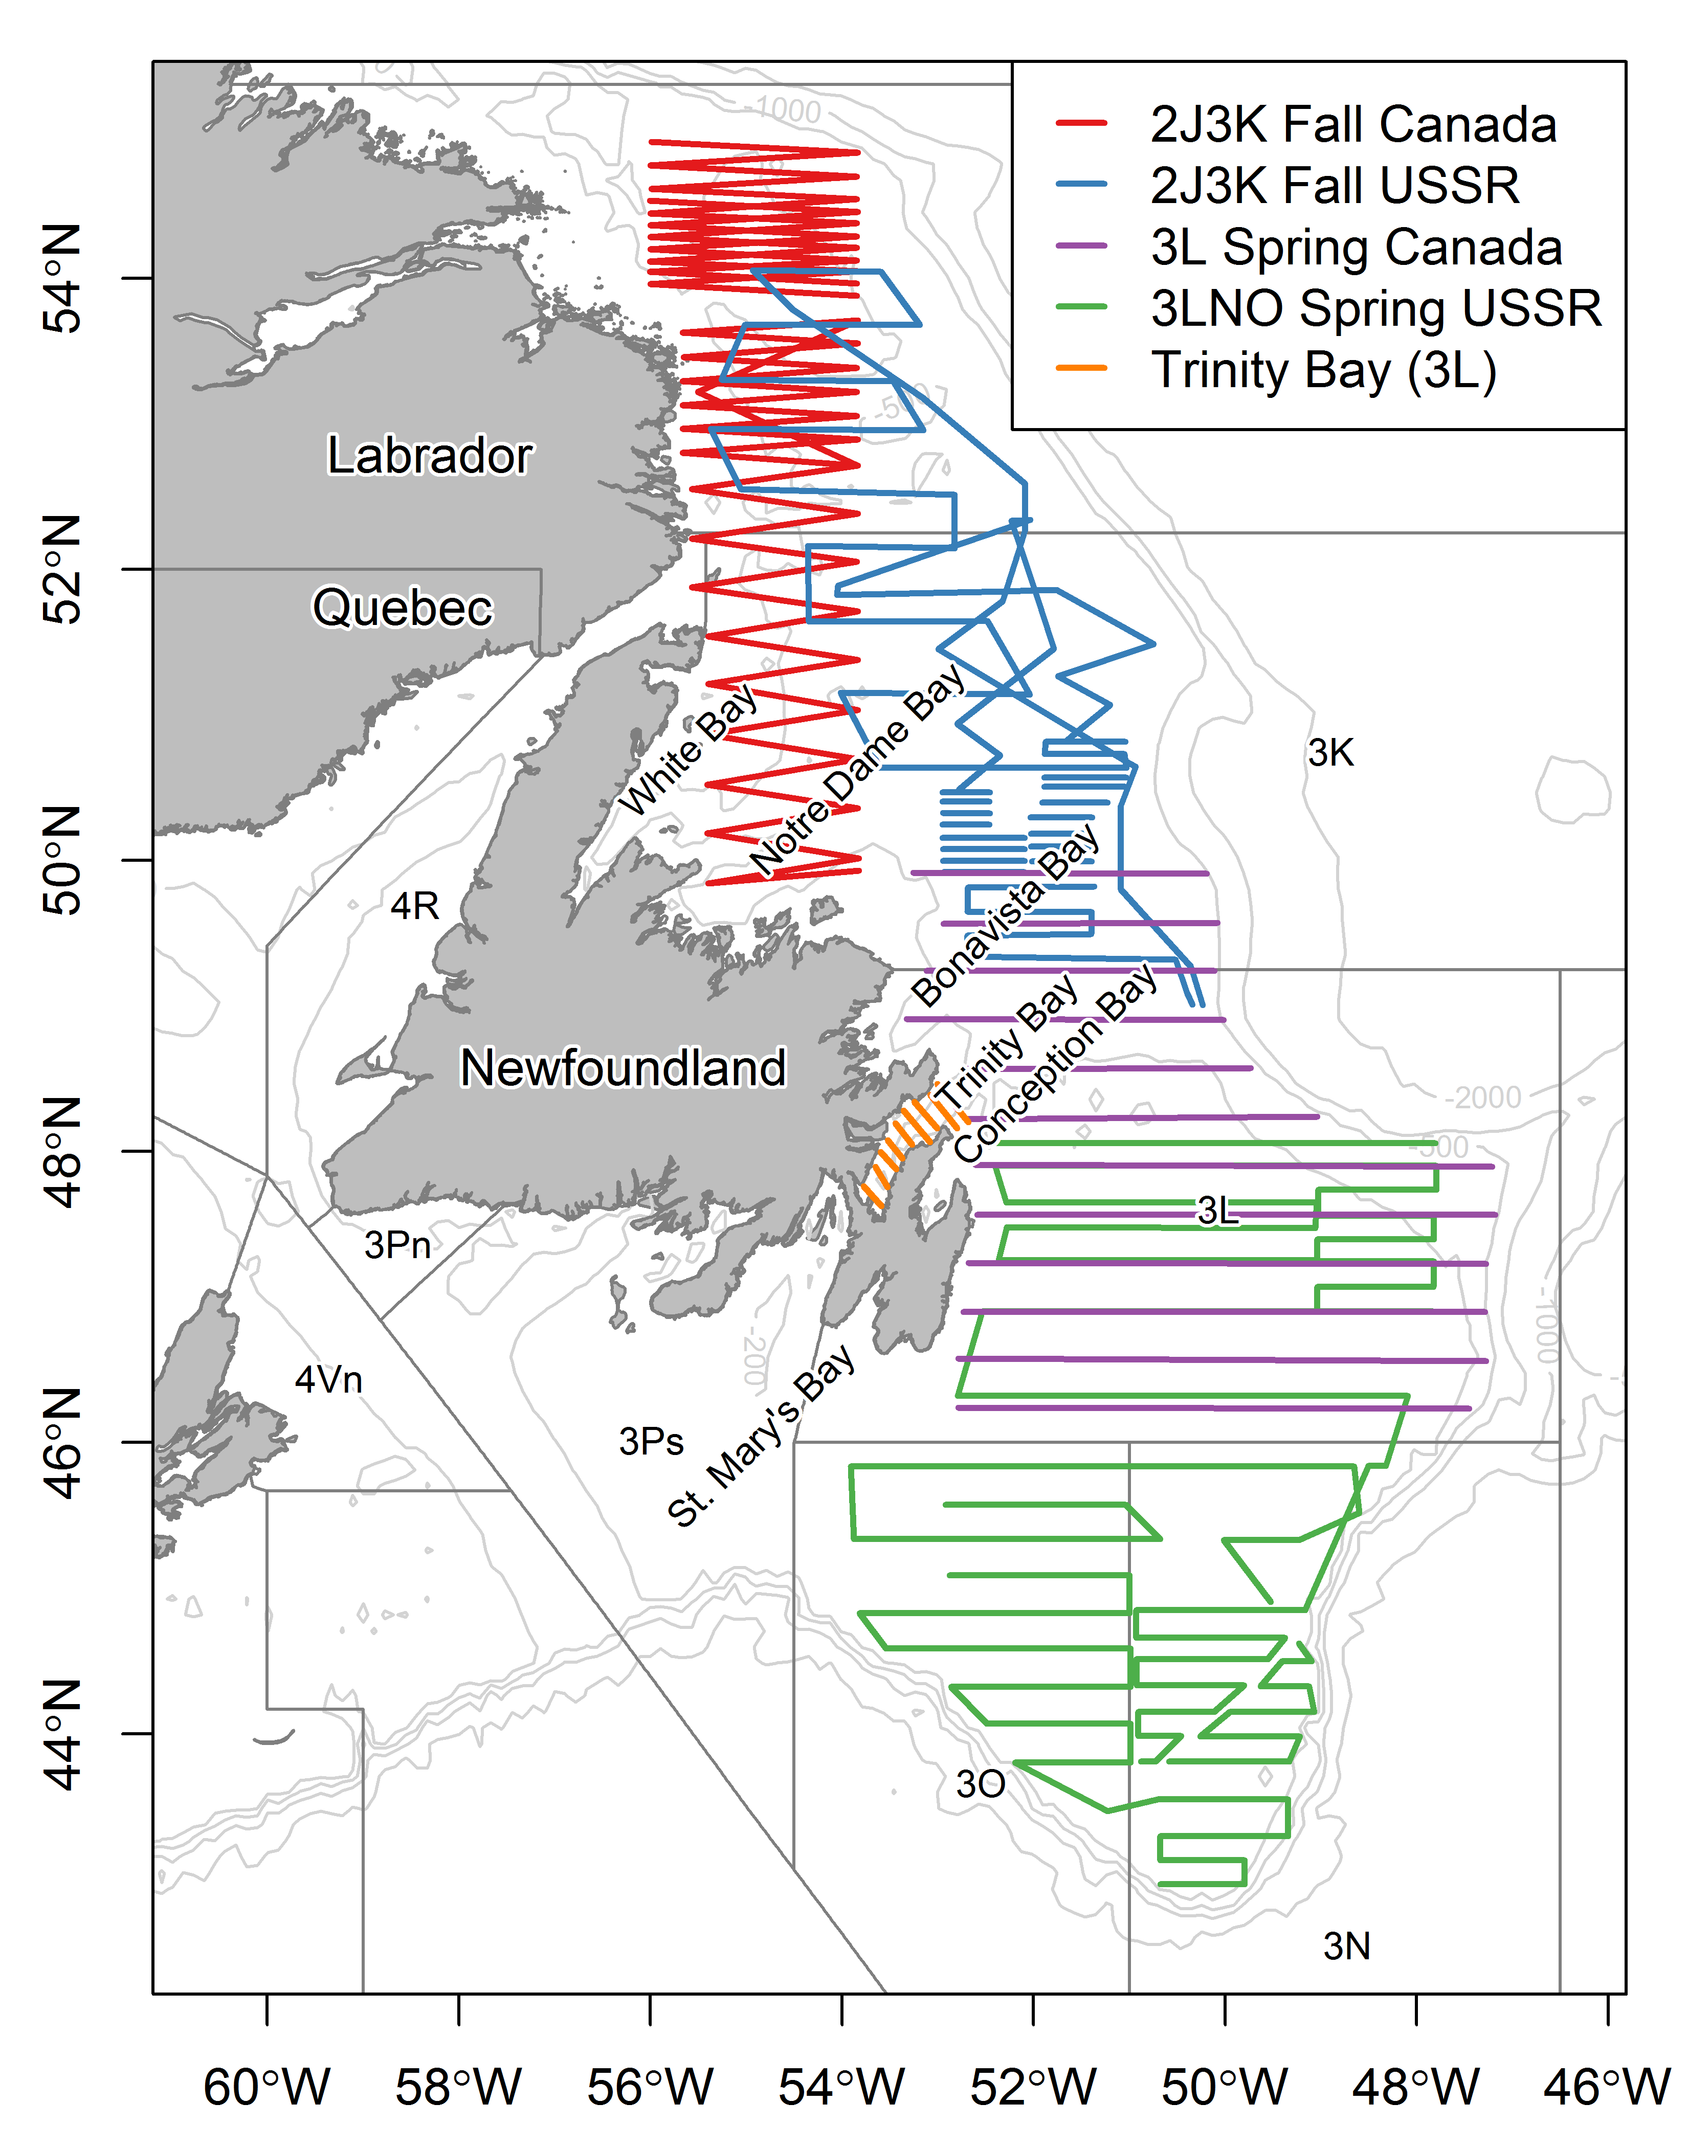

**Fig. 2**

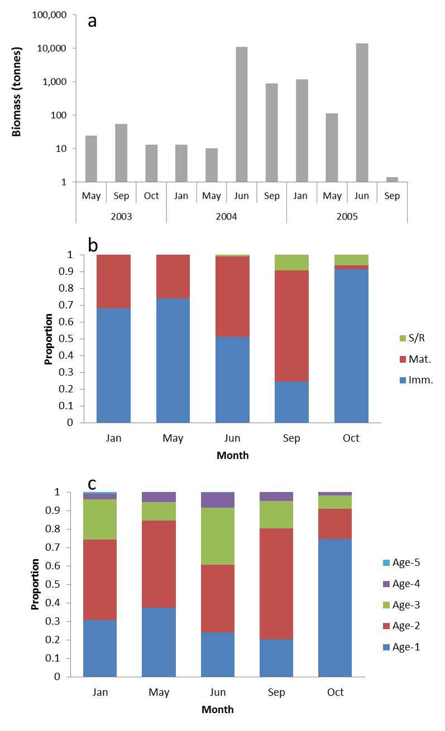

**Fig. 3**

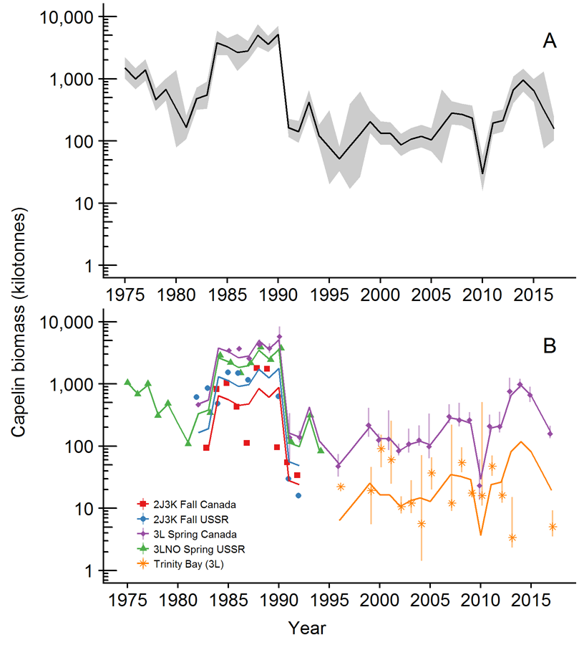

**Fig. 4**

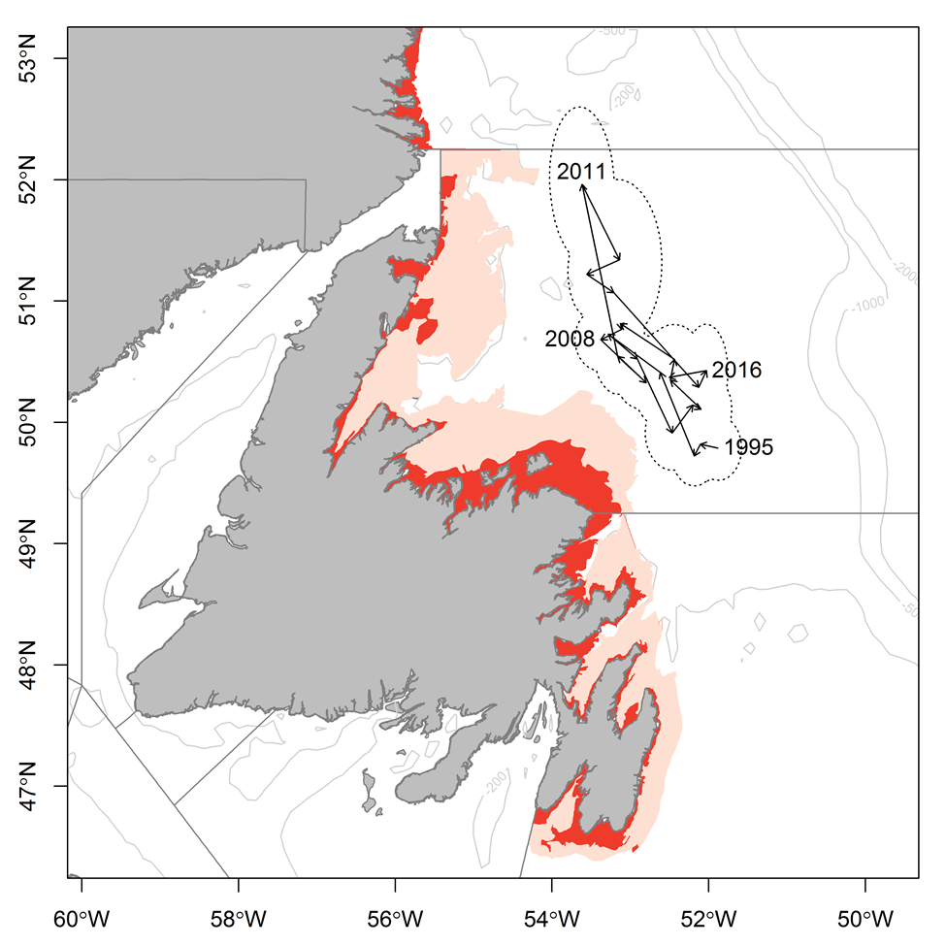

## Supplementary material

### Trinity Bay seasonal inshore acoustic surveys (2003-2005)

Inshore seasonal acoustic surveys (January, June, September) in Trinity Bay were conducted from a 23 m inshore research vessel (CCGS Shamook) using a calibrated EK500 echo-sounder with a towed 38 kHz transducer. Surveys followed a fixed transect design and covered both the main portions and the four arms of Trinity Bay (Suppl. Fig 1). When acoustic targets were encountered, sampling was conducted using bottom and midwater trawls to target the portion of the water column where the acoustic signal occurred. The lack of fishable aggregations of capelin during the seasonal surveys precluded extensive sampling but samples were obtained from most aggregations. Length, sex and maturity stage were recorded for all fish sampled and ages determined for two fish per sex per 0.5 cm interval.

Spatial patterns in age composition were similar to those patterns reported by Winters (1970) with older larger capelin overwintering in the main portion of the bay while juvenile capelin were more prevalent in the inner arms. In all months except June, capelin were aggregated along the sides of the trench around 200 m depth, whereas in June they present in the arms and in shallower water closer to shore at the bottom of the bay (Suppl. Fig. 2).

## References

Anderson JT, Dalley EL, O'Driscoll RL (2002) Juvenile capelin (*Mallotus villosus*) off Newfoundland and Labrador in the 1990s. ICES Journal of Marine Science 59:917-928

Anon (1998) Capelin in SA2 + Div. 3KL. Book 98/63. Canadian Science Advisory Secretariat (CSAS) Research Document

Bakanev VS (1992) Results from the acoustic capelin surveys in Div 3LNO and 2J+3KL in 1991. NAFO SCR Doc 92/1

Bourne C, Mowbray F, Squires B, Croft J (2015) An assessment framework and review of Newfoundland east and south coast Atlantic herring (*Clupea harengus*) stocks to the spring of 2013. Canadian Science Advisory Secretariat (CSAS) Research Document 2015/029

Buren AD, Koen-Alonso M, Pepin P, Mowbray F, Nakashima BS, Stenson GB, Ollerhead N, Montevecchi WA (2014a) Bottom-up regulation of capelin, a keystone forage species. PLoS ONE 9:e87589

Buren AD, Koen-Alonso M, Stenson GB (2014b) The role of harp seals, fisheries and food availability in driving the dynamics of northern cod. Marine Ecology Progress Series 511:265-284

Carscadden J, Nakashima BS, Miller DS (1994) An evaluation of trends in abundance of capelin (Mallotus villosus) from acoustics, aerial surveys and catch rates in NAFO Division 3L, 1982-89. Northw Atl Fish Sci 17:45-57

Carscadden JE, Frank KT, Leggett WC (2001) Ecosystem changes and the effects on capelin (*Mallotus villosus*), a major forage species. Canadian Journal of Fisheries and Aquatic Sciences 58:73-85

Carscadden JE, Gjøsæter H, Vilhjálmsson H (2013) A comparison of recent changes in distribution of capelin (*Mallotus villosus)* in the Barents Sea, around Iceland and in the Northwest Atlantic. Progress in Oceanography

Carscadden JE, Nakashima BS (1997) Abundance and changes in distribution, biology and behavior of capelin in response to cooler water of the 1990s. Forage fishes in marine ecosystems Proceedings of the International Symposium on the Role of Forage Fishes in Marine Ecosystems Alaska Sea Grant College Program Rep No AK-SG-97-01. University of Alaska Fairbanks, Fairbanks, Alaska

Chardine JW, Robertson GJ, Ryan PC, Turner B (2003) Abundance and distribution of common murres breeding at Funk Island, Newfoundland in 1972 and 2000. Canadian Wildlife Service Technical Report Series Atlantic Region:iv + 15

Chavez FP, Ryan J, Lluch-Cota SE, Ñiquen MC (2003) From anchovies to sardines and back: multidecadal change in the Pacific Ocean. Science 299:217-221

Colbourne E, Holden J, Craig J, Senciall D, Bailey W, Stead P, Fitzpatrick C (2014) Physical oceanographic conditions on the Newfoundland and Labrador Shelf during 2013. Canadian Atlantic Fisheries Scientific Advisory Committee Research Document 2014/094

Colbourne E, Holden J, Senciall D, Bailey W, Craig J, Snook S (2015) Physical oceanographic conditions on the Newfoundland and Labrador Shelf during 2014. Canadian Atlantic Fisheries Scientific Advisory Committee Research Document 2015/053

Colbourne E, Holden J, Senciall D, Bailey W, Snook S, Higdon J (2016) Physical oceanographic conditions on the Newfoundland and Labrador Shelf during 2015. Canadian Atlantic Fisheries Scientific Advisory Committee Research Document 2016/079

Dalley EL, Anderson JT, deYoung B (2002) Atmospheric forcing, larval drift, and recruitment of capelin ( Mallotus villosus ). ICES Journal of Marine Science 59:929-941

Davoren GK (2013) Distribution of marine predator hotspots explained by persistent areas of prey. Marine Biology 160:3043-3058

Davoren GK, Montevecchi WA (2003) Signals from seabirds indicate changing biology of capelin stocks. Marine Ecology Progress Series 258:253-261

Davoren GK, Penton P, Burke C, Montevecchi WA (2012) Water temperature and timing of capelin spawning determine seabird diets. ICES Journal of Marine Science 69:1234-1241

Dawe E, Koen-Alonso M, Chabot D, Stansbury D, Mullowney D (2012) Trophic interactions between key predatory fishes and crustaceans: comparison of two Northwest Atlantic systems during a period of ecosystem change. Marine Ecology Progress Series 469:233-248

deYoung B, Rose GA (1993) On recruitment and distribution of Atlantic cod (*Gadus morhua*) off Newfoundland. Canadian Journal of Fisheries and Aquatic Sciences 50:2729-2741

DFO (1994) Report on the status of pelagic fishes (capelin off Newfoundland and in the Gulf of St. Lawrence, and herring off the East, Southeast and South coasts off Newfoundland). DFO Atlantic Fisheries Stock Status Report 1994/3

DFO (2008) Assessment of capelin in SA2+Div. 3KL in 2008. DFO Canadian Science Advisory Secretariat Science Advisory Report 2008/054

DFO (2010) Assessment of Capelin in SA 2 + Div. 3KL in 2010. DFO Canadian Science Advisory Secretariat Science Advisory Report 2010/090

DFO (2013) Assessment of capelin in SA2 + Div. 3KL in 2013. DFO Canadian Science Advisory Secretariat Science Advisory Report 2013/11

DFO (2015) Assessment of capelin in Subarea 2 and Divisions 3KL in 2015. DFO Canadian Science Advisory Secretariat Science Advisory Report 2015/036

DFO (2018) Assessment of Capelin in SA2 and Divs. 3KL in 2017. DFO Canadian Science Advisory Secretariat Science Advisory Report 2018/030

Drinkwater KF (1996) Atmospheric and oceanic variability in the Northwest Atlantic during the 1980s and early 1990s. Journal of Northwest Atlantic Fishery Science 18:77-97

Frank KT, Carscadden JE, Simon JE (1996) Recent excursions of capelin (*Mallotus villosus*) to the Scotian Shelf and Flemish Cap during anomalous hydrographic conditions. Canadian Journal of Fisheries and Aquatic Sciences 53:1473-1486

Frank KT, Leggett WC (1982) Coastal water mass replacement: its effect on zooplankton dynamics and the predator–prey complex associated with larval capelin (*Mallotus villosus*). Canadian Journal of Fisheries and Aquatic Sciences 39:991-1003

Frank KT, Petrie B, Boyce D, Leggett WC (2016) Anomalous ecosystem dynamics following the apparent collapse of a keystone forage species. Marine Ecology Progress Series 553:185-202

Gjøsæter H, Bogstad B, Tjelmeland S (2009) Ecosystem effects of the three capelin stock collapses in the Barents Sea. Marine Biology Research 5:40-53

Gomes MdC, Haedrich RL, Villagarcia MG (1995) Spatial and temporal changes in the groundfish assemblages on the north-east Newfoundland/Labrador Shelf, north-west Atlantic, 1978-1991. Fisheries Oceanography 4:85-101

Gulka J, Carvalho PC, Jenkins E, Johnson K, Maynard L, Davoren GK (2017) Dietary niche shifts of multiple marine predators under varying prey availability on the Northeast Newfoundland Coast. Frontiers in Marine Science 4

Hammill MO, Stenson GB, Doniol-Valcroze T, Mosnier A (2011) Northwest Atlantic harp seals population trends, 1952-2012. DFO Canadian Science Advisory Secretariat Research Document 2011/099

Hamre J (1994) Biodiversity and exploitation of the main fish stocks in the Norwegian - Barents Sea ecosystem. Biodiversity & Conservation 3:473-492

Haug T, Nilssen K (1995) Ecological implications of harp seals *Phoca groenlandica* invasions in northern Norway. In: Schytte Blix A, Walløe L, Ulltang Ø (eds) Whales, seals, fish and man. Elsevier Science

Head EJH, Pepin P (2010) Spatial and inter-decadal variability in plankton abundance and composition in the Northwest Atlantic (1958–2006). Journal of Plankton Research 32:1633-1648

Hop H, Gjøsæter H (2013) Polar cod (*Boreogadus saida*) and capelin (*Mallotus villosus*) as key species in marine food webs of the Arctic and the Barents Sea. Marine Biology Research 9:878-894

ICES (2017) Report of the North Western Working Group (NWWG). Copenhagen, Denmark

Jangaard PM (1974) The capelin (*Mallotus villosus*): biology, distribution, exploitation, utilization, and composition. Bulletin of the Fisheries Research Board of Canada 186:1-70

Jech JM, McQuinn IH (2016) Towards a balanced presentation and objective interpretation of acoustic and trawl survey data, with specific reference to the eastern Scotian Shelf. Canadian Journal of Fisheries and Aquatic Sciences 73:1914-1921

Koen-Alonso M, Fogarty M, Pepin P, Hyde K, Gamble R (2013) Ecosystem production potential in the Northwest Atlantic. Northwest Atlantic Fisheries Organisation Science Council Research Document 13/075

Koen-Alonso M, Pepin P, Mowbray F (2010) Exploring the role of environmental and anthropogenic drivers in the trajectories of core fish species of the Newfoundland-Labrador marine community.

Leggett WC, Frank KT, Carscadden JE (1984) Meteorological and hydrographic regulation of year-class strength in capelin (*Mallotus villosus*). Canadian Journal of Fisheries and Aquatic Sciences 41:1193-1201

Lilly GR (1987) Interactions between Atlantic cod (*Gadus morhua*) and capelin (*Mallotus villosus*) off Labrador and eastern Newfoundland: a review. Canadian Technical Report in Fisheries and Aquatic Sciences 1567:1-37

Lilly GR (1991) Interannual variability in predation by cod (*Gadus morhua*) on capelin (*Mallotus villosus*) and other prey off southern Labrador and northeastern Newfoundland. ICES Marine Science Symposia 193:133-146

Lilly GR, Brattey J, Cadigan NG, Healey BP, Murphy EF (2005) An assessment of the cod (*Gadus morhua*) stock in the NAFO Divisions 2J3KL in March 2005.

Lilly GR, Davis DJ (1993) Changes in the distribution of capelin in Divisions 2J, 3K and 3L in the autumns of recent years, as inferred from bottom-trawl by-catches and cod stomachs examinations. NAFO SCR Doc 93/54

Lilly GR, Hop H, Stansbury DE, Bishop CA (1994) Distribution and abundance of polar cod (*Boreogadus saida*) off southern Labrador and eastern Newfoundland. ICES CM 0:6

Lilly GR, Parsons DG, Kulka DW (2000) Was the increase in shrimp biomass on the northeast Newfoundland shelf a consequence of a release in predation pressure from cod? Journal of Northwest Atlantic Fishery Science 27:45-61

McQuinn IH (2009) Pelagic fish outburst or suprabenthic habitat occupation: legacy of the Atlantic cod (*Gadus morhua*) collapse in eastern Canada. Canadian Journal of Fisheries and Aquatic Sciences 66:2256-2262

Miller DS (1992) Observations and studies on SA2 + Div. 3K capelin in 1991. Canadian Atlantic Fisheries Scientific Advisory Committee Research Document 92/15

Miller DS (1993) Observations and studies on SA2 + Div. 3K capelin in 1992. Canadian Atlantic Fisheries Scientific Advisory Committee Research Document 93/10

Miller DS (1994) Results from an acoustic survey for capelin (*Mallotus villosus*) in NAFO Divisions 2J3KL in the autumn of 1993. Capelin in SA2 + Div 3KL DFO Atlantic Fisheries Research Document 94/18

Miller DS (1995) Results from an Acoustic Survey for Capelin (*Mallotus villosus*) in NAFO Divisions 2J3KL in the Autumn of 1994. Capelin in SA2 + Div 3KL DFO Atlantic Fisheries Research Document 95/70

Miller DS (1997) Results from an acoustic survey for capelin (*Mallotus villosus*) in NAFO Divisions 3KL in the spring of 1996. Capelin in SA2 + Div 3KL DFO Atlantic Fisheries Research Document 97/29

Miller DS, Lilly GR (1991) Observations and studies on SA2 + Div. 3K capelin in 1991. Canadian Atlantic Fisheries Scientific Advisory Committee Research Document 91/11

Montevecchi WA (2007) Binary dietary responses of northern gannets *Sula bassana* indicate changing food web and oceanographic conditions. Marine Ecology Progress Series 352:213-220

Montevecchi WA, Myers RA (1992) Monitoring fluctuations in pelagic fish availability with seabirds. Canadian Atlantic Fisheries Scientific Advisory Committee Research Document 92/94

Montevecchi WA, Myers RA (1997) Centurial and decadal oceanographic influences on changes in Northern Gannet populations and diets in the Northwest Atlantic: Implications for climate change. ICES Journal of Marine Science 54:608-614

Morgan MJ, Koen-Alonso M, Rideout RM, Buren AD, Maddock Parsons D (2017) Growth and condition in relation to the lack of recovery of northern cod. ICES Journal of Marine Science:fsx166-fsx166

Mowbray F (2002) Changes in the vertical distribution of capelin (*Mallotus villosus*) off Newfoundland. ICES Journal of Marine Science 59:942-949

Mowbray F (2014) Recent spring offshore acoustic survey results for capelin, *Mallotus villosus*, in NAFO Division 3L. DFO Canadian Science Advisory Secretariat Research Document 2013/040

Mullowney D, Maillet G, Dawe E, Rose G, Rowe S (2016) Spawning delays of northern capelin (*Mallotus villosus*) and recovery dynamics: A mismatch with ice-mediated spring bloom? Progress in Oceanography 141:144-152

Mullowney DRJ, Rose GA (2014) Is recovery of northern cod limited by poor feeding? The capelin hypothesis revisited. ICES Journal of Marine Science: Journal du Conseil

Munafò MR, Davey Smith G (2018) Robust research needs many lines of evidence. Nature 553:399-401

Murphy HM, Pepin P, Robert D (2018) Re-visiting the drivers of capelin recruitment in Newfoundland since 1991. Fisheries Research 200:1-10

NAFO (2014) Report of the 7th Meeting of the NAFO Scientific Council (SC) Working Group on Ecosystem Science and Assessment (WGESA). Northwest Atlantic Fisheries Organisation Science Council Studies Doc 14/023 Serial No N6410, NAFO Headquarters, Dartmouth, NS, Canada

Nakashima B (1996) The relationship between oceanographic conditions in the 1990s and changes in spawning behaviour, growth and early life history of capelin (M*allotus villosus)*. NAFO Sci Coun Studies 24:55-68

Nakashima BS (1997) Results of the 1996 aerial survey of capelin (*Mallotus villosus*) schools. Capelin in SA2 + Div 3KL DFO Atlantic Fisheries Research Document, 97/29

Nakashima BS, Mowbray F (2014) Capelin (*Mallotus villosus)* recruitment indices in NAFO Division 3KL. DFO Canadian Science Advisory Secretariat Research Document 2013/091

Nakashima BS, Wheeler JP (2002) Capelin (*Mallotus villosus*) spawning behaviour in Newfoundland waters - the interaction between beach and demersal spawning. ICES Journal of Marine Science 59:909-916

Neville V, Rose GA, Rowe S, Jamieson R, Piercey G (2018) Otolith chemistry and redistributions of northern cod: evidence of Smith Sound-Bonavista Corridor connectivity. Canadian Journal of Fisheries and Aquatic Sciences

Nilssen KT, Haug T, Øritsland T, Lindblom L, Kjellqwist SA (1998) Invasions of harp seals *Phoca groenlandica* Erxleben to coastal waters of nor way in 1995: Ecological and demographic implications. Sarsia 83:337-345

Obradovich SG, Carruthers EH, Rose GA (2014) Bottom-up limits to Newfoundland capelin (Mallotus villosus) rebuilding: the euphausiid hypothesis. ICES Journal of Marine Science 71:775-783

Pálsson ÓK, Gislason A, Guðfinnsson HG, Gunnarsson B, Ólafsdóttir SR, Petursdottir H, Sveinbjörnsson S, Thorisson K, Valdimarsson H (2012) Ecosystem structure in the Iceland Sea and recent changes to the capelin (Mallotus villosus) population. ICES Journal of Marine Science 69:1242-1254

Pedersen EJ, Thompson PL, Ball RA, Fortin M-J, Gouhier TC, Link H, Moritz C, Nenzen H, Stanley RRE, Taranu ZE, Gonzalez A, Guichard F, Pepin P (2017) Signatures of the collapse and incipient recovery of an overexploited marine ecosystem. Royal Society Open Science 4

Pepin P, Colbourne E, Maillet G (2011) Seasonal patterns in zooplankton community structure on the Newfoundland and Labrador Shelf. Progress in Oceanography 91:273-285

Pepin P, Cuff A, Koen-Alonso M, Ollerhead N (2010) Preliminary Analysis for the Delineation of Marine Ecoregions on the NL Shelves. NAFO SCR Doc 10/72

Pepin P, Higdon J, Koen-Alonso M, Fogarty M, Ollerhead N (2014) Application of ecoregion analysis to the identification of Ecosystem Production Units (EPUs) in the NAFO Convention Area. NAFO SCR Doc 14/069

Pepin P, Koen-Alonso M, Higdon J, Ollerhead N (2012) Robustness in the delineation of ecoregions on the Newfoundland and Labrador continental shelf. NAFO SCR Doc 12/067

Pikitch EK, Boersma PD, Boyd IL, Conover DO, Cury PM, Essington TE, Heppell SS, Houde ED, Mangel M, Pauly D, Plagányi E, Sainsbury KJ, Steneck RS (2012) Little fish: big impact: managing a crucial link in ocean food webs. Lenfest Ocean Program, Washington, DC

Pikitch EK, Rountos KJ, Essington TE, Santora C, Pauly D, Watson R, Sumaila UR, Boersma PD, Boyd IL, Conover DO, Cury P, Heppell SS, Houde ED, Mangel M, Plagányi É, Sainsbury K, Steneck RS, Geers TM, Gownaris N, Munch SB (2014) The global contribution of forage fish to marine fisheries and ecosystems. Fish and Fisheries 15:43-64

Regular P, Montevecchi W, Hedd A, Robertson G, Wilhelm S (2013) Canadian fishery closures provide a large-scale test of the impact of gillnet bycatch on seabird populations. Biology Letters 9

Reid PC, Colebrook JM, Matthews JBL, Aiken J (2003) The Continuous Plankton Recorder: concepts and history, from Plankton Indicator to undulating recorders. Progress in Oceanography 58:117-173

Rice J (2002) Changes to the large marine ecosystem of the Newfoundland-Labrador shelf. In: Sherman K, Skjoldal HR (eds) Large marine ecosystems of the North Atlantic. Elsevier Science B.V.

Rose GA (1993) Cod spawning on a migration highway in the north-west Atlantic. Nature 366:458-461

Rose GA (2005) Capelin ( *Mallotus villosus* ) distribution and climate: a sea “canary” for marine ecosystem change. ICES Journal of Marine Science 62:1524-1530

Rose GA (2007) Cod: an ecological history of the North Atlantic fisheries. Breakwater Books, St John's, NL

Rose GA, deYoung B, Kulka DW, Goddard SV, Fletcher GL (2000) Distribution shifts and overfishing the northern cod (*Gadus morhua*): a view from the ocean. Canadian Journal of Fisheries and Aquatic Sciences 57:644-663

Rose GA, O'Driscoll RL (2002) Capelin are good for cod: can the northern stock rebuild without them? ICES Journal of Marine Science 59:1018-1026

Rose GA, Rowe S (2018) Does redistribution or local growth underpin rebuilding of Canada’s Northern cod? Canadian Journal of Fisheries and Aquatic Sciences:1-11

Schwartzlose RA, Alheit J, Bakun A, Baumgartner TR, Cloete R, Crawford RJM, Fletcher WJ, Green-Ruiz Y, Hagen E, Kawasaki T, Lluch-Belda D, Lluch-Cota SE, MacCall AD, Matsuura Y, Névarez-Martínez MO, Parrish RH, Roy C, Serra R, Shust KV, Ward MN, Zuzunaga JZ (1999) Worldwide large-scale fluctuations of sardine and anchovy populations. South African Journal of Marine Science 21:289-347

Sherwood GD, Rideout RM, Fudge SB, Rose GA (2007) Influence of diet on growth, condition and reproductive capacity in Newfoundland and Labrador cod (*Gadus morhua*): Insights from stable carbon isotopes (ä13C). Deep Sea Research Part II: Topical Studies in Oceanography 54:2794-2809

Skagseth Ø, Slotte A, Stenevik EK, Nash RDM (2015) Characteristics of the Norwegian Coastal Current during Years with High Recruitment of Norwegian Spring Spawning Herring (Clupea harengus L.). PLOS ONE 10:e0144117

Soutar A, Issacs JD (1969) History of fish populations inferred from fish scales in anaerobic sediments off California. CalCOFI Reports 13:63-70

Stenson GB (2012) Estimating consumption of prey by harp seals (*Pagophilus groenlandicus*) in NAFO Divisions 2J3KL. Canadian Science Advisory Secretariat (CSAS) Research Document 2012/156

Stenson GB, Buren AD, Koen-Alonso M (2016) The impact of changing climate and abundance on reproduction in an ice-dependent species, the Northwest Atlantic harp seal, *Pagophilus groenlandicus*. ICES Journal of Marine Science: Journal du Conseil 73:250-262

Stenson GB, Wakeham D, Buren AD, Koen-Alonso M (2014) Density-dependent and density-independent factors influencing reproductive rates in Northwest Atlantic harp seals, *Pagophilus groenlandicus*. DFO Canadian Science Advisory Secretariat Research Document 2014/058

Templeman W (1948) The life history of the caplin (*Mallotus villosus* O. F. Müller) in Newfoundland waters. Bulletin of the Newfoundland Government Laboratory 17:1-151

Thorson J, T., Pinsky M, L., Ward E, J., Gimenez O (2016) Model‐based inference for estimating shifts in species distribution, area occupied and centre of gravity. Methods in Ecology and Evolution 7:990-1002

Thorson JT, Barnett LAK (2017) Comparing estimates of abundance trends and distribution shifts using single- and multispecies models of fishes and biogenic habitat. ICES Journal of Marine Science 74:1311-1321

Toresen R, Østvedt OJ (2000) Variation in abundance of Norwegian spring-spawning herring (Clupea harengus, Clupeidae) throughout the 20th century and the influence of climatic fluctuations. Fish and Fisheries 1:231-256

Vilhjálmsson H (1994) The Icelandic capelin stock. Rit Fiskideildar 13:1-281

Winters GH (1970) Biological changes in coastal capelin from the over-wintering to the spawning condition. Journal of the Fisheries Research Board of Canada 27:2215-2224

Winters GH (1995) Interaction between timing, capelin distribution and biomass estimates from the Div. 2J3K capelin acoustic survey. Capelin in SA2 + Div 3KL. DFO Atlantic Fisheries Research Document 95/70

Winters GH, Carscadden JE (1978) Review of capelin ecology and estimation of surplus yield from predator dynamics. International Commission for the Northwest Atlantic Fisheries Research Bulletin 13:21-30