ADB
2025-08-07
Harp seal fecundity paper
Data Decisions

Female maturity

Potential inconsistencies, given age
There are a number of younger seals (cohort age 1 to 3) that were coded as mature
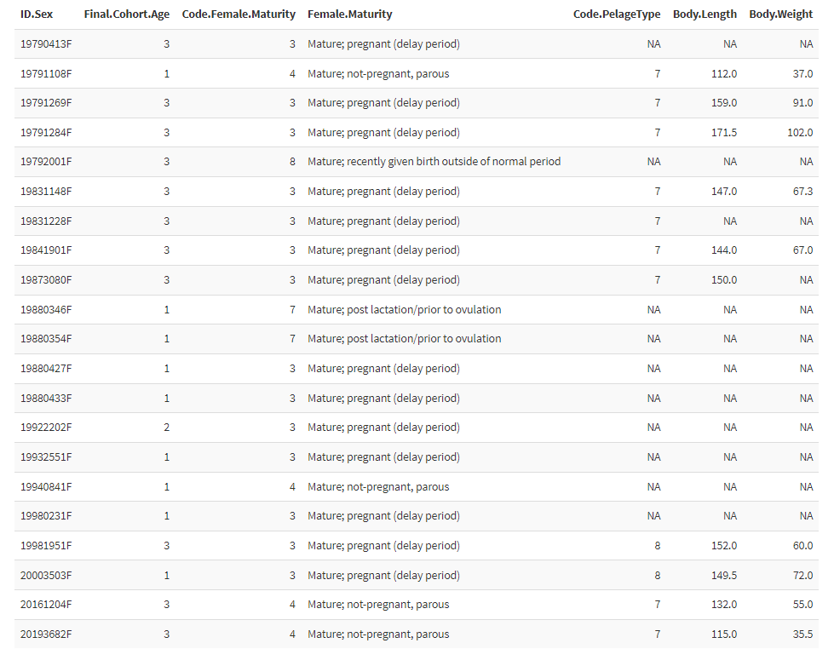
Decision: I set ages 1 and 2 as immatures, and leave age 3 as they are. I would appreciate direction from both of you on what would be best here. See below info from the Ovary dataset
19790413F – original sheets have ‘1st Ovulation, Mature’ – given time of year and age I don’t see an issue with Maturity Code = 3
19791108F – according to the original morph sheets, no repros were collected from this animal – it was listed as age 1 on the morph sheets and the age data and body measurements are consistent with one another. The ovary data sheets have it listed as Age 1 but code it as Maturity 4 with a note that there was no uterus. I’m guessing there was a labelling error somewhere along the line and the repro data belongs to another seal. This one should be coded as Exclude from Repro (the existing ovary data can be deleted). Based on age and morph, it could be coded as immature.
19791269F – original ovary data sheets have ‘1st Ovulation, Mature’ – given time of year and age I don’t see an issue with Maturity Code = 3
19791284F - original ovary data sheets have ‘appears to be 1st ovulation’ – given time of year and age I don’t see an issue with Maturity Code = 3
19792001F – original ovary data sheets have ‘scar in horn of uterus, fetus must have been lost, mature/not pregnant’. Maturity Code was changed from 4 to 8 in 2010 (the initials NW are associated with the change).
19831148F – this one is a bit weird – in the original datasheets it is coded as a 6 but so are a lot of other things that shouldn’t be so I think that just value just got updated later (Garry - were the maturity codes changed at some point??). The original data is consistent with 1st ovulation, so Maturity Code = 3 makes sense for time of year
19831228F – also coded as a 6 in the original sheets - the original data is consistent with it being the 1st ovulation, so a Maturity Code = 3 makes sense for time of year.
19841901F - original sheets have ‘1st Ovulation, newly mature’ – given time of year and age I don’t see an issue with Maturity Code = 3
19873080F - The original data is consistent with 1st ovulation, so Maturity Code = 3 makes sense for time of year.
19880346F, 19880354F, 19880427F and 19880433F – There is a definite mismatch between the original age data sheets and the original ovary data sheets – guessing some things got mislabelled at some point (i.e. the jaws and repros are not from the same animal) – no way to tell which end of the data is correct (there is no morph for these) so they should all be coded as Exclude From All
19922202F - the original ovary data is consistent with it being the 1st ovulation – the age sheets give reliability of 3 for the age assigned, so it’s possible this one is actually a 3 year old. BUT there is no other data to check against so I would code it as Exclude From All in case it is actually a data mismatch issue (jaw and repro not from same animal).
19932551F - the original ovary data is consistent with it being the 1st ovulation but the age makes no sense for that – guessing that the jaw and repros are not from the same animal – there is no way to tell which end of the data is actually correct (there is no morph) so this should be coded as Exclude From All
19940841F - the original ovary data is consistent with ‘mature, not pregnant’ but the age makes no sense for that – guessing that the jaw and repros are not from the same animal – there is no way to tell which end of the data is actually correct (there is no morph) so this should be coded as Exclude From All
19980231F - the original ovary data sheet has ‘check age – not correct’ at the bottom of the sheet. I don’t know if the age was ever checked again but age=1 is what is in the original data sheets. I’m guessing that the jaw and repros are not from the same animal – there is no way to tell which end of the data is actually correct (there is no morph) so this should be coded as Exclude From All.
19981951F - the original ovary data sheet has ‘check age’ which has been crossed out (I’m assuming that means the check was done). The original data is consistent with it being the 1st ovulation, so a Maturity Code = 3 makes sense for time of year.
20003503F – original ovary data is consistent with Maturity Code=3 but morph data (pelage code and length/weight) are consistent with an older individual than the age listed. I checked the original age sheets and there is no indication of an issue with the aging. So, jaw and repros likely not from the same animal (something got mislabelled or misread). I would code this as an Exclude From Age
20161204F - the original ovary data sheet has “Maturity updated by LS after re-analysis” – Lee updated this sample to Maturity Code = 1 after a reanalysis of the sample but (apparently) that did not get entered anywhere. Recode Maturity as 1.
20193682F – not sure what to do with this one. The notes from Lee in the ovary data sheet say “Has 1 CA but no other structures to suggest it was mature. Ovary size suggests mature.” The repro data does not match with age but age and morph are consistent. Guessing there was an error somewhere in sample labelling and the jaw and ovaries are not the same animal. This one should be coded as Exclude from Repro.

