ADB
2025-08-07
Harp seal fecundity paper
Data Decisions

Length and Weight
- 19861123F. Body Length = 2300. This is most likely a typo. It is large, even if we were to consider length = 230. The max length is 203. It is too small if we were to consider length = 23. The min Length is 31 (foetus)
Decision: I will turn length into NA until I am told otherwise
This was some kind of data entry error – based on the records there were no morphometric measurements taken for this ID. Based on collection date (March 20) and age (0) this is a recently weaned beater that had started foraging (we have stomach content data)(some amphipods).
NA is correct – I have updated the database to remove this value.

- From the previous work, I had this (without explanation): at least 3 seals have the wrong weight, turn them to NA
ids_w <- c("19940928F", "20042978F", "20062138F")
Decision: I will turn weight into NA until I am told otherwise
These were a bit confusing but I think I’ve sorted it out – it’s not the weights that are the problem, it’s the ages. The age information was initially recorded incorrectly and then it was subsequently edited because it didn’t make sense for the time of year of collection.

19940928F is a labelled as a newborn in the morph sheets but, given that the collection date is February 5 this has to be a foetus. Cartwright was the collection area (208). Age was coded as 1 and Final Age was initially coded as 0 instead of both being coded as 91. Because of the time of year collected (February) the Final Age was later adjusted to 1 (which makes the weights ridiculous). Please correct Age/Final Age to 91.

20042978F is recorded as a ‘whitecoat, killed on the ice’ in the morph sheets. Age was originally coded as 1 and Final Age as 0. Because the sampling date was in February (February 13) the Final Age got updated to 1. Presumably this is a pup that was dropped a little early. Age and Final/Age should be 0.

20062138F is recorded as a ‘yellow stage” belonging to 20062137F. Age was originally coded as 1 and Final Age as 0. Because the sampling date was in February (February 20) the Final Age got updated to 1. Age and Final/Age should be 0.

Please also update Final Cohort Age for:
20062110M - Final Cohort Age should be 0 (stage 1 pup) – Final Cohort Age was changed to 1 in error
20062167M - Final Cohort Age should be 0 (stage 1 pup) – Final Cohort Age was changed to 1 in error

- From Pete Goulet: 20161235M the girth and length have been inverted, should be girth=130 and length=163
Decision: I will invert girth and length until I am told otherwise
No idea why this wasn’t corrected already but I have updated the database to girth=130 and length=163.

Potential outliers
Based on the LW plot, it looks like there are a few outliers (marked in black – also see interactive plot here https://adbpatagonia.github.io/PG_ReproductivePaper/
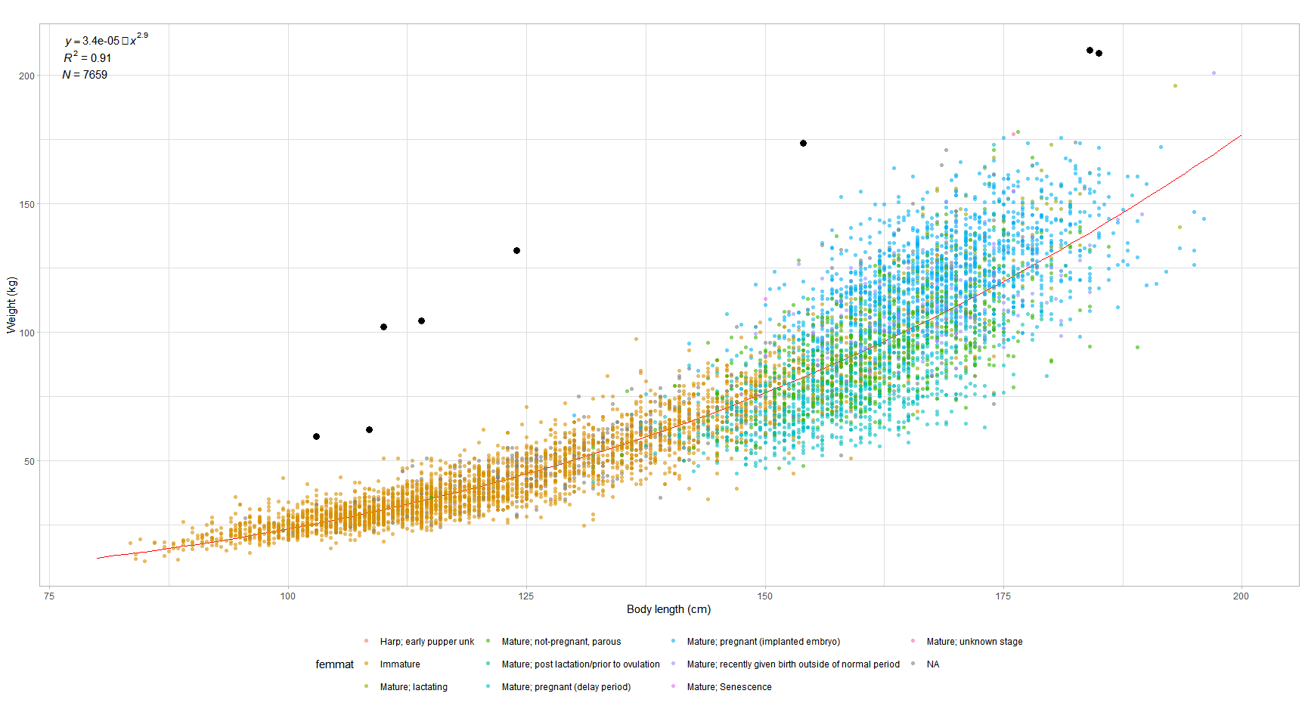
Decision: remove until told otherwise. Shelley, could you please check these values?
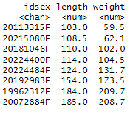
19962312F – can’t see anything wrong with this one – the length is reasonable for age (23 year old) and, while the body weight is definitely at the top of the range, she was a very fat, pregnant female – her blubber depth was 6.9 cm. The sculp and girth measurements are all consistent with a big animal.
20072884F – can’t see anything obviously wrong with this one either – the length is reasonable for age (17 year old) and, while the body weight is definitely at the top of the range, she was a very fat, pregnant female – her blubber depth was 6.7 cm. The sculp and girth measurements are all consistent with a big animal.

20113315F – my best guess for this one is a transcription error when the data was originally recorded – the original data sheets have 103 cm for length but based on individuals of similar age and weight it should be something more like 130 cm – there is no way to know what it should have been so this one should be excluded (at least the body length should be, the weight seems OK).

20181046F – again my best guess for this one is also a transcription error when the data was originally recorded – the original data sheets have 110 cm for length but based on individuals of similar age and weight it should be something more like 160-170 cm – there is no way to know what it should have been so this one should also be excluded (at least the body length should be, the weight seems OK).

20192983F – can’t find an obvious issue with this one (data appears as recorded) except that the weight and length don’t seem to correspond – I’m guessing there is an error in the length measurement (the girth measurement looks off as well). Since I don’t know what happened here, the morph data should be excluded.

20215080F – can’t find an obvious issue with this one (data appears as recorded) except that the weight and length don’t seem to correspond – I’m guessing there is an error in the weight measurement for this one – length for age is reasonable but weight is high. Since I don’t know what happened here, the morph data should be excluded.

20224400F – Exclude from ALL analyses – morphometrics don’t make sense and age data does not match up with pelage or body size – there’s an issue somewhere that we could not resolve for this one (Rachel tried to figure it out based on her notes but couldn’t)
20224484F – correct body length to 174.0 – data was rewritten from original sheets on to new sheets and the number was recorded incorrectly

Bonus Seal:
20183420M – correct body weight to 152 from 15.2 (no idea why no one noticed that one before)

Inconsistencies with previous instructions
edits included in file README_Buren.txt, sent by Rachel
- changeage99 <- c('20100066F','20123810F','20140236F','20150057F','20103066F')
these should be immature, but not all show up as such
ID.Sex Code.Female.Maturity
<char> <num>
1: 20100066F 4
2: 20103066F 8
Decision: no morph data and no ovary data - I will change code.female.maturity to 1, until I am told otherwise
Not sure I understand the issue here.
All of these currently have a Final Cohort Age of 99 in the database (which is what the ‘changeage99’ would have been about) which means that no age was obtained for any of them – no tooth was read - that could be a result of a missing jaw (lost post collection) or a jaw that was never collected. But that 99 for Final Cohort Age does not mean that they should be coded as immature – the ovary data is not changed by the ‘changeage99’ Rachel sent you, just the age (or lack thereof).

- remove <- c('20113802F', '20130095F')
# insert into Do not use table and do not use for anything
These seals are in tbl_Ovary. I am not sure why Rachel had the note.
Decision: I will remove until I am told otherwise
20113802F and 20130095F are coded as Exclude from All in the main data I sent you but I forgot to apply that exclusion filter to the separate Ovary data pull (apologies) – both should be excluded from everything.

- removefornow <- c('20161194F', '20161214F', '20161251F', '20171691F', '20181055F')
# - remove for now. needs to be checked against datasheets.
Have these been checked since?
They are still in the data.
Decision: I will remove until I am told otherwise
The final 3 columns of the main sheet I sent you has a set of “Exclude” True/False filters – if you use those I think you’ll find that '20161194F', '20161214F', '20161251F', and '20171691F' have been checked and coded for exclusion from use depending on the issue identified (issue with age, morph, repro or some combination of those). I left them in (and provided the filters) so that you could decide what to exclude depending on the analysis you were doing.
20181055F should not be excluded. The maturity code for this female was reviewed and should now be OK.

Inconsistency with information from Bonnie
# ages from Bonnie S in emails to GBS - Dec 1 and 4, 2023
age[idsex == "20171709F", age := 25]
age[idsex == "20082059F", age := 99]
age[idsex == "20103001M", age := 27]

These have NA in Final.Cohort.Age.
Decision: I will use age from Bonnie until I am told otherwise
I was never given this info and (apparently) it was not uploaded. A copy of the e-mail would be appreciated.
20171709F has been update as indicated above
20082059F is coded for exclusion from both age and repro (see final 3 columns of the main data I sent) because the age (3) was not reconcilable with the maturity reading so this one should be filtered out depending on what you are selecting for.
20103001M has no age record in the database so I’ll need to sort that with Bonnie.

Foetal weight
For the growth work, I calculated the weight for pregnant females (Code.Female.Maturity = 2) as
Weight = Body.Weight (in database) – monthly mean foetus weight
Where I obtained the monthly mean foetus weight (Dec: 2.9, Jan: 6.3, Feb: 8.3) using this query in the database query qsel_foetus_weight
I checked that the monthly means were constant over the time series (i.e. as a function of year)
Decision: I will use these values, unless you consider it is necessary to update. In that case, Shelley: could you please send me updated values?
I suspect you might need to update this – when redesigning how the database is setup, I found foetuses in the age table that were not coded as 91 under Final Age (which is one of the filters) so you may not have all the data. You should be able to pull from the file I sent you but I will also run a query.
SELECT tbl_Collection.Month, Avg(tbl_Morphometrics.[Body Weight]) AS [AvgOfBody Weight]
FROM tlkp_MarineMammalSp INNER JOIN ((tbl_MarineMammal INNER JOIN ((tbl_MarineMammal_Event INNER JOIN tbl_Collection ON tbl_MarineMammal_Event.[Id MMEvent] = tbl_Collection.[Id MMEvent]) INNER JOIN tbl_FinalAge ON tbl_MarineMammal_Event.[Id MMEvent] = tbl_FinalAge.[Id MMEvent]) ON tbl_MarineMammal.[Id MarineMammal] = tbl_MarineMammal_Event.[Id MarineMammal]) INNER JOIN tbl_Morphometrics ON tbl_MarineMammal_Event.[Id MMEvent] = tbl_Morphometrics.[Id MMEvent]) ON tlkp_MarineMammalSp.[MM ITIS TSN] = tbl_MarineMammal.[MM ITIS TSN]
GROUP BY tlkp_MarineMammalSp.[Code MM sp], tbl_FinalAge.[Final Cohort Age], tbl_Collection.Month
HAVING (((tlkp_MarineMammalSp.[Code MM sp])="1") AND ((tbl_FinalAge.[Final Cohort Age])=91) AND ((tbl_Collection.Month)=12 Or (tbl_Collection.Month)=1 Or (tbl_Collection.Month)=2));

Female maturity

newborns to beaters
There were a number of these seals that had NA as female maturity
Decision: I set them as immatures
That would make sense – if no reproductive organs were collected/analysed (which I guessing would be the norm for most of these depending on time of collection) then there would be no record in the Ovary table and the file should produce a blank (NA in your upload)

Potential inconsistencies, given age
There are a number of younger seals (cohort age 1 to 3) that were coded as mature
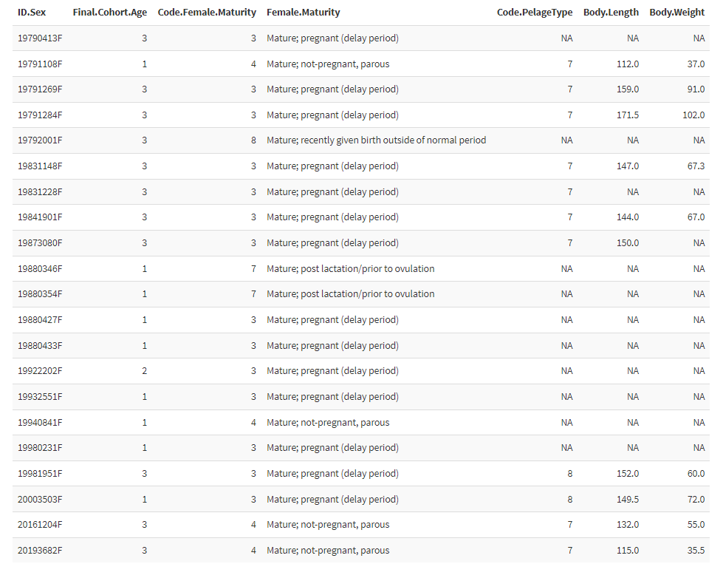
Decision: I set ages 1 and 2 as immatures, and leave age 3 as they are. I would appreciate direction from both of you on what would be best here. See below info from the Ovary dataset
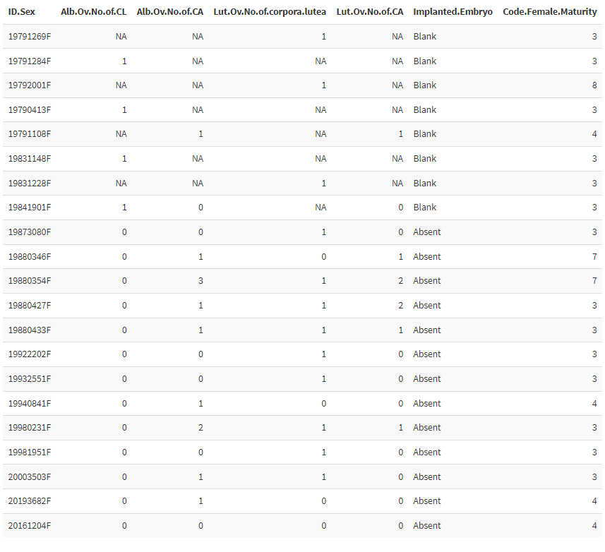
I will look through these and get back to you – I’m guessing since the 2020 Res Doc was summarizing age 3 and up, no one checked age 1 or 2 with weird data OR they did check, they made a list of needed changes, passed it along to someone to do something about which never happened and I haven’t come across that piece of paper OR changes were made and whatever happened with Peter and the database, the changes were reset when that problem got fixed. We came across an a whole pile of data last summer that had to be re-entered because of the post-Peter reset.

