ADB
2025-08-07
Harp seal fecundity paper
Data Decisions

Length and Weight
- 19861123F. Body Length = 2300. This is most likely a typo. It is large, even if we were to consider length = 230. The max length is 203. It is too small if we were to consider length = 23. The min Length is 31 (foetus)
Decision: I will turn length into NA until I am told otherwise
- From the previous work, I had this (without explanation): at least 3 seals have the wrong weight, turn them to NA
ids_w <- c("19940928F", "20042978F", "20062138F")
Decision: I will turn weight into NA until I am told otherwise
- From Pete Goulet: 20161235M the girth and length have been inverted, should be girth=130 and length=163
Decision: I will invert girth and length until I am told otherwise

Potential outliers
Based on the LW plot, it looks like there are a few outliers (marked in black – also see interactive plot here https://adbpatagonia.github.io/PG_ReproductivePaper/
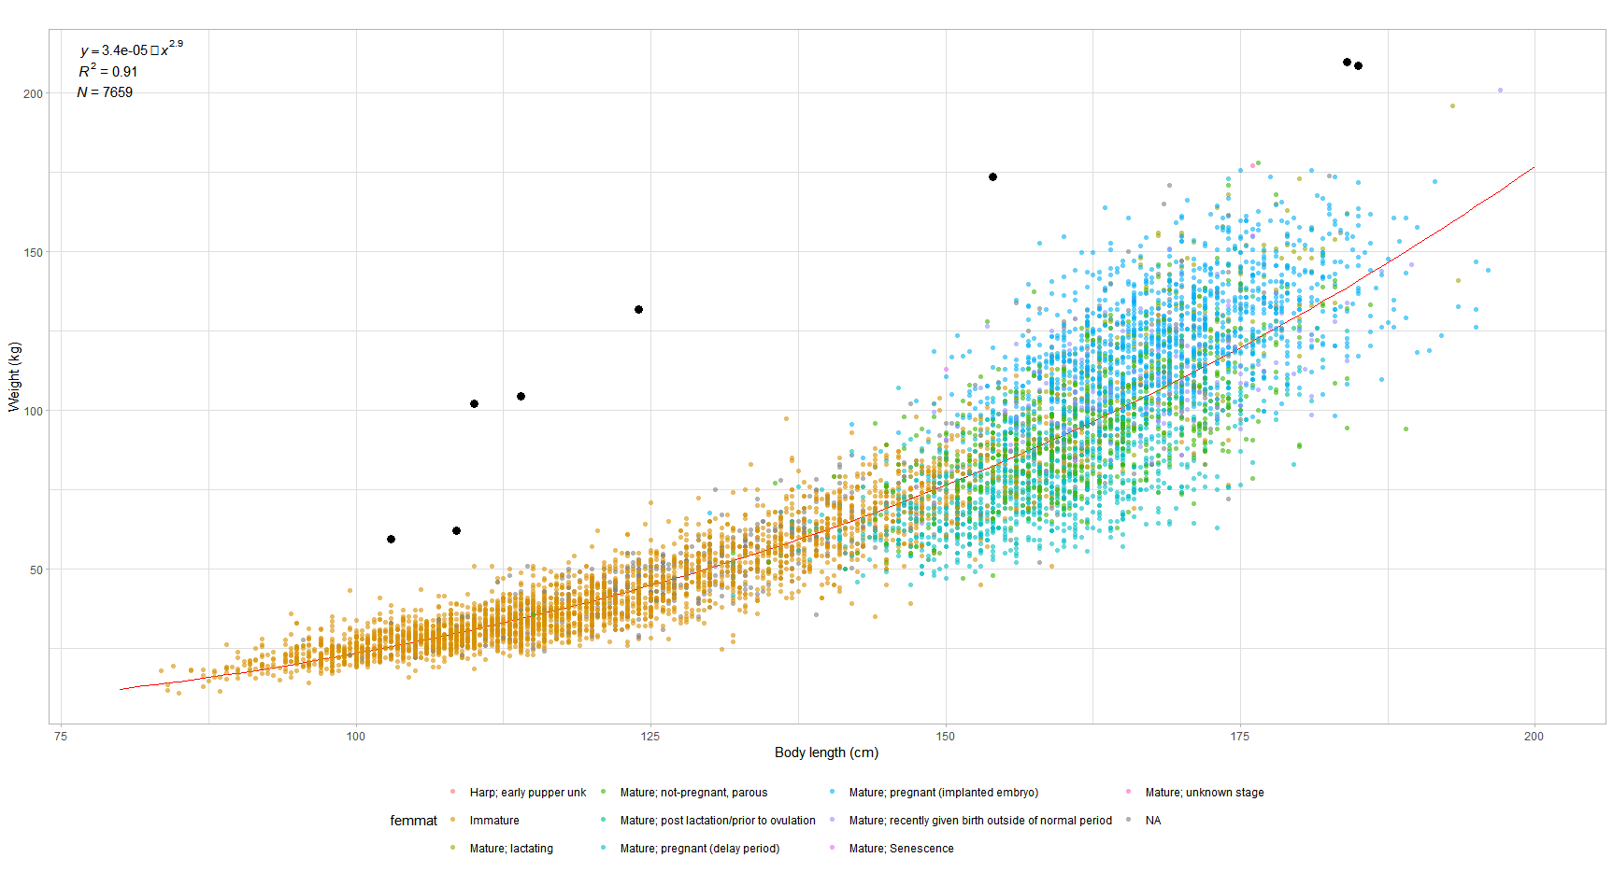
Decision: remove until told otherwise. Shelley, could you please check these values?
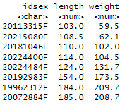

Inconsistencies with previous instructions
edits included in file README_Buren.txt, sent by Rachel
- changeage99 <- c('20100066F','20123810F','20140236F','20150057F','20103066F')
these should be immature, but not all show up as such
ID.Sex Code.Female.Maturity
<char> <num>
1: 20100066F 4
2: 20103066F 8
Decision: no morph data and no ovary data - I will change code.female.maturity to 1, until I am told otherwise

- remove <- c('20113802F', '20130095F')
# insert into Do not use table and do not use for anything
These seals are in tbl_Ovary. I am not sure why Rachel had the note.
Decision: I will remove until I am told otherwise

- removefornow <- c('20161194F', '20161214F', '20161251F', '20171691F', '20181055F')
# - remove for now. needs to be checked against datasheets.
Have these been checked since?
They are still in the data.
Decision: I will remove until I am told otherwise

Inconsistency with information from Bonnie
# ages from Bonnie S in emails to GBS - Dec 1 and 4, 2023
age[idsex == "20171709F", age := 25]
age[idsex == "20082059F", age := 99]
age[idsex == "20103001M", age := 27]

These have NA in Final.Cohort.Age.
Decision: I will use age from Bonnie until I am told otherwise

Foetal weight
For the growth work, I calculated the weight for pregnant females (Code.Female.Maturity = 2) as
Weight = Body.Weight (in database) – monthly mean foetus weight
Where I obtained the monthly mean foetus weight (Dec: 2.9, Jan: 6.3, Feb: 8.3) using this query in the database query qsel_foetus_weight
I checked that the monthly means were constant over the time series (i.e. as a function of year)
Decision: I will use these values, unless you consider it is necessary to update. In that case, Shelley: could you please send me updated values?

SELECT tbl_Collection.Month, Avg(tbl_Morphometrics.[Body Weight]) AS [AvgOfBody Weight]
FROM tlkp_MarineMammalSp INNER JOIN ((tbl_MarineMammal INNER JOIN ((tbl_MarineMammal_Event INNER JOIN tbl_Collection ON tbl_MarineMammal_Event.[Id MMEvent] = tbl_Collection.[Id MMEvent]) INNER JOIN tbl_FinalAge ON tbl_MarineMammal_Event.[Id MMEvent] = tbl_FinalAge.[Id MMEvent]) ON tbl_MarineMammal.[Id MarineMammal] = tbl_MarineMammal_Event.[Id MarineMammal]) INNER JOIN tbl_Morphometrics ON tbl_MarineMammal_Event.[Id MMEvent] = tbl_Morphometrics.[Id MMEvent]) ON tlkp_MarineMammalSp.[MM ITIS TSN] = tbl_MarineMammal.[MM ITIS TSN]
GROUP BY tlkp_MarineMammalSp.[Code MM sp], tbl_FinalAge.[Final Cohort Age], tbl_Collection.Month
HAVING (((tlkp_MarineMammalSp.[Code MM sp])="1") AND ((tbl_FinalAge.[Final Cohort Age])=91) AND ((tbl_Collection.Month)=12 Or (tbl_Collection.Month)=1 Or (tbl_Collection.Month)=2));

Female maturity

newborns to beaters
There were a number of these seals that had NA as female maturity
Decision: I set them as immatures

Potential inconsistencies, given age
There are a number of younger seals (cohort age 1 to 3) that were coded as mature
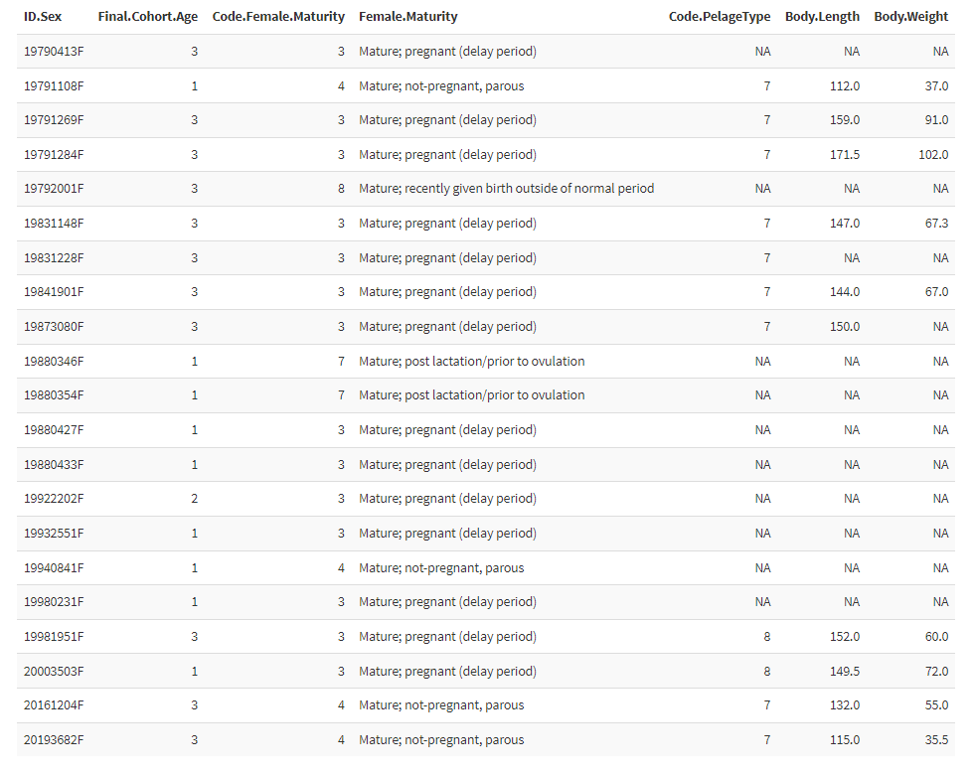
Decision: I set ages 1 and 2 as immatures, and leave age 3 as they are. I would appreciate direction from both of you on what would be best here. See below info from the Ovary dataset
