MMU Functionality in TizenRT
rtl8730e / amebaSmart (ARM Cortex-A32, ARMv7-A)

A code-level walkthrough with flow charts, plus an assessment of whether the MMU can be used to debug heap memory corruption (use-after-free and double free).
Contents
1. Scope — which boards actually have an MMU
2. The mental model: two-level translation
3. Job 1 — building the memory map at boot
4. Where the page tables live
5. Job 2 — sandboxing downloadable applications
6. Runtime: context switching and teardown
7. Fault handling
8. What TizenRT deliberately does NOT use the MMU for
9. Can the MMU debug memory corruption?
10. Source file reference

1. Scope — which boards actually have an MMU
Before anything else it is worth being precise about where this applies. In the TizenRT tree, an MMU is enabled for exactly two chip families:
Core | Selected by | Boards | Memory protection
Cortex-A32 | ARCH_CORTEXA32 | rtl8730e / amebaSmart | MMU (page tables)
Cortex-A9 | ARCH_CORTEXA9 | sabre-6quad / imx6 | MMU (page tables)
Cortex-M / R | (various) | amebalite, amebad, s5j, bk7239n, … | MPU only — 8-16 fixed regions

Both MMU cores are selected in os/arch/arm/Kconfig (lines 268 and 289) via select ARCH_USE_MMU. Every other board in the tree is a Cortex-M or Cortex-R part with an MPU, which has no page tables at all. So "the TizenRT MMU" is, in practice, the rtl8730e and imx6 code path.
All of the architecture-independent logic lives in just two files: os/arch/arm/src/armv7-a/arm_mmu.c and os/arch/arm/src/armv7-a/mmu.h.

2. The mental model: two-level translation
ARMv7-A uses a two-level translation table, and TizenRT uses both levels:
- L1 table — 4096 entries, 16 KB total. Each entry covers 1 MB of address space. An entry is one of two things: a "section", which describes that whole 1 MB directly and ends the lookup; or a pointer to an L2 table, meaning "this 1 MB is described in finer detail over there".
- L2 table — 256 entries, 1 KB total. Each entry covers 4 KB, which TizenRT calls a "small page". 256 x 4 KB = 1 MB, exactly the span of the parent L1 entry.
The 4 KB page size is fixed at SMALL_PAGE_SZ in os/include/tinyara/mmu.h:37, and mmu.h rejects any other value for the paging page size at compile time.
In one line: 1 MB blocks by default, drop to 4 KB blocks only where the extra precision is needed. TizenRT uses sections almost everywhere; L2 tables exist in only two places — the interrupt vector page, and loaded application binaries.
The register TTBR0 tells the CPU where the current L1 table is. Changing TTBR0 changes the entire memory view.
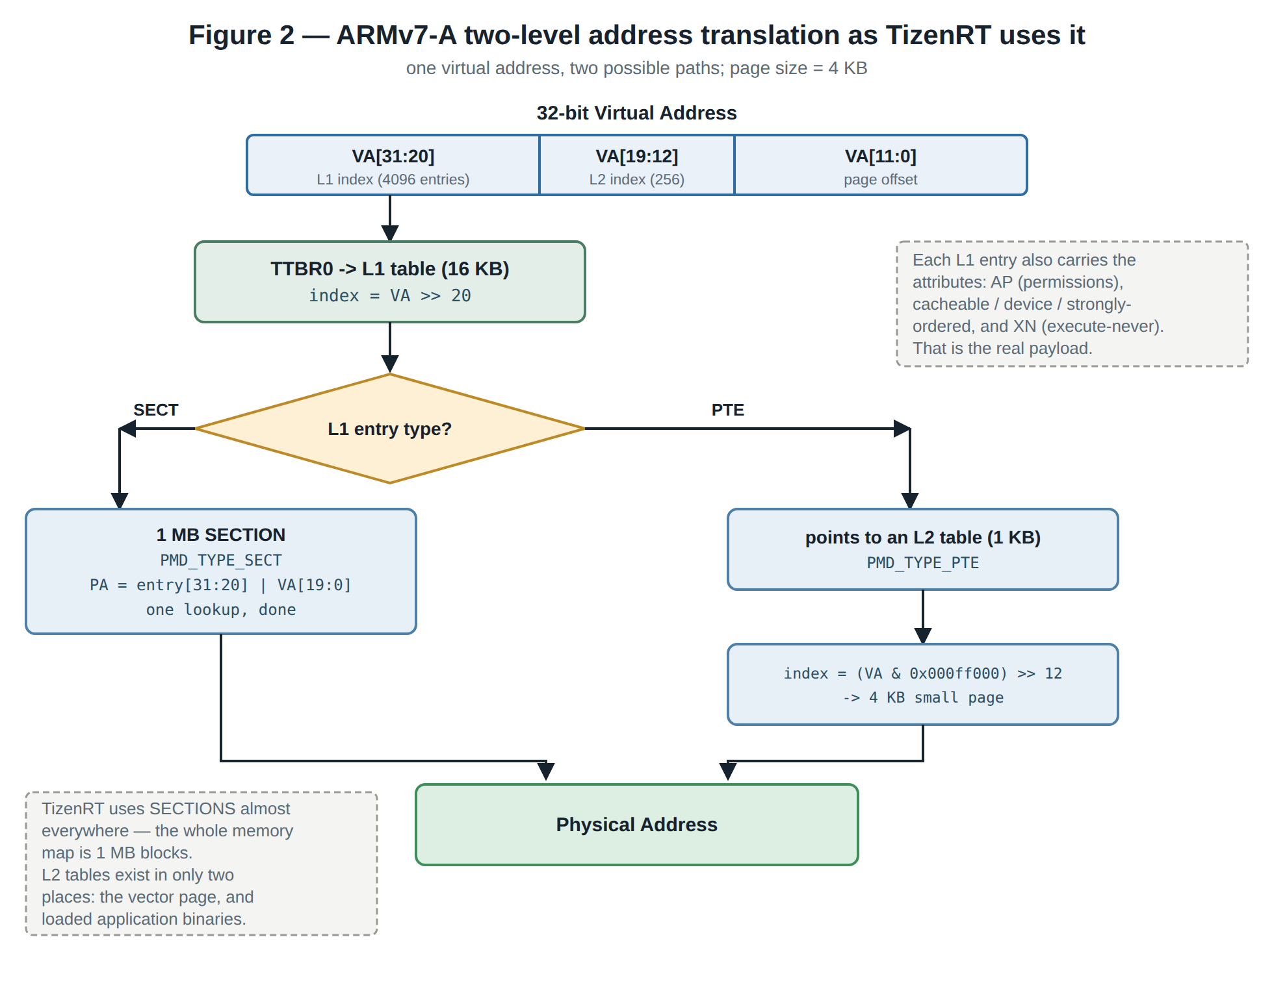
Figure 2 — How one virtual address is resolved, and where the two paths diverge.

3. Job 1 — building the memory map at boot
The first thing to understand about the boot sequence is that the MMU is switched on very early, before most of the memory map exists.
__start in arm_head.S runs with the MMU and caches off, hand-builds a minimal L1 table covering only .text and the primary RAM region, programs TTBR0 and the domain access register, and then enables the MMU by setting SCTLR_M (around line 388). Only after translation is live does it branch to arm_boot(), which installs the real map.
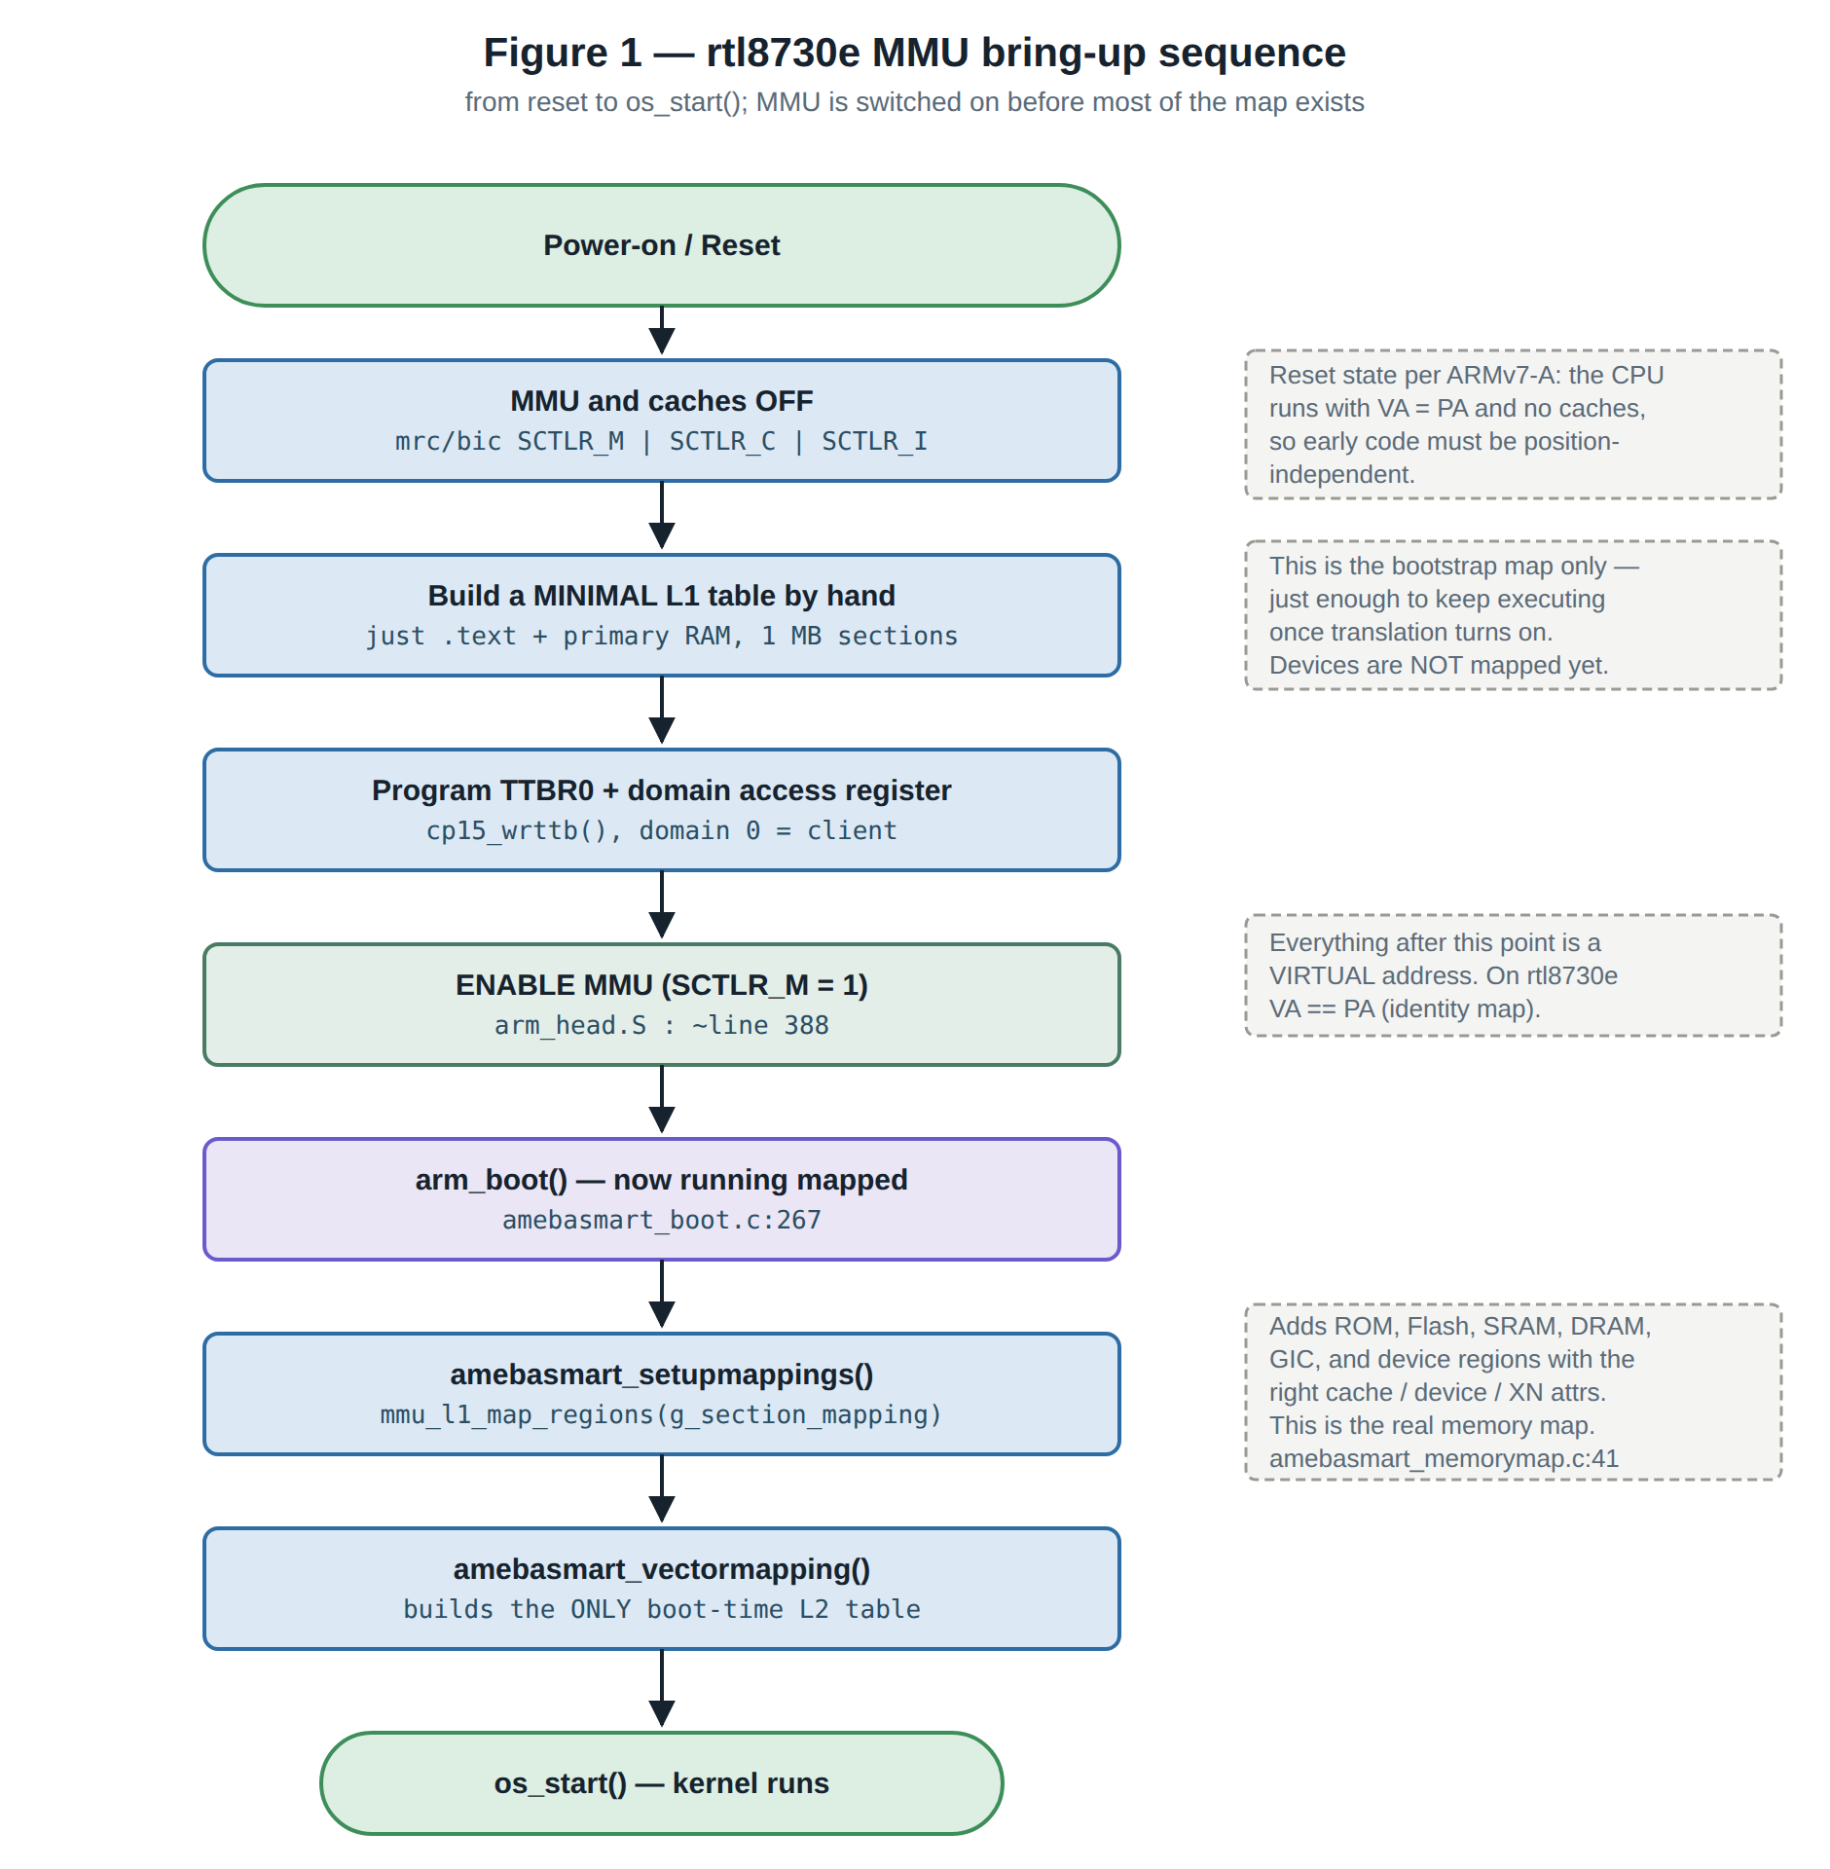
Figure 1 — Bring-up order. The bootstrap map exists only to keep the CPU executing once translation turns on.
The real map is declared as a plain table of regions, and installed with a loop that writes one L1 section entry per megabyte:
/* os/arch/arm/src/amebasmart/amebasmart_memorymap.c:41 */
struct section_mapping_s g_section_mapping[] = {
{ AMEBASMART_ROMCP_PSECTION, AMEBASMART_ROMCP_VSECTION, ... }, /* Boot ROM */
{ AMEBASMART_FLASH_PSECTION, AMEBASMART_FLASH_VSECTION, ... }, /* Flash */
{ AMEBASMART_SRAM_PSECTION, AMEBASMART_SRAM_VSECTION, ... }, /* SRAM */
{ AMEBASMART_DRAM_PSECTION, AMEBASMART_DRAM_VSECTION, ... }, /* DRAM */
{ AMEBASMART_GIC_REG_PSECTION, ... }, /* GIC regs */
...
};
Two details here surprise people coming from Linux.
First, virtual address == physical address. These are identity mappings. TizenRT is not relocating anything and is not creating a fake address space. The MMU here is not being used to move memory around.
Second — so what is the point? The attributes. Each entry carries flags that tell the CPU how to treat that megabyte:
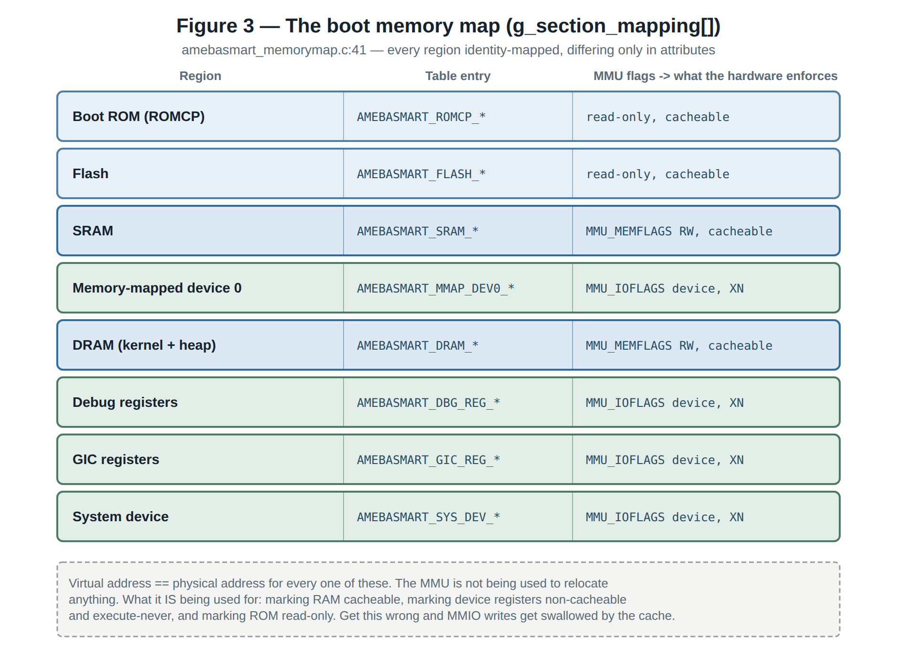
Figure 3 — The boot memory map. Every region is identity-mapped; the regions differ only in their attributes.
This is the real day-one job of the MMU on this board: marking RAM cacheable, marking device registers non-cacheable and execute-never, and marking ROM read-only. Get it wrong and MMIO writes get reordered or swallowed by the cache.
The one exception to the 1 MB rule at boot is the interrupt vector table. amebasmart_vectormapping() builds a genuine L2 table so the vectors can sit at 4 KB granularity at the high vector address.

4. Where the page tables live
Page tables are carved out of DRAM statically — never allocated from the heap. The total reservation is PGTABLE_SIZE = 0x00010000 (64 KB), defined in mmu.h:709, and placed at the top or bottom of DRAM depending on where the vectors are.
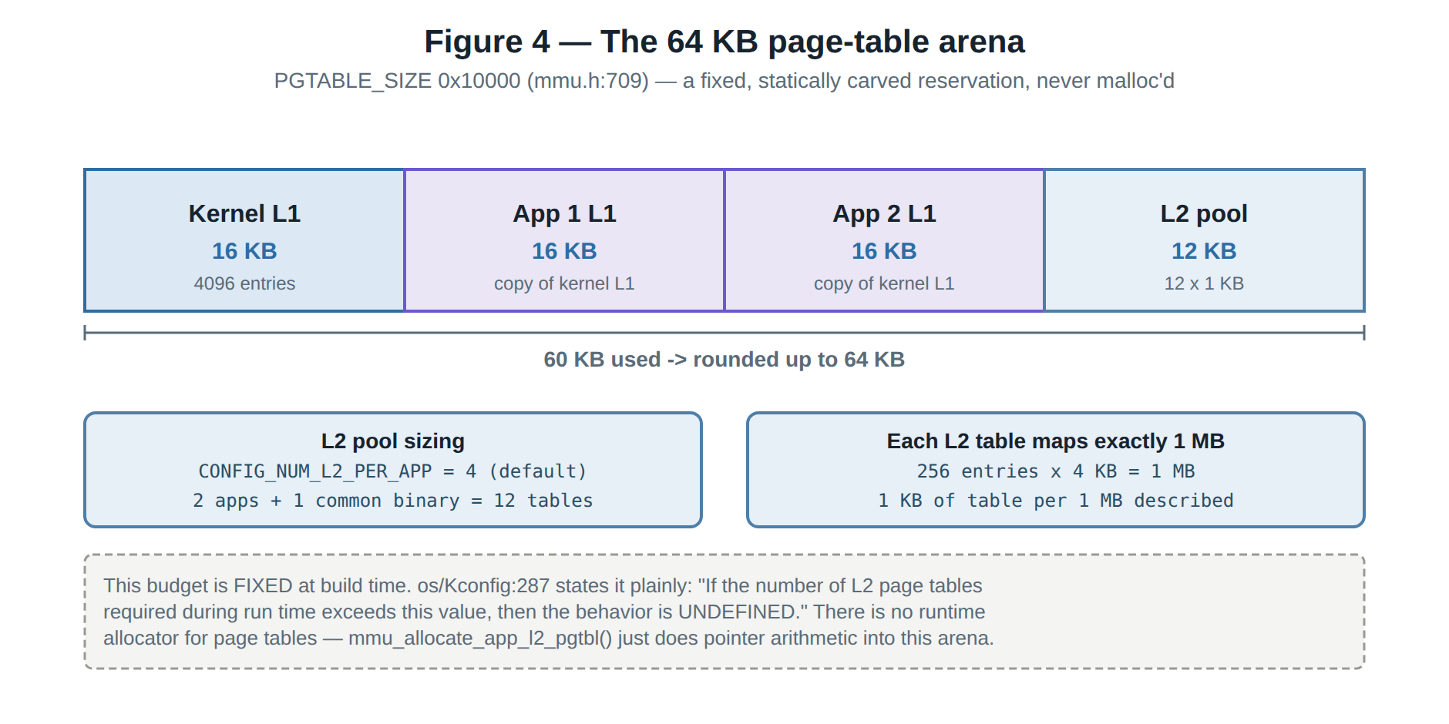
Figure 4 — The fixed 64 KB page-table arena and how it is divided.
This budget is fixed at build time. CONFIG_NUM_L2_PER_APP defaults to 4, and the Kconfig help text at os/Kconfig:287 states the consequence plainly: "If the number of L2 page tables required during run time exceeds this value, then the behavior is UNDEFINED." There is no runtime allocator for page tables — mmu_allocate_app_l2_pgtbl() simply does pointer arithmetic into this arena.

5. Job 2 — sandboxing downloadable applications
This is what CONFIG_APP_BINARY_SEPARATION buys, and it is the main reason the MMU code exists at all.

5.1 The whole sandbox is one permission bit
Look at the access-permission macros and the mechanism becomes obvious:
Macro | Privileged (kernel) | Unprivileged (app) | Used for
AP_RW1 | read / write | NO ACCESS | everything mapped at boot
AP_RW01 | read / write | read / write | app .data and .bss
AP_R01 | read | read | app .text and .rodata

Every region mapped at boot uses AP_RW1 — kernel-only. App regions are mapped AP_RW01 — user-accessible. That single permission-bit difference IS the sandbox. An app running in user mode that touches kernel RAM takes a permission fault in hardware, immediately.

5.2 What happens when an app is loaded
The sequence lives in binfmt_setup_app_pgtable() (os/binfmt/binfmt_pgtable.c:53). The step that catches people out is the second one: the app's L1 table starts life as a straight 16 KB memcpy of the kernel's L1 table, so the app initially sees exactly the world the kernel sees — same devices, same RAM, all still kernel-only. Only then are the app's own regions punched in with user permissions.
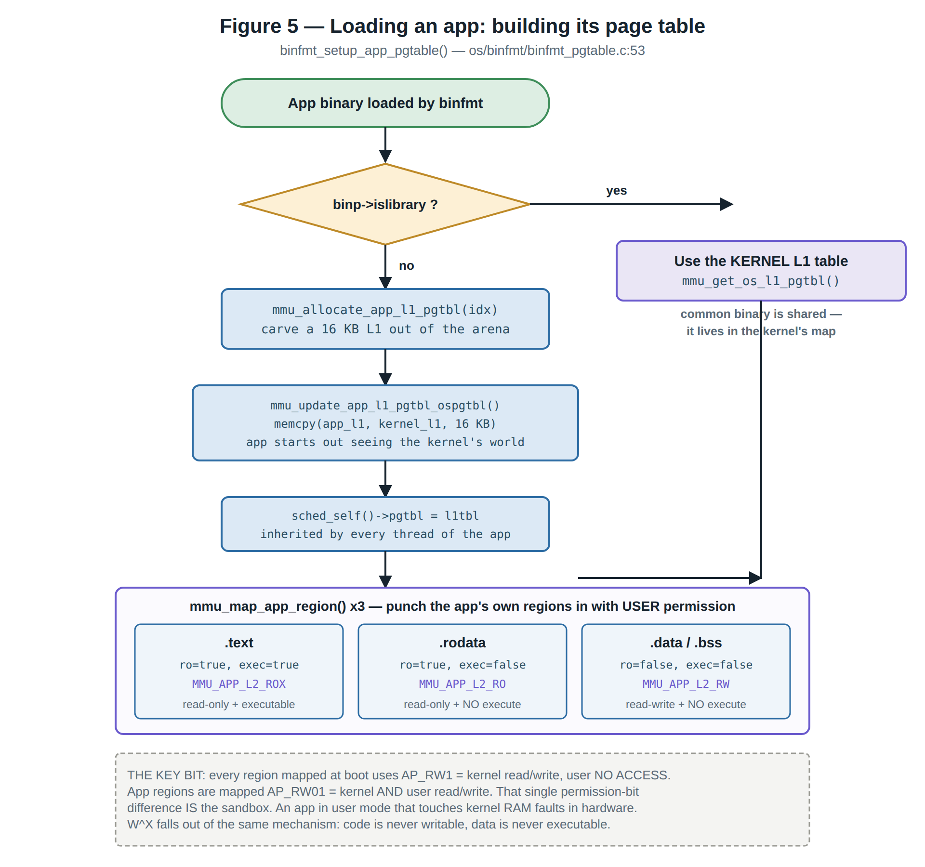
Figure 5 — App load. W^X falls out of the same mechanism: code is never writable, data is never executable.
/* os/binfmt/binfmt_pgtable.c:94 */
mmu_map_app_region(idx, l1tbl, sections[BIN_TEXT], sizes[BIN_TEXT], true, true); /* RO + X */
mmu_map_app_region(idx, l1tbl, sections[BIN_RO], sizes[BIN_RO], true, false); /* RO + XN */
mmu_map_app_region(idx, l1tbl, sections[BIN_DATA], ramsize, false, false); /* RW + XN */

5.3 Inside mmu_map_app_region()
This function is where L2 tables actually get created. It is greedy: if a region happens to be 1 MB-aligned and at least 1 MB long, it writes a cheap L1 section entry. Otherwise it builds an L2 table and maps 4 KB at a time. App RAM partitions are rarely megabyte-aligned, so in practice most app mappings end up as 4 KB pages — which is exactly why CONFIG_NUM_L2_PER_APP has to exist.
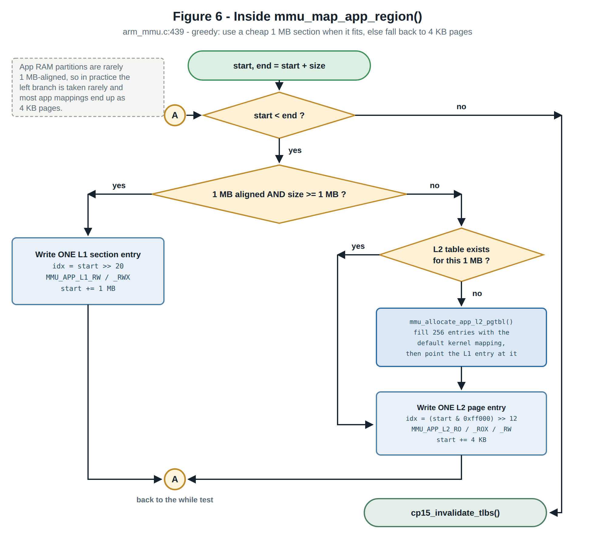
Figure 6 — The mapping loop, and the section-versus-page decision at its core.

6. Runtime: context switching and teardown
On every context switch, up_restoretask() (os/arch/arm/src/common/up_restoretask.c:85) points TTBR0 at the incoming task's L1 table and flushes the TLB:
if (tcb->app_id && tcb->pgtbl && tcb->pgtbl != mmu_l1_pgtable()) {
cp15_wrttb((uint32_t) tcb->pgtbl | TTBR0_RGN_WBWA | TTBR0_IRGN0);
cp15_invalidate_tlbs();
}
That is the entire switch. App A's memory is simply not described in App B's table, so App B cannot reach it. Note that the whole TLB is flushed every time — ARMv7-A has ASIDs that would make this unnecessary, but TizenRT does not use them. That is fine for a handful of apps, but it is not free.
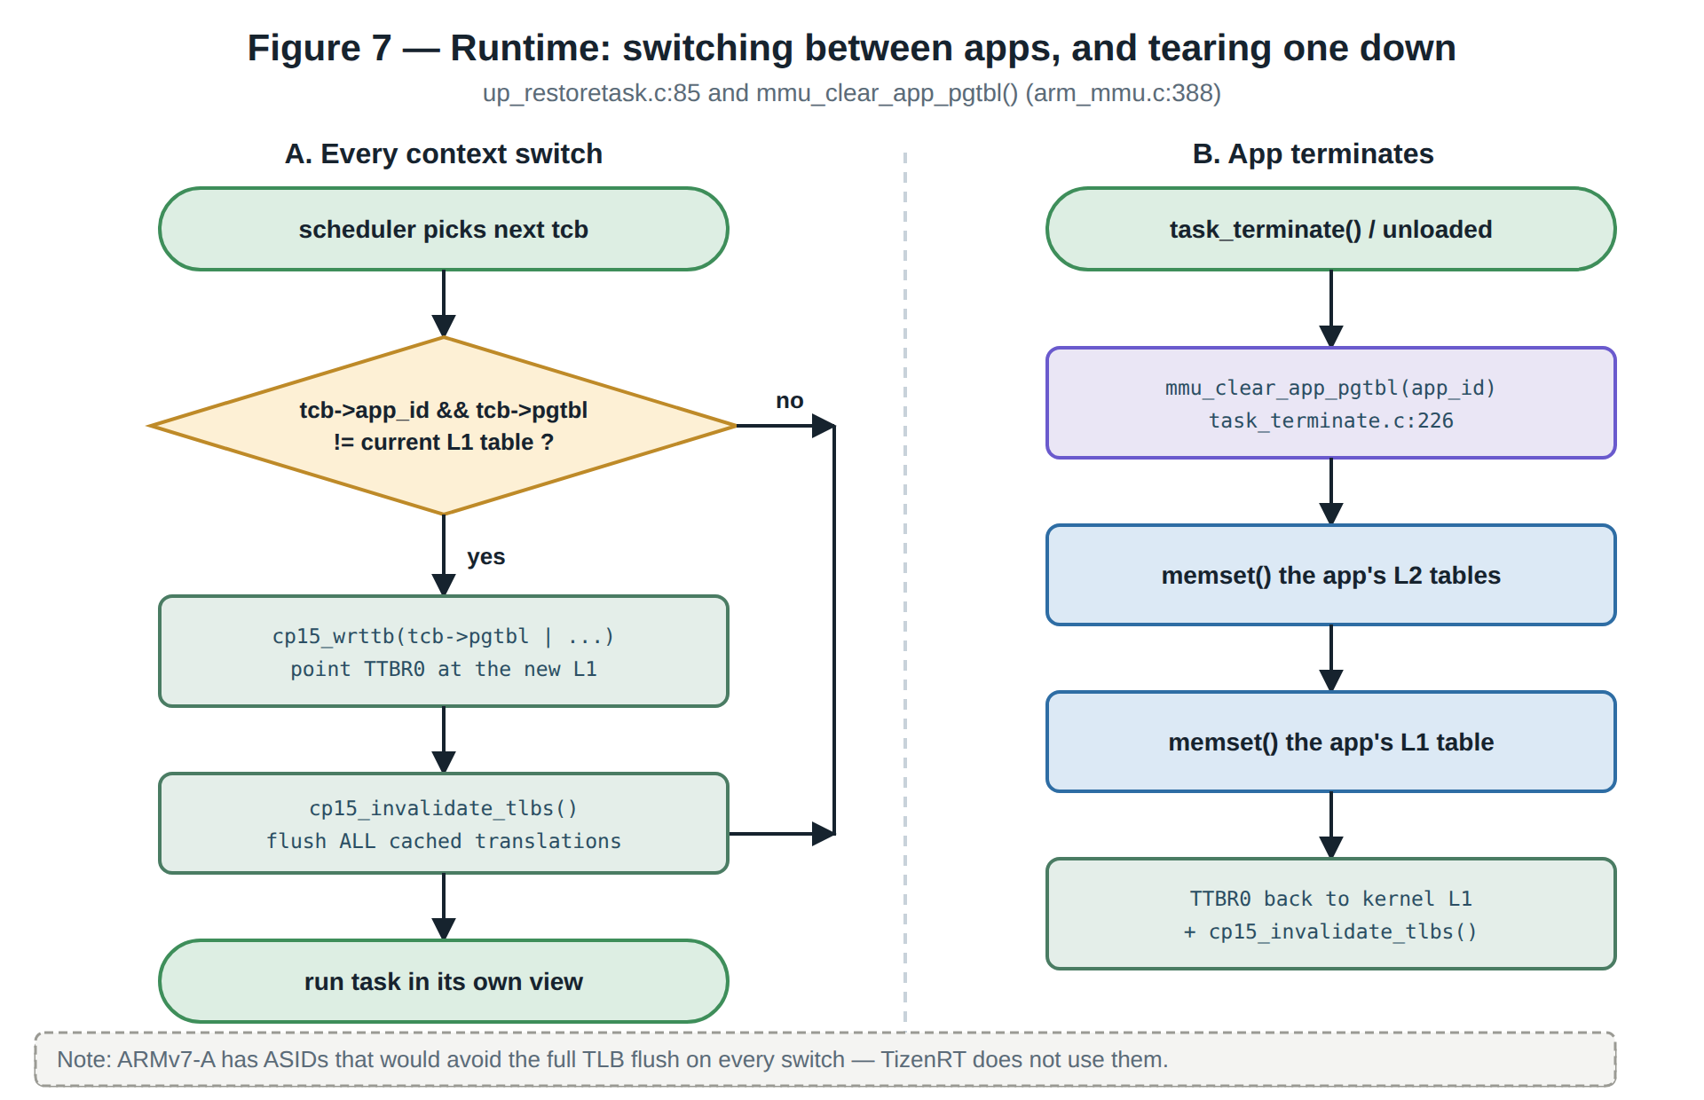
Figure 7 — Switching between address spaces, and reclaiming one when an app dies.

7. Fault handling
An illegal data access raises a Data Abort, handled by arm_dataabort() in os/arch/arm/src/armv7-a/arm_dataabort.c. The hardware hands the handler two very useful registers: DFAR, the exact address that was touched, and DFSR, the reason it failed (nothing mapped there, versus mapped but no permission). Combined with the saved PC, that is a precise report.
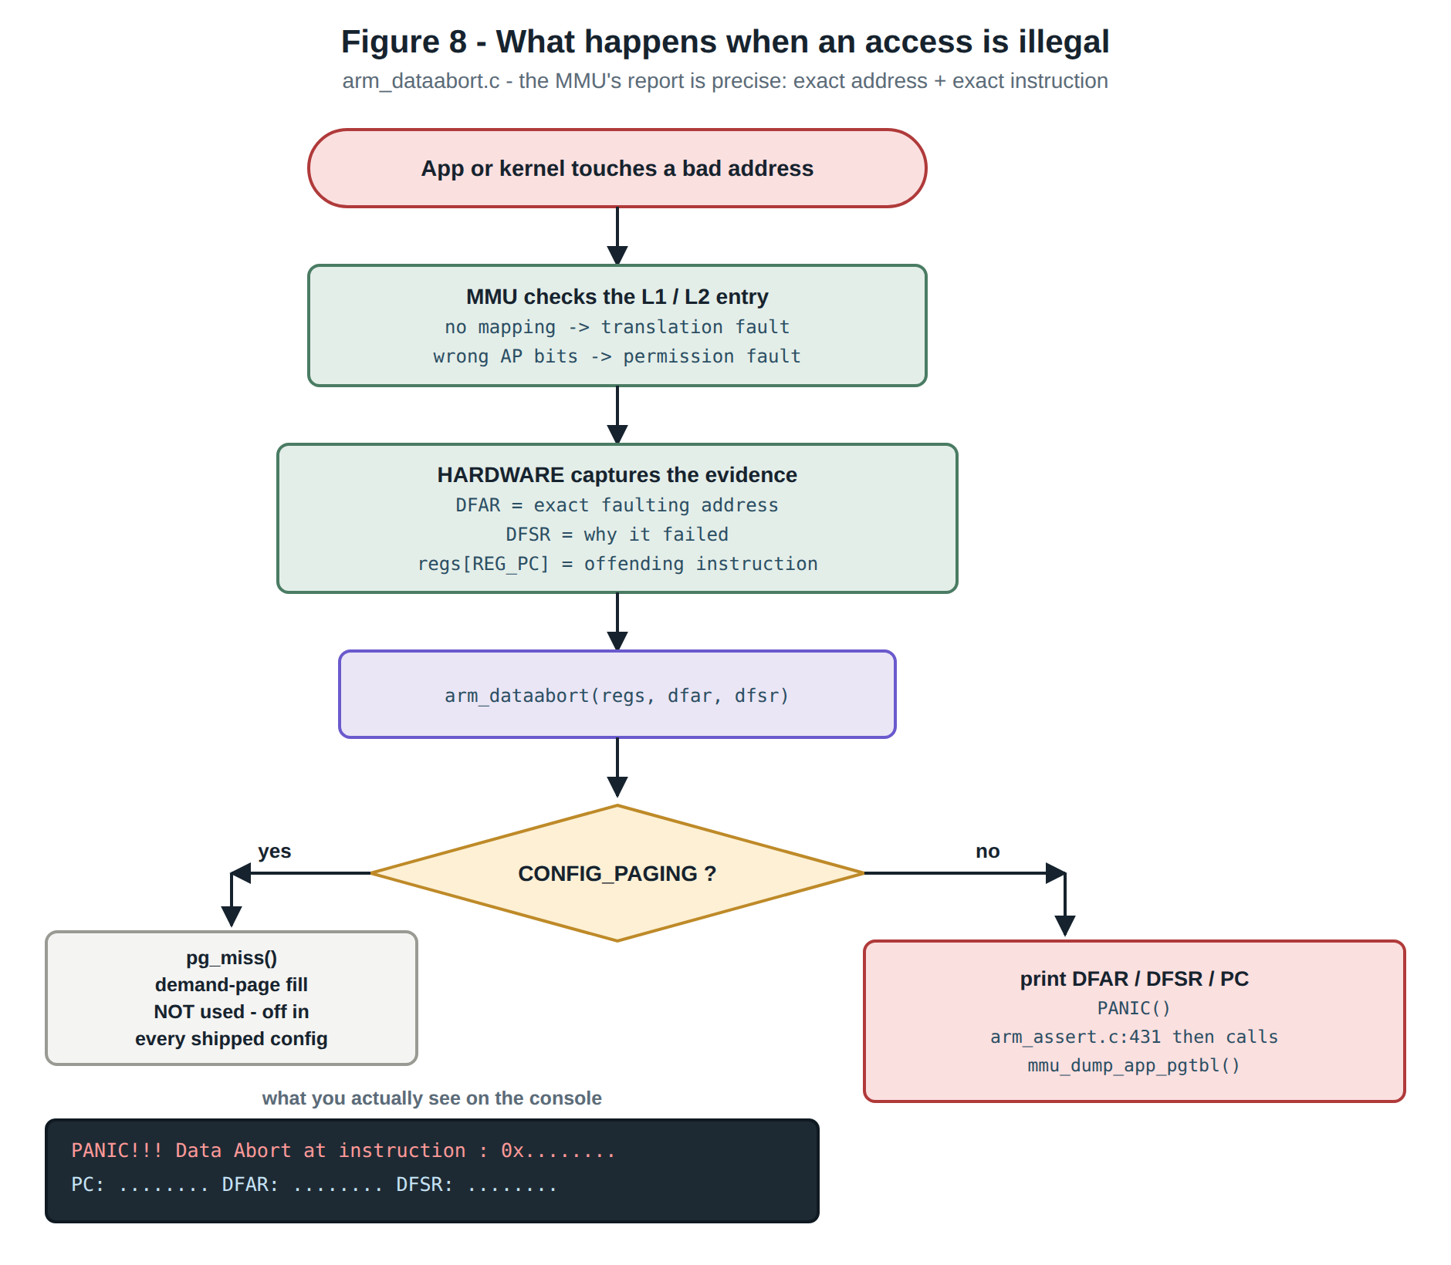
Figure 8 — The abort path. Bad instruction fetches go through arm_prefetchabort() the same way.
On a crash, arm_assert.c:431 also calls mmu_dump_app_pgtbl() (arm_mmu.c:506), which prints the offending app's full page table — every section and page with its RO/RW and X/XN state.

8. What TizenRT deliberately does NOT use the MMU for
This is the part worth internalising, because the feature is far smaller than the word "MMU" usually implies:
- No demand paging. CONFIG_PAGING is off in every shipped configuration. The code path in arm_dataabort.c that calls pg_miss() to fill pages on fault exists, but is unused.
- No swap and no overcommit. All RAM is mapped up front.
- No address translation. Everything is identity-mapped: virtual equals physical.
- No per-process virtual address space. CONFIG_ARCH_ADDRENV is off in the rtl8730e configurations. Apps are separated by permissions, not by having private address ranges. The arm_addrenv*.c files are largely inherited scaffolding — up_addrenv_mprot() in arm_addrenv_perms.c:70 is an empty stub that returns OK.
- No heap protection. The heap sits inside ordinary 1 MB MMU_MEMFLAGS sections. The MMU has no idea the allocator exists.
Summary: TizenRT uses the MMU for two things — setting correct cache and device attributes on an identity-mapped memory map at boot, and giving each downloadable app its own copy of the page table in which only that app's regions carry user-accessible permission bits. It is a memory protection mechanism, not a virtual memory mechanism.

9. Can the MMU debug memory corruption?
That last point — the MMU has no idea the allocator exists — is what governs the answer to the original question. The two cases behave very differently.

9.1 Double free — the MMU adds nothing
A double free is a metadata event, not a memory access. The MMU only faults on a load, store, or instruction fetch. free() never dereferences the payload; it reads the boundary tag.
TizenRT already detects this in software, at os/mm/mm_heap/mm_free.c:164:
node = (FAR struct mm_freenode_s *)((char *)mem - SIZEOF_MM_ALLOCNODE);
if ((node->preceding & MM_ALLOC_BIT) != MM_ALLOC_BIT) {
mdbg("WARNING!! Attempt for double freeing a pointer ...");
With CONFIG_DEBUG_MM_FREEINFO (os/Kconfig.debug:787) it prints both free sites and both PIDs, plus the original allocation site, because free_call_addr and free_call_pid are stored in the freed node. That is strictly better diagnostics than a Data Abort would give you.
You could force the second free() to fault by unmapping the page after the first free — the read of node->preceding would trap. But you would get only DFAR and PC, and you would lose the "who freed it first" information, because that metadata now lives in an unmapped page.
And the one case software misses — free(p); q = malloc(...); free(p); where the chunk was reallocated in between — the MMU also misses, because the page is legitimately mapped for its new owner.
Recommendation for double free: enable CONFIG_DEBUG_MM_FREEINFO together with CONFIG_DEBUG_MM_HEAPINFO. Nothing needs to be built.

9.2 Use-after-free — possible, but not with the code as it stands
Here the MMU genuinely can help. The classic technique is one allocation per page, revoke the page on free, and do not recycle the address. Any subsequent touch traps with an exact address and an exact faulting instruction — which is strictly better than software poisoning, because poisoning only tells you at some later allocator call that something was overwritten, not who did it or when.
The obstacle is granularity, and then four structural issues.
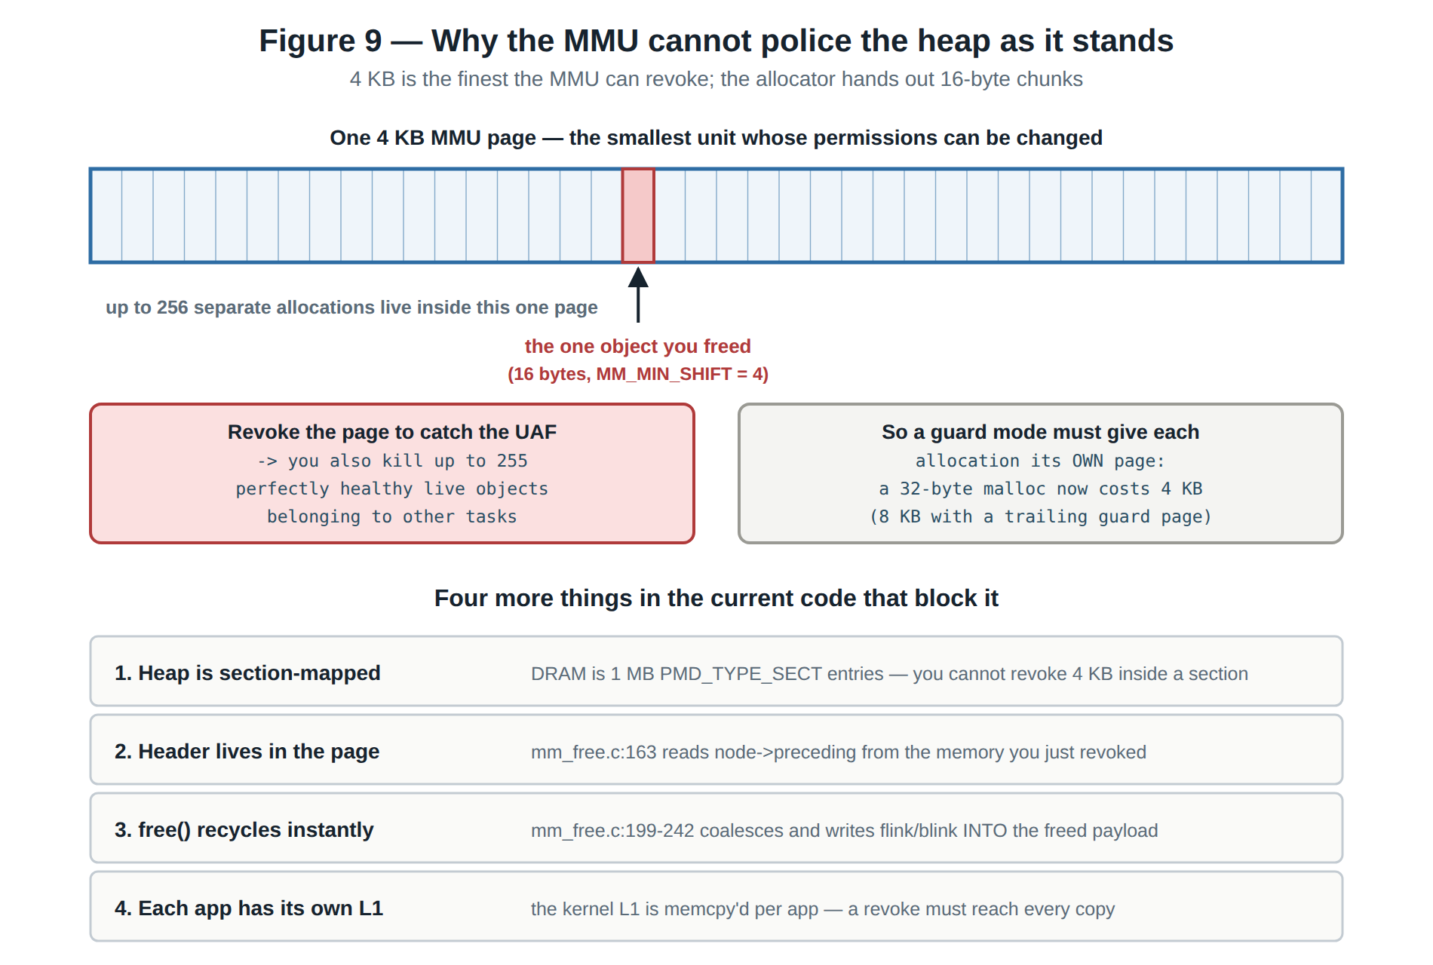
Figure 9 — The granularity mismatch, and the four code-level blockers.
Taking those in turn:
- Granularity. MM_MIN_SHIFT is hard-coded to 4 in os/include/tinyara/mm/mm.h:149, so chunks are 16-byte granular and a single 4 KB page can hold up to 256 separate allocations. Revoking one page to catch one bug would kill up to 255 healthy live objects. A guard mode must therefore round every allocation up to a whole page — a 32-byte malloc then costs 4 KB, or 8 KB with a trailing guard page. On the 7 MB rtl8730e heap that caps you at roughly 1700 live allocations, far fewer than the system boots with. This cannot be a global mode; it has to be scoped to one heap, one PID, one size class, or an explicit malloc_guarded() API.
- The heap is section-mapped. DRAM is covered by 1 MB PMD_TYPE_SECT entries, and you cannot revoke a 4 KB window inside a section. Each covering megabyte would have to be split into an L2 table. For a 7 MB heap that is only 7 KB of tables — cheap in RAM — but the arena is the fixed 64 KB described in section 4, already fully budgeted, so it would have to be enlarged and mmu_allocate_app_l2_pgtbl() extended.
- The header lives inside the page. The allocator is a boundary-tag design that walks through freed chunks: mm_free.c:163 reads the header, line 201 reads the next node, line 229 reads the previous one. Every one of those reads lands in the region you just revoked. Guarded chunks would need out-of-band metadata.
- free() recycles the payload immediately. mm_free.c:199-242 coalesces with both neighbours, and mm_addfreechunk() writes flink and blink into the freed payload. Without a quarantine, a later stray write lands on a legally mapped page owned by someone else and the MMU never sees it. Note that the existing heap->mm_delaylist is not a quarantine — it is a deferred-free path for when the heap semaphore cannot be taken, and mm_malloc() drains it on the very next allocation.
- Each app has its own L1 table. mmu_update_app_l1_pgtbl_ospgtbl() memcpy's the kernel L1 into every app L1, entry by value, so a revoke applied to the kernel table afterwards is invisible to the apps. The clean fix falls out of the second point: if the heap's L1 entries point at a shared L2 table, the pointer is what gets copied, and a single mmu_l2_setentry() then covers every address space.
Cache and TLB maintenance is a further requirement: before revoking a data page you must clean and invalidate that page's dcache lines, or dirty lines can be written back afterwards.

9.3 A cheaper variant worth considering
Instead of making the page fault outright (PTE_TYPE_FAULT), set PTE_AP_R01 — read-only. Then use-after-free writes trap while reads still succeed, which conveniently lets the allocator keep reading its own boundary tags and sidesteps the header problem. Use-after-free writes are the dangerous case anyway, since they are what corrupts the heap. The allocator would still need RW restored at the small number of places where it legitimately writes into a freed chunk.
One approach that does not work: using privileged-RW / user-no-access to exempt the allocator. There is no malloc syscall — umm_malloc.c calls mm_malloc() directly — so in a protected build the user allocator runs unprivileged, at the same level as the code being investigated.

9.4 Recommendation
Approach | Catches | Cost | Available on
CONFIG_DEBUG_MM_FREEINFO (already in tree) | double free, with both call sites | ~8 B per chunk | all boards
Redzone + poison-on-free + quarantine in mm_free.c | UAF write, overflow, wild write | ~8-16 B per chunk; detection is deferred | all boards
MMU page-guard mode | UAF read and write, immediate, exact PC | ~4 KB per allocation | rtl8730e, imx6 only
ARMv7-A hardware watchpoints (DBGWVR/DBGWCR) | one specific object, read and write, byte granularity | negligible; 4-8 objects | rtl8730e, imx6

Two conclusions follow from that table. First, because only two board families have an MMU and the guard mode needs 4 KB per allocation, the MMU approach is best framed as an opt-in guarded-allocation mode for a suspect subsystem, not as a global configuration option. Software redzones plus a quarantine in mm_free.c give most of the use-after-free coverage on every board for about 16 bytes per chunk.
Second, if a specific suspect object is already known rather than a blind hunt, the Cortex-A32 debug unit's hardware watchpoints are dramatically cheaper than page-guarding the entire heap, and they catch reads as well as writes at byte granularity. There is currently no ARMv7-A watchpoint support in the tree, but adding a small up_watchpoint_set() would be a far smaller change than a page-granular heap.

10. Source file reference
File | Role
os/arch/arm/src/armv7-a/mmu.h | All page-table bit definitions, AP macros, PGTABLE_SIZE, mmu_l1_pgtable()
os/arch/arm/src/armv7-a/arm_mmu.c | L1/L2 entry writers, app page-table alloc/map/clear/dump
os/arch/arm/src/armv7-a/arm_head.S | Bootstrap L1 table, TTBR0 setup, MMU enable
os/arch/arm/src/armv7-a/arm_dataabort.c | Data Abort handler; DFAR / DFSR reporting
os/arch/arm/src/amebasmart/amebasmart_boot.c | arm_boot(): installs the real map and the vector L2 table
os/arch/arm/src/amebasmart/amebasmart_memorymap.c | g_section_mapping[] — the board memory map
os/arch/arm/src/common/up_restoretask.c | TTBR0 switch on context switch
os/binfmt/binfmt_pgtable.c | Per-app page-table construction
os/include/tinyara/mmu.h | SMALL_PAGE_SZ, MMU_ALIGN_UP, public app-mapping prototypes
os/mm/mm_heap/mm_free.c | free() path, existing double-free detection
os/include/tinyara/mm/mm.h | MM_MIN_SHIFT, node layout, MM_ALLOC_BIT

