ST-TRAP-ARCHDIAG-001
Electrical Architecture Diagram Package
Rev 0.1 — Working Draft
Document | ST-TRAP-ARCHDIAG-001
Title | Electrical Architecture Diagram Package
Project | Trappey's AI Center, Lafayette, Louisiana
Revision | Rev 0.1 — working draft
Date | April 17, 2026
Owner | Scott Tomsu
Status | Companion visual to ELEC-001 Rev 1.1 and BOD-001 Rev 0.3
Supersedes | — (first issue)

1. Purpose
This document is the visual companion to ST-TRAP-ELEC-001 Rev 1.1 (Electrical Architecture) and ST-TRAP-BOD-001 Rev 0.3 (Basis of Design). It captures the end-to-end electrical path of one Marlie-pattern block at Trappey's AI Center — from natural gas genset through medium-voltage paralleling, LV AC distribution, AC-DC conversion at the in-row power rack, 800 VDC common busway with DC-coupled BESS and solar, cassette umbilical, and cassette-internal distribution to the Vera Rubin GPU die.
Six diagrams are included. The first is an orientation overview; the next four zoom into each domain (MV AC, LV AC and in-row rack, 800 VDC with DER, cassette internal); the sixth shows the AMCL control hierarchy and the 11-block campus replication pattern.
The diagrams are architectural, not construction-issue. They precede the formal single-line drawing (ST-TRAP-SLD-001, not yet drafted) and the protection coordination study (ST-TRAP-PROT-001, not yet drafted). CT and PT designations, conductor sizing, breaker frame sizes, and trip settings are deliberately not shown — those belong in the downstream documents, which will inherit from this package's topology.

2. Relationship to other documents
This package is cited by and inherits from:
- ELEC-001 Rev 1.1 — authoritative source for block architecture, protection philosophy, DC-coupled BESS and solar coupling, and the in-row power rack product category.
- BOD-001 Rev 0.3 — authoritative source for Locked / Working / Open status of every design parameter. All values in this package carry forward the BOD-001 ledger status.
- Pod Swarm eng-pack-5MW Rev 3.x — architectural reference for the Marlie block. Trappey's is N replicated Marlie blocks with Cat CG260-16 substituted for Cat G3520K.
- 800 VDC Vendor Comparison sheet — procurement basis for the in-row power rack selection (Delta scored 4.75, Eaton 3.80, Schneider 3.15).
Downstream documents that will reference this package:
- ST-TRAP-SLD-001 — formal single-line drawing with CT/PT designations, conductor sizes, and breaker frame ratings.
- ST-TRAP-PROT-001 — protection coordination study, including cross-domain AC-to-DC trip schemes.
- ST-TRAP-BESS-001 — procurement-level DC-coupled BESS specification.
- ST-TRAP-SOLAR-001 — solar integration detail, including the DC-DC buck converter selection.

3. Conventions
Domain color coding (applied consistently across all six diagrams):
Color | Domain | Elements
Blue | MV AC (13.8 kV) | Gensets, generator breakers, MV bus, paralleling switchgear, transformer primary
Amber | LV AC (480 V) | Step-down transformer secondary, 480 VAC main, feeders, in-row rack AC side
Teal | 800 VDC | Common busway, SSCBs, blocking diodes, cassette umbilicals, overhead busbar
Purple | BESS / compute | LFP battery racks, bidirectional DC-DC, cassettes, ORV3/Kyber PDUs
Green | Solar / PV | First Solar array, combiners, DC-DC buck converter
Pink | Controls / GPU tray | AMCL tiers, sub-100 ms storage (PCS), rack detail with NVL72 tray
Gray | Neutral / shared | Gas header, shared campus services, protection reference tables

4. Diagram 1 — Block overview: generator to GPU
One of eleven identical Marlie-pattern blocks shown end to end. Top-down flow: natural gas header into four CG260-16 gensets, paralleled on the 13.8 kV block MV bus, stepped down to 480 VAC, rectified to 800 VDC through in-row power racks, onto the block DC busway where the DC-coupled BESS and solar DER tie in as side taps, out through four cassette umbilicals to 2,880 Vera Rubin GPUs per block.
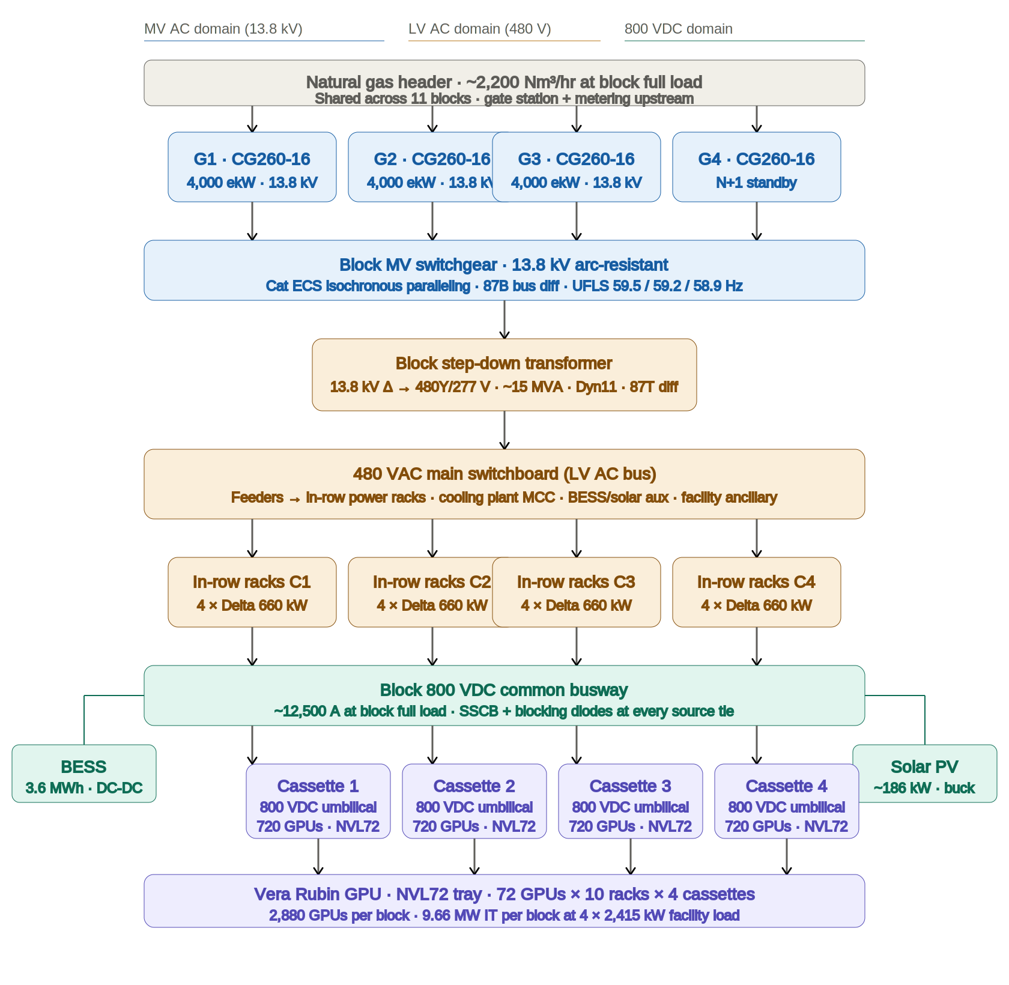
Diagram 1 — Block overview: generator to GPU

5. Diagram 2 — MV AC detail: protection and paralleling
MV AC-side detail for one block. Per-genset protection relay set (87G, 32, 40, 46, 47, 59/27, 64G, 78), neutral grounding resistor callout, generator circuit breakers, paralleling to the 13.8 kV block bus with Cat ECS isochronous sharing and 87B bus differential, three-stage UFLS at the block MV inlet, step-down transformer with 87T primary and secondary differential and 49T thermal, secondary main with LSIG trip and 50G residual ground. ANSI device number legend at the bottom for cross-reference.
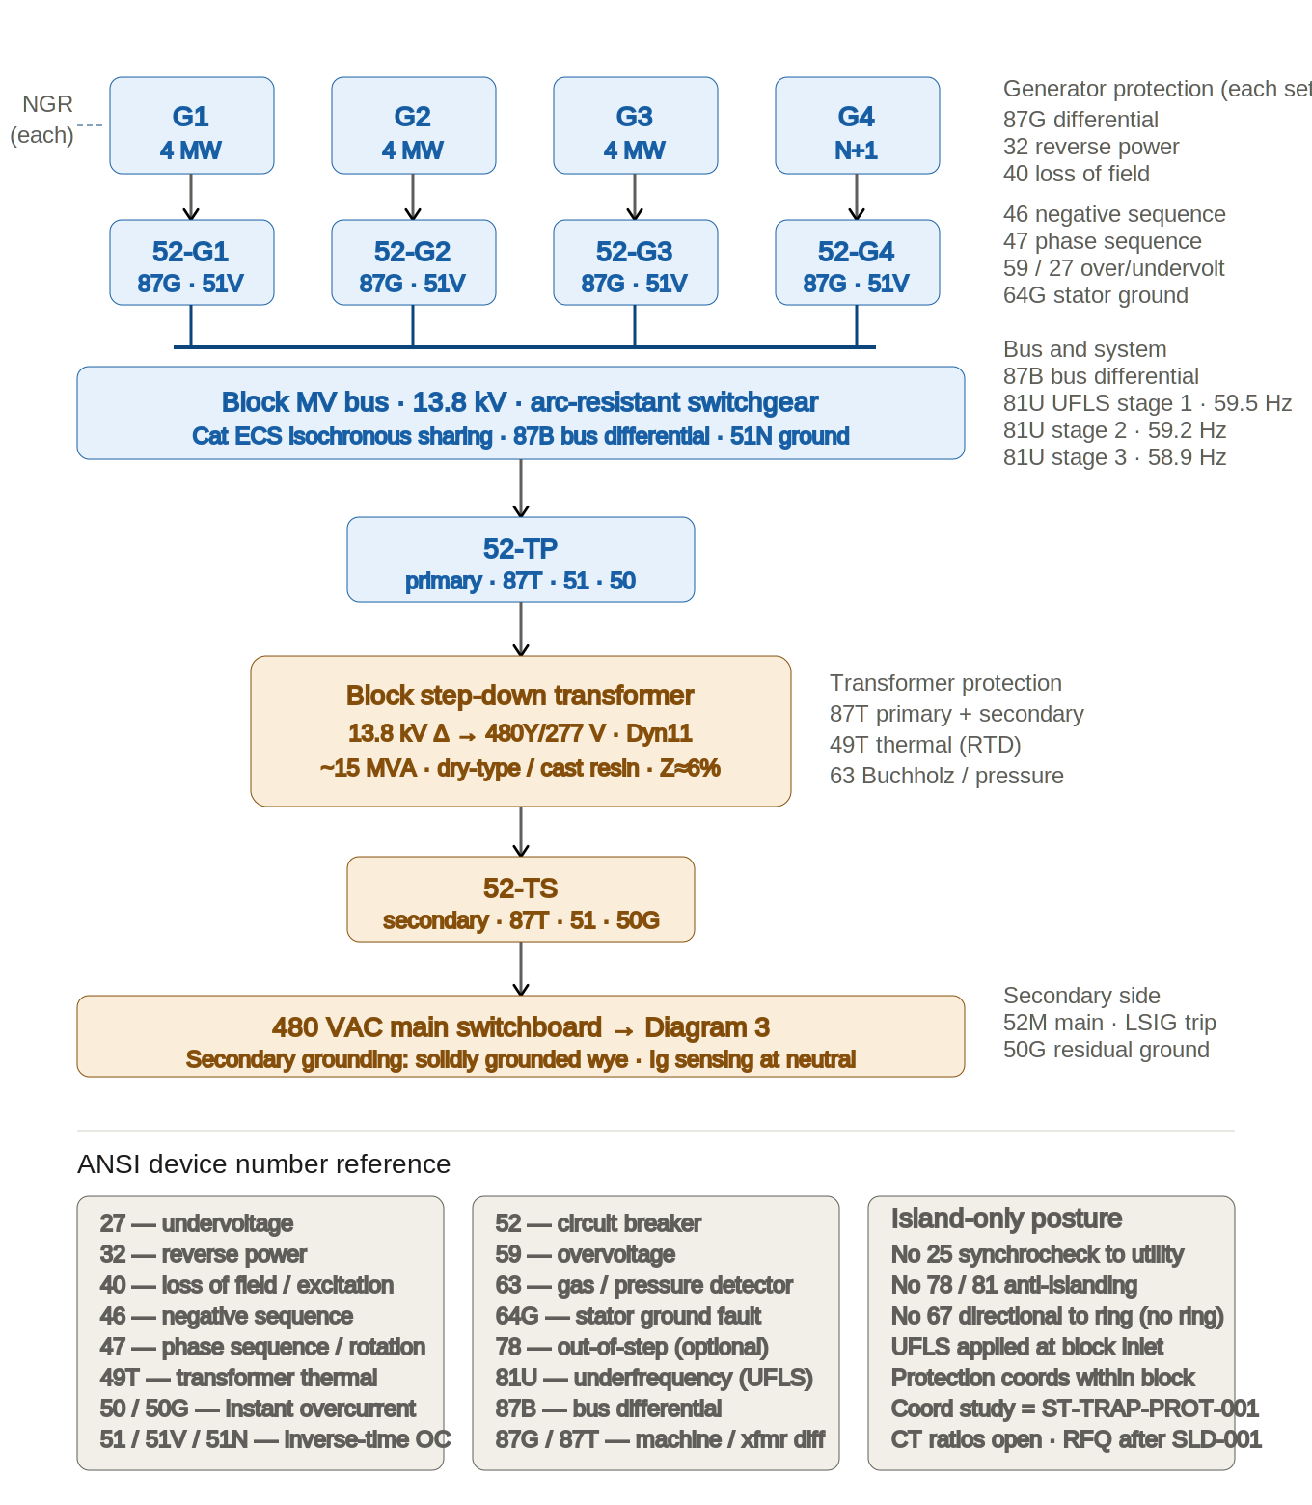
Diagram 2 — MV AC detail: protection and paralleling

6. Diagram 3 — LV AC distribution and in-row rack internals
480 VAC main switchboard with five feeder categories: 16 in-row power racks (~10.6 MVA), cooling plant MCC (~600 kW, VFD-driven pumps and fans), BESS auxiliary (HVAC and BMS, ~80 kW), solar buck auxiliary (~10 kW), and facility ancillary (SCADA, NOC, life safety, ~200 kW). Lower half: one Delta 660 kW in-row power rack exploded to show six 110 kW PSU shelves with 80 kW BBU per shelf (480 kW aggregate), the Power Capacitance Shelf with aluminum capacitors and supercapacitors that closes the sub-100 ms GPU load-swing band, Energy Variance Appliance for peak shaping, and integrated DC fault protection at the touch-safe 800 VDC output.
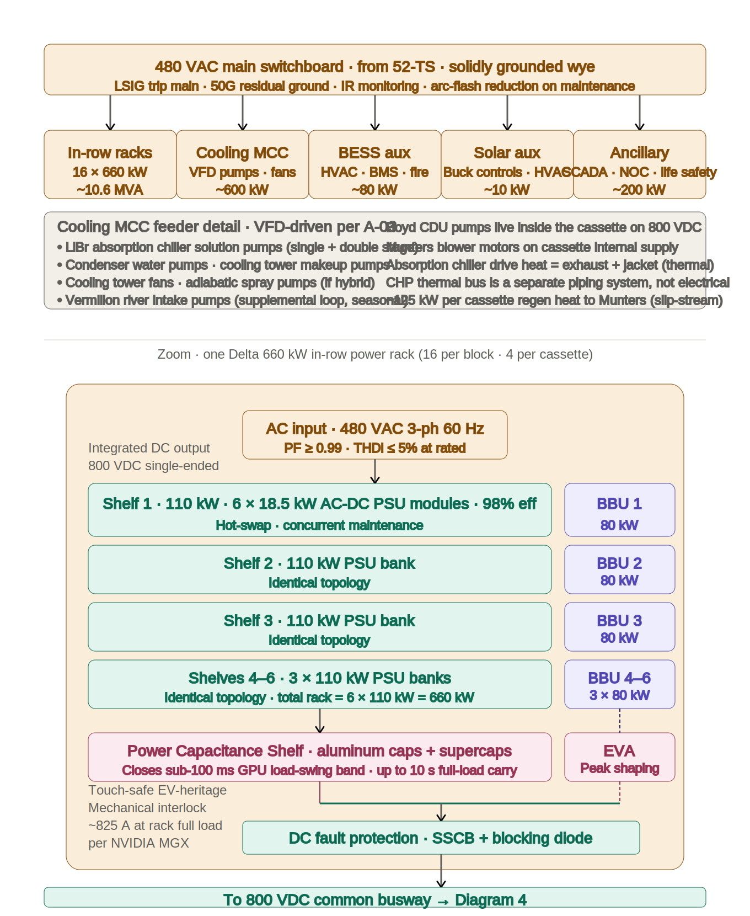
Diagram 3 — LV AC distribution and in-row rack internals

7. Diagram 4 — 800 VDC common bus, BESS, solar, cassette umbilicals
Three DC sources converge on the 800 VDC common busway: the in-row rack output (rectified from 480 VAC, integrated BBU and PCS storage), the DC-coupled BESS via a bidirectional DC-DC converter (~2 MW continuous, ~4 MW peak), and the DC-coupled solar array via a 1500 to 800 V buck converter with MPPT. SSCB and blocking diode at every source tie enforces DC-domain protection discipline. Four cassette umbilicals exit the bus through load-break contactors and additional SSCBs. The bus carries approximately 12,500 A at full block load.
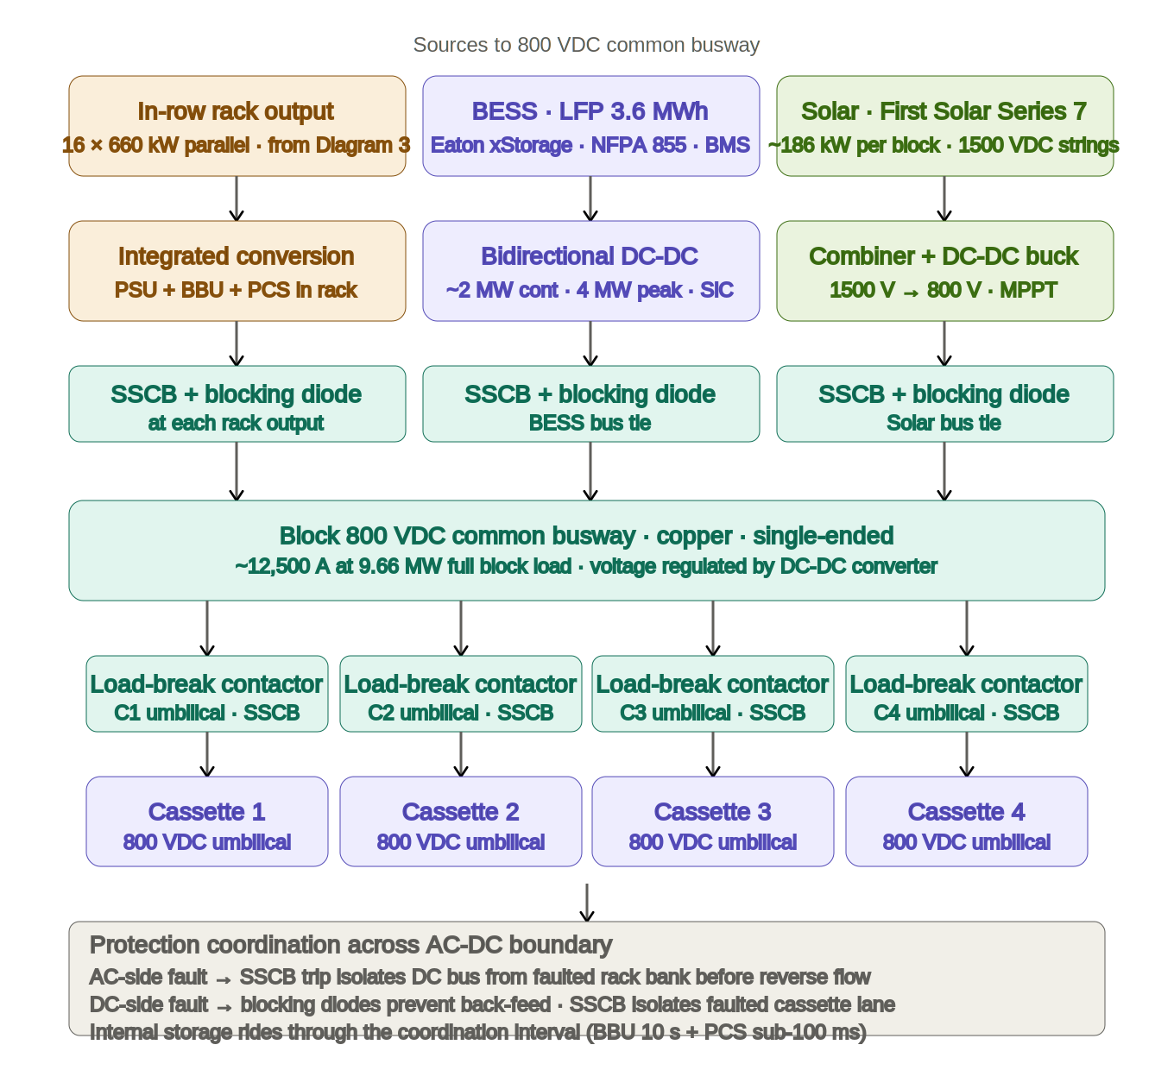
Diagram 4 — 800 VDC common bus, BESS, solar, cassette umbilicals

8. Diagram 5 — Cassette internal distribution: umbilical to GPU
Inside one cassette. The 800 VDC umbilical enters through a Staubli hot-swap disconnect at the cassette IP boundary (this is where vendor-neutral facility infrastructure ends and cassette IP begins). The overhead busbar feeds two branches: the main DC distribution (three Eaton ORV3 PDUs plus NVIDIA Kyber PDUs serving ten OCP ORV3 racks at 230 kW each) and an auxiliary DC-DC for the Boyd CDU pumps, Munters HCD/MCD blowers, and the Jetson AGX Orin BMS. One rack is expanded to show the NVL72 tray with 72 Vera Rubin GPUs, each with 288 GB of HBM4 memory, cooled direct-to-chip by the water-glycol loop with the Boyd CDU supplying ≤45°C.
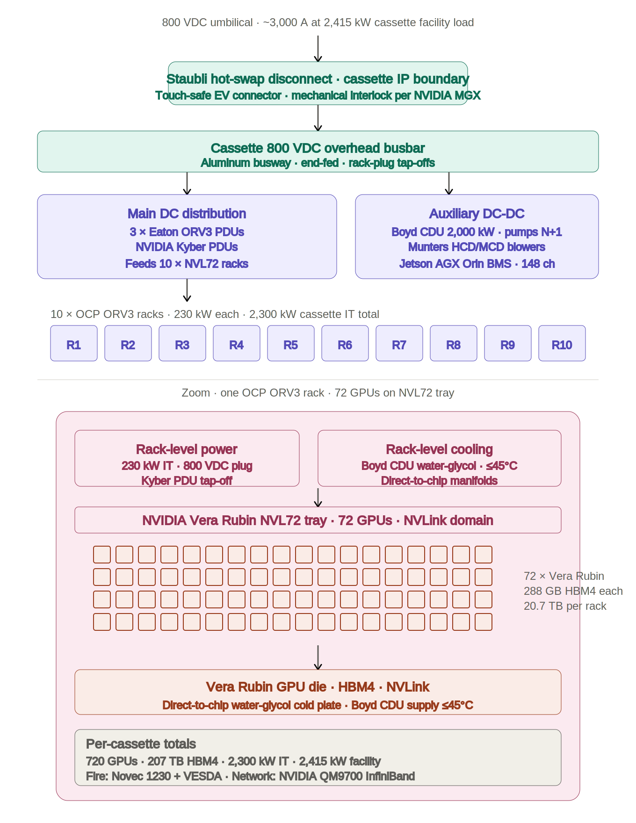
Diagram 5 — Cassette internal distribution: umbilical to GPU

9. Diagram 6 — AMCL controls and campus replication
Two views combined. Upper half: the five-tier AMCL control hierarchy, from L0 field devices (Cat ECS governors, protection IEDs, VFDs, Jetson Orin BMS) through L1 block controller (paralleling, UFLS, DC-DC setpoints), L2 plant SCADA, L3 AMCL AI dispatch layer, and L4 HMI with operator override and IEC 62443 cybersecurity. Lower half: the campus replication pattern — shared services (gas header, water plant, NOC, security, LUS future tie) above eleven electrically independent blocks (E-23 inter-block tie deferred).
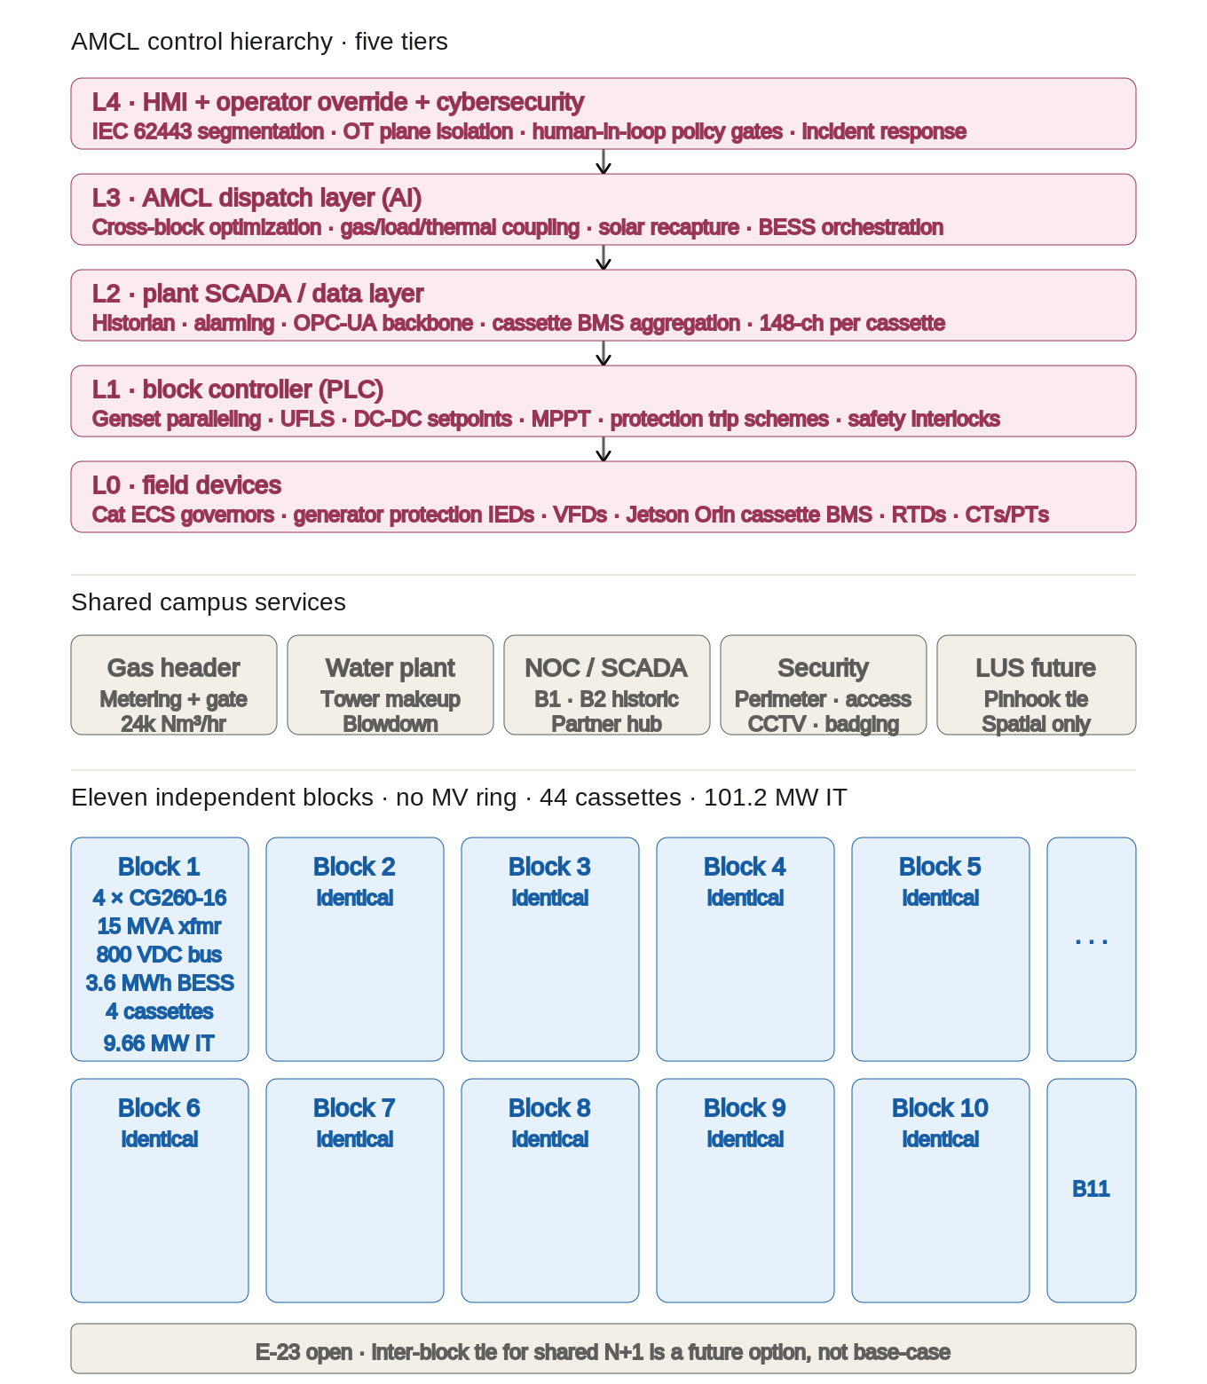
Diagram 6 — AMCL controls and campus replication

10. Engineering notes
This section separates the architecture shown in the diagrams into four categories: what comes directly from the source documents, what is filled in with standard engineering practice, what is still open per the source documents, and design choices that may be revisited as the engineering matures.

10.1 Anchored directly in ELEC-001 Rev 1.1 and BOD-001 Rev 0.3
- 4 × Cat CG260-16 gas gensets per block, 4,000 ekW continuous each at 13.8 kV, with isochronous paralleling via Cat ECS (E-03, E-04).
- One per-block step-down transformer, 13.8 kV Δ → 480Y/277 V, ~15 MVA continuous (E-08).
- In-row power racks at the cassette, vendor-neutral with Delta / Eaton / Schneider as the qualified vendor list, with Delta 660 kW rack as the primary candidate at approximately 4 racks per 2.5 MW cassette (E-09).
- Single 800 VDC common busway per block, single-ended, with SSCBs and blocking diodes at every source tie (E-18, E-22).
- DC-coupled BESS on the 800 VDC bus via bidirectional DC-DC converter, LFP chemistry, 40 MWh across the facility (E-10, E-11, E-12, E-13).
- DC-coupled solar via 1500 V DC strings → DC-DC buck → 800 VDC bus, First Solar Series 7 array at 2.05 MW total across the campus (E-14 through E-17).
- Three-stage UFLS at 59.5 / 59.2 / 58.9 Hz applied at the block MV inlet, island-only protection posture with no anti-islanding (E-18, E-19).
- Integrated sub-100 ms GPU load-swing storage inside the in-row rack (BBU + PCS / supercaps), closing the NVIDIA MGX dual-layer storage requirement (E-20).
- Touch-safe 800 VDC connectors with mechanical interlock, EV-heritage per NVIDIA MGX, at the in-row rack output and the cassette umbilical (E-21).
- Staubli hot-swap disconnects at the cassette boundary (C-22); 3 × Eaton ORV3 PDUs plus NVIDIA Kyber PDUs inside the cassette (C-18); 10 × OCP ORV3 racks with NVL72 trays, 72 GPUs per rack, 720 GPUs per cassette (C-11, C-12).
- Boyd CDU, 2,000 kW water-glycol, direct-to-chip cooling with ≤45°C supply to rack (C-03, C-04).
- 11 electrically independent blocks in the base case, no campus MV ring, inter-block tie deferred as open item E-23 (E-07).

10.2 Filled in with standard engineering practice
These items are not locked in ELEC-001 or BOD-001 but are drawn with industry-standard values for a paralleled gas-genset permanent island. They are expected to become Working entries in BOD-001 Rev 0.4 and then Locked after vendor RFQs close.
- Generator protection relay set: 87G differential, 32 reverse power, 40 loss of excitation, 46 negative sequence, 47 phase sequence, 59/27 over/undervoltage, 64G stator ground, 78 out-of-step. This is the standard IEEE/ANSI set for paralleled gensets in island service.
- Transformer protection: 87T primary and secondary differential, 49T thermal via RTDs, 63 pressure/gas (Buchholz equivalent for cast-resin). Standard for a 15 MVA dry-type transformer.
- 480 VAC main solidly grounded wye with 50G residual ground sensing and LSIG trip unit on the main. Standard for LV data center mains; ELEC-001 does not specify grounding scheme but it aligns with the protection philosophy.
- Arc-resistant MV switchgear at the block bus, per ELEC-001 §11.5 direction to minimize arc-flash category for maintenance personnel.
- Cooling MCC feeder sized at approximately 600 kW — order-of-magnitude estimate pending CHP heat balance closure (T-08). Real value sizes with absorption chiller solution pumps, tower fans, condenser water pumps, cooling tower makeup pumps, and Vermilion intake pumps.
- BESS aux at ~80 kW and facility ancillary at ~200 kW are placeholders within the BOD-001 §D.2 "3-5% of IT load" band (~3 MW total across the block).
- Five-tier AMCL control hierarchy (L0 field devices through L4 HMI + cybersecurity). BOD-001 §I calls out AI dispatch as the operating model but leaves the layered architecture open; the tiers shown are a working template consistent with ISA-95 for industrial control systems.

10.3 Still open per source documents
These items are flagged Open in BOD-001 §M.1 or ELEC-001 §16 and gate the progression to Rev 1.0 of the architectural documents:
- CG260-16 factory voltage option (13.8 kV is the working assumption, pending Cat CSA confirmation — E-5, E-6).
- CG260-16 governor response at island-mode 24/7 duty under AI dispatch — the single biggest technical risk per ELEC-001 §15 and BOD-001 §E.8.
- Chilled water supply temperature compatibility between the LiBr absorption chiller output (7–12°C range) and the Boyd CDU requirement (T-11, C1 open item, inherited from Rev 3.1 E-2G / E-8).
- Inter-block tie for shared N+1 load sharing (E-23 — base case is 11 independent blocks, no inter-block electrical connection).
- Cassette-internal auxiliary DC-DC specifics for Boyd CDU pumps, Munters blowers, and the Jetson Orin BMS — shown as a placeholder block; actual topology is a cassette-IP decision not yet locked.
- CHP heat balance including the 5.5 MW Munters exhaust slip-stream deduction at Stage 1 (T-08, T-12 — gates cooling tower sizing and thus the cooling MCC feeder sizing).

10.4 Design choices subject to revision
- In-row power rack count per cassette: 4 × Delta 660 kW gives 2,640 kW (9.3% headroom) and is the BOD-001 E-09 working number. 5 × Delta 660 kW gives 36.6% headroom and rack-level N+1 — preferred for Trappey's 24/7 duty cycle if the vendor-comparison scoring holds. Alternatively 1 × Delta 1.1 MW system × 3 per cassette. Rev 1.3 of ELEC-001 will lock this after Delta/Eaton/Schneider RFQs close.
- Transformer MVA rating: 15 MVA continuous is comfortable at 9.66 MW cassette load plus ~1 MW ancillary plus BESS charging headroom. 12 MVA is tight and will be limited by absorbed reactive power during paralleling transients. RFQ-dependent — Rev 1.3 of ELEC-001.
- Per-block BESS at 3.6 MWh is 40 MWh / 11 blocks. Envelope is 3–5 MWh per §9.2; contingency analysis (E-8) refines. If the single-genset-trip scenario scales higher than ~1-2 MWh or if the gas-supply-loss graceful shutdown scenario requires >15 minutes, per-block BESS may need to scale up.
- Solar allocation per block: 186 kW is 2.05 MW / 11 blocks, spread uniformly for sizing math. Actual allocation will be driven by rooftop proximity — blocks near Building 1 and Building 2 receive the physical tie, others carry zero solar. This does not affect individual block electrical design but does affect AMCL dispatch modeling.
- 480 VAC secondary grounding: solidly grounded wye is shown. High-resistance grounding is an alternative that preserves uptime on first-fault detection at the cost of additional ground-fault detection complexity. Locked as solidly grounded in most modern data center LV mains; worth reconfirming with insurance underwriters given the 800 VDC downstream.

11. Open items ledger
Items flagged here are blocked on external validation (vendor RFQ, Cat CSA, thermal engineering) or on downstream documents that have not yet been drafted. Priority codes follow the BOD-001 §M.1 convention: C1 must happen and is on the critical path, C2 is desirable but not blocking, C3 is optional.
Ref | Item | Blocked on | Priority
E-05 | CG260-16 nominal loading (61.5% working) | Cat CSA | C1
E-06 | CG260-16 factory MV voltage option (13.8 kV assumed) | Cat CSA | C1
E-06 | Governor response at island-mode 24/7 under AI dispatch | Cat CSA black-box test | C1
E-08 | Block step-down transformer RFQ (~15 MVA working) | Vendor RFQ | C1
E-09 | In-row power rack count per cassette (4 vs 5 for N+1) | Delta/Eaton/Schneider RFQ | C1
E-10 | BESS per-block sizing (3.6 MWh working, 3-5 envelope) | Contingency analysis | C1
E-22 | Solar DC-DC buck converter vendor selection | Vendor RFQ | C2
E-23 | Inter-block tie for shared N+1 (base case is 11 independent) | Contingency analysis | C2
T-11 | Chiller CHW supply temperature vs Boyd CDU requirement | Chiller + Boyd spec confirmation | C1
T-08 | CHP heat balance including Munters slip-stream | Thermal engineering | C1
PROT-001 | Protection coordination across AC-DC boundary | Downstream document | C1
SLD-001 | Formal single-line with CT/PT designations and conductor sizing | Downstream document | C1

12. Revision plan
- Rev 0.1 (current) — first issue of the diagram package. Companion to ELEC-001 Rev 1.1 and BOD-001 Rev 0.3.
- Rev 0.2 — after Cat CSA returns voltage confirmation and governor characterization. Updates MV voltage annotation on Diagrams 1 and 2 if CG260-16 comes back at a different voltage option.
- Rev 0.3 — after 800 VDC vendor RFQs close (Delta / Eaton / Schneider). Updates Diagrams 1 and 3 with locked in-row rack vendor, per-rack kW rating, and rack count per cassette (4 vs 5).
- Rev 0.4 — after BESS RFQ closes. Updates Diagram 4 BESS annotations with locked bidirectional DC-DC specifics.
- Rev 0.5 — after protection coordination study (PROT-001) completes. Updates Diagram 2 with locked CT ratios, pickup settings, and coordination interval annotations.
- Rev 1.0 — ready for external circulation. All C1 dependencies closed. Paired with SLD-001 Rev 1.0 (formal single-line) and PROT-001 Rev 1.0 (protection study).

13. Approval
This document, at Rev 0.1, does not carry external circulation approval. Scott Tomsu's sign-off on the architecture it depicts is inherited from the ELEC-001 Rev 1.1 and BOD-001 Rev 0.3 approval status. External distribution waits for Rev 1.0, which is gated on all C1 external dependencies closing per BOD-001 §M.1.

