Tables

Table 1: Past (1900-2015) and future (2015 to 2050) global trends in alpha diversity ($P_{α}$) and gamma diversity ($P_{γ}$) of the different bird species groups (i.e., total bird species, forest bird species and non-forest bird species). Values in brakets show the per year rate of change. See supplementary table (Sx) and (Sxx) for all group-specific (total bird species, forest bird species and non-forest bird species) estimates along with 95% confidence intervals (resulting from 100 model runs per scenario) at different time-steps.

Alpha diversity ($P_{α}$) | Historical |  |  |  |  | SSP1 |  |  |  |  |  | SSP3 |  |  |  |  |  |  | SSP5
$R∆$ -Relative change (%)
Total sp. | 2.98 | [ 0.026 yr⁻¹] |  |  |  | -0.02 | [-0.001 yr⁻¹] |  |  |  |  |  | 0.37 | [ 0.010 yr⁻¹] |  |  |  |  |  | 0.09 |  | [ 0.002 yr⁻¹]
Forest sp. | -5.72 | [-0.050 yr⁻¹] |  |  |  | -0.50 | [-0.014 yr⁻¹] |  |  |  |  |  | -1.67 | [-0.048 yr⁻¹] |  |  |  |  |  | -1.39 |  | [-0.040 yr⁻¹]
Non-Forest sp. | 4.12 | [ 0.036 yr⁻¹] |  |  |  | 0.06 | [ 0.002 yr⁻¹] |  |  |  |  |  | 0.63 | [ 0.018 yr⁻¹] |  |  |  |  |  | 0.32 |  | [ 0.009 yr⁻¹]
$A∆$ -Absolute change (sp)
Total sp. | 7.17 | [ 0.062 yr⁻¹] |  |  |  | -0.29 | [-0.008 yr⁻¹] |  |  |  |  |  | 0.82 | [ 0.023 yr⁻¹] |  |  |  |  |  | -0.01 |  | [-0.0003 yr⁻¹]
Forest sp. | -1.59 | [-0.014 yr⁻¹] |  |  |  | -0.18 | [-0.005yr⁻¹] |  |  |  |  |  | -0.50 | [-0.014 yr⁻¹] |  |  |  |  |  | -0.53 |  | [-0.015 yr⁻¹]
Non-Forest sp. | 8.76 | [ 0.076 yr⁻¹] |  |  |  | -0.10 | [-0.003 yr⁻¹] |  |  |  |  |  | 1.32 | [ 0.038 yr⁻¹] |  |  |  |  |  | 0.52 |  | [ 0.015 yr⁻¹]
Gamma diversity ($P_{γ}$)
$R∆$ -Relative change (%)
Total sp. | -1.63 | [-0.014 yr⁻¹] |  |  | -0.22 |  | [-0.006 yr⁻¹] |  |  |  |  |  | -0.48 |  | [-0.014 yr⁻¹] |  |  |  |  |  | -0.43 |  | [-0.012 yr⁻¹]
Forest sp. | -4.35 | [-0.038 yr⁻¹] |  |  | -0.53 |  | [-0.015 yr⁻¹] |  |  |  |  |  | -1.28 |  | [-0.036 yr⁻¹] |  |  |  |  |  | -1.10 |  | [-0.031 yr⁻¹]
Non-Forest sp. | -0.13 | [-0.001 yr⁻¹] |  |  | -0.05 |  | [-0.001 yr⁻¹] |  |  |  |  |  | -0.04 |  | [-0.001 yr⁻¹] |  |  |  |  |  | -0.06 |  | [-0.002 yr⁻¹]
$A∆$ -Absolute change (sp)
Total sp. | -160.32 | [-1.394 yr⁻¹] |  |  | -21.92 |  | [-0.626 yr⁻¹] |  |  |  |  |  | -47.45 |  | [-1.356 yr⁻¹] |  |  |  |  |  | -41.98 |  | [-1.199 yr⁻¹]
Forest sp. | -152.33 | [-1.325 yr⁻¹] |  |  | -18.67 |  | [-0.533 yr⁻¹] |  |  |  |  |  | -44.68 |  | [-1.276 yr⁻¹] |  |  |  |  |  | -38.44 |  | [-1.098 yr⁻¹]
Non-Forest sp. | -7.99 | [-0.069 yr⁻¹] |  |  | -3.25 |  | [-0.093 yr⁻¹] |  |  |  |  |  | -2.78 |  | [-0.079 yr⁻¹] |  |  |  |  |  | -3.53 |  | [-0.101 yr⁻¹]

Figures

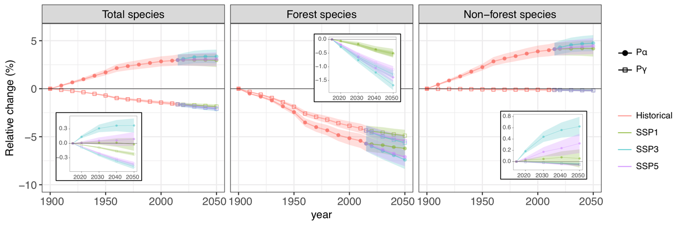
Fig. 1. Past (1900-2015) and future (2015-2050) global trends in alpha diversity ($P_{α}$; points) and gamma diversity ($P_{γ}$; squares) of different bird species groups (i.e., total bird species, forest bird species and non-forest bird species). Plots represent the relative change (%) in species richness of each species group at different time steps between 1900 and 2050, while inset figures show the relative change between 2015 and 2050 alone for both alpha and gamma diversity. The displayed ribbons are 95% CIs derived from different model runs (100 for each scenario). Future projections represent three alternative scenarios of land-use change as described in the main text: environmental sustainability (SSP1), regional rivalry (SSP3), fossil-fuelled development (SSP5). See supplementary table (Sx) and (Sxx) for all estimates with 95% confidence intervals for all time steps.

Fig. 2. Past (1900-2015) and future (2015-2050) local changes in alpha diversity ($P_{α}$) of different bird species groups. Forest bird species are shown on the left panel (a-d) and non-forest bird species on the right panel (e-h). Maps represent the absolute change (sp) per year in species richness of each species group associated with a given grid cell. Future projections represent three alternative scenarios of land-use change as described in the main text: environmental sustainability (SSP1), regional rivalry (SSP3), fossil-fuelled development (SSP5). Gray areas represent terrestrial areas with no change or insufficient data. The color scale is based on quantile intervals when considering all maps features.

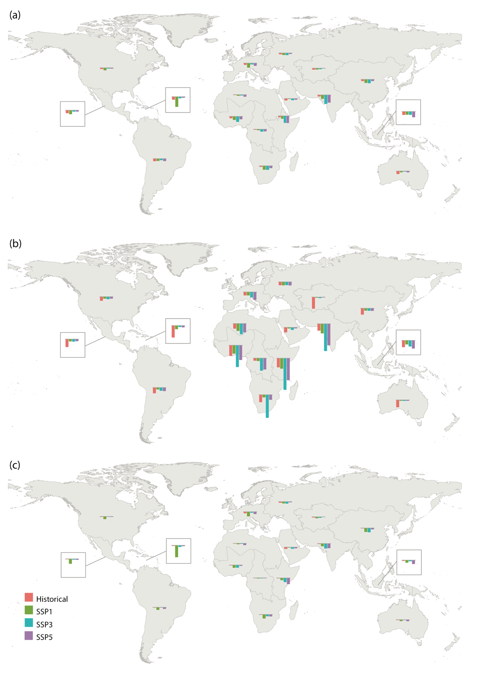
Fig. 3. Past (1900-2015) and future (2015-2050) regional trends in gamma diversity ($P_{γ}$) of different bird species groups. For (a) total bird species, (b) forest bird species and (c) non-forest bird species. The barplots in the maps show the per year relative change (%) standardized by the absolute maximum value. Future projections represent three alternative scenarios of land-use change as described in the main text: environmental sustainability (SSP1), regional rivalry (SSP3), fossil-fuelled development (SSP5).

Supplementary tables

Table S1. Reclassification of LUH2 land cover classes into five land use classes to project biodiversity change until year 2090.
LUH2 original states | LUH2 reclass
Forested primary land | Primary vegetation
Non-forested primary land | Primary vegetation
Potentially forested secondary land | Secondary vegetation
Potentially non-forested secondary land | Secondary vegetation
Managed pasture | Pasture
Rangeland | Pasture
C3 annual crops | Cropland
C3 perennial crops | Tree plantations
C4 annual crops | Cropland
C4 perennial crops | Tree plantations
C3 nitrogen-fixing crops | Cropland

Table S2. Local sensitivities (sigma) for each LUH2 land cover
(see excel)
Table S3. Number bird species in each IPBES sub-region of the World
IPBES region | IPBES sub-region | Forest | Non-forest | All
Africa | Central Africa | 203 | 1069 | 1272
Africa | East Africa and adjacent islands | 257 | 1392 | 1649
Africa | North Africa | 23 | 706 | 729
Africa | Southern Africa | 124 | 1061 | 1185
Africa | West Africa | 137 | 786 | 923
Americas | Caribbean | 149 | 539 | 688
Americas | Mesoamerica | 478 | 880 | 1358
Americas | North America | 185 | 559 | 744
Americas | South America | 1336 | 1832 | 3168
Asia-Pacific | North-East Asia | 287 | 942 | 1229
Asia-Pacific | Oceania | 555 | 930 | 1485
Asia-Pacific | South-East Asia | 1063 | 1364 | 2427
Asia-Pacific | South Asia | 229 | 1030 | 1259
Asia-Pacific | Western Asia | 22 | 424 | 446
Europe-Central Asia | Central and Western Europe | 36 | 443 | 479
Europe-Central Asia | Central Asia | 29 | 380 | 409
Europe-Central Asia | Eastern Europe | 57 | 500 | 557

Supplementary figures

Fig. S1. Global trends in land-use change for the five land use classes considered, from 1900 to 2050. Plots represent the relative change of the area of each land use class across all grid cell. Future projections, from year 2015 to 2050, represent three alternative scenarios of land-use change as described in the main text: environmental sustainability (SSP1), regional rivalry (SSP3), fossil-fuelled development (SSP5).

Fig. S2. Alpha species richness of (a) forest bird species and (b) non-forest bird species per 1 degree grid cell. Unit: number of bird species.

Fig. S3. Scheme exemplifying how the relative and absolute changes in both alpha, or $P_{α}$, and gamma, or $P_{γ}$, diversity of birds species were calculated. (a) Diversity changes were calculated at three distinct spatial scales: global, regional (i.e., IPBES sub region level) and local (1 degree grid cell). (b) At each sampling scale and time-step we projected biodiversity change 100 times (i.e., run of the cSAR model), each time calculating the $h_{ij}$ values of the different species group to the different land-use types from sensitivity values randomly picked from the full dataset (Table S2). (c) To calculate regional and global $P_{α}$ changes we carry an additional middle step where we averaged the cell projections of each model run at the relevant scale. (d) The projections of different simulations for different time steps were then averaged and the mean and the 95% CI values retrieved for each sampling at each scale were considered. All results can be found in supplementary tables (S4-S11).

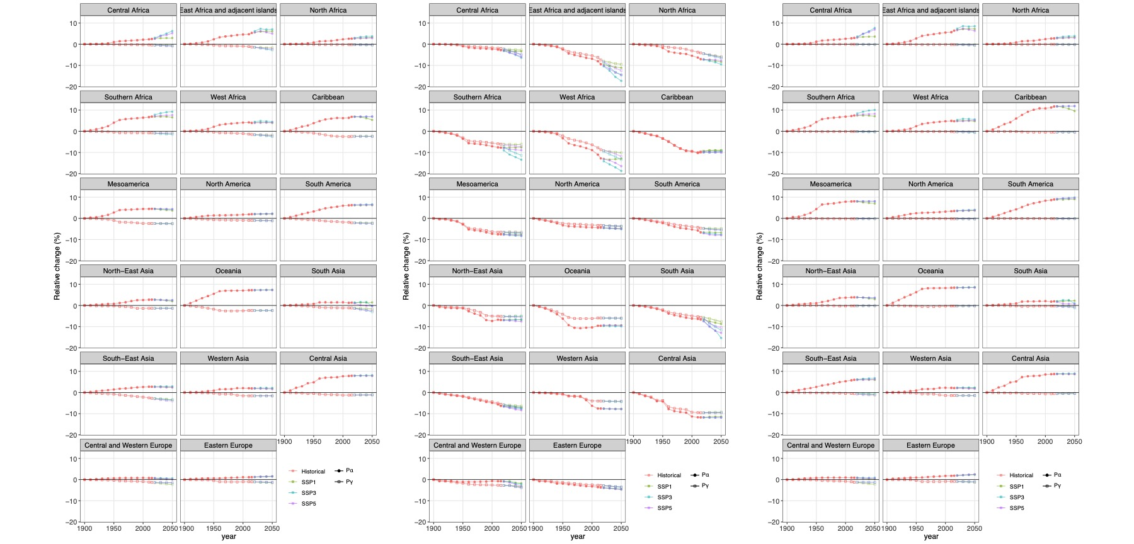
c)
b)
a)

Fig. S4. Past (1900-2015) and future (2015-2090) regional trends in alpha diversity ($P_{α}$; points) and gamma diversity ($P_{γ}$; squares) of different bird species groups. For a) total bird species, b) forest bird species and c) non-forest bird species. Plots represent the relative change (%) in species richness of each species group. Future projections represent three alternative scenarios of land-use change as described in the main text: environmental sustainability (SSP1), regional rivalry (SSP3), fossil-fuelled development (SSP5). All $P_{α}$ and $P_{γ}$values and their 95% confidence intervals (resulting from 100 model runs per scenario) for relative change (%) and absolute change (sp) can be found in supplementary tables (Sx) and (Sxx), respectively.
Fig. Sxx. Local change in alpha diversity ($P_{α}$) of the different bird species groups from 1900 to present day. For (a-d) total bird species, (e-h) forest bird species and (i-l) non-forest bird species. Maps represent the relative change (%) per year in species richness of each species group associated with a given grid cell. Future projections represent three alternative scenarios of land-use change as described in the main text: environmental sustainability (SSP1), regional rivalry (SSP3), fossil-fuelled development (SSP5). Gray areas represent terrestrial areas with no change or insufficient data. Color scale is based on quantile intervals when considering all maps features.

