Goal

The objective is to collect 10 coins. But you will need to make some changes to the game to be able to collect them all!

Task 1

The first coin is just to your right. Unfortunately, you can only move left at the moment with the left arrow key.

To collect the coin you will need to add code to detect the right arrow key and change the players x velocity.

Velocity just means speed with a direction:

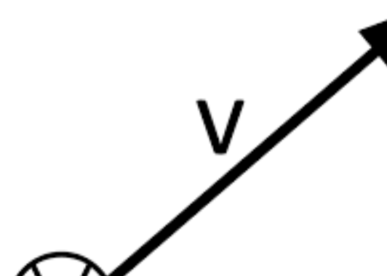

A positive x velocity means an object is moving to the right. A negative x velocity means the object is moving to the left.

Steps

- Open the keyboard.js file.
- Find the code for moving the player to the right:

- if (keyIsDown(LEFT_ARROW))
- {
- player.velocity.x = -3;
- }

- Copy and paste the code below on line 10.
- Change the code so the it detects the right arrow key and sets the velocity to 3.

Task 2

Good job on collecting the first coin. The second coin is on a platform. You can jump using the space bar. Try collecting the now.

You probably noticed that you can't jump high enough. So let us make the character jump higher.

Steps

- In keyboard.js find the code block that checks if the up arrow or space bar is pressed:

// 32 is space bar
if ((keyIsDown(32)) && player.isInAir === false)
{
player.velocity.y = -6;
player.isInAir = true;
}

- Change the y velocity to -5. Here a negative y value points up the screen. This is because computers use grid coordinates where positive y points down:

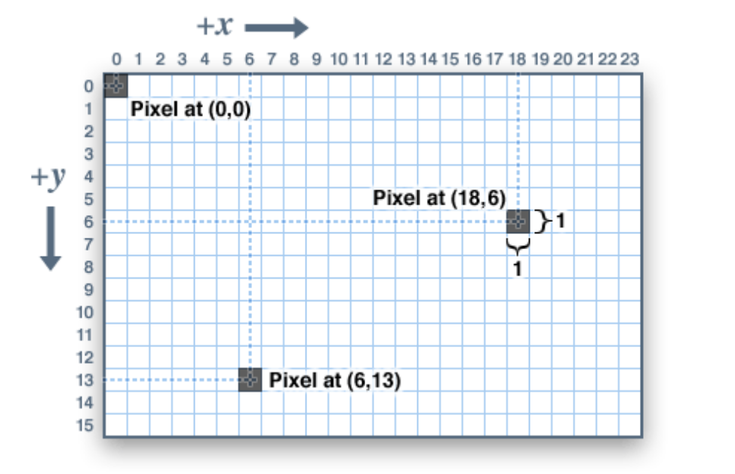

Task 3

Nice work, you now have the first two coins. The third coin is hovering in the air. To reach this one we will place a platform in the game.

Steps

- Open world.js.
- Copy the line for creating the current platform and paste it beneath the existing one:

platforms.push(new Platform(1500, 700, 200, 20));

Here platforms is a list of all of the platforms in the game. And we are adding (or pushing) a new platform to the list.
The numbers have special meanings and represent the following:

First number (1500): The x co-ordinate of the platform.
Second number (700): The y co-ordinate of the platform.
Third number (200): The width of the platform in pixels.
Fourth number (20): The height of the platform in pixels.

- Now place a platform at the following position:

x: 1800
y: 600

Give the platform the following width and height:

width: 100
height: 30

Task 4

That's 3 coins in the bag now. To collect the next coin we will be using a different type of platform that can move.

Steps

- Under the line for the previous platform, type the following code in:

platforms.push(new MovingPlatform(350, 600, 150, 20, 100, 2, 'HORIZONTAL'));

- This new platform is called a MovingPlatform. It takes the following parameters (or settings):

1st parameter: The x co-ordinate of the platform.
2nd parameter: The y co-ordinate of the platform.
3rd parameter: The width of the platform.
4th parameter: The height of the platform.
5th parameter: The range (or distance) the platform moves.
6th parameter: The speed the platform moves in pixels/frame.
7th parameter: The direction the platform moves in.
This can be 'HORIZONTAL' or 'VERTICAL'.

- Create a moving platform that has the following properties:

x co-ordinate: 2000
y co-ordinate: 600
width: 100
height: 20
range: 200
speed:2
direction: 'HORIZONTAL'

