**Experiment No: 06**

Name: Suraj P. Patil Roll: 4120

Class: B.Tech URN: 20131086

Div: B Date: 16-09-2023

**Steps to Follow:**

1. Logging to AWS Account
2. Create Web Server By Using Bootstrap Commands
3. Verify content of Web Server in Browser

**1. Logging to AWS Account**

First, we need to AWS Console page by using below link.

<https://aws.amazon.com/console/>

Click on ***sign in to Console*** button.

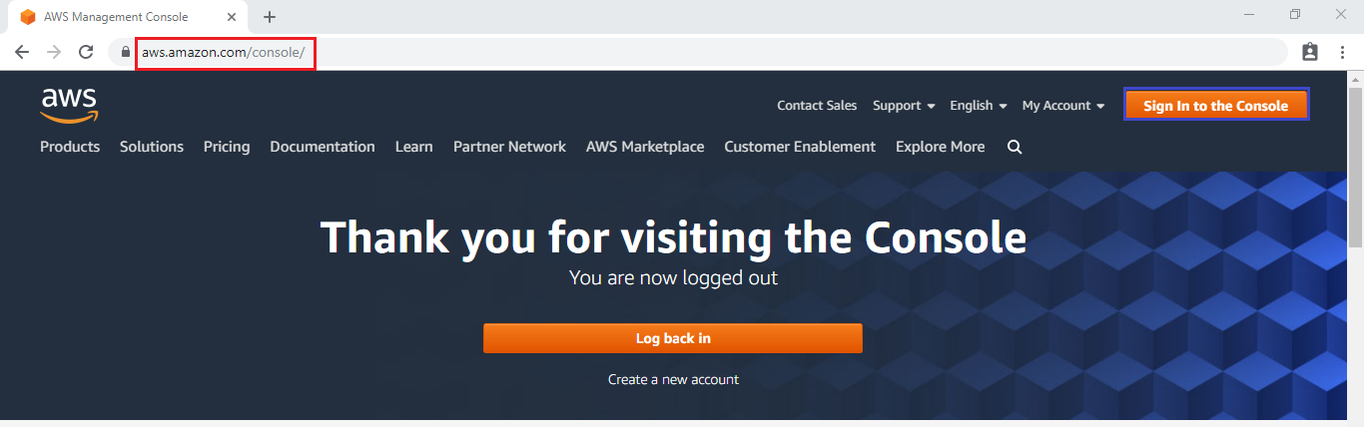

**Logging to aws account**

Login using username & password and click on ***sign in*.**

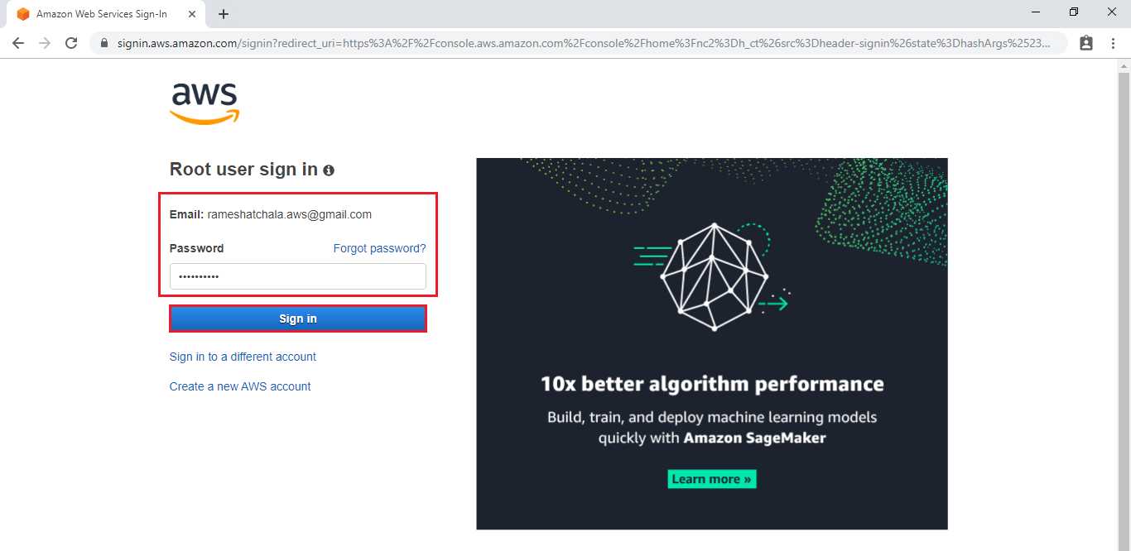

**Enter to AWS Management Console**

We can see the AWS Management Console Dashboard.

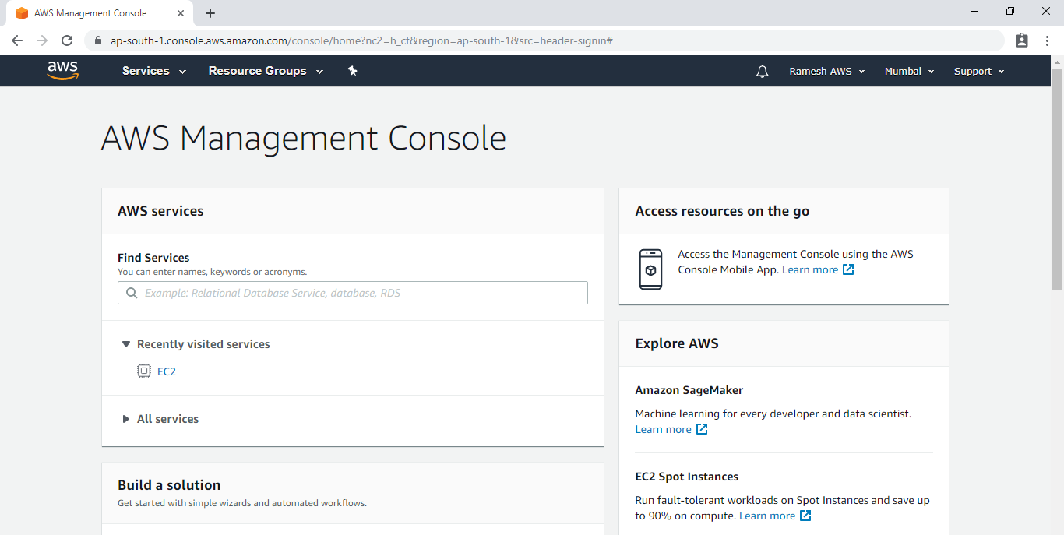

Go to Services, under the compute module click ***EC2*** service to open.



**2. Create Web Server By Using Bootstrap Script**

Go to Services, under the compute module click ***EC2*** service to open.

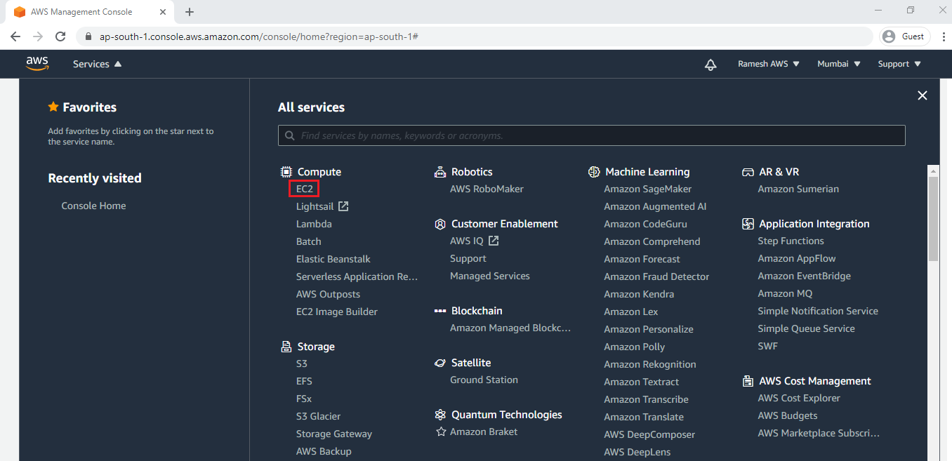

Click on ***Launch Instance.***

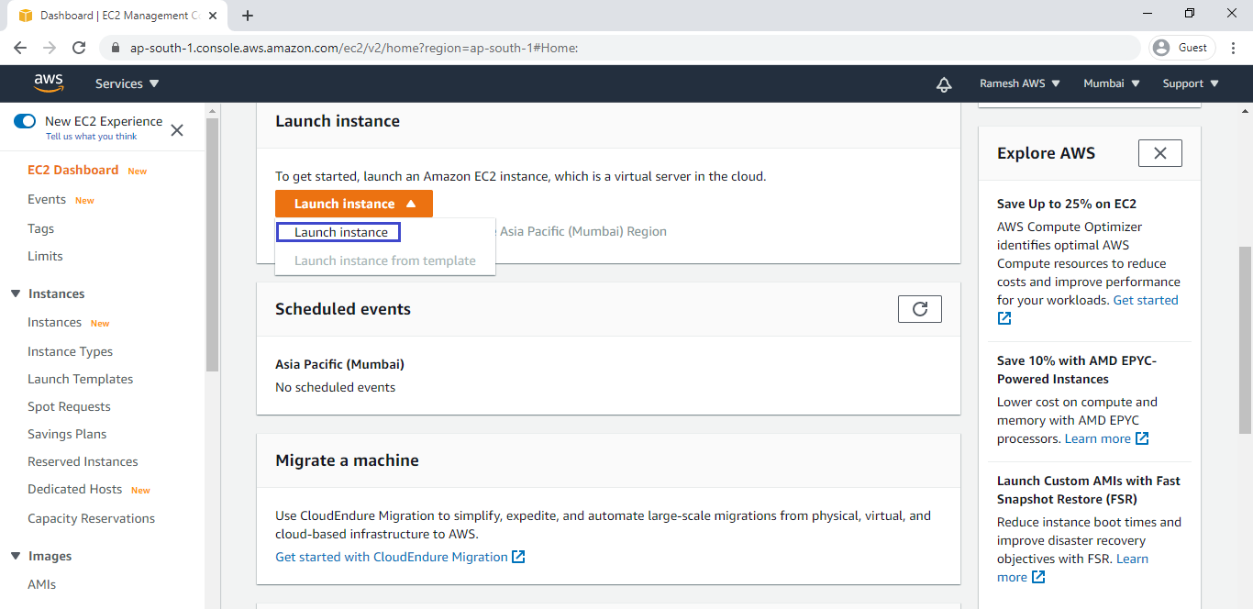

**Choose an Amazon Machine Image (AMI)**

Select the Operating system of the EC2 instance by choosing any of the Amazon Machine Images (AMI). Select the Microsoft Windows Server.

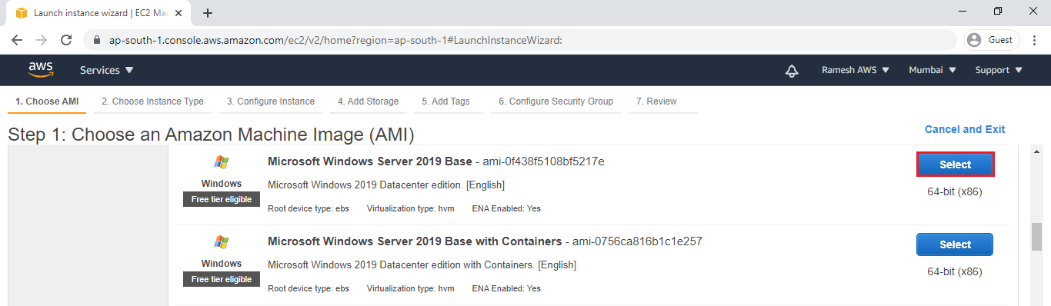

**Choose an Instance type**

Choose the Type of instance depending on your requirements.

Instance types comprise of varying combinations of CPU, memory, storage, and networking capacity.

select the default option of *t2. micro –*this instance type is covered within the free tier. Then click on ***Configure Instance Details.***

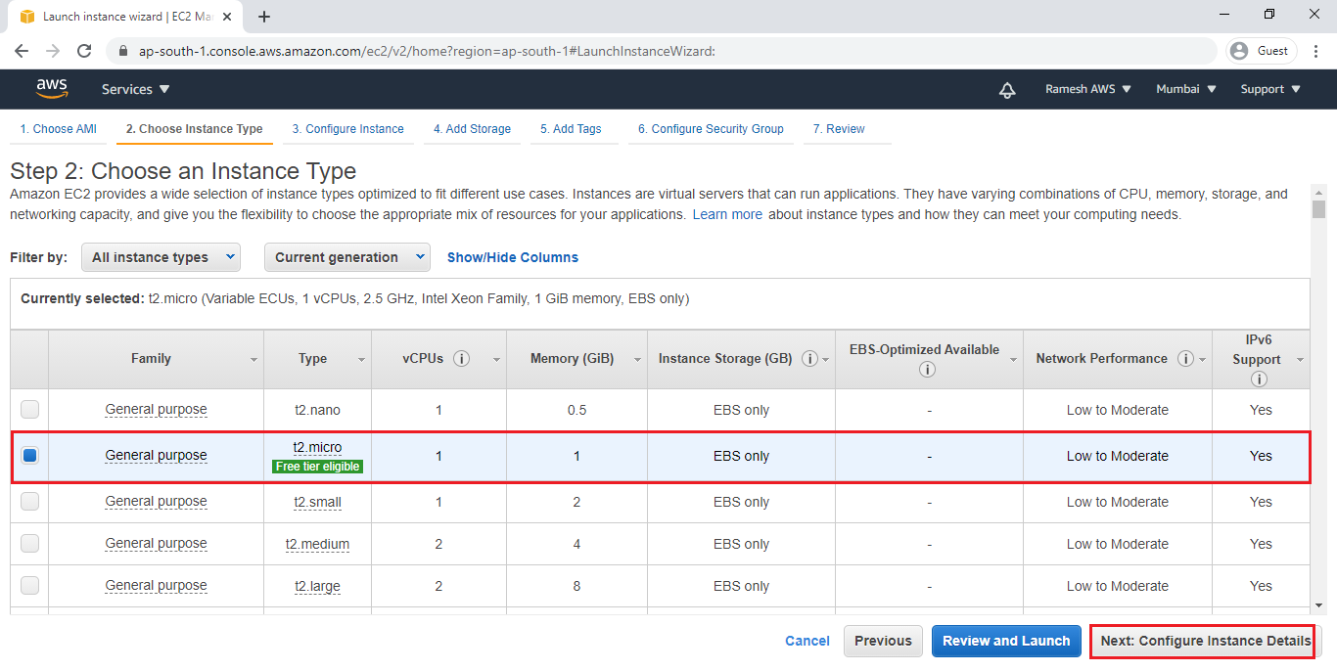

**Configure Instance Details**

Configure EC2 instance details as per requirements of your environment and click on ***Add Storage.***

Choose the Type of instance depending on your requirements.

Instance types comprise of varying combinations of CPU, memory, storage, and networking capacity so you can choose the appropriate mix for your applications.

select the default option of *t2.micro –*this instance type is covered within the free tier. Then click on Configure Instance Details.

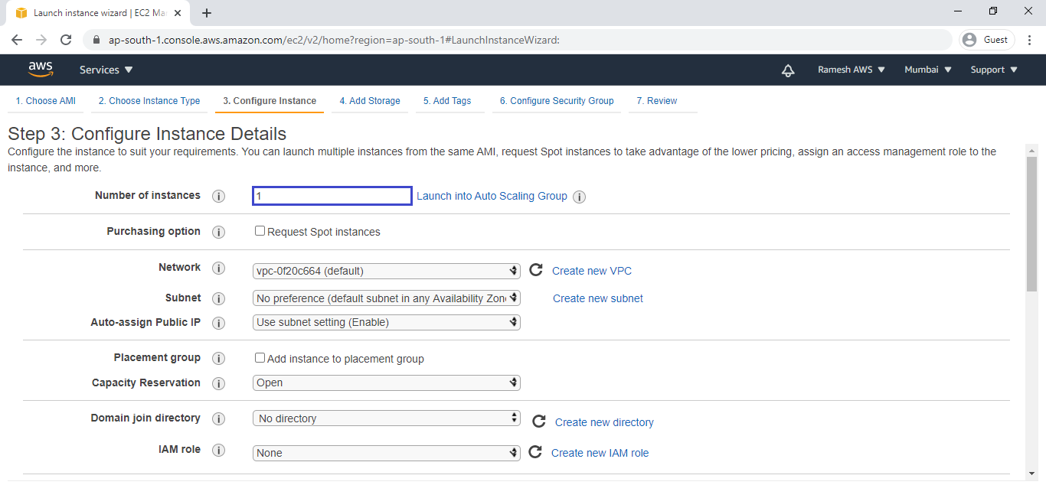

Go to Advanced Details and type commands for bootstrapping in user data.

**The Script is**

|  |  |
| --- | --- |
| 1  2  3  4 | <powershell>  Install-WindowsFeature -name Web-Server -IncludeManagementTools  New-Item -Path C:\inetpub\wwwroot\index.html -ItemType File -Value "KTExperts is a knowledge Sharing Platform" -Force  </powershell> |

Click on ***Add Storage***.

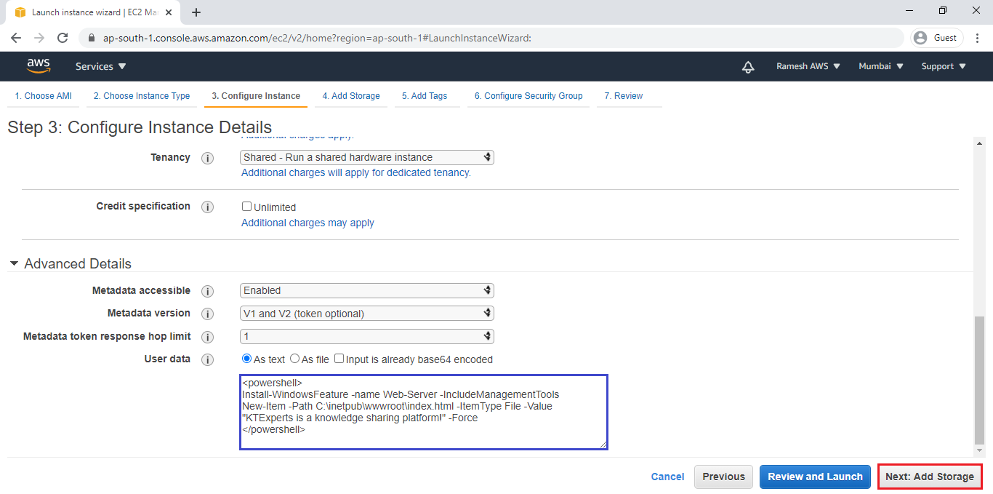

**Add Storage**

Here, we can see root volume by default and size of 8GB

Add a new volume if required

Click on ***Add Tags.***

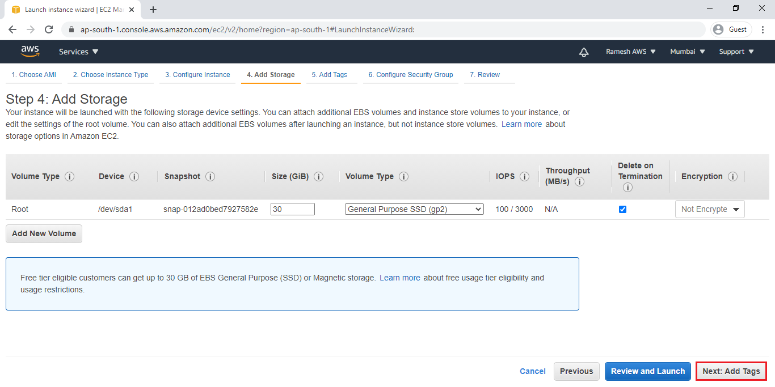

**Add Tags**

Tags assist in easier identification and classification of the various instances in your AWS environment.

Click on ***click to add a Name tag***to provide name for our server.

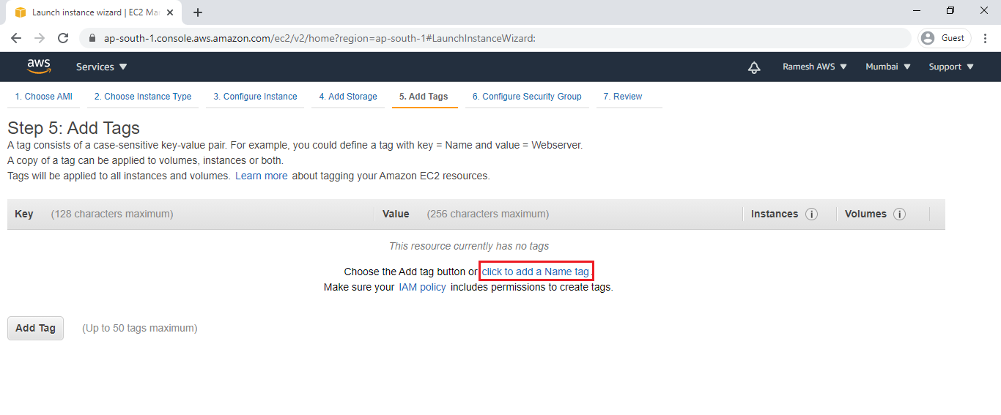

Provide the name for the ec2 instance for easier understanding and click on ***Configure Security Groups.***

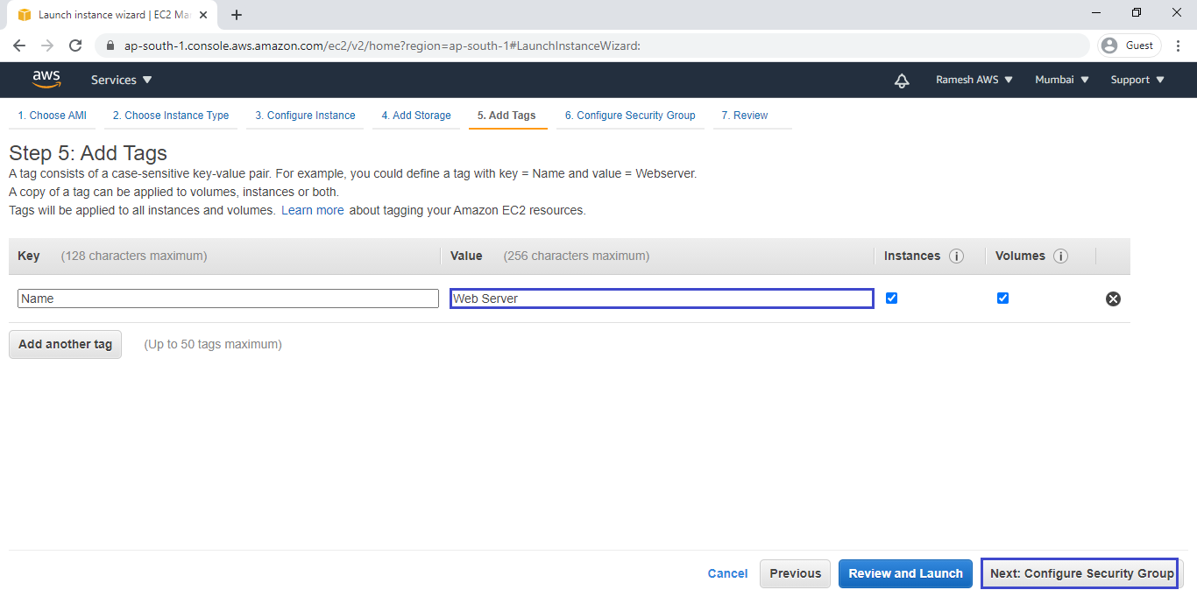

**Configure Security Group**

A security group allows configuring firewall rules to allow traffic as needed.

RDP Is enough to connect to our Windows Server and HTTP is for accessing Web Server and click on ***Review and Launch.***

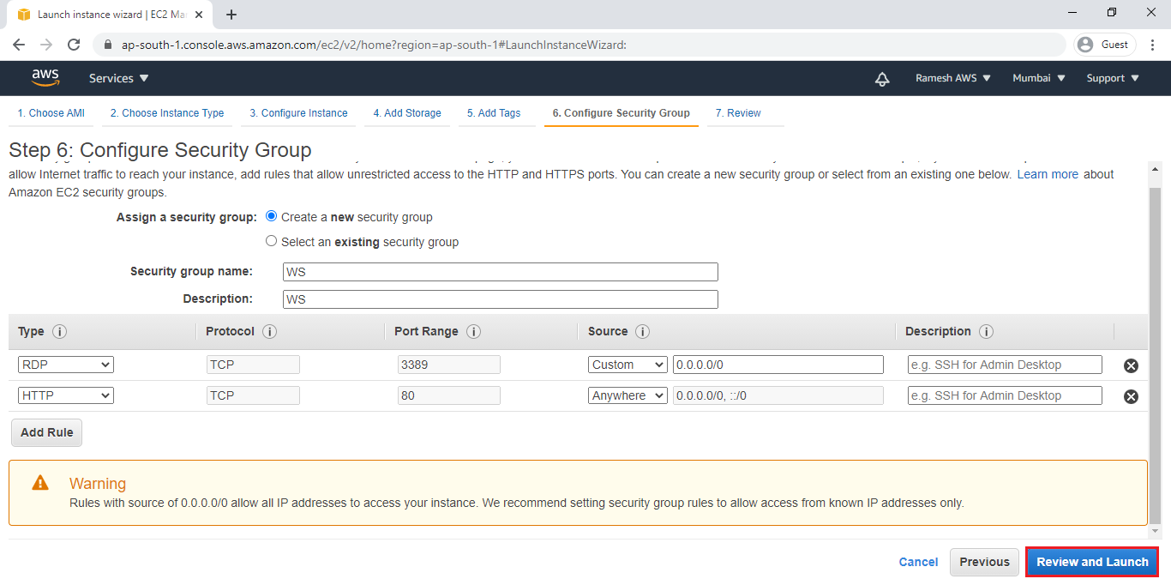

**Review Instance Launch**

Review and confirm the configuration of the instance. Click on the Edit button on each configuration item to make changes and click on ***Launch***.

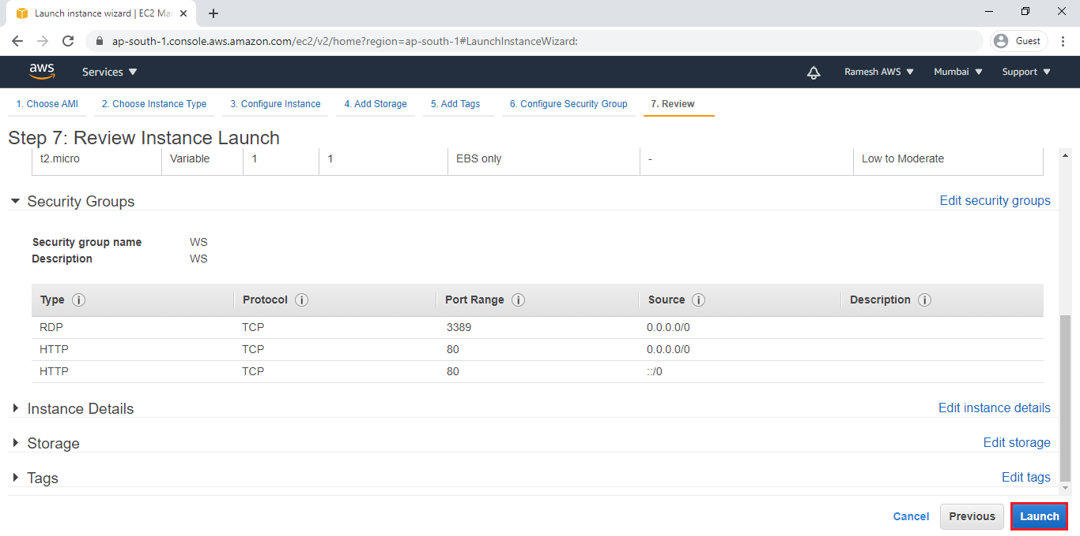

***Choose existing Key Pair and Launch Your Instance***

To connect to your webserver, you need a key pair. A key pair is used to log into your instance and select existing key pair.

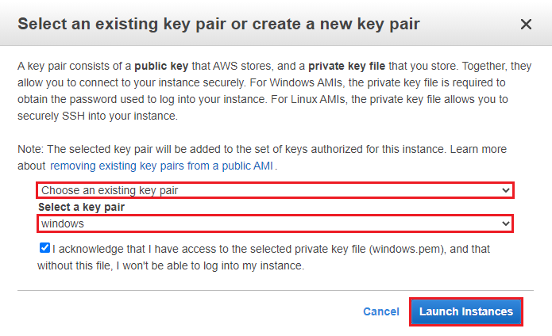

click on View Instances to view the instance you have just created and see its status.

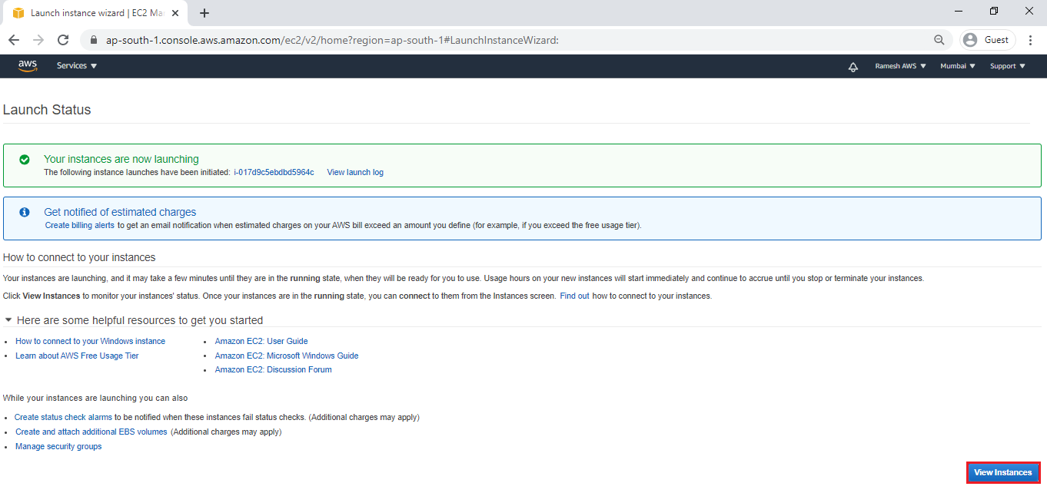

We can see the instance “Web Server” has been created successfully.

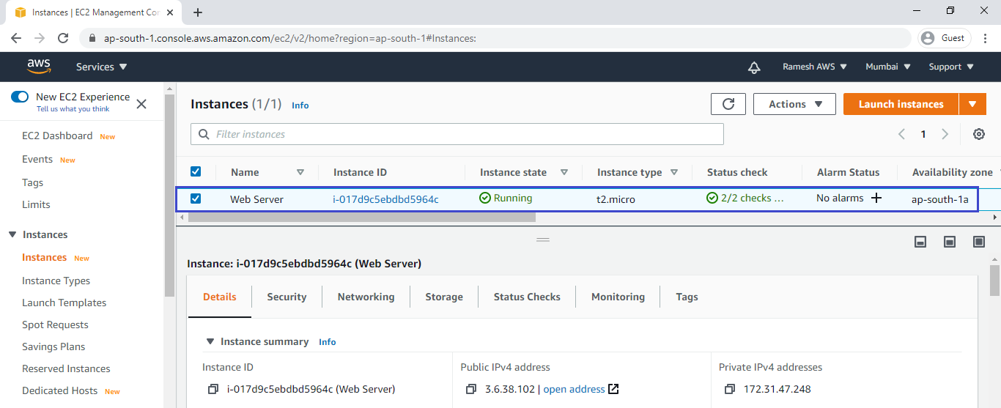

**3. Verify content of Web Server in Browser**

Copy public IP of webserver as shown below.

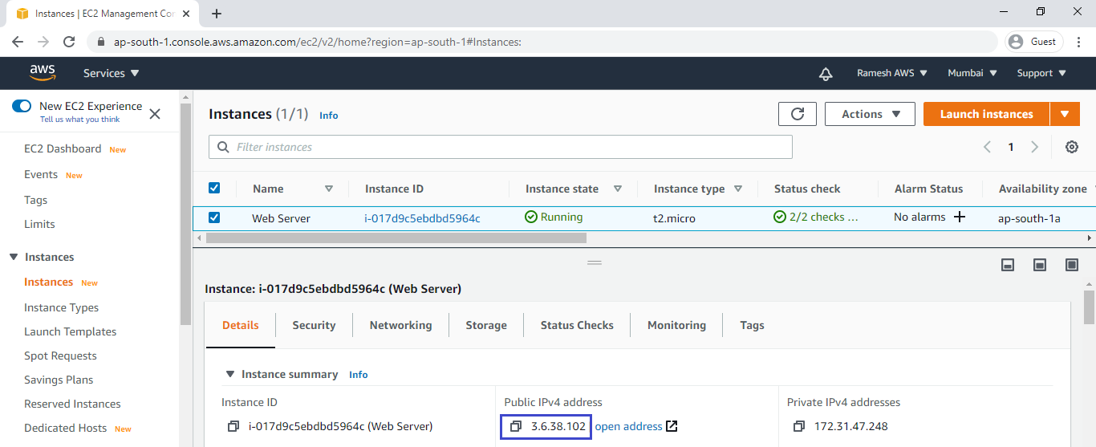

Search Public IP of Web Server which was copied.