**Experiment No: 08**

Name: Suraj P. Patil Roll: 4120

Class: B.Tech URN: 20131086

Div: B Date: 16-09-2023

# Steps for creating IAM users & making instances

Step1: Go to AWS console Home

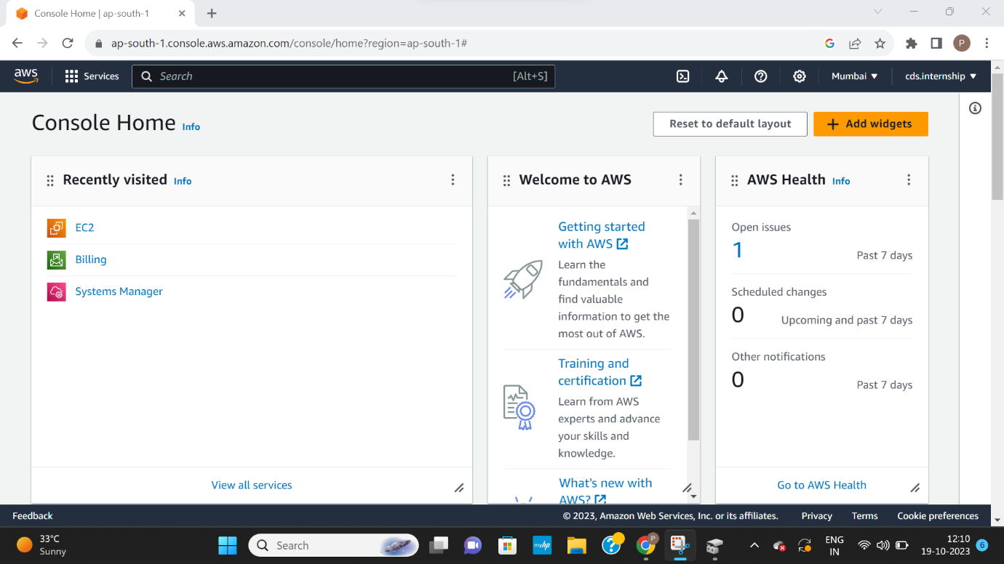

Step 2: Search & Select IAM Services.

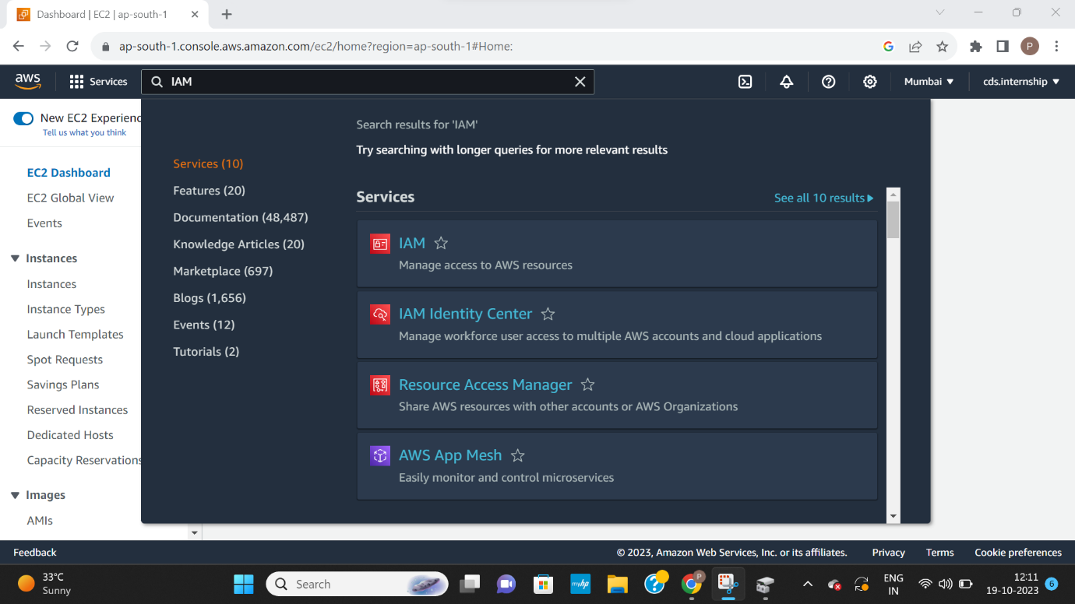

Step 3: Create users.

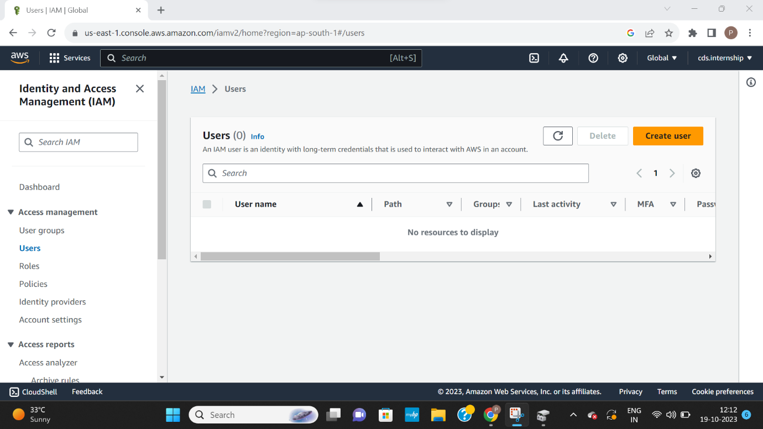

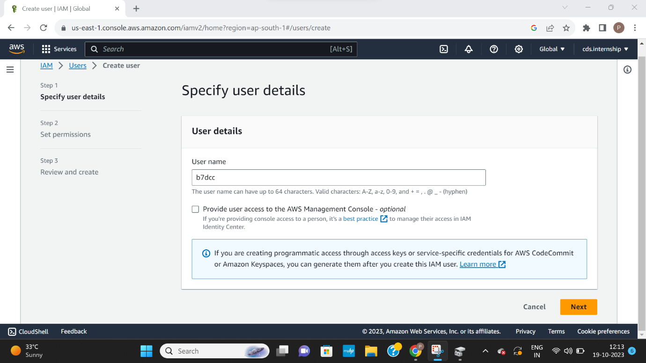

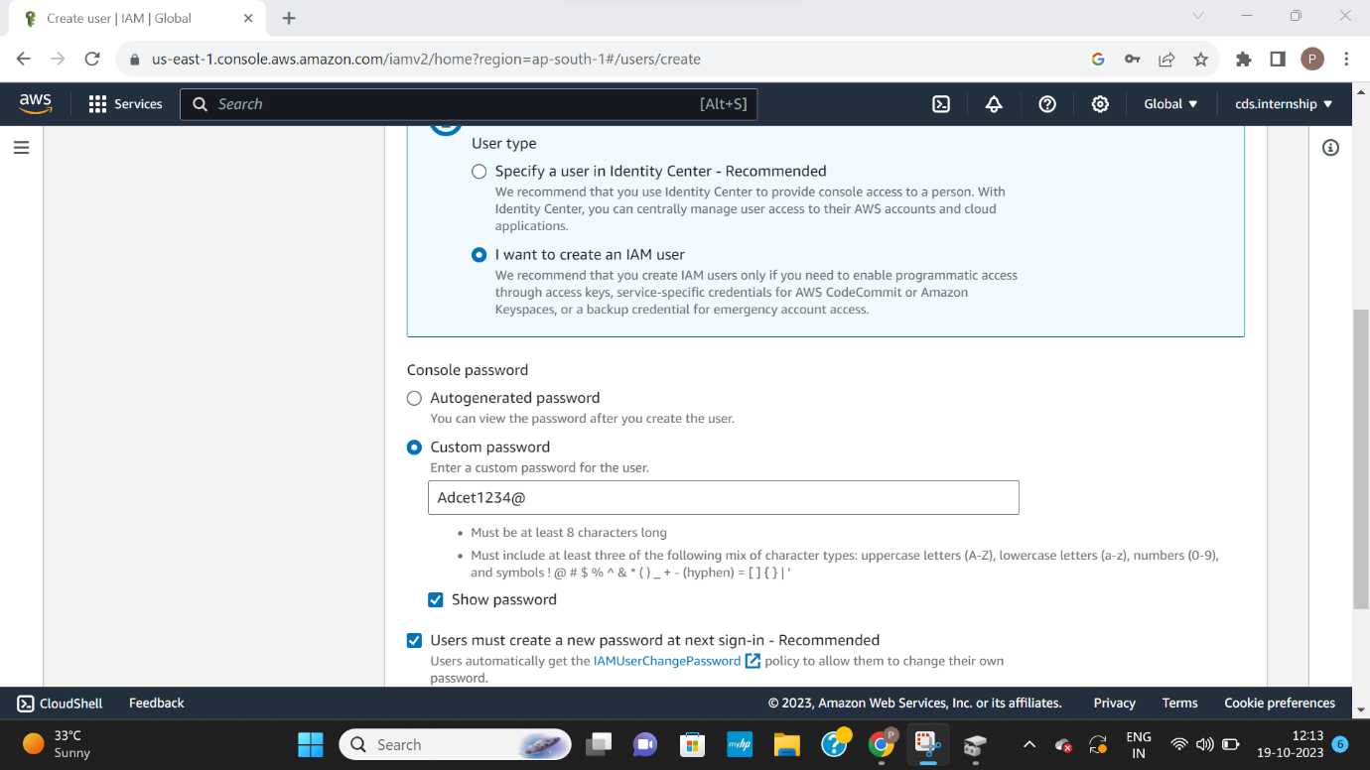

Step 4: Add users to an existing group using groups Set & manage user’s permissions

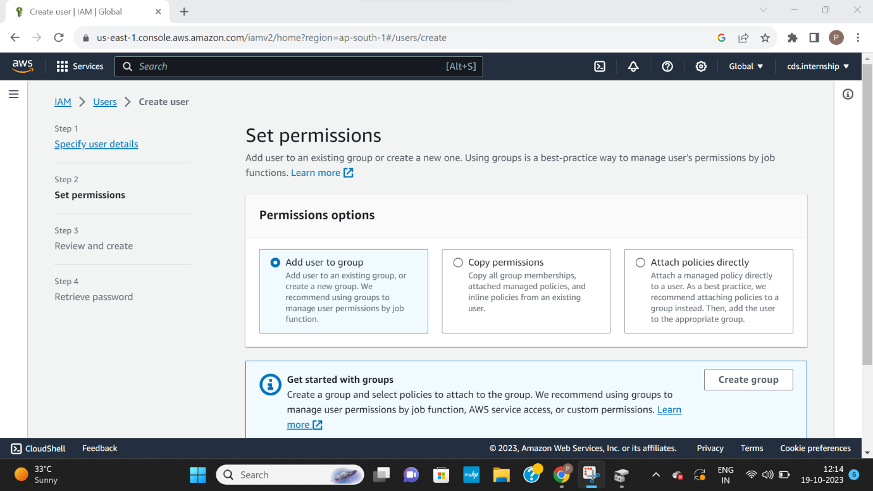

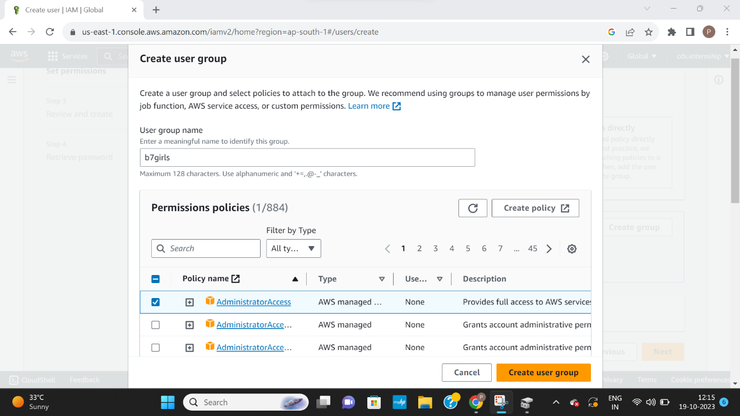

Step 5: successfully user group created.

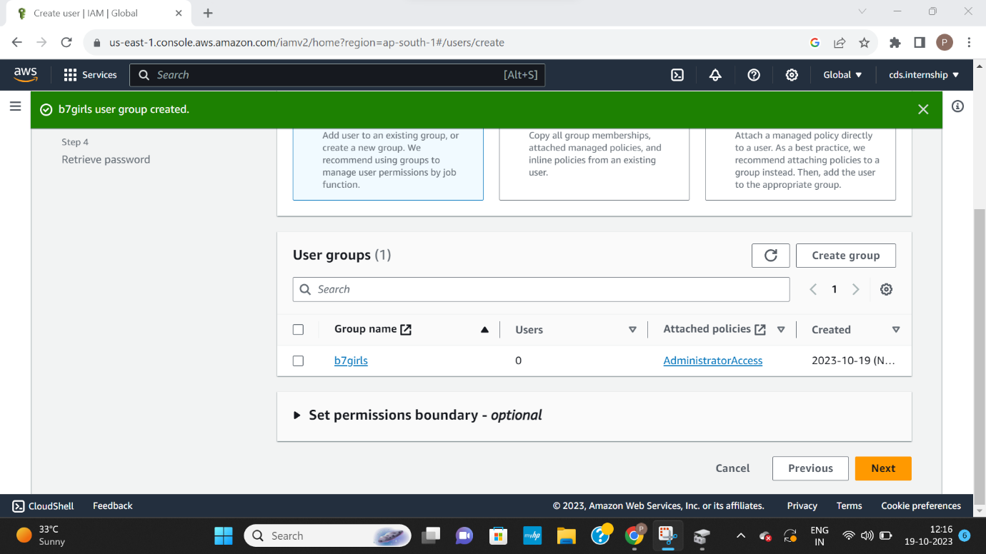

Step 6: successfully user created.

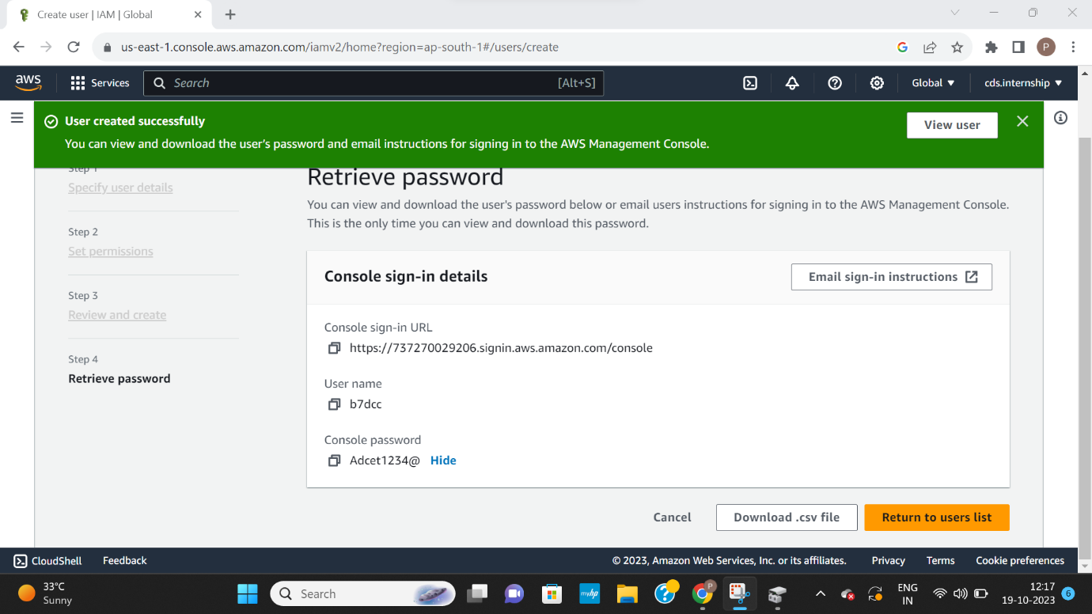

Step7: sign in as IAM user

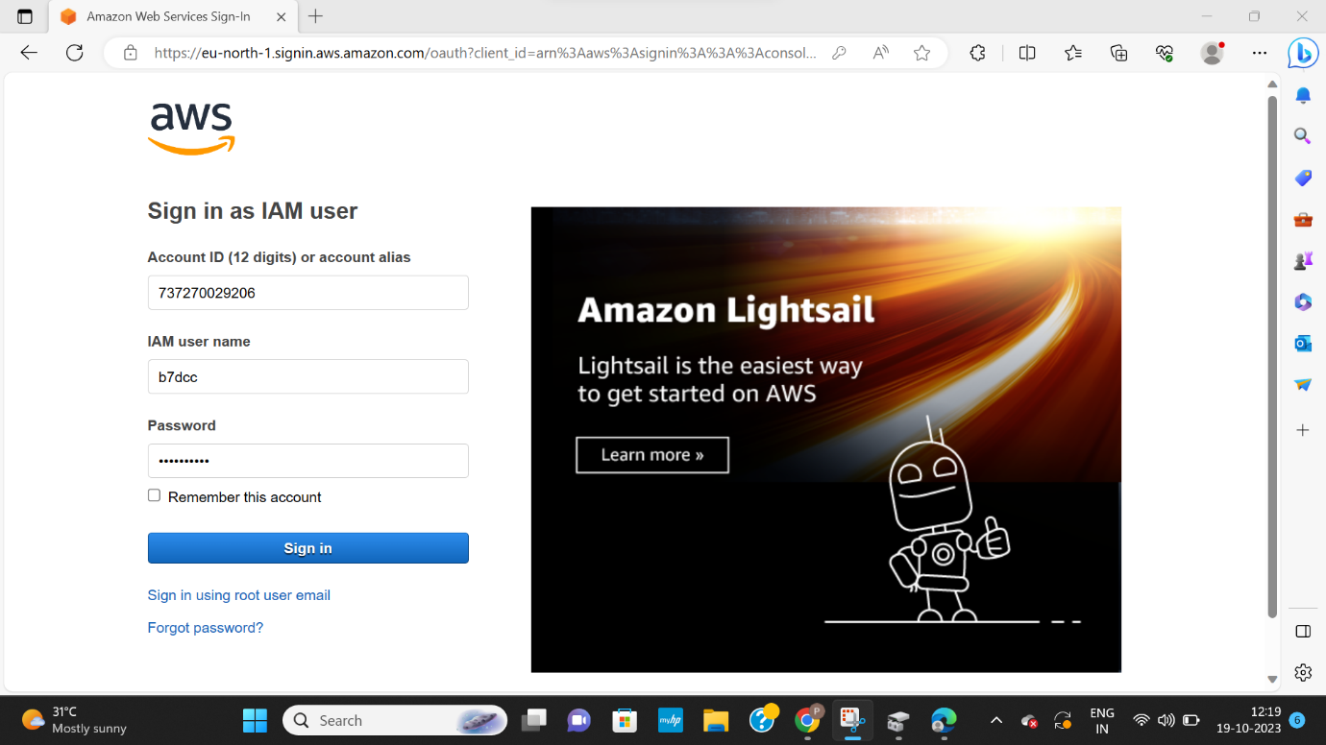

Step8 : Access IAM service

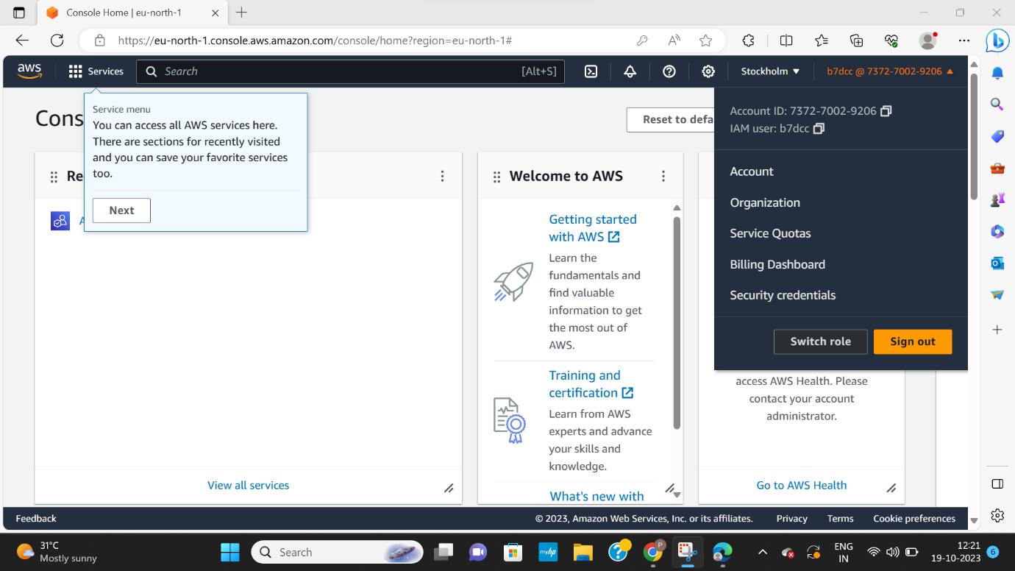

Step 9: Create policy

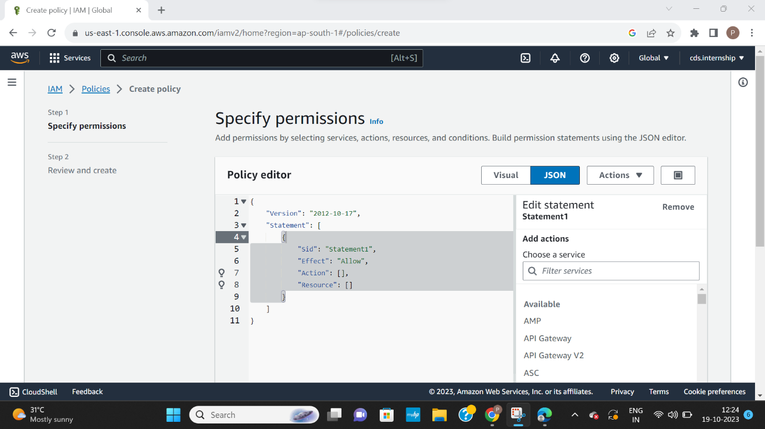

Step 10: add user to group.

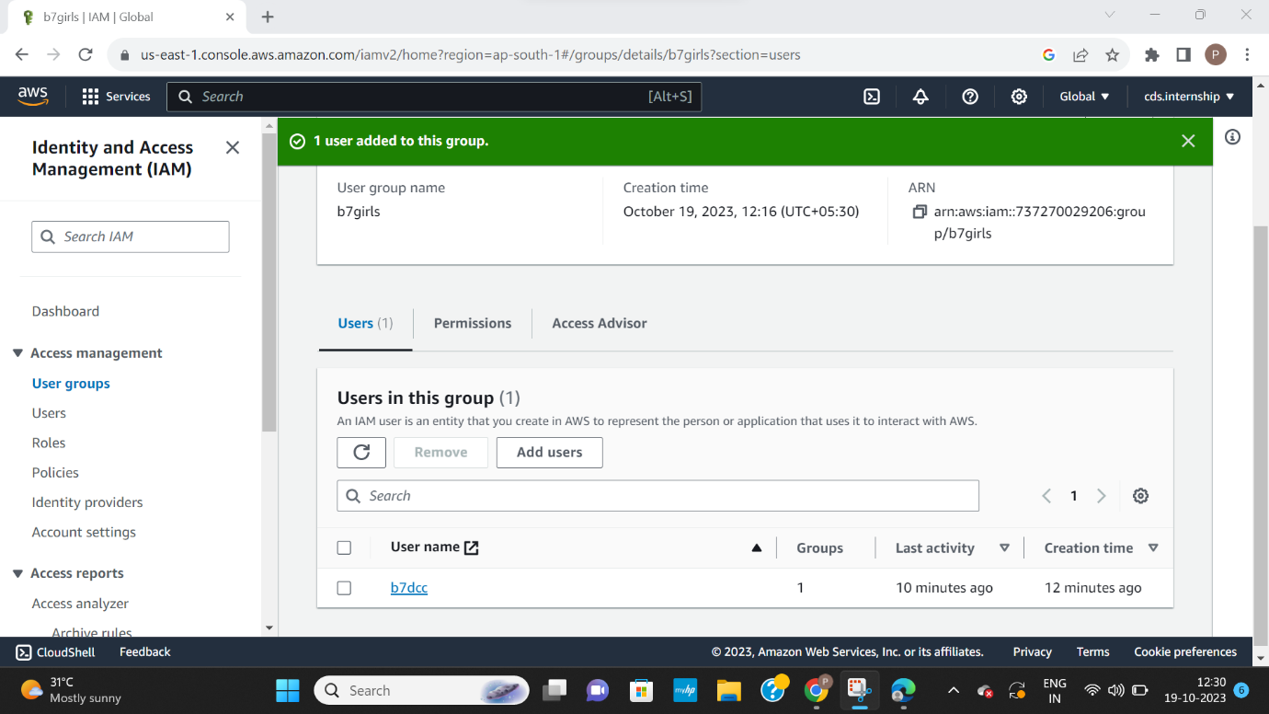

Step 11: Now a user group is a collection of users. use groups to specify permission’s for a collection of users.

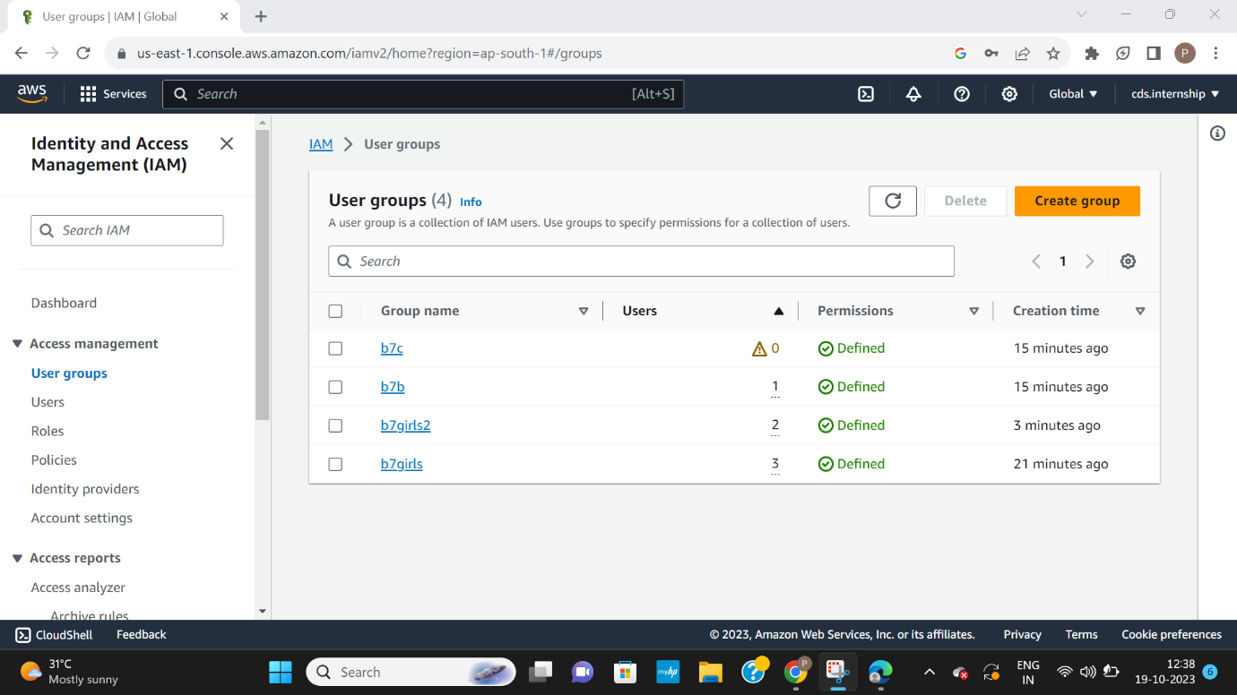

Step 12: Assign permissions policies to groups.

