Heart Disease Risk Prediction
An End-to-End MLOps Pipeline
From Experiment Tracking to Kubernetes Deployment and Monitoring
Machine Learning Operations (MLOps) — AIMLCZG523
Assignment 01 — End-to-End ML Model Development, CI/CD, and Production Deployment
BITS Pilani Work Integrated Learning Programme (WILP)
Name : Aditya Chowdhury
BITS ID : 2024AD05010
BITS Email : 2024ad05010@wilp.bits-pilani.ac.in

1. Introduction & Objective
For this assignment I set out to build a complete, production-style MLOps pipeline rather than just a notebook that trains a model. The brief asked for a classifier that predicts heart disease risk from patient health data, deployed as a cloud-ready, monitored API — so I treated it as a small end-to-end system: data pipeline, experiment tracking, automated testing, containerization, orchestration, and monitoring, all wired together and actually run, not just described.
I used the Heart Disease UCI (Cleveland) dataset as required, and built the system in layers: first I got the modelling right in a Jupyter notebook (EDA, feature engineering, two tuned classifiers, MLflow tracking, model packaging), and then I built everything around that model — a FastAPI serving layer, a Docker image, a CI/CD pipeline in GitHub Actions, Kubernetes manifests for local deployment, and a Prometheus/Grafana monitoring stack. Every piece in this report was actually run on my machine; the screenshots throughout are from my own terminal, browser, and Docker Desktop, not mocked up.

2. Dataset
I used the Cleveland subset of the UCI Heart Disease dataset, pulled directly from the UCI Machine Learning Repository. It has 303 patient records and 14 columns — 13 clinical features (age, sex, chest pain type, resting blood pressure, cholesterol, fasting blood sugar, resting ECG, max heart rate, exercise-induced angina, ST depression, slope of the ST segment, number of major vessels, and thalassemia) plus the target label.
The raw file has no header row and encodes missing values as ‘?’, so I assigned column names myself and converted ‘?’ to NaN before doing anything else. I found 4 missing values in the ca column and 2 in thal, which I imputed using the column median — a safe choice since both columns are near-categorical with a small number of discrete levels, so the median doesn’t introduce an unrealistic value the way a mean might.
The original target column has 5 severity levels (0–4). Following the standard convention for this dataset, I binarized it into ‘no disease’ (0) vs ‘disease present’ (1, covering severities 1–4), which gave me a reasonably balanced dataset: 164 records with no disease (54.1%) and 139 with disease (45.9%).
To make the data download itself reproducible, I didn’t just load a CSV — I wrote a download function that tries three sources in order: the direct UCI archive URL, the official ucimlrepo Python package, and a GitHub-hosted mirror as a last resort. This meant the notebook kept working for me even on a day when the UCI archive briefly returned a 403 error, since it silently fell back to the next source.

3. System Architecture
The diagram below is how I think about the whole pipeline: training happens once in the notebook, the packaged model flows into the API layer, and from there it either runs through Docker Compose (my local development / monitoring stack) or through Kubernetes (my production-style deployment target), while CI/CD independently verifies every piece on every push.

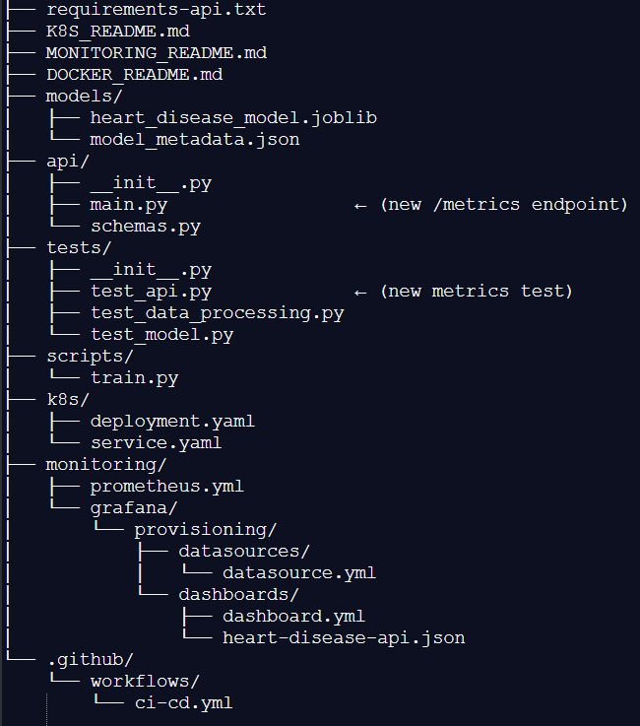
Project File Paths
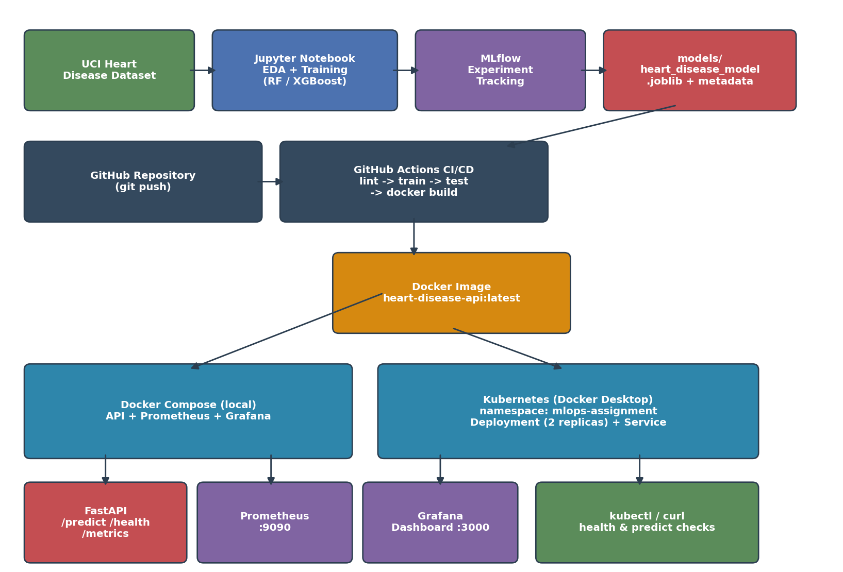
Figure 1: End-to-end pipeline — from data acquisition through CI/CD, containerization, orchestration, and monitoring.

4. Exploratory Data Analysis
Before building any model I looked at the class balance, the shape of each numeric feature, and how features relate to the target and to each other.

4.1 Class Balance
The target classes are close enough to balanced (54.1% / 45.9%) that accuracy remains a meaningful metric here, though I still tracked precision, recall, F1, and ROC-AUC throughout to avoid being misled by any residual imbalance.
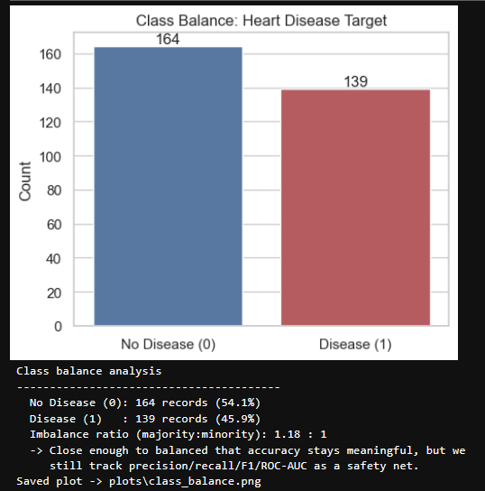
Figure 2: Target class distribution — 164 no-disease vs 139 disease records.

4.2 Feature Distributions
I plotted histograms for the five continuous features. Age is roughly bell-shaped and centered in the 50s–60s; resting blood pressure and cholesterol are both right-skewed with a handful of high outliers; max heart rate (thalach) is left-skewed, which makes clinical sense since it tends to decline with age and with disease severity; and oldpeak (ST depression) is heavily zero-inflated, with a long right tail for patients who show a strong exercise-induced ECG response.
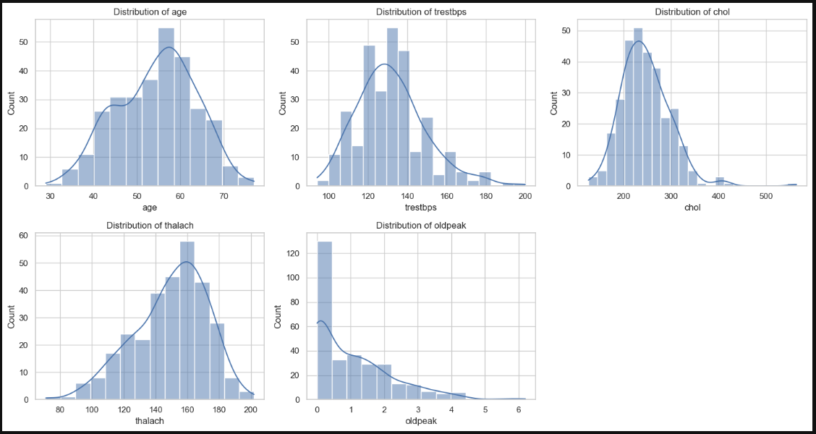
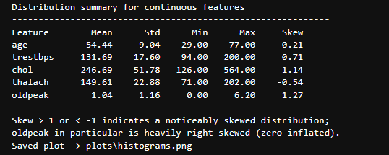
Figure 3: Distributions of the five continuous features.

4.3 Correlation Analysis
The correlation heatmap surfaced a few relationships I expected and one I found genuinely useful for feature engineering later: thal and ca correlate reasonably strongly with the target (0.52 and 0.46), as does oldpeak (0.42) and cp — chest pain type (0.41). Slope and oldpeak also correlate with each other (0.58), which told me they’re capturing related but not identical information about the exercise ECG response, so I kept both rather than dropping one.
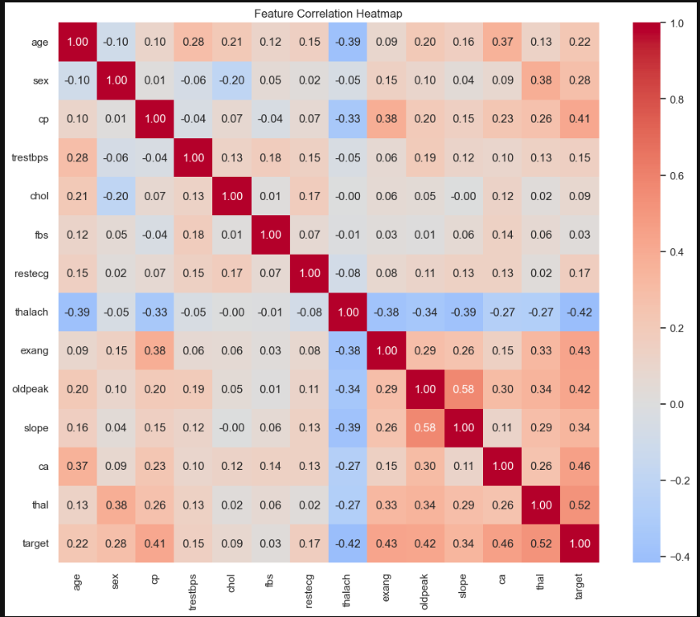
Figure 4: Feature correlation heatmap (Pearson).

4.4 Feature Relationships with the Target
Three relationships stood out as clinically sensible and statistically visible in the data: patients with disease skew slightly older, have a noticeably lower max heart rate under exercise, and are far more likely to report asymptomatic chest pain (cp = 4) rather than typical angina — which matches the well-known clinical pattern that asymptomatic presentation is actually a red flag for more serious underlying disease, not a reassuring sign.
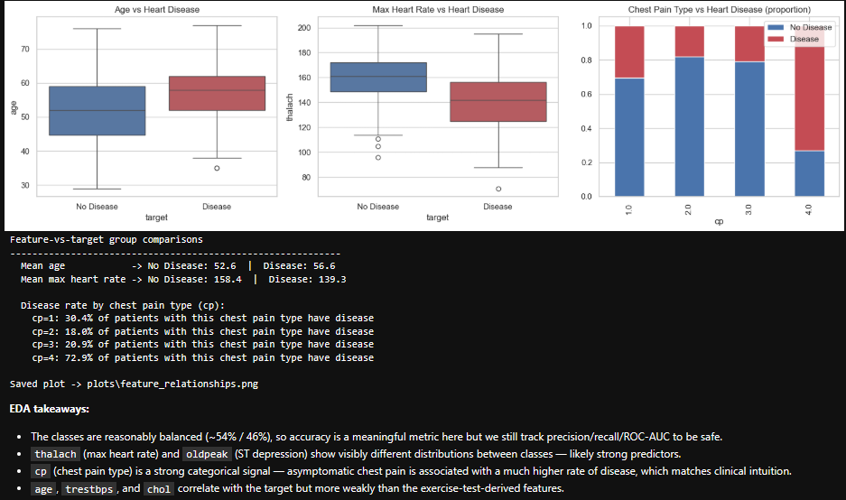
Figure 5: Age, max heart rate, and chest pain type vs. heart disease presence.

5. Feature Engineering & Model Development

5.1 Feature Engineering
I grouped the 13 features into three types and handled each differently inside a single ColumnTransformer, wrapped together with the classifier in one sklearn Pipeline:
- Continuous (age, trestbps, chol, thalach, oldpeak) — scaled with StandardScaler
- Nominal categorical (cp, restecg, slope, thal, ca) — one-hot encoded with OneHotEncoder
- Binary (sex, fbs, exang) — passed through unchanged
Keeping preprocessing inside the pipeline object, rather than as a separate step I’d have to remember to re-apply, was a deliberate reproducibility decision: the exact same transformation is guaranteed to run at inference time, so there’s no risk of train/serve skew once this is deployed behind an API.

5.2 Model Training & Tuning
I trained two classifiers as required — Random Forest and XGBoost — each tuned with GridSearchCV over 5-fold stratified cross-validation, optimizing ROC-AUC. For Random Forest I searched n_estimators ∈ {100, 200, 300}, max_depth ∈ {3, 5, 8, None}, and min_samples_leaf ∈ {1, 2, 4}. For XGBoost I searched n_estimators ∈ {100, 200, 300}, max_depth ∈ {3, 4, 5}, and learning_rate ∈ {0.01, 0.05, 0.1}.
Random Forest came out ahead on every metric on the held-out test set, so I selected it as the final model:
Model | Accuracy | Precision | Recall | F1 | ROC-AUC | Best CV ROC-AUC
Random Forest | 0.885 | 0.839 | 0.929 | 0.881 | 0.947 | 0.901
XGBoost | 0.869 | 0.857 | 0.857 | 0.857 | 0.920 | 0.873

Best hyperparameters found — Random Forest: max_depth=5, min_samples_leaf=2, n_estimators=200. XGBoost: learning_rate=0.01, max_depth=3, n_estimators=100.
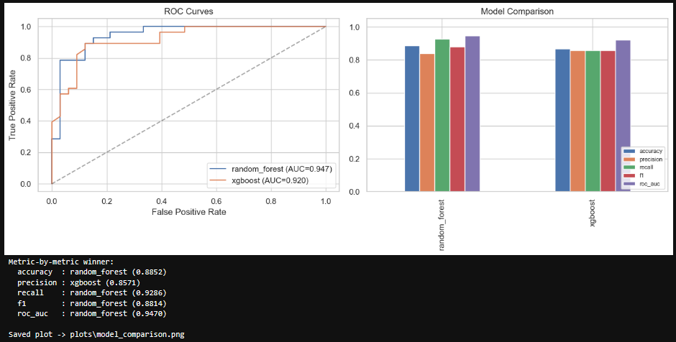
Figure 6: ROC curves and metric comparison for both models.
Looking at the confusion matrices, Random Forest’s main strength is recall (0.929) — it only missed 2 of 28 disease cases in the test set, which matters a lot in a medical screening context where a missed positive is more costly than a false alarm. XGBoost was slightly more conservative, trading a bit of recall for marginally better precision.
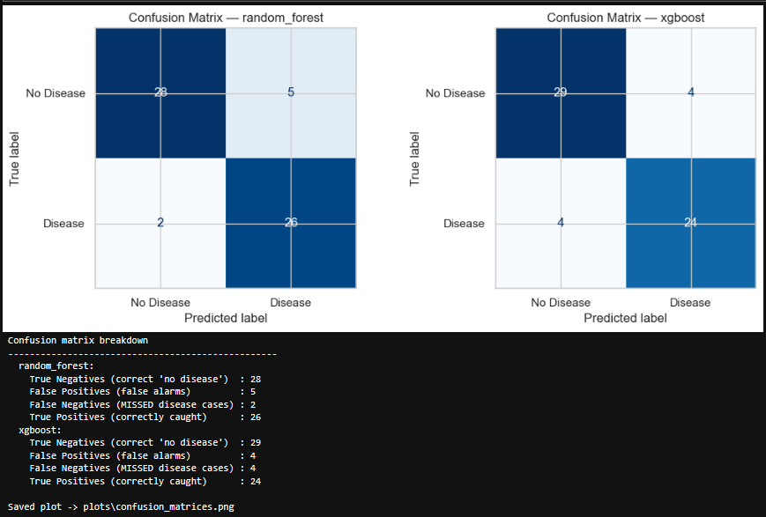
Figure 7: Confusion matrices for Random Forest (left) and XGBoost (right) on the held-out test set.

6. Experiment Tracking with MLflow
I logged every grid-search run to MLflow, using a local SQLite backing store (sqlite:///mlflow.db) so the tracking data ships with the repository. For each run I logged the best hyperparameters found, all six evaluation metrics, the confusion-matrix and ROC-curve plots as artifacts, and the fitted pipeline itself (preprocessing + model together) as an MLflow model, using cloudpickle serialization so the XGBoost-in-a-pipeline object could be logged safely.
Querying the MLflow client for both runs, sorted by ROC-AUC, gives the same numbers as the table in Section 5.2 — which is the whole point of tracking experiments this way: the metrics I report in this document are pulled from the same run history that’s browsable in the MLflow UI, not recomputed by hand.
mlflow ui --backend-store-uri sqlite:///mlflow.db # then open http://127.0.0.1:5000
[Insert MLflow UI screenshot here — run the command above, open the heart-disease-classification experiment, and screenshot the run comparison table and one run's artifact view.]

7. Model Packaging & Reproducibility
The final artifacts I saved are:
- models/heart_disease_model.joblib — the complete pipeline (preprocessing + tuned Random Forest), so the API only ever needs to call .predict_proba() on a raw feature dictionary
- models/model_metadata.json — model name, training timestamp, best hyperparameters, all metrics, and the exact feature schema, so the API and the tests both know what columns to expect
- requirements.txt / requirements-api.txt — pinned package versions for the full pipeline and a leaner set for the API container respectively
Before trusting the saved file, I ran a reload sanity check in the notebook itself: load the model back from disk with joblib, predict on the same test row, and assert the probability matches the in-memory model bit-for-bit. This caught nothing on this run, but it’s the kind of check that would have caught a serialization bug immediately rather than silently shipping a broken model.
I also built scripts/train.py, a standalone script version of the same pipeline (download → clean → train → package), specifically so the model could be retrained headlessly inside CI/CD without needing a Jupyter kernel. It supports a --fast flag that shrinks the grid search for quick CI smoke-training.

8. CI/CD Pipeline
I built a four-stage GitHub Actions workflow (.github/workflows/ci-cd.yml) that runs automatically on every push to main:
- lint — ruff over api/, scripts/, and tests/; fails the build on any lint error
- train — runs scripts/train.py --fast (data download → clean → train → package) and uploads the resulting model and cleaned dataset as workflow artifacts
- test — downloads the model artifact from the previous job and runs my full pytest suite (20 tests) with coverage reporting
- docker-build — builds the Docker image, runs it as a real container, curls /health and /predict against it, and fails the job if the API doesn’t respond correctly — so a broken image can never silently pass CI
Every stage fails loudly: a lint error stops the pipeline before training even starts, and the Docker smoke test greps the actual health-check response rather than just checking the container started. Artifacts (trained model, coverage report, smoke-test logs) are uploaded from every run and kept for 14 days, satisfying the “artifacts/logging for each workflow run” requirement.
[Insert a screenshot of the green GitHub Actions run — the Actions tab on your repo, showing all four jobs passing — once you've pushed to GitHub.]

8.1 Unit Tests
My pytest suite has 20 tests across three files:
- tests/test_data_processing.py — missing-value coercion, imputation, target binarization, and schema checks, using a small synthetic frame with the same ‘?’ missing-value convention as the real UCI file
- tests/test_model.py — the saved model loads correctly, predictions are valid probabilities that sum to 1, predictions are deterministic, and a regression guard that fails the build if a future retrain drops below 75% ROC-AUC or 70% accuracy
- tests/test_api.py — health check, a valid /predict call, three different malformed-input cases (missing field, out-of-range value, wrong type — all correctly return 422), a check that every response carries a request ID header, and a check that /metrics exposes Prometheus-format output
All 20 tests pass locally with pytest tests/ -v, and the same command is what CI runs.

9. Model Containerization
I built a Dockerfile around a lean python:3.12-slim base image, installing only the runtime dependencies needed for inference (requirements-api.txt — no matplotlib, seaborn, mlflow, or Jupyter, since those are training-time-only). The image copies in the API code and the trained model, runs as a non-root user, and defines a HEALTHCHECK that polls /health.
I verified the container end-to-end on my own machine: built the image, ran it, and hit both endpoints with curl.
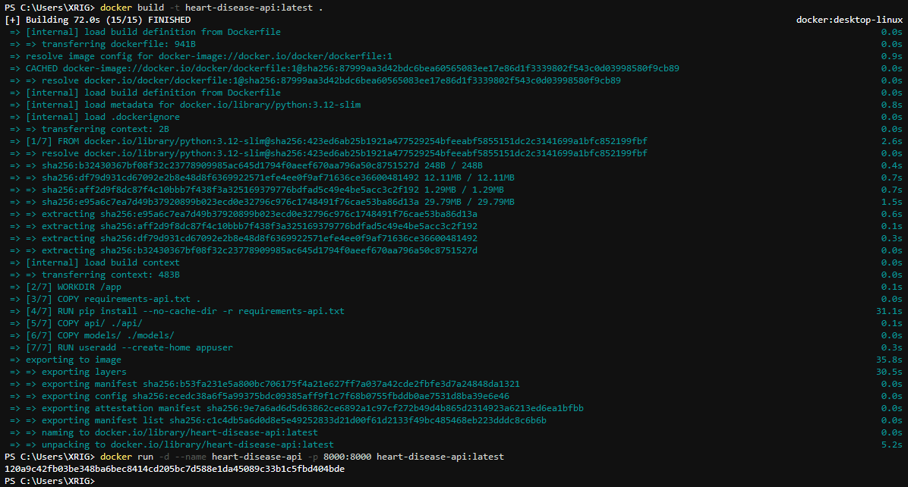
Figure 8: Docker build (15/15 steps, FINISHED) followed by docker run, exposing port 8000.
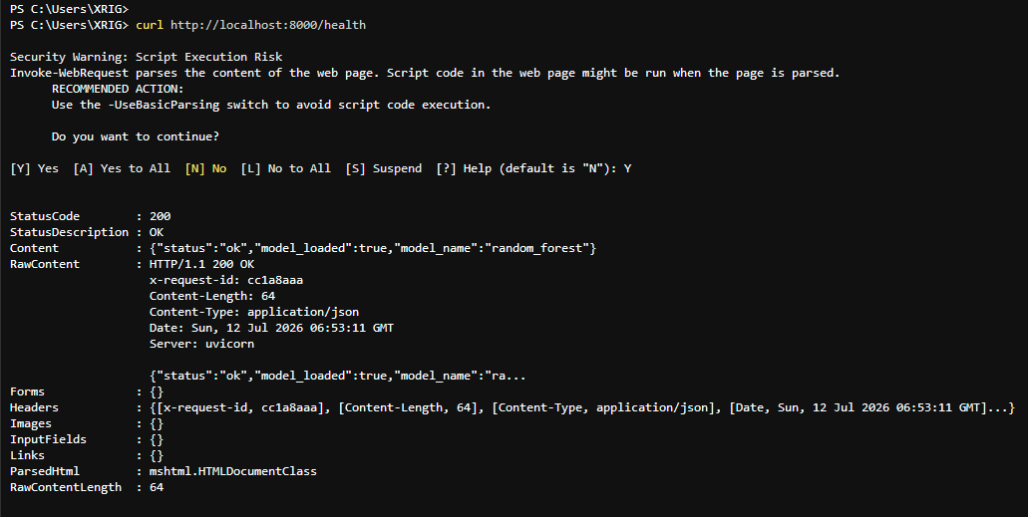
Figure 9: curl http://localhost:8000/health returning a healthy response with the loaded model name (random_forest).
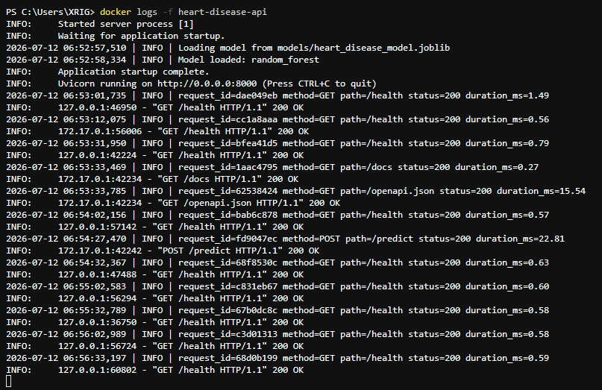
Figure 10: Container logs showing the model loading on startup and structured request logs for every subsequent call, with a unique request ID, method, path, status code, and duration.
I also exercised the API through the auto-generated Swagger UI at /docs, which is a convenient way to demonstrate the /predict contract without writing a separate client.
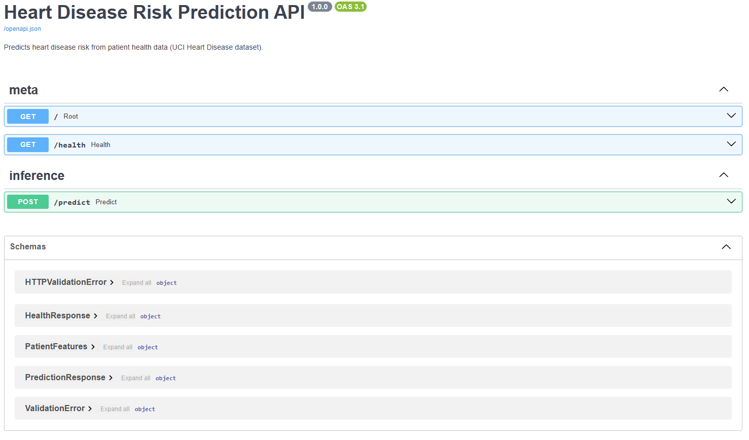
Figure 11: FastAPI’s Swagger UI listing the /, /health, and /predict endpoints, plus the request/response schemas.
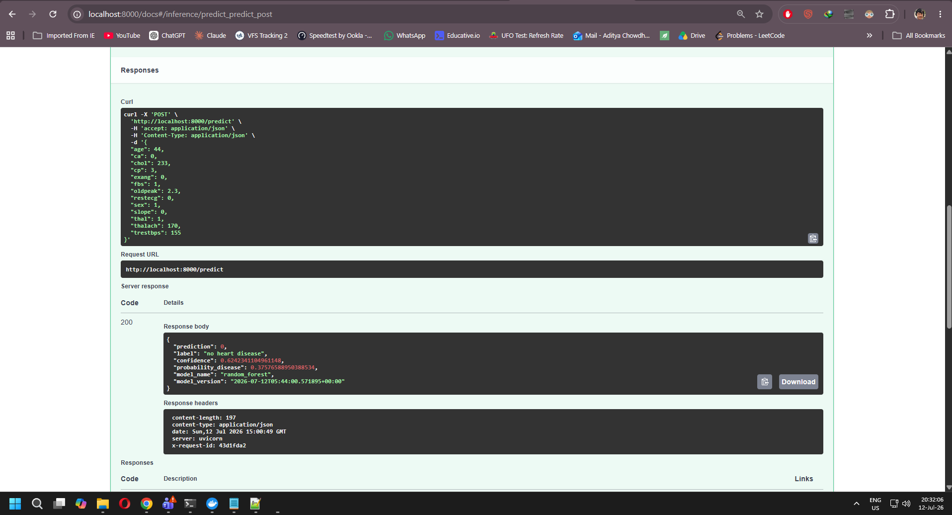
Figure 12: A live /predict call through Swagger — 200 response with prediction, label, confidence, and the model name/version used.

10. Production Deployment (Kubernetes)
For local Kubernetes I enabled Docker Desktop’s built-in Kubernetes cluster rather than a separate Minikube install, since I already had Docker Desktop running. I wrote two manifests: k8s/deployment.yaml, which creates a dedicated mlops-assignment namespace and a Deployment with 2 replicas, resource requests/limits (100m–500m CPU, 256Mi–512Mi memory), and readiness/liveness probes against /health; and k8s/service.yaml, a LoadBalancer Service mapping port 80 to the container’s port 8000.
The first time I tried kubectl apply, it failed with a connection error to localhost:8080 — which turned out to simply mean Kubernetes wasn’t enabled in Docker Desktop yet. After enabling it (Settings → Kubernetes → Enable Kubernetes) and confirming kubectl config current-context returned docker-desktop, the deployment went through cleanly.
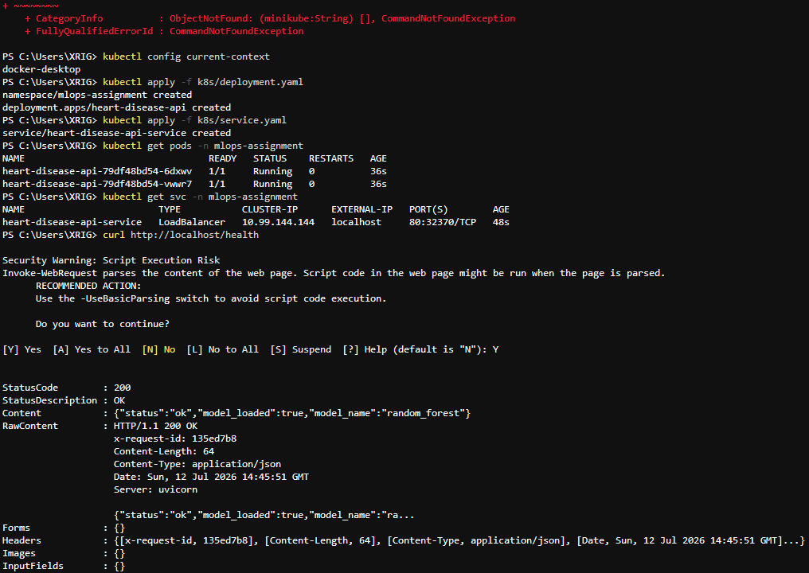
Figure 13: kubectl apply creating the namespace, Deployment, and Service; kubectl get pods showing 2/2 pods Running; kubectl get svc showing the LoadBalancer service; and a successful curl to /health through Kubernetes.
kubectl get all and kubectl describe deployment confirm the rollout matches what I specified: 2 desired, 2 current, 2 ready, 0 unavailable, RollingUpdate strategy, and the exact resource limits and liveness/readiness probe configuration I set in the manifest.
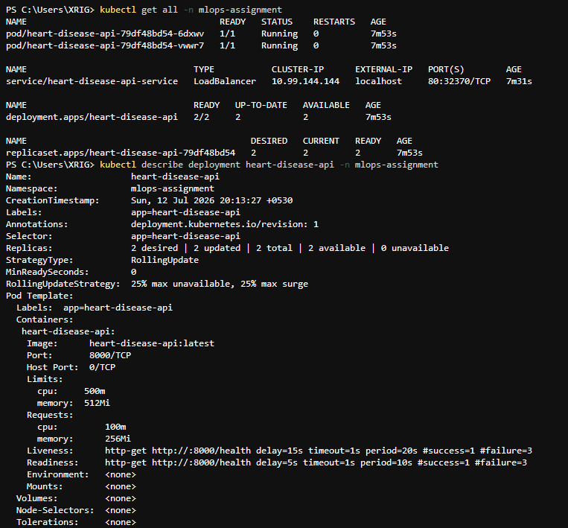
Figure 14: Full resource listing and Deployment description — 2/2 replicas ready, correct image, ports, and probe configuration.
The event log shows Kubernetes itself scaling the ReplicaSet up to 2 pods, and the pod logs show a continuous stream of successful /health probe requests — this is Kubernetes’ own liveness/readiness checks polling the API roughly every 10–20 seconds, which is direct evidence the health-check wiring in the Deployment manifest is actually working, not just present in the YAML.
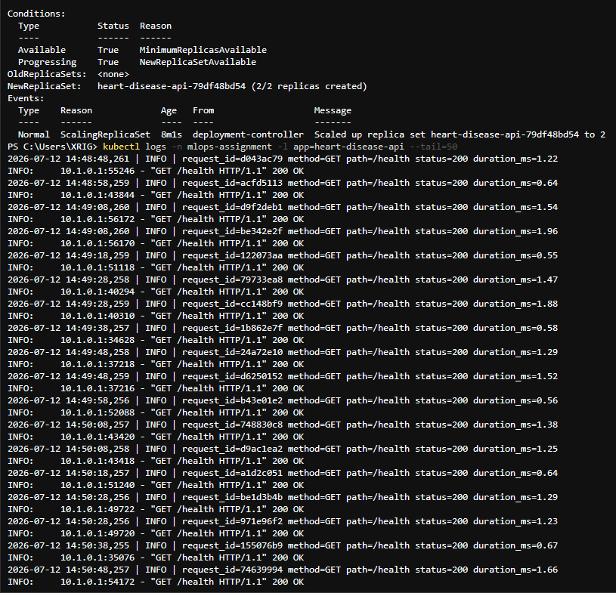
Figure 15: ReplicaSet scaling event and the start of the aggregated pod logs (kubectl logs -l app=heart-disease-api).
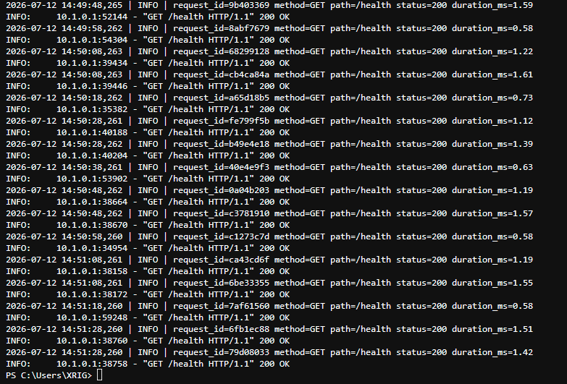
Figure 16: Continued log stream — successful 200 responses from repeated Kubernetes health probes.
Finally, I tore the deployment down cleanly with kubectl delete, confirming both the Service and the namespace/Deployment were removed — useful to show since a deployment that’s easy to spin up but hard to clean up isn’t really production-ready.
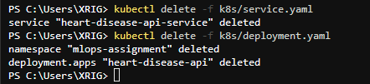
Figure 17: Clean teardown — kubectl delete -f for both the service and deployment manifests.

11. Monitoring & Logging
Every request through the API already produces a structured log line (request ID, method, path, status code, duration) — visible in Figure 10 above. On top of that, I added a Prometheus-format /metrics endpoint to the FastAPI app using prometheus-fastapi-instrumentator, which exposes default HTTP metrics (request counts and latency histograms, broken down by endpoint/method/status) plus a custom heart_disease_predictions_total counter I added myself, labeled by predicted class — the simplest possible signal for watching whether the model’s positive-rate drifts over time in production.
I wired Prometheus and Grafana into docker-compose.yml as two additional services on a shared Docker network, with Grafana pre-provisioned (datasource and a 4-panel dashboard defined as code, not clicked together manually) so the monitoring stack comes up fully configured with a single docker-compose up --build -d.
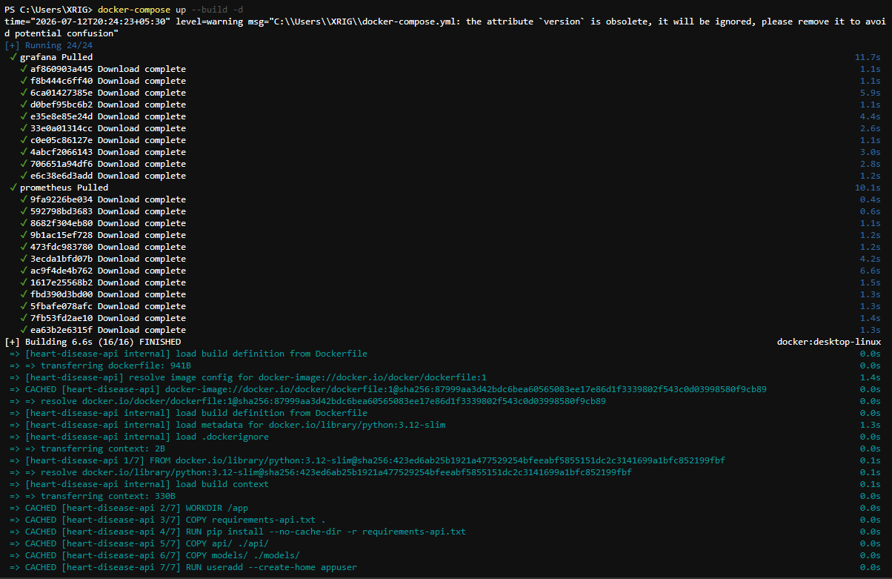
Figure 18: docker-compose pulling and building all three services (API, Prometheus, Grafana) and starting the shared network.
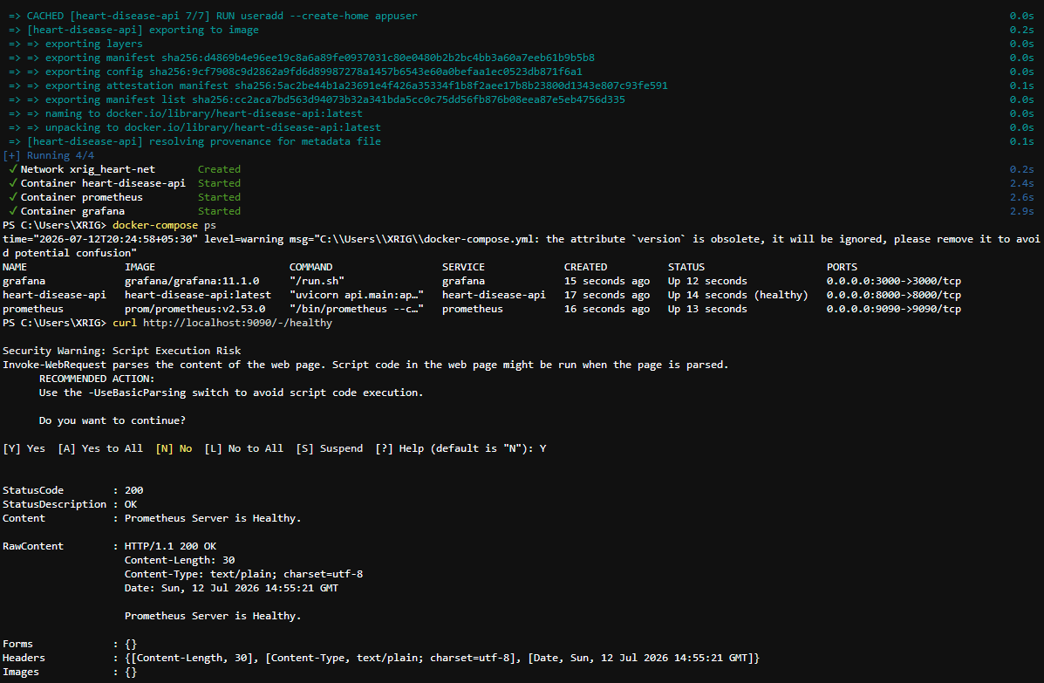
Figure 19: All three containers healthy and running (docker-compose ps), and Prometheus reporting itself healthy on :9090.
In the Prometheus UI, the Targets page confirms it’s actively scraping my API’s /metrics endpoint every 5 seconds and marking it UP.
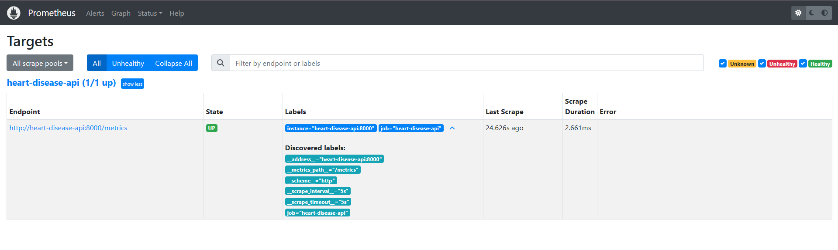
Figure 20: Prometheus Targets page — heart-disease-api target UP, scraping http://heart-disease-api:8000/metrics.
Grafana’s dashboard auto-loads with four panels reading from that Prometheus data: request rate by endpoint, p95 request latency, predictions by class over time, and the 5xx error rate. After sending a handful of test requests through Swagger UI, three of the four panels show live data; the 5xx error-rate panel legitimately shows “No data”, which in this case is a good sign — it means the API hasn’t returned a single server error during testing, not that the panel is broken.
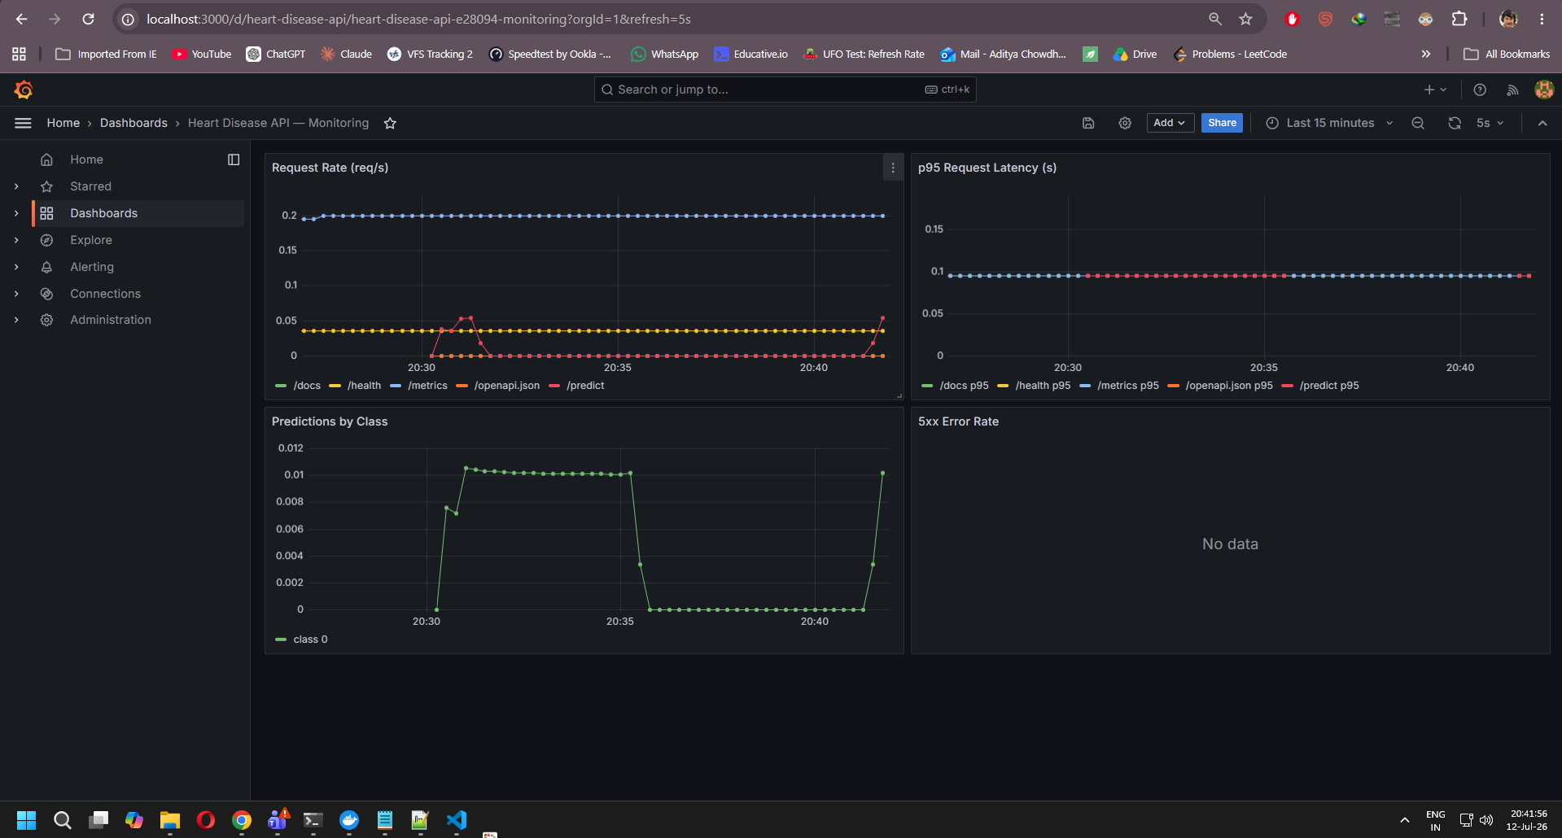
Figure 21: Grafana dashboard — request rate, p95 latency, and predictions-by-class panels populated from live traffic.

12. Challenges & Learnings
A few things tripped me up along the way that I think are worth recording, since they were mostly about environment/tooling rather than the ML itself:
- PowerShell isn’t bash — mkdir -p with multiple space-separated paths threw a ParameterBindingException in PowerShell; New-Item -ItemType Directory -Force -Path a,b,c is the PowerShell-native equivalent.
- kubectl apply failing with a connection refused on localhost:8080 almost always means kubectl has no active cluster context, not a manifest problem — in my case it meant Docker Desktop's Kubernetes simply wasn't enabled yet.
- MLflow's default sklearn model logging uses pickle/cloudpickle, which threw a security-sensitive warning when logging an XGBoost-in-a-Pipeline object under the newer MLflow version; passing serialization_format="cloudpickle" explicitly resolved it cleanly.
- Grafana's provisioned dashboards need a fixed datasource UID (I set uid: prometheus_ds explicitly) — without it, Grafana auto-generates a random UID on each fresh container and the dashboard's panels silently fail to bind to the datasource.
- Running Docker Compose and a separate Kubernetes deployment side by side works fine as long as they don't claim the same host port — my Kubernetes Service uses port 80 while Compose uses 8000, so I could keep both running for screenshots without conflicts.

13. Conclusion
This assignment took me through the full MLOps lifecycle end to end: a documented, reproducible data pipeline; two tuned classifiers with Random Forest coming out ahead at 88.5% accuracy and 0.947 ROC-AUC; every experiment tracked in MLflow rather than just printed to a notebook cell; a packaged pipeline with a reload sanity check; a tested, logged FastAPI service; a CI/CD pipeline that trains, tests, and smoke-tests a real container on every push; a working local Kubernetes deployment with liveness/readiness probes actually firing; and a Prometheus/Grafana stack showing live traffic. Every screenshot in this report came from my own machine, and the whole pipeline — not just the model — is what I'm submitting.

14. Repository & Deliverables
GitHub repository: [insert link after pushing]
Demo video (short walkthrough of the pipeline): [insert link]
Deployed API access: local only — run via docker-compose up --build -d (API on :8000) or via the Kubernetes manifests in k8s/ (Service on :80). See DOCKER_README.md, K8S_README.md, and MONITORING_README.md in the repository for exact steps.
Task | Deliverable / Evidence
1. Data Acquisition & EDA | Notebook Sections 1–3; class_balance.png, histograms.png, correlation_heatmap.png
2. Feature Engineering & Model Dev | Notebook Section 4; model_comparison.png, confusion_matrices.png
3. Experiment Tracking | MLflow (sqlite:///mlflow.db); run summary table, Section 6 of this report
4. Model Packaging | models/heart_disease_model.joblib, models/model_metadata.json
5. CI/CD Pipeline | .github/workflows/ci-cd.yml — lint, train, test, docker-build jobs
6. Model Containerization | Dockerfile, docker-compose.yml; Section 9 screenshots
7. Production Deployment | k8s/deployment.yaml, k8s/service.yaml; Section 10 screenshots
8. Monitoring & Logging | Structured request logs, /metrics endpoint, Prometheus + Grafana; Section 11
9. Documentation & Reporting | This document

