**An Observation of Senior Citizens Daily Life**

**Introduction**

As we grow older we have gained a lot of experiences as the time passes, as our parents grow older they will face challenges of a senior citizen, this observation paper will list down a list of common problems of senior citizens and what they do in their daily lives.

**Problem**

Identifying their hobbies, likes, dislikes, health issues, and day to day activities.

**Observations**

Based on what we’ve observed, their day to day activities include;

* Cleaning
* Watching TV
* Listening to the radio
* Playing bingo
* Walking the dogs
* Feeding the dogs
* Watering the plants
* Going to the marketplace
* Sleeping
* Gossiping

Further observation concerning their health;

* Mental Health
  + Loneliness
  + Anger issues
  + Privileged attitude
  + Depression
  + Cognitive Impairment
* Physical Health
  + Sensory Impairment
  + Arthritis
  + Osteoporosis
  + Oral Decay
  + Kidney
* Relationships
  + Colleagues
  + Family
  + Neighbors
  + Pets
* Likes
  + Grandchildren
  + Peace
  + Serenity
  + TV drama shows
  + Old action movies
  + Horse Racing
  + Cock Fighting
  + Sewing
* Dislikes
  + Noise
  + Mischievous Children
  + Litters around the house
  + Rude people

**Ideas Proposed**

An app where it reminds the user to spend time with their beloved grandparents or make a schedule every week, month, or year. The reason is because our grandparents will not be with us for a long time. So spend time when they are still with us. ☹

A public transportation vehicle designed for senior citizens that will help them go around spaces easily with their frail bodies. Since our transportations are not catered to the elderly, we thought of this idea so that we can make our elders lives easier for them to live in.

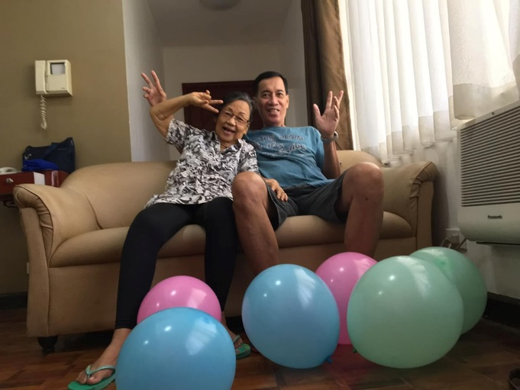 **Domingo Family San Pedro Family**



**Asia Pacific College**

**An Observation of Senior Citizens Daily Life**

**UI/UX Design and Programming (USERDES)**

**Submitted by:**

**Robert Vincent S. Conche**

**Aaron Sebastian D. Consumo**

**18 July 2019**