WDD230 - BYU Idaho

Final Project: Bountiful Foods

Student: Andres Costanzi

Bountiful Foods Website

**Site purpose:** The site purpose is to provide an easy-to-use and simple platform for the client to connect with the Bountiful Foods business for either ordering their products, getting contact business information or general information of the business and it’s uniqueness within the industry.

**Target Audience:** The audience is mainly individuals who prioritize their health and well-being, seeking fresh, organic and locally grown foods. These individuals seek a balanced diet, outdoor activities and nutritious products. Their age range is most predominant in young adults and middle age which would be from 18 to 45 years old. They could be locals, tourists or any health-conscious person who is looking for businesses that promote, participate or prioritize environmentally friendly food production.

Persona 1:

John Doe

Age 40

Description: John is a middle-aged individual who strives to maintain good health overall. He prioritizes a balanced diet and appreciates locally sourced and organic foods. John seeks nutritious options for himself and his family.

Persona 2:

Jessica Dom

Age 28

Description: Jessica is a health-conscious young professional who leads an active lifestyle. She values nutritious and organic foods to support her overall well-being. Hannah enjoys outdoor activities like hiking and biking. As a local resident, she seeks convenient and environmentally friendly food options to maintain her balanced diet.

Persona 3:

Alice Wonderland

Age 32

Description: Alice is an adventurous individual who loves to explore new places. She enjoys trying different cuisines and wants to support businesses that prioritize environmentally friendly practices. She values businesses that offer nutritious meals and snacks to fuel her active lifestyle while also being mindful of the environment.

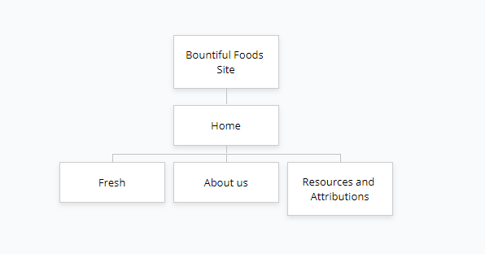**Site Map:**

**Color Scheme:**

**Typography:**





**Wireframe Sketches:**

Large View

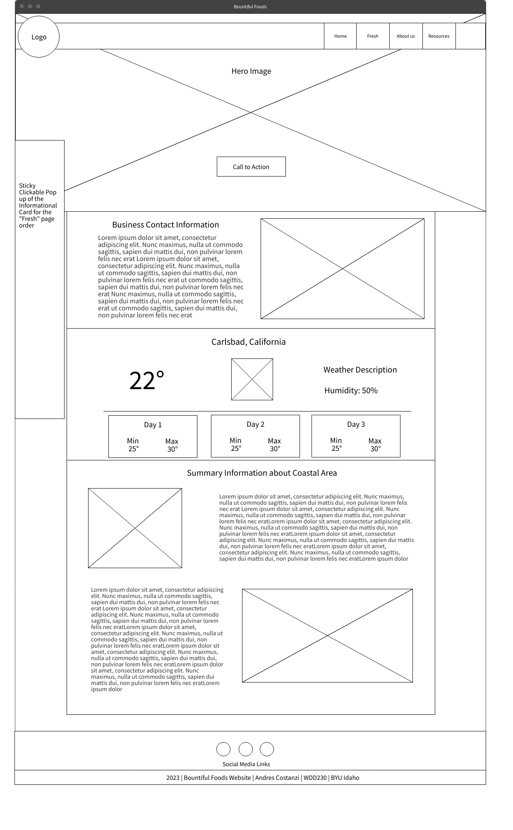

Medium View

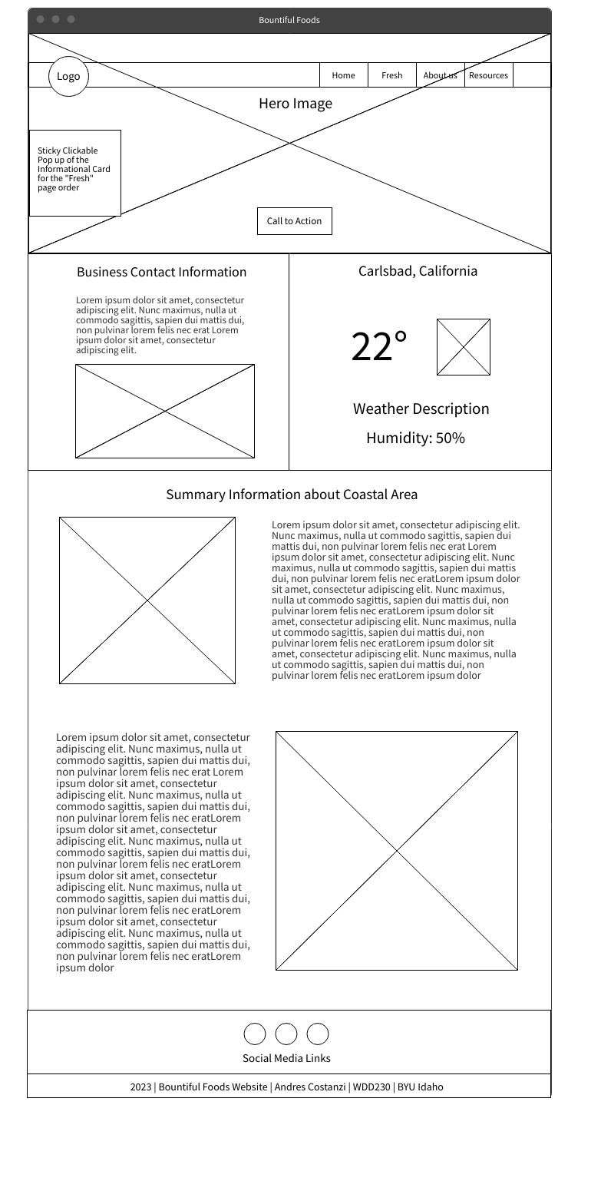

Small View

