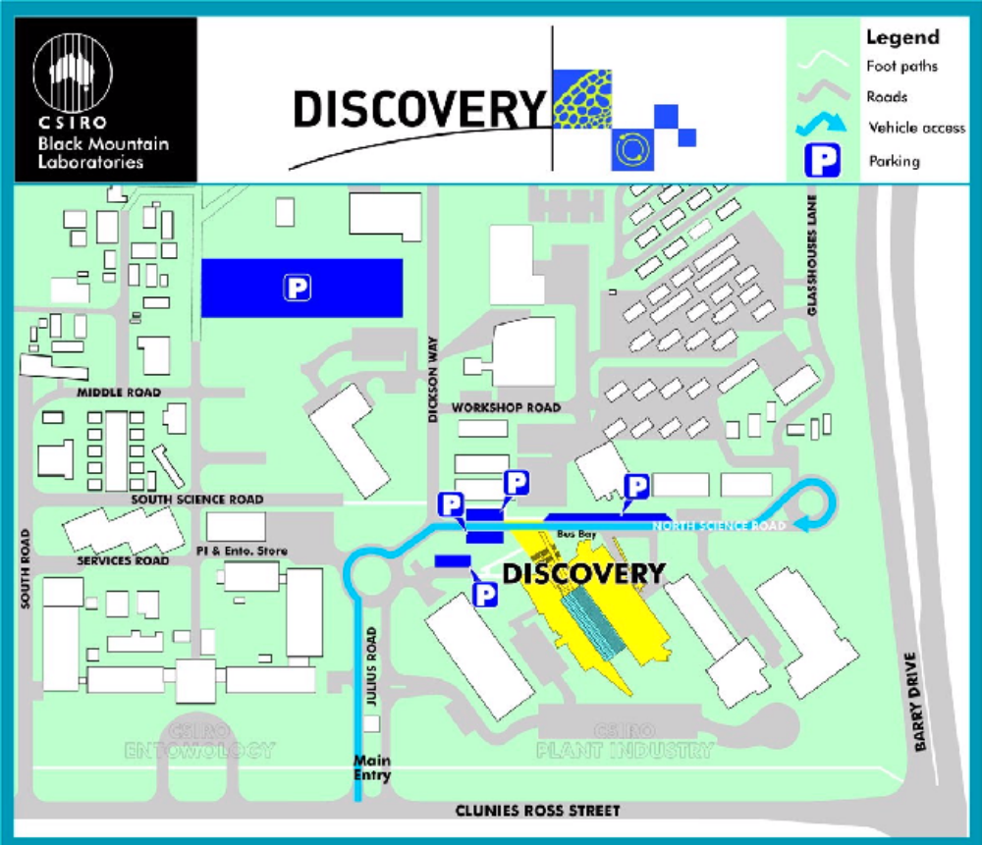

Discovery Parking Map

Clunies Ross Street, Black Mountain

