HOTEL OPTIONS FOR ADCS ALTA 2016

[**Fraser Place Melbourne**](http://melbourne.frasershospitality.com/)

Prices start from $159 per night

Enjoy everything Melbourne has to offer at Fraser Place Melbourne. Our contemporary apartment hotel is tucked away from the main street in a charming laneway in the middle of the city’s cultural, retail and entertainment hub. The hotel is just minutes from Her Majesty’s Theatre, Princess Theatre and the Melbourne Comedy Club, perfect to keep you entertained during your stay. Free breakfast is included.

We would like to offer 10% off our BFR rates – Best Flexible rates and offer FREE breakfast if they book via our website.

[www.frasershospitality.com/en/our-properties/melbourne](http://www.frasershospitality.com/en/our-properties/melbourne)

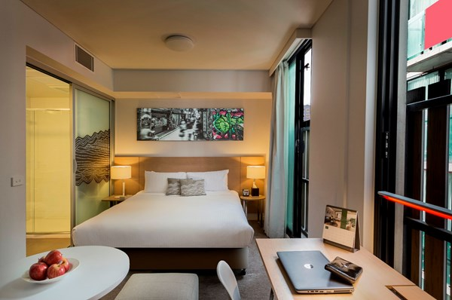

**Pegasus Apart'Hotel**

**Prices start from $210 per night weekdays and $230 per night weekends.**

Pegasus offers a combination of studios and suites, you are sure to find your preferred accommodation style. Highly suited to the business traveller. Pegasus keeps you connected with free Wi-Fi throughout the property. There is a restaurant and bar offering breakfast and dinner daily or dine in with your kitchenette featuring gas stove, microwave and refrigerator.

Phone [+61 3 9284 2400](tel:+61%203%209284%202400)

Email: reservations@pegasussuites.com.au

[www.pegasussuites.com.au](http://www.pegasussuites.com.au)

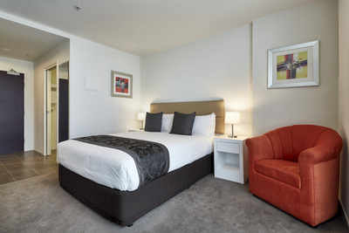

**Adina Melbourne Apartments**

**Prices start from $224 per night.**

Located at 189 Queen Street, Melbourne. It is a 7 minute walk to the Monash Law Chambers.

When you stay at Adina Apartment Hotels, you're living like a local - immersed in the culture of the city you’re in. You can shop, drink and eat like locals do - by the end of your stay, you'll be on first name basis with the barista at the cafe next door

**Phone: +61** 3 9934 0000

Email: [melbourne@adinahotels.com.au](mailto:melbourne@adinahotels.com.au)

www.tfehotels.com/adina

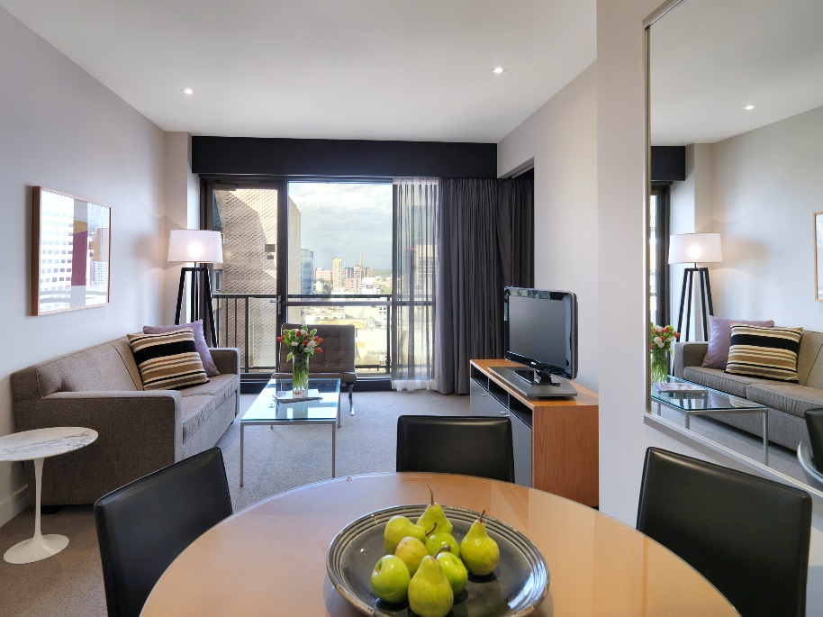

**Mantra on little Bourke**

**Prices start from $229**

Located at 471 Little Bourke Street, Melbourne. It is a short 5 minute walk to the Monash Law Chambers.

There's self-contained accommodation to suit everyone at this [Melbourne hotel](http://www.mantra.com.au/victoria/melbourne-and-surrounds/accommodation/), with great value Executive Suites, Studio Queen and One and Two Bedroom Apartments. All the conveniences of modern city living and 4.5 star hotel facilities are at your fingertips at Mantra on Little Bourke.

Phone: +61 7 5665 4450

Email: [littlebourke.res@mantra.com.au](mailto:littlebourke.res@mantra.com.au)

[www.mantra.com.au](http://www.mantra.com.au)

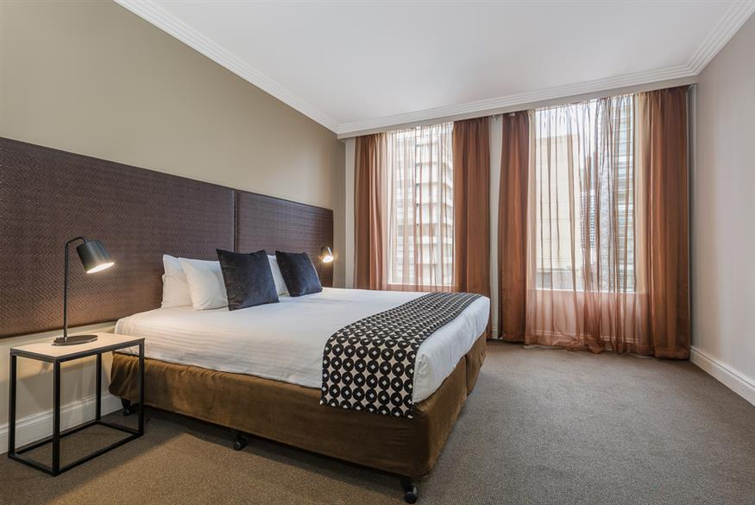

**Mantra City Central**

**Prices start from $149 per night**

Located at 318 Little Bourke St, Melbourne. A 10 minute walk to the Monash Law Chambers.

The hotel offers spacious, self-contained 1 and 2 Bedroom Apartments. All are newly refurbished with urban and funky touchers. Right on the doorstep of Mantra City Central, you will find just about every high street store imaginable, from high end to bargain basement. Lose yourself in Melbourne's famous laneways, which weave a maze across the city. Discover a treasure trove of restaurants, bars, cafes, galleries and boutique shops.

Phone: [+61 7 5665 4450](tel:+61756654450)

Email: [citycentral.res@mantra.com.au](mailto:citycentral.res@mantra.com.au)

[www.mantra.com.au](http://www.mantra.com.au)

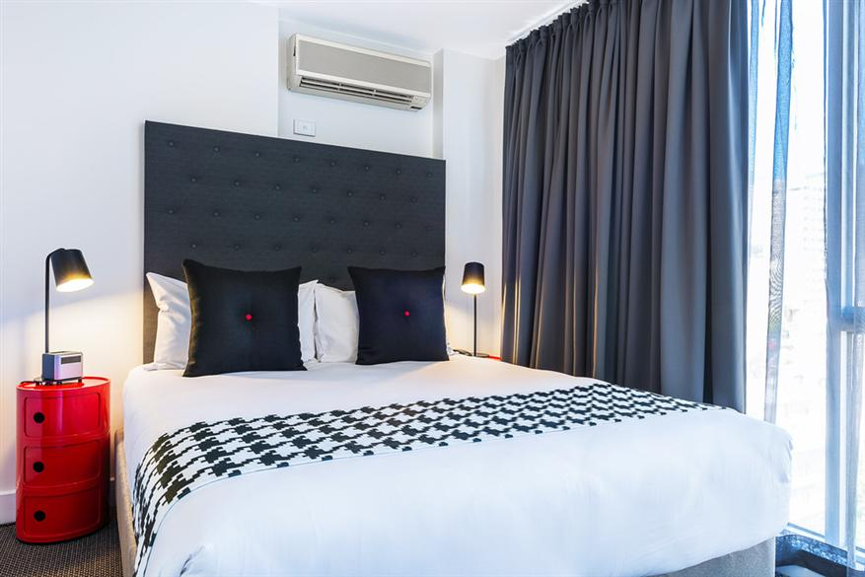

**The Swanston Hotel Melbourne Grand Mercure**

**Prices start from $189.00 per night**

Located at 195 Swanston St, Melbourne. It is a 13 minute walk to the Monash Law Chambers.

Melbourne's most centrally located accommodation, The Swanston Hotel, Grand Mercure is surrounded by the most popular shopping and business precincts, theatres, galleries, bars and restaurants. Located close to Bourke Street Mall and Federation Square and offering 200 modern, spacious rooms, The Swanston Hotel, Grand Mercure features superior service, along with a well-equipped gym, indoor swimming pool and valet parking, plus three unique dining options including 24 hour room service.

Phone: +61 3 96634711

Email: [H3028-RE5@accor.com](mailto:H3028-RE5@accor.com)

[www.mecure.com](http://www.mecure.com)

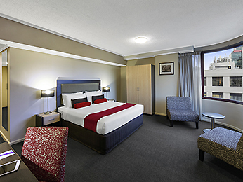

**ibis Styles Melbourne, The Victoria Hotel**

**Prices start from $130 per night**

Located at 215 Collins Street, Melbourne. It is a 16 minute walk to the Monash Law Chambers.

Located in the heart of the Melbourne CBD, ibis Styles Melbourne, The Victoria Hotel is the ideal accommodation option for your corporate and leisure travel needs. The hotel offers easy access to [key attractions](http://www.victoriahotel.com.au/melbourne/), as well as the countless cafes and eateries that Melbourne has become renowned for.

Phone: 1800 331 147 (QUOTE ICER 2016)

Email: [stay@victoriahotel.com.au](mailto:stay@victoriahotel.com.au) (QUOTE ICER 2016)

[www.victoriahotel.com.au/](http://www.victoriahotel.com.au/) and in the promotional code put ICER2016

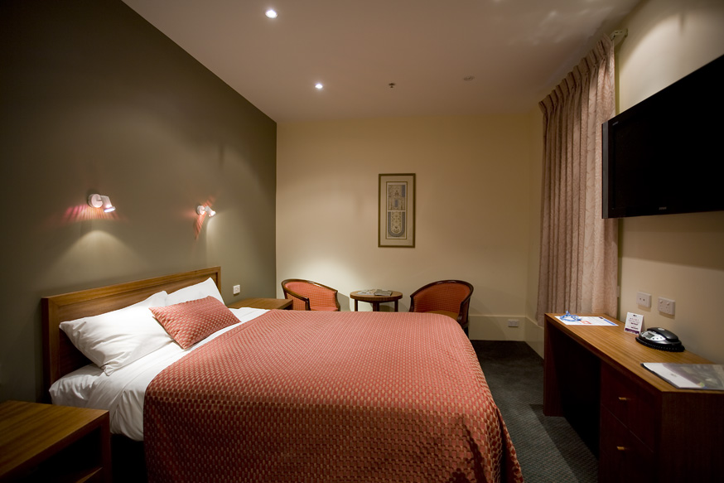

**Mercure Welcome Melbourne**

**Prices start from: $149.00**

Located at 265 Little Bourke Street, Melbourne. It is a 12 minute walk to the Monash Law Chambers.

Melbourne's most centrally located accommodation, Mercure Welcome Melbourne is surrounded by the city's popular shopping precincts, theatres, galleries, bars and restaurants, along with its own chic and cosy Cocoon Bar, Soul Café and The Louden Kitchen &Grill. Rooms have TVs with Foxtel and pay movie channels, plus broadband and wireless internet. Other facilities include valet or self parking, complimentary luggage storage and 'We Know Melbourne' - the most knowledgeable Concierge in town.

Phone: +61 3 96390555

Email: [H3031@accor.com](mailto:H3031@accor.com)

[www.mercure.com](http://www.mercure.com)

