**STM32 Nucleo-F446RE Pin to Signal**

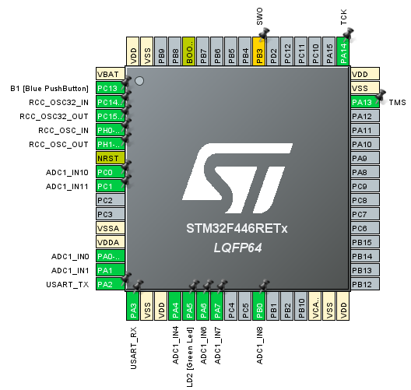

**ADC1 Pinout and Channels**

Buf_Idx - Channel - Pin ID - Board Pin

|  |  |  |  |  |
| --- | --- | --- | --- | --- |
| Buffer Index | ADC Input Channel | STM32 Pin ID | Board Pin | Signal |
| 0 | In 0 | PA0 | A0 | P1X Buf |
| 1 | In 1 | PA1 | A1 | P1Y Buf |
| 2 | In 4 | PA4 | A2 | P2X Buf |
| 3 | In 6 | PA6 | D12 | Collision Detect |
| 4 | In 7 | PA7 | D11 | Pendulum |
| 5 | In 8 | PB0 | A3 | P2Y Buf |
| 6 | In 10 | PC0 | A5 | P2 It Buf |
| 7 | In 11 | PC1 | A4 | P1 It Buf |

