Northern Three Mapping (Docx Test)

Adam Shand

16, November, 2022

Table of contents

## 1 Test 1

Can I read in an output from a variable path?

#get the date  
date <- format(Sys.time(), "%Y-%m-%d")  
  
#create the file path  
save_path <- glue::glue("output/{date}_n3-basin-builder/")  
  
#grab whatever we are looking for  
shape <- sf::st_read(dsn = glue::glue("{save_path}"),  
 layer = "Dry-Tropics-Basins-Detailed")

Reading layer `Dry-Tropics-Basins-Detailed' from data source   
 `C:\Users\adams\Documents\GitHub\mapping\output\2022-11-16_n3-basin-builder'   
 using driver `ESRI Shapefile'  
Simple feature collection with 50 features and 3 fields  
Geometry type: MULTIPOLYGON  
Dimension: XY  
Bounding box: xmin: 146.1678 ymin: -19.70039 xmax: 148.0303 ymax: -17.4958  
Geodetic CRS: GCS_GDA2020

#display  
plot(shape["sub_zone"])

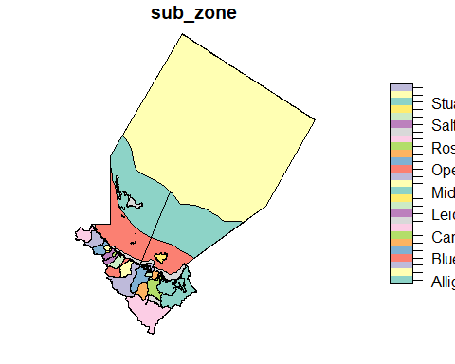

## 2 Test 2

Can I display images using quarto in-text methods?

|  |
| --- |
| 3D Map MWI |

## 3 Test 3

Can I get tables?

tb <- read.csv("images/2022-11-07_annual-ltm-rainfall_fyear-2021.csv")  
  
head(tb)

basin region fyear rainfall cumulative_mean units  
1 Plane Mackay Whitsunday Isaac 1912 734.766 734.766 mm  
2 Plane Mackay Whitsunday Isaac 1913 1943.144 1338.955 mm  
3 Plane Mackay Whitsunday Isaac 1914 1644.351 1440.754 mm  
4 Plane Mackay Whitsunday Isaac 1915 647.667 1242.482 mm  
5 Plane Mackay Whitsunday Isaac 1916 899.110 1173.808 mm  
6 Plane Mackay Whitsunday Isaac 1917 1991.566 1310.101 mm