Corrigendum
Altricial-precocial spectra in animal kingdom

Starrlight Augustine ª, Konstadia Lika ^{b}, Sebastiaan A.L.M. Kooijman ^{c}
ª
Akvaplan-niva, Fram High North Research Centre for Climate and the Environment, Tromsø 9296, Norway
^{b}
Department of Biology, University of Crete, 70013 Heraklion, Greece
^{c}
Department of Theoretical Biology, VU University Amsterdam, de Boelelaan 1087, Amsterdam 1081 HV, The Netherlands

The authors regret that for fig. 6: legend is correct but the figures are not. The figures are copies of figures from fig 7 which was an error during the final typesetting of the article.
The authors would like to apologise for any inconvenience caused.

The correct figures for fig. 6 are in this Corrigendum:

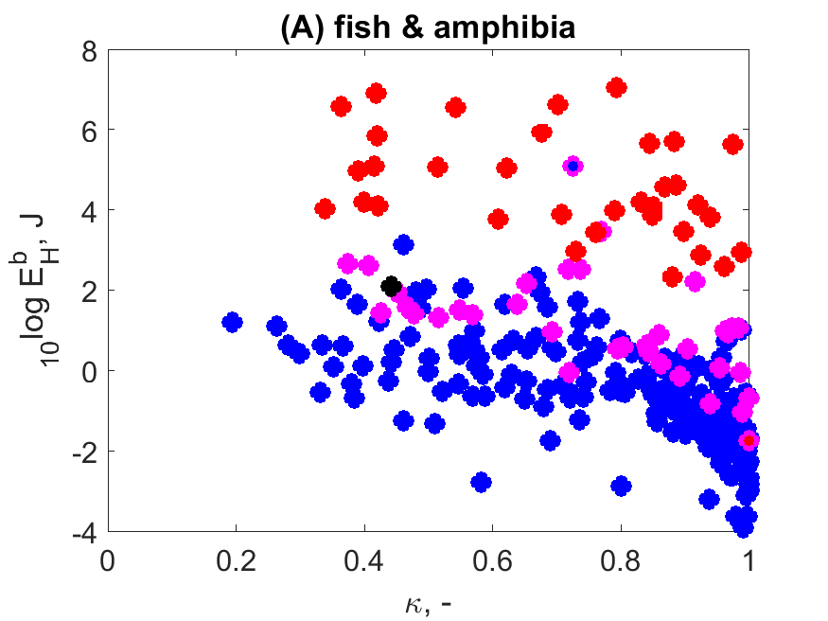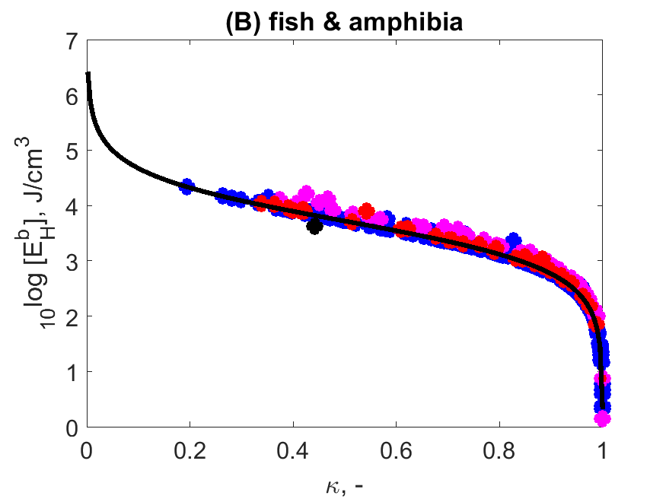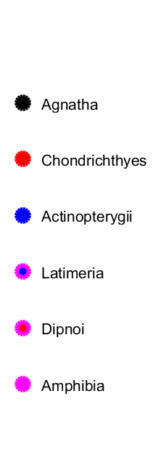
Figure 6: Maturity at birth (E_{H}^{b},left) and maturity density at birth ([E_{H}^{b}], right) for fishes and amphibians as functions of allocation fraction κ. The curve shows the expected relationship, see text Section 3.4.

It is possible to access the supplementary information for this paper on GitHub https://github.com/add-my-pet/SI/tree/main/AuguLika2019 . The reader will find therin Matlab code to generate figures from the same database as was used in the figure (the AmP database). At the time of publication the figures were based on 875 species. The database now has over 4000 species so the supplementary information will generate the same figures but with more points.

__________________________
DOI of original article: 10.1016/j.seares.2018.03.006
Starrlight Augustine
starrlight@tecnico.ulisboa.pt

