Johne's Disease Transmission & Diagnostic Model

Students: Andrew Magnus, Jordan Lys, Alexander Dumais

Stakeholder: Dr. Cheryl Waldner

CMPT 394 - Simulation Principles

Dr. Nathaniel Osgood

July 2017

**Table of Contents**

**Abstract** **4**

**Background** **5**

Motivation 5

Context 5

Goals 7

**Model** **7**

Model Scope 8

Birth, Pregnancy and Population Control Model 8

Ignored Factors 8

Exogenous Factors 9

Endogenous Factors 10

Infection Model 11

Ignored Factors 11

Exogenous Factors 12

Endogenous Factors 13

Diagnostic Testing Model 14

Ignored Factors 14

Exogenous Factors 14

Endogenous Factors 15

Model Architecture 16

Model Parameters 17

Disease Parameters 17

Testing Parameters 18

Initialization Parameters 20

Cow Parameters 21

Birth, Pregnancy, and Population Control Model 22

Pregnancy Cycle statechart 22

Initial State 24

Evolving State 25

Pregnancy 26

Interactions with other statecharts 27

Infection Model 28

Initial State 28

Infection 29

Infection from Mother 29

Infection from Environment 30

Interactions With Other statecharts 30

Diagnostic Testing Model 31

Testing Idle States 32

Testing States 32

Diagnostic Testing Action Charts 33

Is the Cow Adult Female? 33

Is the Cow Disease Positive? 34

**Calibrations** **36**

**Sensitivity Analysis** **37**

Variation of Initial Infection 37

Initial Clinical Percentage (baseline value 0.01, no testing) 37

Initial Subclinical Percentage (baseline value 0.03, no testing) 39

Varying Initial Infection Conclusion 40

Frequency of Infected contact 41

Normal value of 6.6 41

Alternate values 41

**Scenarios** **42**

Baseline No Testing 43

Baseline With Testing 45

Both Tests Active 45

Blood Test Only 45

Fecal Test Only 46

Slow Removal After Testing 48

Fast Removal After Testing 50

Future Scenario Ideas 50

**Learning** **51**

Challenges 52

**Future Considerations** **53**

**Conclusion** **54**

**References** **55**

# Abstract

Johne's disease affects herds of beef cattle across Canada. With no known cure, management of the disease from spreading throughout a herd is critical to herd health and profitability. This project creates an accurate model of disease transmission within a herd and overlays said model with a flexible model of diagnostic treatments to gain insights into how to better treat and manage an infected herd. Using the powerful Anylogic modeling software, spread of the disease from mother to calf and via environmental factors is explored. An agent-based SEIR model of infection transmission is used to accurately represent Johne’s based on what data is available on the lifecycle and spread of the disease. In the end, a flexible, adaptable model of diagnosing Johne's disease within a herd has been developed that shows promising results for possible treatment strategies for managing the disease within a herd.

# Background

## Motivation

The motivations for this modeling project are threefold: the first motivation is one of animal health and quality, as better understanding the spread and treatment of Johne's disease has potential to benefit herds of cattle all over Canada. Closely related to that motivation is the business motivation. Unhealthy, sickly cattle are not good for farmers, they are not good for consumers, they are not good for anyone. Motivation is thus also found on the bottom line, keeping animals healthy is critical for the success of Canadian beef farmers and industry competitiveness. Finally, the third motivation is to open new avenues of investigation and study; the intention of this model is for it to be used far beyond the scope this project. This model can serve as a baseline or starting point for continued research into Johne's disease using agent based methods or perhaps a starting point for study in other areas related to cattle herds.

## Context

Johne's Disease is caused a bacterium called *Mycobacterium avium* subspecies *paratuberculosis* (MAP). It causes gradual thickening of intestines, reducing nutrient absorption and the cow's ability to process food, leading to weight loss, diarrhea and eventually death. The disease primarily affects cattle, this study and model focus specifically on beef cows.

MAP is passed between cows in two general ways; one is through mother-to-calf transmission and the other is a more general cow-environment-cow transmission. As MAP develops within a cow it can be spread through bodily fluids such as milk; this is the primary method of transmission between mothers and calves. Environmental transmission is more general; because MAP resides primarily in the intestines, the bacteria is often shed through fecal matter. As MAP has a long lifespan and hardy nature, it can survive outside the body; cows can thus meet fecal matter in their environment and have a chance to pick up the disease indirectly. As the prevalence of MAP in a population increases, this environmental contact with the disease necessarily increases.

As cows get older, their risk of infection lowers dramatically. Primary infection occurs in the first 6-12 months of life, with mother to calf transmission happening within the first 6 months while being fed by the mother. One of the problems with MAP is that because it has a long gestation period, cows can be infected for years without showing any symptoms, all the while shedding/spreading the disease for much of that time. Cows with the disease grow up to be smaller, die younger and often spread the disease for a long time before being clinically assessed.

Currently, there is no vaccine or effective drugs for Johne’s Disease in Canada. Current diagnostic tests are unreliable in that they do not accurately determine if a cow is disease positive, and often do not accurately find infected cows until the later stages of the disease, after they have had significant time to spread. The inaccurate tests coupled with the long gestation and spreading period and lack of a cure are a cause for mounting concern. A testing regimen needs to be applied to remove cows in earlier stages of the disease to reduce overall prevalence.

## Goals

There are several goals for this modeling project. The first is to create a model that can accurately model the spread of Johne's disease. The second is closely related to the first: once we have an accurate working model of the disease, we want to overlay the infection model with a process in which diagnostic tests can be imposed on the population, attempting to detect the disease and removing animals that are ill. These models or pieces are to be built in such a way as to be easily reusable for further study or alternative study in related fields. Lastly, modeling helps us gain greater understanding of the spread of Johne’s Disease. Out of these goals we want to be able to draw conclusions about possible testing regimes, finding one that is best able to manage the disease within the herd. Because the disease cannot be cured, effective management of the disease is of utmost importance to cattle, farmers, and the beef industry.

# Model

Link to the latest Anylogic model can be found on GitHub [here](https://github.com/magnusandy/ModelingJohnesDisease).4

## Model Scope

There are three basic components that work together to form our model: the birth/life cycle statechart, the SEIR infection model statechart and the diagnostic testing statecharts and flows. For each component, there are various exogenous/endogenous/ignored factors that we have considered. One overall model factor is the model time, which is set in months. In terms of structural considerations, there are a couple of concepts that we chose to ignore (see Model Architecture for more details). This model choses to ignore spatial and location based interactions of cows, both in terms of disease spreading and for lifecycle. The major components of the model are discussed below.

### Birth, Pregnancy and Population Control Model

This part of the model follows a simple/straightforward approach, as this portion of the model is necessary but not central to the goals of the model, that is infection spread and diagnosis. As such, there are several things that have been ignored in favor of simplicity.

#### Ignored Factors

* Male and Female Interactions
  + The model keeps track of males and females but does not simulate or consider contact between them as being necessary for breeding. It is sufficient that there are a number males and females in the population.
* Spatial Interactions between cows
  + Cows do not interact spatially or in fact in any way besides infection transmission between mother and calf. (see Infection Model for more details)
* Birthing fluctuations such as twins
  + Female cows simply have one offspring each year (90% of the time).
* Birth date range
  + All calves are born at the same time, instead of over a period of a couple of months.

#### Exogenous Factors

Much of the factors of this part of the model are pre-specified and exogenous

* Times between states
  + Times such as length of Pre/post weaning or pregnancy duration are well known and observed quantities; our model takes a single value for them for simplicity.
* Pregnancy chance
  + The likelihood that a cow will have a calf is pre-specified. It does not depend on any factors such as disease. It is simply set as a rate.
* The upper limit on female/male cows
  + Both female and male cows have a separate limit (0.95 * *totalPopulation* and 0.05 * *totalPopulation*), respectively.
* The upper limit on old cows
  + Currently, female cows can reach a maximum of ten years of age. When they exceed that, they are removed from the population. Male cows, are removed at a maximum age of 6 years old and then are replaced.
* The percentage of successful births & and percentage of the failed pregnancy cows
  + Currently, there is a 90% chance of a successful birth
  + The 10% that don’t get pregnant are removed from the population at the time they would otherwise be pregnant.
* Male cow introduction
* male cows are introduced from external sources into the population, all male calves born into the population are removed (sold) after weaning and breeding bulls are brought in from external sources. The ratio of Bulls to female calves is 1:20.

#### Endogenous Factors

* Population Over time
  + The model has parameters and limits, but the population at any given moment is not specified; instead, it is calculated based on numerous removal possibilities of a cow (removal by old age, population control, disease, positive diagnosis, etc.) as well as births coming into the population.
* Number of Births
  + These are not pre-specified, but a result of the modeling of the cow state.
* Cow removals
  + There is a total of 7 ways that a cow can be removed
    - young male cow removal
    - Failed pregnancy
    - Old age
    - Male population control
    - Female population control
    - False and true positive fecal test result
    - False and true positive blood test result

### Infection Model

This part of the model is where many of the key endogenous factors are being realized. The model of infection and its spread throughout the population is a key element of model dynamics.

#### Ignored Factors

* Spatial Interactions of Cows
  + As mentioned earlier, this model does not consider proximity/location interactions of cows within an environment. Infection is spread through an aggregated weighted prevalence. (see Infection Model for more details)
* Male Cow effects of Weighted Prevalence
  + Because males are separated from the rest of the herd, they are assumed to have no impact on weighted prevalence. This is mostly due to the segregation but also on the unknown nature of sexual transmission (it is thought to be very low or nonexistent).
  + The male cows do affect the overall prevalence because there is still a chance for them to be introduced as infected.

#### Exogenous Factors

* Times between states
  + Times between states are pre-specified, both in terms of the latency between infection and subclinical as well as between subclinical and the clinical symptoms appearing. These values are set as best guesses or informed values based on research.
  + These values could possibly be affected by current levels of disease within the population but the possible effects are unknown, and are thus ignored.
* Rate of infection from mother to child
  + This is one of the few known values when it comes to the disease; the rate is to be ⅓ over 6 months. That is, if the mother is infected, the calf has a ⅓ chance to catch it over the 6 months that elapse from birth until weaning.
* Environmental Infection chance based on calf age
  + Calves in the PreWeaning state are more likely to be infected, thus the model assumes that calves in the PostWeaning state are 50% less likely to catch the disease than when they were PreWeaning.
* Factors of weighted Prevalence
  + *ClinicalModifier:* Cows in the clinical state shed more MAP bacteria than subclinical animals; the model assumes that this risk ratio is fixed (4x those in a subclinical state).
  + *FrequencyOfInfectiveContact:* This fixed value captures the combined values of number of contacts per cow and infection chance per contact (c and 𝛃)

#### Endogenous Factors

Many of the key outputs of this model reside here in the infection model; they give insights into how effective diagnostic regimes are in each scenario.

* Number of infected cows in each infection state
  + The number of cows getting infected is a result of the modeling of the mother/child infection rate, and the environmental infection rate.

* Prevalence of disease
  + Prevalence of the disease within the population is a key value; it gives indication of the levels of infection and sickness within the population. The goals of the diagnostic testing are to manage or eliminate the prevalence of the disease from the population.
* Environmental Contact Rate
  + Based on several exogenous factors as well as the current population of infected cows, this value is dynamically generated or updated as the model runs. As prevalence rises, the rate at which cows are becoming infected also rises.

### Diagnostic Testing Model

Diagnostic testing is the final step in the model. Once we have an accurate model of the population dynamics and infection spread, we necessarily want to be able to discover which cows are infected and remove them in as timely a manner as possible. This last portion of the model holds the final goals and intentions of the model outputs, namely being able to manage and/or remove the disease from the population.

#### Ignored Factors

* Complex testing dynamics
  + The model takes a simple approach to testing: it tests every cow individually. It does not consider other possible testing methods like batch testing.
  + Time and resources to do testing; all tests are run simultaneously, which is unrealistic for a large herd.

#### Exogenous Factors

* Testing times/delays
  + Times and delays of running test (getting results back) and time until subsequent removal are specified beforehand. Tests take a certain time to be processed and results to come back, and it takes farmers a bit of time to arrange for removal.
* Testing sensitivity/ specificity
  + These values are gathered from the literature,2 and have ranges based on the current state of infection; currently these values are set to extreme ends of the ranges, but with more information could be varied based on the length of infection (i.e., fecal testing becomes more effective as disease progresses).

#### Endogenous Factors

* Numbers of cows diagnosed (true positive)
  + Key values coming out of the testing are of course how many are being accurately diagnosed. Numbers of cows with the disease that get discovered by the disease.
* Number of cows removed in error (false positives)
  + Also of interest is the number of cows that do not have the disease that are inaccurately diagnosed. While small, this number represents a significant cost or price to the farmers.
* Diagnosis time
  + Another number of interest is the average time it takes for a cow to be discovered as infected, from the time of initial infection to when cows are diagnosed by the tests.
* Prevalence
  + As mentioned earlier, this value is key to the model and the goals of the project. The goal is to know how the testing lowers or manages the prevalence over time, hopefully but not necessarily removing the disease completely. It refers to the true prevalence, the fraction of known cases.

## Model Architecture

This model relies on an Agent-Based modeling approach with some aggregated elements. Cows are modeled through agents, which allows for cow specific diagnostic testing to be applied on a per animal basis. It also allows keeping track more information about the state and attributes of each cow like age, gender. The model does not utilize spatial/ environmental modeling techniques for agent interactions; instead it takes a more system dynamics approach. Disease prevalence and environmental infection rate are calculated in a aggregate (random mixing) fashion, using a rate of infection based on the aggregate weighted prevalence (number of infected cows weighted by state over total population) and average frequency of infective contact.

This choice of architecture was motivated by the limited data around spread of infection via cow to cow and environmental transmission. The data available around mother to calf transmission is captured in an agent based fashion, but because there is limited around environmental transmission it makes the most sense to aggregate it rather than try model it with multiple unknowns. Environmental contact is complex and not well known, there is many possible sources and scenarios that would lead to a cumbersome model with a lot more unknowns.

## Model Parameters

There are many parameters used in this model due to the complex nature of interactions between agents and other agents, agents and statecharts, and agents and their testing charts. We have separated the parameters into groups to help organize them and think about them in relation to sections of the model. All parameters can be found in **main**. Each group has parameters assumed to be static, varying, and in some cases there are exceptions. The groups are *Disease Parameters, Testing Parameters, Initialization Parameters* and *Cow Parameters*.

*All values are based on the Baseline Scenario with both tests active

### Disease Parameters

These parameters change the way that the *JohnesStateChart* behaves. Changes in the varying parameters coupled with the stochastics involved with this particular statechart can cause major effects on the Prevalence of Johne’s Disease in the model.

Static Parameters:

* SubclinicalPrevalenceModifier = 1
* ClinicalPrevalenceModifier = SubclinicalPrevalenceModifier * ClinicalMultiplier
* PreWeaningCalfIntensityOfPrevalenceModifier = 1
* MeanLatencyDuration = 6 months
* MeanInfectedDuration = 18 months
* MeanSubClinicalDuration = 24 months

Varying Parameters:

* ClinicalMultiplier = 4
* PostWeaningCalfIntensityOfPrevalenceModifier = 0.5
* MeanClinicalRemovalDuration = 2 months

Exceptional Parameters:

* *FrequencyOfInfectiveContact = 6.6 (Value chosen through manual calibration)
* **MomToChildInfectionRate = -(log(0.7))/6

*This value should be 2.7 if *JohnesStateChart.susceptibleUpdate* transition is set to a weekly timeout. See Fast Removal After Testing for more details.

**This is derived from the probability curve for a calf becoming infected over the first 6 months. The curve is $$e^{-at}=(1-0.3)$$ where *a* = *MomToChildInfectionRate* and *t* = 6 months. Solving this for *a* results in *a* = -(log(0.7))/6

### Testing Parameters

These parameters change the way the *TestingStateChart*’s and *TestActionChart*’s behave. The biggest factor is, of course, whether testing is turned on or off for a particular scenario. Testing result delays are the next biggest factor. It may be helpful in further studies to do calibration testing on the values in Exceptional Parameters, as having those properly calibrated could lead to more precise results.

Static Parameters:

* FecalTestingDate = October 1
* BloodTestingDate = October 1
* FecalTestSpecificity = 0.999
* BloodTestSpecificity = 0.99

Varying Parameters:

* *RunFecalTest = true
* FecalTestReturnDelay = 2 weeks
* *RunBloodTest = true
* BloodTestReturnDelay = 2 weeks
* PositiveCowRemovalDelay = 2 weeks

Exceptional Parameters:

All of these were assumed based on the data in *Testing for Johne’s Disease*2. It’s logical that a Cow which sheds more would exhibit a higher sensitivity to the testing, but in the case of Blood testing, the test exhibits greater cows are more sensitivity for cows in the Subclinical state than they are at for those in the Clinical state. Cows in the infected state are very unlikely to return true positive test results. The values for *TestSubclinicalSensitivity* and *TestClinicalSensitivity* (for both blood and fecal) are the min/max values (for subclinical and clinical respectively) in the range given by *Testing for Johne’s Disease*. It might be valuable to explore calibration testing with these 6 parameters varying by some range rather than picking low vs high values, which is why they are listed as exceptional.

* FecalTestInfectedSensitivity = 0.01
* FecalTestSubclinicalSensitivity = 0.3
* FecalTestClinicalSensitivity = 0.5
* BloodTestInfectedSensitivity = 0.1
* BloodTestSubclinicalSensitivity = 0.8
* BloodTestClinicalSensitivity = 0.4

### Initialization Parameters

These parameters modify the behavior of the model as it starts. Using these parameters, a model can be started with high or low disease Prevalence, allowing careful herd specific calibrations from the start. This model's baseline has ~3% of the population initially infected. Changing the initial infection percentages can also be heavily calibrated with the use of real world data.

Static Parameters:

* InitialFemalePercentage = 0.9

Varying Parameters:

* maxMales = (0.05 * InitialPopulation)
* maxFemales = ((1.0 - maxMales) * InitialPopulation)
* InitialPopulation = 1000
* InitialClinicalPercentage = 0.002
* InitialSubclinicalPercentage = 0.03
* InitialInfectedPercentage = 0.06

Exceptional Parameters:

* None

### Cow Parameters

These parameters are well defined and changing them without necessity would skew the data unnecessarily.

Static Parameters:

* PreWeaningTime = 6 months
* PostWeaningCalfTime = 6 months
* PregnancyTime = 9 months
* NonPregnantTime = 3 months
* PregnancyPercentage = 0.9

Varying Parameters:

* MaxFemaleAge = 120 months
* MaxBullAge = 72 months
* PurchasedBullAge = 12 months

Exceptional Parameters:

* None

## Birth, Pregnancy, and Population Control Model

This portion of the model is critical; it defines the basic (if simplistic) lifecycle of a cow and it gives us a foundation on which to base the rest of the model. This model takes some liberties when it comes to the nuances of birth and death. In this statechart, movements between states are characterized as a timeout and are fixed values. Cows in a real herd have a pretty static/predictable lifecycle. We are thus able to capture pregnancy and removal in simple terms in order to make the rest of the model more manageable. In real life, births of calves is fairly predictable: cows are born in the spring around April, and weaned (separated from the mother) after about 6 months in October. Because of this, our model assumes specific timeouts for the various transitions, Pregnancy time (9 months) and not pregnant time (3 months) to create a predictable yearly cycle. As well, the time for a calf to grow up and join the pregnancy cycle is also one year (6 months until weaning, 6 months postWeaning) so they join at the correct time and can start having calves with the rest of the population at the right time.

### Pregnancy Cycle statechart

At a very high level, calves are born and they are linked to their mothers for the duration of their 6 month nursing period. After weaning, all of the male calves are removed (sold) because a large number is not necessary for management of population. The population of Bulls for breeding are brought in from an external source. The rest of the calves grow up, and after 6 months they enter adulthood start having calves of their own once they reach 2 years old. Cows can be removed by old age, by “Population Control” (removal/sale of cows to maintain the population within limits), or as a result of infertility.

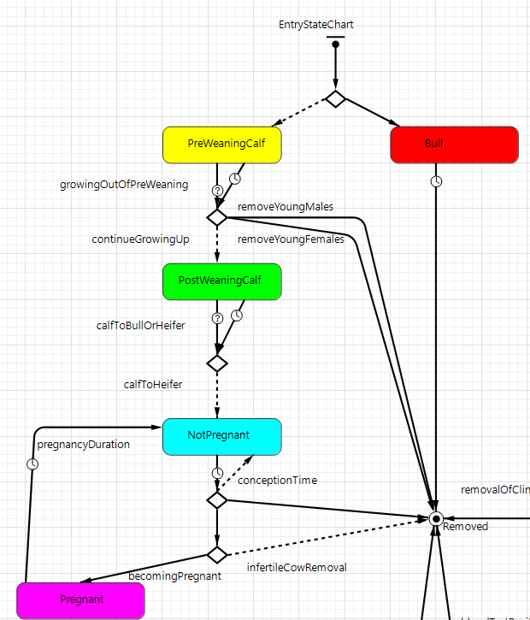

### Initial State

There are several things that are done at the start the model in order to get the life and pregnancy cycle into motion. Within a regular herd of cows on a farm, a majority of the cows are female. There is a significantly lower number of male cows that are kept around (for breeding purposes). Because of this, the initial Gender variable is set according to the parameter *InitialFemalePercentage* (95%). Once the model has started running, the chance a new calf is male or female is equal, at 50%. Age of cows is also varied at the start, the function *InitialCowPopulation()* gives the initial cows an age between 1 and 9 years old.

### Evolving State

There are two main factors or variables that govern state transitions: *currentAge,* and *Gender* (or more specifically, *isFemale).*

Age is kept track in two ways. One is implicitly through state changes. Young cows or newborn cows will start in the **PreWeaningCalf** state and be in this stage for 6 months and in the **PostWeaningCalf** state for another 6 months. The other way age is kept track of in the *currentAge* variable. This is used in the removal of old cows and keeping track of when they should die (in the *RemoveOldCows* event).

The second major variable or factor in the evolution of this statechart is the cow’s Gender, male or female. Male cows, as mentioned earlier, are removed more frequently; there should only 5% males in the population at any time. Because of this, there is a removal transition (from branch after **PreWeaningCalf** to **Removed**) in which all of male calves are removed after they are weaned. As well, male cows who stay within the population are segregated from the females (they do not go through the pregnancy states). Realistically, the small male population is kept separate from the females of the herd until breeding time, so Male cows do not add to the weighted prevalence of the disease. (See Interactions with other statecharts for more details).

Finally, there is another detail of evolving the state that is indirectly linked to these two main factors. Characterized in the model as “Population Control”, there is a mechanism in place via the transitions *FemalePopulationControl* by which cows are removed from the population as it grows too high. This mechanism can be thought of generally as removal, but more realistically would be the selling of stock. We characterize it as a general removal as the cows are no longer a part of the population.

### Pregnancy

Pregnancy, and by extension births, is the key element of this model. After female calves have grown up (12 months), they enter the Pregnancy cycle and wait until they are fertile at 24 months to begin having calves of their own. After 3 months of **NotPregnant,** cows enter the **Pregnant** state where they stay for 9 months before giving birth. One of the simplifications we took with this model is to not include direct interactions between male and female cows (via movement, proximity, etc). It is assumed that because we have a population of males and females that the mating process just happens, there is no need to simulate those interactions for the purposes of this model.

The birth rate of cows is 90%, the 10% of cows who do not become pregnant are removed on the assumption that they are too old, infertile, or other such ailment. When a calf is born, the mother and the calf are linked together via two variables, *mother* and *offspring.* The mother's *offspring* variable is set to the child calf’s agent and the calf's *mother* variable is set to the mother agent, this allows for mother-calf interactions (See Interactions with other statecharts for more details).

### Interactions with other statecharts

The biggest interaction between the statecharts is the dependence on infection transmission on states within the Pregnancy Cycle Statechart. There are two possibilities for getting infected (moving from **Susceptible** to **Infected**). One is *exposureFromEnvironment* and the other is *motherToChildInfectiveContactRate.* Exposure from the environment depends on the cows being in one of the two calf states, **PreWeaningCalf** or **PostWeaningCalf.** This is because cows are only susceptible to the MAP bacteria in the first 6-12 months of their life, after which their immune system is strong enough so that infection is unlikely to impossible. Secondly, the infection from mother depends the connection between the mother and the child during the **PreWeaningCalf** state. If the mother is infected and the calf is in the pre-weaning calf state, the is an approximately ⅓ chance over the first 6 months that the mother will infect the calf.

There are other, less direct interactions stemming from the Pregnancy Cycle statechart. As stated earlier, male cows are assumed to be separated from the general population; because of this, male cows do not contribute to *WeightedPrevalence,* which is used to calculate the environmental infection rate. Male cows essentially have no bearing on the spread of infection. Another critical interaction is with the Diagnostic Testing Model. Diagnostic tests are only performed on Adult cows within the **Pregnant,** **NotPregnant** or **Bull** states as even cows infected very early will not hit the **Subclinical** state during the calf states.

## Infection Model

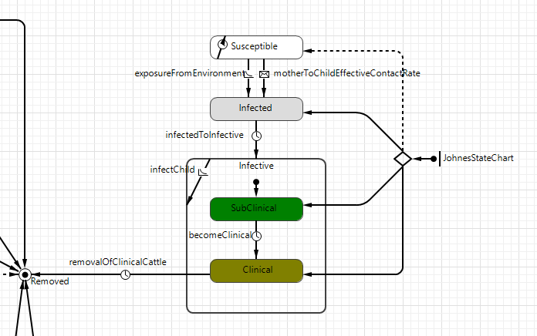

### Initial State

At the start of the model, cows can be in one of the four states **(Susceptible, Infected, Subclinical, Clinical)**. The percentage of cows being put in the infected, subclinical or clinical state depends on the *InitialInfectedPercentage, InitialSubClinicalPercentage,* and *InitialClinicalPercentage*. These will take a percentage of the cows that are old enough to be in one of the states and randomly seed the infection with a proportions of cows.

### Infection

After initialization, All calves start in the **Susceptible** state. To move to **Infected**, they either can get infected from their **Infective** mother (⅓ chance over 6 months) during the **PreWeaningCalf** State. Another method of infection applies if they are in **PreWeaningCalf** or **PostWeaningCalf,** in which case they can be infected from *exposureFromEnvironment.*

After they move to **Infected,** there is a time period to progress to each **Infective** state of the disease (**Clinical** or **SubClinical)** in which the disease can now spread. When cows reach the **Clinical** Stage, they are removed after the time set in *MeanClinicalRemovalDuration.* Only the cows in **SubClinical** or **Clinical** will affect the *WeightedPrevalence(),* with the weight of a single cow in either **Subclinical**or**Clinical** being determined by *SubclinicalPrevalenceModifier* (value of 1) or *ClinicalPrevalenceModifier* (value of 4).

#### Infection from Mother

One of the two methods of infection is infection from the mother, this rate of infection is around ⅓ chance over six months over the first six months of life (**PreWeaningCalf**). In order to keep this value consistent with the model time, this rate has been converted into a monthly rate which values is $$\frac{-log(0.7)}{6}$$. This is the monthly rate of infection based on a 30% chance over 6 months. This rate is only applied to cows with an infected mother.

#### Infection from Environment

Another way for cows to become infected by the disease is to be infected from the environment. If they are in **PreWeaningCalf** or **PostWeaningCalf,** they can be infected from *exposureFromEnvironment*, with the rate based off the *WeightedPrevalence() * FrequencyOfInfectiveContact * ( PreWeaningCalfIntensityOfPrevalenceModifer* OR *PostWeaningCalfIntensityOfPrevalenceModifer )*. The intensity prevalence modifiers are based on disease information and research suggesting that as the cows grow older and develop they become less susceptible to catching the disease, up to a point that the chances of contraction are low. The current model assumes that pre-weaning calves are fully susceptible and post-weaning calves are half as susceptible due to their relative maturity. Adult cows are no longer in danger of contracting the disease.

*FrequencyOfInfectiveContact* is the biggest unknown factor in the model; it is the key value when it comes to calibration and tuning of the model. This value embodies the number of contacts and chance to become infected with each contact. Modified by the weighted prevalence (that is, the pervasiveness of the disease within the population) this value becomes the effective rate of contact from the environment that a cow experiences at any one time. The model itself is quite sensitive to changes in this value.

### Interactions With Other Statecharts

The impact of the fecal and blood test results rely on knowing which state of the infection the cows are in. If they are in **Susceptible,** they will only get removed if they are a false positive test result. If a cow is in **Infected, SubClinical** or **Clinical,** they have a chance to be removed by a true positive test result, with the possibilities varying based on state and test type. Fecal tests, for example, are more effective in the later stages of disease.

The infection statechart includes interactions which were mentioned above, in the Birth, Pregnancy, and Population Control Model.

## Diagnostic Testing Model

There are two statecharts that handle the flow of cows through the testing sequence; **FecalTestingStateChart** and **BloodTestingStateChart**. They both have the same logic, which will be explained below.

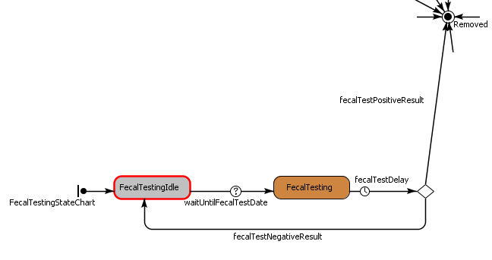

The two main features of these statecharts are simulating delay of the annual testing cycle, and removing cows that return a positive test result. The original reason for creating these statecharts as opposed to removing cows directly from the action chart was to simulate this delay as a timeout. The testing months for blood and fecal testing can be changed individually using the sliders in the simulation experiment window. The delay for test results can also be changed via the sliders in the simulation experiment window. The figures found in these charts were gathered from “Testing for Johne’s’ Disease”.2

The expected result of testing for and removing disease positive cows is the reduction of prevalence of Johne’s Disease in the herd. Changes to the testing parameters to see the effect on prevalence will be performed in the Scenarios section of this report. For information on the Action Charts associated with the testing types, see Diagnostic Testing Action Charts.

### Testing Idle States

**FecalTestingIdle** and **BloodTestingIdle** are the states which the cows reside in while they are not being tested. The baseline testing month for both Blood and Fecal testing is October, which is the only time that the cows will not be in this state. These dates can be altered within *FecalTestingDate* and *BloodTestingDate* parameters.

### Testing States

**FecalTesting** and **BloodTesting** are the states which call on the testing logic for all cows if the test is set to active. The parameters in main called *runFecalTest* and *runBloodTest* control whether these tests will be run.  
 This state calls the appropriate Action Chart associated with its test type, and the result is a determination as to whether or not the cow is infected. It’s important to note that due to the *fecalTestDelay* and *bloodTestDelay* transitions that lead out of this state, test positive cows are not removed immediately after having acquired the *toRemove* status.

## Diagnostic Testing Action Charts

There are two Action Charts, one for each test type that is currently implemented, and which handle the testing logic; **FecalTestActionChart** and **BloodTestActionChart**. They both have the same logic which will be explained below. Each run through this action chart will be considered one test on exactly one cow. The tests are currently conducted on the entire population of adults.

### Is the Cow Disease Positive?

This condition separates susceptible cows from those who are infected with the disease. The model takes into account specificity of testing, which is the percentage of true negative test results. These specificity percentages were significant enough to include in the model, and so there is a chance for removal of cows from the population even when they do not have Johne’s Disease. This percentage is small; it is 0.01 (1-*fecalTestSpecificity)* for Blood ELISA testing and 0.001 (1-*bloodTestSpecificity*) for Fecal Culture testing. These are very low percentages, but over the 20 years that the model runs, these add up to a significant amount of cows removed through false positive testing.

In the case where the Cow is disease positive, it continues down the decision tree, where its sensitivity, the rate of true positive test results, is calculated based on percentages that depend on the stage of infection of the cow. The percentages for each stage of infection are as follows:

**Infected:**

Culture Fecal Sensitivity: 0.01

ELISA Blood Sensitivity: 0.1

**SubClinical:**

Culture Fecal Sensitivity: 0.3

ELISA Blood Sensitivity: 0.4

**Clinical:**

Culture Fecal Sensitivity: 0.5

ELISA Blood Sensitivity: 0.8

The Cow is marked for removal if the result of the Specificity test is false, or the result of the sensitivity test is true. At this time, analytical data is collected on the how the cow was removed if it is test positive. The reason for this is so that future work can be done to determine when to stop testing a herd. It’s also a good measure of success for the tests. Charts plotting *True Positive / Total Disease Positive* and *True Negative / Total Disease Negative* for both test types can be found in the Testing analytics charts group.

Another measure of success is the ratio of *# removed by false positive testing / total number removed by testing*. As this value approaches 1, it means that testing is no longer catching disease positive cows and only false positive tests are being returned. It’s expensive for a farmer to continue testing a herd, so once a certain level of confidence has been reached that a herd is disease free, testing should be stopped. Naturally, a farmer would not be able to distinguish between false positive and true positive testing, but the simulation data can be used to identify better algorithms for labeling a herd disease free with greater confidence. This feature has not been implemented yet, so more details will be in the Future Considerations section of this report.

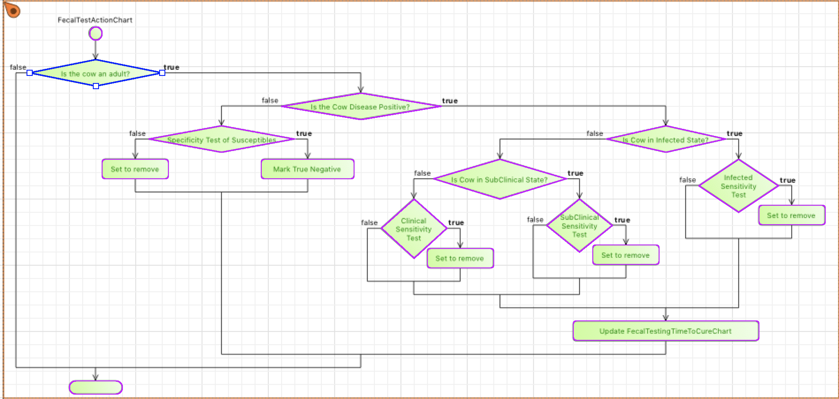

# Calibrations

We performed manual calibrations for the Frequency of Infective Contact. All other parameters stayed constant during these manual calibrations. With fecal and blood testing turned off, The population should reach 10-15% true prevalence over 20 years with no active testing. The manual calibration runs for 50 realizations with the same parameters, and we can see the output below using our tuned value of 6.6. We can see that there is a large amount of variance, but the prevalence usually falls between 10-15% by 20 years. The large fluctuations within each year can be explained by the large influx of calves into the population every April.

X-axis = time in months

Y-axis = prevalence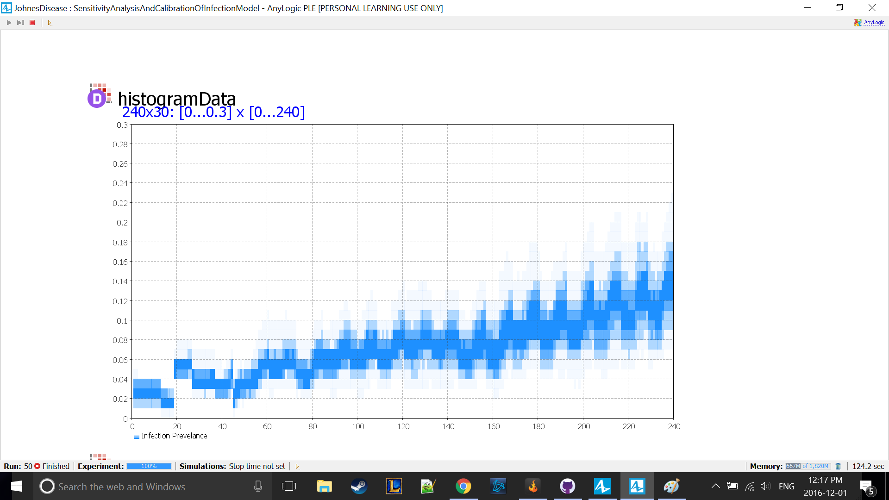

# Sensitivity Analysis

## Variation of Initial Infection

Doing sensitivity analysis on this model can help to define which parameters are useful for use in scenarios and which ones are not. The majority of this analysis will be to determine the change in Prevalence based on parameter changes.

### Initial Clinical Percentage (baseline value 0.01, no testing)

*InitialClinicalPercentage* at 0.02:

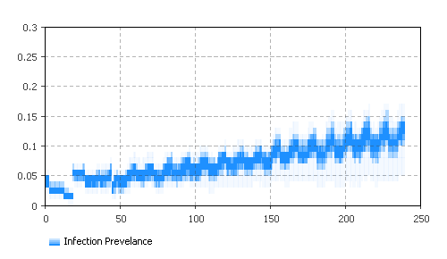

Changing this value didn’t seem to change the general slope of the prevalence. Let’s try a larger value.

*InitialClinicalPercentage* at 0.2:

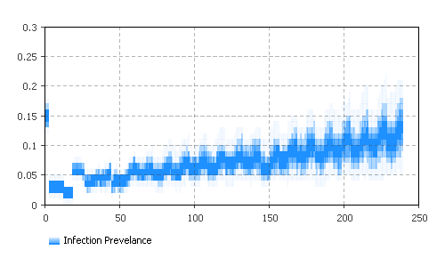

Again, very little change. The reason is because clinical cows get removed automatically after 2 months (*MeanClinicalRemovalDuration*) because at this stage of the infection the disease has a massive effect on the cows’ health. Even if half of the population was Clinical to start, they would be removed within 2 months and wouldn’t spread the disease by a great amount. In fact this was tested, and the histogram is the same as when the initial percentage is 0.2.

### Initial Subclinical Percentage (baseline value 0.03, no testing)

*InitialSubclinicalPercentage* at 0.3:

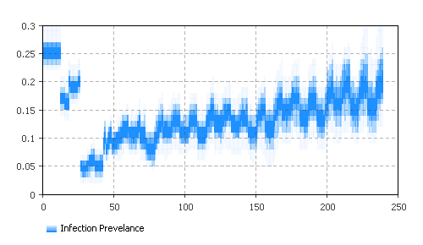

We expected this to cause more of a change in the slope of the prevalence. The difference in the amplitude did change. Every 24 months the prevalence drops as Cows enter clinical state and die, then the prevalence goes back up as the calves who were weaned by Infected or Subclinical mothers change infection states, then back down as those calves die. This cycle gives the graph a less linear shape. We’ll try a simulation with high Infected Percentage and high Subclinical Percentage to see if we can make this more extreme.

*InitialInfectedPercentage* at 0.5 AND *InitialSubClinicalPercentage* at 0.5:

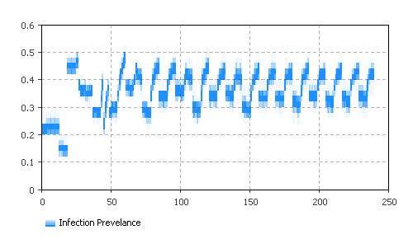

We expected an initial large spike in prevalence, followed by a drop after 26 months when the SubClinical cows become Clinical and die. That does happen, but then the prevalence jumps to almost 0.5 and oscillates by 0.1 between 0.32 and 0.42. The overall prevalence has been increased on average, but it reaches some sort of equilibrium value and maintains a maximum. This would suggest that prevalence in a population, at least as we have simulated it, cannot exceed a certain value. It may be because once a cow is removed from the population, there is no source of lingering prevalence. The prevalence is recalculated without that infected cow. In reality, some of the disease might remain from that cow in the environment.

### Varying Initial Infection Conclusion

Varying the initial levels of infection did have a large impact on the overall growth and spread of the disease, but it did not have the level of effect that we were expecting. Starting with over ten times the subclinical cows (from 0.03 to 0.3) did not even double the prevalence by the end of the simulation. It is interesting to see the lack of sensitivity when it comes to the initial disease, that starting with many infected cows does not greatly increase either the slope or the final prevalence by an equal degree.

## Frequency of Infected contact

This part of the model is critical; it is a key value of the model, and the main value that we used when calibrating the model outputs to reach expected level. This value captures two things, the number of contacts a cow has and chance to become infected with each contact. Coupled with weighted prevalence, the weighted proportion of the herd that is infected, we come to our total rate of infection (environmental infection). This value represents two unknowns for the population, combined into one value. It is of critical importance as it dictates the spread of the infection throughout the population.

### Normal value of 6.6

This is the baseline run of the simulation; 6.6 is the value that was found that best fits the desired outputs (based on real populations).

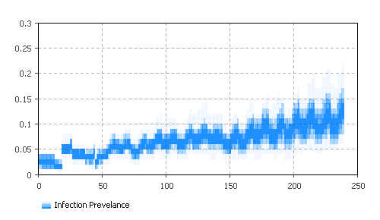

### Alternate values

Frequency of infective contact is a particularly sensitive value; an increase in ~10% affects the model output quite significantly – with no testing the value of the prevalence over time increases from around 0.13 to 0.18, almost a 40% increase. Similarly when we decreased the value by ~10% we get a similar magnitude of drop, from 0.13 to 0.06 in overall prevalence. This indicates, as expected, our uncertainty in this value, small changes in this value can lead to big impacts to model output, research and data on this value and the particulars of disease transmission would go a long way to giving more confidence in the output of the model.

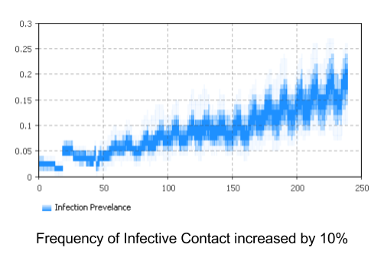

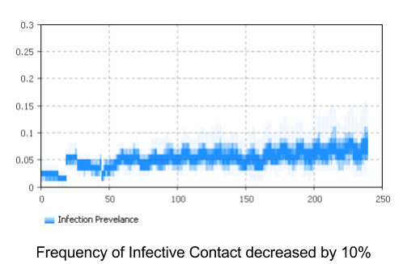

# Scenarios

The scenarios built in the Johne's Disease model show information that can be used to achieve great understanding of the underlying features of the model. With the testing scenarios, it compares different testing regimes of managing a diseased population.

## Baseline No Testing

The baseline model with no testing is what was used in calibrating the natural progression of Johne’s Disease Prevalence in our model. For more details on the calibration, see the Calibrations section.

Figure s1 is the collective 2D histogram of prevalence without testing. There are 50 simulations run to remove bias.

Figure s1 is the most important chart. It shows Prevalence of Johne’s Disease over time in one simulation run of 20 years. Without interference, a herd starting with ~2-3% of the Cows infected approaches an infection percentage of 15%. Most future scenarios will be comparing with these graphs.

Figure s2 is a record of cow removals through various means. What we expect to see with testing turned on is no change in removal by population control, failed pregnancies or old age every year, but instead a reduction of removals due to clinical sickness and an increase (from 0) of removals due to testing. These two data sets will only show until the disease is eradicated from the population.

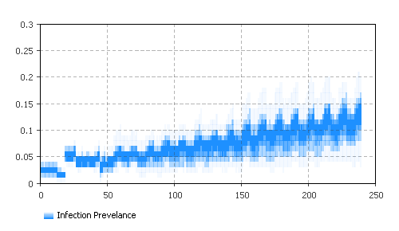

Figure s1: Baseline No Test Weighted Prevalence - 50 simulations

## Baseline With Testing

### Both Tests Active

Expected:

The expectation for both tests being active is that the prevalence will be reduced to 0 before the end of the simulation completes. This is due to the very high testing sensitivity for Blood tests for Subclinical cows. We do still expect fecal testing to have an effect on the model, but not as much as the blood testing.

Result:

The resulting histogram will serve as a baseline comparison for Blood or Fecal testing on their own.

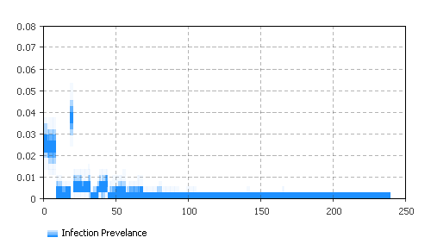

### Blood Test Only

Expected:

Slower removal than Both tests active, but faster than Fecal Testing alone. We expect the difference between Fecal and Blood testing results to be quite significant because the higher sensitivity in Blood testing is when the cow is in the SubClinical state.

Result:

This result looks similar to the Slow Removal After Testing scenario below. The reduction in prevalence is also significantly better when compared to Fecal Testing. Our theory is that this is mostly due to the highest sensitivity to blood testing being when the cow is in the **Subclinical** state. The *MeanSubclinicalDuration* for any cow is 24 months, which means a cow stays in Subclinical for 24 months before becoming Clinical. Every Subclinical cow goes through two cycles of testing with an 80% chance of a true positive result being returned when blood testing is active.

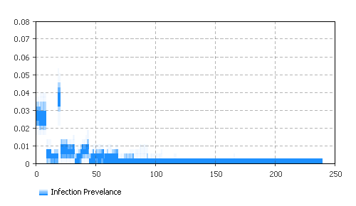

### Fecal Test Only

Expected:

The Clinical testing for Blood testing is 10% more effective than for fecal testing, and the SubClinical testing is 20% more effective, so Fecal testing should be at least 20% less effective at catching the disease.

Result:

Fecal testing succeeded in keeping the disease under control. The overall slope of the collective histogram is slightly negative, so the disease is slowly dying out.

Since the highest sensitivity for Fecal Testing is in the **Clinical** state, any cow only has a maximum of one cycle of fecal testing with a chance of 60% for a true positive test result to be returned.

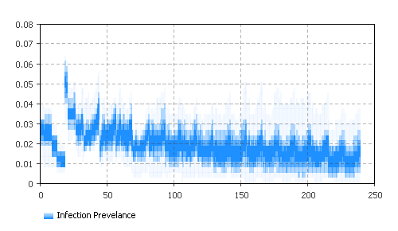

## Slow Removal After Testing

The *WeightedPrevalence* is a statistic in the **Cows** population which takes the average of the prevalence modifiers for the population. The longer a Clinical or Subclinical cow stays in the population, the higher the effective Prevalence will be and the greater chance other cows in the population will become infected. One way to combat this is fast isolation/removal of cows once they are determined to be Clinical or Subclinical.

This scenario in comparison to the Fast Removal After Testing scenario will hopefully show how significant of an effect the *PositiveCowRemovalDelay* parameter has on the Weighted Prevalence of the model.

Expected:

Cows continue to shed in the herd for a longer average amount of time. *MeanClinicalRemovalDuration* is set to 2 months, so the largest value for *PositiveCowRemovalDelay* is 2 months (baseline is 2 weeks). I expect the Prevalence to take longer to reach 0 when we have a longer removal delay.

Result:

After running 50 simulations, we found that the vast majority of the time, prevalence reached 0 before 100 months. Now we’ll compare this result with the fast removal rate scenario.

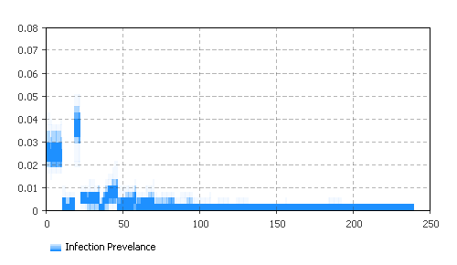

## Fast Removal After Testing

Expected:

We expect the Weighted Prevalence to show a significant drop after every testing cycle, but what’s important is whether the Prevalence jumps back up within 3.5 years (MeanInfectedDuration + MeanSubclinicalDuration). The baseline scenario with both tests active has the Prevalence hit 0 after a maximum of 80 months. The expected result of this scenario is that the Prevalence will reach 0 before 80 months.

Result:

In contract with the slow removal rate scenario, this batch of 50 simulations shows that the majority of the time the Prevalence was reduced to 0 before 60 months. The expectation of this scenario has been met. The difference between removing a cow within a week after test results return positive and removing them after 2 months is an additional 40 months to remove the disease from the population.

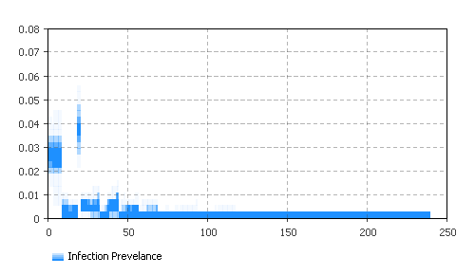

# Learning

As a team we gained lots of insights into the modeling process, the challenges associated with modeling as well as the challenge of modeling a real world scenario and using real world data (or, in our case, lack thereof!). If we were to do this project again, it would be interesting to take a more agent based approach to the infection model, with the current model we abstracted the environmental infection rate/prevalence into an aggregate value, applying it to each cow, in reality there would be nuances of environment and habitat (feeding areas versus sleeping areas or pastures vs pens, etc.) that could make a difference. As well, our study focused primarily of beef cows, but dairy cows also deal with the disease but live in different sets of conditions. This different architecture might include Discrete Event workflows to model the cows daily activities within their spatial environment.

Taking a different approach would require more data real life data to base interactions on that we simply did not have within the current scope of the model; having more data would have affected the approach we took. With the limited data, it was an easier decision to take a more aggregated System Dynamics-inspired approach so that we could condense our unknown into a few values rather than have to manage many unknowns around cow activity and transmission. We learned a lot about the domain area, about transmission and lifecycle modeling for cattle that could be easily applied to other animals or diseases. We have and a great opportunity to work with a knowledgeable stakeholder that was able to give us valuable feedback both in the modeling process area as well as the problem area of Johne's Disease. The project has given us a chance to expand our knowledge around medical diagnostic testing and terminology and how testing Sensitivity and Specificity are used practically within the field.

On the actual development of the model, we took a pair programming approach. We found that we developed the model faster than we would have working alone. Another benefit to this is that we caught more bugs sooner than we would have solo. In addition to this, we store our repository on GitHub to prevent any critical data loss.

## Challenges

One of the biggest challenges we faced with this project was the lack of data around the disease and its transmission. We had some basic information around long run trends ( progression of true prevalence from ~3% to ~15% over 20 years) as well as information about transmission rate from mother to calf (⅓ over 6 months). Other than these basic points, we did not have historical data around environmental transmission and prevalence within real herds of cattle. Having more or different data points would have influenced our architectural decisions, but we took the approach we did partly because of the limited amount of data available and had to work around these limitations. The challenge therefore was building the model around or to accommodate these values so we were able to best represent the model and the available data.

One of the other challenges we faced is related to this idea of limited data in that, we had to make compromises or sacrifices in parts of the model in order to get a model that was straightforward and easy to use. We made choices, especially around the birth and pregnancy statechart that reduced the model complexity and possibly true to life accuracy in favor of a simpler and easier to understand model (using timeout instead of distributions). Picking what to include and – in many cases – what to ignore were some of the more difficult problems to tackle as part of the modeling process. After working through these challenges, we can see the value of simplicity in some parts of the model, especially in parts of the model that are necessary but not critical to the goals of the model and output.

# Future Considerations

Further considerations for the model would be to expand the graphs and reporting of data. Some smaller graphs that could be added are what fraction of the cattle are ill and get diagnosed, or analysis of different scenarios might reveal important information for the model.

Some considerations for the model itself would be about proximity and spatial modeling of the cattle, which was excluded in the model. This would affect the prevalence. A second step to consider, would be the removal of cows for different farms. Different farms have different priorities on the cows being removed. For example, a farm might sell more older cows than younger ones, or vice versa. This could affect the rise of prevalence. Next, adding support for other tests might show better results in reducing prevalence. Lastly, some of the parameters were based off of hypotheses, so further study of Johne's disease would further improve the model.

Due to testing being so expensive, it would be beneficial to produce a function for stopping testing once a certain confidence level has been reached that the herd is disease free. As mentioned in Is the Cow Disease Positive, as ratio of *# removed by false positive testing / total number removed by testing* approaches 1, the amount of wasted testing increases. Calibrating to find a decent stopping point for testing to avoid just as this ratio = 1 is a good goal for the future to save money.

# Conclusion

The goals of this project were to create an accurate, adaptable model of Johne's Disease, one that would allow better understanding of possible testing regimes that can be used to control and manage the disease in a herd. The current state model achieves all of these goals; it includes a model of cows and disease spread through an Agent Based model using elements of inspired by classic aggregate modeling. The model includes as well an adaptable system of diagnostic testing where tests can be run solo or in tandem. Through the model, we have gained insights into possible testing regimes, and how different sets of testing can manage the prevalence over time, with enough flexibility to be adapted and reused for different simulations in the future. Our calibrations and analysis of the model have found some places where historical or experimental data may be most pertinent to increasing the accuracy of the model.

Overall, our group felt that the project was a success; we developed a base understanding of cattle and farming practices, the spread of Johne's Disease and control. In addition to this, we learned about many of the terms used to describe diseases, and how to model them using a hybrid approach. Compared to doing the assignments, we felt like we gained greater insight into the agent based modelling process. The only drawback to this is that we might have a weaker understanding of the course material as a whole.

On the actual model, we felt like we achieved what Dr. Waldner had envisioned for this project. Working with Dr. Waldner gave us a great opportunity to get experience with a real modeling scenario. Compared to a system dynamics model, we felt using a majority of agent based modeling techniques did a better job at describing the situation. To further iterate on the model, using proximity based disease hazards might be a good way to replace the random chance a calf gets infected from the prevalence of the herd. While out of our control, as a group we felt the need for more data to tune and refine the model.

# References

1. *“Johne’s Disease: Prevention and Control” BCRC,* Feb. 29 2016, <http://www.beefresearch.ca/research-topic.cfm/johnes-disease-51#vaccination>
2. *Testing for Johne’s Disease*. Aug. 2015. Accessed Sep. 2016. <https://www.nmr.co.uk/uploads/files/files/testingforjohnes.pdf>
3. *Guidelines for Johne’s Disease Test Utilization and Interpretation for Ontario Veterinarians.* Dec. 2009. Accessed Sept. 2016. <http://www.johnes.ca/pdf%20files/interpreting%20johne's%20test%20results%20for%20vets.pdf>
4. *“Repository - Anylogic Model of Johne's Disease in beef cattle.”,* Dec. 7th 2016,<https://github.com/magnusandy/ModelingJohnesDisease>