

|  |
| --- |
| Reference Guide |

|  |
| --- |
| Table of Contents |

Reference Guide 1

Table of Contents 1

1 Employee Table Management (Unique Features) 2

1.1 Adding a New Employee 3

1.2 Editing Employee Information 5

1.3 Deleting an Employee 8

1.4 Setting an Employee Supervisor 11

1.4 Deleting an Employee Supervisor 13

2 Department and Other Categories Management (Shared Functionality) 16

2.1 Adding a Record 17

2.2 Editing a Record 19

3 Login and Logout Functionality 23

3.1 Logging in 24

3.2 Logging out 24

4 Search Functionality 24

3.1 Using Search by ID Across Categories 25

3.2 Using Search Buttons on left Navigation Bar 25

|  |
| --- |
| 1 Employee Table Management (*Unique Features*) This section is intended for highlight how authorized users can make add, edit, and delete records for the Employee data type. |
| 1.1 Adding a New Employee  1. After logging in, you'll land on the **Employee** screen by default. You can also use the **navigation bar** at the top of the GUI to switch between different sections.        1. Navigate to or stay in the **Employee section** and press the **Add Employee** button on the bottom left of the panel. |
| 1. The **Add New Employee modal** will open, fill out with new employee information. To navigate to other pages, use the **Next and Back** buttons on the bottom right of the modal.        1. When new employee information is filled out, navigate to or stay on the **final page** of the modal. There you’ll see that the **Next** button has become a **Finish** button. Press this to store employee information in the database. |

1. If all information is filled out properly, you’ll get an **Employee Added Successfully** message.

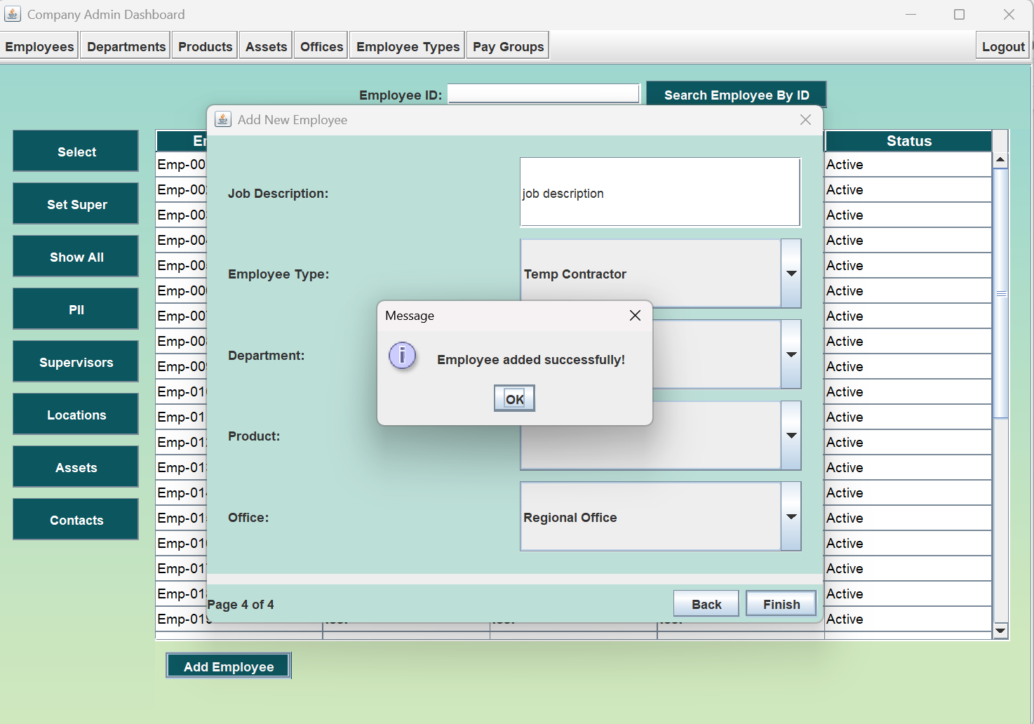

1. View new Employee at the bottom of Employee table.

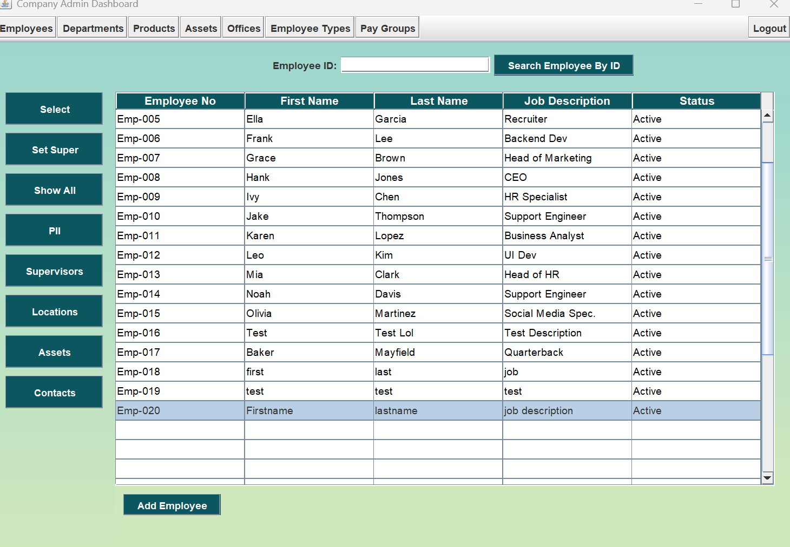

## 1.2 Editing Employee Information

1. To edit employee information, select a row on the Employee table and press the **Select button** at the top of the left navigation bar.

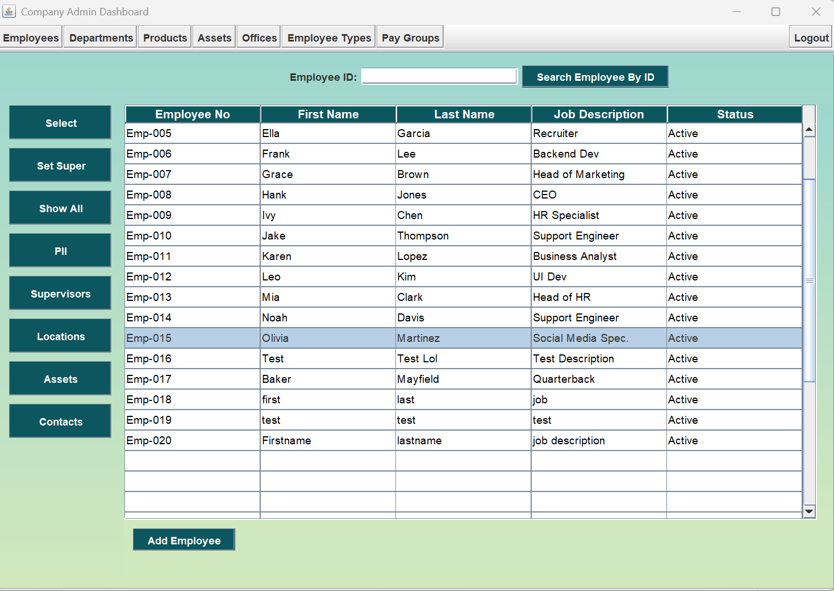

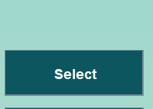

1. This opens the **edit modal** with fields already filled out. Change fields as you see fit, navigating between pages using the **Next** and **Back** buttons on the bottom right of the panel.

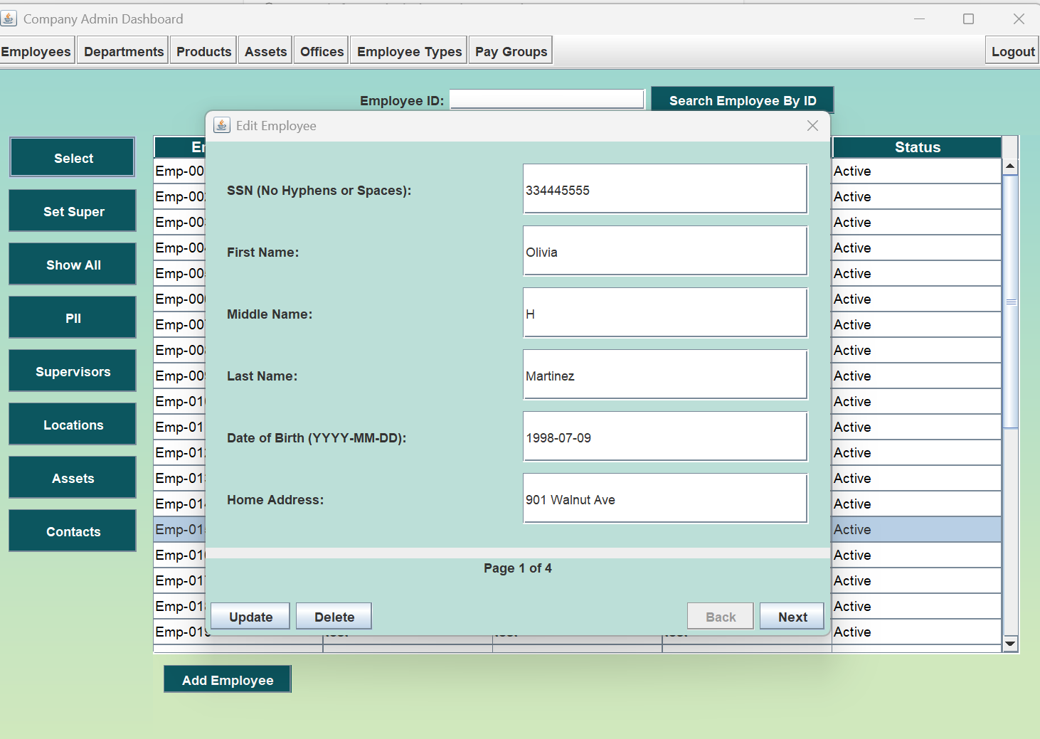

Example update:

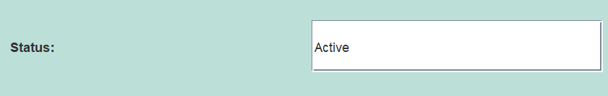

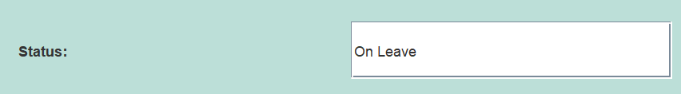

1. When you’ve finished editing, press the **Update button** at the bottom left of the edit modal.

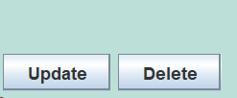

1. If all information is filled out properly, you’ll get an **Employee Updated Successfully** message.

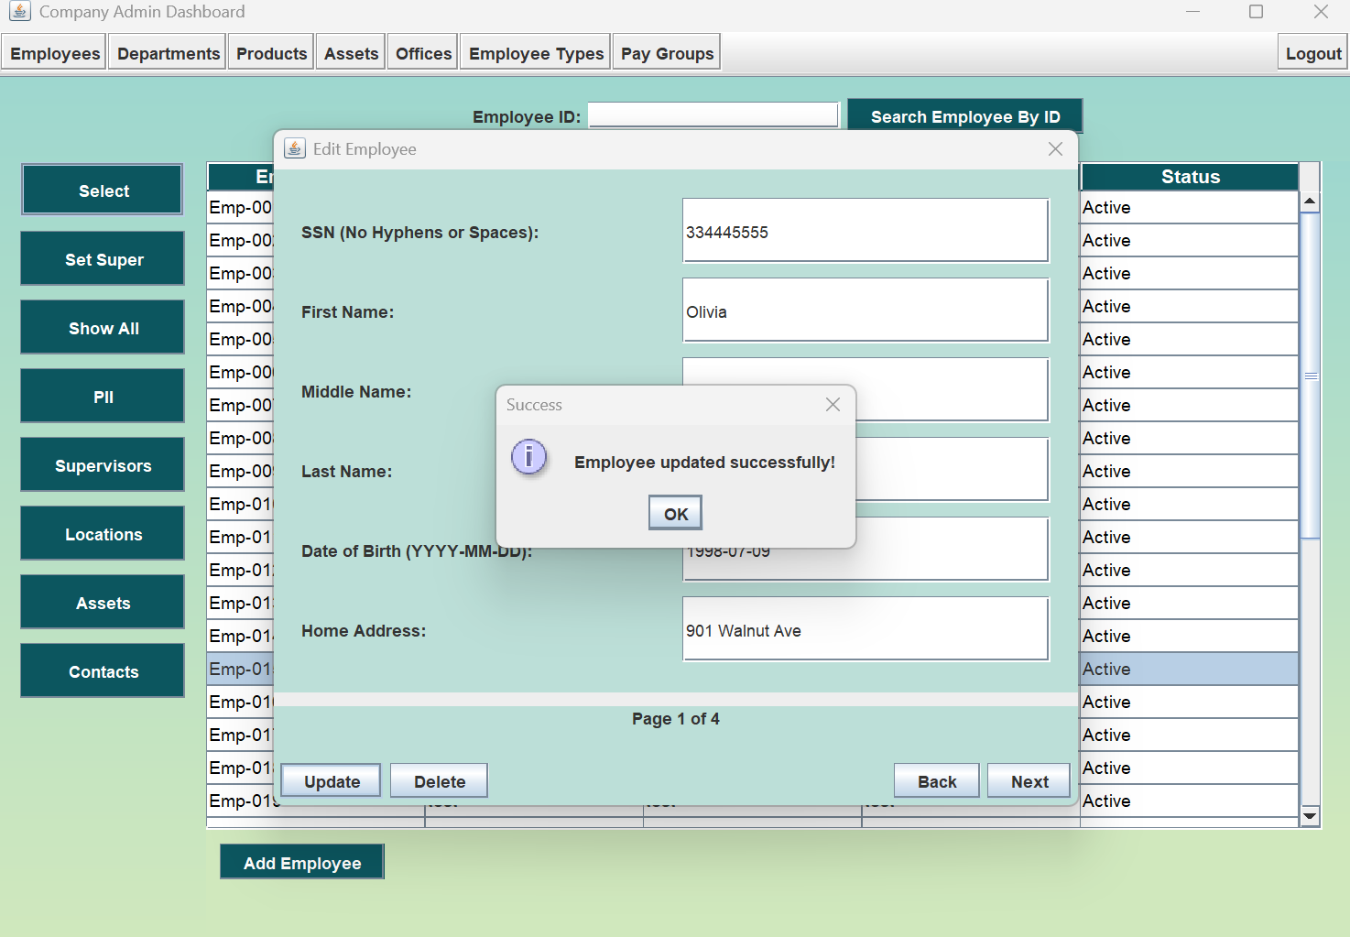

1. Press **Show All** Button near the top of the left navigation panel. This will refresh the page so you can view your edits.

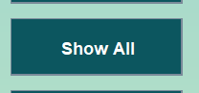

1. View successfully updated employee in Employee table.

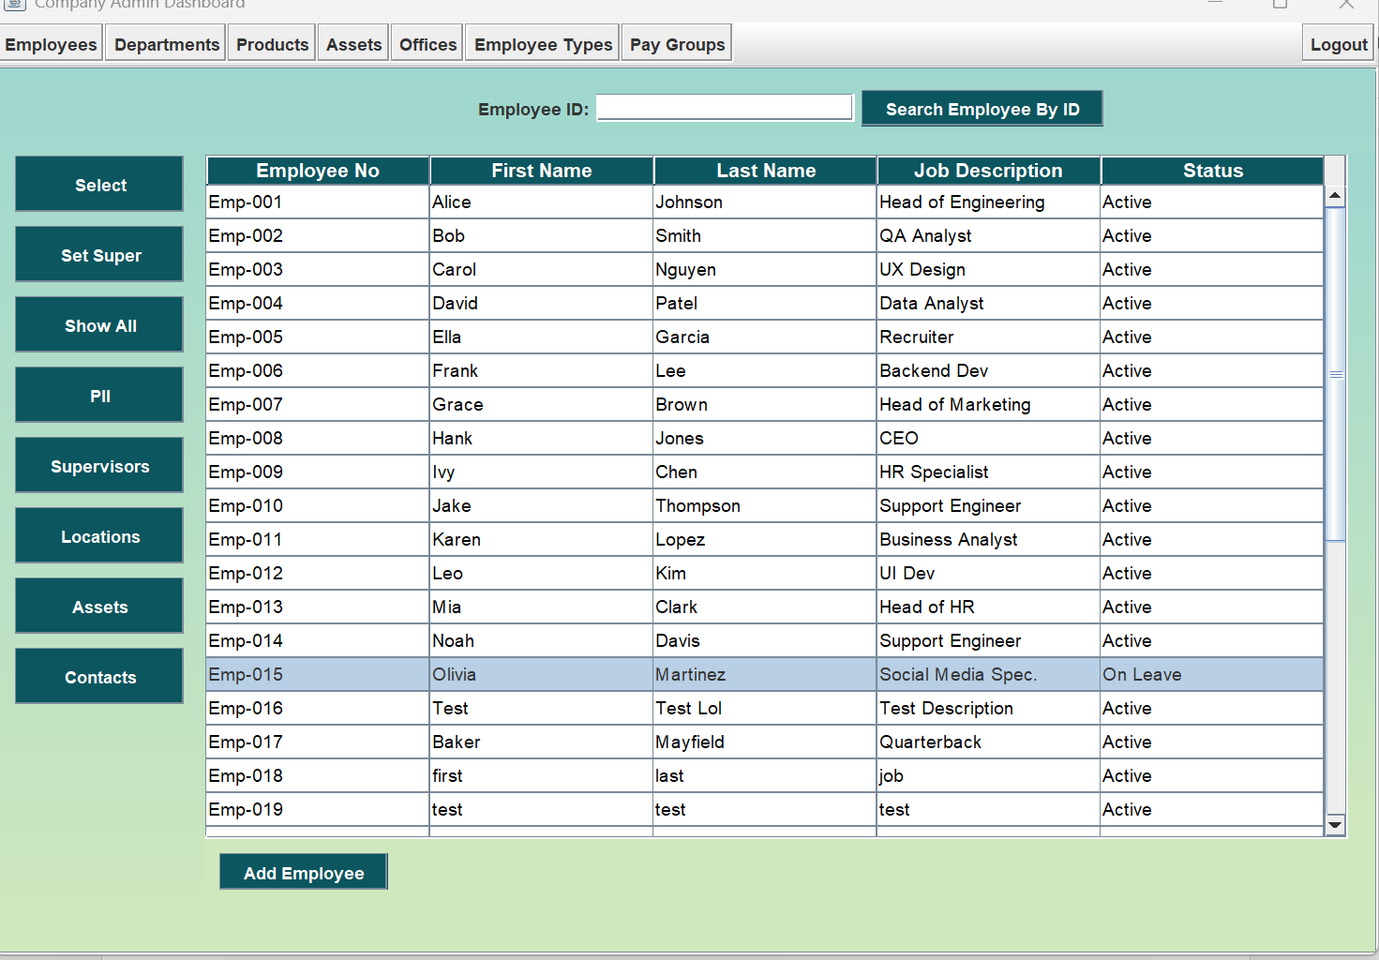

## 1.3 Deleting an Employee

1. To delete an employee, select a row on the Employee table and press the **Select button** at the top of the left navigation bar

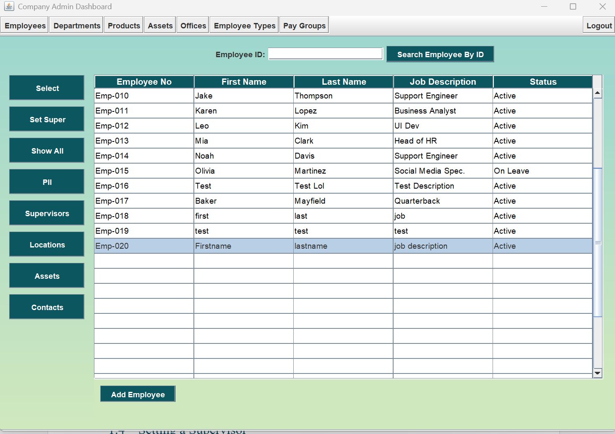

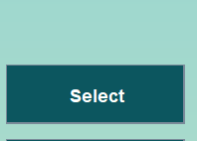

1. This opens the **edit modal** with fields already filled out.

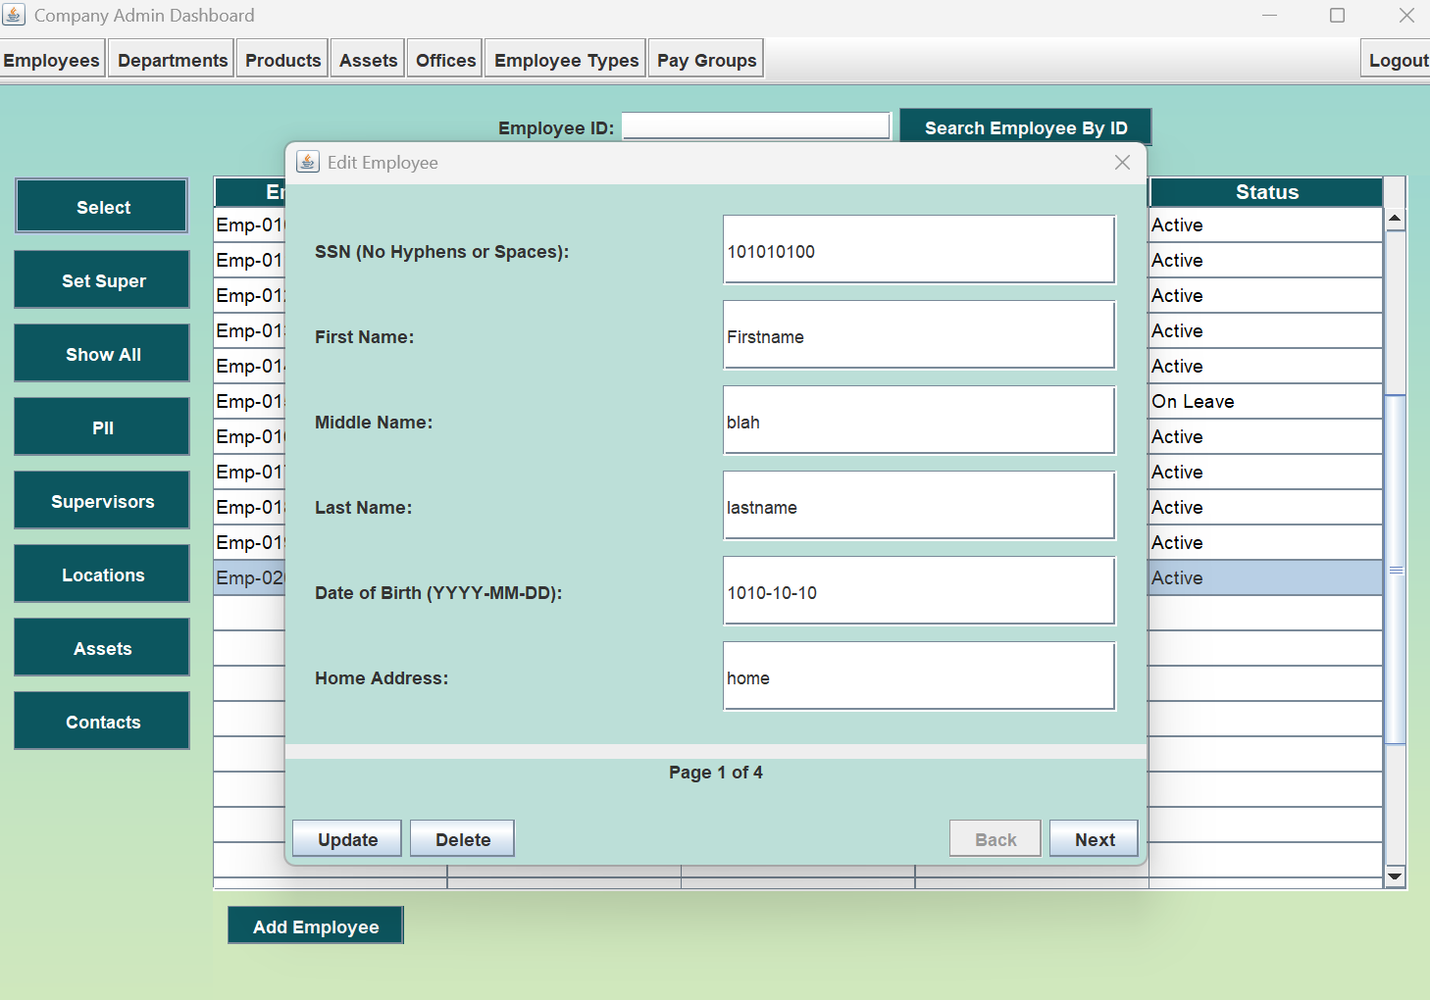

1. Press the **delete button** on the bottom left of the **edit modal.**

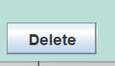

1. This will open a prompt asking if you’re sure you want to delete the employee (**this is permanent**). Press the **Yes button** to delete.

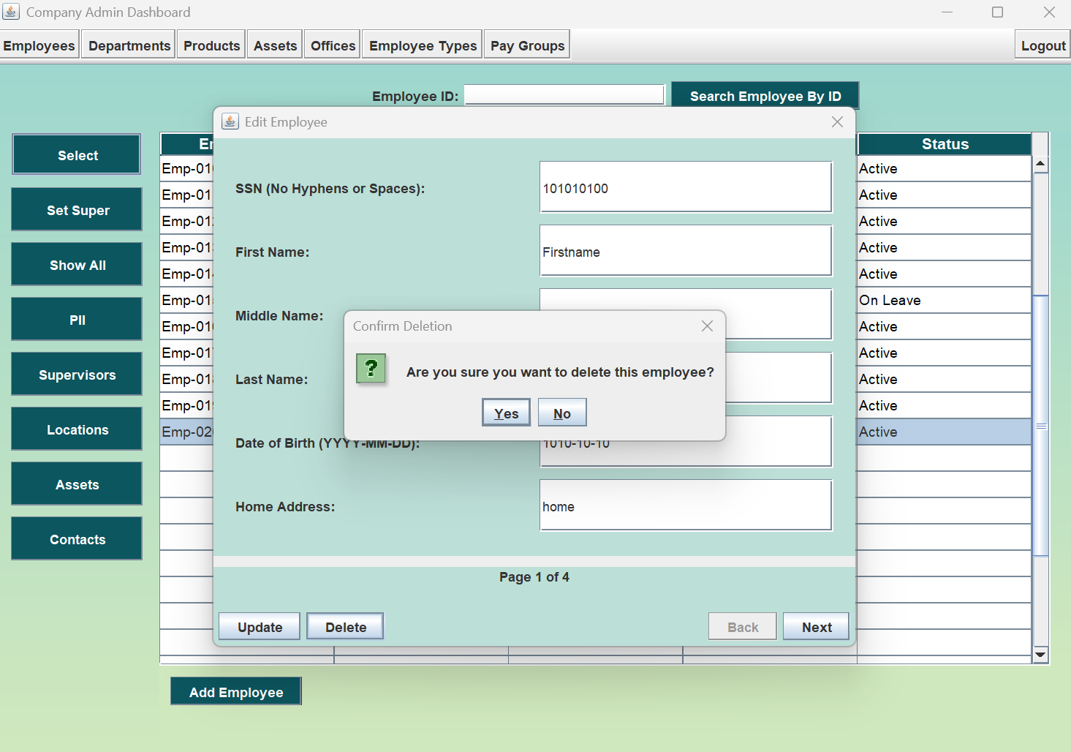

1. An **Employee Deleted Successfully** message will display.

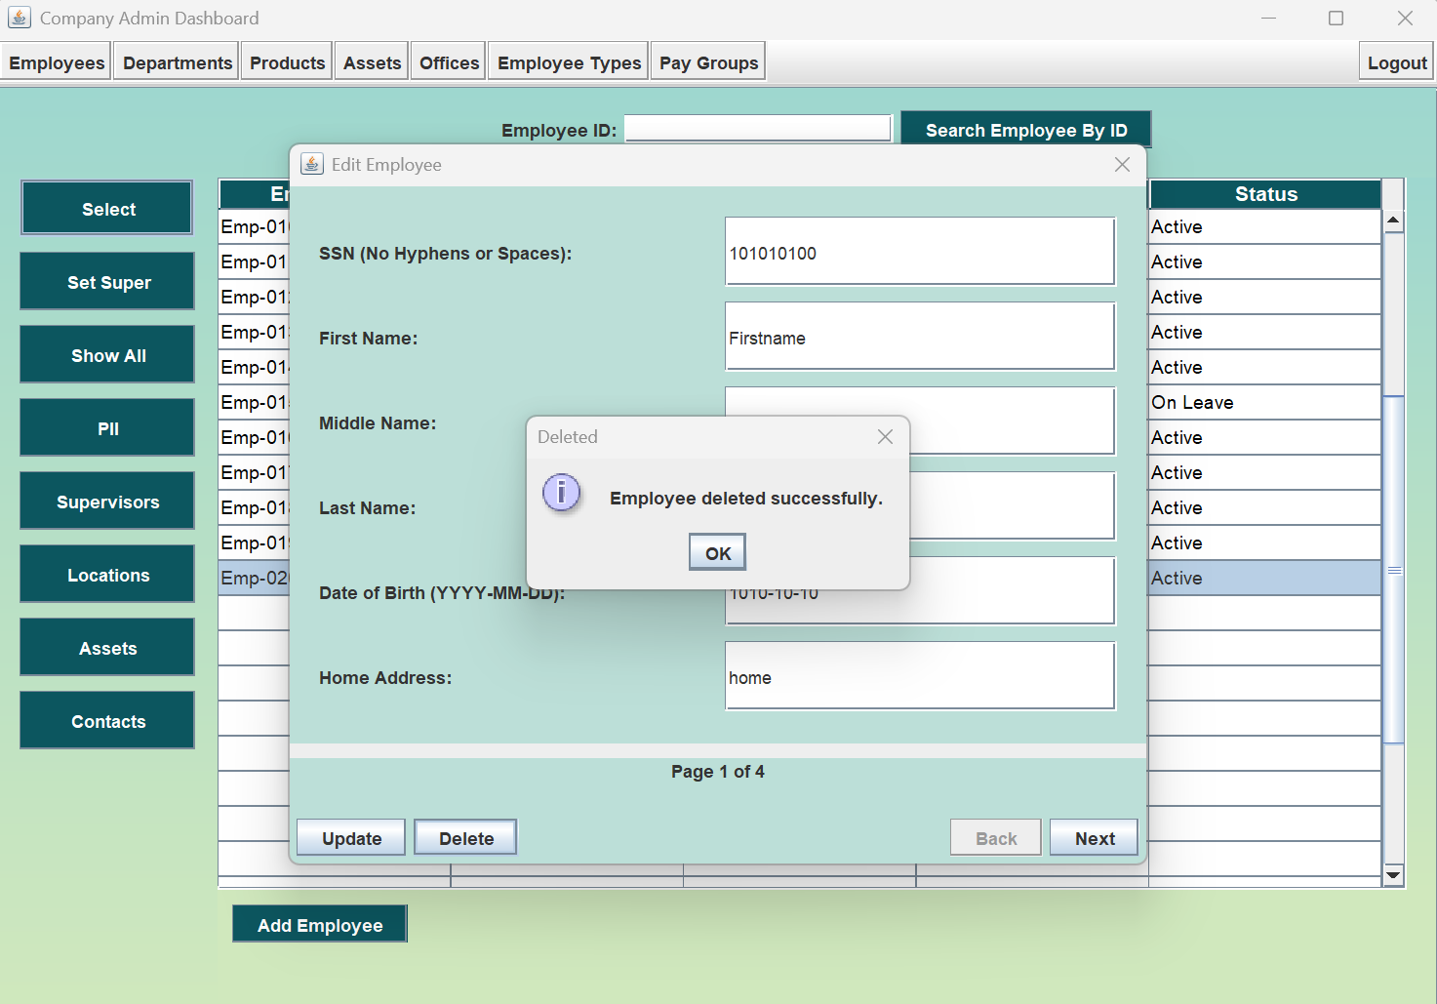

1. View Employee table with removed employee.

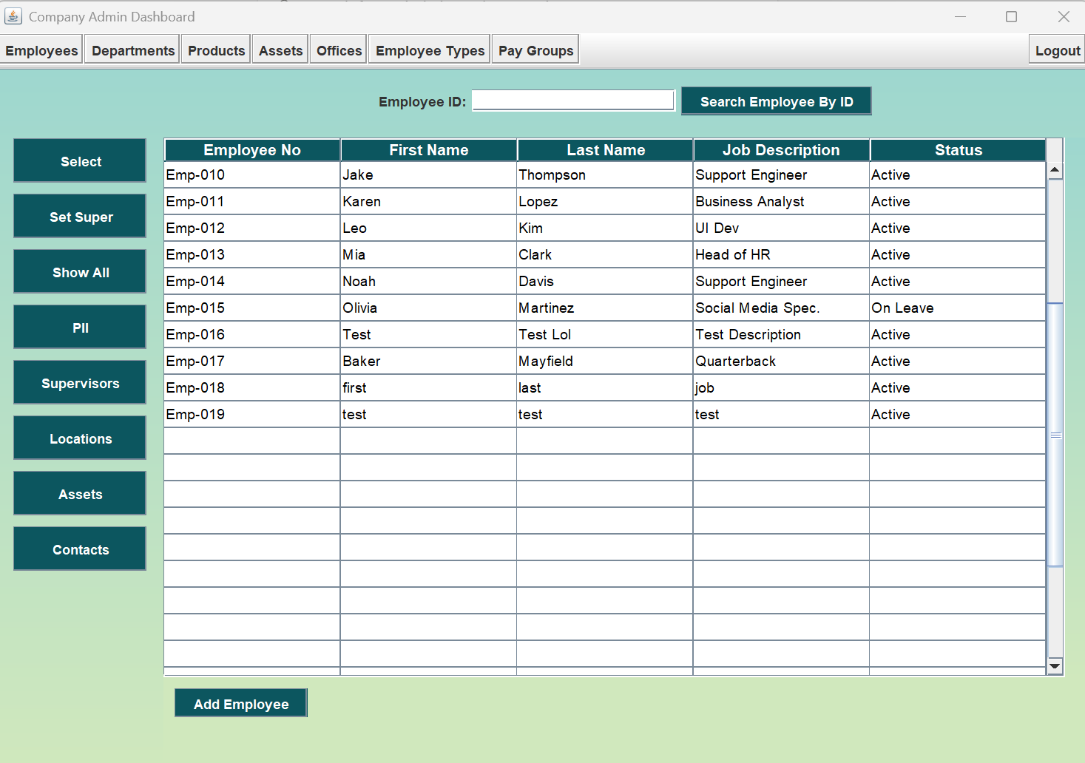

## 1.4 Setting an Employee Supervisor

1. To set an Employee Supervisor, first use the buttons on the left navigation bar to either display the **Show All** page or the **Supervisors** page**.**

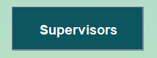 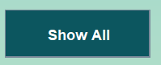

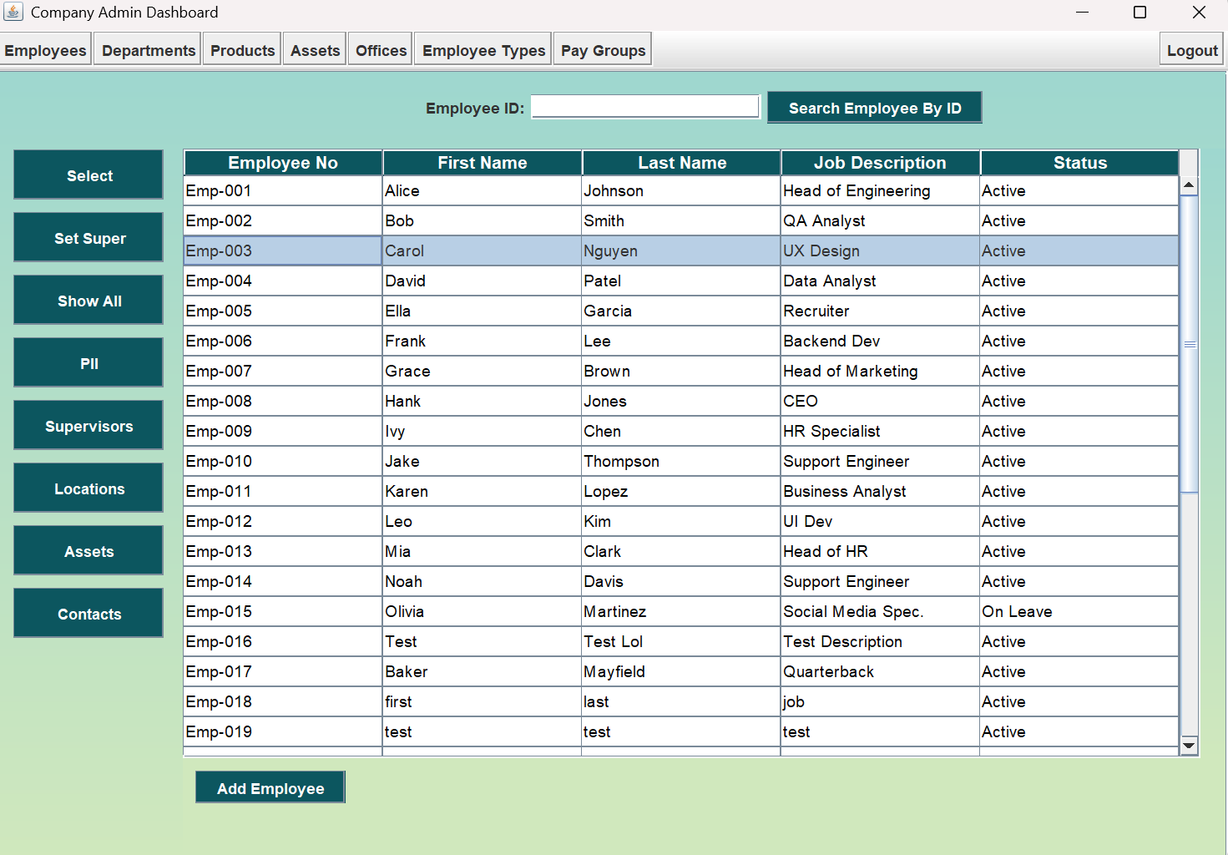

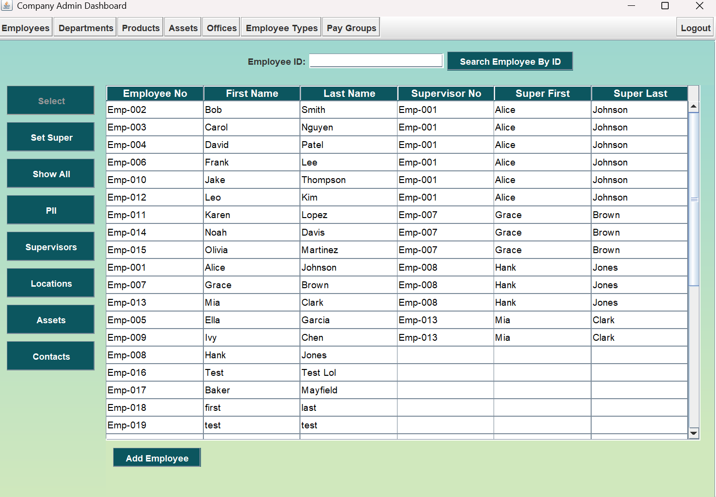

1. Select a row in the table and press the **Set Super** button near the top of the left nav bar.



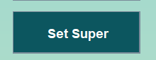

Set Supervisor by Id modal opens. Change the Supervisor ID as needed, then press the **Update** button.

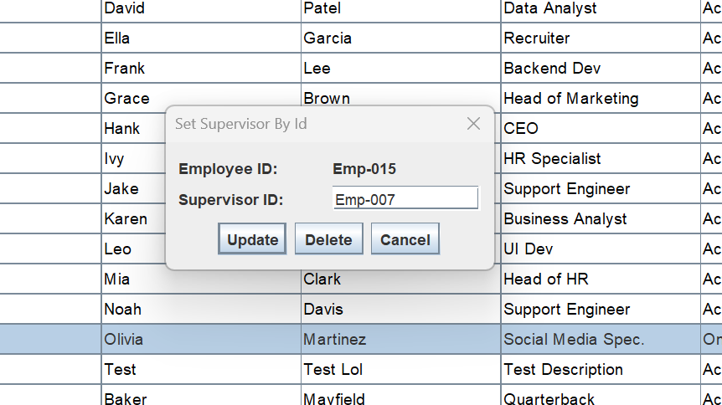

1. If Supervisor ID is input correctly, Supervisor updated successfully message shows.

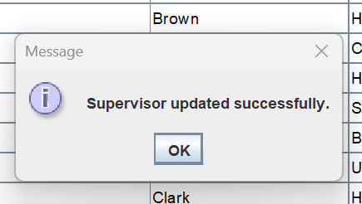

1. Stay on or navigate to **Supervisors** page to view change made.

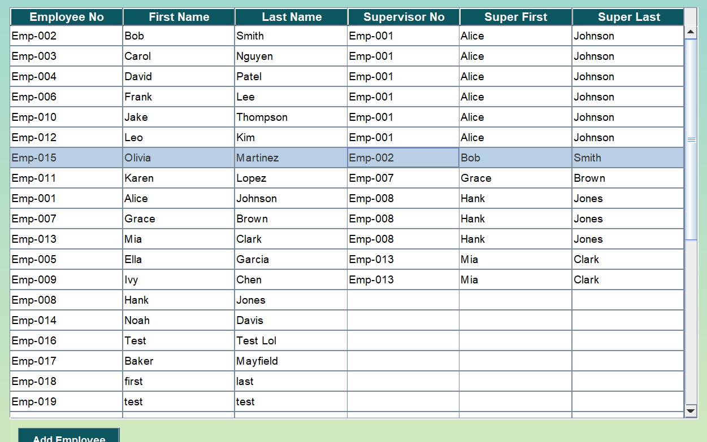

## 1.4 Deleting an Employee Supervisor

1. To set an Employee Supervisor, first use the buttons on the left navigation bar to either display the **Show All** page or the **Supervisors** page**.**

 





1. Select a row in the table and press the **Set Super** button near the top of the left nav bar.





1. Set Supervisor by Id modal opens. Press the **Delete** button.



1. Confirmation panel appears asking if you’re sure you want to remove supervisor. Press **Yes** button.

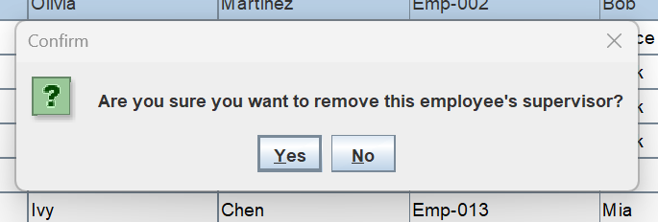

1. Banner confirming successful removal of supervisor displays.

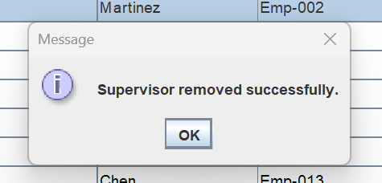

1. Stay on or navigate to **Supervisors** page to view change made.

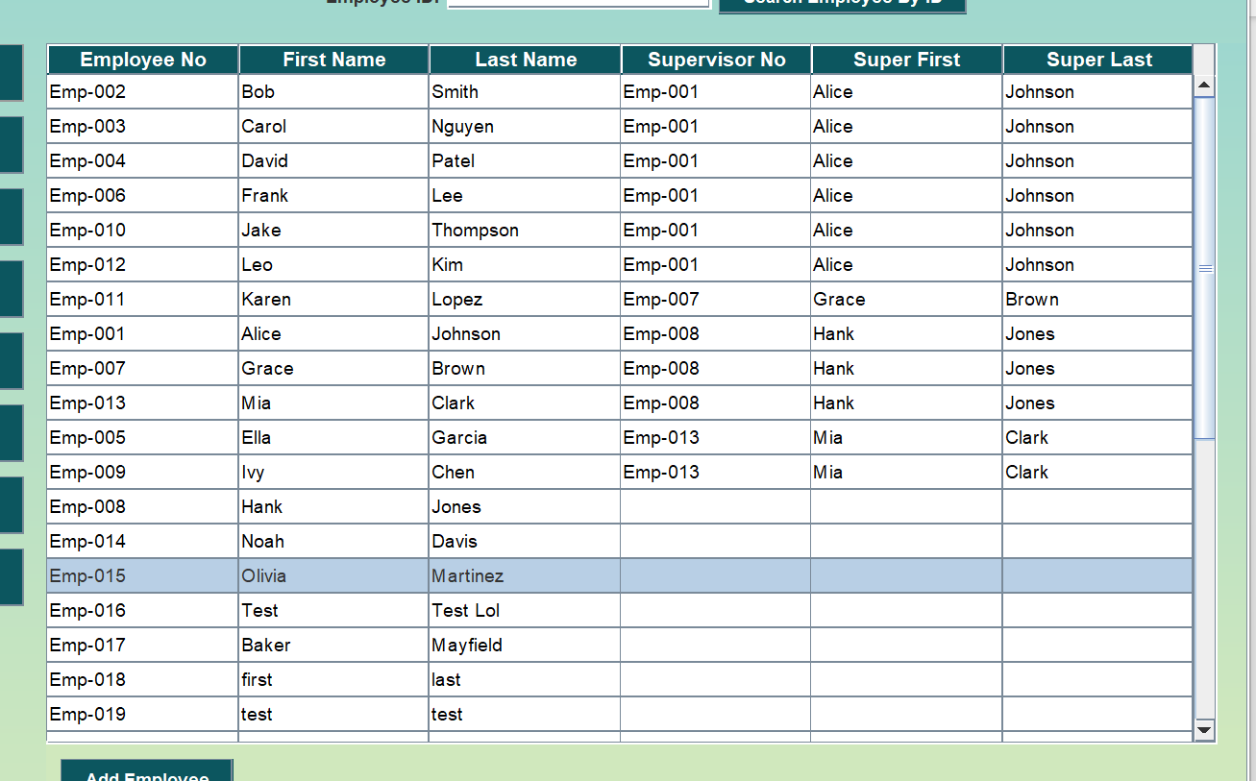

|  |
| --- |
| 2 Department and Other Categories Management (*Shared Functionality*) This section is intended for highlight how authorized users can make add, edit, and delete records for Departments, Products, Assets, Offices, Employee Types, and Pay Groups. |
| 2.1 Adding a Record  1. Navigate to the **Departments** tab at the top of the GUI        1. At the bottom left of the application select **Add Department** |

1. Here you can fill out **Name**, **Budget**, **Employee Count**, **Department Head SSN**, and **Department Head Bonus**

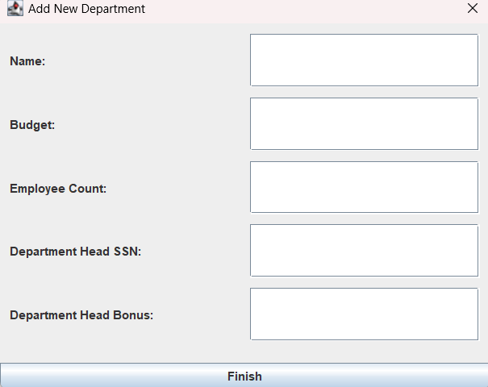

1. Select **Finish** and the Department will be added and assigned a **Department ID**. If added correctly, you will receive a message.

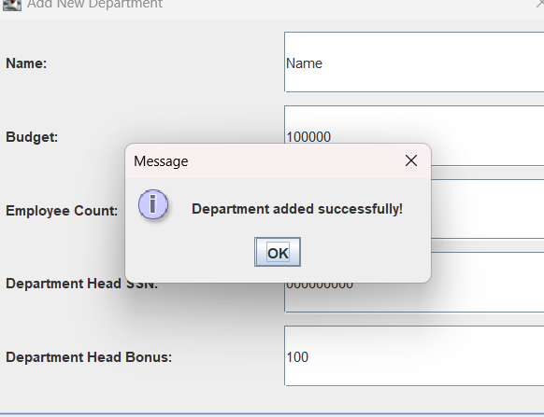

1. You can now view the newly added Department.

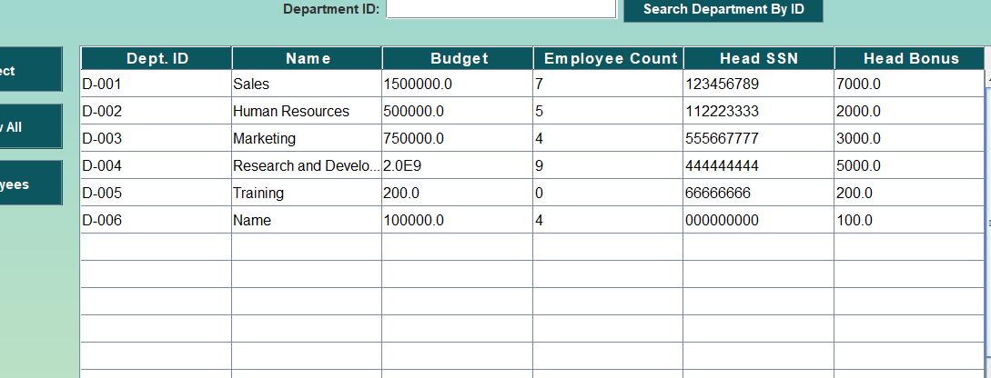

## 2.2 Editing a Record

1. To edit department information, select a row on the Department table and press the **Select button** at the top of the left navigation bar.

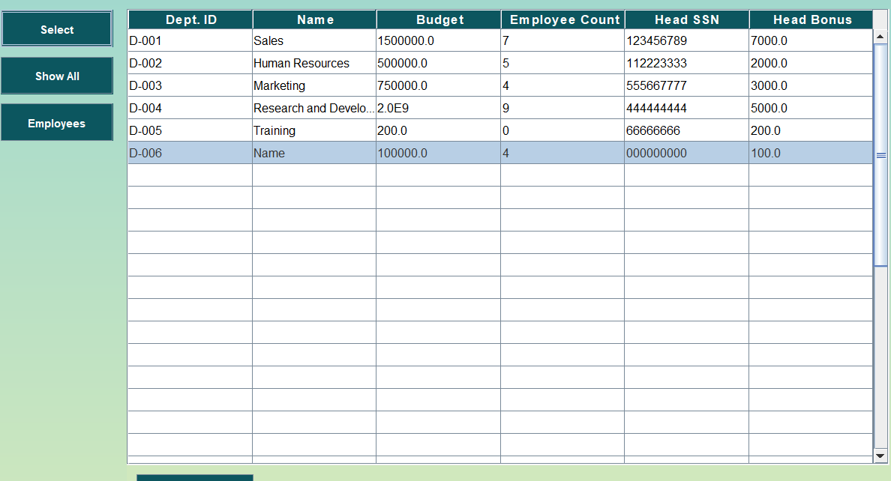

1. This opens the **edit modal** with fields already filled out. Change fields as you see fit.

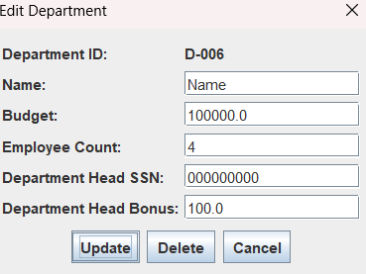

1. When you’ve finished editing, press the **Update button** at the bottom left of the edit modal.

Inserting image...

1. If all information is filled out properly, you’ll get a **Department Updated Successfully** message.

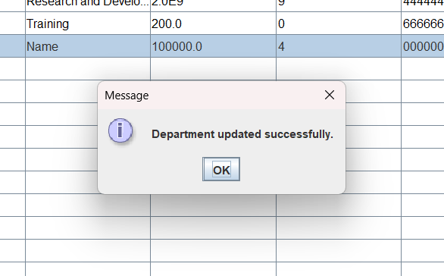

1. Press **Show All** Button near the top of the left navigation panel. This will refresh the page so you can view your edits.



1. View successfully updated employee in Department table.

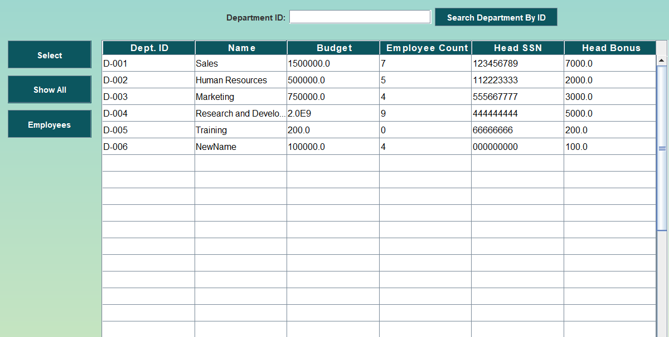

2.3 Deleting a Record

1. To delete a department, select a row on the department table and press the **Select button** at the top of the left navigation bar.



1. This opens the **edit modal** with fields already filled out.

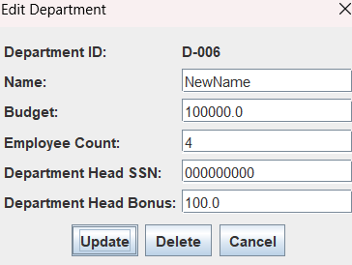

1. Press the **delete button** on the bottom left of the **edit modal.**



1. This will open a prompt asking if you’re sure you want to delete the employee (**this is permanent**). Press the **Yes button** to delete.

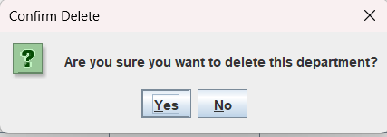

1. **Department Deleted Successfully** message will display.

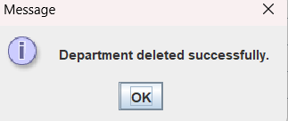

1. View Department table with removed Department.

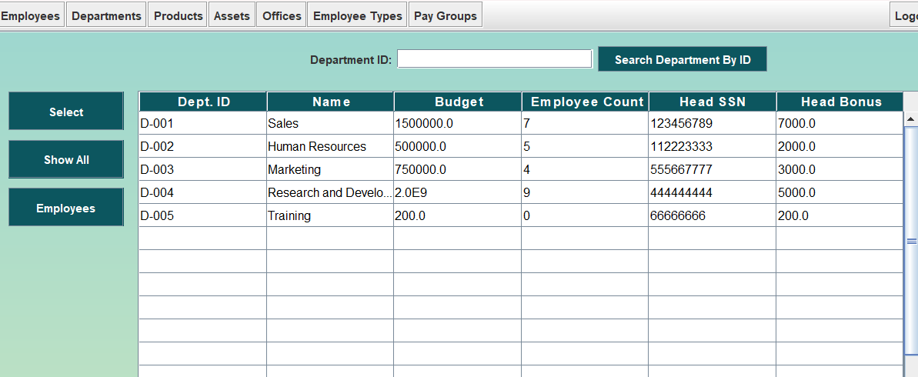

|  |
| --- |
| 3 Login and Logout Functionality This section is intended for highlight how authorized users can login and logout. |
| 3.1 Logging in  1. Upon opening MySequel Solutions, you’ll be greeted with a login page. You’ll input your company given **Username and Password** in the input fields and press either the **Login button** or Enter on your keyboard. |

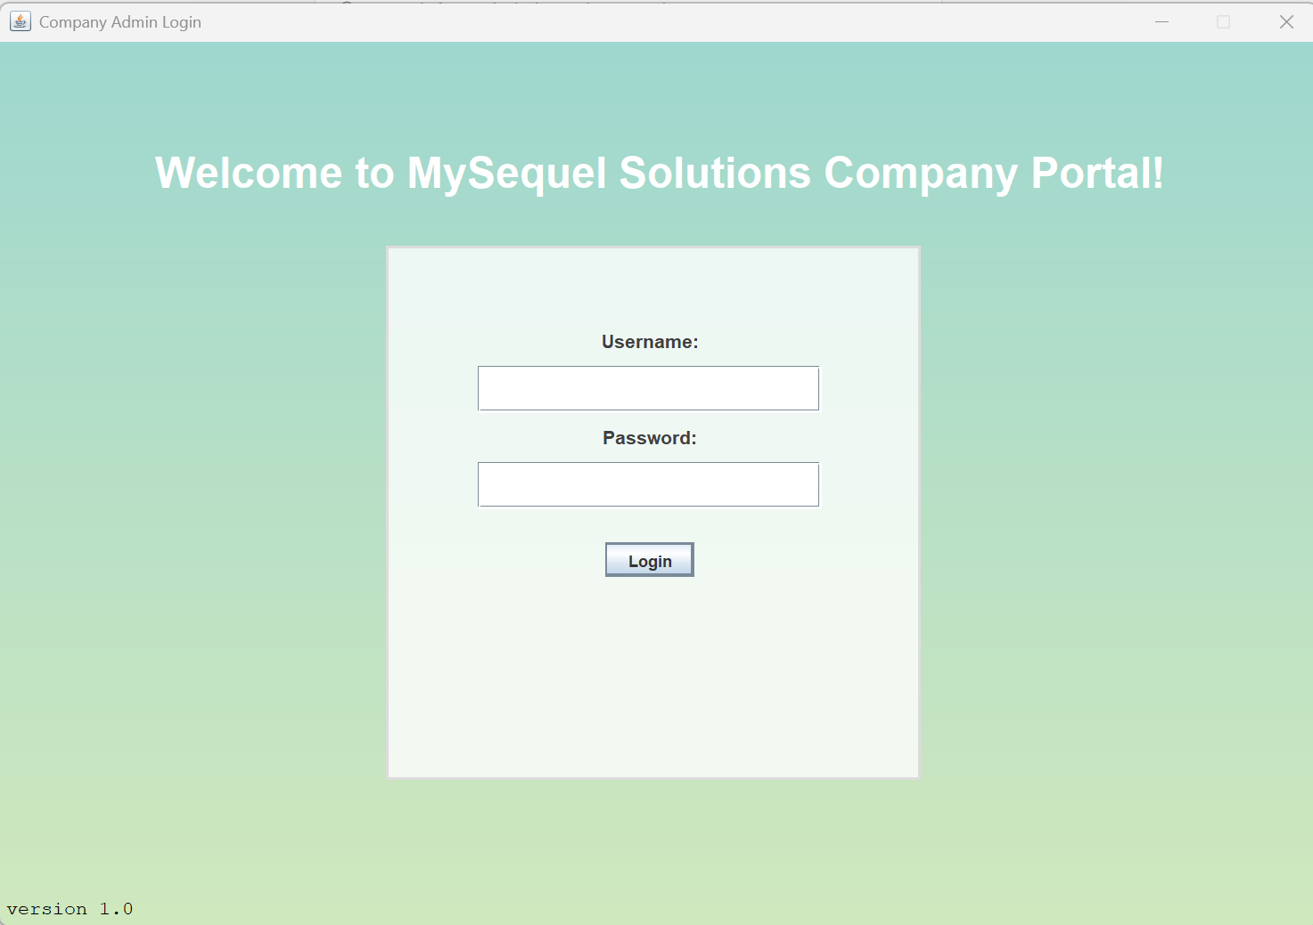

## 3.2 Logging out

1. Once logged in, users can log themselves out by pressing the **Logout** button on the top navigation bar located all the way to the right. This will send the user back to the login panel.

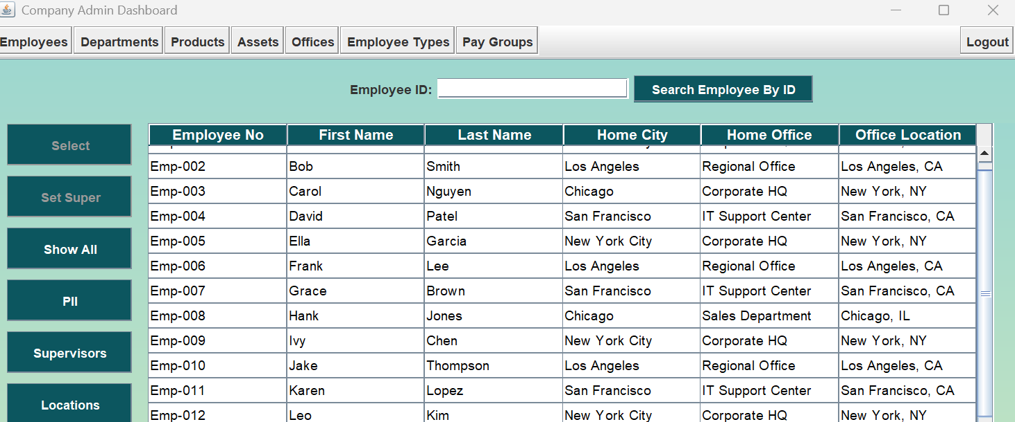

|  |
| --- |
| 4 Search Functionality This section is intended for highlight how authorized users can make searches in all categories using either Search by ID, or the left navigation bar presets. |
| 3.1 Using Search by ID Across Categories  1. Each data type (i.e. Employee, Department, Pay Group, etc.) will have a search bar at the top of the panel. For this example, we’ll be looking at Employee Type.      1. Input a properly formatted ID of that data type into the **search bar** at the top of the panel and press the **Search by ID** button. |

1. Searched for row appears. To see other rows, press the **Show All** button on the navigation bar of any section.

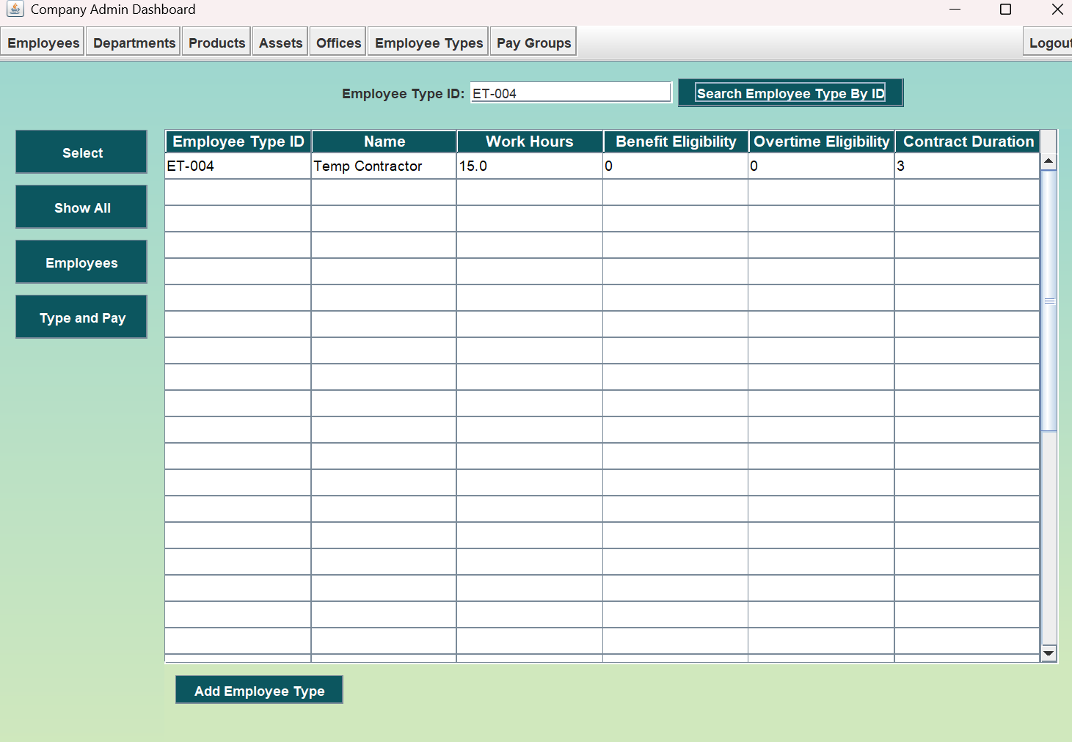

## 3.2 Using Search Buttons on left Navigation Bar

1. Each data type will have a left navigation bar with a **Select button, Show All button,** and other buttons used for viewing specific information, we’ll look at the Employee data type as an example.

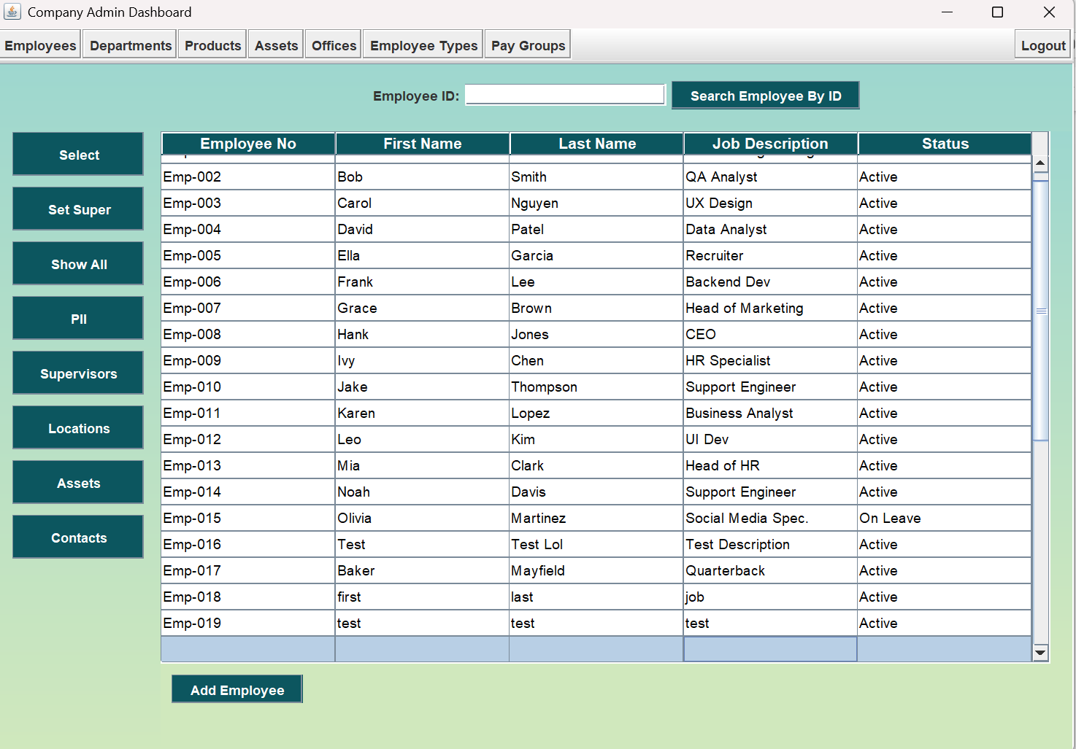

1. EXAMPLE: Press **PII** (Personally Identifiable Information) to display Employee PII.

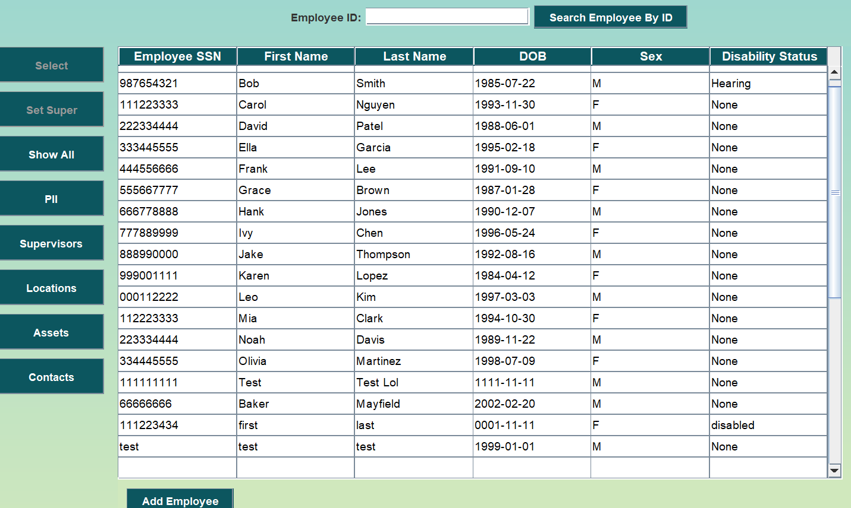

1. EXAMPLE: Press **Locations** to display where Employees are located and what office they belong to.

