# Picture

|  |
| --- |
| User Guide |

|  |
| --- |
| Table of Contents |

User Guide 1

Table of Contents 1

1 Introduction of MySequel Solutions Software 2

1.1 Who Should Use This Software 2

1.2 Who Should Use This Guide 3

2 Key Features 4

2.1 Administrator Features 4

2.2 Executive Features 5

3 Administrator and Executives – Guided Tour 6

3.1 Login 6

3.1.1 Base Functionality 7

3.2 Navigation 9

3.3 Employee Management 11

3.4 Department Management 13

3.5 Products Management 15

3.6 Assets Management 15

3.7 Offices Management 16

3.8 Employee Types Management 16

3.9 Pay Groups Management 19

4 Logout 20

|  |
| --- |
| 1 Introduction of MySequel Solutions Software |

## 1.1 Who Should Use This Software

In many organizations, employee information is one of the most valuable assets. Managing that information efficiently is critical—not only for day-to-day operations, but also for strategic planning and organizational growth. Where manufacturers rely on supply chain systems and retailers use inventory tools, administrative teams depend on reliable, accessible databases to manage personnel and company data.

MySequel Solutions software was designed to meet that need. It provides a streamlined, user-friendly interface for administrators to manage employee records and organizational information. With features that allow easy updating, editing, and deletion of employee data, the system supports secure and centralized access to key information. This enables faster decision-making, simplifies staffing and resource allocation, and improves overall organizational efficiency.

By focusing on clarity, security, and usability, the software helps businesses maintain accurate records and adapt quickly to changing administrative needs—all within a single, integrated platform.

## 1.2 Who Should Use This Guide

This guide is intended for users of the MySequel Solutions software and provides step-by-step instructions to help them effectively utilize its features. The intended audiences include:

* **Company Administrators**: Administrative users will learn how to manage large volumes of data within the company’s database. This includes overseeing department tasks, maintaining employee records, tracking company assets, and more.
* **Executives and Managers**: Executives and management personnel will be guided on how to edit payrolls, allocate funding, monitor ongoing projects, and manage pay groups. These tools will help leadership gain clear insights into company operations and make informed decisions moving forward.

|  |
| --- |
| 2 Key Features |

## 2.1 Administrator Features

The following are key system functions present for administrators of the company:

* User Login
* View all employees, departments, offices, products, assets
* Add employees to database
* View Supervisors
* Edit Employee information: The feature allows administrators the ability to update employee information. For example, if an employee’s status or location changed
* PII: This feature shows personal employee information that is not normally viewable
* View Employees: This function in the Departments tab allows administrators to view employees belonging to each department
* Add department
* Show Assets
* Search employee, department, asset, product, office

## 2.2 Executive Features

The following are key features available to executives and managers of the company:

* Employee-Type: This feature outlines what category of employment contracts an employee belongs to. Employees can either be full-time, part-time, or contracted
* Pay Groups: This feature displays the given pay groups an employee can be assigned to. Pay periods, frequency, and rates are outlined here.
* Get Employees: This function gets the pay group each employee belongs to
* Employee Type and Pay
* Show All Pay groups
* Add pay group
* Search pay group

|  |
| --- |
| 3 Administrator and Executives – Guided Tour |

This section aims to teach users how to use the unique features and functions present in the software.

## 3.1 Login

Upon launching of the software, users are greeted with a standard login window (Figure 1) that requires a username and password to be authenticated. To access any features, authentication is necessary.

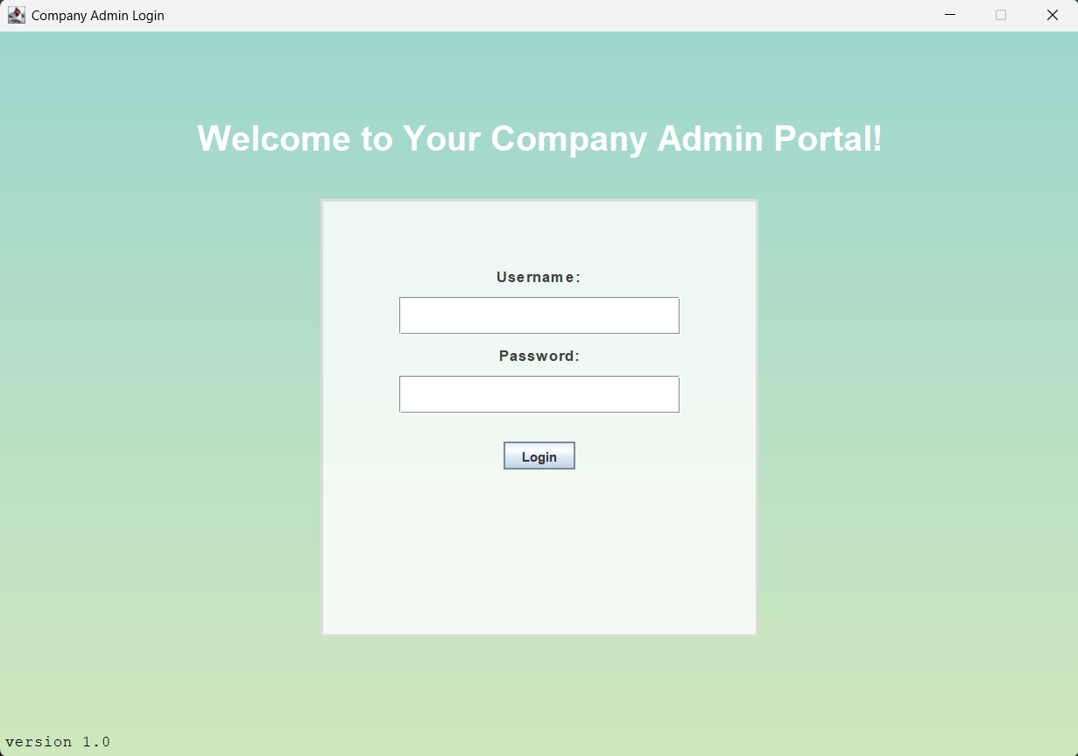

Figure 1

Invalid username or password credentials will not be authenticated and will result in a pop-up window (Figure 2) that tells users of an unsuccessful login.

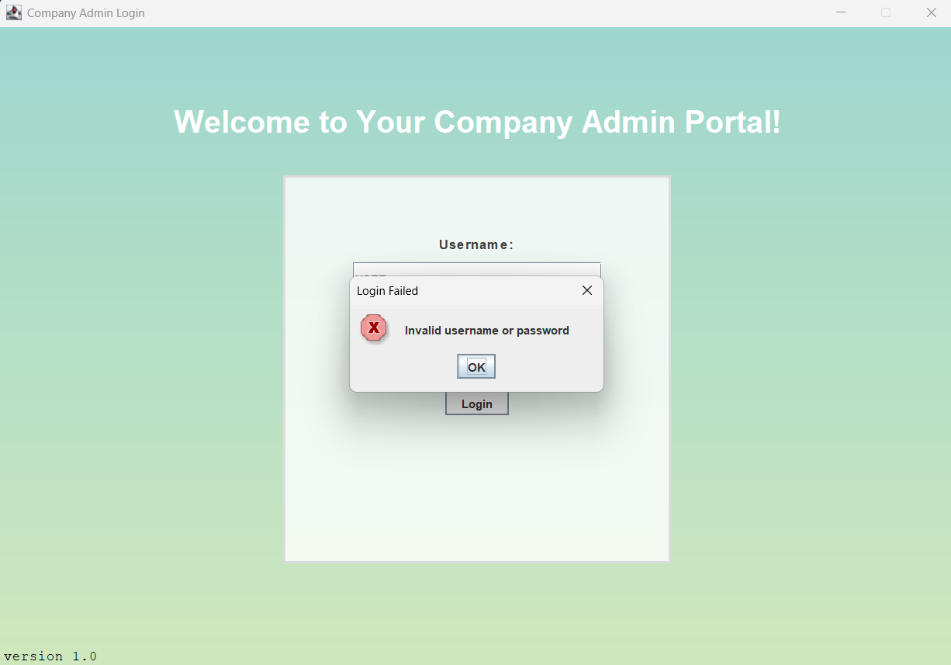

Figure 2

Upon successful login, the software automatically navigates to the default employee panel. As shown in Figure 4, the user is now presented with the main interface, granting access to all available features of the application.

Additionally, to log out, a user simply needs to click the button “Logout” located at the top right of the interface, which will take the user back to the login page.

### 3.1.1 Base Functionality

To introduce the functionality of each page, the interface includes a set of core operations that behave consistently across the application, with slight variations depending on context. These foundational features are described here and in their relevant sections.

Each page incorporates three primary functions: **Select**, **Show All**, **Search By**, and **Add**. While their purposes remain consistent, their specific behavior can vary slightly from page to page.

* **Select** is used to retrieve detailed information about a specific entry displayed on a table. For instance, on the **Department** page, clicking on a department entry and then selecting the **Select** button will open a window displaying detailed department information (see Figure 3).
* Show All displays all entries of a given table, depending on the page the user is on.
* **Search by** is used to search a database given an ID.
* The **Add** function allows users to create and insert new entries into the database, with the interface tailored to the specific context of each page. This functionality is consistent across the application—whether adding a new employee, department, office, asset, or other entity, the **Add** function provides the necessary fields to input and save the relevant information.

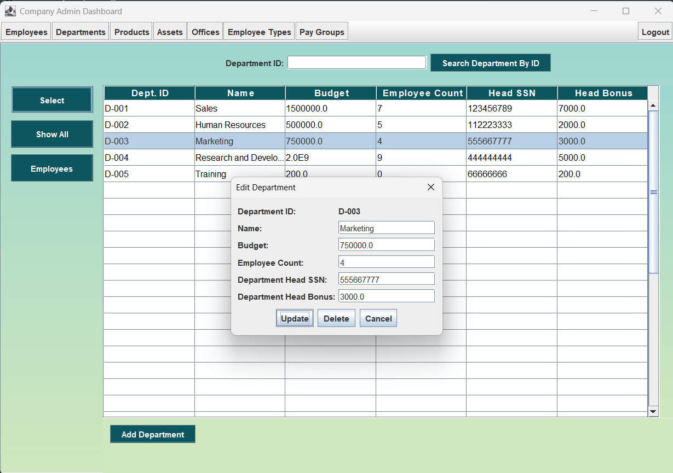

Figure 3

## 3.2 Navigation

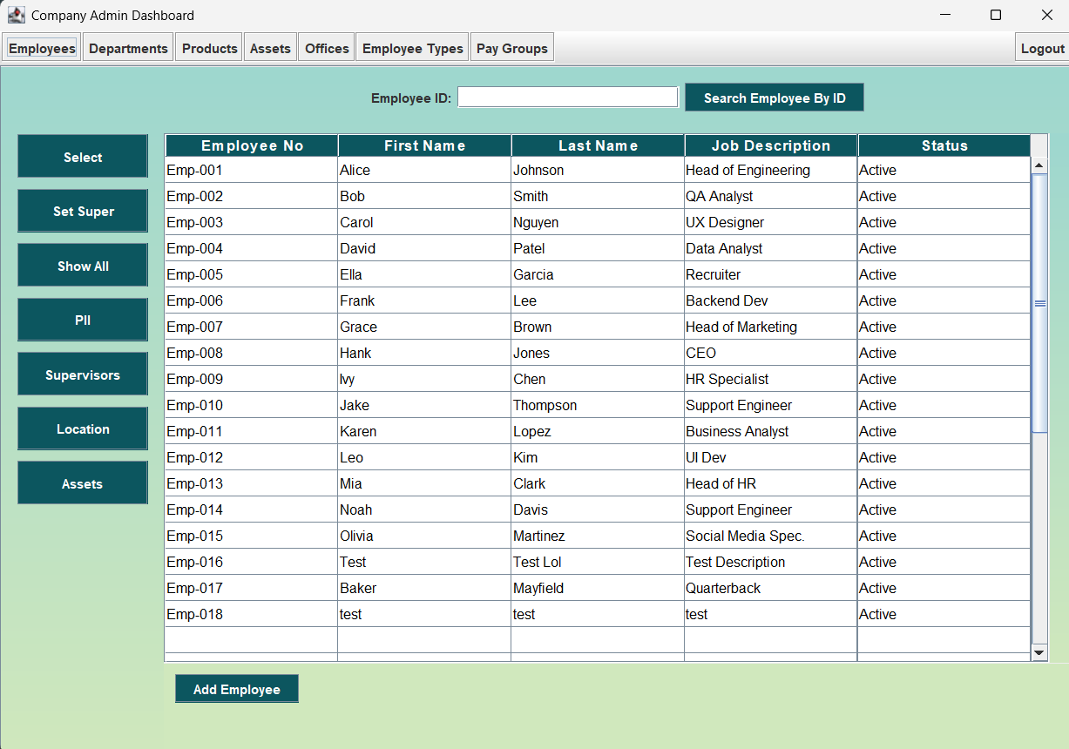

Figure 4

Here, we can immediately see the data stored in the employee table of the database. The administrator dashboard can be split into 5 main sections, which will be referred to as panels. On the left panel, the user has access to a multitude of functions/buttons that all result in different outcomes.

1. The top panel, toolbar, contains all the different pages that a user can navigate depending on their specific task. Each page has a different purpose and functions with what data is fetched from the database.
2. The middle panel, the dataset, contains fetched data from the database. The main purpose of this panel is to allow users a user-friendly visual representation of the database. This displays the most current data within the database and is updated accordingly when any changes are made.
3. The left panel, side bar, contains a set of functions that the user can operate that give more detailed information on a given database table. In Figure 3, the user sees functions that control employee data.
4. The bottom panel contains a button that allows users to add new entries into the database. Upon this button being clicked, a new window (Figure 5) appears for the user to fill out information about the new entry. In the case of Figure 5, this window is the employee creation window and has a few distinctions compared to other creation windows due to the number of attributes that define an employee.
5. The search panel, located in between the middle and top panels gives the user search capability when looking for entries in the table. In most cases, it can be used to find a specific employee, department, asset, etc., depending on the page the user is on.

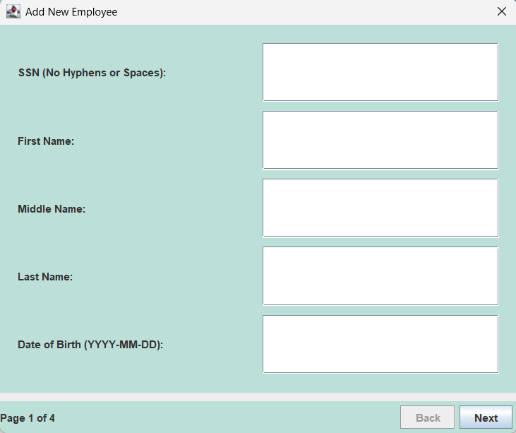

Figure 5

## 3.3 Employee Management

Employee management is one of the key features of this software. There are several functions used in the employee page that make it user-friendly and robust. As mentioned above, the left panel on the employee page defines multiple functions that define how employee data is retrieved. These functions are:

* Select – Fetches user data that can be changed and updated.
* Set Super – Sets the supervisor of an employee using employee numbers
* Show All – Show All updates and displays all employees found in the database
* PII – Displays personal information on employees (i.e., DOB, sex, disability)
* Supervisors – Fetches a list of all supervisors
* Location – Fetches the location of all employees
* Assets – Fetches a list of employees who have assets associated with them

Each having their own functionality. Like the add employee function, “Select” fetches an employee from the database, and makes their information editable. It does this by opening a window (Figure 6) containing text fields for each employee's attributes. In this window, there is also the option to delete the employee, or remove them from the database.

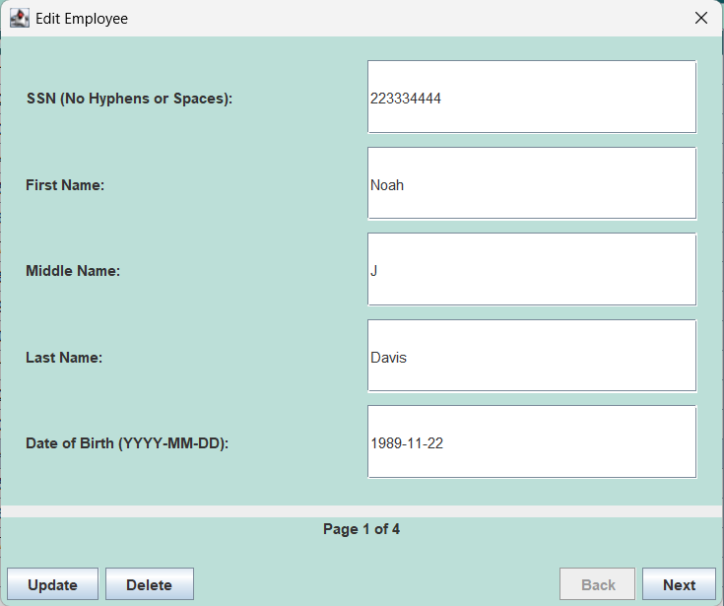

Figure 6

Additionally, the last key function of the employee page is “Add Employee.” To add an employee, the user must follow three important steps. First, the user must click on the “Add Employee” button located in the bottom panel of the page. From there, the user then enters employee information for each attribute. Lastly, to add the new employee the “finish” button must be clicked, and only once a pop window appears

## 3.4 Department Management

To access the department page, select **Department** from the toolbar. As shown in Figure 7, this page provides several functions that offer access to additional information not at once visible elsewhere in the interface. These functions include:

* Select
* Show All
* Employees

To get a list of employees in each department, click on a department and then click on the “Employees” button. In figure, the “Marketing Department” was selected, and when the “Employee” button was clicked, it displayed the current employees belonging to Marketing.

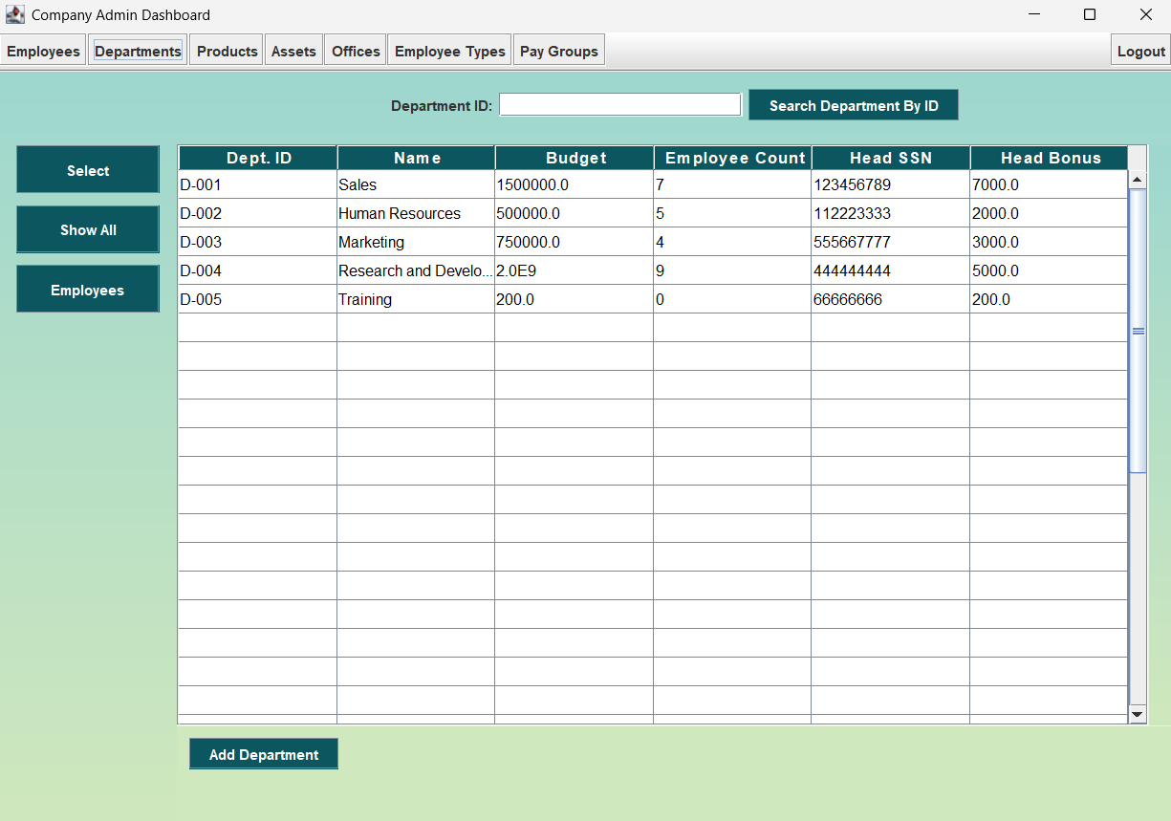

Figure 7

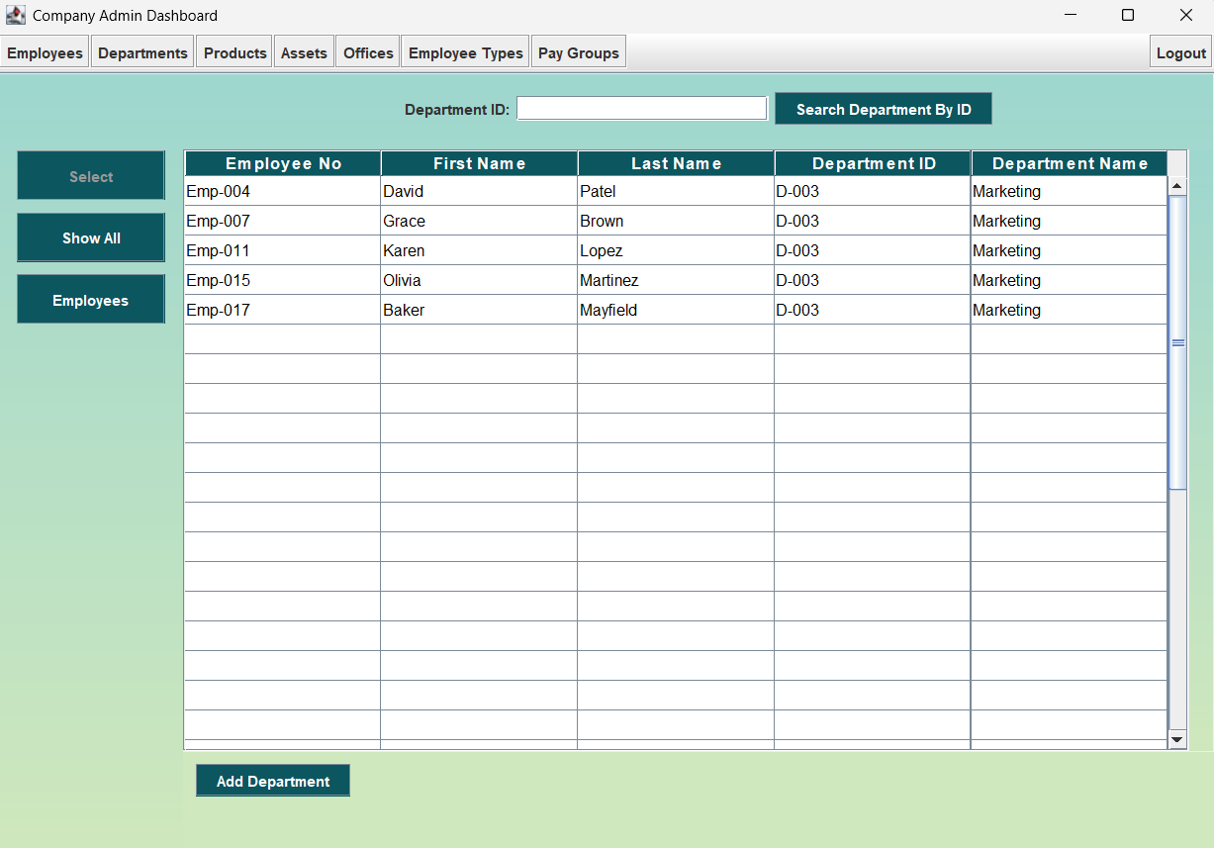

Figure 8

## 3.5 Products Management

Refer to Section 3.1.1, *Base Functionality*. In addition to the core features **Select** and **Show All**, users can manage products through the **Add Product** function, which allows them to add, edit, update, or delete product entries. Users can also assign products to a specific department directly from this interface.

## 3.6 Assets Management

To view a company’s assets, navigate to the **Assets** page. This section displays a comprehensive list of all available assets. A key feature of this page is the ability to view detailed asset information, including warranty coverage and purchase dates. Additionally, administrators can assign assets to employees, view existing assignments, or reassign assets as needed. For standard features available on this page, refer to Section 3.1.1, *Base Functionality*. Figure 9 is a visual representation of asset information when “Dates” button is clicked.

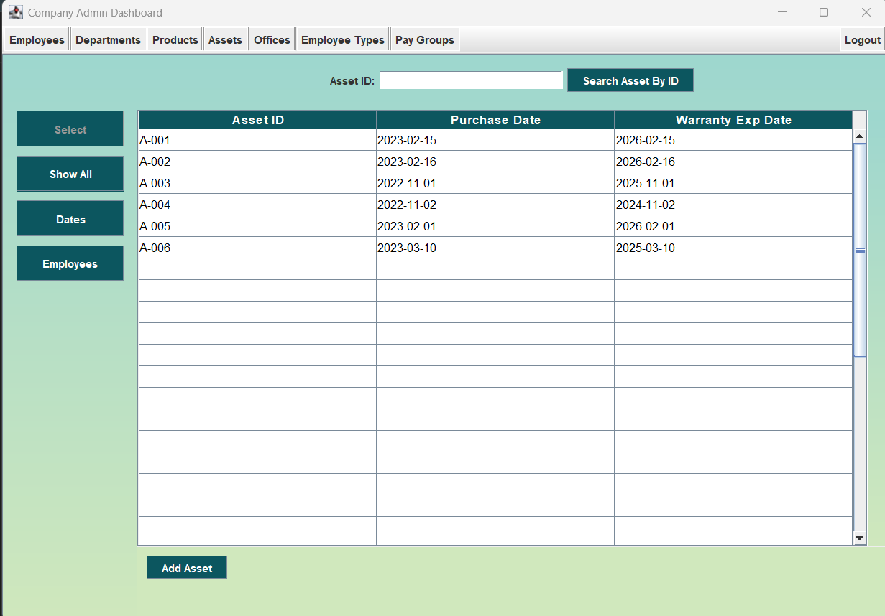

Figure 9

## 3.7 Offices Management

The **Office Management** page functions similarly to the **Department** page. For details on the **Employee** button, refer to Section 3.4, *Department Management*. Standard features available on the Office page are outlined in Section 3.1.1, *Base Functionality*.

## 3.8 Employee Types Management

To manage a company's work contracts, administrators must navigate to the **Employee Types** page. From this interface, they can create, edit, or delete existing contract types. As shown in Figure 10, the system currently includes three types of work contracts, all of which are fully customizable. For example, if the company hires a contractor to handle outsourced tasks, the administrator can create a new contract type specifically for that role and assign it to relevant employees. This process is illustrated in Figures 11 and 12, where a new contractor contract has been successfully added. 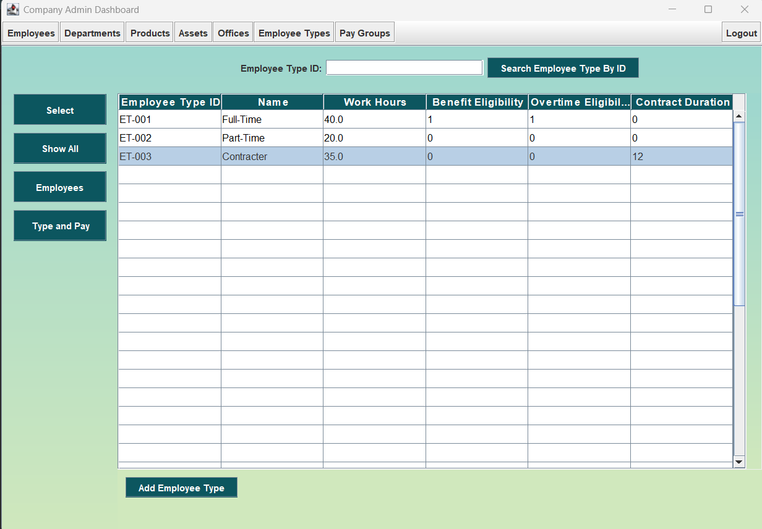

Figure 10

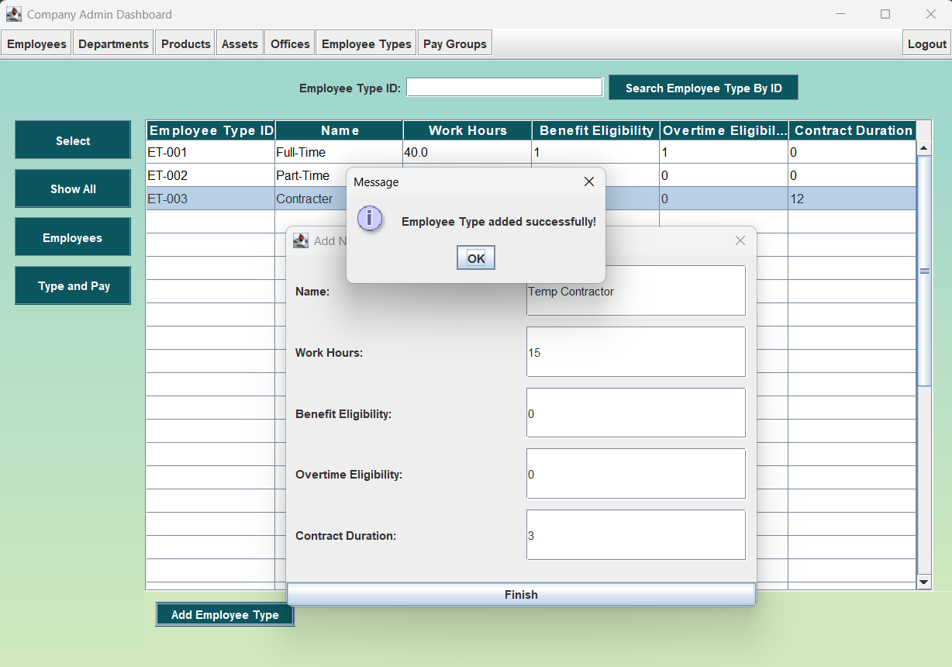

Figure 11

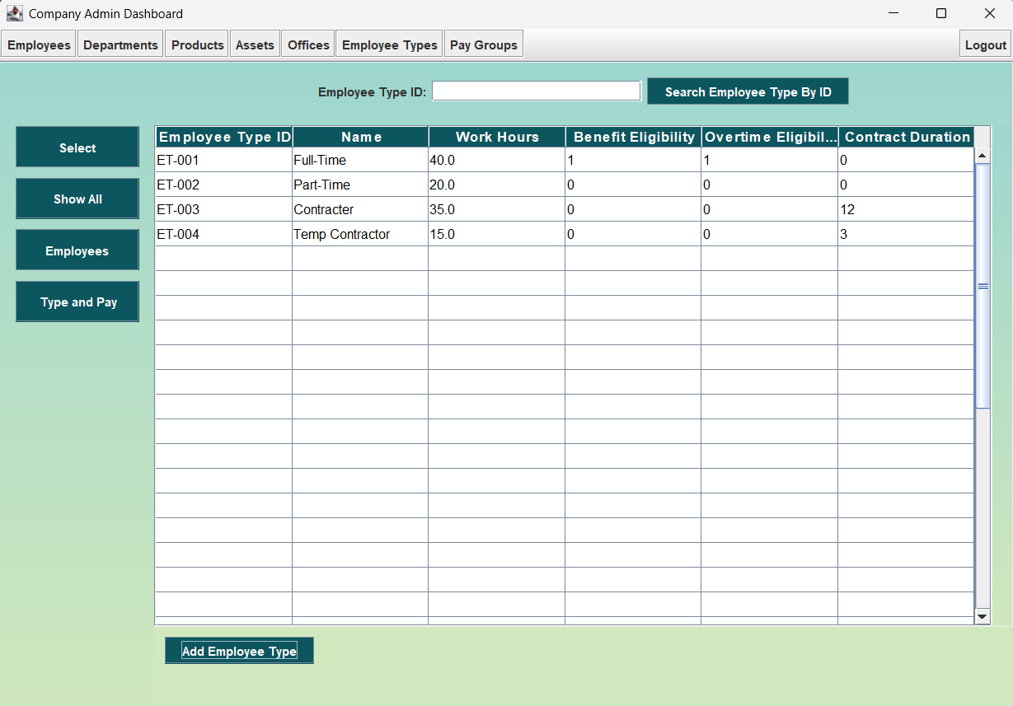

Figure 12

## 3.9 Pay Groups Management

In conjunction with employee type, the **Pay Groups** page defines the type of compensation assigned to each employee. Administrators can use this page to manage and configure various pay groups applicable to distinct roles. As shown in Figure 13, clicking the **Employee** button displays the pay group associated with the selected employee.

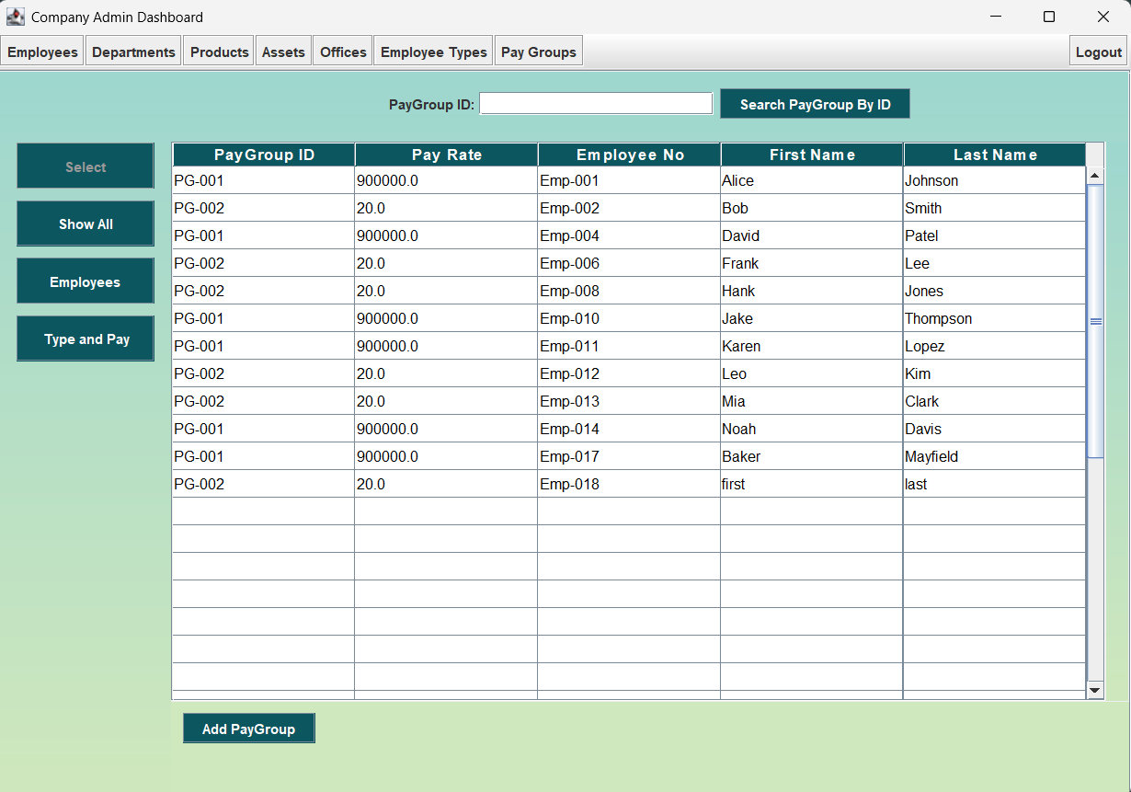

Figure 13

|  |
| --- |
| 4 Logout |

Refer to section 3.1, which details the login process along with logging out.